Supporting Information

Dual-Channel NIR-II/Red Probe for Simultaneously Visualizing Mitochondrial Viscosity and NAD(P)H Dynamics Reveals Cuproptosis Mechanisms
Zhiwen Zhao¹, Ying Dang², Shihao Sun¹, Xinyue Li¹, Xue Zhang¹, Wenting Guo¹*, Baodui Wang¹*

¹ Z. Zhao, Y. Dang, S. Sun, X. Li, X. Zhang, W. Guo, Prof. B. Wang
State Key Laboratory of Applied Organic Chemistry and Key Laboratory of Nonferrous Metal Chemistry and Resources Utilization of Gansu Province, Lanzhou University, Lanzhou, 730000, P. R. China.
E-mail: guowenting@mail.lzjtu.cn; wangbd@lzu.edu.cn.

² Y. Dang
The Second Hospital & Clinical Medical School, Lanzhou University, Lanzhou, 730030, P. R. China.

Experimental Section
Synthesis Experiment
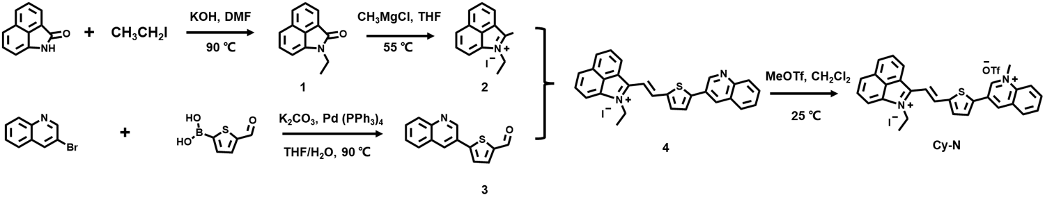
Supplementary Fig 1. Synthetic route for Cy-N.
Synthesis of compound 1: 1,8-Naphthaolactam (507 mg, 3 mmol) and potassium hydroxide (560 mg, 10 mmol) were dissolved in anhydrous DMF (10 mL) under nitrogen atmosphere. The reaction mixture was stirred for 10 min at 30 °C and iodoethane (0.75 mL, 10 mmol) was introduced into the system. After stirring at 90 °C for 12 h, the reaction was cooled at room temperature and extracted with ethyl acetate, then concentrated. The crude product was purified via silica gel column chromatography with PE / EtOAc (10:1 v/v) as the eluent to afford a yellow oil product (yield 89.5%). ¹H NMR (400 MHz, Chloroform-d): δ 8.12-7.95 (m, 2H), 7.71 (ddd, J=8.9, 7.0, 1.9 Hz, 1H), 7.57-7.50 (m, 1H), 7.47 (ddd, J=8.8, 6.8, 1.9 Hz, 1H), 6.92 (ddd, J=6.9, 1.9, 0.7 Hz, 1H), 3.99 (qd, J=7.3, 1.9 Hz, 2H), 1.38 (td, J=7.3, 1.9 Hz, 3H). ESI-MS: m/z calcd. for 1 (C₁₃H₁₁NO, [M+H]⁺), 197.2370; found, 198.0573.
Synthesis of compound 2: A solution of compound 1 (493 mg, 2.5 mmol) in anhydrous THF (20 mL) was cooled to 0 °C, and methyl magnesium chloride (3 M solution in THF, 1 mL, 3mmol) was added into the system. The reaction was stirred at 55 °C for 1 h under nitrogen atmosphere. After cooling to room temperature, the reaction neutralized by adding 1 M hydrochloric acid, then was poured into saturated sodium iodide solution to form crystallization, obtaining brown precipitates. The precipitates were filtered, washed by water and ethyl acetate, and then dried under vacuum to give a dark brown solid (yield, 70.1%). ¹H NMR (400 MHz, DMSO-d₆): δ 8.98 (d, J=7.3 Hz, 1H), 8.80 (d, J=8.1 Hz, 1H), 8.54 (d, J=7.4 Hz, 1H), 8.45 (d, J=8.3 Hz, 1H), 8.18 (t, J=7.7 Hz, 1H), 8.01 (t, J=7.8 Hz, 1H), 4.72 (q, J=7.3 Hz, 2H), 1.55 (t, J=7.3 Hz, 3H). ESI-MS: m/z calcd. for 2 (C₁₄H₁₄IN⁺, [M-I]⁺), 196.1121; found, 196.0760.
Synthesis of compound 3: 3-Bromoquinoline (520 mg, 2.5 mmol) and 5-formyl-2-thiopheneboronic acid (390 mg, 2.5 mmol) were dissolved in THF/H₂O (v/v:6/1) solution. Under N₂ atmosphere, the catalytic content of 5 mol% Pd(PPh₃)₄ and K₂CO₃ (864 mg, 6.25 mmol) were added and stirred at 90 °C for 8 h. After the reaction was completed, the mixture was extracted with dichloromethane (3×20 mL), then concentrated. The crude product was purified via silica gel column chromatography with PE/ EtOAc (10:1 v/v) as the eluent to afford the target product (yield 29.2%). ¹H NMR (400 MHz, Chloroform-d) δ 9.95 (s, 1H), 9.23 (d, J=2.4 Hz, 1H), 8.39 (d, J=2.5 Hz, 1H), 8.13 (d, J=8.5 Hz, 1H), 7.90 (d, J=8.2 Hz, 1H), 7.83 (d, J=3.9 Hz, 1H), 7.77 (t, J=7.7 Hz, 1H), 7.61 (dd, J=10.3, 5.6 Hz, 2H). ¹³C NMR (101 MHz, Chloroform-d) δ 182.82, 148.19, 137.48, 133.00, 132.27, 132.17, 132.09, 128.33, 127.88, 125.38, 130.61, 129.55, 128.70, 128.58. ESI-MS: m/z calcd. for 3 (C₁₄H₉NOS, [M+H]⁺), 239.0405; found, 240.0035.
Synthesis of compound 4: Compound 2 (239 mg, 1 mmol) and compound 3 (323 mg, 1 mmol) were dissolved in Toluene/1-butanol (v/v:1/1) solution and stirred overnight at 100 °C. After completion, the solution was cooled to room temperature and concentrated. Then, the solvent was removed under reduced pressure and the solid residue was purified by column chromatography on silica gel with DCM/MeOH (20:1 v/v) to give compound 4 (yield, 42.4%). ¹H NMR (400 MHz, DMSO-d₆) δ 9.39 (d, J=2.3 Hz, 1H), 9.33 (d, J=7.4 Hz, 1H), 9.08 (d, J=15.7 Hz, 1H), 8.81 (s, 1H), 8.72 (d, J=8.1 Hz, 1H), 8.38 (d, J=7.4 Hz, 1H), 8.34 (d, J=8.2 Hz, 1H), 8.30 (d, J=4.0 Hz, 1H), 8.19 (d, J=7.8 Hz, 1H), 8.15 (d, J=4.0 Hz, 1H), 8.10–8.05 (m, 2H), 7.96 (t, J=7.8 Hz, 1H), 7.83 (t, J=7.8 Hz, 1H), 7.73–7.68 (m, 2H), 4.86 (q, J=7.3 Hz, 2H), 1.55 (t, J=7.2 Hz, 3H). ¹³C NMR (101 MHz, DMSO-d₆) δ 160.09, 149.38, 147.65, 147.20, 144.38, 141.09, 138.46, 134.62, 132.12, 130.80, 129.86, 128.60, 127.70, 127.17, 125.61, 122.90, 118.89, 112.85, 41.23, 15.52. ESI-MS: m/z calcd. for 4 (C₂₈H₂₁IN₂S⁺, [M-I]⁺), 417.1420; found, 417.2121.
Synthesis of Cy-N: Under N₂ atmosphere, compound 4 (109 mg, 0.2 mmol) and MeOTf (65 mg, 0.4 mmol) were dissolved in dichloromethane (5 ml) and stirred 24 h at 25 °C. TLC was employed for monitoring the progress of the reaction. After completion, the solid residue was purified by column chromatography on silica gel with DCM/MeOH (10:1 v/v) to afford the final product Cy-N (yield, 61.8%). ¹H NMR (400 MHz, TFA-d) δ 10.12 (s, 1H), 9.83 (s, 1H), 9.45 (d, J=7.4 Hz, 1H), 9.31 (d, J=15.6 Hz, 1H), 9.13 (d, J=8.1 Hz, 1H), 8.95 (d, J=8.1 Hz, 1H), 8.91 (d, J=9.1 Hz, 1H), 8.87–8.78 (m, 2H), 8.70–8.63 (m, 2H), 8.61 (d, J=7.3 Hz, 1H), 8.48 (d, J=7.9 Hz, 1H), 8.44 (d, J=8.5 Hz, 2H), 8.12 (d, J=15.7 Hz, 1H), 5.37 (s, 3H), 5.31 (dd, J=14.1, 7.2 Hz, 2H), 2.30 (t, J=7.1 Hz, 3H). ¹³C NMR (101 MHz, TFA-d) δ 148.91, 146.12, 145.52, 145.01, 144.93, 140.88, 140.57, 140.51, 139.95, 139.47, 136.62, 133.97, 133.88, 133.35, 133.31, 132.48, 132.28, 132.26, 131.53, 130.52, 129.81, 126.08, 121.29, 119.92, 56.65, 47.78, 44.09, 16.52, 16.43. ESI-MS: m/z calcd. for Cy-N (C₃₀H₂₄F₃IN₂O₃S₂⁺, [M-I⁻-OTf]²⁺/2), 216.0825; found, 216.0424.

Supporting Figures
Supplementary Fig 2. The ¹H NMR of compound 1.
Supplementary Fig 3. The ¹H NMR of compound 2.
Supplementary Fig 4. The ¹H NMR of compound 3.
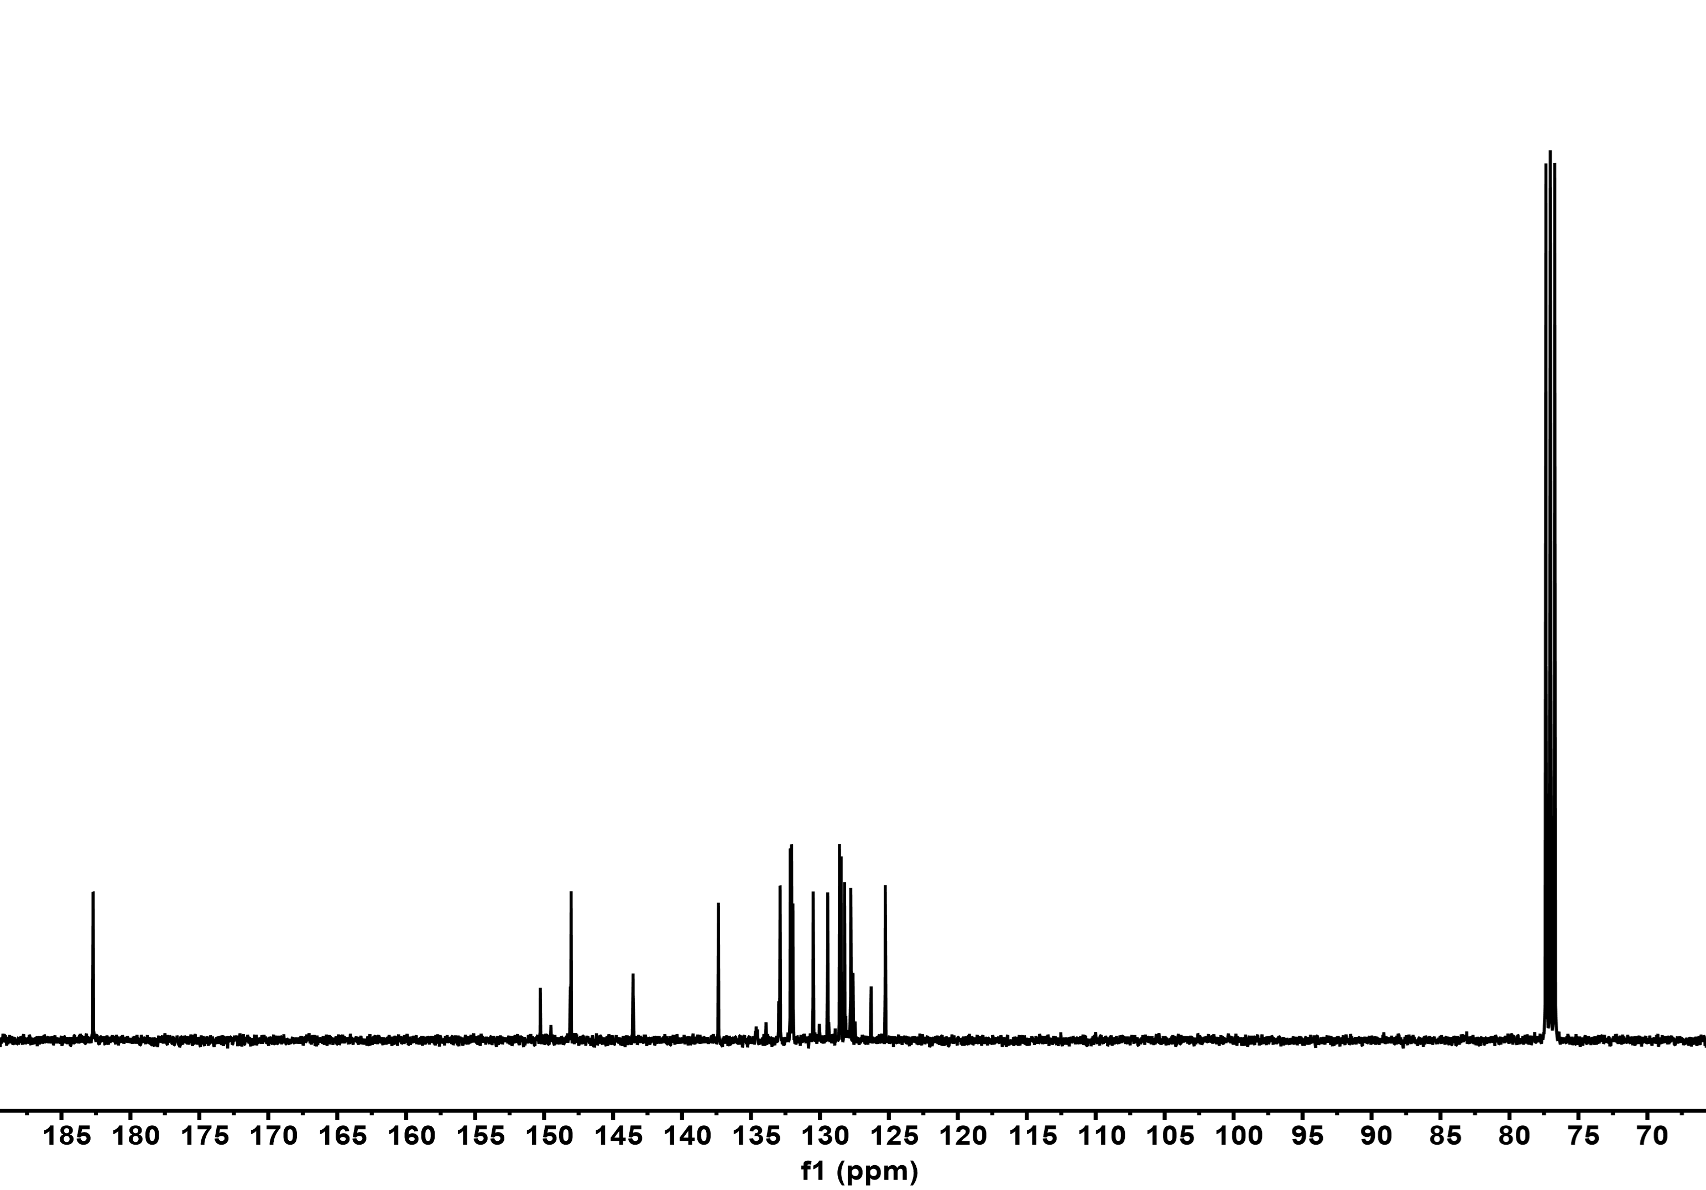
Supplementary Fig 5. The ¹³C NMR of compound 3.

Supplementary Fig 6. The ¹H NMR of compound 4.
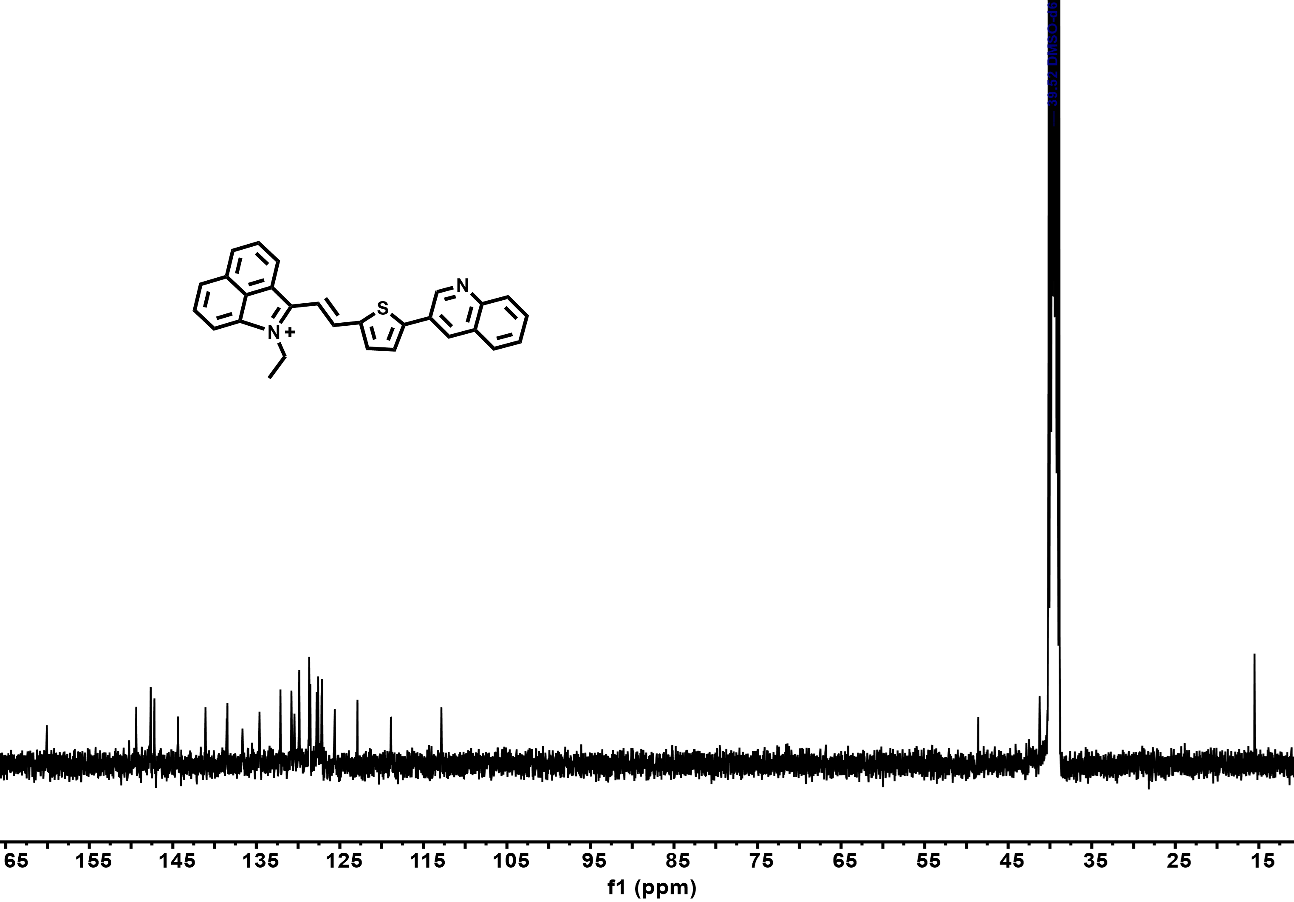
Supplementary Fig 7. The ¹³C NMR of compound 4.

Supplementary Fig 8. The ¹H NMR of Cy-N.
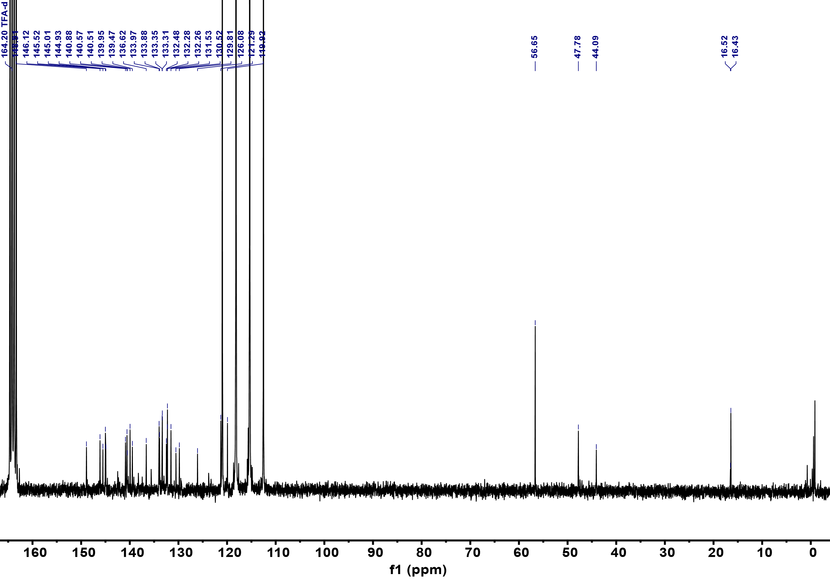
Supplementary Fig 9. The ¹³C NMR of Cy-N.
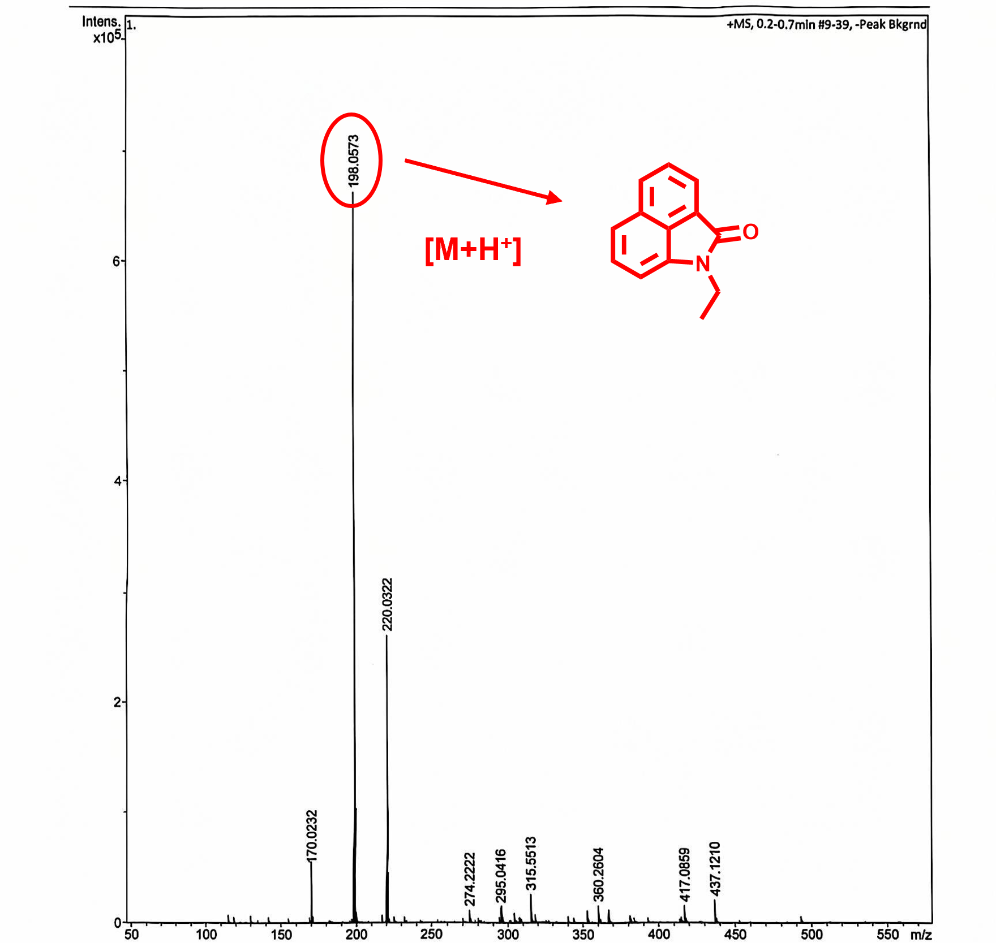
Supplementary Fig 10. The MS of compound 1.
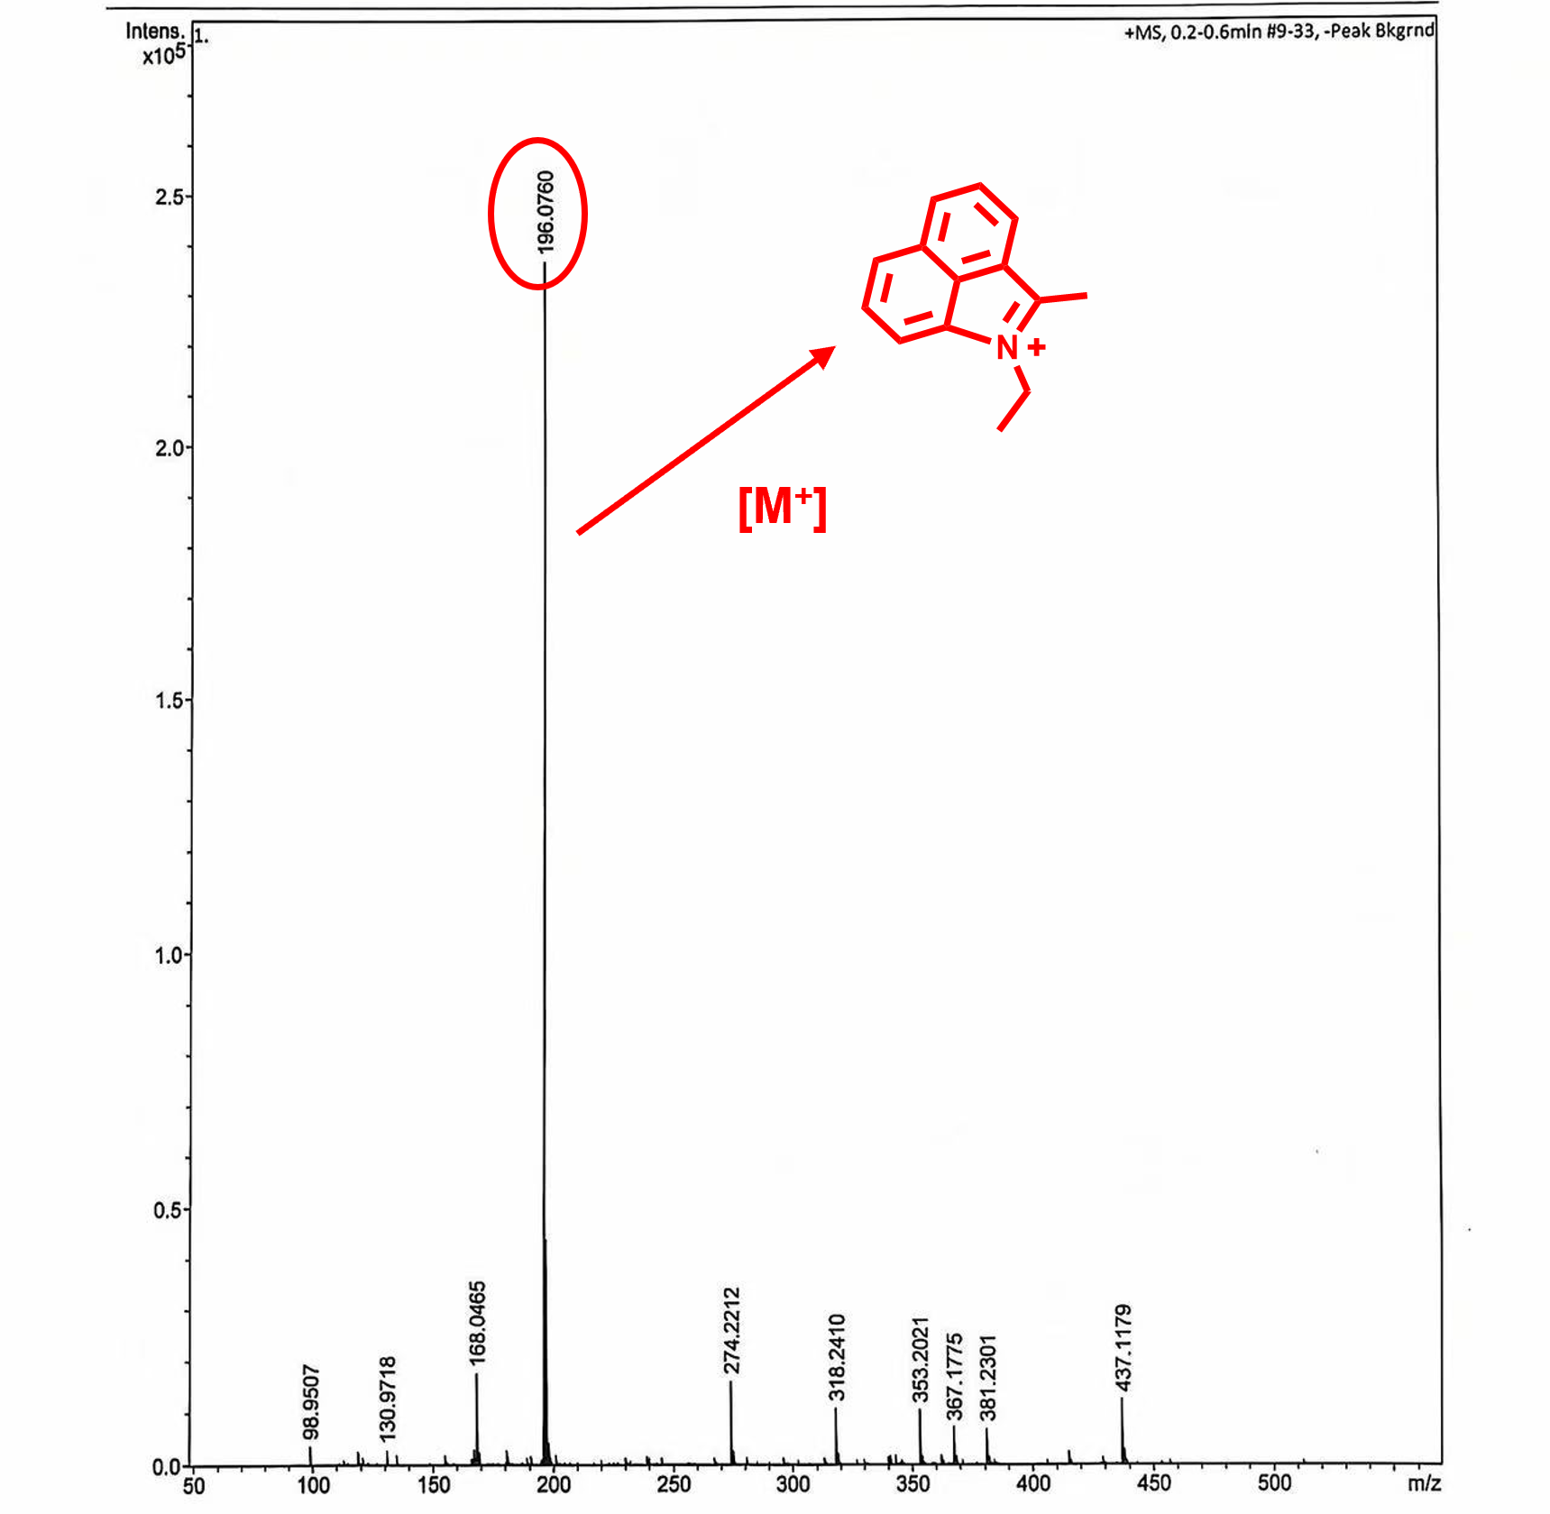
Supplementary Fig 11. The MS of compound 2.
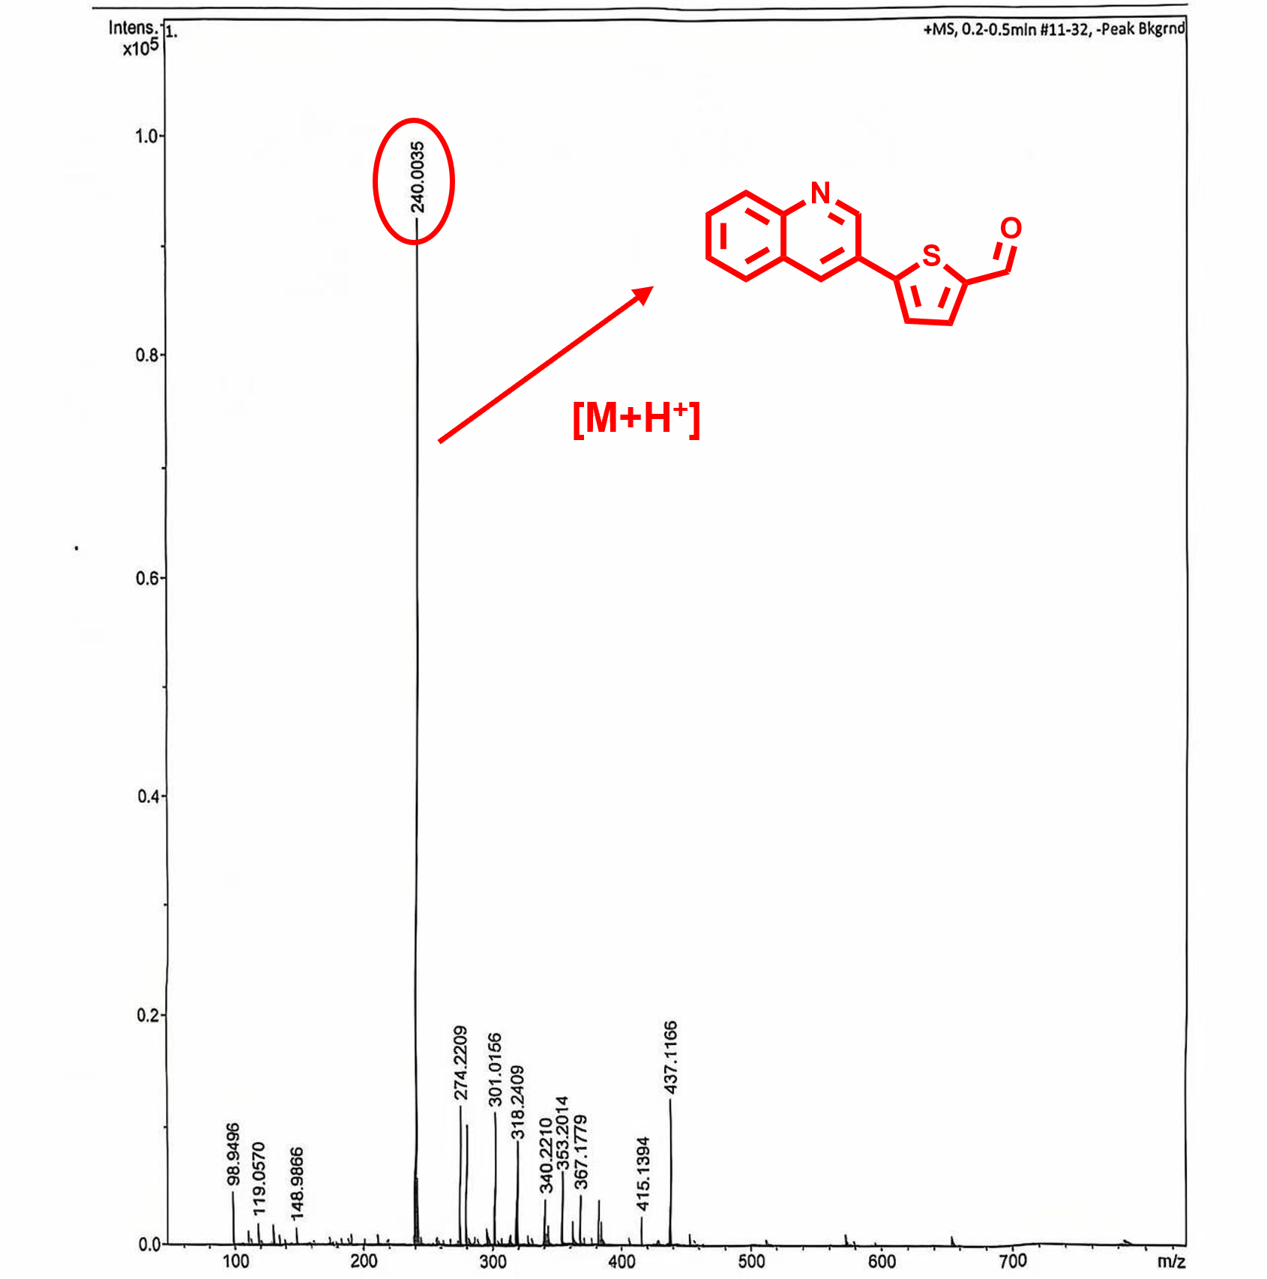
Supplementary Fig 12. The MS of compound 3.
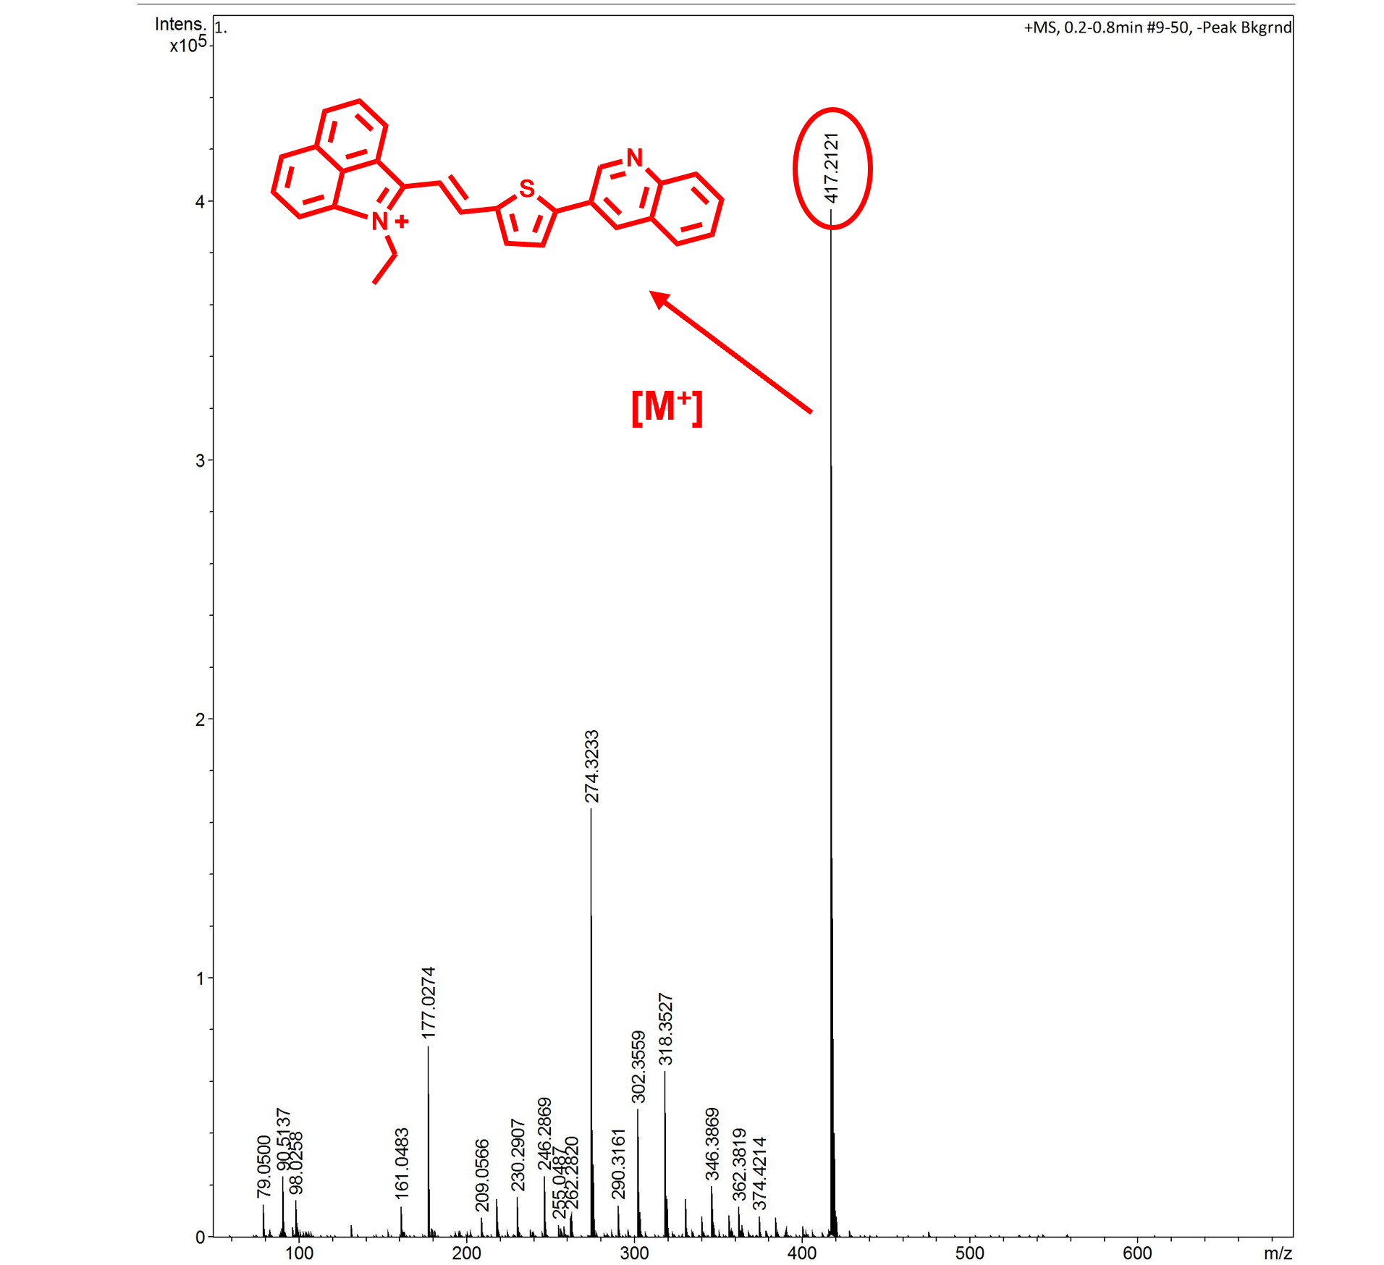
Supplementary Fig 13. The MS of compound 4.
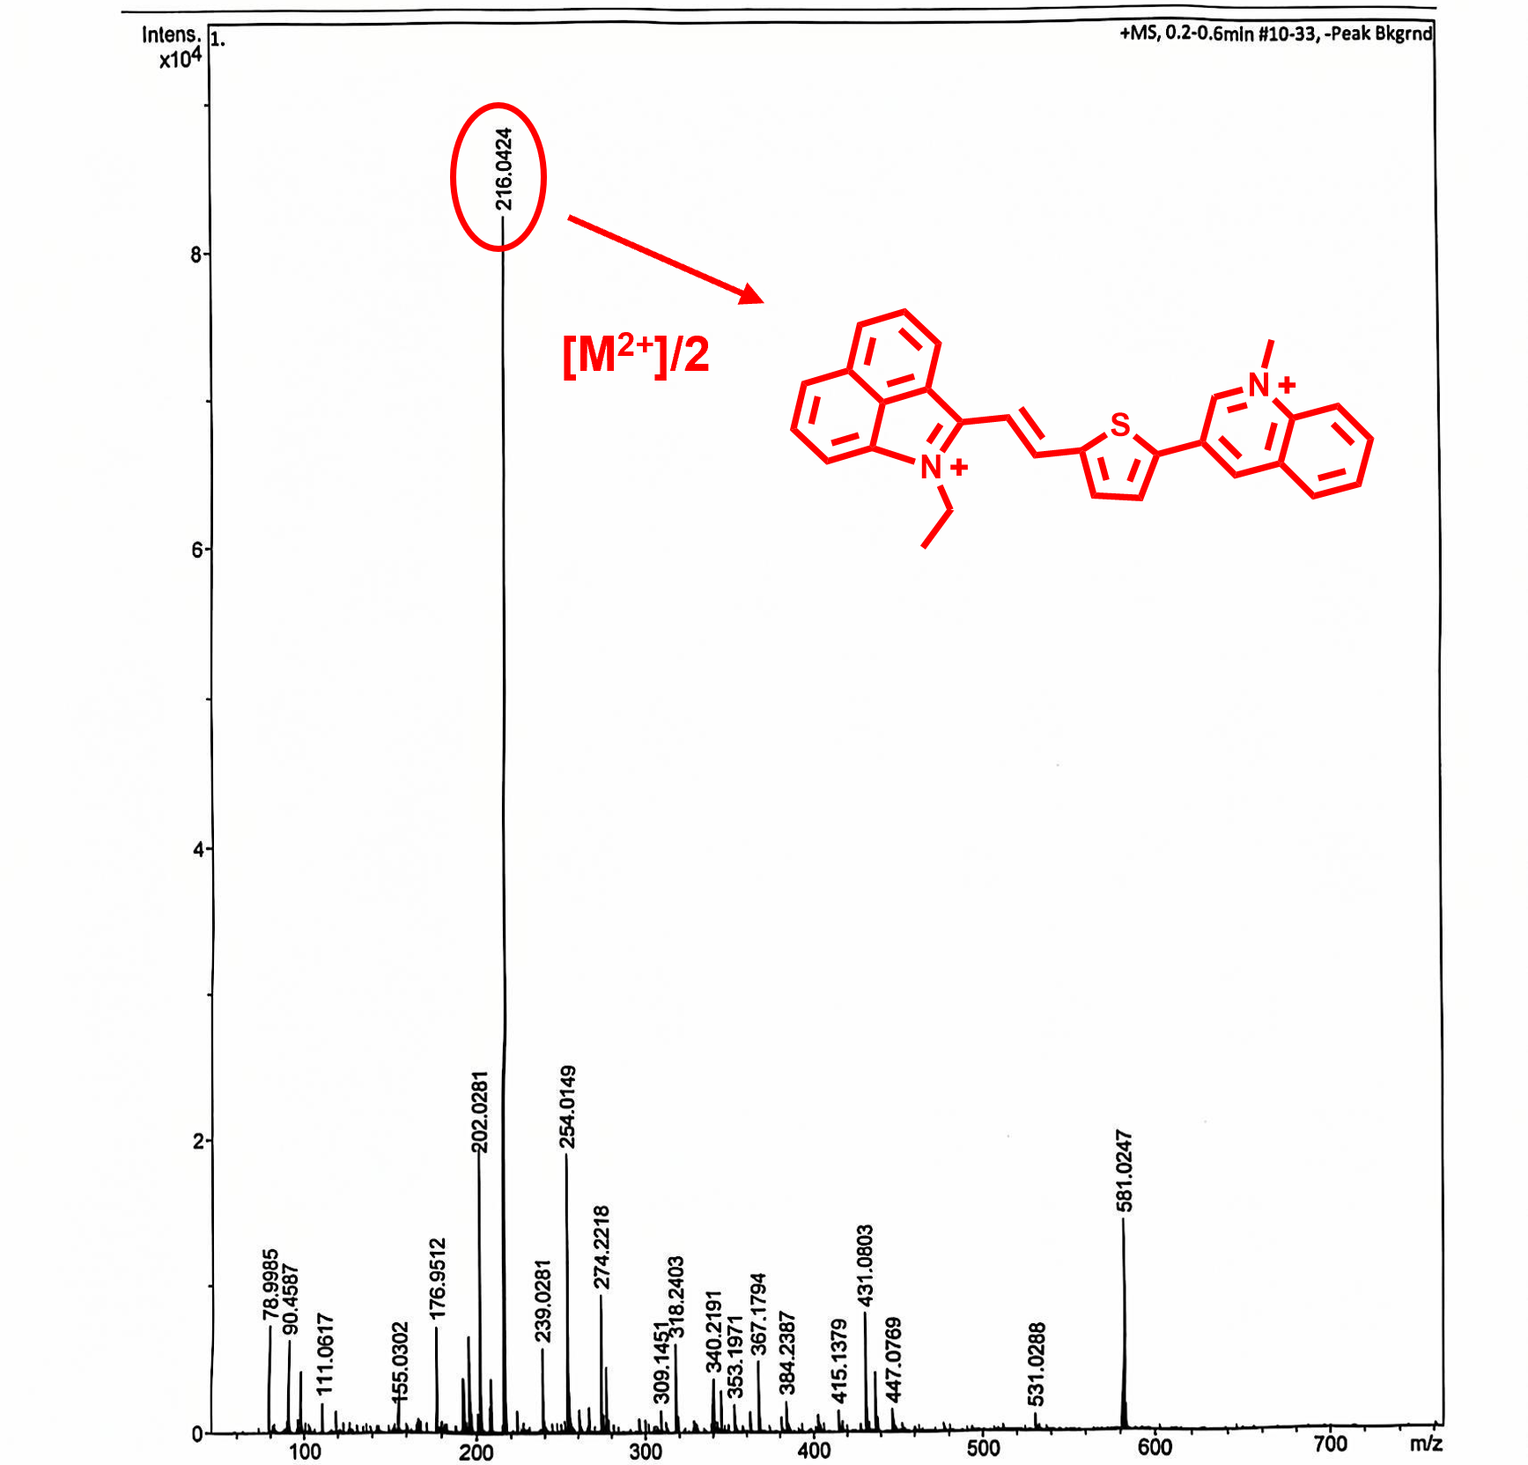
Supplementary Fig 14. The MS of Cy-N.
Supplementary Fig 15. The HRMS of the product after Cy-N reacted with NADH.

