Supplementary Information for
Growth-Driven Polymorphism Engineering and Direct Phase Modulation of α- and β′-In₂Se₃
Lei Xu¹, Dongyan Liu¹, Zhenhua Wu¹, Han Chen¹, Yutao Han^{1,2}, Mingzheng Wang^{2,3}, Haoyue Guo¹, Tian Tan¹, Yakui Mu¹, Yang Wang¹, Zengqin Song¹, Qunli Rao⁴, Xuewei Feng¹, Yakun Yuan^{2,5}, Lei Shi⁶, Xiaotian Zhang^{1*} and Tianru Wu^{1*}
¹School of Mechanical Engineering, Shanghai Jiao Tong University, Shanghai 200240, P. R. China
²Future Material Innovation Center, Zhangjiang Institute for Advanced Study, Shanghai Jiao Tong University, Shanghai, 200240, P. R. China
³School of Materials Science and Engineering, Shanghai Jiao Tong University, Shanghai, 200240, P. R. China
⁴Instrumental Analysis Center, Shanghai Jiao Tong University, Shanghai, 200240, P. R. China
⁵School of Physics and Astronomy, Shanghai Jiao Tong University, Shanghai, 200240, P. R. China
⁶Hefei National Research Center for Physical Sciences at the Microscale, University of Science and Technology of China, Hefei, Anhui 230026, P. R. China
* E-mail: xiaotianzhang@sjtu.edu.cn * E-mail: trwu@sjtu.edu.cn

Table of Contents
Supplementary Fig. 1| Time dependent PVD growth of large area In₂Se₃ films. 4
Supplementary Fig. 2| TEM and polarized light microscopy characterization of β'-In₂Se₃ 5
Supplementary Fig. 3| Raman characterization of In₂Se₃ films grown on mica substrates via CVD and PVD under various growth conditions 5
Supplementary Fig. 4| SHG characterization of In₂Se₃ films grown on mica substrates via CVD and PVD under various growth conditions 6
Supplementary Fig. 5| PL characterization of In₂Se₃ films grown on mica substrates via CVD and PVD under various growth conditions 7
Supplementary Fig. 6| In situ temperature dependent XRD full spectrum of α-In₂Se₃ powder 7
Supplementary Fig. 7| Comparison of XRD peak shifts during the α→β→β′ phase transition 8
Supplementary Fig. 8| Phase characterization of α-In₂Se₃ cooled to room temperature at different cooling rates after heating 9
Supplementary Fig. 9| Cross-sectional TEM characterization of β'-In₂Se₃ grown on rigid HOPG substrates 9
Supplementary Fig. 10| In situ optical microscopy image of time-dependent β'→α phase transition 10
Supplementary Fig. 11| AFM image of wrinkles generated by stress release. 10
Supplementary Fig. 12| In situ strain release was performed on CVD grown triangular β′-In₂Se₃ domain 11
Supplementary Fig. 13| In situ strain release was performed on CVD grown continuous β′-In₂Se₃ film 11
Supplementary Fig. 14| In situ strain release was performed on PVD grown triangular β′-In₂Se₃ domain 11
Supplementary Fig. 15| In situ strain release was performed on PVD grown continuous β′-In₂Se₃ film 12
Supplementary Fig. 16| HAADF images of kinks located at bottom of the wrinkle 12
Supplementary Fig. 17| Polarized light optical microscopy image of disappearance of distinctive domain structures following phase transition 13
Supplementary Fig. 18| Optical image of centimeter-scale α-In₂Se₃ films fabricated by mechanical-contact-induced stress release 13
Supplementary Fig. 19| Characterization of the (00l) interplanar spacing shifts of β'-In₂Se₃ before and after stress release 14
Supplementary Fig. 20| Characterization of physical properties before and after stress release 14
Supplementary Fig. 21| Characterization of the (00l) interplanar spacing shifts of released α-In₂Se₃ after annealing 15
Supplementary Fig. 22| Characterization of the (110) interplanar spacing shifts of released α-In₂Se₃ after annealing 15
Supplementary Fig. 23| Characterization of the (100) peak shifts of released α-In₂Se₃ after annealing 16
Supplementary Fig. 24| Cross-sectional TEM characterization of β'-In₂Se₃ on rigid SiO₂/Si substrates (after annealing) 17
Supplementary Fig. 25| Angle-resolved SHG spectra of strain-released α-In₂Se₃ films on mica after annealing 17
Supplementary Fig. 26| Annealing of stress-released α-In₂Se₃ eliminates its ferroelectricity 18
Supplementary Fig. 27| Operational states diagrams of vertical α-In₂Se₃/β′-In₂Se₃ Fe-FETs under P-down and P-up conditions 18

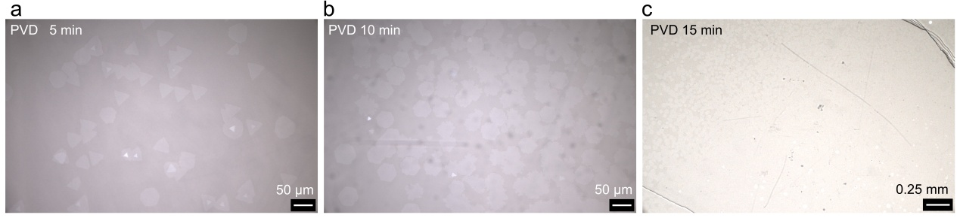
Supplementary Fig. 1| Time dependent PVD growth of large area In₂Se₃ films. b 5 min growth with triangle domain b 10 min growth with merging hexagonal domain. c 15 min growth with large area films.

Supplementary Fig. 2| TEM and polarized light microscopy characterization of β'-In₂Se₃. a Magnified diffraction pattern and intensity profile of the area indicated by the yellow dashed rectangle in Fig. 1a b Polarized light optical microscopy of as grown In₂Se₃ film. Scale bar: 25 um. Polarized light optical microscopy image at the polarizer azimuth angle φ = 45° presenting the typical domain structure of β'-In₂Se₃.

Supplementary Fig. 3| Raman characterization of In₂Se₃ films grown on mica substrates via CVD and PVD under various growth conditions. Raman spectrum of In₂Se₃ grown under rapid cooling conditions via a CVD and b PVD, under slow cooling conditions via c CVD and d PVD, under natural cooling conditions via e salt-assisted CVD f salt-assisted PVD.

Supplementary Fig. 4| SHG characterization of In₂Se₃ films grown on mica substrates via CVD and PVD under various growth conditions. SHG spectrum of In₂Se₃ grown under rapid cooling conditions via a CVD and b PVD, under slow cooling conditions via c CVD and d PVD, under natural cooling conditions via e salt-assisted CVD f salt-assisted PVD.

Supplementary Fig. 5| PL characterization of In₂Se₃ films grown on mica substrates via CVD and PVD under various growth conditions. PL spectrum of In₂Se₃ grown under rapid cooling conditions via a CVD and b PVD, under slow cooling conditions via c CVD and d PVD, under natural cooling conditions via e salt-assisted CVD f salt-assisted PVD.

Supplementary Fig. 6| In situ temperature dependent XRD full spectrum of α-In₂Se₃ powder. a XRD spectra of α-In₂Se₃ at different temperatures b Partial enlarged view of XRD spectra. Original α-In₂Se₃ powder and β-In₂Se₃ above 200°C show unsplit XRD peaks. However, when cooled below 200°C, the XRD patterns exhibit characteristic peak splitting, which is typical of β′-In₂Se₃ with anisotropic lattice distortion and symmetry breaking.

Supplementary Fig. 7| Comparison of XRD peak shifts during the α→β→β′ phase transition. a (100) . b (110) . Differential XRD peak shifting emerges in β'-In₂Se₃ derived from cooled α-phase powder, with the ($11\overline{2}0$) reflection demonstrating significantly stronger shifts than ($1\overline{1}00$) .

Supplementary Fig. 8| Phase characterization of α-In₂Se₃ cooled to room temperature at different cooling rates after heating. a Normalized XRD full spectra of α-In₂Se₃ powder cooled to room temperature at different cooling rates after heating. b Partial enlarged view of (006) spectra. c Raman spectra of slow-cooled In₂Se₃ powder at eight distinct spatial positions. d Raman spectra of rapid-cooled In₂Se₃ powder at eight distinct spatial positions. From b, it is observed that after liquid-nitrogen cooling of heated α-In₂Se₃, only the (006) peak of β'-In₂Se₃ remains. As the cooling rate decreases, the intensity of β'-In₂Se₃'s (006) peak diminishes, while the (006) peak intensity of α-In₂Se₃ progressively increases. Notably, the (006) peak of β'-In₂Se₃ virtually disappears after slow cooling compared to the original α-In₂Se₃ (006) peak. This indicates that the β phase spontaneously transforms into β' upon cooling, and β'-In₂Se₃ thermally relaxes back to α-In₂Se₃ with reduced cooling rates. Furthermore, Raman tests performed at multiple locations on both slow-cooled and rapidly cooled specimens reveals a significant presence of α-phase. Notably, the slow-cooled samples exhibit a higher proportion of α-In₂Se₃ compared to their rapidly cooled counterparts.

Supplementary Fig. 9| Cross-sectional TEM characterization of β'-In₂Se₃ grown on rigid HOPG substrates. a AFM image of β'-In₂Se₃ grown on a HOPG substrate. b Corresponding Raman spectrum. c Cross-sectional HAADF image of the as-grown In₂Se₃/HOPG interface. d Cross-sectional HAADF and corresponding EDS image of the as-grown In₂Se₃/HOPG interface. Scale bar: 10nm. β'-In₂Se₃ grown on HOPG via PVD method using slow cooling rate. Raman spectroscopy indicates the as-grown In₂Se₃ corresponds to β′ phase.
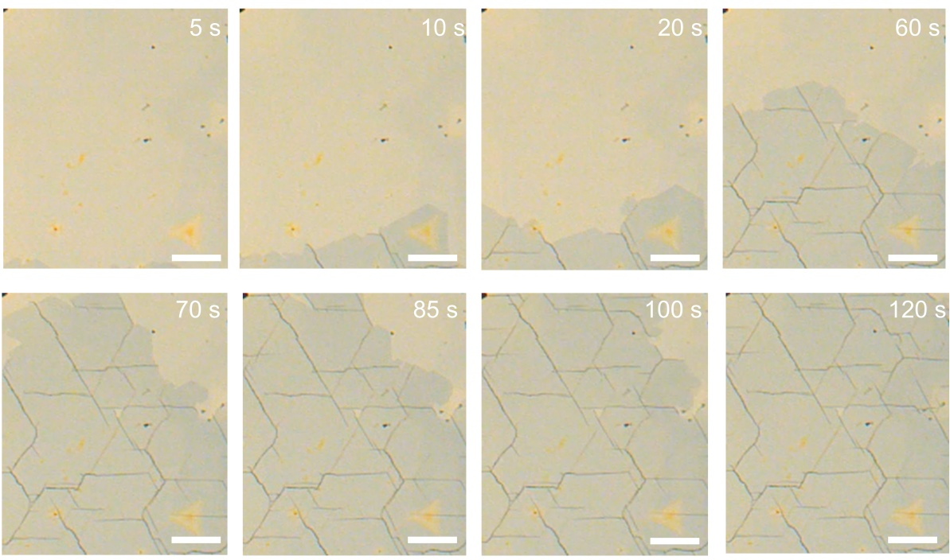
Supplementary Fig. 10| In situ optical microscopy image of time-dependent β'→α phase transition. As wrinkles propagate along the <$1\overline{1}00$> direction, β'-In₂Se₃ thin films undergo progressive phase transition to α-In₂Se₃. Scale bar: 50 μm

Supplementary Fig. 11| AFM image of wrinkles generated by stress release. wrinkles reach heights of several hundred nanometers. Scale bar: 4 μm

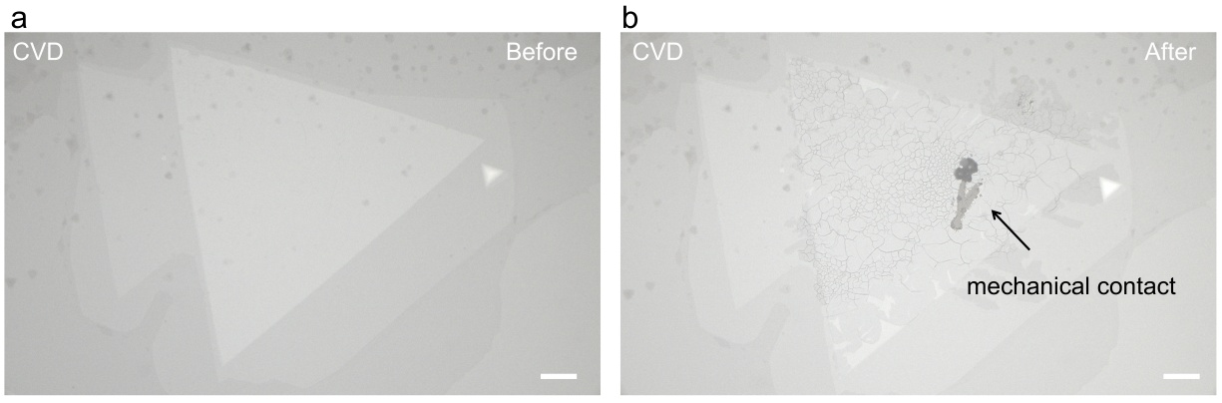
Supplementary Fig. 12| In situ strain release was performed on CVD grown triangular β′-In₂Se₃ domain. CVD-grown triangular β'-In₂Se₃ domain a before and b after stress release. Scale bar: 50 μm

Supplementary Fig. 13| In situ strain release was performed on CVD grown continuous β′-In₂Se₃ film. CVD-grown continuous β'-In₂Se₃ film a before and b after stress release. Scale bar: 50 μm
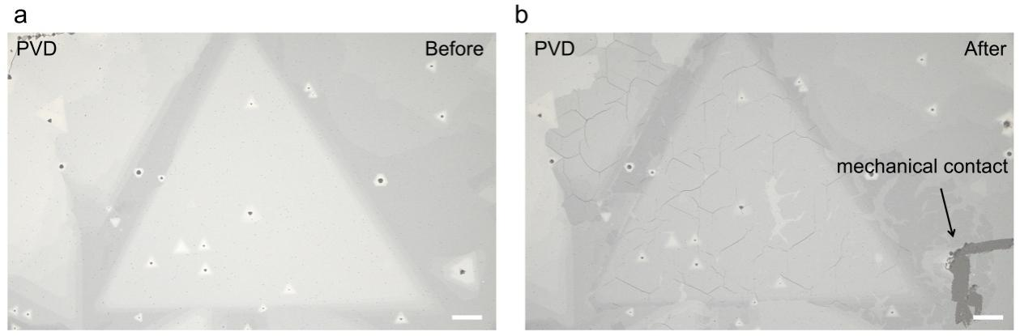
Supplementary Fig. 14| In situ strain release was performed on PVD grown triangular β′-In₂Se₃ domain. PVD-grown triangular β'-In₂Se₃ domain a before and b after stress release. Scale bar: 50 μm

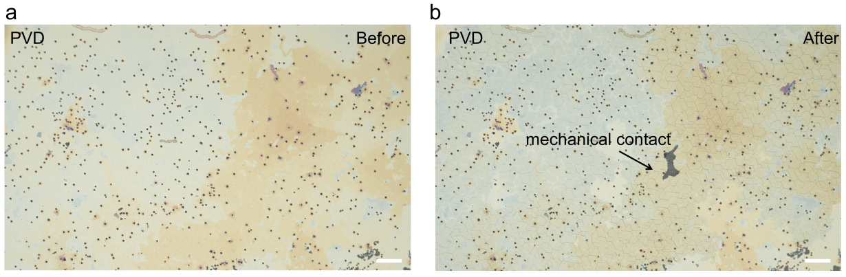
Supplementary Fig. 15| In situ strain release was performed on PVD grown continuous β′-In₂Se₃ film. PVD-grown continuous β'-In₂Se₃ film a before and b after stress release. Scale bar: 50 μm

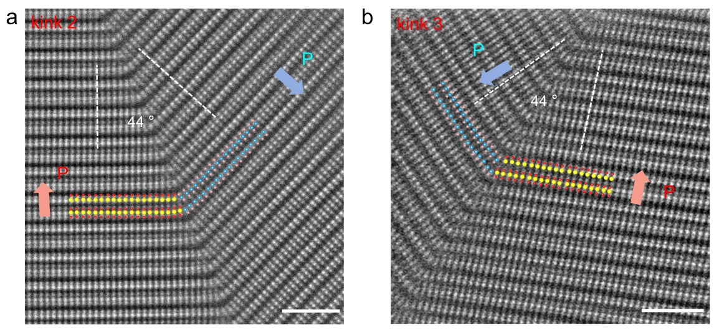
Supplementary Fig. 16| HAADF images of kinks located at bottom of the wrinkle. a kink2 with 44° bending angle. b kink3 with 44° bending angle. Atomic-resolution characterization clearly reveals antiparallel displacement of central Se atoms in α-In₂Se₃ at kink2 and kink3 boundaries, generating domains with opposing polarization directions. Scale bar: 2 nm.

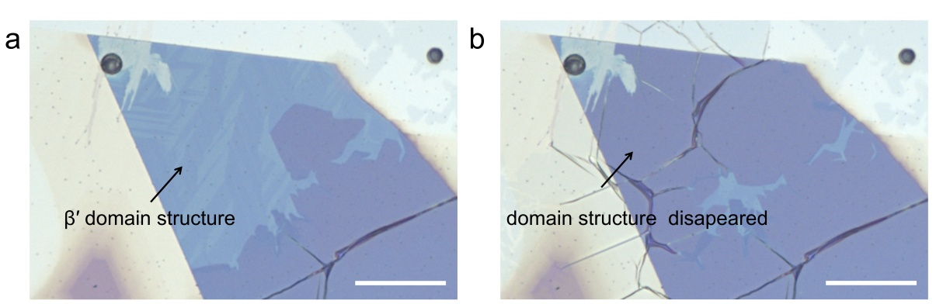
Supplementary Fig. 17| Polarized light optical microscopy image of disappearance of distinctive domain structures following phase transition. a As-grown β'-In₂Se₃ film exhibiting domain structures. b Wrinkle propagation triggering β'→α phase transition with domain dissolution. Through in situ optical microscopy, we observed the characteristic domain structure in β'-In₂Se₃ progressively dissolve during wrinkle propagation, indicating the β'→α phase transition in real time. (Supplementary Video 1) Scale bar: 25 μm

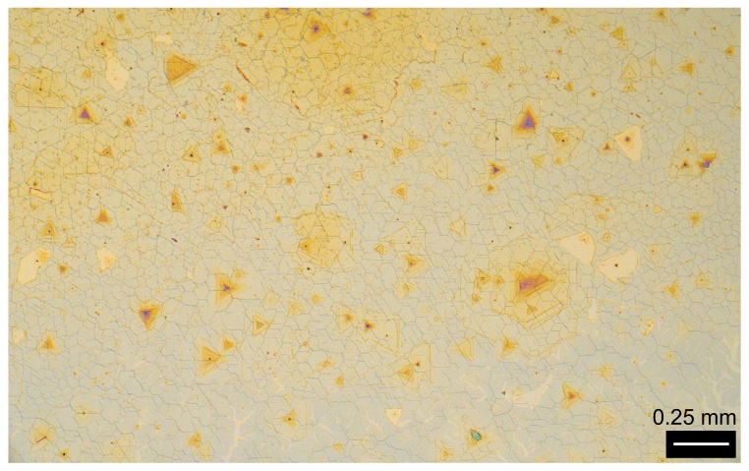
Supplementary Fig. 18| Optical image of centimeter-scale α-In₂Se₃ films fabricated by mechanical-contact-induced stress release.

Supplementary Fig. 19| Characterization of the (00l) interplanar spacing shifts of β'-In₂Se₃ before and after stress release. a Comparative XRD spectra of (00l) reflections between stressed β'-In₂Se₃ and stress-released α-In₂Se₃. b Partial enlarged views of (006) reflections for stressed β′-In₂Se₃ and stress-released α-In₂Se₃. Notably, stress release transforms β′-In₂Se₃ grown on mica into α-In₂Se₃ while preserving the original out-of-plane epitaxial relationship: the parallelism between mica (00l) and In₂Se₃ (00l) planes remains intact. However, the (00l) interplanar spacing increases following the β'→α phase transition, exhibiting identical expansion behavior to that observed in powdered α-In₂Se₃ during the same phase transformation.

Supplementary Fig. 20| Characterization of physical properties before and after stress release. a Comparison of Raman spectra before (β'-In₂Se₃) and after (α-In₂Se₃) stress release. b Comparison of SHG spectra before (β'-In₂Se₃) and after (α-In₂Se₃) stress release. c Comparison of PL spectra before (β'-In₂Se₃) and after (α-In₂Se₃) stress release.

Supplementary Fig. 21| Characterization of the (00l) interplanar spacing shifts of released α-In₂Se₃ after annealing. a Comparative XRD spectra of (00l) reflections between stressed β'-In₂Se₃, stress-released α-In₂Se₃ and annealed β'-In₂Se₃. b Partial enlarged views of (006) reflections for stressed β′-In₂Se₃, stress-released α-In₂Se₃ and annealed β'-In₂Se₃. Notably, Following annealing of the stress-released α-In₂Se₃, the out-of-plane epitaxial relationship remains unchanged: the parallelism between mica (00l) and In₂Se₃ (00l) planes remains intact. Moreover, the (00l) diffraction peak positions of the annealed In₂Se₃ precisely coincide with those of the original as-grown β′-In₂Se₃ on mica. This demonstrates the successful α→β' phase reversal achieved via thermal annealing on mica substrates.

Supplementary Fig. 22| Characterization of the (110) interplanar spacing shifts of released α-In₂Se₃ after annealing. a Comparative in-plane XRD spectra of (110) reflections between stressed β'-In₂Se₃, stress-released α-In₂Se₃ and annealed β'-In₂Se₃. b Partial enlarged views of (110) reflections for stressed β′-In₂Se₃, stress-released α-In₂Se₃ and annealed β'-In₂Se₃. Remarkably, annealing of stress-released α-In₂Se₃ preserves the in-plane epitaxial registry, evidenced by persistent alignment between mica (130) and In₂Se₃ (110) planes. Furthermore, the annealed (110) diffraction peaks perfectly match those of pristine β′-In₂Se₃ on mica, demonstrating complete α→β' phase reversion via annealing processing.

Supplementary Fig. 23| Characterization of the (100) peak shifts of released α-In₂Se₃ after annealing. a Comparative XRD spectra of (100) reflections between stressed β'-In₂Se₃, stress-released α-In₂Se₃ and annealed β'-In₂Se₃. b Partial enlarged views of (100) reflections for stressed β′-In₂Se₃, stress-released α-In₂Se₃ and annealed β'-In₂Se₃. Remarkably, annealing of stress-relaxed α-In₂Se₃ preserves the original in-plane epitaxial registry: mica (100) ∥ In₂Se₃ (010) alignment remains undisturbed. Furthermore, the annealed (100) diffraction peaks precisely recover the original β′-In₂Se₃ peak positions, confirming complete α→β' phase reversal via thermally driven transformation on mica.
Supplementary Fig. 24| Cross-sectional TEM characterization of β'-In₂Se₃ on rigid SiO₂/Si substrates (after annealing). Cross-sectional HAADF and corresponding EDS image of the β'-In₂Se₃/SiO₂ interface.

Supplementary Fig. 25| Angle-resolved SHG spectra of strain-released α-In₂Se₃ films on mica after annealing. Upon annealing, α-In₂Se₃ transforms into β′-In₂Se₃ with concomitant disappearance of SHG signal.
Supplementary Fig. 26| Annealing of stress-released α-In₂Se₃ eliminates its ferroelectricity. After annealing the α-In₂Se₃ transferred on the Au coated SiO₂/Si substrate, the ferroelectric phase-voltage hysteresis loop and amplitude-voltage butterfly loop disappeared.

Supplementary Fig. 27| Operational states diagrams of vertical α-In₂Se₃/β′-In₂Se₃ Fe-FETs under P-down and P-up conditions. When α-In₂Se₃ is in the P-up polarization state, a trap layer forms at the α-In₂Se₃/β′-In₂Se₃ interface, confining electrons and depleting the β′-In₂Se₃ channel, thereby switching the device to the off-state. Conversely, under P-down polarization, holes become confined at the interface while electrons accumulate in β′-In₂Se₃, establishing the on-state.

