Western Blotting Membrane Blots

The blotting membrane was stripped and re-incubated with antibodies.
Left to Right (MCF-7 Control, LDC 1267 inhibitor concentration 1.62uM and 0.81uM, MDA-MB-231 Control, LDC1267 inhibitor Concentration 1.62uM, 0.81uM)
Dissection of Intrinsic Apoptotic pathway was being carried out using the below mentioned antibodies
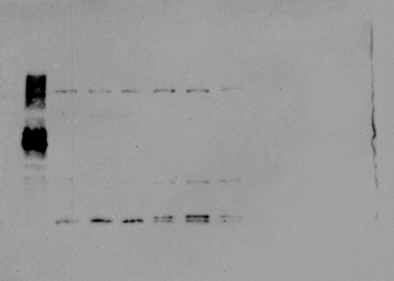
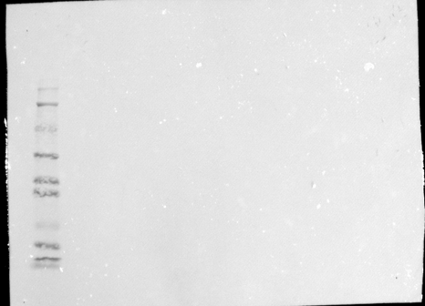
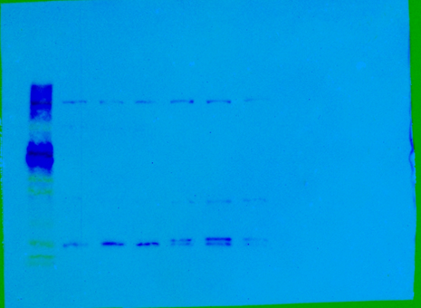
Cleaved Caspase 3
Cleaved Caspase 3
Composite Figure
250kD
150kD
100kD
75kD

50kD
37kD
25kD

20kD
15kD
10kD

250kD
150kD
100kD
75kD

50kD
37kD
25kD

20kD
15kD
10kD

250kD
150kD
100kD

75kD

50kD
37kD

25kD

20kD
15kD
10kD

250kD
150kD
100kD

75kD

50kD
37kD

25kD

20kD
15kD
10kD

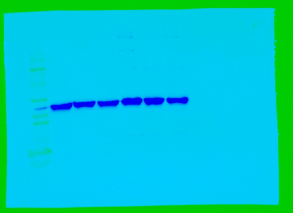
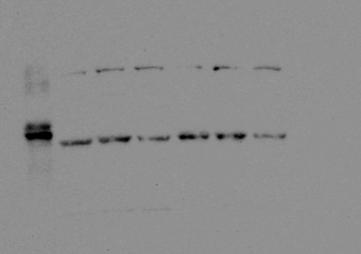
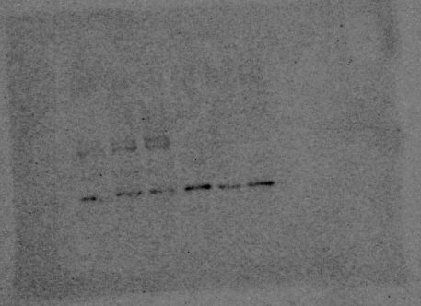
B-actin
Bax
BCl2
250kD
150kD
100kD
75kD

50kD
37kD
25kD

20kD
15kD
10kD

250kD
150kD
100kD
75kD

50kD
37kD
25kD

20kD
15kD
10kD

250kD
150kD
100kD
75kD

50kD
37kD
25kD

20kD
15kD
10kD

250kD
150kD
100kD
75kD

50kD
37kD
25kD

20kD
15kD
10kD

250kD
150kD
100kD
75kD

50kD
37kD
25kD

20kD
15kD
10kD

250kD
150kD
100kD
75kD

50kD
37kD
25kD

20kD
15kD
10kD

