Supplementary Materials for

Phlebotomus duboscqi gut microbiota dynamics in the context of Leishmania infection
Kristina Tang¹, Yue Zhang^{2#}, Claudio Meneses^{1#}, Luana A. Rogerio¹, Laura Willen¹, Eva Iniguez¹, Shaden Kamhawi¹, Jesus G. Valenzuela¹, Fabiano Oliveira^{1*}, and Pedro Cecilio^{3*}

¹Vector Molecular Biology Section, Laboratory of Malaria and Vector Research, National; Institute of Allergy and Infectious Diseases, National Institutes of Health, Rockville, MD, USA;
²Integrated Data Sciences Section (IDSS), Research Technologies Branch, National Institute of Allergy and Infectious Diseases, National Institutes of Health, Rockville, MD, USA;
³Vector Biology Section, Laboratory of Malaria and Vector Research, National Institute of Allergy and Infectious Diseases, National Institutes of Health, Rockville, MD, USA;
# These authors contributed equally to this work.

*Address correspondence to: Pedro Cecilio (pedro.amadocecilio@nih.gov), and/or Fabiano Oliveira (loliveira@niaid.nih.gov).

This document includes:
Figures S1 and S2
Tables S1 to S7
Data S1

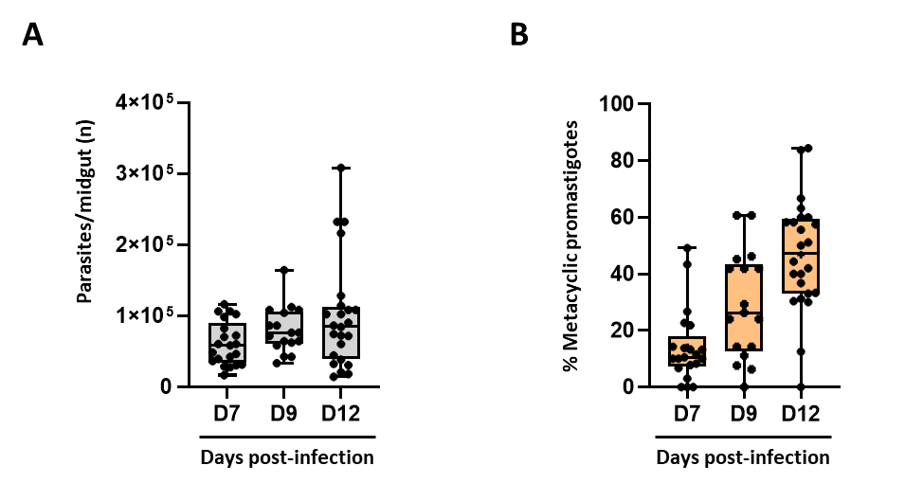
Supplementary Figure 1. Quality control: sand fly infection status. For the metagenomics analysis of Leishmania-infected sand flies, after an overnight starving period, Phlebotomus duboscqi sandflies were infected by artificial feeding with Leishmania major promastigotes. After infection, blood-fed females were sorted and kept on a 30% sucrose diet for up to 12 days. Midguts were dissected 7-, 9-, and 12-days post-bloodmeal and the infection burden was quantified microscopically for quality control purposes. (A) Total number of parasites per midgut of L. major-infected sand flies, 7-, 9-, and 11-days post-infection. (B) Percentage of metacyclic promastigotes per midgut of L. major-infected sand flies, 7-, 9-, and 11-days post-infection. Results are presented in the form of box and whiskers graphs (from maximum to minimum) overlapped with symbols referring to individual midgut data. All results were obtained in three independent experiments.
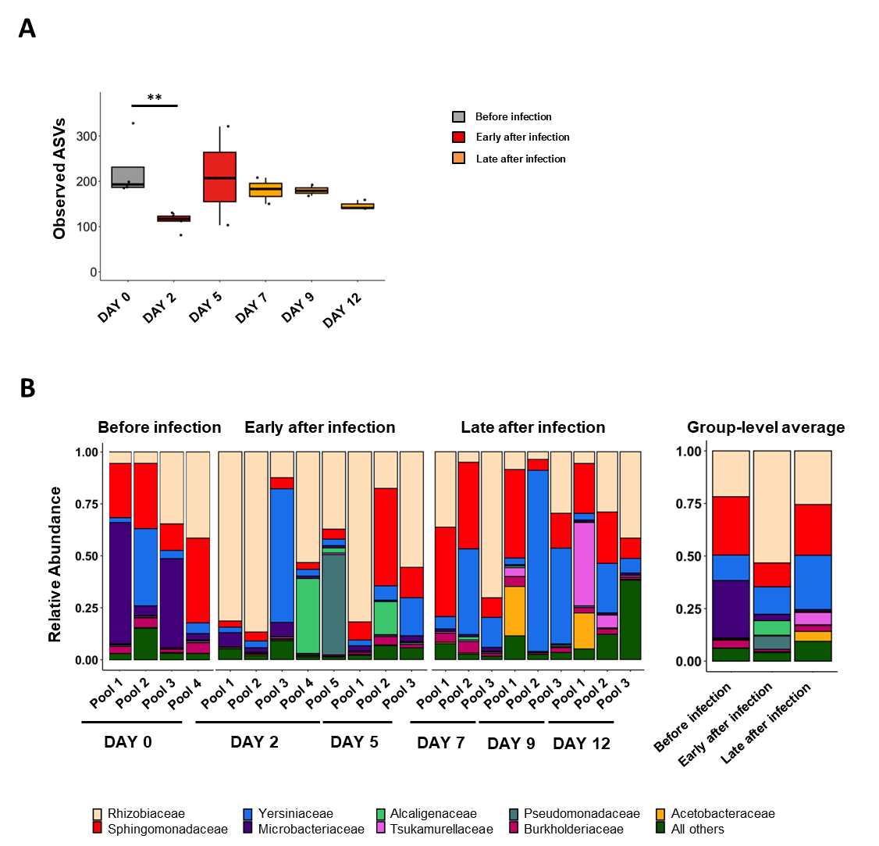
Supplementary Figure 2. The relative abundance of observed ASVs per time-point and relative abundance at the family level. Pools of P. duboscqi sand fly midguts were collected one day before (day 0), as well as 2, 5, 7, 9, and 12 days after infection with L. major parasites and subjected to metagenomics analysis. In some instances, analysis was done in the frame of three major groups: before infection (day 0), early after infection (days 2 and 5), and late after infection (days 7, 9, and 12). (A) Variation in the number of observed Amplicon Sequence Variants ASVs in function of the collection time-point. Box-and-whisker graphs show an overview of the calculated values per pool of sand fly midguts collected before infection (grey; n=4), early after Leishmania infection (red; n=8), and late after Leishmania infection (orange; n=9). Statistical significance was determined using the Kruskal-Wallis test followed by post-hoc analysis and is highlighted (**p<0.01). (B) Relative abundance at the family level per sample pool and time-point (left panel), as well as per infection status (right panel). The most abundant genera are color-coded. All results were obtained in three independent experiments.
Supplementary Table 1. Observed ASVs at the group level: statistical analysis
Statistical analysis
Kruskal-Wallis |  | p value | Significant?
 |  | 0.044 | YES *
Post-hoc analysis (multiple comparisons)
Dunn's test with p value adjustment by the holm method |  | p value | Significant?
Group1 (n) | Group2 (n) | p value | Significant?
Before infection (4) | Early after infection (8) | 0.040838723 | YES *
Before infection (4) | Late after infection (9) | 0.30922063 | No
Early after infection (8) | Late after infection (9) | 0.30922063 | No

Supplementary Table 2. Observed ASVs at the sample level: statistical analysis
Statistical analysis
Kruskal-Wallis |  | p value | Significant?
 |  | 0.035 | YES *
Post-hoc analysis (multiple comparisons)
Dunn's test with p value adjustment by the holm method |  | p value | Significant?
Group1 (n) | Group2 (n) | p value | Significant?
Day 0 (4) | Day 2 (5) | 0.009315256 | YES **
Day 0 (4) | Day 5 (3) | 1 | No
Day 0 (4) | Day 7 (3) | 1 | No
Day 0 (4) | Day 9 (3) | 1 | No
Day 0 (4) | Day 12 (3) | 0.302909009 | No

Supplementary Table 3. Relative abundance of different bacterial genera in the sand fly midgut in function of the infection status.
Genus | Average frequency
Genus | Before infection | Early after infection | Late after infection
Ochrobactrum | 19.2727861 | 48.95067514 | 19.66886229
Sphingomonas | 27.72359134 | 11.34435001 | 24.06344928
Serratia | 11.98897221 | 13.05864478 | 25.77821661
Leifsonia | 27.21022856 | 3.000370262 | 0.894335701
Tsukamurella | 0.326397321 | 0.385522436 | 5.883565127
Pseudomonas | 0.468164169 | 6.314712397 | 0.303103082
Ralstonia | 3.647410837 | 1.110034424 | 2.770921081
Asaia | 0.171454495 | 0.412624922 | 4.749875097
Unknown | 3.415747128 | 11.37170267 | 6.56738169
All others | 5.775247842 | 4.051362963 | 9.320290042
Total | 100 | 100 | 100

 | Family | Average frequency (%)
 | Family | Before infection | Early after infection | Late after infection
 | Rhizobiaceae | 21.79873777 | 53.30667005 | 25.5372315
 | Sphingomonadaceae | 27.7584493 | 11.37303695 | 24.13713098
 | Yersiniaceae | 12.1345751 | 13.06464902 | 25.78244181
 | Microbacteriaceae | 27.23057627 | 3.005623974 | 0.895373471
 | Alcaligenaceae | 0.295375399 | 6.894955769 | 0.496499007
 | Tsukamurellaceae | 0.326397321 | 0.385522436 | 5.883565127
 | Pseudomonadaceae | 0.470332368 | 6.316463634 | 0.304214979
 | Burkholderiaceae | 3.736140206 | 1.128213938 | 2.801238801
 | Acetobacteraceae | 0.172788771 | 0.412624922 | 4.750319856
 | All others | 6.076627483 | 4.112239316 | 9.411984469
 | Total | 100 | 100 | 100
Supplementary Table 4. Relative abundance of different bacterial families in the sand fly midgut in function of the infection status.

Supplementary Table 5. Beta diversity: pairwise comparison analyses.
Statistical test | Pairwise Comparison | Adjusted p value*
PERMANOVA | Before infection Vs Early after infection | 0.024
PERMANOVA | Before infection Vs Late after infection | 0.0959
PERMANOVA | Early after infection Vs Late after infection | 0.054
PERMDISP | Before infection Vs Early after infection | 0.2967
PERMDISP | Before infection Vs Late after infection | 0.2967
PERMDISP | Early after infection Vs Late after infection | 0.998
Note: *p values adjusted using the Holm–Bonferroni method.

Supplementary Table 6. Significant variation in bacterial absolute abundance values in the sand fly midgut in function of the infection status: ANCOM-BC analysis output at the Genus level, including statistics.
Comparison | Genus | LOG  (fold change) | Standard error | p value | q value
Early after infection Vs Before infection | Corynebacterium | -2.550108675 | 0.486234759 | 1.56618E-07 | 2.42759E-05
Early after infection Vs Before infection | Cutibacterium | -1.253870294 | 0.35498539 | 0.000412157 | 0.062647939
Early after infection Vs Before infection | Enterococcus | 3.075213141 | 0.752029691 | 4.3283E-05 | 0.006622306
Early after infection Vs Before infection | Porphyromonas | -3.01254993 | 0.585223842 | 2.63716E-07 | 4.06123E-05
Late after infection Vs Before infection | Corynebacterium | -1.977938971 | 0.534805636 | 0.000216941 | 0.039049331
Late after infection Vs Before infection | Enterococcus | 2.812635793 | 0.627916415 | 7.48827E-06 | 0.001355378
Late after infection Vs Early after infection | Abiotrophia | 1.776974428 | 0.470850387 | 0.000160671 | 0.028920815
Late after infection Vs Early after infection | Ralstonia | 1.166642739 | 0.271526217 | 1.73429E-05 | 0.003139057
Late after infection Vs Early after infection | Saccharimonadales (Order) | 1.534455371 | 0.432579032 | 0.000389311 | 0.069297397
Late after infection Vs Early after infection | Sphingomonas | 1.066516591 | 0.283731475 | 0.000170666 | 0.030549213
Late after infection Vs Early after infection | Streptococcus | 1.7906524 | 0.336582165 | 1.03707E-07 | 1.88748E-05

Supplementary Table 7. Significant variation in bacterial absolute abundance values in the sand fly midgut in function of the infection status: ANCOM-BC analysis output at the Family level, including statistics.
Comparison | Family | LOG  (fold change) | Standard error | p value | q value
Early after infection Vs Before infection | Corynebacteriaceae | -2.199585124 | 0.45028383 | 1.03489E-06 | 0.000101419
Early after infection Vs Before infection | Enterococcaceae | 3.075957675 | 0.805265376 | 0.000133557 | 0.012954987
Early after infection Vs Before infection | Porphyromonadaceae | -3.011805396 | 0.587245754 | 2.91755E-07 | 2.88837E-05
Early after infection Vs Before infection | Propionibacteriaceae | -1.248579804 | 0.371307405 | 0.000771959 | 0.074108108
Late after infection Vs Before infection | Corynebacteriaceae | -1.763487427 | 0.426477328 | 3.54941E-05 | 0.003904355
Late after infection Vs Before infection | Enterococcaceae | 2.649873186 | 0.642371909 | 3.70511E-05 | 0.004038575
Late after infection Vs Before infection | Microbacteriaceae | -2.778810275 | 0.83056206 | 0.000820756 | 0.088641621
Late after infection Vs Before infection | Peptostreptococcaceae | -1.676604501 | 0.367609785 | 5.09526E-06 | 0.000565574
Late after infection Vs Early after infection | Aerococcaceae | 1.670108796 | 0.473419972 | 0.000419103 | 0.046101309
Late after infection Vs Early after infection | Burkholderiaceae | 1.058159138 | 0.280725702 | 0.00016366 | 0.018166249
Late after infection Vs Early after infection | Streptococcaceae | 1.617334246 | 0.326269447 | 7.15712E-07 | 8.01598E-05

Supplementary Data 1. Assignment of ASVs, taxonomic details, and relative abundance per sample. This table is available as a separate .xlsx file.

