Supplementary Information
Erysipelothrix rhusiopathiae clone associated with recurrent mass mortality events in High Arctic muskoxen (Ovibos moschatus)
McCaide T. Wooten¹*, Taya L. Forde², Amélie Roberto-Charron³, Matthew Fredlund³, Tabitha Mullin³, Olaf A. Christensen³, Angela Schneider¹, Sreejith Radhakrishnan^{2†}, Dayna Goldsmith^{1,4}, Eugene Lau², Fabien Mavrot¹, L. Vineesha Seru¹, Tianjiao Fang², Ronan M. Donovan^{5,6}, H. Dean Cluff⁷, Frank van der Meer¹, Susan J. Kutz¹

Affiliations:
¹Faculty of Veterinary Medicine, University of Calgary; Calgary, Alberta, Canada
²School of Biodiversity, One Health, and Veterinary Medicine, University of Glasgow; Glasgow, Scotland, United Kingdom
³Department of Environment, Government of Nunavut; Kugluktuk (Roberto-Charron), Igloolik (Fredlund), Resolute Bay (Mullin), Grise Fiord (Christensen), Nunavut, Canada
⁴Canadian Wildlife Health Cooperative; Saskatoon, Saskatchewan, Canada
⁵Ronan Donovan Photo & Film; Bozeman, Montana, United States
⁶The National Geographic Society; Washington, D.C., United States
⁷Department of Environment and Climate Change, Government of the Northwest Territories; Yellowknife, Northwest Territories, Canada (retired)
†Current Affiliation: HCAI, Fungal, AMR, AMU & Sepsis Division, UK Health Security Agency, London, United Kingdom
*Corresponding author: caide.wooten.dvm@gmail.com

Supplementary Tables

Supplementary Table 1. Summary of gross pathological , histological, and non-E. rhusiopathiae microbiological findings from all definitive and presumptive cases of E. rhusiopathiae Arctic clone septicemia
Carcass ID | Date of Death | Initial Sample Date | Sex / Age (Years) | Gross Observations | Significant Histopathological Findings | Other Testing
MX-21-01 | ~18-Aug-2021 | 21-Aug-2021 | F / 3 | MA, abdomen opened with heavy scavenging, moderate epicardial fat stores, yellow-tinged liver, NSF on joint exam | MA, occasional sarcocysts within skeletal muscle | Parapoxvirus Negative
MX-21-02 | ~1-9 Aug-2021 | 21-Aug-2021 | F / ≥5 | MA, intact, bloated and odorous, some evidence of scavenging (holes in skin), regurgitant in oral cavity, 1cm back fat (adequate BC), yellow-tinged liver, excessive bicavitary serosanguinous fluid accumulation | MA, histologic evaluation hindered by autolysis | B. anthracis, Parapoxvirus, Yersinia spp. Negative
MX-21-03 | ~1-9 Aug-2021 | 21-Aug-2021 | F / ≥5 | Found in lateral along creek with head and thorax submerged in water, abdomen opened with heavy scavenging, unable to assess BC | MA, NSF on examined tissues (haired skin and tongue), one intracytoplasmic sarcocyst observed in lingual muscle | Parapoxvirus Negative
MX-21-04 | ~18-Aug-2021 | 21-Aug-2021 | M / ≥5 | MA, testes scavenged but otherwise intact and bloated, blood staining from nares, multifocal 4-10mm ulceration of the nasal mucosa, mild perineal fecal matting, regurgitant in oral cavity, 2cm back fat (good BC), plenty of peri-renal fat, yellow-tinged liver, excessive bicavitary serosanguinous fluid accumulation | MA, histologic evaluation hindered by autolysis | B. anthracis, Parapoxvirus, Yersinia spp. Negative
MX-21-05 | ~3-11 Aug-2021 | 21-Aug-2021 | F / ≥5 | Ground disturbance at the feet indicative of terminal struggle, odorous, evidence of mild scavenging (missing eyes, hair removed) but otherwise intact, desiccated tongue and nasal tissue, limited necropsy | ND | ND
MX-21-06 | ~1-9 Aug-2021 | 22-Aug-2021 | M / ≥5 | MA, ground disturbance at the feet indicative of terminal struggle, scavenged testes but otherwise intact, blood staining of the muzzle and perineum, firm feces in the perineal hair, 4cm back fat (excellent BC), excessive bicavitary serosanguinous fluid accumulation | MA, only haired skin submitted for evaluation, NSF aside from one section containing a single cross-section of a suspected mite within a hair follicle | Parapoxvirus Negative
MX-21-07 | ~1-9 Aug-2021 | 22-Aug-2021 | M / ≥5 | MA, ground disturbance at the feet indicative of terminal struggle, scavenged testes but otherwise intact, hair completely sloughed from right forelimb, 2.8cm back fat (good BC), limited necropsy | ND | ND
MX-21-08 | ~5-13 Aug-2021 | 22-Aug-2021 | M / 4 | MA, scavenged testes but otherwise intact, blood staining of the muzzle, 3.2cm back fat (excellent BC), limited necropsy | MA, only haired skin submitted for evaluation, NSF | Parapoxvirus Negative
MX-21-09 | ~25 Jul – 1 Aug-2021 | 23-Aug-2021 | M / 3 | Small opening in the lower left abdominal wall with entry into the rumen and testes scavenged otherwise intact, some solid feces in perineal hair, 1.5cm back fat (good BC), plenty of intraperitoneal fat, yellow-green viscous fluid in the left tarsometatarsal joint | MA, diffuse vacuolation of hepatocytes possibly indicative of underlying fatty liver disease or secondary to autolysis | B. anthracis, Parapoxvirus, Yersinia spp. Negative
MX-21-10 | ~1-9 Aug-2021 | 23-Aug-2021 | F / ≥5 | Intact and unscavenged, blood staining of the muzzle, 2.5cm back fat (good BC), limited necropsy | ND | Parapoxvirus Negative
MX-21-13 | ~Early Aug-2021 | 16-Aug-2022 | M / 4 | First visited well beyond the time of death – necropsy ND | ND | ND
MX-21-15 | ~Early Aug-2021 | 5-Aug-2023 | M / 4 | First visited well beyond the time of death – necropsy ND | ND | ND
MX-21-16 | ~Early-to-mid Aug-2021 | 15-Aug-2022 | M / ≥5 | First visited well beyond the time of death – necropsy ND | ND | ND
MX-21-19 | ~Mid-Aug-2021 | 16-Aug-2022 | M / 4 | First visited well beyond the time of death – necropsy ND | ND | ND
MX-21-21 | ~Early-to-mid Aug-2021 | 18-Aug-2022 | M / ≥5 | First visited well beyond the time of death – necropsy ND | ND | ND
MX-21-24 | ~Mid-Aug-2021 | 18-Aug-2022 | M / ≥5 | First visited well beyond the time of death – necropsy ND | ND | ND
MX-21-25 | ~Mid-to-late Aug 2021 | 26-Jul-2022 | M / ≥5 | First visited well beyond the time of death – necropsy ND | ND | ND
MX-21-26A | 12-Sep-2021 | 14-Aug-2022 | M / ≥5 | First visited well beyond the time of death – necropsy ND | ND | ND
MX-21-26B | ~13-16 Sep-2021 | 14-Aug-2022 | F / 4 | First visited well beyond the time of death – necropsy ND | ND | ND
MX-22-40 | 26-Aug-2021 | 16-Aug-2022 | F / ≥5 | First visited well beyond the time of death – necropsy ND | ND | ND
MX-22-44 | ~Spring 2022 | 18-Aug-2022 | U / 1 | First visited well beyond the time of death – necropsy ND | ND | ND
MX-22-46 | ~Fall 2021 to Spring 2022 | 19-Aug-2022 | M / ≥5 | First visited well beyond the time of death – necropsy ND | ND | ND
MX-22-F-01 | ~25-26 Jul-2022 | 27-Jul-2022 | M / 4 | MA, fully intact and unscavenged, ground disturbance at the feet indicative of terminal struggle, body cavity is warm, bloated rumen, mild ocular discharge and crusting, 0.1cm back fat (poor BC) | MA, liver and lung contain intracytoplasmic bacterial rods without convincing inflammation, NSF on evaluation of kidney and haired skin sections | Salmonella spp., Yersinia spp. Negative
MX-22-F-02 | ~26-27 Jul-2022 | 28-Jul-2022 | F / 4 | MA, heavily scavenged, no internal organs, skin and muscle fully removed from the face | MA, mild orthokeratotic hyperkeratosis throughout section of haired skin analyzed | ND
*MX-22-F-03 | 30-Jul-2022 | 30-Jul-2022 | M / ≥5 | Fully intact and unscavenged, observed struggling before death, 0.8cm back fat (adequate BC), NSF on necropsy | WP, Lung: discernible bacilli in interstitium and vessels  Heart: vessels contain free small bacilli;  Liver: portal areas infiltrated by small numbers of lymphocytes and plasma cells, small infiltrates of suspected histiocytes randomly throughout parenchyma, neutrophils, lymphocytes and plasma cells associated with basophilic cytoplasmic material within histiocytes and hepatocytes (suspect bacteria) - in some areas these infiltrates are associated with small numbers of degenerating hepatocytes;  Kidney: multifocal small interstitial infiltrates of lymphocytes and plasma cells, sometimes associated with blood vessels, frequent medullary blood vessels containing large numbers of bacteria variably admixed with neutrophils - also occasionally within tubules, rare bacteria within histiocytes;  Small intestine: markedly dilated submucosal lymphatic vessels, autolysis hinders evaluation of the superficial mucosa, rare luminal suspect oocysts;  Haired skin: small numbers of sarcocysts within the attached deep skeletal muscle | Parapoxvirus, Salmonella spp., Yersinia spp. Negative
MX-22-F-04 | ~17-24 Jul-2022 | 31-Jul-2022 | F / ≥5 | MA, moderately scavenged and odorous, internal organs cannot be assessed due to autolysis | MA, remnants of the exoskeleton of a single mite visible in one section of haired skin, abundant black birefringent pigment present in the spleen – suspect artifactual hematin | Parapoxvirus Negative
*MX-22-F-05 | 31-Jul-2022 | 31-Jul-2022 | M / ≥5 | Fully intact and unscavenged, ground disturbance at the feet indicative of terminal struggle, 1cm back fat (adequate BC), yellow-tinged liver with multifocal petechiae across the serosal surface | WP, Lung: interlobular septae expanded by clear space (edema), some blood vessels associated with aggregates of small lymphocytes;  Liver: multifocal infiltration by very large numbers of extracellular and intracellular bacteria, infiltrates are both portal and randomly distributed and are variably associated with small numbers of neutrophils as well as areas of hepatocellular necrosis, centrilobular hepatocytes have cytoplasmic accumulation of fine brown granular cytoplasmic pigment (lipofuscin suspected);  Spleen: frequent accumulation of coarsely granular brown pigment (hemosiderin) as well as accumulation of black birefringent pigment - suspect artifactual hematin;  Kidney: multifocal proliferation of extracellular bacteria within interstitium with mild to marked inflammation | Parapoxvirus, Salmonella spp., Yersinia spp. Negative
MX-22-F-06 | 31-Jul-2022 | 31-Jul-2022 | F / ≥5 | Fully intact and unscavenged, body cavity warm, 1cm back fat (adequate BC), mild ocular discharge, limited necropsy due to limited remaining flight time | WP, focal area of mild orthokeratotic hyperkeratosis in section of poorly haired skin (nasal skin), NSF within the examined sections of haired skin | Parapoxvirus Negative
MX-23-76 | ~Jul/Aug 2023 | 28-Aug-2023 | M / ≥5 | MA, heavily scavenged – no internal organs remain, blood staining of the muzzle | ND | ND
MX-23-F-01 | ~25-31 Jul-2023 | 4-Aug-2023 | M / ≥5 | MA, fully intact and unscavenged but severely bloated – not opened, NSF on external examination | ND | Parapoxvirus Negative
MX-23-F-03 | ~3-10 Aug-2023 | 12-Aug-2023 | M / ≥5 | MA, intact and minimally scavenged, ground disturbance at the feet indicative of terminal struggle, yellow-tinged liver, splenomegaly, distended urinary bladder, reddened small intestine, 0.1cm back fat, no renal fat (poor BC), fecal matting of the perineum | MA, myocytes occasionally contain cytoplasmic sarcocysts, abundant epicardial fat is present | Parapoxvirus, Salmonella spp., Yersinia spp. Negative
NOTE: Er test results are not listed as all definitive and presumptive cases tested positive for the Er AC by culture with follow-up genetic confirmation of the recovered bacteria; for full descriptions of diagnostic testing, see Methods
Abbreviations: BC = body condition, MA = marked autolysis, ND = not done, NSF = no significant findings, WP = well-preserved
*Definitive case

Supplementary Table 2. Summary of clinical abnormalities observed in video footage of muskoxen on the Fosheim Peninsula of Ellesmere Island, mid-July to late September 2021
System | Affected Sex(es) | Affected Age Class(es) | Description
Integumentary | Both | All except calves | - Many animals possessed periorbital pallor/whiteness, producing a “raccoon-like” appearance from a distance; closer inspection generally revealed varying degrees of alopecia +/- crusty debris and/or non-purulent discharge  - Two animals had notable epilation/alopecia over regions of the nasal and maxillary bones (i.e., most of the “bridge” of the nose)  - One animal appeared to have focal crusts at the caudodorsal area of the nasal planum
Musculoskeletal | Both | Adults | - Two or three animals were noted to have weight-bearing lameness of one limb; one of these animals had a visibly enlarged carpal joint
Ophthalmic | Both | Adults | - One animal had loss of its left eye or severe conjunctivitis obliterating the globe (i.e., only pink conjunctiva was visible)

Supplementary Table 3. Summary of live muskox observations stratified by year, sex, location, and observational unit
 | Counts by Sex
Year | Male (%) | Female (%) | Juvenile Unclassified (%)¹ | Unclassified (%) | Total
Ellesmere Island – Ground Observations
2022 | 21 (30.4) | 8 (11.6) | 4 (5.8) | 36 (52.2) | 69
2023 | 26 (28.3) | 38 (41.3) | 11 (11.9) | 17 (18.5) | 92
2024* | 24 (16.9) | 46 (32.4) | 39 (27.5) | 33 (23.2) | 142
Ellesmere Island - Aerial Observations
2022 | 115 (29.0) | 61 (15.4) | 16 (4.0) | 205 (51.6) | 397
2023 | 84 (20.6) | 48 (11.8) | 58 (14.2) | 218 (53.4) | 408
Axel Heiberg Island – Aerial Observations
2022* | 109 (17.4) | 48 (7.6) | 52 (8.3) | 418 (66.7) | 627
2023 | 152 (26.7) | 93 (16.3) | 89 (15.6) | 236 (41.4) | 570
*Indicated years had significantly different (p < 0.05) adjusted sex compositions (male:female, ≥2 years old) relative to calculated “norms” (see Methods, Supplementary Table 4) when evaluated using chi-square tests (Supplementary Table 5).
^{1”}Juvenile Unclassified” animals were those confirmed to be calves or yearlings.

Supplementary Table 4. Summary of muskox population data collected from stable populations in July/August
 |  |  | Age/Sex Category
Location | Survey Date(s) | ≥2 Years, Male (%) | ≥2 Years, Female (%) | ≥2 Years, Male:Female | ≥2 Years, Overall (%) | Yearling (%) | Calf (%) | Total | Reference
Northeastern Prince of Wales Island | August 25, 1983 | 33 (35.9) | 36 (39.1) | 0.917 | 69 (75.0) | 8 (8.7) | 15 (16.3) | 92 | Gunn, et al.
Minto Inlet, Victoria Island | July 16-24, 1986 | 194 (32.0) | 220 (36.3) | 0.882 | 414 (68.3) | 66 (10.9) | 126 (20.8) | 606 | Gunn, et al.
Prince Albert Sound, Victoria Island | July 16-24, 1986 | 57 (25.7) | 88 (39.6) | 0.648 | 145 (65.3) | 23 (10.4) | 54 (24.3) | 222 | Gunn, et al.
Richard Collinson Inlet, Victoria Island | July 16-24, 1986 | 88 (24.1) | 142 (38.9) | 0.620 | 230 (63.0) | 61 (16.7) | 74 (20.3) | 365 | Gunn, et al.
Wynniatt Bay, Victoria Island | July 16-24, 1986 | 120 (30.6) | 137 (34.9) | 0.876 | 257 (65.6) | 66 (16.8) | 69 (17.6) | 392 | Gunn, et al.
Thomsen River, Banks Island | July 25 – August 3, 1986 | 456 (33.4) | 609 (44.6) | 0.749 | 1065 (78.0) | 124 (9.1) | 176 (12.9) | 1366 | Gunn, et al.
Parker River, Banks Island | July 25 – August 3, 1986 | 291 (38.9) | 284 (38.0) | 1.025 | 575 (76.9) | 113 (15.1) | 60 (8.0) | 748 | Gunn, et al.
Mercy Bay, Banks Island | July 25 – August 3, 1986 | 89 (34.5) | 98 (38.0) | 0.908 | 187 (72.5) | 25 (9.7) | 46 (17.8) | 258 | Gunn, et al.
Jesse Bay, Banks Island | July 25 – August 3, 1986 | 199 (26.4) | 314 (41.6) | 0.634 | 513 (68.0) | 119 (15.8) | 122 (16.2) | 754 | Gunn, et al.
Castel Bay, Banks Island | July 25 – August 3, 1986 | 99 (41.4) | 89 (37.2) | 1.112 | 188 (78.7) | 22 (9.2) | 29 (12.1) | 239 | Gunn, et al.
Big River, Banks Island | July 25 – August 3, 1986 | 139 (27.9) | 197 (39.5) | 0.706 | 336 (67.3) | 62 (12.4) | 101 (20.2) | 499 | Gunn, et al.
Southeast Victoria Island | August 6-13, 1988 | 352 (25.0) | 611 (43.4) | 0.576 | 963 (68.3) | 233 (16.5) | 213 (15.1) | 1409 | Gunn & Patterson
Queen Maud Gulf Region,  Canadian Mainland | August 9-12, 1988 | 480 (32.7) | 729 (49.6) | 0.658 | 1209 (82.2) | 109 (7.4) | 152 (10.3) | 1470 | Gunn & Sutherland
South Ellesmere Island | July 17-23, 1989 | 33 (20.1) | 82 (50.0) | 0.402 | 115 (70.1) | 14 (8.5) | 26 (15.9) | 164 | Case & Ellsworth
Svendsen Peninsula, Ellesmere Island | July 17-23, 1989 | 31 (34.8) | 36 (40.4) | 0.861 | 67 (75.3) | 4 (4.5) | 17 (19.1) | 89 | Case & Ellsworth
East Vendom Fiord, Ellesmere Island | July 17-23, 1989 | 30 (33.7) | 36 (40.4) | 0.833 | 66 (74.2) | 14 (15.7) | 7 (7.9) | 89 | Case & Ellsworth
Bjorne Peninsula, Ellesmere Island | July 17-23, 1989 | 22 (21.8) | 56 (55.4) | 0.393 | 78 (77.2) | 8 (7.9) | 15 (14.9) | 101 | Case & Ellsworth
Southwest Ellesmere Island | July 17-23, 1989 | 18 (14.5) | 64 (51.6) | 0.281 | 82 (66.1) | 8 (6.5) | 34 (27.4) | 124 | Case & Ellsworth
Mean Categorical Percentage/Ratio (SD) |  | 29.6 (±6.96) | 42.2 (±5.81) | 0.727 (0.503-0.951) | 71.8 (±5.59) | 11.2 (±3.96) | 16.5 (±5.19)

Supplementary Table 5. Results of chi-square tests comparing distributions of age and sex classes of live muskoxen observed in this study against calculated seasonal values from stable populations*
Analytical Group | Year | Statistic | df | p
Ellesmere Island – Ground Observations
Age¹ | 2022 | 14.4 | 2 | <0.001
Age¹ | 2023 | 14.2 | 2 | <0.001
Age¹ | 2024 | 0.64 | 2 | 0.725
Sex² | 2022 | 0.3 | 1 | 0.607
Sex² | 2023 | 0.8 | 1 | 0.366
Sex² | 2024 | 6.0 | 1 | 0.01
Ellesmere Island – Aerial Observations
Age¹ | 2022 | 108.0 | 2 | <0.001
Age¹ | 2023 | 15.0 | 2 | <0.001
Sex² | 2022 | 0.2 | 1 | 0.670
Sex² | 2023 | 1.3 | 1 | 0.263
Axel Heiberg Island – Aerial Observations
Age¹ | 2022 | 87.3 | 2 | <0.001
Age¹ | 2023 | 20.8 | 2 | <0.001
Sex² | 2022 | 7.4 | 1 | 0.006
Sex² | 2023 | 0.4 | 1 | 0.508
*See Methods, Supplementary Table 4 for derivation of stable population values
¹Age categories: ≥2 Years, Yearling, Calf
²Sex categories: Male, Female (only animals ≥2 years old)

Supplementary Table 6. Probe sequences used in this study
Probe Name | Sequence
E. rhusiopathiae probe | 5’-/6-FAM/AAC GAA ACG/ZEN/ATT AGT AGT CCA ACA/IABkFQ/-3’
E. tonsillarum probe | 5’-/Cy5/AAA TAT TCA/TAO/TGA GAC AAT CAG CAG T/IAbRQ/-3’
E. rhusiopathiae Arctic clone probe | 5’-/TAMN/TCA CTG TTG ATG GAA AAC TTC GGA GA/IAbRQ/-3’
Abbreviations: 6-FAM, 6-Carboxyfluorescein; ZEN, ZEN™ internal quencher; IABkFQ, Iowa Black® FQ; Cy5, Cyanine 5; TAO, TAO™ internal quencher; IAbRQ, Iowa Black® RQ; TAMN, Tetramethylrhodamine N-Hydroxysuccinimide Ester

Supplementary Table 7. Primer sequences used in this study
Primer Name | Gene Target | Sequence | Reference
Erysipelothrix rhusiopathiae (general)
Ery4423F | Noncoding region downstream from 5S rRNA gene | 5’-ATT TCT CTA GCA GGT GAT TTG G-3’ | Pal, et al.
Ery4587R | Noncoding region downstream from 5S rRNA gene | 5’-ACC CTC TAA TCG ATA TGC ATC A-3’ | Pal, et al.
Erysipelothrix rhusiopathiae (Arctic clone)
ArcticCloneF | hhalm_1 DNA methyltransferase | 5’-AAA ATC GCT CGG CCA CTT TT-3’ | This publication
ArcticCloneR | hhalm_1 DNA methyltransferase | 5’-TAG TGA TTC TCG TGG CGT CA-3’ | This publication
Parapoxvirus
PPP-1 | B2L Envelope Protein | 5’-GTC GTC CAC GAT GAG CAG CT-3’ | Inoshima, et al.
PPP-4 | B2L Envelope Protein | 5’- TAC GTG GGA AGC GCC TCG CT-3’ | Inoshima, et al.
VIR-F | Interferon Resistance | 5’-TTA GAA GCT GAT GCC GCA G-3’ | Guo, et al.
VIR-R | Interferon Resistance | 5’- ACA ATG GCC TGC GAG TG-3’ | Guo, et al.
PPV/DNApol-F | DNA Polymerase | 5’- GCG AGC ACC TGC ATC AAG-3’ | Bracht, et al.
PPV/DNApol-R | DNA Polymerase | 5’-CTG TTI CGG AAG CCC ATG AG-3’ | Bracht, et al.

Supplementary Figures
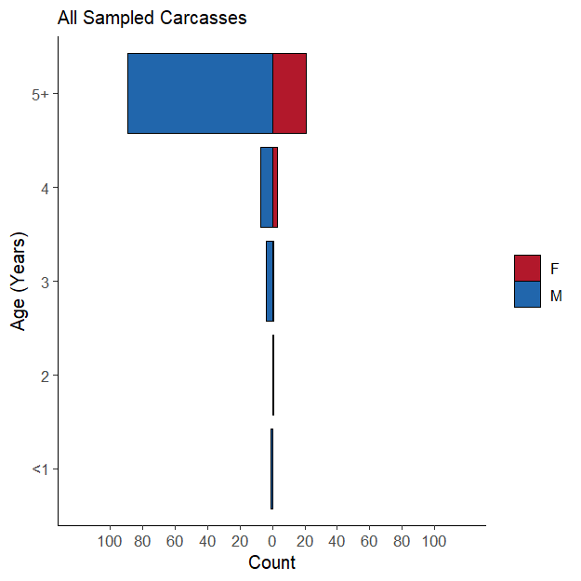
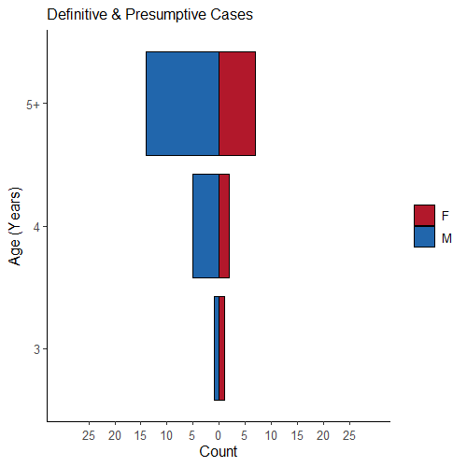
A
B
Supplementary Figure 1. Population pyramid plots for muskox carcasses evaluated between 2021 and 2024. Carcasses defined as definitive & presumptive cases of Er septicemia (n = 30) are shown in panel A, and all sampled carcasses (n = 127) are shown in panel B. Data are restricted to those carcasses for which both sex and age data were available.
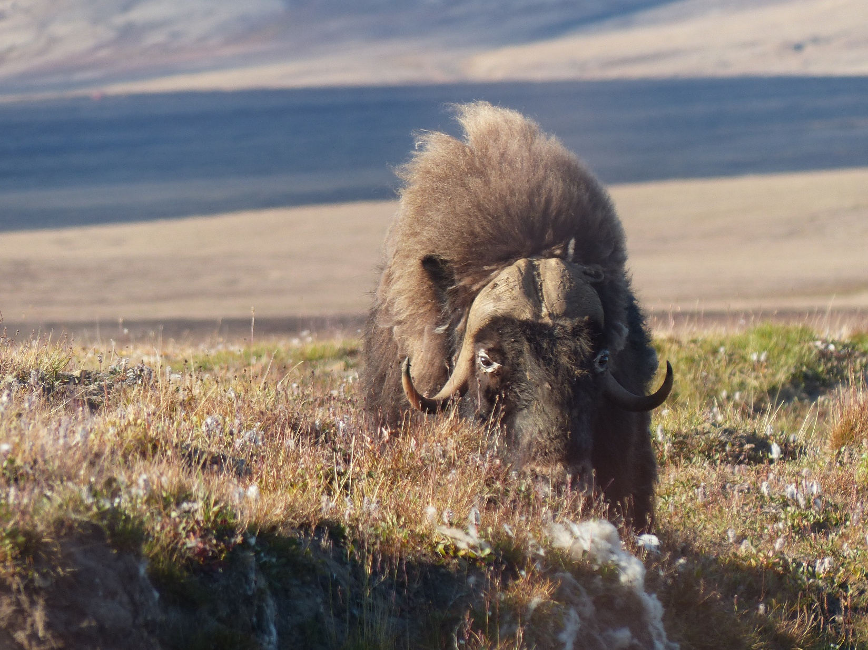
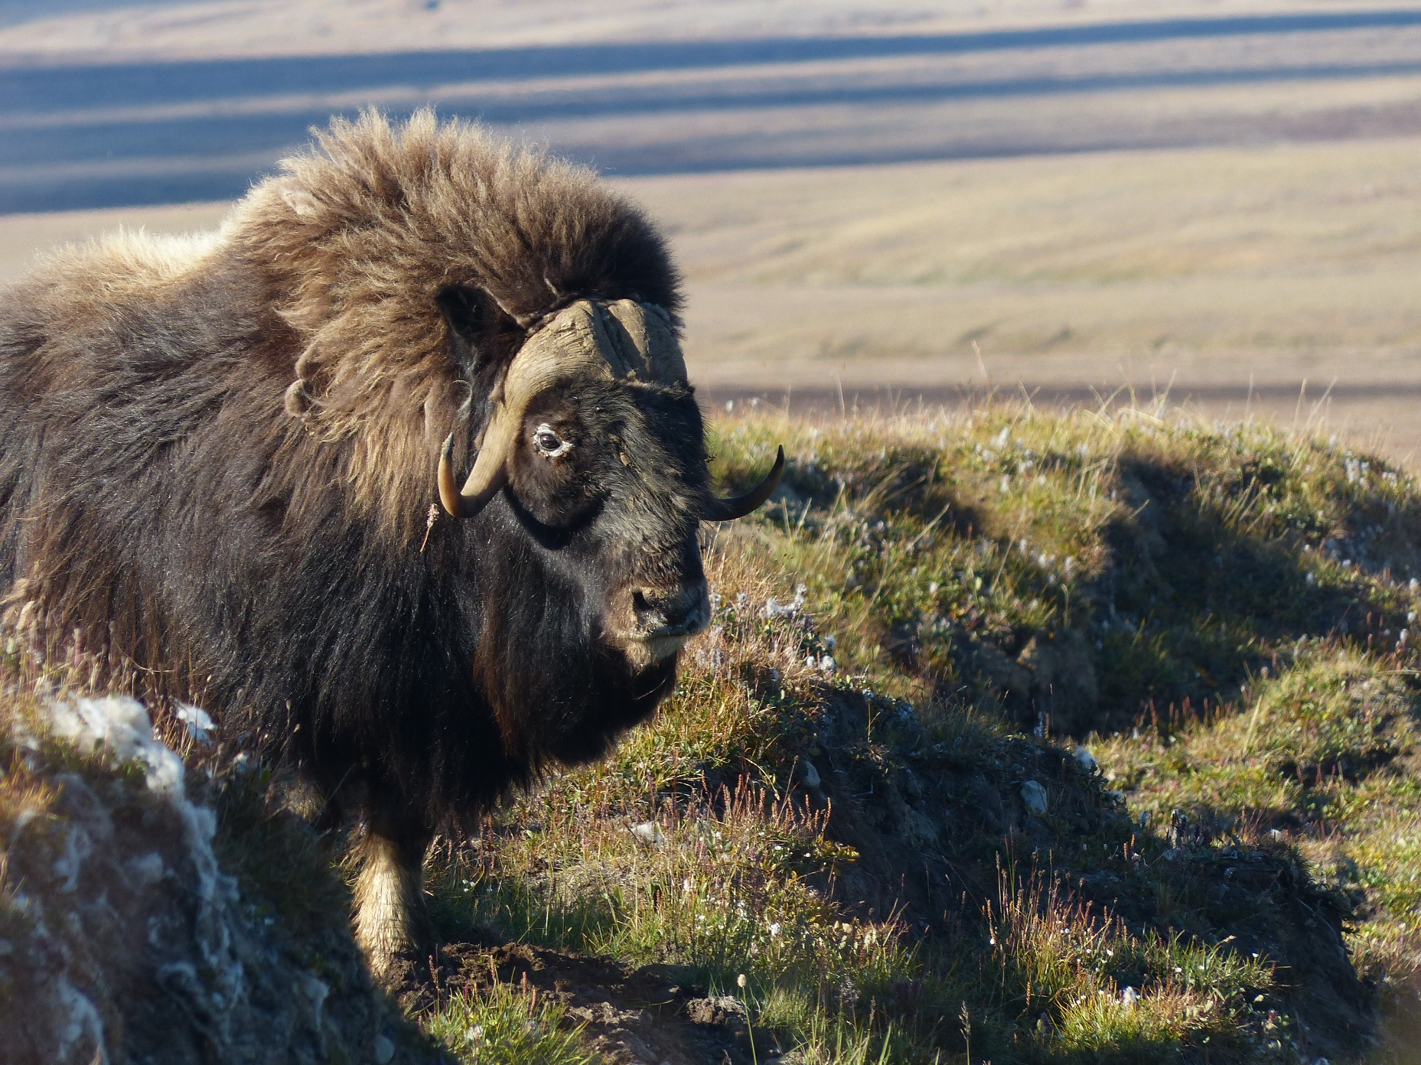
Supplementary Figure 2. Photos of an adult male muskox showing bilateral periorbital alopecia and nasal discharge. Photos were taken in August 2022 on the Fosheim Peninsula of Ellesmere Island.

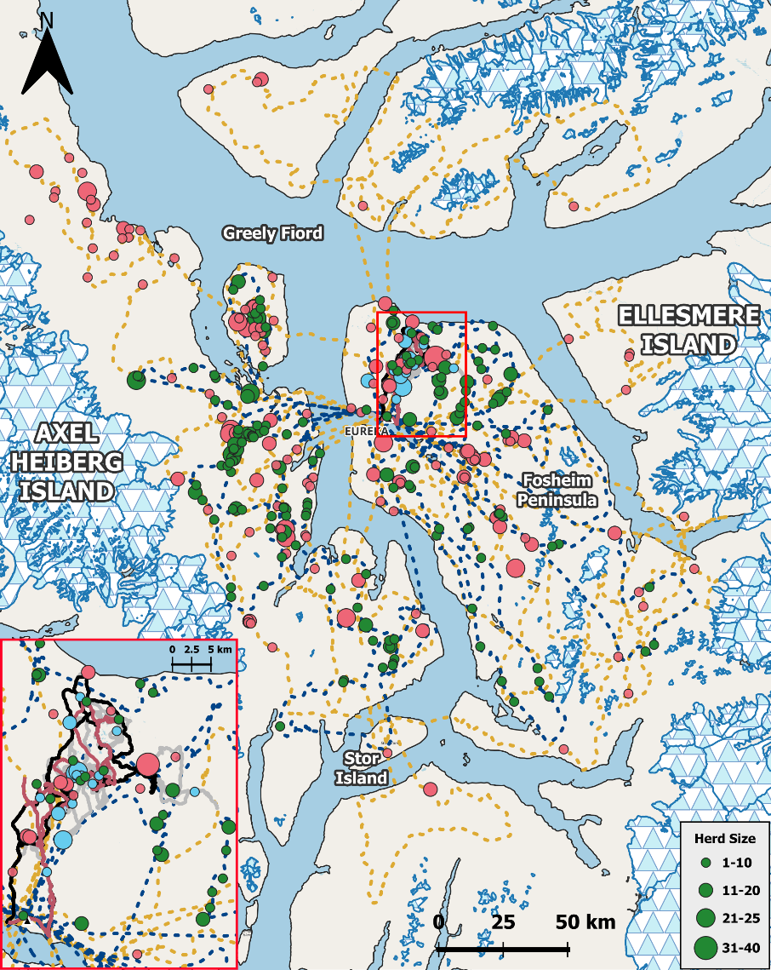
Supplementary Figure 3. Map of west-central Ellesmere Island and eastern Axel Heiberg Island depicting live muskox herd observations and routes of travel as depicted in main text Fig. 6. Observations differentiated by herd size and year of observation are shown by dots of different sizes (green for 2022, pink for 2023, and blue for 2024). 2022 travel routes and herd observations are superimposed on those from 2023 and 2024, and 2023 travel routes and herd observations are superimposed on those from 2024 where overlap exists. Maps developed using QGIS⁸⁸ version 3.40.1 (“Bratislava”). Available at: https://www.qgis.org.

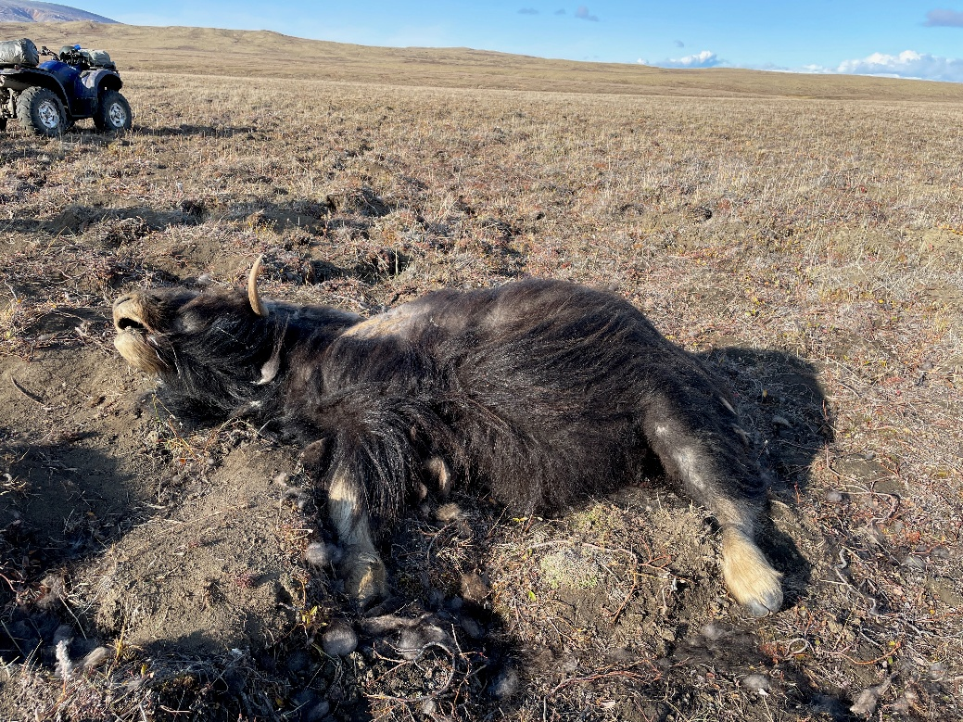
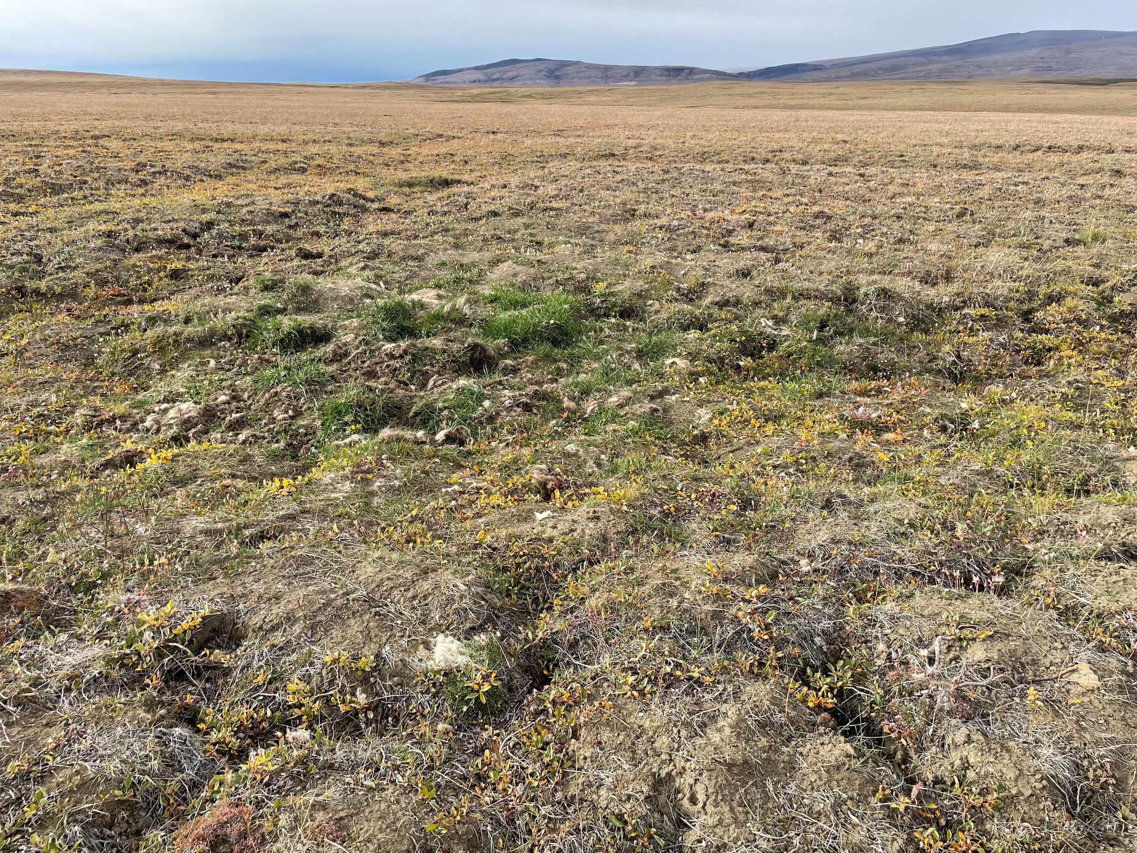
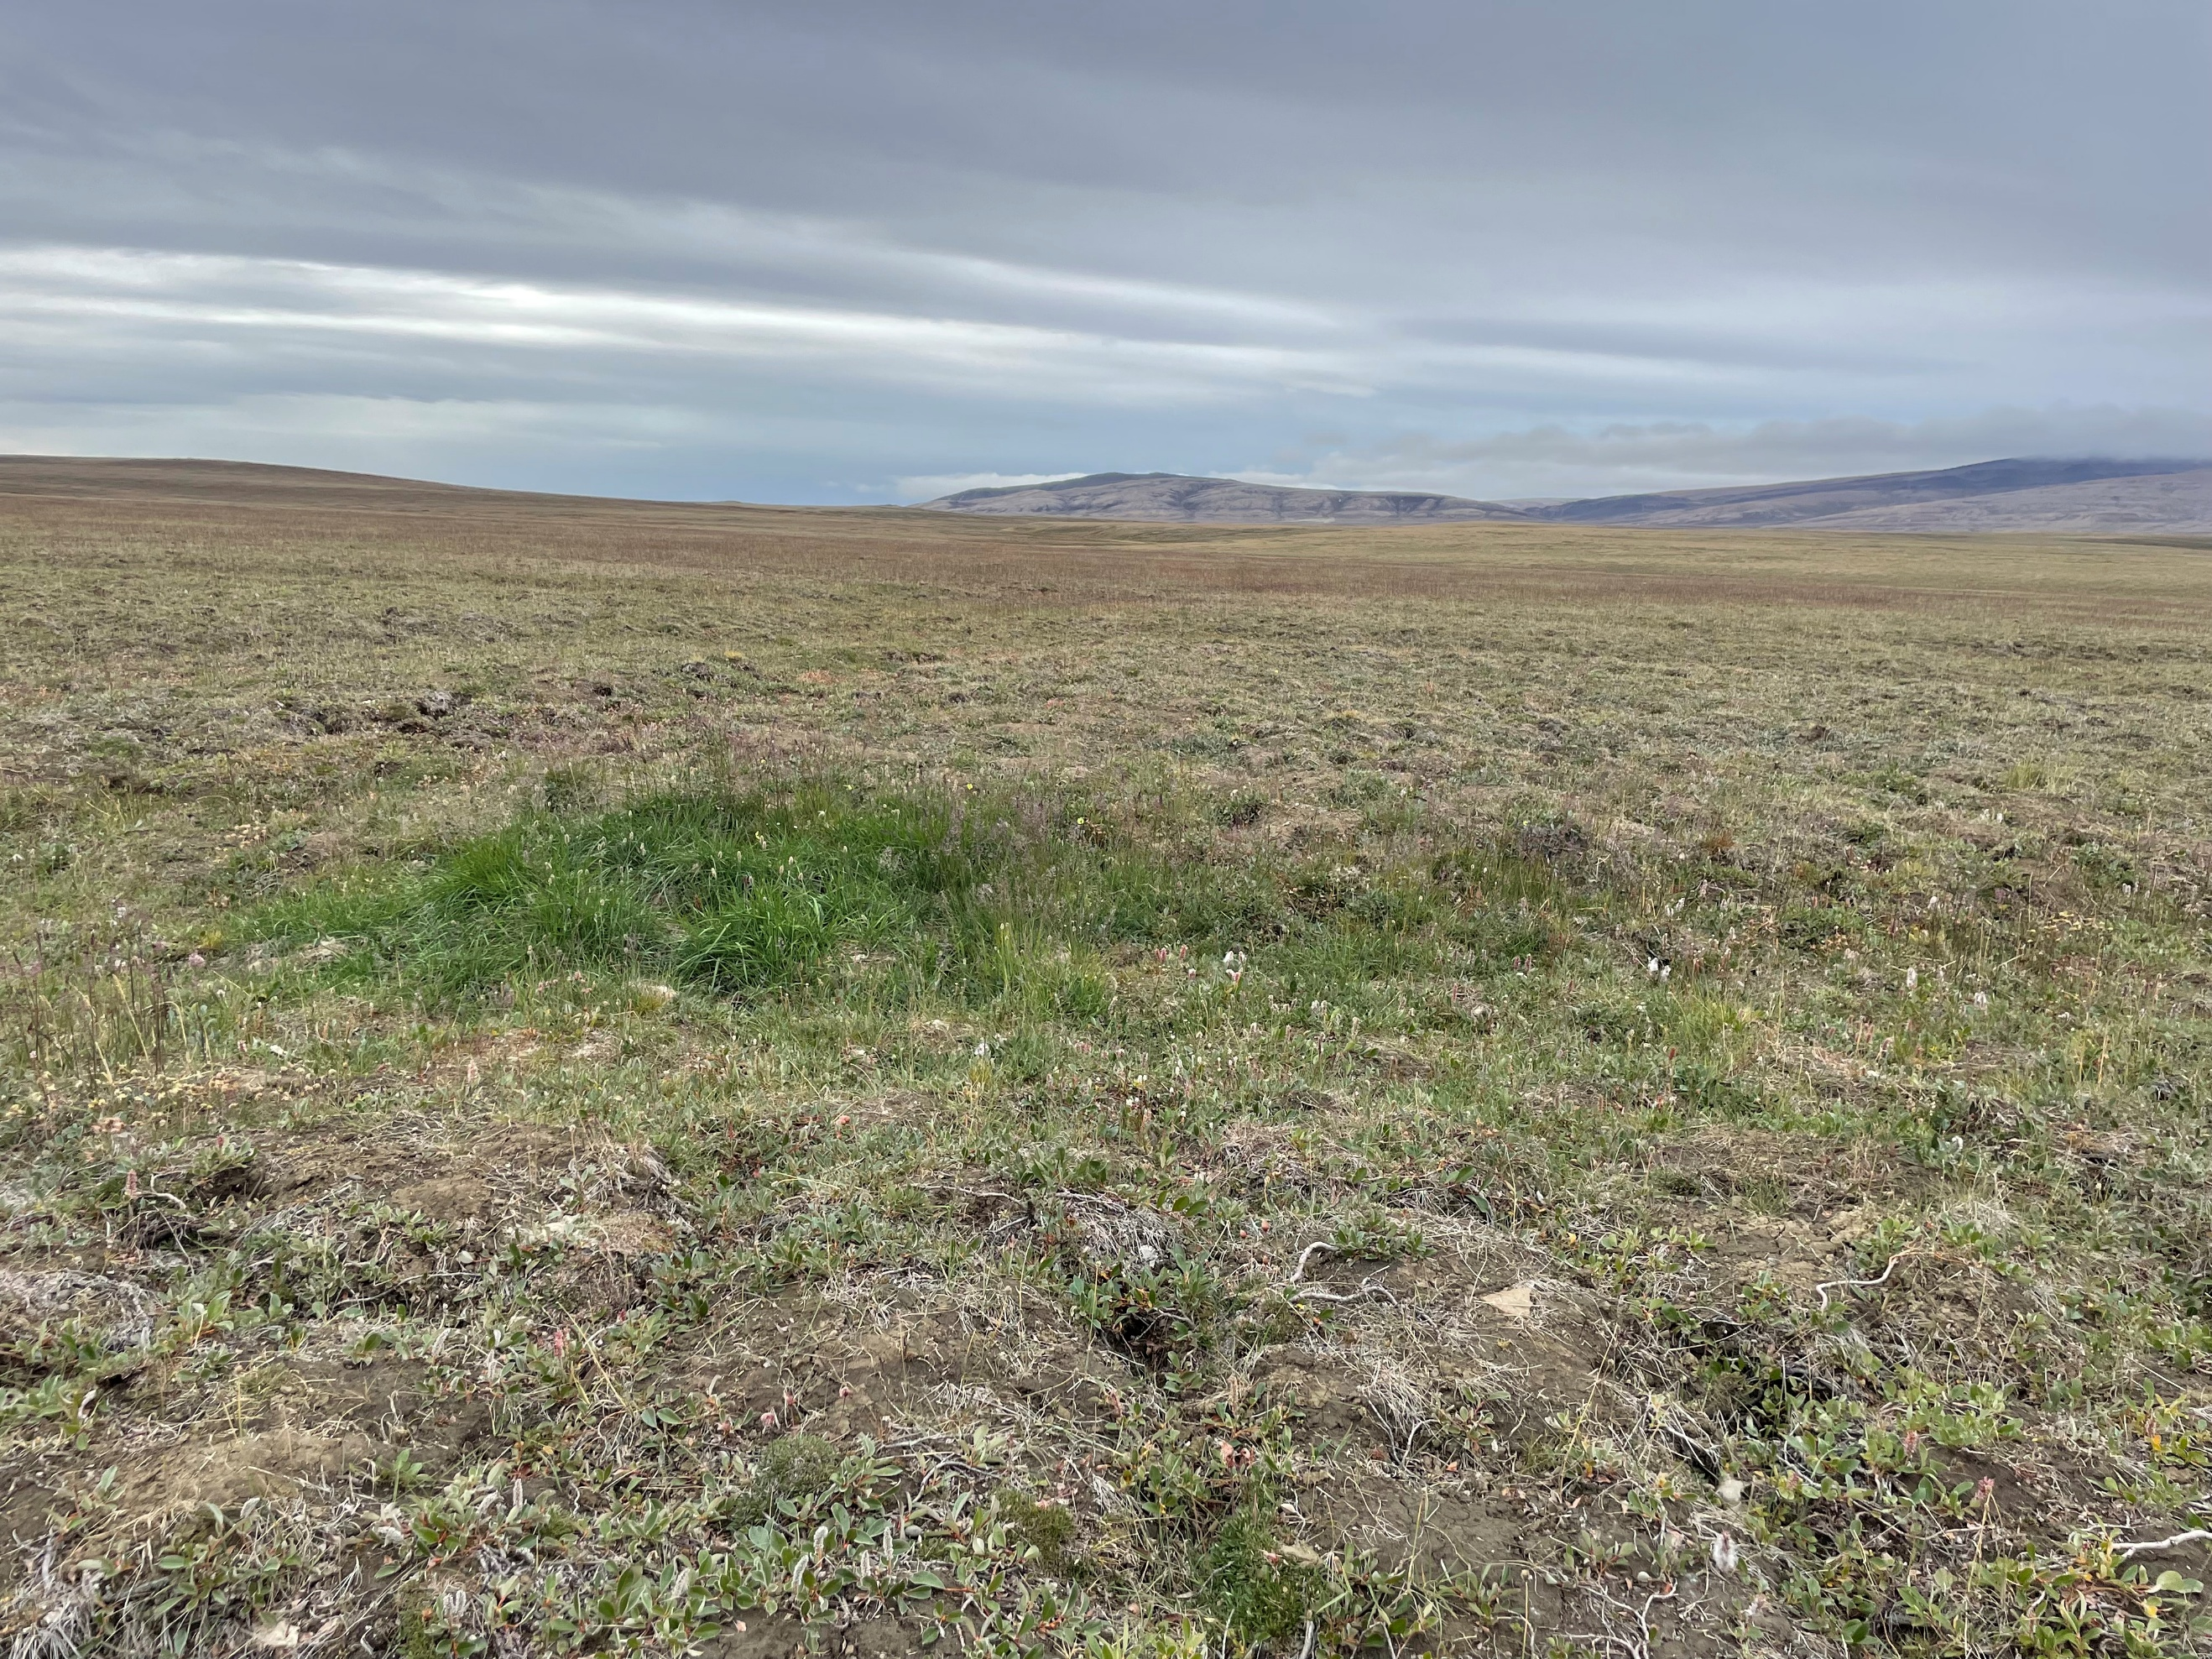
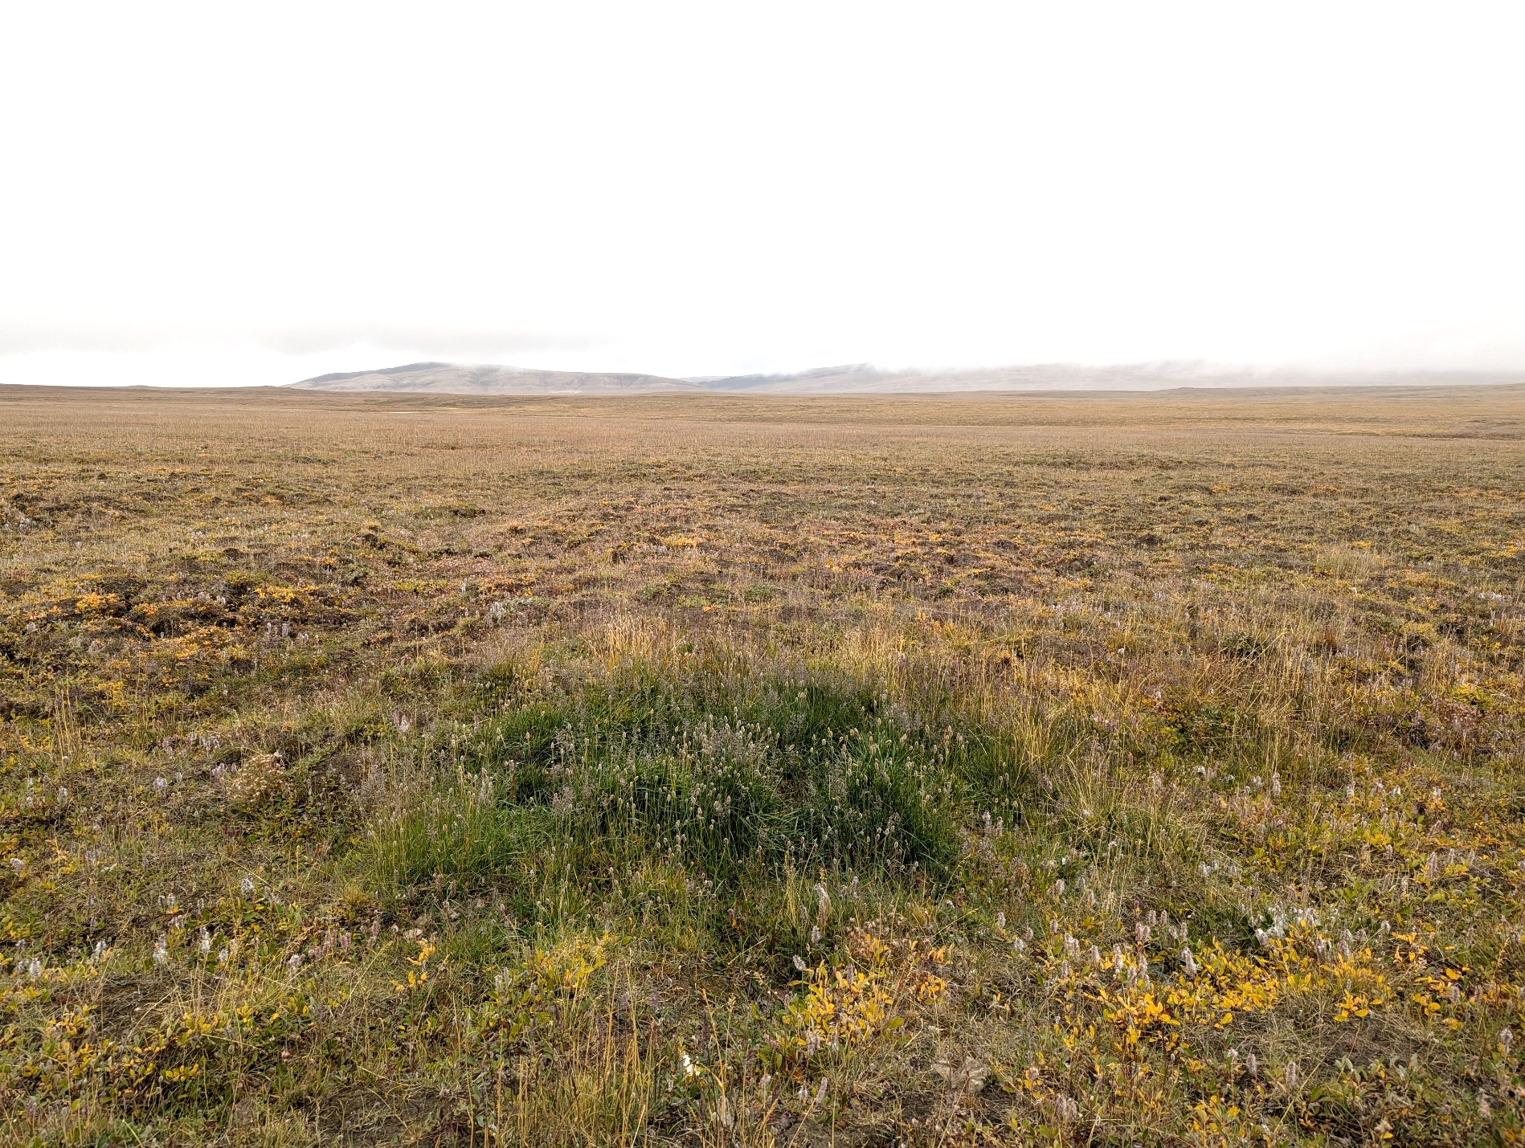
Supplementary Figure 4. Time series of photos showing vegetative “greening” of a muskox mortality site. The presented photos were collected at the carcass site of MX-21-02. Approximately 1 year has transpired between each photo, beginning in 2021 (A) and ending in 2024 (D).
A
D
C
B

