Supplementary- Table 6: Level of Neurodevelopmental Impairment-
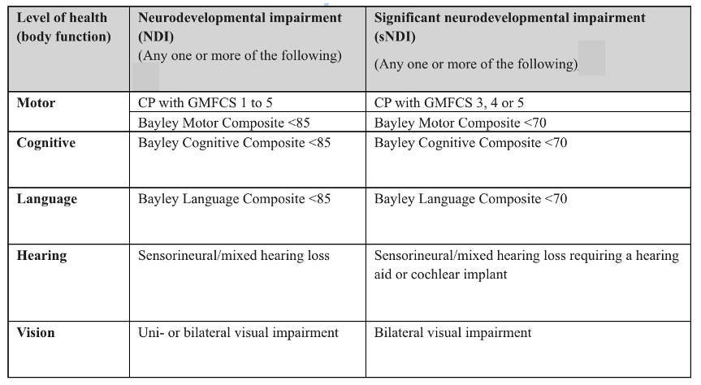

Reference: Synnes A, Luu TM, Moddemann D, Church P, Lee D, Vincer M, et al. Determinants of developmental outcomes in a very preterm Canadian cohort. Arch Dis Child Fetal Neonatal Ed. 2017;102(3):F235-F4.

