Supplemental Table 1. Primers Used in This Study
Gene | Forward (5’→3’) | Reverse (5’→3’)
Gapdh | GATGGCAACAATCTCCACTTTGC | GCCGCATCTTCTTGTGCAGT
Ifi27l2a | CTGTTTGGCTCTGCCATAGGAG | CCTAGGATGGCATTTGTTGATGTGG
Il-1α | TGCAGTCCATAACCCATGATC | ACAAACTTCTGCCTGACGAG
Il-1β | CTGTGTCTTTCCCGTGGACC | CAGCTCATATGGGTCCGACA
Tnfα | GTGGAACTGGCAGAAGAGGC | AGACAGAAGAGCGTGGTGGC
Mmp2 | GCTCTGTCCTCCTCTGTAGTTA | GGTACAGTCAGCACCTTTCTT
Mmp3 | GGATCTTCGCAGTTGGAATTTC | GATGCCTTCCTTGGATCTCTT
Mmp9 | TGCACTGGGCTTAGATCATTC | TGCCGTCTATGTCGTCTTTATTC
Acod1 | GTATCATTCGGAGGAGCAAGAG | GGAGGTGTTGGAACTGTAGATT
Icam1 | AGTAGATCAGTGAGGAGGTGAA | GCATCCTGACCAGTAGAGAAAC
Vcam1 | CCACGTGGACATCTACTCTTTC | CCAGCCTGTAAACTGGGTAAA
Tf | CTCCTGGCCACCATCTTTATC | GGCTTCAGCCTTTCCTCTATG
Mcp1 | AGTAGGCTGGAGAGCTACAA | GTATGTCTGGACCCATTCCTTC

SUPPLEMENTARY FIGURE LEGENDS
Supplementary Fig. 1. Ifi27l2a does not affect cell viability and increases microglial activation Primary microglia were treated with rIfi27l2a was added to cells for 24 hours. (a) Cell viability was measured by MTT assay after rIfi27l2a treatment in primary microglia. (n=4, NS, non-significance). (b) RNA amount was measured after rIfi27l2a treatment (n=6, ** p<0.01 compared to 0 ng/ml, Student t-test).
Supplementary Fig. 2. GSEA analysis highlights the key enriched molecular function gene set in rIfi27l2a-treated MG. GSEA analysis using DESeq2 normalized count matrix revealed that the gene sets related to (a) 'chemokine receptor binding’, (b) 'cytokine activity', (c) 'cytokine receptor binding', (d) 'antigen binding', (e) 'chemokine activity' and (f) 'hormone binding' in GO: molecular function were enriched in rIfi27l2a-treated MG.
Supplementary Fig. 3. The effect of 2-DG on Mmp2 and Mmp9 expression levels in rIfi27l2a-treated cells. The glycolysis inhibitor, 2-DG did not alter the expression of (a) Mmp2 and (b) Mmp9 in rIfi27l2a-treated Sim9A cells (n = 7-8, NS: not statistically significant, * p < 0.05, *** p < 0.001, One-way ANOVA with Sídák's multiple comparisons test).
Supplementary Fig. 4. Proinflammatory effect of exogenous Ifi27l2a on endothelial cells. (a) bEnd3 cells were treated with rIfi27l2a at 10 ng/ml and 100 ng/ml for 24 hours, stress fiber formation was visualized and analyzed after phalloidin staining. (b) Quantification of stress fiber (n=6, * p<0.05, two-tailed unpaired t-test. (c) bEnd3 cells were treated with rIfi27l2a at 10 ng/ml and 100 ng/ml for 24 hours and gene expression of Il1a and Il1b was measured by qRT-PCR. (d) Expression level of Icam1, TF, and Mcp1 were measured (n=5-8. * p<0.05, one-way ANOVA with Tukey's multiple comparisons).
Supplementary Fig. 5. The effect of Ifi27l2a on Mmp2, Mmp3, and Mmp9 expression levels in bEnd3 cells. bEnd3 cells were treated with rIfi27l2a at 10 ng/ml and 100 ng/ml for 24 hour and Mmp2, Mmp3 and Mmp9 expression were measured (n =5-8, * p < 0.05, One-way ANOVA with Šídák's multiple comparisons test).
Supplementary Fig. 6. The effect of exogenous Ifi27l2a on neurovascular units. Rat primary neurons were treated with 5 ng/ml LPS to induce cell death. rIfi27l2a was co-treated with LPS to the neurons for 24 hours. LDH assay was performed to measure cell death. Data was expressed as % of full kill control (n=5-6, * p<0.05, ** p<0.01 One-way ANOVA with Tukey's multiple comparisons).
Supplementary Fig. 1

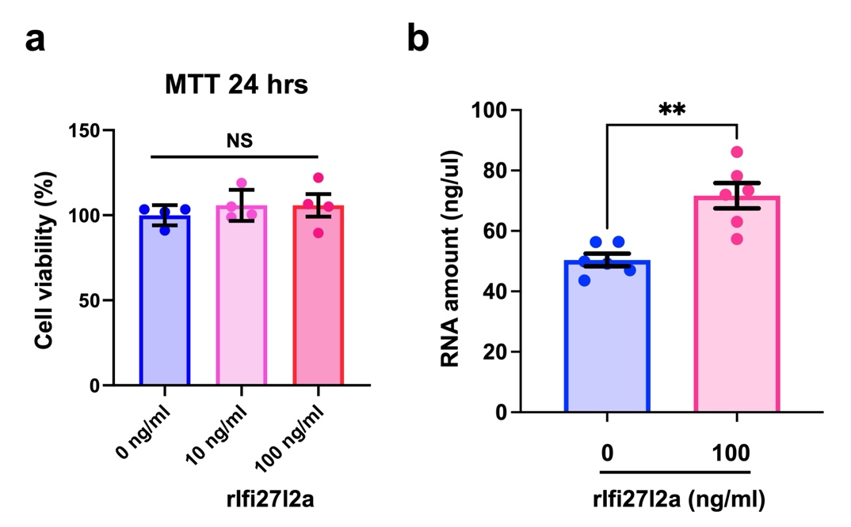

Supplementary Fig. 2

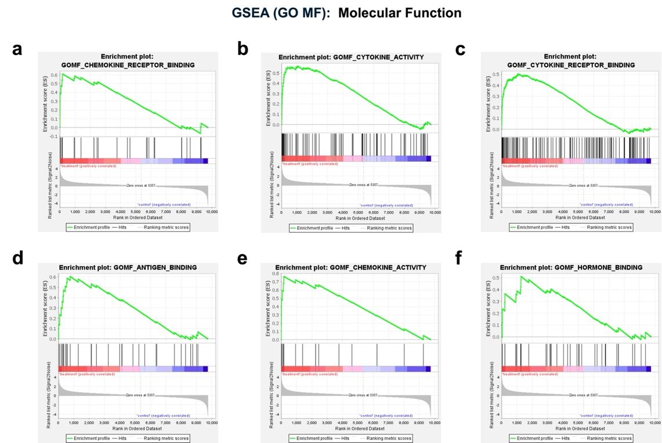

Supplementary Fig. 3

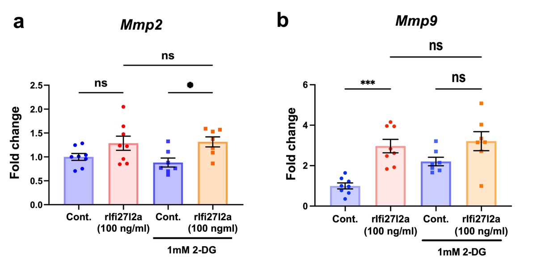

Supplementary Fig. 4

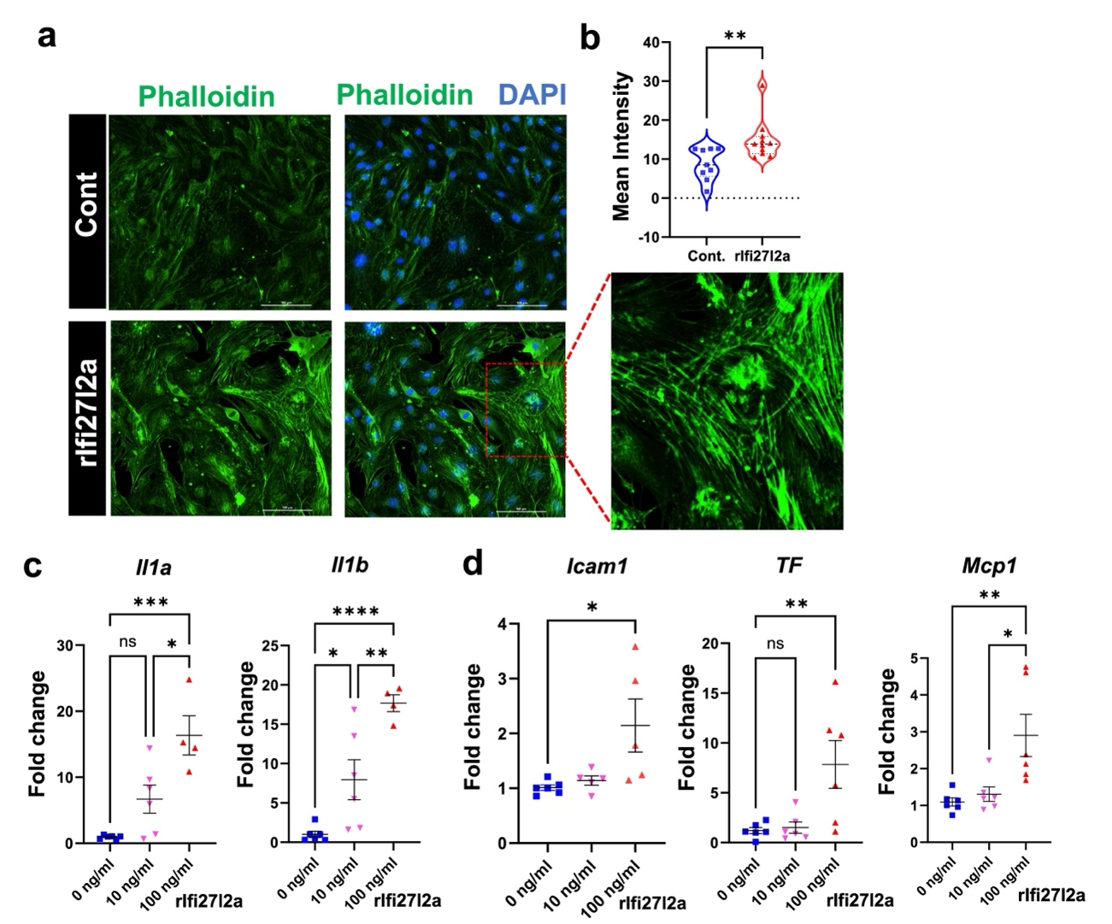

Supplementary Fig. 5

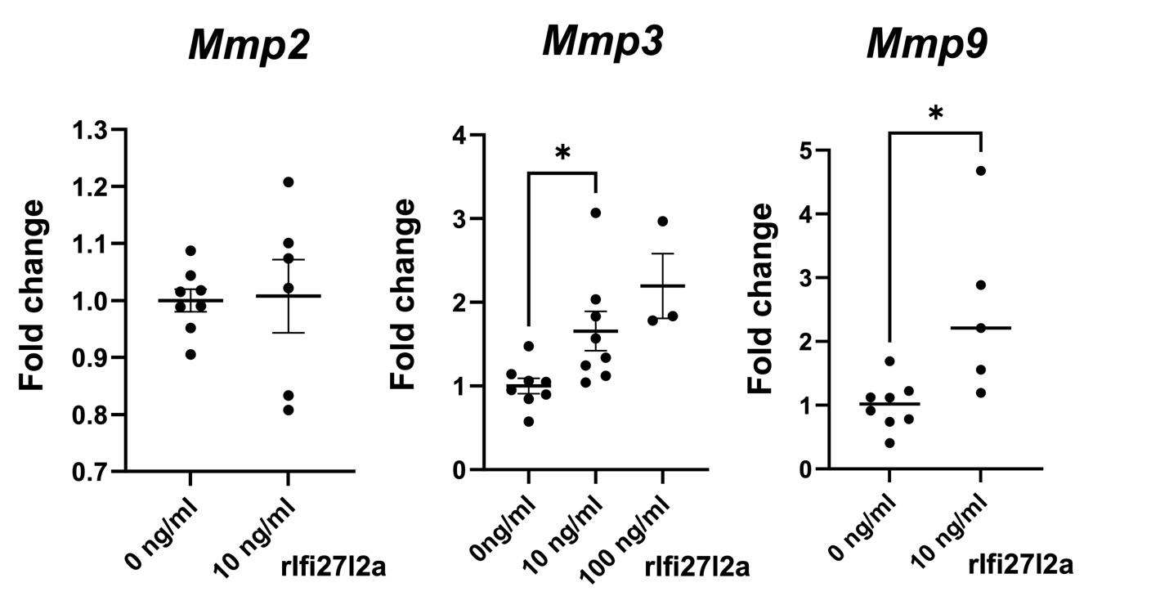

Supplementary Fig. 6

