Supplementary Table 1. Association of the Chao1 and Shannon indices with species, treatment groups, and the presence of relevant respiratory bacteria in tonsillar swabs
Variable | Chao1 Coefficient | Chao1 95% CI | Chao1 P value | Shannon Coefficient | Shannon 95% CI | Shannon P value
Species (AD versus BHS) | -1.46 | -18.36, 15.44 | 0.866 | 0.21 | -0.14, 0.56 | 0.242
Sex (Male versus Female) | -7.04 | -23.75, 9.68 | 0.413 | 0.06 | -0.3, 0.42 | 0.761
Age | -0.17 | -0.49, 0.14 | 0.281 | 0.003 | -0.004, 0.009 | 0.44
Treatment (wash versus movi) | 8.42 | -9.75, 26.59 | 0.368 | 0.39 | 0.02, 0.76 | 0.0425
Treatment (control versus movi) | 14.77 | -8.49, 38.03 | 0.219 | -0.16 | -0.63, 0.31 | 0.5134
Mycoplasma ovipneumoniae detection via qPCR (yes vs no) | 11.18 | -8.19, 30.56 | 0.263 | 0.47 | 0.07, 0.87 | 0.0249
Bibersteinia trehalosi detection (yes versus no) | -9.8 | -26.24, 6.64 | 0.248 | -0.23 | -0.58, 0.12 | 0.205
Mannheimia haemolytica detection (yes versus no) | 20.44 | -5.76, 46.63 | 0.132 | 0.63 | 0.08, 1.18 | 0.0295
Trueperella pyogenes detection (yes versus no) | 2.02 | -18.8, 22.84 | 0.85 | -0.06 | -0.51, 0.38 | 0.78

Supplementary Table 2. Association of the Chao1 and Shannon indices with species, days post infection, treatment groups, and the presence of relevant respiratory bacteria in lower respiratory tract tissue samples
Variable | Chao1 Coefficient | Chao1 95% CI | Chao1 P value | Shannon Coefficient | Shannon 95% CI | Shannon P value
Species (BHS versus AD) | -61.7 | -108.82, -14.58 | 0.0161 | -1.62 | -2.44, -0.79 | 0.000681
Sex (Male versus Female) | 30.57 | -19.39, 80.53 | 0.241 | -0.03 | -1.04, 0.97 | 0.946
Age | 0.58 | 0.08, 1.07 | 0.0299 | 0.01 | 0.002, 0.02 | 0.021
Treatment (wash versus movi) | 28.1 | -23.38, 79.57 | 0.294 | 0.24 | -0.78, 1.26 | 0.647685
Days post infection (late versus early) | 23.26 | -27.26, 73.77 | 0.375 | 0.5 | -0.49, 1.48 | 0.329
Mycoplasma ovipneumoniae prevalence via PCR (yes vs no) | -8.82 | -65.77, 48.14 | 0.764 | 0.28 | -0.83, 1.39 | 0.629961
Pasteurella multocida detection (yes versus no) | -20.69 | -71.89, 30.51 | 0.436 | -0.31 | -1.37, 0.76 | 0.58
Bibersteinia trehalosi detection (yes versus no) | -32.95 | -88.59, 22.69 | 0.257 | -0.93 | -2.06, 0.19 | 0.116
Mannheimia haemolytica detection (yes versus no) | -39.17 | -91.79, 13.46 | 0.157 | -0.63 | -1.74, 0.48 | 0.276
Trueperella pyogenes detection (yes versus no) | -23.53 | -79.9, 32.84 | 0.421 | -1.18 | -2.27, -0.09 | 0.044

Supplementary Table 3. Association between the beta diversity of the tonsillar microbiome with species, days post infection, treatment groups, and the presence of relevant respiratory bacteria in tonsillar swabs
 | Beta diversity distance
Variable | Bray-Curtis | Jaccard | Aitchison
Species | R²=0.058  P value=0.011  Dispersion homogeneity P value=0.3181 | R²=0.05  P value=0.001  Dispersion homogeneity P value=0.5268 | R²=0.08  P value=0.001  Dispersion homogeneity P value=0.0002893
Sex | R²=0.03  P value=0.089 | R²=0.021  P value=0.263 | R²=0.02  P value=0.418
Age | R²=0.08  P value=0.003  Dispersion homogeneity P value= N/A | R²=0.06  P value=0.001  Dispersion homogeneity P value= N/A | R²=0.11  P value=0.001  Dispersion homogeneity P value= N/A
Treatment Groups | R²=0.042  P value=0.251 | R²=0.04  P value=0.243 | R²=0.04  P value=0.251
Days post infection | R²=0.221  P value=0.001  Dispersion homogeneity P value=0.0001515 | R²=0.16  P value=0.001  Dispersion homogeneity P value=0.001067 | R²=0.33  P value=0.001  Dispersion homogeneity P value=0.003227
M. ovipneumoniae detection via qPCR | R²=0.096  P value=0.001  Dispersion homogeneity P value=0.0226 | R²=0.06  P value=0.001  Dispersion homogeneity P value=0.03558 | R²=0.16  P value=0.001  Dispersion homogeneity P value=0.5392
B. trehalosi detection | R²=0.04  P value=0.032  Dispersion homogeneity P value=0.3532 | R²=0.04  P value=0.003  Dispersion homogeneity P value=0.4499 | R²=0.04  P value=0.029  Dispersion homogeneity P value=0.105
M. haemolytica detection | R²=0.015  P value=0.531 | R²=0.02  P value=0.684 | R²=0.02  P value=0.394
T. pyogenes detection | R²=0.021  P value=0.328 | R²=0.02  P value=0.165 | R²=0.02  P value=0.465

Supplementary Table 4. Association between the beta diversity of the lower respiratory tract with species, days post infection, treatment groups, and the presence of relevant respiratory bacteria in lower respiratory tract tissue samples
 | Beta diversity distance
Variable | Bray-Curtis | Jaccard | Aitchison
Species | R²=0.07  P value=0.04  Dispersion homogeneity P value=0.2509 | R²=0.06  P value=0.025  Dispersion homogeneity P value=0.4267 | R²=0.12  P value=0.004  Dispersion homogeneity P value=0.0008775
Sex | R²=0.06  P value=0.062 | R²=0.05  P value=0.028  Dispersion homogeneity P value=0.06581 | R²=0.06  P value=0.107
Age | R²=0.07  P value=0.032  Dispersion homogeneity P value=N/A | R²=0.05  P value=0.032  Dispersion homogeneity P value=N/A | R²=0.08  P value=0.014  Dispersion homogeneity P value=N/A
Treatment Groups | R²=0.12  P value=0.003  Dispersion homogeneity P value=0.4489 | R²=0.07  P value=0.001  Dispersion homogeneity P value=0.3243 | R²=0.05  P value=0.131
Days post infection | R²=0.12  P value=0.001  Dispersion homogeneity P value=0.7686 | R²=0.07  P value=0.001  Dispersion homogeneity P value=0.5948 | R²=0.06  P value=0.094
M. ovipneumoniae prevalence via PCR | R²=0.07  P value=0.009  Dispersion homogeneity P value=0.1018 | R²=0.06  P value=0.02  Dispersion homogeneity P value=0.03832 | R²=0.03  P value=0.733
P. multocida prevalence | R²=0.15  P value=0.001  Dispersion homogeneity P value=0.5103 | R²=0.08  P value=0.001  Dispersion homogeneity P value=0.454 | R²=0.07  P value=0.074
B. trehalosi prevalence | R²=0.04  P value=0.49 | R²=0.03  P value=0.699 | R²=0.05  P value=0.126
M. haemolytica prevalence | R²=0.15  P value=0.001  Dispersion homogeneity P value=0.005215 | R²=0.1  P value=0.001  Dispersion homogeneity P value=0.001621 | R²=0.08  P value=0.026  Dispersion homogeneity P value=0.015
T. pyogenes prevalence | R²=0.05  P value=0.189 | R²=0.04  P value=0.361 | R²=0.06  P value=0.141

Figure S1: Rarefaction curves for full-length 16S rRNA gene. Each line represents a single sample. The number of observed genera is represented in the y axis and the sequencing depth in the x-axis. The rarefaction curves are stratified by species; aoudad (Ammotragus lervia), and bighorn sheep (Ovis canadensis; sheep).

Figure S2: Rarefaction curves for full-length 16S rRNA gene. Each line represents a single sample. The number of observed genera is represented in the y axis and the sequencing depth in the x-axis. The rarefaction curves are stratified by sample type; tissue from the lower respiratory tract (lung parenchyma and respiratory-associated lymph nodes) and tonsillar swabs (swab).

Figure S3: Boxplot of the relative abundance of the 20 most abundant bacterial genera (in descending order) in samples collected from aoudad (Ammotragus lervia), and bighorn sheep (Ovis canadensis; sheep). Boxes indicate the interquartile range (IQR, the middle 50% of the data), with a line within the box to identify the median relative abundance. Whiskers represent ± 1.5 times the IQR. Individual points represent outliers.

Figure S4: Boxplot of the relative abundance of the 20 most abundant bacterial genera (in descending order) in samples from two locations; tissue from the lower respiratory tract (lung parenchyma and respiratory-associated lymph nodes) and tonsillar swabs (swab). Boxes indicate the interquartile range (IQR, the middle 50% of the data), with a line within the box to identify the median relative abundance. Whiskers represent ± 1.5 times the IQR. Individual points represent outliers.

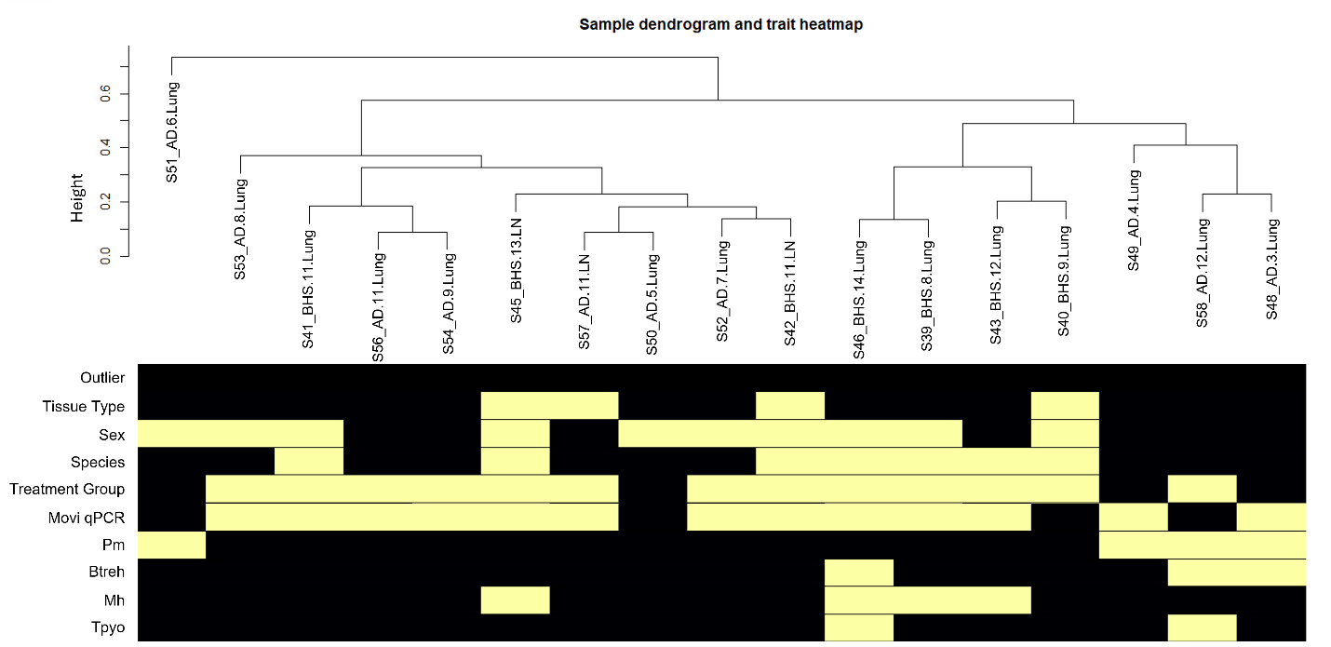
Figure S5. Hierarchical clustering of clinical metadata across all sheep samples utilized for transcriptome gene expression network analysis. Standardized connectivity was calculated from network adjacency matrices and used to classify potential outliers (Z.k < -5); no sample was identified as an outlier for downstream analyses (Outlier; No=0, 1=Yes). Colors indicate an increase (yellow/white) or decreased (purple/black) value for each trait. Binary metadata variables were utilized for outlier identification (Tissue Type (lung = 0, lymph node = 1), Sex (Female=0, Male=1), Species (AD = 0, BHS = 1), Treatment Group (Movi=0, Wash=1), Movi qPCR (Mycoplasma ovipneumoniae qPCR results; negative = 0, positive = 1), Pm (Pasteurella multocida culture results; negative = 0, positive = 1), Btreh (P Bibersteinia trehalosi culture results; negative = 0, positive = 1), Mh (Mannheimia haemolytica culture results; negative = 0, positive = 1), Tpyo (Trueperella pyogenes culture results; negative = 0, positive = 1).
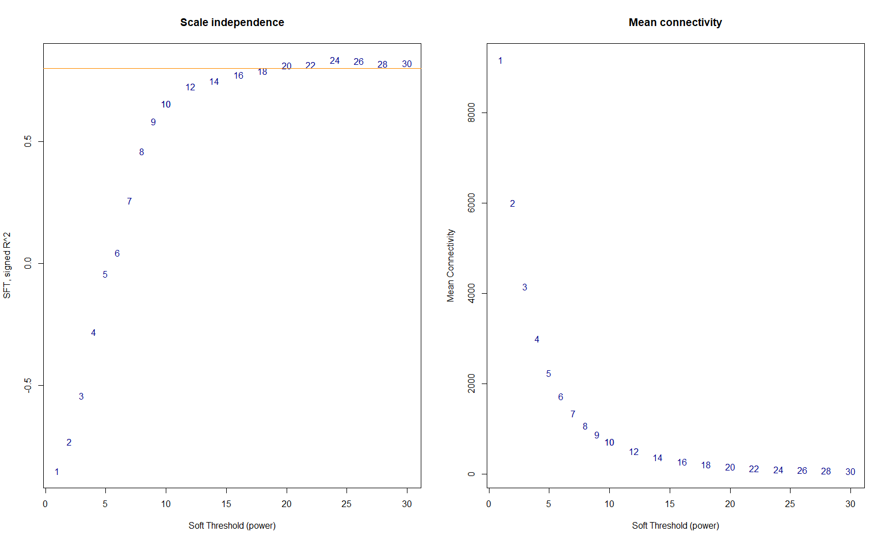
Figure S6. Soft thresholding (β) selection for signed weighed correlation network construction of all sheep samples via scale free topology analysis. A) Scale free topology indices (R²; y-axis) at increasing soft threshold powers (β; x-axis). The value β = 24 was selected, seen where the saturation curve is above 0.8 (orange horizontal line). B) Increasing soft threshold powers (β; x-axis) with respect to decreasing mean connectivity (y-axis).

