Extended Data Figures (cited in text)
Extended Data Figure 1a
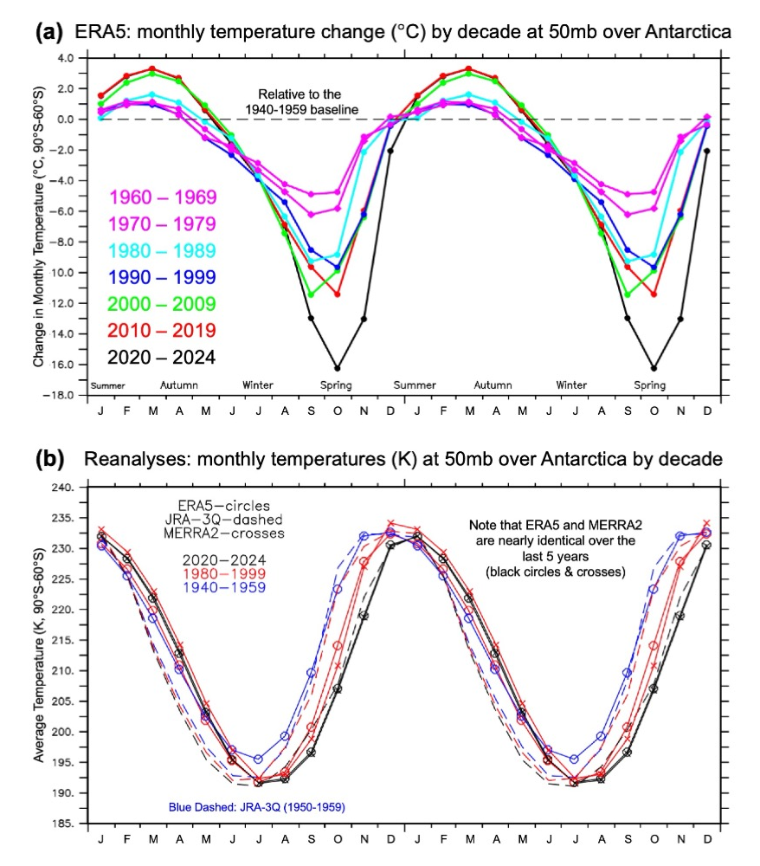
Ext Figure 1: a) ERA5 reanalysis monthly average temperature change (°C) at 50 hPa over Antarctica south of 60°S, by decade relative to the 1940-1959 baseline; 1960s (purple, diamonds), 1970s (purple, circles), 1980s (cyan, circles), 1990s (blue, circles), 2000s (green, circles); 2010s (red, circles), 2020s (black, circles); b) Monthly average temperatures (K) at 50 hPa over Antarctica south of 60°S for selected intervals from the three reanalyses; black lines indicate the 2020-2024 monthly average temperature, red lines indicate the 1980-1999 monthly average temperature, blue lines indicate the earliest 20th Century period (1940-1959 for ERA5, 1950-1959 for JRA-3Q). ERA5 data are indicated by lines with circles (black, red, blue), JRA-3Q data are indicated with dashed lines (black, red, blue), MERRA2 data are indicated with crosses (black, red). Two seasonal cycles are shown for clarity.
Extended Data Figure 2
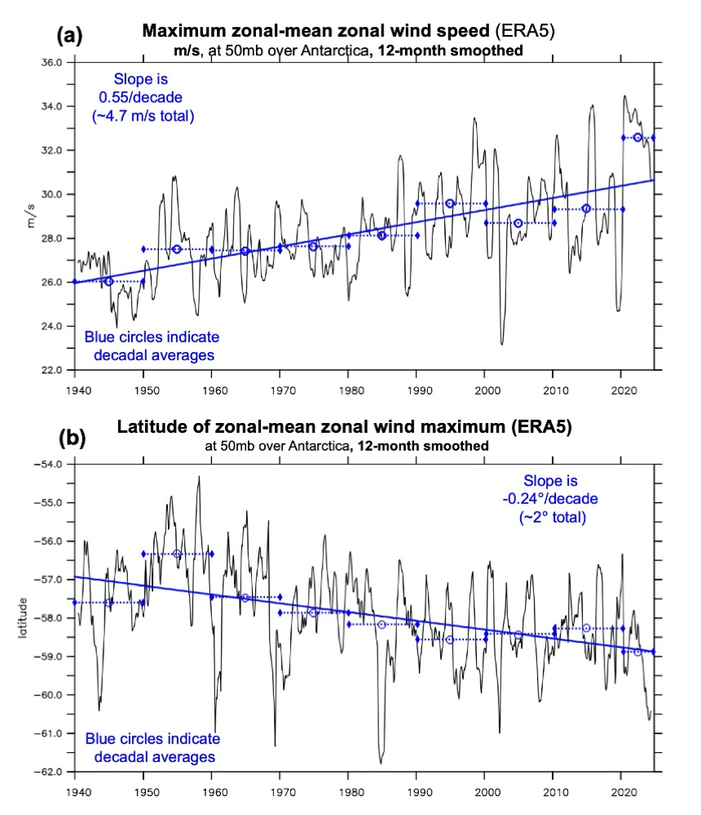

Ext Figure 2: a) The maximum, monthly, zonal-mean, zonal wind speed (m/s) between 80°S-30°S at 50 hPa from the ERA5 reanalysis after a 12-month running-mean smoother has been applied. The blue circles indicate decadal averages for each given decade indicated by the blue dashed lines (1940-1949, etc.). The solid blue line is the calculated least-squares regression line fit to the decadal averages. The slope of the blue line indicates that the maximum speed in the jet is increasing by ~0.55 m/s per decade. b) The latitude at which the maximum, monthly, zonal-mean, zonal wind speed (m/s) between 80°S-30°S at 50 hPa occurs from the ERA5 reanalysis after a 12-month running-mean smoother has been applied is shown. The blue circles indicate decadal averages for each given decade indicated by the blue dashed lines (1940-1949, etc.). The solid blue line is the calculated least-squares regression line fit to the decadal averages. The slope of the blue line indicates that the location of the jet is moving poleward by ~0.24° of latitude per decade.

Extended Data Figure 3
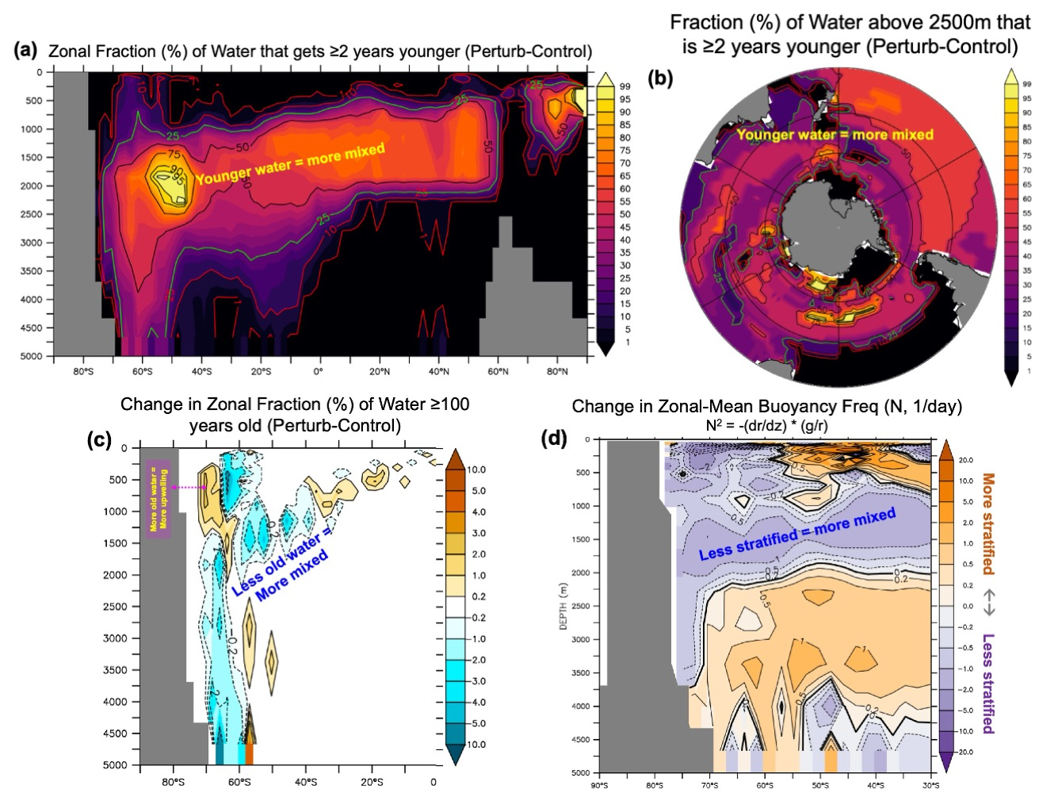

Ext. Figure 3: These panels show changes in various measures of the ocean’s annual-mean mixing and/or stratification that occur in response to the seasonal stratospheric cooling averaged over the 300-year simulation. a) The zonal fraction (%) of ocean water for which the ventilation age decreases by at least 2 years in response to the cooling perturbation in the stratosphere. All of the water at 50°S and 2000m depth is more recently ventilated, as is most of the intermediate water and water at the bottom in the ACC. b) Similar to (a), but the fraction of water (%) between the surface and 2500m for which the ventilation age decreases by at least 2 years in response to the cooling perturbation in the stratosphere. More than 50% of the water in the South Pacific is more recently ventilated, but none of the water on the northern side of the ACC in the Atlantic basin is younger. c) The change in the zonal fraction (%) of water with a ventilation age of 100 years or more; in contrast to (a), this panel shows the decrease in “older” water at 60°S at depth (indicating more mixing) as well as the pocket of older water at 70°S between 500-1000m that indicated increased upwelling of older deep water at this location. d) Stratification, a measure of the vertical change in density (specifically, the strength of the internal restoring force within a stratified fluid to vertical displacements), is quantified by determining the Brunt–Väisälä frequency otherwise known as the buoyancy frequency. Decreased stratification (a lower frequency, purple areas) indicates the increase in vertical mixing due to the increased wind stress caused by the seasonal cooling of the stratosphere.

Extended Data Figure 4
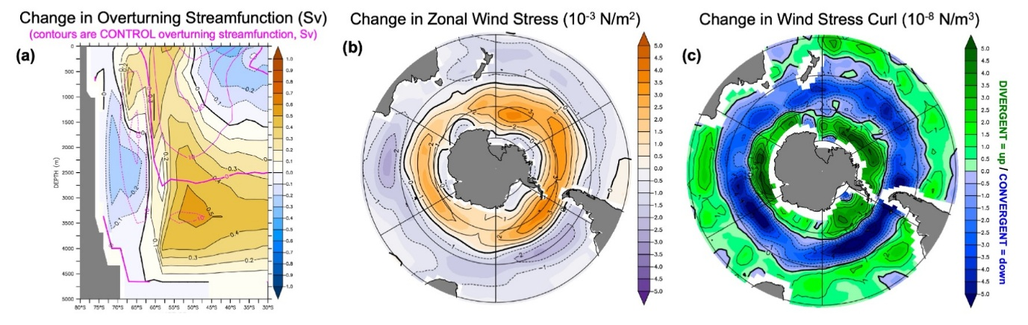
Ext. Figure 4: a) Physical oceanographers have long relied on the calculation of an “overturning streamfunction” to quantify and describe the movement of ocean water in latitude-depth space. The authors generally do not place much value on using the strength of the overturning as a benchmark for simulations as there can be no “observationally-based” determination of this quantity in the real ocean. However, overturning serves well in a descriptive sense. The thin purple lines indicate the meridional overturning streamfunction in the CONTROL simulation; positive contours (in Sv, 10⁶ m³/s) indicate a clockwise circulation (e.g. the upper water column, equatorward of ~65°S) and negative contours indicate a counter-clockwise circulation. The colors indicate the change in the streamfunction (in Sv) in response to the stratospheric cooling. Again, the positive and negative contours from the bottom to the surface at ~60°S indicate increased upwelling throughout the ACC as well as downwelling on the northern edge (at ~50°S). b) The change in the annual-mean zonal surface wind stress (10⁻³ N/m²; also shown in Fig 3d) as a polar projection clearly indicates the poleward intensification and increased wind stress over the SO. c) The change in the curl of the annual-mean zonal wind stress (calculated as the latitudinal gradient of the annual-mean zonal wind stress). Over the latitudes of the Drake Passage where there can be no geostrophically-balanced flow, the curl of the wind stress indicates the locations of wind-driven (Ekman) convergence and divergence at the surface due to the Coriolis force. The increased wind stress curl indicates increased divergence (shown here in green, e.g. at 60°S) at the surface which must be balanced by increased upwelling (or decreased downwelling). Stratospheric cooling leads to enhanced upwelling on the southern side of the ACC (see also the change in overturning in panel a). Increased surface convergence at ~50°S (shown in blue) must be balanced by increased downwelling and/or reduced upwelling (again also seen in panel a).

