Supplementary Information:

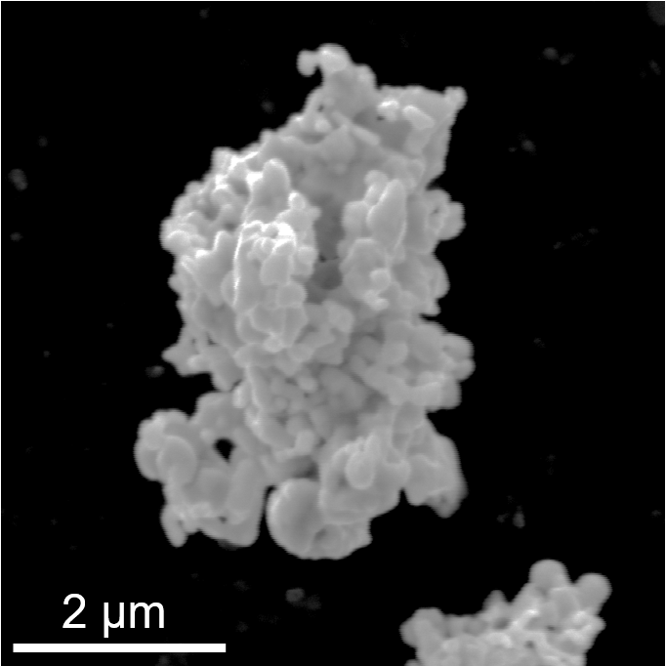
Fig. S1. Morphology of silver powder.

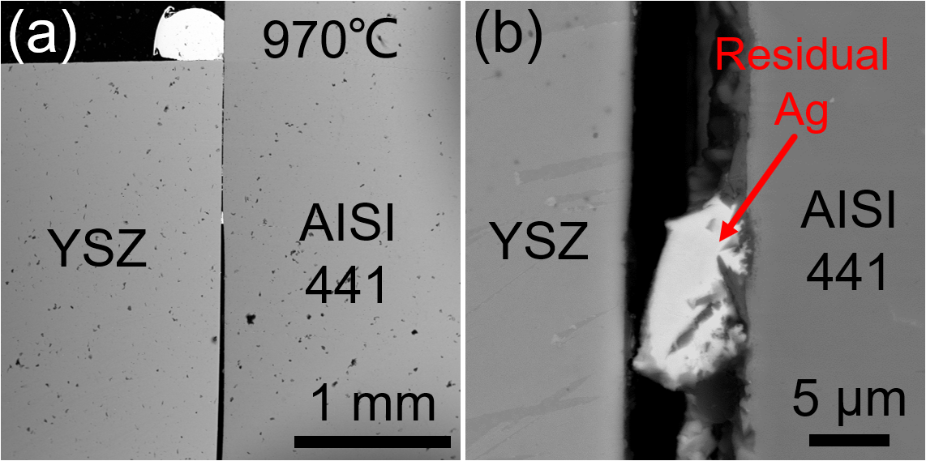
Fig. S2. (a) Overview SEM image and (b) interfacial microstructure of YSZ/AISI 441 joints obtained at 970 ℃ for 30 min.

