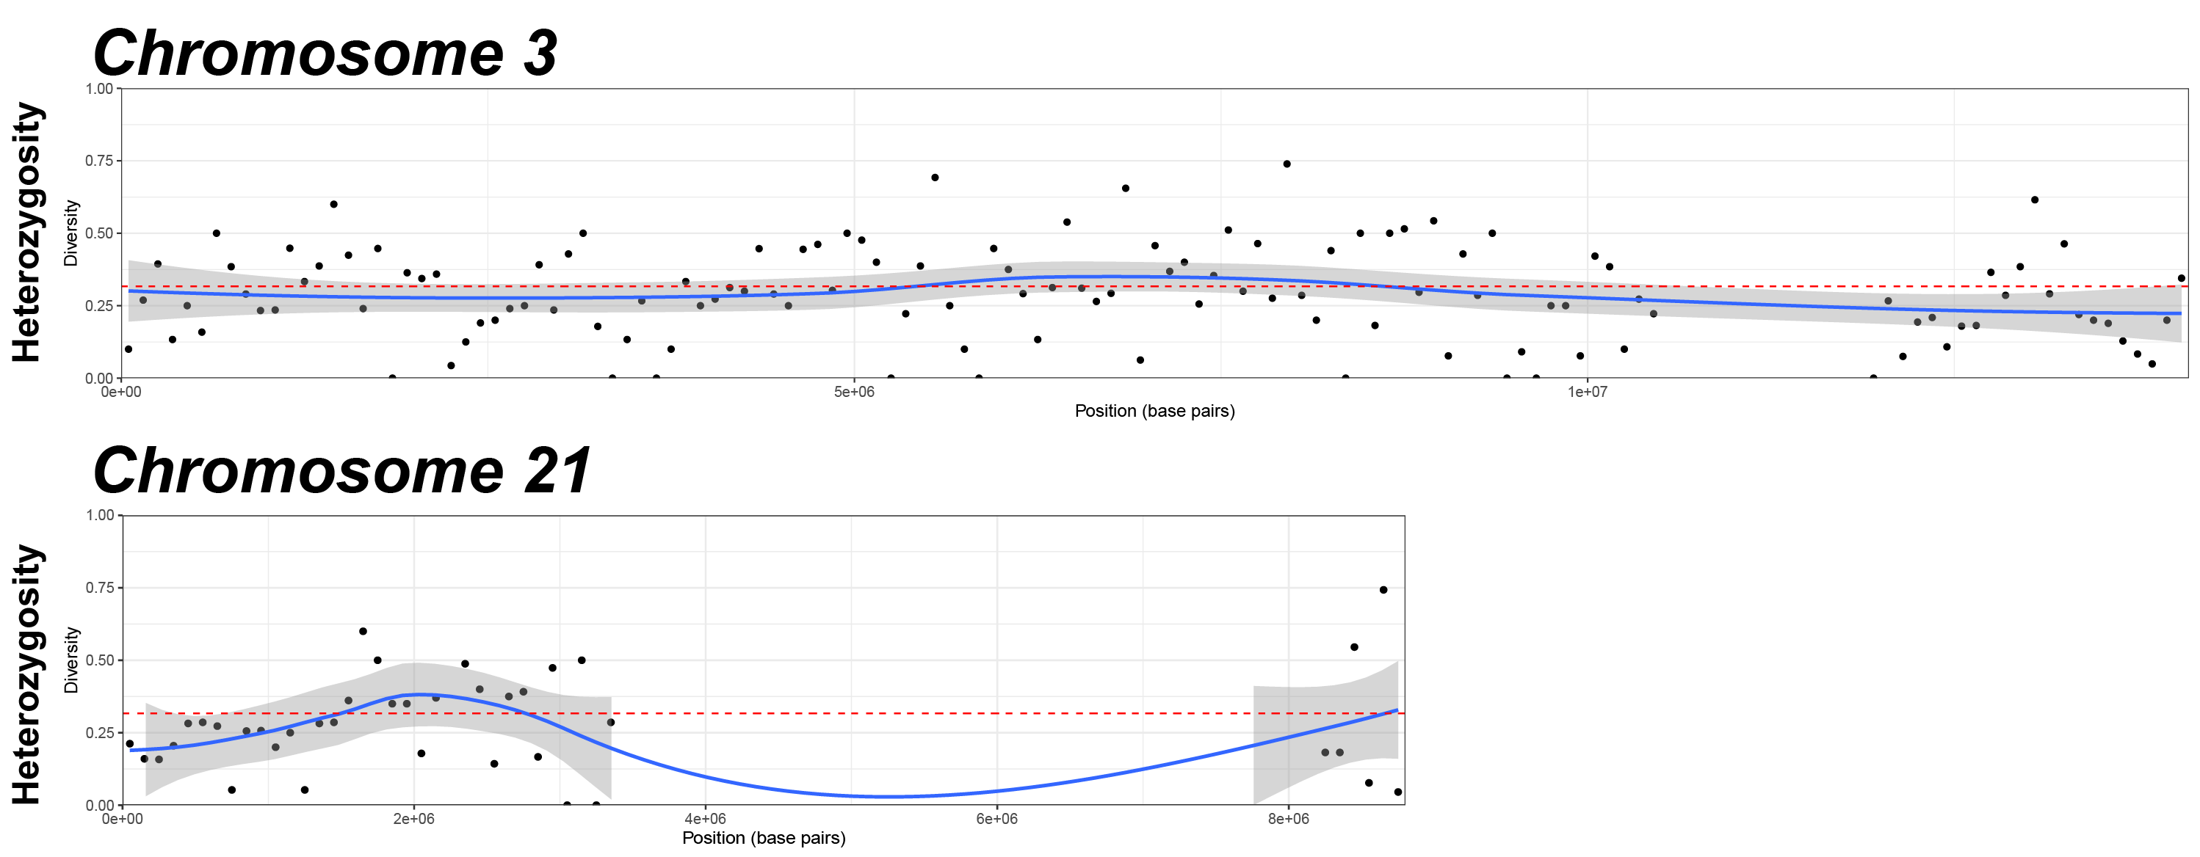
Supplementary Figure S1. Heterozygosity of Vespa mandarinia alleles along chromosomes 3 and 21. Dots represent the number of heterozygous variants in Canadian V. mandarinia divided by all V. mandarinia variants, computed in 100,000 base pair windows; blue line and shaded region represent LOESS regression; red dashed line denotes genome-wide average variation across windows.

Supplementary table S1: Copy number of transposable elements identified in the Vespa and Vespula.
Family Name | Vespa mandarinia  Washington | Vespa mandarinia  Canada | Vespa crabro | Vespula pensylvanica
SINEs | 17,085 | 16,956 | 16,352 | 14,921
LINE/L1 | 8,748 | 8,788 | 8,014 | 6,768
LINE/L2 | 109 | 95 | 105 | 57
LINE/R1 | 6,157 | 6,524 | 7,609 | 4,419
LINE/RTE | 154 | 165 | 335 | 34
LTR/BEL/Pao | 140 | 166 | 200 | 89
LTR/Ty1/Copia | 309 | 303 | 304 | 301
LTR/Gypsy/DIRS1 | 6,617 | 6,523 | 6,635 | 7,375
DNA/hAT | 11,827 | 11,652 | 11,240 | 11,157
DNA/Tc1 | 2,576 | 2,606 | 2,635 | 1,689
DNA/MULE-MuDR | 1,685 | 1,716 | 1,653 | 1,682
DNA/PiggyBac | 2,968 | 2,965 | 2,591 | 2,289
DNA/Tourist | 54 | 55 | 54 | 76

Supplementary table S2: Base pairs comprising transposable elements identified in the Vespa and Vespula.
Family Name | Vespa mandarinia  Washington | Vespa mandarinia  Canada | Vespa crabro | Vespula pensylvanica
SINEs | 1,512,551 | 1,514,326 | 1,448,699 | 1,302,610
LINE/L1 | 1,929,147 | 1,949,957 | 849,829 | 1,713,103
LINE/L2 | 54,791 | 40,462 | 35,187 | 11,839
LINE/R1 | 4,267,095 | 5,453,491 | 6,853,553 | 278,927
LINE/RTE | 169,184 | 191,009 | 487,222 | 11,328
LTR/BEL/Pao | 62,859 | 78,556 | 76,909 | 91,772
LTR/Ty1/Copia | 180,224 | 186,863 | 132,767 | 108,872
LTR/Gypsy/DIRS1 | 2,323,465 | 2,259,712 | 1,797,812 | 850,254
DNA/hAT | 1,279,150 | 1,262,060 | 1,059,923 | 971,359
DNA/Tc1 | 984,989 | 976,938 | 1,000,928 | 581,013
DNA/MULE-MuDR | 119,449 | 123,316 | 121,297 | 120,333
DNA/PiggyBac | 1,442,745 | 1,484,895 | 752,551 | 787,257
DNA/Tourist | 7,963 | 8,211 | 7,827 | 10,892

Supplementary table S3: Base pairs comprising transposable elements identified from insertion events the pangenomic graph relative to Vespula. Asterisks indicate genomes that were no produced in this study.
Family Name | Vespa mandarinia  Washington |  | Vespa mandarinia  Canada  Primary | Vespa mandarinia  Canada  Alternate | Vespa crabro  US | Vespa crabro  UK* | Vespa Velutina*
SINEs |  | 10 | 9 | 9 | 13 | 13 | 9
LINE/L1 |  | 9 | 10 | 9 | 10 | 8 | 5
LINE/L2 |  | 0 | 0 | 0 | 3 | 3 | 1
LINE/R1 |  | 17 | 18 | 18 | 19 | 17 | 17
LINE/RTE |  | 0 | 0 | 0 | 1 | 1 | 1
LTR/BEL/Pao |  | 2 | 2 | 2 | 3 | 3 | 2
LTR/Ty1/Copia |  | 2 | 2 | 2 | 2 | 2 | 3
LTR/Gypsy/DIRS1 |  | 49 | 48 | 47 | 51 | 51 | 37
DNA/hAT |  | 34 | 37 | 37 | 35 | 33 | 34
DNA/Tc1 |  | 128 | 127 | 128 | 121 | 121 | 140
DNA/MULE-MuDR |  | 3 | 2 | 3 | 0 | 0 | 0
DNA/PiggyBac |  | 90 | 89 | 89 | 101 | 100 | 99
DNA/Tourist |  | 0 | 0 | 0 | 0 | 0 | 0

Supplementary table S4: Copy number of transposable elements identified from insertion events the pangenomic graph relative to Vespula. Asterisks indicate genomes that were no produced in this study.
Family Name | Vespa mandarinia  Washington |  | Vespa mandarinia  Canada  Primary | Vespa mandarinia  Canada  Alternate | Vespa crabro  US | Vespa crabro  UK* | Vespa Velutina*
SINEs |  | 569 | 524 | 524 | 639 | 637 | 412
LINE/L1 |  | 691 | 764 | 753 | 873 | 739 | 494
LINE/L2 |  | 0 | 0 | 0 | 378 | 378 | 90
LINE/R1 |  | 1,113 | 1,129 | 1,153 | 983 | 941 | 1,013
LINE/RTE |  | 0 | 0 | 0 | 42 | 42 | 13
LTR/BEL/Pao |  | 1,363 | 1,363 | 1,363 | 1,694 | 1,694 | 1,009
LTR/Ty1/Copia |  | 118 | 118 | 118 | 172 | 172 | 218
LTR/Gypsy/DIRS1 |  | 11,525 | 11,524 | 11,467 | 12,540 | 12,964 | 10,882
DNA/hAT |  | 3,236 | 3,418 | 3,355 | 3,642 | 3,542 | 3,299
DNA/Tc1 |  | 27,595 | 27,551 | 27,563 | 23,005 | 23,006 | 25,866
DNA/MULE-MuDR |  | 164 | 132 | 164 | 0 | 0 | 0
DNA/PiggyBac |  | 15,123 | 15,108 | 15,108 | 16,080 | 16,090 | 15,257
DNA/Tourist |  | 0 | 0 | 0 | 0 | 0 | 0

Supplementary table S5: Mitochondrial genome assembly variants.
VNTR variant | Length (base pairs) | Coverage | Relative abundance
5 | 20,009 | 160x | 5%
6 | 20,831 | 1800x | 54%
7 | 21,654 | 850x | 25%
8 | 22,474 | 500x | 15%
9 | 23,300 | 30x | 1%

