Supplementary file
Phytochemical analysis and biological activities of Scabiosa atropurpurea L. aerial parts
growing on Northern Algeria
Hadjer Sekhri Zeggar¹, Ahlem Karbab¹, Esraa A. Elhawary², Noureddine Charef¹, Lekhmici Arrar¹, Salma Sameh², Ahmed M. Elissawy^{2,3}, Abdel Nasser B. Singab^{2,3*}
¹Laboratory of Applied Biochemistry, University, Setif-1, Ferhat Abbas 19000 Algeria.
²Department of Pharmacognosy, Faculty of Pharmacy, Ain-Shams University, Cairo
11566, Egypt.
³Center of Drug Discovery Research and Development, Ain Shams University, Cairo
11566, Egypt.
Corresponding author: Abdel Nasser B. Singab, Professor of Pharmacognosy, Department of Pharmacognosy, Faculty of Pharmacy, Ain-Shams University, Cairo, Egypt. E-mail: abdelnassersingab@pharma.asu.edu.eg, vpr.nassersingab@asu.edu.eg.

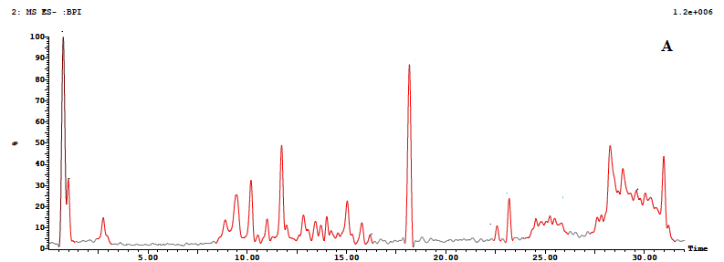
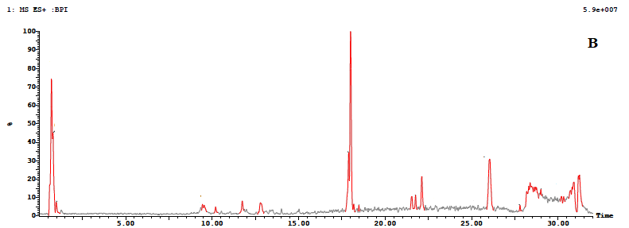

Fig. S1. BPI chromatogram of UPLC/ESI/MS profile of the aqueous extract in the negative (A) and positive (B) modes.
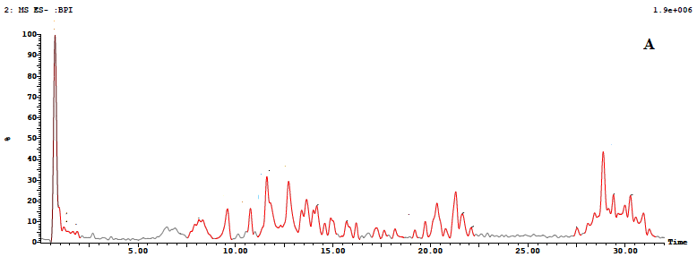
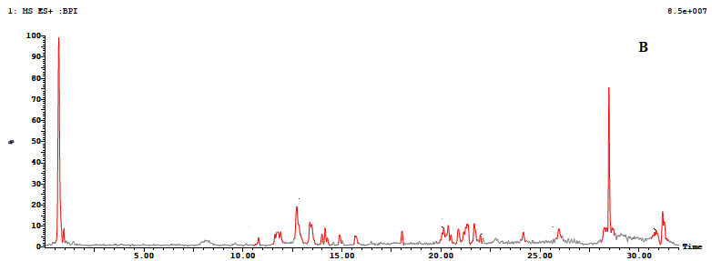

Fig. S2. BPI chromatogram of UPLC/ESI/MS profile of the methanol extract in the negative (A) and positive (B) modes.

Fig. S3. Hydroxyl radical scavenging effect of aqueous extract (AqE) and methanol extract (ME) from S. atropurpurea L. Outcomes are given as mean ± SD (n=3). **p<0.01, ***p<0.001.

Fig. S4. Hydrogen peroxide scavenging effect of aqueous extract (AqE) and methanol extract (ME) from S. atropurpurea L. Results are shown as mean ± SD (n=3). *p<0.05, **p<0.01.

Fig. S5. Analgesic impact of S. atropurpurea, at different concentrations. Values are represented as mean ± SEM (n = 5). ns: no significant difference, **P<0.01, ***P<0.001. AqE: aqueous extract, ME: methanol extract.

Table S1. Total phenolic, flavonoids and condensed tannins content of S. atropurpurea extracts.
Extracts | TPC (µg GAE/mg DE) ª | TFC (µg QE/mg DE) ^{b} | CTC (µg CE/mg DE) ^{c}
AqE | 81.6 ± 1.6 | 45.33 ± 0.36 | 41.04 ± 0.64
ME | 114.13 ± 0.92 | 100.57 ± 0.93 | 26.22 ± 1.11

Data are shown as mean ±SD (n=3). ª Gallic acid equivalent/mg of dried extract, ^{b} Quercetin equivalent/mg of dried extract, ^{c} Catechin equivalent/mg of dried extract.

Table S2. Tentatively identified secondary metabolites from the methanol extract of Scabiosa atropurpurea aerial parts

No. | Compound name | Chemical  Class | Molecular Formula | R_{t}  (min.) | [M-H]⁻  m/z | [M+H] ⁺  m/z | % Composition | MS/MS fragments | Ref.
 |  |  |  |  |  |  | ME. | MS/MS fragments | Ref.
1 | Catechin hexoside | Flavonoid | C₂₁H₂₄O₁₁ | 1.60 | 451 | - | 1.06 | 405, 375, 353, 339, 305, 247, 181 | ^{1,2}
2 | Catechin hexoside isomer | Flavonoid | C₂₁H₂₄O₁₁ | 5.96 | 451 | - | 0.21 | 405, 389, 353, 325, 243, 191 | ^{1,2}
3 | Caffeoyl quinic acid dimer | Cinnamic acid deriv. | C₃₂H₃₆O₁₈ | 7.94 | 707 | 732 | 8.54  (5.62) | 353, 191 | ³
4 | Eustomoside* | Secoiridoid | C₁₆H₂₂O₁₁ | 9.40 | 389 | 401 | 5.76 | 353, 233, 225, 179 | ⁴
5 | Fragment of ursolic acid* | Triterpenoid | ----- | 10.33 | 363 | - | 2.35 | 393, 336, 308, 191, 179 | ⁵
6 | Phloridzin | Dihydrochalcone | C₂₁H₂₄O₁₀ | 10.57 | 435 | 447 | 1.19  (1.12) | 403, 381, 377, 353, 335, 281, 246, 195 | ^{1,4,6}
7 | Tetrahydroxy trimethoxy dihydroxyflavone | Flavonoid | C₁₉H₁₈O₁₀ | 10.79 | 377 | - | 0.52 | 374, 336, 305, 275, 199, 179 | ^{1,7}
8 | Ursolic acid derivative* | Triterpenoid | ----- | 12.64 | 547 | - | 4.50 | 447, 411, 393, 300, 291, 253, 241, 149 | ^{1,8}
9 | di-Caffeoyl quinic acid* | Cinnamic acid deriv. | C₂₅H₂₄O₁₂ | 13.19 | 515 | - | 2.21 | 447, 431, 353, 337, 265, 231, 201, 169 | ^{9,10}
10 | di-Caffeoylquinic acid isomer* | Cinnamic acid deriv. | C₂₅H₂₄O₁₂ | 13.56 | 515 | - | 7.18 | 489, 447, 353, 301, 265, 193, 187, 179, 161 | ^{9,10}
11 | Unknown saponin | Saponin | ----- | 13.88 | 789 | 808 | 4.45  (1.93) | 706, 653, 631, 584, 525, 461, 372, 331, 265, 225, 199, 181, 161 | -
12 | Caffeoyl-succinyl-[(hydroxyphenyl)-acetyl)]-methyl quinate | Phenolic acid | ----- | 14.79 | 629 | - | 1.52 | 587, 520, 458, 421, 373, 285, 201, 187, 179, 161 | ^{1,11}
13 | Diosmetin-hexoside* | Flavonoid | C₂₂H₂₂O₁₁ | 16.05 | 461 | - | 0.30 | 440, 433, 389, 330, 285, 253, 212, 191, 179 | ¹⁰
14 | tri-Galloyl-hexose | Tannin | C₂₇H₂₄O₁₈ | 16.66 | 635 | 637 | 0.45 | 537, 465, 419, 368, 341, 309, 280, 269, 181 | ^{1,12}
15 | Glycosilated dimeric proanthocyanidin | Tannin | ----- | 17.12 | 739 | - | 2.50 | 538, 467, 426, 393, 313, 289, 213, 183, 163 | ¹³
16 | Hypolaetin-allosyl-[acetyl]-hexoside | Flavonoid | ----- | 17.59 | 667 | - | 0.55 | 537, 489, 375, 344, 309, 285, 185, 179 | ^{1,14}
17 | Cirsimaritin* | Dimethoxyflavone | C₁₇H₁₄O₆ | 19.05 | 313 | - | 0.44 | 297, 249, 229, 177, 175 | ^{1,15}
18 | Hederagenin* | Saponin | C₃₀H₄₈O₄ | 19.99 | 471 | 476 | 0.42 | 457, 434, 325, 293, 249, 190 | ¹⁶
19 | Apigenin-rutinoside | Flavonoid | C₂₇H₃₀O₁₄ | 20.70 | 577 | - | 0.06 | 564, 476, 448, 339, 295, 291, 217, 191, 181 | ^{1,15}
20 | alpha-Artemisic acid | Sesquiterpenoid | C₁₈H₃₂O₃ | 21.19 | 295 | 298 | 6.36 | 246, 223, 205, 199, 177, 167, 127 | ¹⁷
21 | Caffeoyl-2-hydroxyethane-1,1,2-tricarboxylic acid | Cinnamic acid deriv. | C₁₄H₁₂O₁₀ | 27.39 | 339 | - | 0.41 | 326, 299, 265, 186, 174 | ¹⁷⁻¹⁹
22 | Caffeic acid-hexouronide | Cinnamic acid deriv. | C₁₅H₁₆O₁₀ | 28.78 | 355 | - | 7.21 | 339, 311, 300, 221, 197, 161, 145 | ^{17,20}
Compounds in bold are the major components. R_{t}; retention time, Ref.; reference(s).
* For compounds previously identified from genus Scabiosa.

Table S3. Tentatively identified secondary metabolites from the aqueous extract of Scabiosa atropurpurea aerial parts

Compounds in bold are the major components. R_{t}; retention time, Ref.; reference(s).
* For compounds previously identified from genus Scabiosa.

No. | Compound name | Chemical  Class | Molecular Formula | R_{t}  (min.) | [M-H]⁻  m/z | [M+H] ⁺  m/z | % Composition | MS/MS fragments | Ref.
 |  |  |  |  |  |  | AqE. | MS/MS fragments | Ref.
1 | Myricetin-(galloyl)-pentoside | Flavonoid | C₂₈H₂₄O₁₇ | 13.32 | 601 | - | 4.48 | 525, 483, 447, 431, 379, 265, 225, 189, 179 | ^{1,7,21}
2 | Protocatechuic acid-hexoside* | Cinnamic acid deriv. | C₁₃H₁₆O₉ | 17.17 | 315 | - | 4.52 | 293, 271, 219, 212, 179, 153 | ²²
3 | Feruloyl-caffeoyl-quinic acid derivative | Cinnamic acid deriv. | ----- | 22.30 | 265 | - | 32.81 | 243, 196, 154, 116 | ^{17,23}
4 | Feruloyl-caffeoyl-quinic acid derivative isomer | Cinnamic acid deriv. | ----- | 22.57 | 265 | - | 4.71 | 249, 203, 194, 178, 156, 123, 117 | ^{17,23}
5 | p-Coumaric acid-hexoside* | Cinnamic acid deriv. | C₁₅H₁₈O₈ | 25.82 | 325 | - | 8.67 | 311, 293, 271, 265, 235, 145 | ²⁴

Table S4. Inhibition percent of protein denaturation by aqueous extract (AqE) and methanol extract (ME) from S. atropurpurea L at different doses. Data are given as mean ± SD (n=3).

[C] mg/mL | % Inhibition
 | AqE | ME
0.5 mg/mL | 61.97 ± 1.35 | 33.60 ± 1.29
0.25 mg/mL | 54.70 ± 0.34 | 25.66 ± 1.36
0.125mg/mL | 37.85 ± 1.76 | 19.06 ± 1.50

Table S5. Anti-inflammatory potential of S. atropurpurea on formalin-induced paw edema. Results are given as mean ± SEM (n=5). ns: no significant difference, *P<0.05, **P<0.01, ***P<0.001. AqE: aqueous extract, ME: methanol extract.
Extracts/  Standard | [C] mg/kg |  |  | Inhibition %
 |  | 30 min | 1h |  | 2h |  |  | 3h
AqE | 25 | 27.29 ± 1.42** | 29.44 ± 1.79*** |  | 30.77 ± 0.84*** |  |  | 32.28 ± 2.37***
AqE | 50 | 32.6 ± 2.7^{ns} | 37.9 ± 3.12^{ns} |  | 46.15 ± 1.66** |  |  | 48.58 ± 2.46***
AqE | 100 | 39.22 ± 2.85^{ns} | 42.26 ± 4.57 ^{ns} |  | 52 ± 2.89 ^{ns} |  |  | 57.91 ± 3.76**
ME | 25 | 34.64 ± 2.31 ^{ns} | 39.87 ± 0.8 ^{ns} |  | 43.46 ± 1.11*** |  |  | 50.65 ± 3.07***
ME | 50 | 37.25 ± 2.29 ^{ns} | 40.2 ± 2.4 ^{ns} |  | 52.94 ± 2.75 ^{ns} |  |  | 55.88 ± 2.37***
ME | 100 | 42.48 ± 1.74 ^{ns} | 43.79 ± 2.35 ^{ns} |  | 54.9 ± 2.17 ^{ns} |  |  | 61.11 ± 1.58*
Diclofenac | 25 | 39.13±2.04 | 44.35±3.64 |  | 60±2.79 |  |  | 70.25±3.52

Table S6. Binding interactions of the major compounds with cyclooxygenase-2 (5F19)
Compound name | Score Kcal/mol | Hydrophobic | Hydrogen bond | π-stacking | π-cation | Salt bridge
Loganic acid | -7.6 | VAL 447 | THR 206 | - | - | HIS 207
Loganic acid | -7.6 | VAL 447 | HIS 207 | - | - | HIS 207
Loganic acid | -7.6 | VAL 447 | ASN 382 | - | - | HIS 386
Loganic acid | -7.6 | VAL 447 | ASN 382 | - | - | HIS 386
Loganic acid | -7.6 | VAL 447 | GLN 454 | - | - | HIS 388
 |  |  |  |  |  | HIS 388
Chlorogenic acid | -9.5 | GLN 203 | ALA 199 | - | - | HIS 207
Chlorogenic acid | -9.5 | GLN 203 | PHE 210 | - | - | HIS 207
Chlorogenic acid | -9.5 | LEU 391 | THR 212 | - | - | HIS 214
Chlorogenic acid | -9.5 | LEU 391 | HIS 214 | - | - | HIS 386
Chlorogenic acid | -9.5 | LEU 391 | ASN 382 | - | - | HIS 388
Chlorogenic acid | -9.5 | LEU 391 | HIS 386 | - | - | HIS 388
Chlorogenic acid | -9.5 | LEU 391 | HIS 386 | - | - | HIS 388
Luteolin hexoside | -9.7 | GLN 203 | ALA 199 | HIS 207 | HIS 388 | HIS 207
Luteolin hexoside | -9.7 | GLN 203 | HIS 214 | HIS 207 | HIS 388 | HIS 214
Luteolin hexoside | -9.7 | LEU 391 | ASN 382 | HIS 207 | HIS 388 | HIS 214
Caffeoyl quinic acid dimer | -9.4 | GLN 203 | ALA 199 | - | - | HIS 207
Caffeoyl quinic acid dimer | -9.4 | PHE 210 | ALA 202 | - | - | HIS 207
Caffeoyl quinic acid dimer | -9.4 | PHE 210 | GLN 203 | - | - | HIS 386
Caffeoyl quinic acid dimer | -9.4 | VAL 291 | GLN 203 | - | - | HIS 388
Caffeoyl quinic acid dimer | -9.4 | LEU 294 | HIS 214 | - | - | HIS 388
Caffeoyl quinic acid dimer | -9.4 | TRP 387 | TRP 387 | - | - | HIS 388
Caffeoyl quinic acid dimer | -9.4 | ILE 408 | HIS 388 | - | - | HIS 388
Caffeoyl quinic acid dimer | -9.4 | VAL 447
Eustomoside | -8.1 | - | THR 206 | - | - | HIS 207
Eustomoside | -8.1 | - | TYR 385 | - | - | HIS 207
Eustomoside | -8.1 | - | TYR 385 | - | - | HIS 214
Eustomoside | -8.1 | - | TRP 387 | - | - | HIS 386
Eustomoside | -8.1 | - | HIS 388 | - | - | HIS 386
Eustomoside | -8.1 | - | GLN 454 | - | - | HIS 388
 |  |  |  |  |  | HIS 388
Apigenin-hexoside | -9.9 | VAL 295 | HIS 207 | HIS 207 | - | HIS 207
Apigenin-hexoside | -9.9 | LEU 391 | ASN 382 | HIS 207 | - | HIS 386
Apigenin-hexoside | -9.9 | LEU 391 | ASN 382 | HIS 207 | - | HIS 388
Apigenin-hexoside | -9.9 | LEU 391 | TYR 385 | HIS 207 | - | HIS 388
Apigenin-hexoside | -9.9 | LEU 391 | HIS 386 | HIS 207 | - | HIS 388
Apigenin-hexoside | -9.9 | LEU 391 | TRP 387 | HIS 207 | - | HIS 388
Derivative of syringaldehyde | -7.2 | GLN 203 | HIS 207 | - | HIS 207 | -
Derivative of syringaldehyde | -7.2 | GLN 203 | TYR 385 | - | HIS 207 | -
Derivative of syringaldehyde | -7.2 | GLN 203 | HIS 388 | - | HIS 207 | -
Table S6. Binding interactions of the major compounds with cyclooxygenase-2 (5F19) (Cont.)
Compound name | Score  Kcal/mol | Hydrophobic | Hydrogen bond | π-stacking | π-cation | Salt bridge
Ursolic acid | -8.5 | LEU 145 | ARG 376 | - | - | -
Ursolic acid | -8.5 | ASP 229 | ARG 376 | - | - | -
Ursolic acid | -8.5 | ILE 337
Ursolic acid | -8.5 | VAL 538
Ursolic acid | -8.5 | VAL 538
di-caffeoylquinic acid | -10.1 | HIS 388 | GLN 203 | HIS 388 | - | HIS 207
di-caffeoylquinic acid | -10.1 | LEU 391 | HIS 207 | HIS 388 | - | HIS 386
di-caffeoylquinic acid | -10.1 | VAL 444 | PHE 210 | HIS 388 | - | HIS 386
di-caffeoylquinic acid | -10.1 | VAL 444 | THR 212 | HIS 388 | - | HIS 388
di-caffeoylquinic acid | -10.1 | VAL 444 | HIS 214 | HIS 388 | - | HIS 388
di-caffeoylquinic acid | -10.1 | VAL 444 | ASN 382 | HIS 388 | - | HIS 388
Protocatechuic acid-hexoside | -8.2 | GLN 203 | ALA 199 | HIS 388 | - | HIS 207
Protocatechuic acid-hexoside | -8.2 | GLN 203 | HIS 207 | HIS 388 | - | HIS 386
Protocatechuic acid-hexoside | -8.2 | GLN 203 | HIS 214 | HIS 388 | - | HIS 388
Protocatechuic acid-hexoside | -8.2 | GLN 203 | ASN 382 | HIS 388 | - | HIS 388
Protocatechuic acid-hexoside | -8.2 | GLN 203 | ASN 382 | HIS 388 | - | HIS 388
Protocatechuic acid-hexoside | -8.2 | GLN 203 | TYR 385 | HIS 388 | - | HIS 388
Protocatechuic acid-hexoside | -8.2 | GLN 203 | HIS 386 | HIS 388 | - | HIS 388
Caftaric acid | -8.6 | ALA 202 | GLN 203 | - | - | HIS 207
Caftaric acid | -8.6 | GLN 203 | PHE 210 | - | - | HIS 207
Caftaric acid | -8.6 | GLN 203 | THR 212 | - | - | HIS 214
Caftaric acid | -8.6 | GLN 203 | ASN 382 | - | - | HIS 386
 |  |  |  |  |  | HIS 386
 |  |  |  |  |  | HIS 386
 |  |  |  |  |  | HIS 388
Hydroxy-octadecatrienoic acid | -6.9 | ALA 202 | HIS 207 | - | - | HIS 214
Hydroxy-octadecatrienoic acid | -6.9 | TYR 385 | HIS 388 | - | - | HIS 386
Hydroxy-octadecatrienoic acid | -6.9 | TRP 387 | HIS 388 | - | - | HIS 386
Hydroxy-octadecatrienoic acid | -6.9 | LEU 390 | GLN 454 | - | - | HIS 386
Hydroxy-octadecatrienoic acid | -6.9 | LEU 391 | GLN 454 | - | - | HIS 386
p-coumaric acid-hexoside | -9.2 | PHE 210 | GLN 203 | HIS 386 | HIS 207 | HIS 207
p-coumaric acid-hexoside | -9.2 | PHE 210 | THR 212 | HIS 386 | HIS 207 | HIS 214
p-coumaric acid-hexoside | -9.2 | PHE 210 | THR 212 | HIS 386 | HIS 207 | HIS 388
p-coumaric acid-hexoside | -9.2 | PHE 210 | ASN 382 | HIS 386 | HIS 207 | HIS 388
p-coumaric acid-hexoside | -9.2 | PHE 210 | TRP 387 | HIS 386 | HIS 207 | HIS 388
p-coumaric acid-hexoside | -9.2 | PHE 210 | HIS 388 | HIS 386 | HIS 207 | HIS 388
Caffeic acid-hexouronide | -8.9 | PHE 210 | GLN 203 | HIS 386 | HIS 207 | HIS 214
Caffeic acid-hexouronide | -8.9 | PHE 210 | THR 206 | HIS 386 | HIS 207 | HIS 388
Caffeic acid-hexouronide | -8.9 | PHE 210 | HIS 207 | HIS 386 | HIS 207 | HIS 388

Table S6. Binding interactions of the major compounds with cyclooxygenase-2 (5F19) (Cont.)
Compound name | Score  Kcal/mol | Hydrophobic | Hydrogen bond | π-stacking | π-cation | Salt bridge
Caffeic acid-hexouronide (Cont.) | - | - | THR 212 | - | - | -
Caffeic acid-hexouronide (Cont.) | - | - | THR 212 | - | - | -
Caffeic acid-hexouronide (Cont.) | - | - | ASN 382 | - | - | -
Caffeic acid-hexouronide (Cont.) | - | - | TYR 385 | - | - | -
Caffeic acid-hexouronide (Cont.) | - | - | TRP 387 | - | - | -
Caffeic acid-hexouronide (Cont.) | - | - | TRP 387 | - | - | -
Diclofenac (Standard) | -7.9 | ALA 202 | ASN 382 | HIS 207 | HIS 388 | HIS 207
Diclofenac (Standard) | -7.9 | GLN 203 | HIS 388 | HIS 207 | HIS 388 | HIS 386
Diclofenac (Standard) | -7.9 | LEU 390

References
1 Nilofar et al. Exploring the chemical composition and biological effects of four Salvia hybrids: an innovative perspective on functional yields. eFood 5, e70012 (2024).
2 Kang, J., Price, W. E., Ashton, J., Tapsell, L. C. & Johnson, S. Identification and characterization of phenolic compounds in hydromethanolic extracts of sorghum wholegrains by LC-ESI-MSn. Food chemistry 211, 215-226 (2016).
3 Morsi, E. A., Abdel-Hameed, E.-S., El-Sayed, M. M. & Rabia, I. A. HPLC-ESI-MS characterization of certain compounds of methanolic extract of Nerium oleander and its fractions as well as evaluation of their potential against Schistosomiasis mansoni. Egyptian Journal of Chemistry 65, 133-143 (2022).
4 Kılınc, H. et al. Scabiosa atropurpurea: A rich source of iridoids with α-glucosidase inhibitory activity evaluated by in vitro and in silico studies. Phytochemistry 205, 113471 (2023).
5 Mostafa, S. F., Abdou, R. M., El-Tanbouly, N. D. & El-sayed, A. M. Metabolites Proﬁling of Pouteria Campechiana (Kunth) Baehni Different Organs Using UPLC-PDA-MS and its Biological Activities. Egyptian Journal of Chemistry 66, 167-176 (2023).
6 Hossain, M. B., Rai, D. K., Brunton, N. P., Martin-Diana, A. B. & Barry-Ryan, C. Characterization of phenolic composition in Lamiaceae spices by LC-ESI-MS/MS. Journal of agricultural and food chemistry 58, 10576-10581 (2010).
7 Elhawary, E., Mostafa, N., Shehata, A. & Labib, R. Comparative study of selected Rosa varieties’ metabolites through UPLC-ESI-MS/MS, chemometrics and investigation of their insecticidal activity against Culex pipiens L. Jordan Journal of Pharmaceutical Sciences 14 (2021).
8 Abdelaziz, S. et al. Ultra performance liquid chromatography-tandem mass spectrometeric analysis of ethyl acetate fraction from saudi Lavandula coronopifolia Poir and evaluation of its cytotoxic and antioxidant activities. Journal of Herbmed Pharmacology 9, 268-276 (2020).
9 Kılınç, H. Isolation and characterization of secondary metabolites from apolar fraction of Scabiosa sicula and evaluation of their antioxidant activities. Gümüşhane Üniversitesi Fen Bilimleri Dergisi 11, 934-942 (2021).
10 Ben Toumia, I. et al. A methanol extract of Scabiosa atropurpurea enhances doxorubicin cytotoxicity against resistant colorectal Cancer cells in vitro. Molecules 25, 5265 (2020).
11 Brito, A., Ramirez, J. E., Areche, C., Sepulveda, B. & Simirgiotis, M. J. HPLC-UV-MS profiles of phenolic compounds and antioxidant activity of fruits from three citrus species consumed in Northern Chile. Molecules 19, 17400-17421, doi:10.3390/molecules191117400 (2014).
12 Mekam, P. N., Martini, S., Nguefack, J., Tagliazucchi, D. & Stefani, E. Phenolic compounds profile of water and ethanol extracts of Euphorbia hirta L. leaves showing antioxidant and antifungal properties. South African Journal of Botany 127, 319-332 (2019).
13 Maldini, M., Montoro, P., Piacente, S. & Pizza, C. ESI-MS, ESI-MS/MS fingerprint and LC-ESI-MS analysis of proathocyanidins from Bursera simaruba Sarg bark. Natural Product Communications 4, 1934578X0900401212 (2009).
14 Petreska, J. et al. Phenolic compounds of mountain tea from the Balkans: LC/DAD/ESI/MSn profile and content. Natural product communications 6, 1934578X1100600107 (2011).
15 Gkioni, M. D., Zeliou, K., Dimaki, V. D., Trigas, P. & Lamari, F. N. GC-MS and LC-DAD-MS Phytochemical Profiling for Characterization of Three Native Salvia Taxa from Eastern Mediterranean with Antiglycation Properties. Molecules 28, 93 (2022).
16 Skała, E. & Szopa, A. Dipsacus and Scabiosa Species—The Source of Specialized Metabolites with High Biological Relevance: A Review. Molecules 28, 3754 (2023).
17 Yagi, S. et al. Functional constituents of Colchicum lingulatum Boiss. & Spruner subsp. rigescens K. Perss. extracts and their biological activities with different perspectives. Food Bioscience, 104496 (2024).
18 Ben Said, R. et al. Tentative characterization of polyphenolic compounds in the male flowers of Phoenix dactylifera by liquid chromatography coupled with mass spectrometry and DFT. International journal of molecular sciences 18, 512 (2017).
19 Ye, M., Guo, D., Ye, G. & Huang, C. Analysis of homoisoflavonoids in Ophiopogon japonicus by HPLC-DAD-ESI-MS. Journal of the American Society for Mass Spectrometry 16, 234-243 (2005).
20 Zhong, B. et al. LC-ESI-QTOF-MS/MS characterization of seaweed phenolics and their antioxidant potential. Marine drugs 18, 331 (2020).
21 Saldanha, L. L., Vilegas, W. & Dokkedal, A. L. Characterization of flavonoids and phenolic acids in Myrcia bella cambess. Using FIA-ESI-IT-MSn and HPLC-PAD-ESI-IT-MS combined with NMR. Molecules 18, 8402-8416 (2013).
22 Akar, Z. Chemical compositions by using LC–MS/MS and GC–MS and antioxidant activities of methanolic extracts from leaf and flower parts of Scabiosa columbaria subsp. columbaria var. columbaria L. Saudi journal of biological sciences 28, 6639-6644 (2021).
23 Simirgiotis, M. J., Benites, J., Areche, C. & Sepulveda, B. Antioxidant Capacities and Analysis of Phenolic Compounds in Three Endemic Nolana Species by HPLC-PDA-ESI-MS. Molecules 20, 11490-11507, doi:10.3390/molecules200611490 (2015).
24 Corradi, E., De Mieri, M., Gafner, F., Hamburger, M. & Potterat, O. A new secoiridoid glucoside, and a metabolite profile of Scabiosa lucida. Natural Product Communications 11, 1934578X1601100705 (2016).

