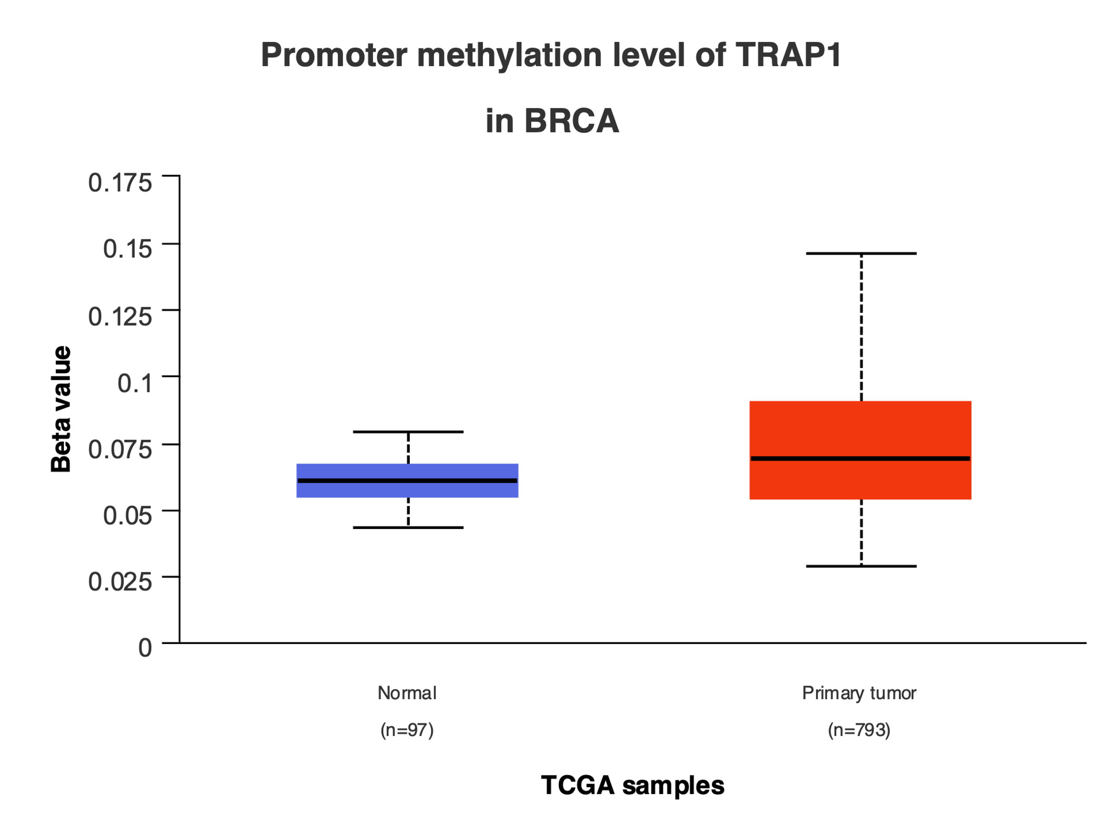
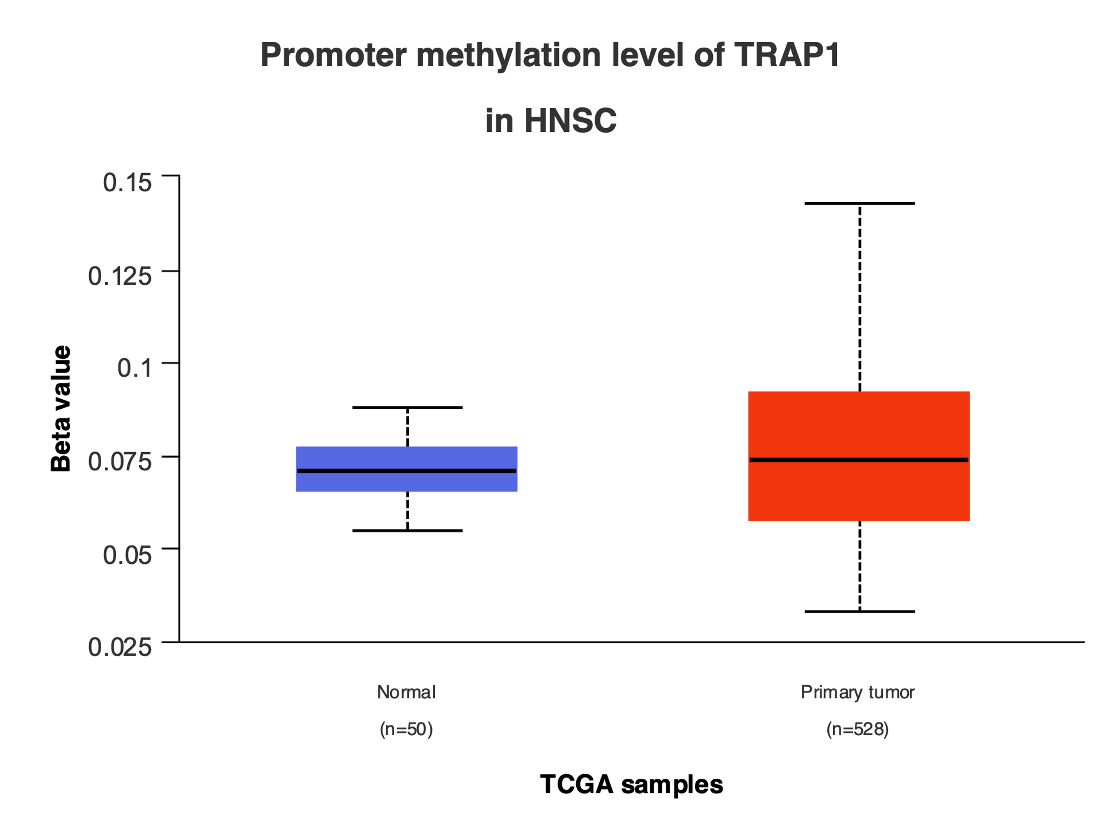
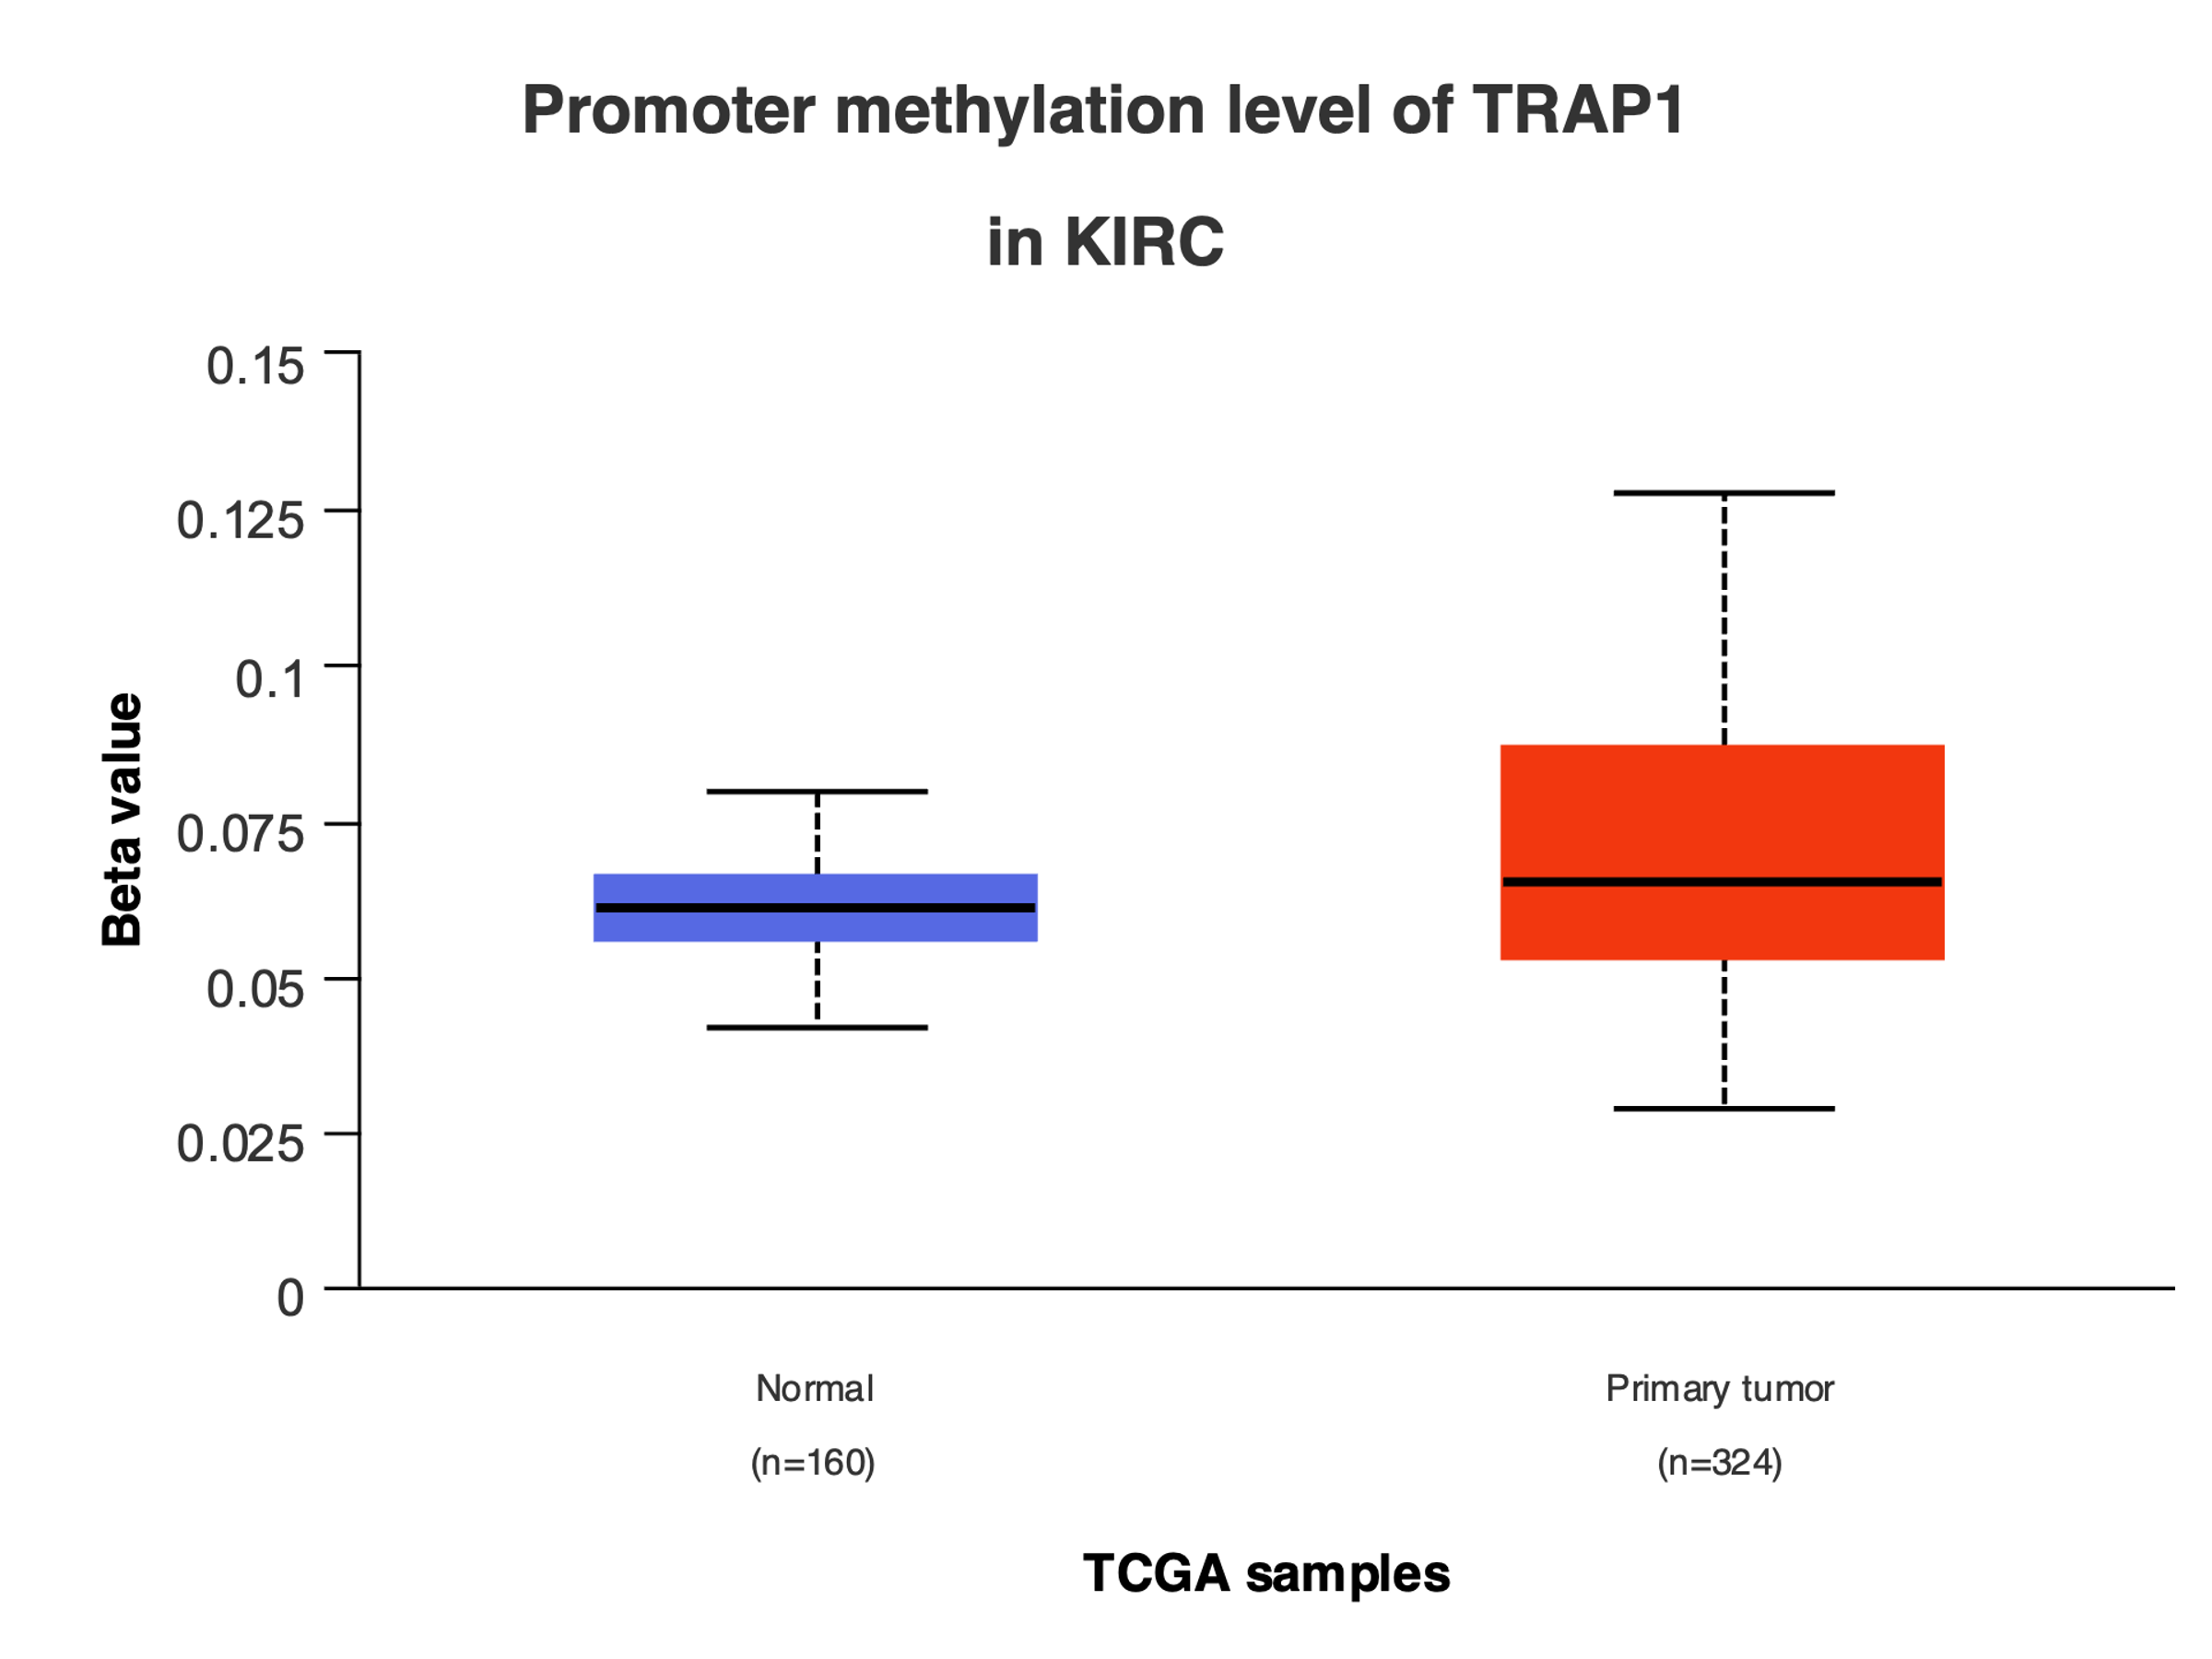
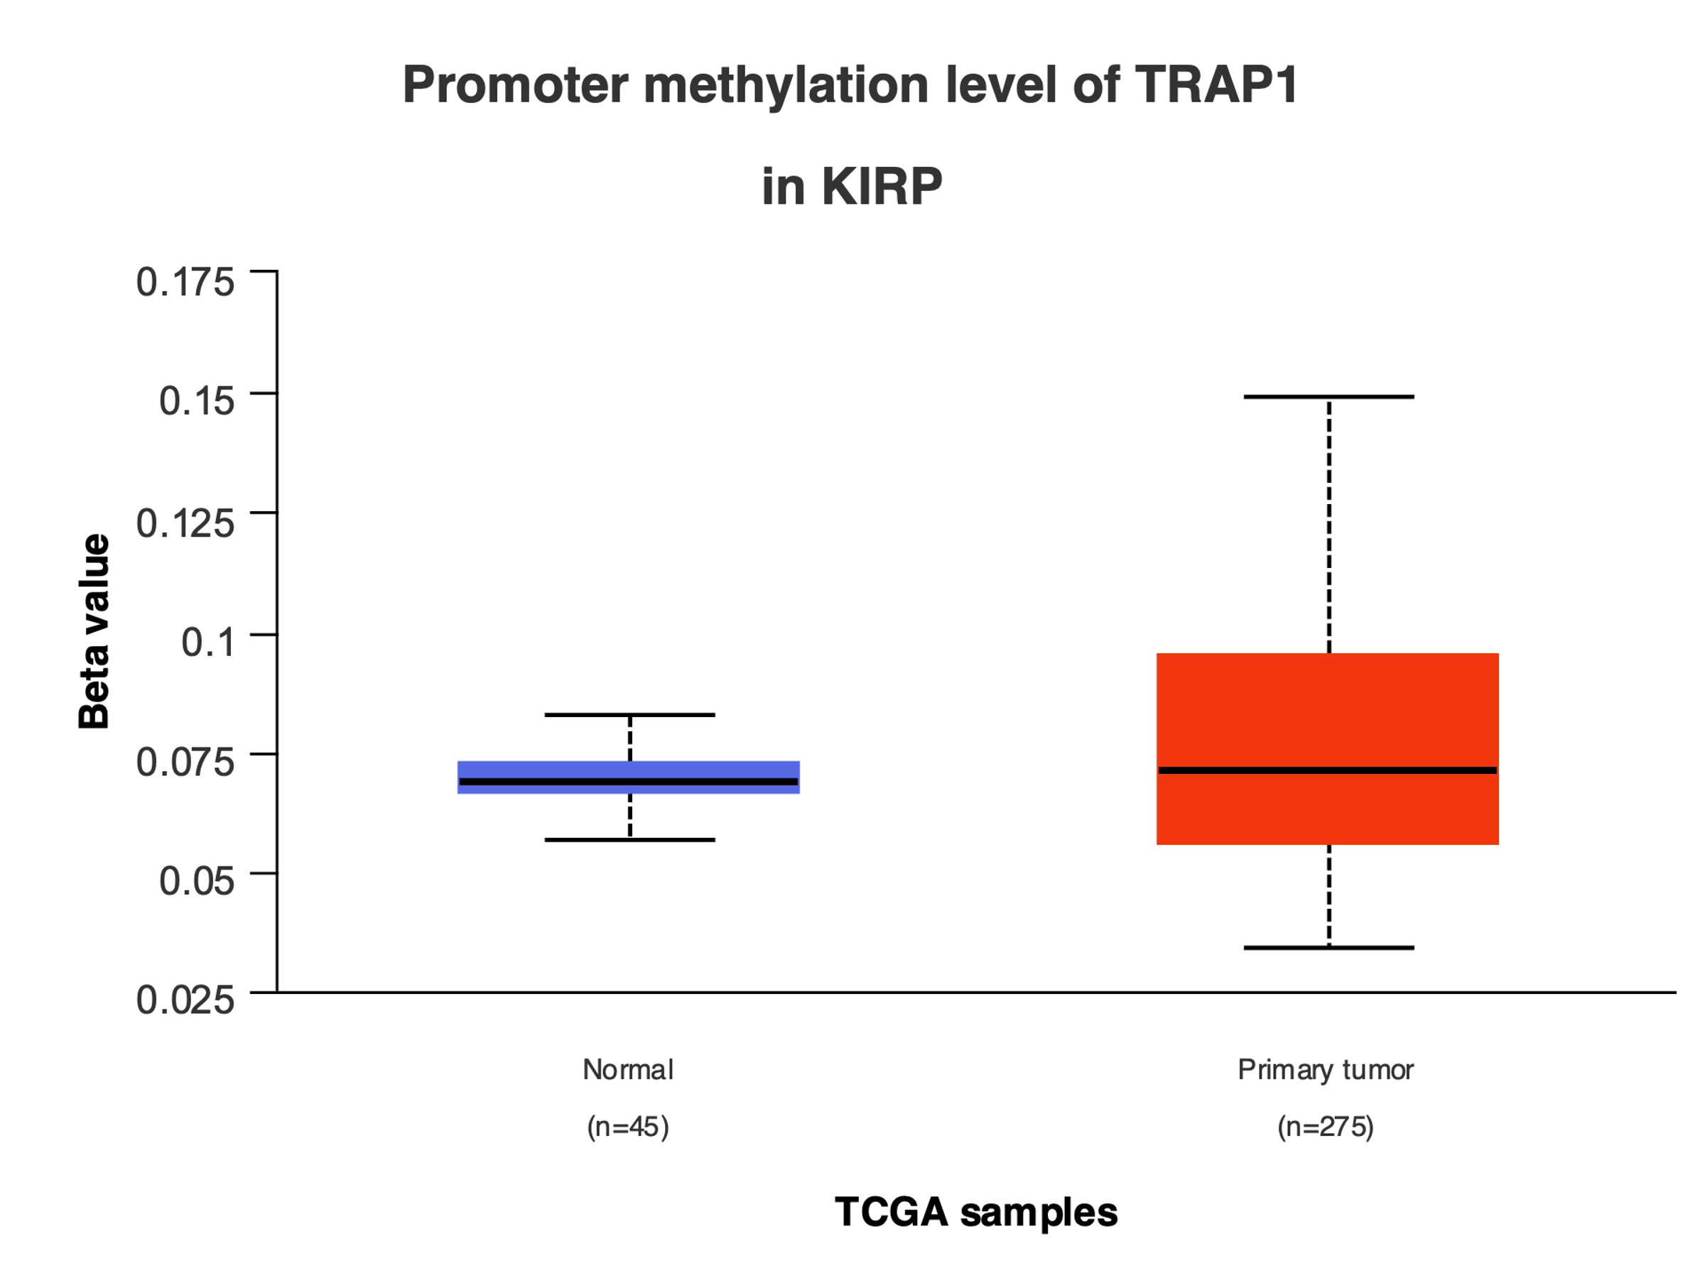
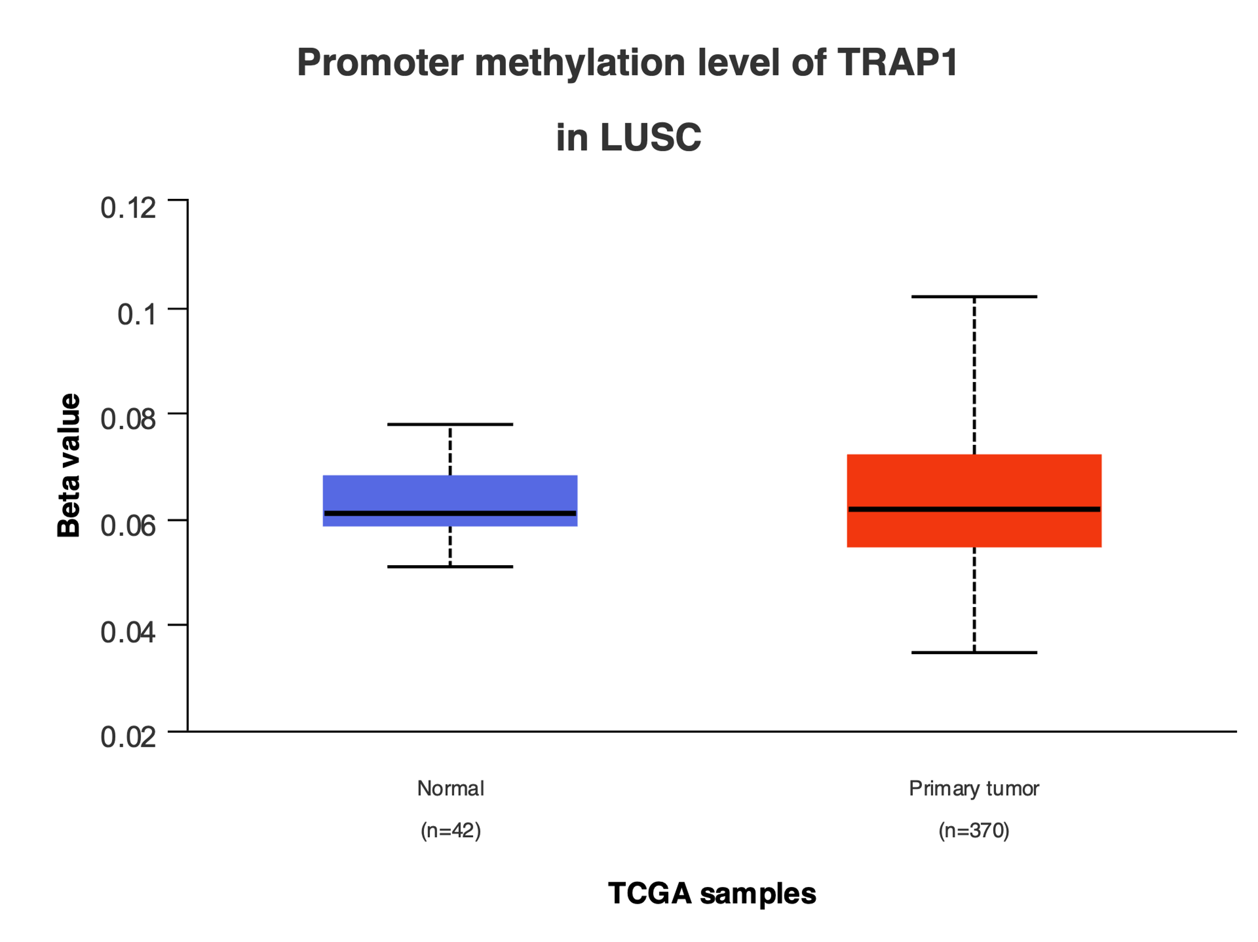
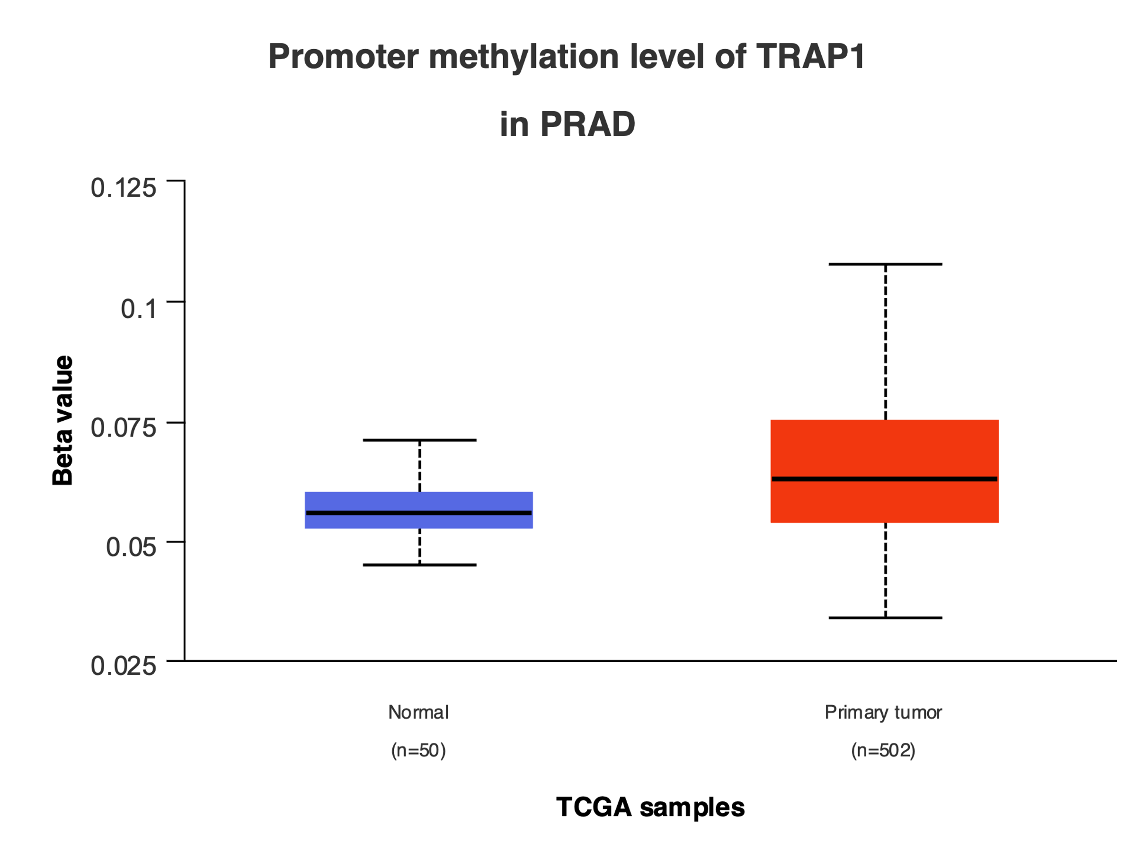
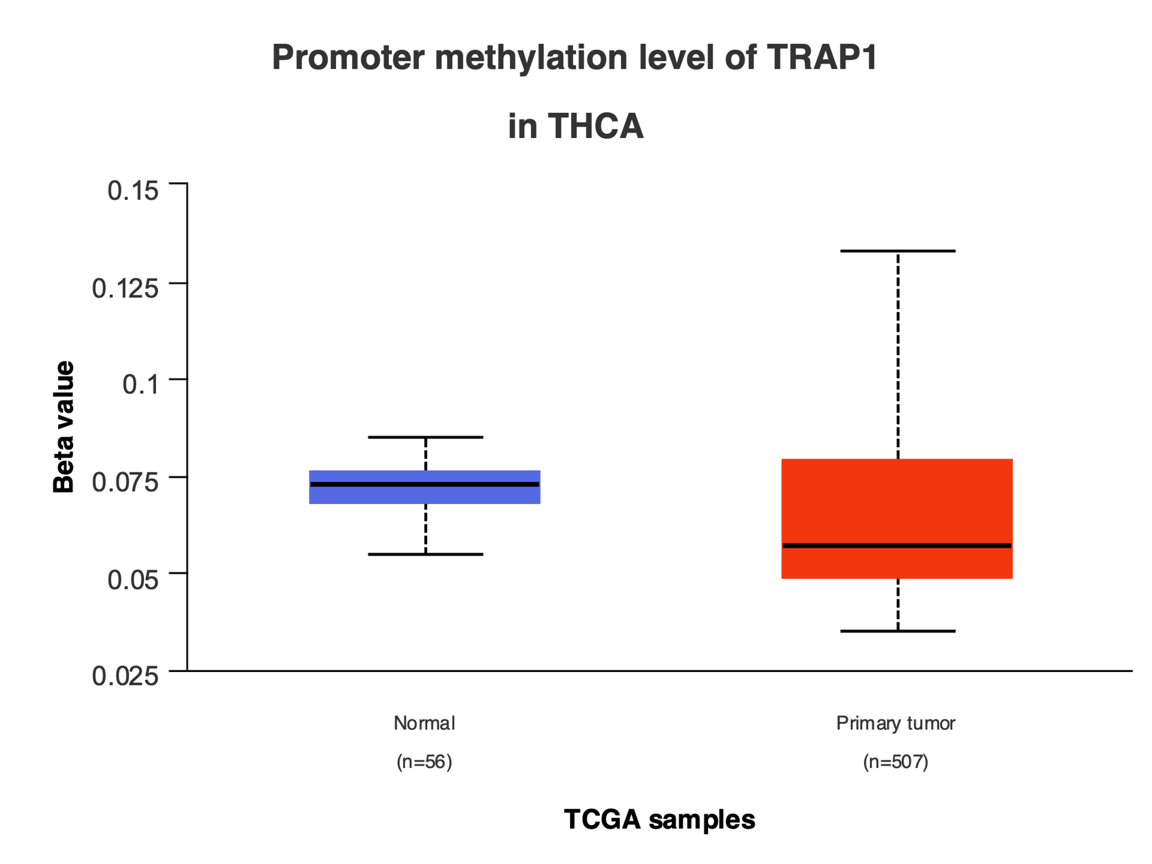
A box plot showing the levels of TRAP1 DNA methylation in tumor and normal tissues, where red denotes tumor tissues and blue denotes normal tissues.
p=6.828e-08
p=1.825e-04
p=2.277e-11
p=7.174e-04
p=9.738e-03
p=1.988e-09
p=1.242e-02

