Epigenetic Rewiring Connects Aging to Alzheimer’s Pathology in the Human Prefrontal Cortex

Supplementary Figure

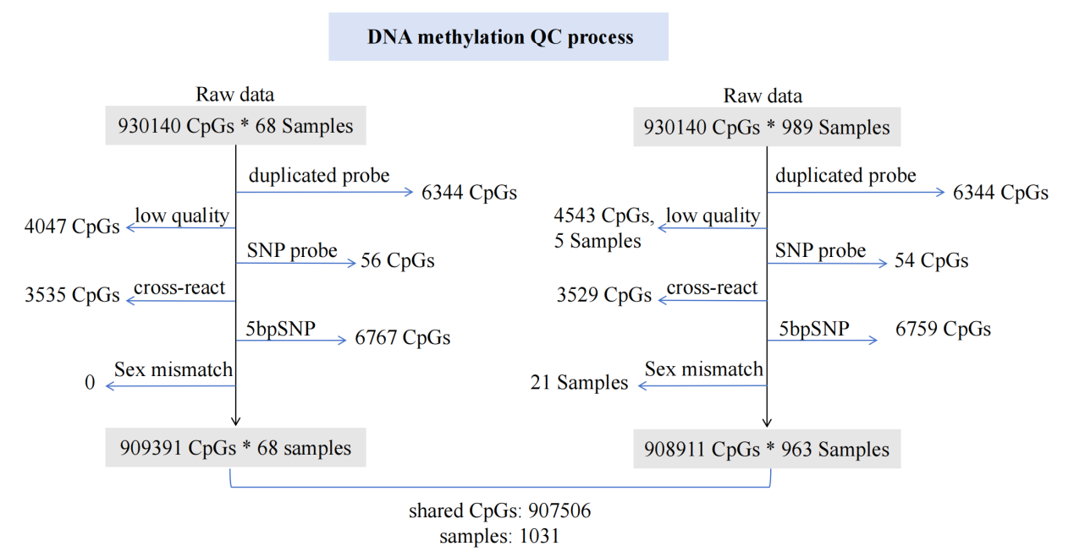
Extended Data Fig. 1. DNA methylation quality control and filtering. 907,506 CpG sites from 1,031 samples passed quality checks and were retained in downstream analyses.

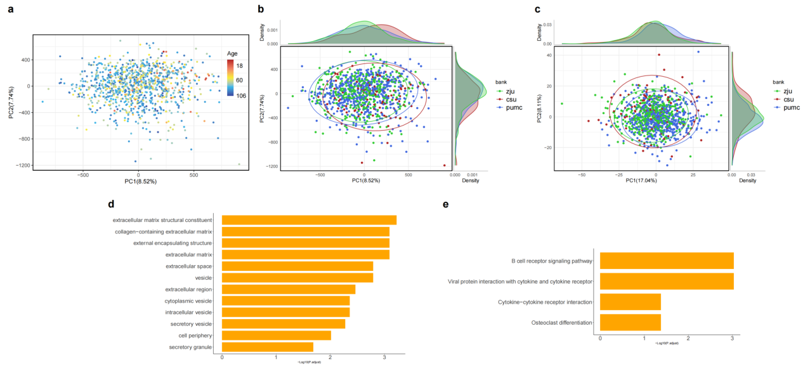
Extended Data Fig. 2. PCA of methylation data and functional enrichment analysis (GO/KEGG) of genes linked to methylation differences between northern and southern regions. a, PCA of methylation data across age; b, PCA of methylation data across regions; c, PCA of the most differentially methylated CpGs between northern and southern China. d, GO terms enriched in genes linked to differentially methylated CpGs between northern and southern China. e, KEGG pathways enriched in genes linked to differentially methylated CpGs between northern and southern China.

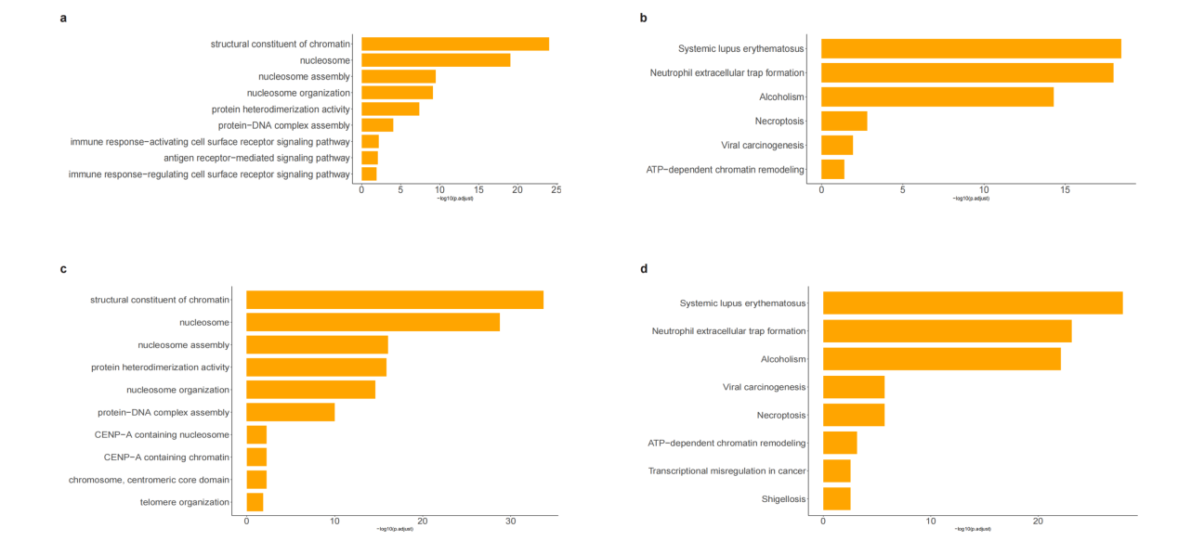
Extended Data Fig. 3. Functional enrichment analysis (GO/KEGG) of genes linked to PFC-shared and PFC-specific CpGs. a, PFC-shared GO terms; b, PFC-shared KEGG pathways; c, PFC-specific GO terms; d, PFC-specific KEGG pathways.

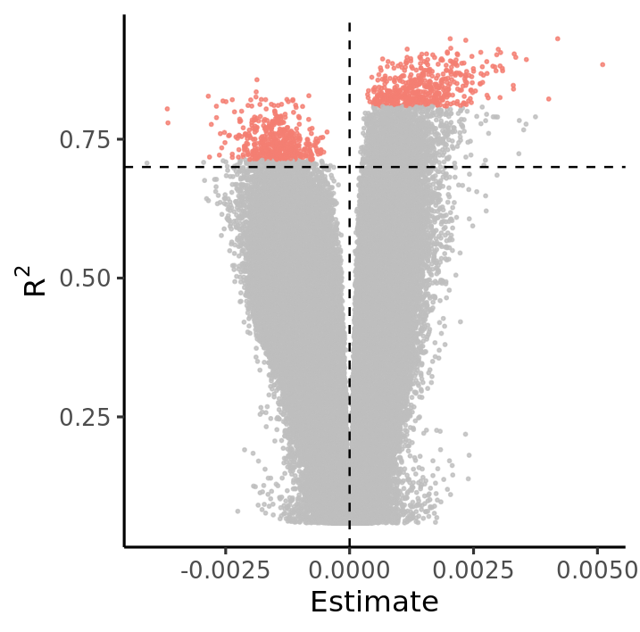
Extended Data Fig. 4. Scatter plot of DNA methylation-age associations. The x-axis represents the regression coefficient for the linear relationship between methylation levels and age at each CpG site. The y-axis shows the coefficient of determination (R²) from the regression model. Dashed lines indicate thresholds: x = 0 and y = 0.7 (high variance explained). Red highlights denote the top 500 CpG sites with the smallest P-values, stratified by positive and negative coefficients. These selected sites were prioritized for downstream analysis due to their strong age-related methylation signals.

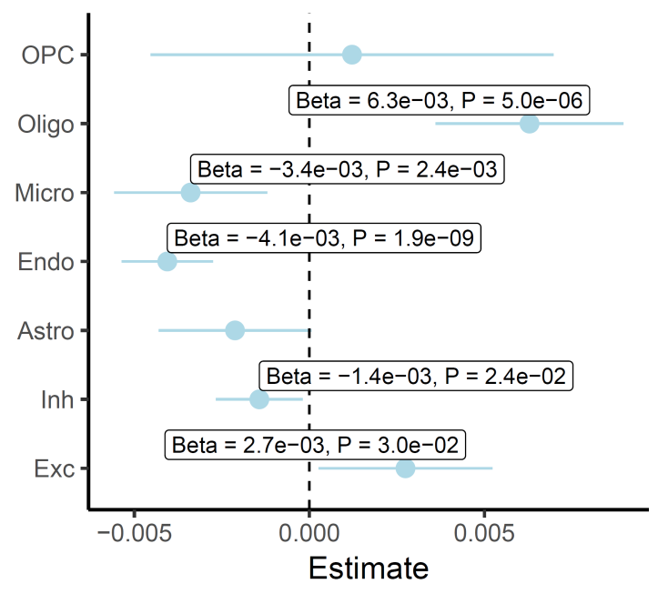
Extended Data Fig. 5. Associations between MethAge and estimated cell-type proportions in ROSMAP.

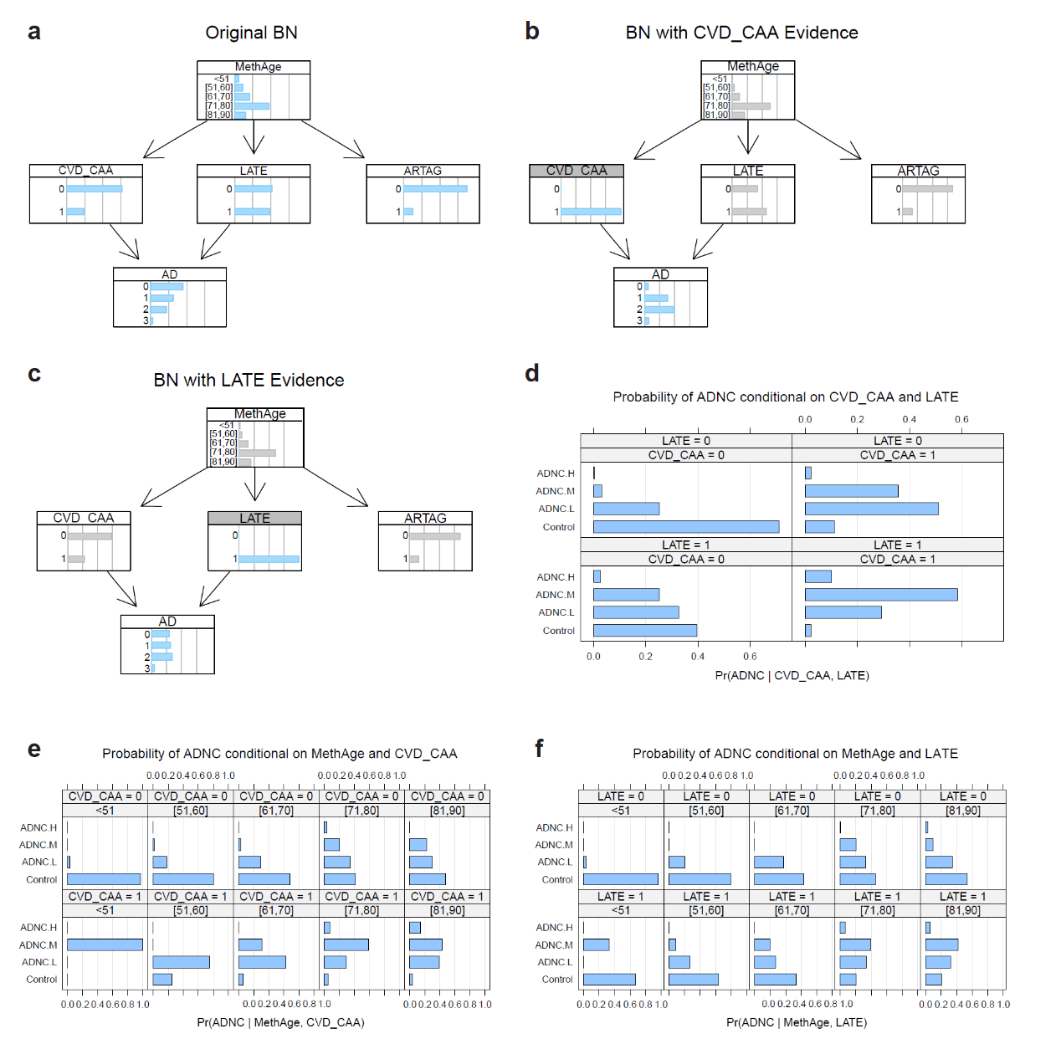
Extended Data Fig. 6. Bayesian network analysis of conditional dependencies between MethAge, ADNC, and neuropathological variables. a, The original Bayesian network (BN) structure with MethAge as the upstream variable and ADNC as the primary outcome. b, The Bayesian network incorporating cerebral amyloid angiopathy (CVD_CAA) evidence. c, The Bayesian network with limbic-predominant age-related TDP-43 encephalopathy (LATE) evidence. d, Conditional probabilities of ADNC given CVD_CAA and LATE, showing the distribution of probabilities across different ADNC groups under varying CVD_CAA and LATE conditions. e, Conditional probabilities of ADNC given MethAge and CVD_CAA, stratified by MethAge groups (<51, [51.60], [61.70], [71.80], [81.90]). f, Conditional probabilities of ADNC given MethAge and LATE, further stratified by MethAge groups.

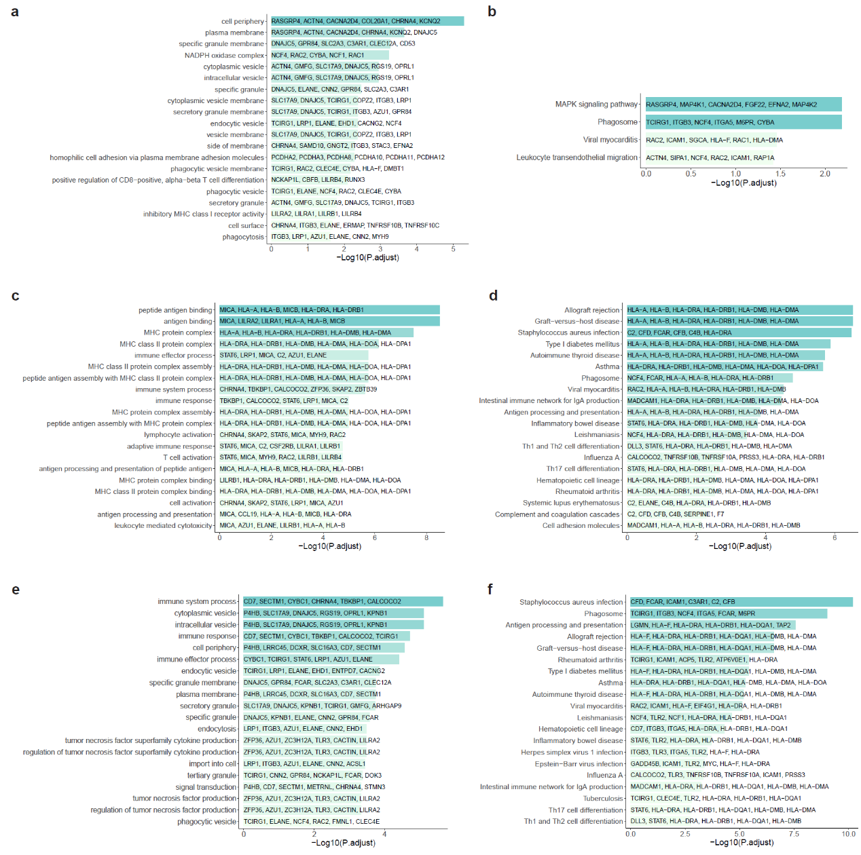
Extended Data Fig. 7. Functional enrichment analysis (GO/KEGG) of genes linked to AD pathology-related CpGs. a, ADNC-associated GO terms; b, ADNC-associated KEGG pathways; c, Braak-associated GO terms; d, Braak-associated KEGG pathways; e, Aβ-associated GO terms; f, Aβ-associated KEGG pathways. Top 20 terms most significant shown per panel; darker bars indicate lower P-values.
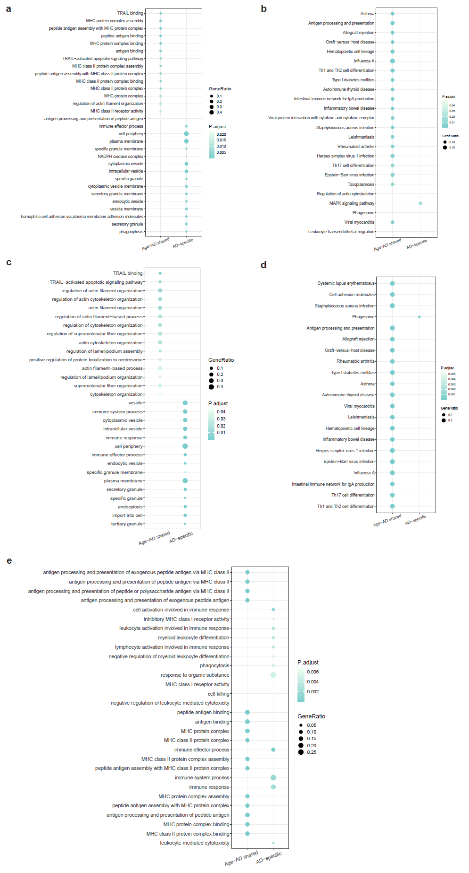
Extended Data Fig. 8. Functional enrichment analysis (GO/KEGG) of genes linked to CpG sites associated with age and Alzheimer’s disease neuropathology. a–e, Bubble plots showing Gene Ontology (GO) and KEGG pathway enrichment results for CpG sites associated with Alzheimer’s disease–related neuropathological traits. In each panel, the x-axis distinguishes CpG sites associated with both age and neuropathology (left column) from those associated exclusively with neuropathological features (right column), including ADNC level, Braak NFT stage, or A score. a, GO enrichment for CpG sites associated with ADNC. b, KEGG enrichment for CpG sites associated with ADNC. c, GO enrichment for CpG sites associated with A score. d, KEGG enrichment for CpG sites associated with A score. e, GO enrichment for CpG sites associated with Braak NFT stage.

