Modulation of immunological responses by aqueous extract of Datura stramonium L. seeds on cyclophosphamide-induced immunosuppression in Wistar rats
Parker Elijah Joshua ª, Junaidu Yahaya ^{a, b}, Daniel Emmanuel Ekpo ª, Joyce Oloaigbe Ogidigio ^{a, c}, Arome Solomon Odiba ^{d, e, f}, Rita Onyekachukwu Asomadu ª, Samson Ayodeji Oka ^{a, g}, and Olasupo Stephen Adeniyi ^{h}

ª Department of Biochemistry, Faculty of Biological Sciences, University of Nigeria, 410001, Nsukka, Enugu State, Nigeria.
^{b} Department of Human Physiology, Faculty of Basic Medical Sciences, Colleges of Health Sciences, Kogi State University, P.M.B. 1008, Anyigba, Kogi State, Nigeria.
^{c} Bioresources Development Centre, National Biotechnology Development Agency (NABDA), Federal Capital Territory, Abuja, Nigeria.
^{d} Department of Molecular Genetics and Biotechnology, Faculty of Biological Sciences, University of Nigeria, 410001, Nsukka, Enugu State, Nigeria.
^{e} Department of Biochemistry, College of Life Science and Technology, Guangxi University, 530007, Nanning, People’s Republic of China.
^{f} National Engineering Research Centre for Non-Food Biorefinery, Guangxi Academy of Sciences, 530007, Nanning, People’s Republic of China.
^{g} Department of Medical Biochemistry, Faculty of Basic Medical Sciences, Colleges of Health Sciences, Kogi State University, P.M.B. 1008, Anyigba, Kogi State, Nigeria.
^{h} Department of Physiology, Faculty of Basic & Allied Medical Sciences, Benue State University, Benue State, Nigeria.

Corresponding author:
Daniel Emmanuel Ekpo
ekpodaniele@gmail.com; daniel.ekpo.pg67714@unn.edu.ng
Department of Biochemistry, Faculty of Biological Sciences, University of Nigeria, 410001, Nsukka, Enugu State, Federal Republic of Nigeria.
https//orcid.org/0000-0001-9201-8811

Co-authors e-mail and ORCID
Parker Elijah Joshua Junaidu Yahaya
parker.joshua@unn.edu.ng yayajunaidu@gmail.com
http://orcid.org/0000-0002-1837-0312
Joyce Oloaigbe Ogidigo Arome Solomon Odiba
jogidigo@yahoo.com arome.odiba@unn.edu.ng
https//orcid.org/0000-0003-3323-0657

Rita Onyekachukwu Asomadu Samson Ayodeji Oka
rita.asomadu@unn.edu.ng samson.oa@ksu.edu.ng
http://orcid.org/0000-00022424-1488 http://orcid.org/0000-0002-4269-1562
Olasupo Stephen Adeniyi
supoadeniyi@yahoo.com
http://orcid.org/0000-0001-5648-441X

Table 4 Effect of ASEDS on immunoglobulin A, G and M levels of cyclophosphamide-induced immunosuppression in rats
Groups | Treatments | IgA (mg/dl) | IgG (mg/dl) | IgM (mg/dl)
1 | Normal control (distilled water) | 185.72 ± 3.88 ª | 931.60 ± 18.26 ª | 154.99 ± 3.59 ª
2 | Negative control (IMSD) | 174.03 ± 5.24 ^{e} | 875.58 ± 19.53 ^{e} | 149.80 ± 6.06 ª
3 | IMSD + 5 mg/kg b.w. Levamisole | 226.78 ± 5.25 ^{b} | 1007.59 ± 42.10 ª | 198.82 ± 24.28 ^{b}
4 | IMSD + 60 mg/kg b.w. ASEDS | 306.63 ± 9.23 ^{c} | 1339.83 ± 32.31 ^{b} | 221.61 ± 4.48 ^{c}
5 | IMSD + 90 mg/kg b.w. ASEDS | 261.30 ± 6.54 ^{d} | 1491.16 ± 26.35 ^{b} | 259.94 ± 31.68 ^{c}
6 | IMSD + 120 mg/kg b.w. AESDS | 267.26 ± 6.78 ^{d} | 1396.52 ± 52.01 ^{b} | 231.15 ± 8.05 ^{d}
Results are expressed as mean ± standard deviation, n = 5. Mean values with different lowercase alphabets as superscripts when compared down the groups are significantly different at p < 0.05. IMSD: Immunosuppressed.

Table 5 Effect of ASEDS on the activities of antioxidant enzymes of cyclophosphamide-induced immunosuppression in rats
Groups | Treatments | Catalase (IU/L) | SOD (IU/L) | GP_{X} (IU/L)
1 | Normal control (distilled water) | 199.08 ± 9.93 ª | 19.60 ± 4.109 ª | 2.10 ± 0.41 ª
2 | Negative control (IMSD) | 64.35 ± 18.69 ^{b} | 11.22 ± 2.07 ^{a, b} | 0.55 ± 0.47 ^{b}
3 | IMSD + 5 mg/kg b.w. Levamisole | 138.95 ± 20.13 ^{c} | 15.99 ± 7.89 ^{b} | 2.37 ± 0.57 ª
4 | IMSD + 60 mg/kg b.w. ASEDS | 157.45 ± 1.06 ^{c} | 26.24 ± 1.72 ^{c} | 2.80 ± 0.73 ª
5 | IMSD + 90 mg/kg b.w. ASEDS | 279.00 ± 38.30 ^{d} | 24.69 ± 1.03 ^{c} | 2.55 ± 0.37 ª
6 | IMSD + 120 mg/kg b.w. ASEDS | 219.15 ± 0.84 ^{e} | 27.65 ± 0.96 ^{c} | 2.34 ± 0.45 ª
Results are expressed as mean ± standard deviation, n = 5. Mean values with different lowercase alphabets as superscripts when compared down the groups are significantly different at p < 0.05. IMSD: Immunosuppressed.

Table 6 Effect of ASEDS on antioxidant vitamin concentrations of cyclophosphamide-induced immunosuppression in rats
Groups | Treatments | Vitamin A (mg/dl) | Vitamin C (mg/dl) | Vitamin E (mg/dl)
1 | Normal control (distilled water) | 32.26 ± 2.44 ª | 1.54 ± 0.12 ª | 1.43 ± 0.19 ª
2 | Negative control (IMSD) | 28.96 ± 3.33 ^{b} | 0.98 ± 0.25 ^{b} | 0.78 ± 0.10 ^{b}
3 | IMSD + 5 mg/kg b.w. Levamisole | 46.86 ± 2.42 ^{c} | 1.40 ± 0.22 ª | 0.93 ± 0.11 ^{b, c}
4 | IMSD + 60 mg/kg b.w. ASEDS | 35.06 ± 1.84 ^{d} | 2.62 ± 0.38 ^{c} | 1.26 ± 0.05 ª
5 | IMSD + 90 mg/kg b.w. ASEDS | 50.60 ± 1.39 ^{e} | 1.77 ± 0.18 ^{d} | 1.02 ± 0.23 ^{c}
6 | IMSD + 120 mg/kg b.w. AESDS | 40.24 ± 2.78 ^{f} | 1.66 ± 0.16 ^{a, d} | 1.25 ± 0.06 ª
Results are expressed as mean ± standard deviation, n = 5. Mean values with different lowercase alphabets as superscripts when compared down the groups are significant different at p < 0.05. IMSD: Immunosuppressed.

Table 7 Effect of ASEDS on lipoprotein levels of cyclophosphamide-induced immunosuppression in rats
Groups | Treatments | HDL (mg/dl) | LDL (mg/dl)
1 | Normal control (distilled water) | 1.86 ± 0.17 ª | 0.80 ± 0.35 ^{a, b}
2 | Negative control (IMSD) | 1.21 ± 0.19 ^{b} | 0.63 ± 0.15 ^{a, b}
3 | IMSD + 5 mg/kg b.w. Levamisole | 2.01 ± 0.13 ª | 1.36 ± 0.37 ^{c}
4 | IMSD + 60 mg/kg b.w. ASEDS | 3.32 ± 0.65 ^{d} | 1.51 ± 0.30 ^{c}
5 | IMSD + 90 mg/kg b.w. ASEDS | 1.57 ± 0.39 ^{c} | 0.87 ± 0.06 ^{a, b}
6 | IMSD + 120 mg/kg b.w. ASEDS | 1.14 ± 0.35 ^{b} | 0.36 ± 0.33 ^{d}
Results are expressed as mean ± standard deviation, n = 5. Mean values with different lowercase alphabets as superscripts when compared down the groups are significantly different at p < 0.05. IMSD: Immunosuppressed.

Graphpad Prism Statistical analysis
1. Immunoglobulin G
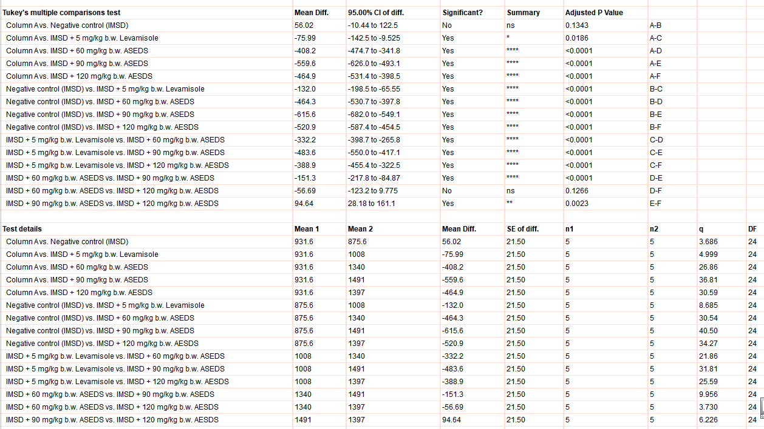

2. Immunoglobulin A
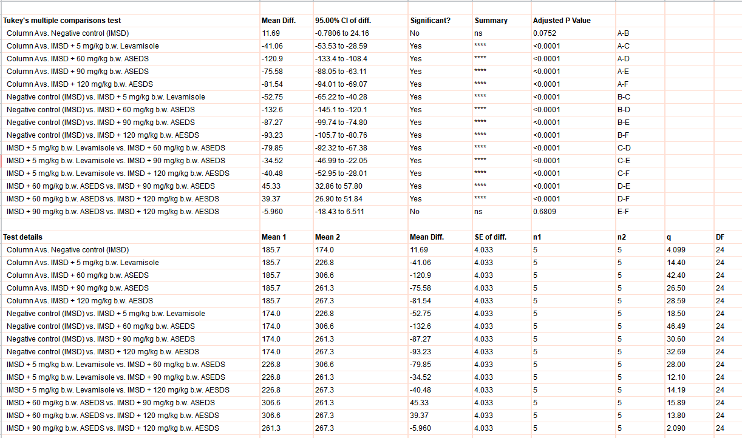

3. Immunoglobulin M
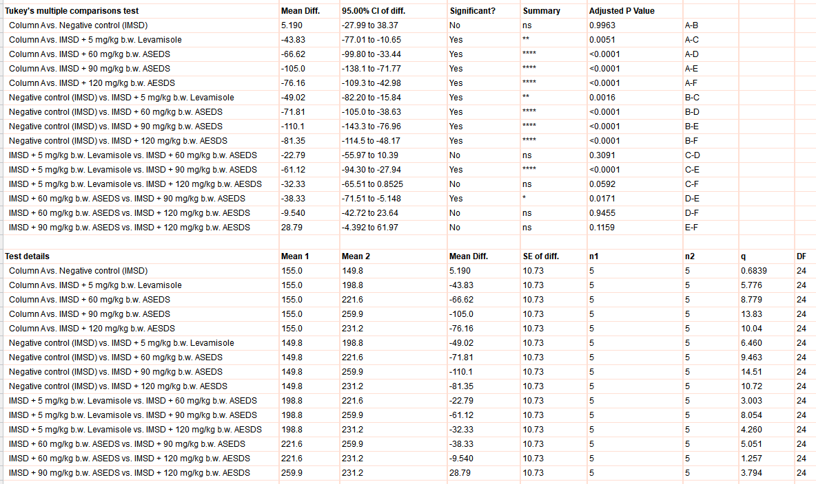

4. High-density Lipoprotein (HDL)
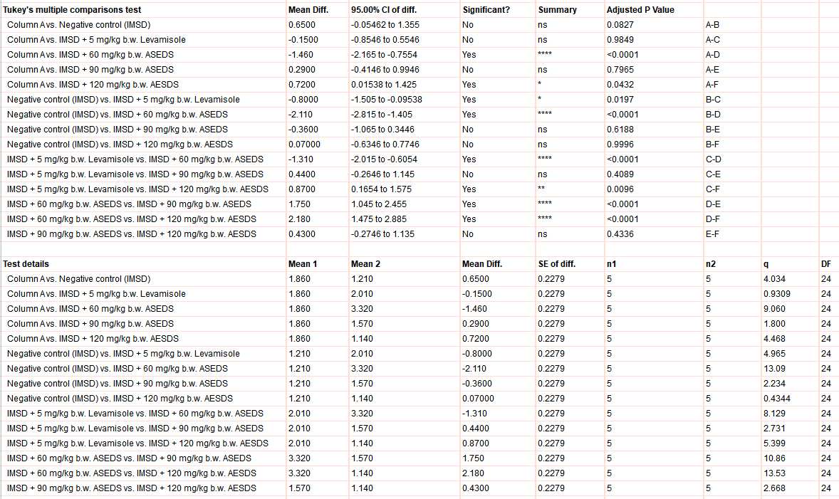

5. Low-density Lipoprotein (LDL)
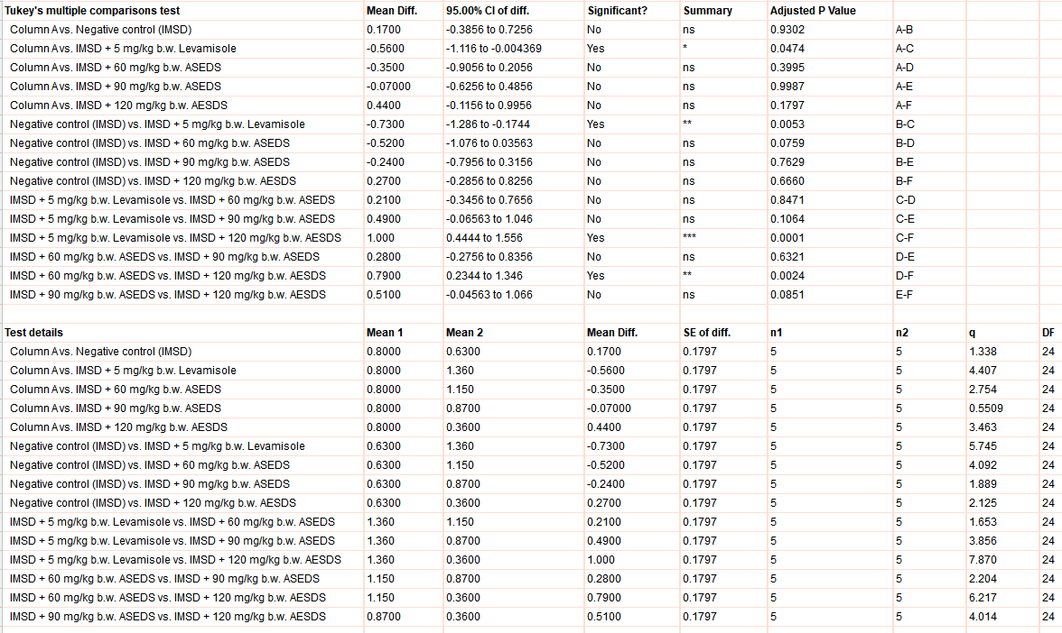

6. Glutathione Peroxidase (GPx)
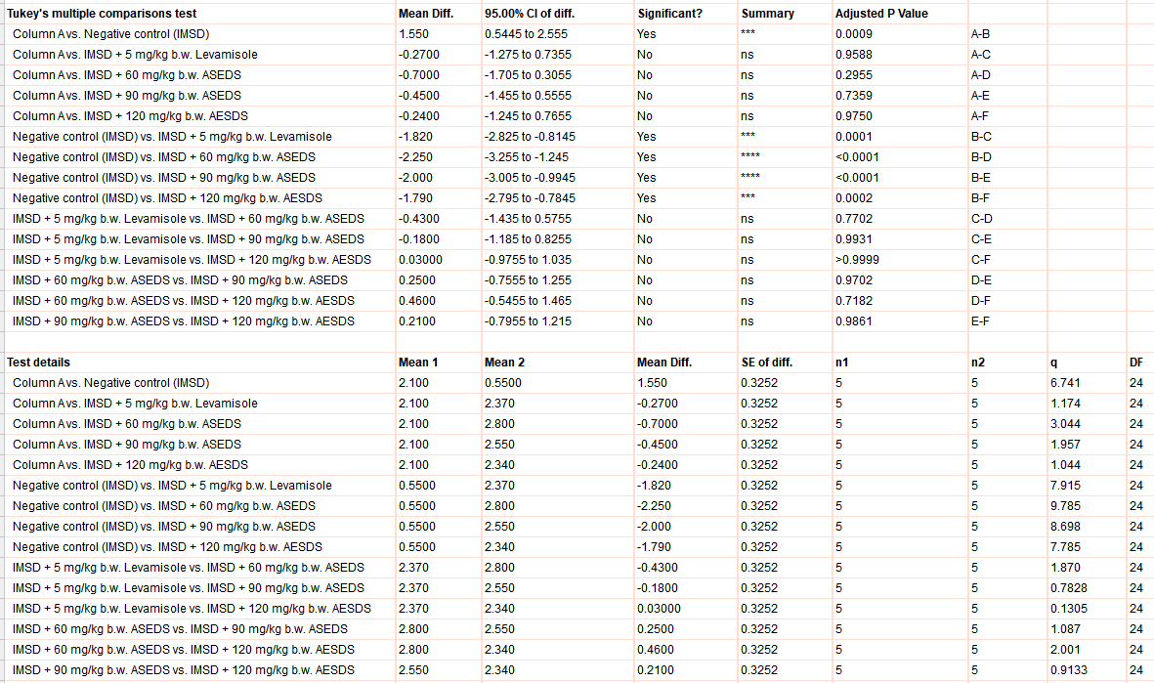

7. Catalase
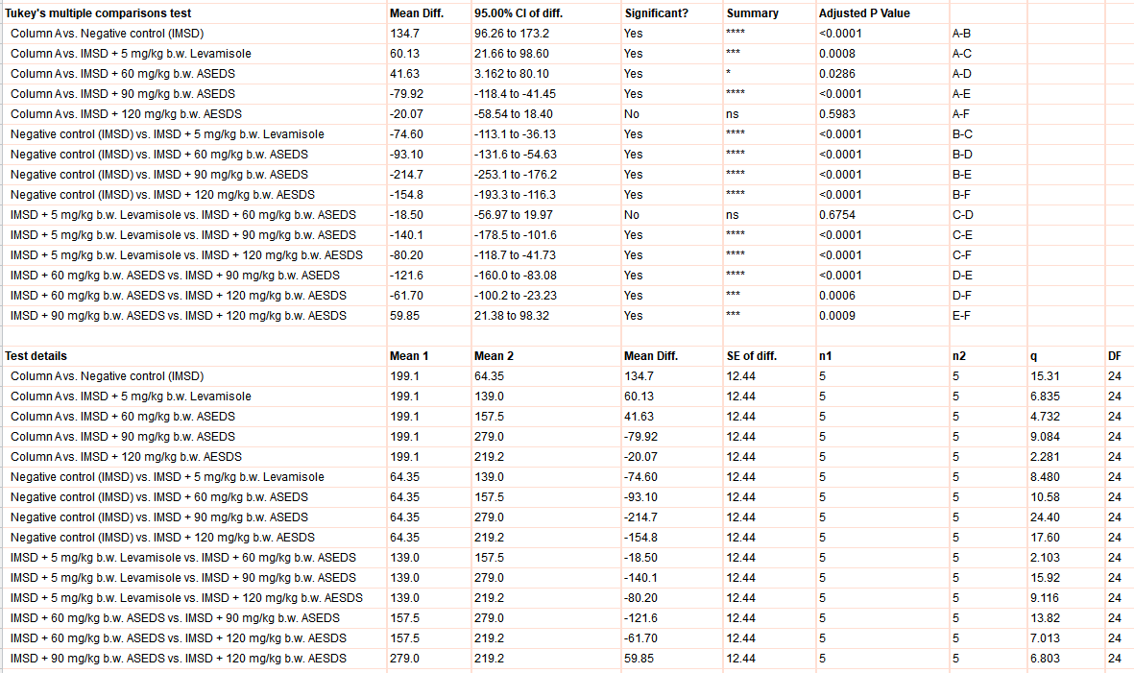

8. Superoxide diamutase (SOD)
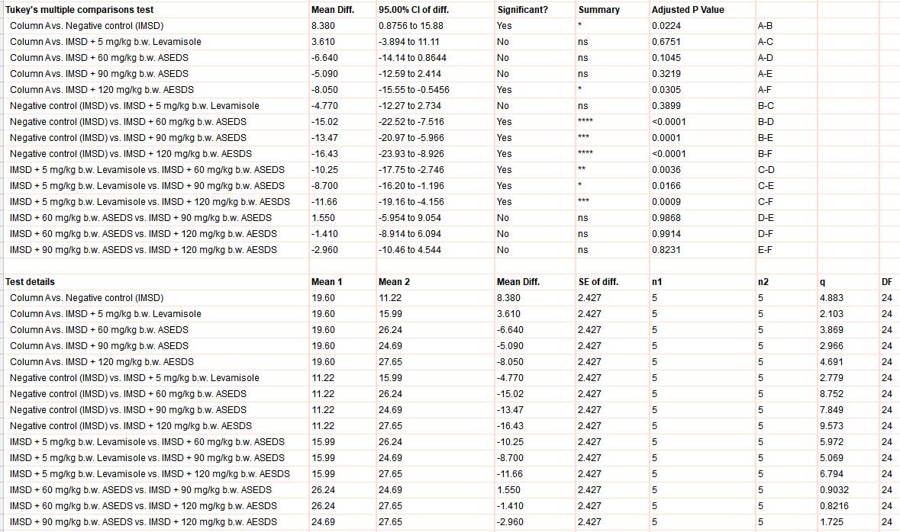

9. Vitamin E
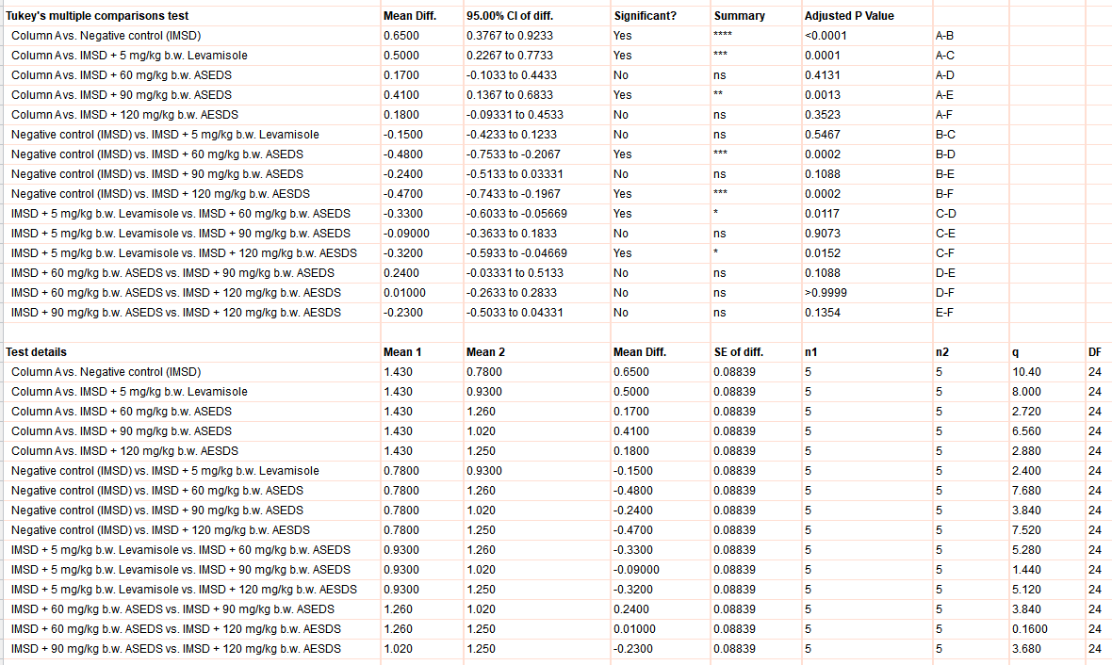

10. Vitamin C
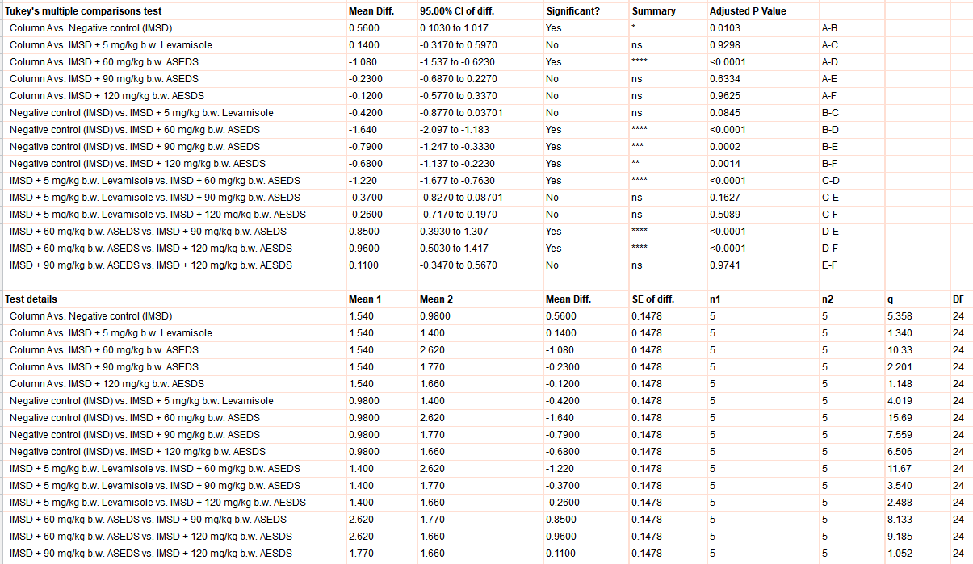

11. Vitamin A
