Title: The co-occurrence of soil protists and prokaryotes is affected by rhizocompartment and wheat variety
Journal: Plant and Soil
Authors: Christine Lorenzen Elberg¹, Rumakanta Sapkota¹, Athanasios Zervas¹, Dorette S. Müller-Stöver², Mette Haubjerg Nicolaisen², Rosanna Catherine Hennessy², Anne Winding^{1*}
1Aarhus University, Department of Environmental Science, Frederiksborgvej 399, 4000 Roskilde, Denmark
2University of Copenhagen, Department of Plant and Environmental Science, Thorvaldsensvej 40, 1871 Frederiksberg C, Denmark
*Corresponding author, E-mail: aw@envs.au.dk
Supplementary material
Supplementary Figure 1: Rhizocompartment protists community beta diversity. Non-metric multidimensional scaling (NMDS) plot based on Bray-Curtis dissimilarity matrices of protist communities showing separation according to three rhizocompartments and four wheat varieties.
Supplementary Figure 2: Relative abundance (%) of protist classes in rhizocompartments of four wheat varieties (n=120).
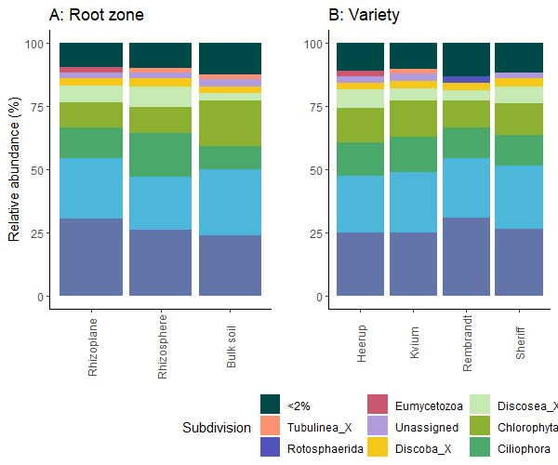

Supplementary Figure 3: Differential abundant ASVs differing between rhizocompartments and between wheat varieties, calculated using Deseq2 with standard settings. eASV: eukaryotic ASV followed by class and species where possible.
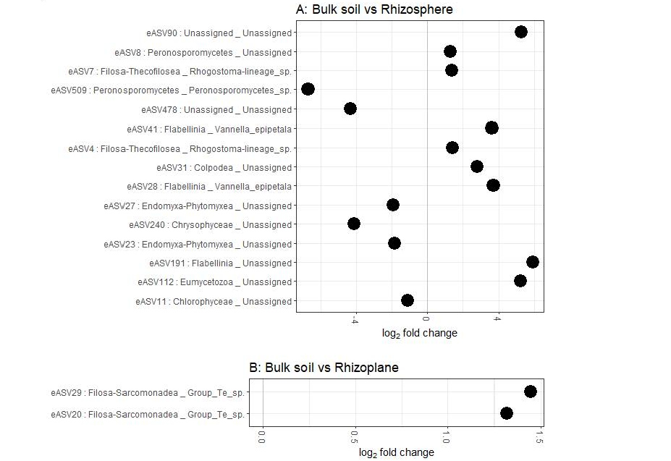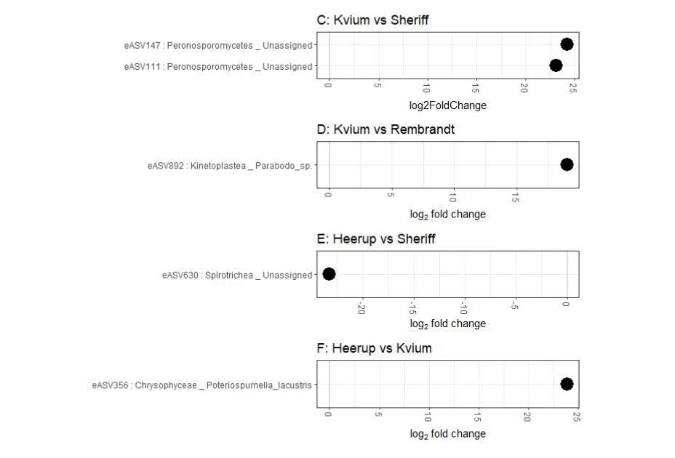
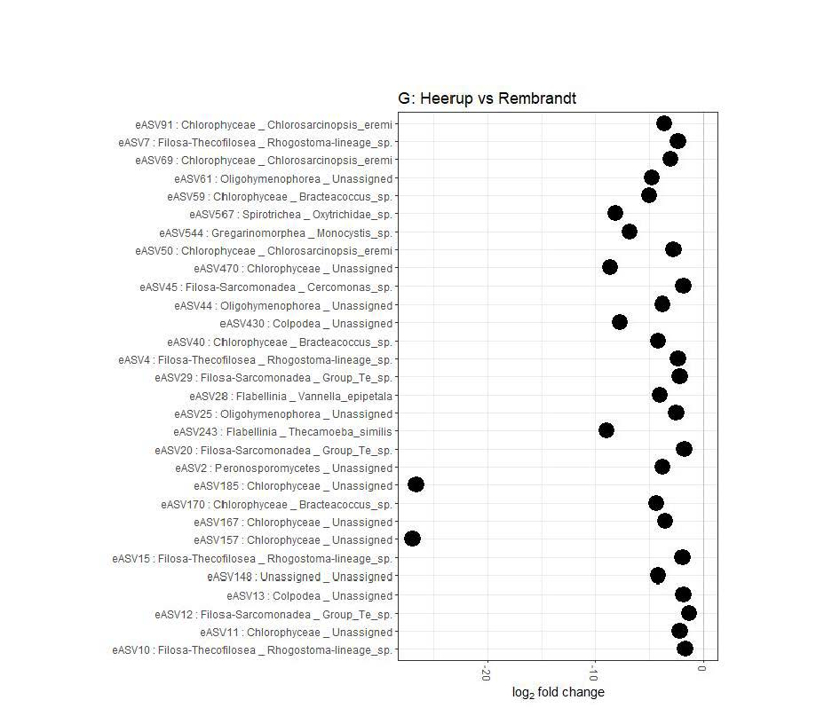

Supplementary Figure 4: Random Forest analysis shown as mean decrease of Gini followed relative abundance A: of each rhizocompartment; B: of the four wheat varieties. eASV: eukaryotic ASV followed by class and species where possible.
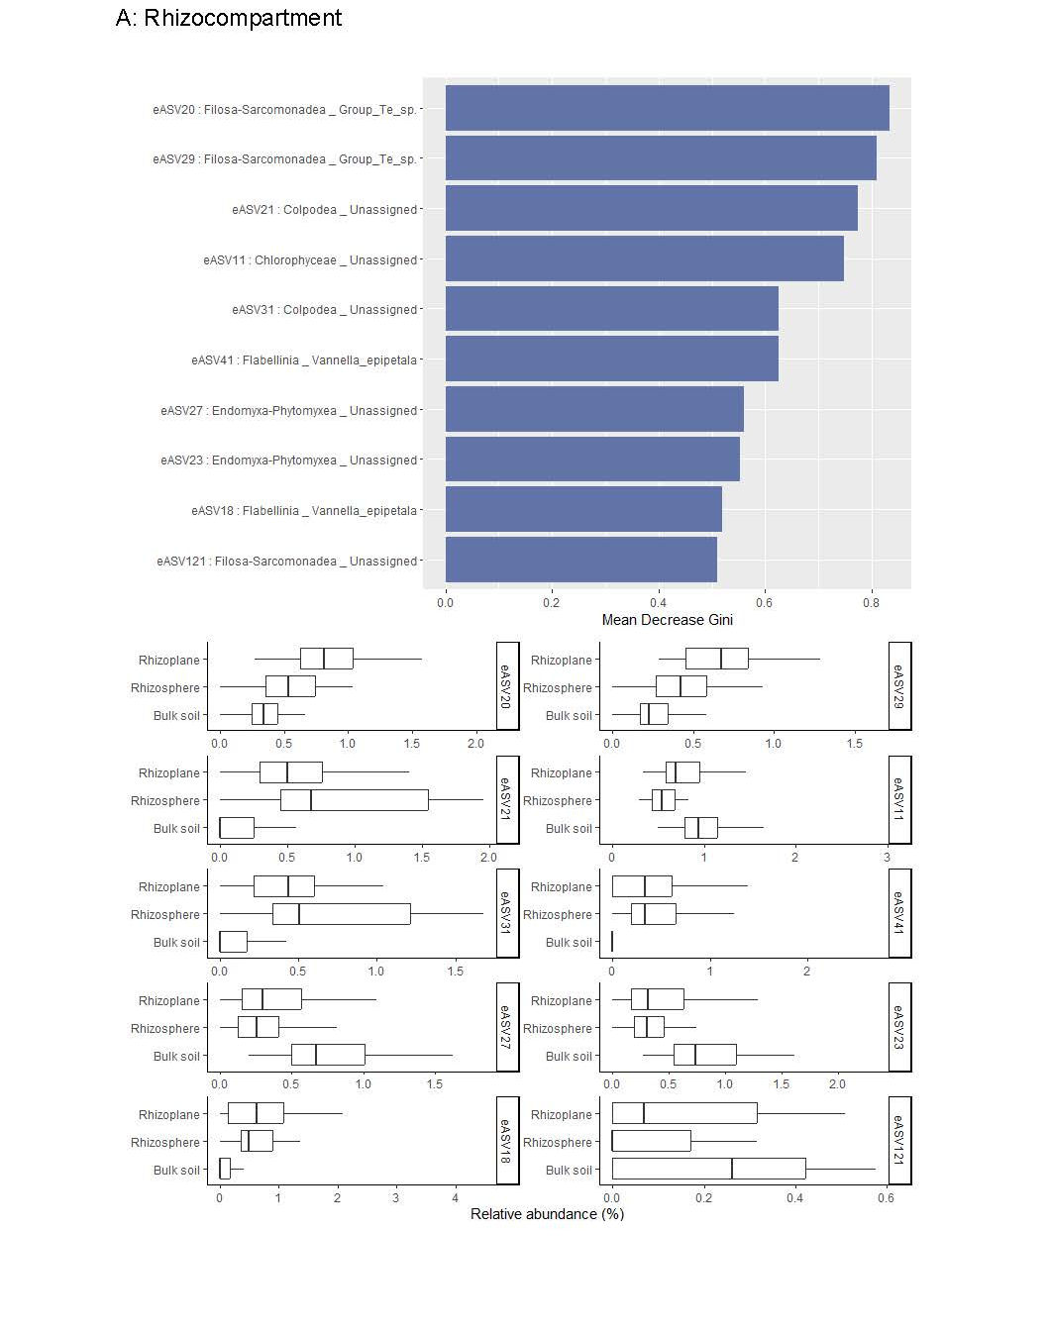
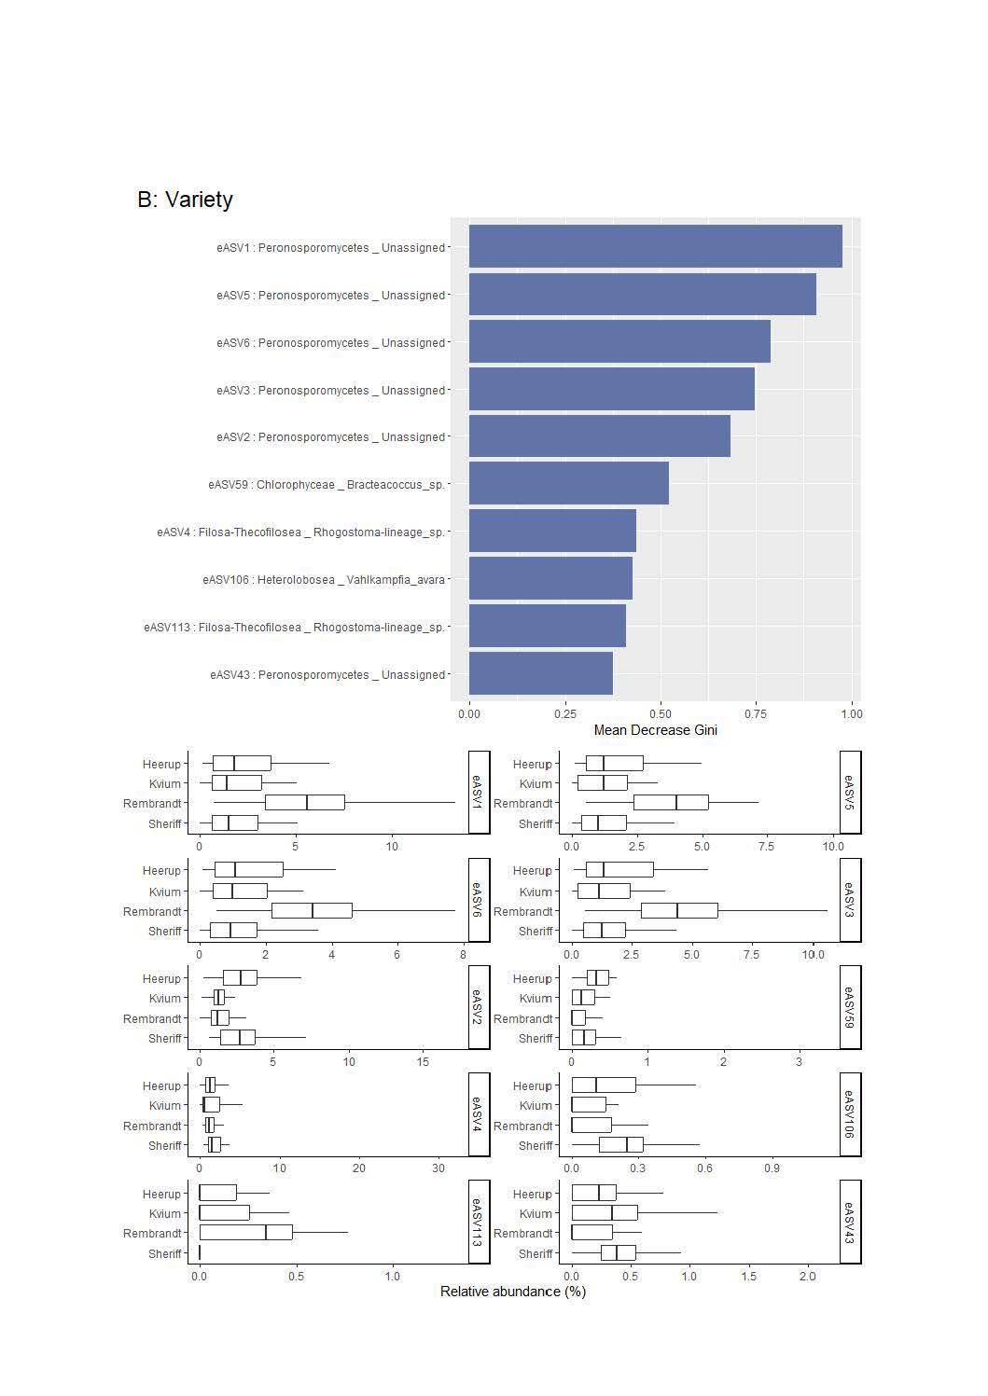

Supplementary Table 1: Statistical tests (Kruskal-Wallis) on protist subdivisions.

 | Rhizocompartment | Wheat variety
Apicomplexa | <0.0001 | 0.62
Bigyra | 0.027 | 0.0017
Centroplasthelida | 0.017 | 0.00058
Cercozoa | <0.0001 | 0.53
Chlorophyta | <0.0001 | 0.047
Choanoflagellata | 0.68 | 0.7
Chrompodellids | 0.85 | 0.2
Ciliophora | <0.0001 | 0.42
Cryptophyta | 0.35 | 0.13
Dinoflagellata | 0.26 | 0.25
Discoba | 0.046 | 0.27
Discosea | <0.0001 | 0.033
Euglenozoa | 0.21 | 0.69
Eumycetozoa | 0.049 | 0.2
Evosea | <0.0001 | <0.0001
Foraminifera | 0.6 | 0.2
Gyrista | <0.0001 | <0.0001
Haptophyta | 0.23 | 0.027
Ichthyosporea | 0.47 | 0.045
Kathablepharida | 0.14 | 0.57
Nibbleridia | 0.58 | 0.55
Parabasalia | 0.56 | 0.55
Prexostyla | 0.15 | 0.19
Radiolaria | 0.13 | 0.64
Rotosphaerida | 0.35 | 0.41
Telonemia | 0.0006 | 0.54
Tubulinea | 0.04 | 0.041

Supplementary Table 2: Statistical tests (Kruskal-Wallis) on eukaryotic ASVs (eASV) identified as predictor ASVs by Random Forest analysis. eASVs are identified to class and species where possible. A: Rhizocompartments. B: Wheat varieties. The data shown represents the p values after adjustment using the Bonferroni correction.
A | Filosa-Sarcomonadea Group Te sp. | Filosa-Sarcomonadea Group Te sp. | Colpodea | Chlorophysea | Colpodea | Flabellina Vanella epipetata | Endomyxa-Phytomyxea | Endomyxa-Phytomyxea | Flabellina Vanella epipetata | Filosa-Sarcomonadea
Rhizocompartment | eASV20 | eASV29 | eASV21 | eASV11 | eASV31 | eASV41 | eASV27 | eASV23 | eASV18 | eASV121
Bulk soil - Rhizosphere | 0.00038 | 0.00015 | <0.0001 | <0.0001 | <0.0001 | <0.0001 | <0.0001 | <0.0001 | <0.0001 | <0.0001
Rhizoplane - Rhizosphere | 0.00018 | 0.00019 | 0.025 | 0.0017 | 0.028 | 0.6 | 0.34 | 0.84 | 0.89 | 0.025
Rhizoplane –  Bulk soil | <0.0001 | <0.0001 | <0.0001 | 0.0022 | <0.0001 | <0.0001 | <0.0001 | <0.0001 | <0.0001 | 0.02
B | Peronosporomycetes | Peronosporomycetes | Peronosporomycetes | Peronosporomycetes | Peronosporomycetes | Chlorophysea Bracteacoccus sp. | Filosa-Thecofilosea Rhogostoma sp. | Heterolobosa Vahlkampfia avara | Filosa-Thecofilosea Rhogostoma sp. | Peronosporomycetes
Wheat variety | eASV1 | eASV5 | eASV6 | eASV3 | eASV2 | eASV59 | eASV4 | eASV106 | eASV113 | eASV43
Kvium - Heerup | 0.53 | 0.27 | 0.44 | 0.29 | 0.00054 | 0.0025 | 0.07 | 0.04 | 0.84 | 0.45
Rembrandt - Heerup | <0.0001 | <0.0001 | <0.0001 | <0.0001 | 0.00052 | <0.0001 | 0.47 | 0.12 | 0.026 | 0.098
Sheriff - Heerup | 0.42 | 0.32 | 0.36 | 0.48 | 0.74 | 0.0045 | 0.62 | 0.12 | 0.11 | 0.033
Rembrandt - Kvium | <0.0001 | <0.0001 | <0.0001 | <0.0001 | 0.8 | 0.15 | 0.23 | 0.84 | 0.025 | 0.032
Sheriff - Kvium | 0.93 | 0.95 | 0.87 | 0.67 | 0.0012 | 0.96 | 0.038 | 0.00026 | 0.066 | 0.36
Sheriff - Rembrandt | <0.0001 | <0.0001 | <0.0001 | <0.0001 | 0.00051 | 0.13 | 0.06 | 0.0035 | 0.00035 | <0.0001

Supplementary Table 3: Overview of the number of nodes, edges, and correlations identified in the seven different co-occurrence networks
 | Nodes | Edges | Positive correlations | Negative correlations
Rhizoplane | 803 | 1045 | 1041 | 4
Rhizosphere | 821 | 944 | 933 | 11
Bulk soil | 1010 | 1149 | 1138 | 11
Heerup | 1401 | 2733 | 2602 | 131
Kvium | 1332 | 2861 | 2647 | 214
Rembrandt | 1266 | 2684 | 2508 | 176
Sheriff | 1335 | 2943 | 2655 | 288

Supplementary Table 4: Heatmap of bacteria and protist top connector species identified using a Spearman’s correlation co-occurrence network analysis.