Supplementary Text
S1 Warm and cold extremes based on different methods and datasets
In this study, we have used a new definition of temperature extremes focusing on consistent SAT anomalies over northern Eurasia. The new definition based on Gaussian distributions (Supplementary Fig. S1) identifies extreme events via the SAT anomalies over most of the region exceeding certain standard deviation threshold. This provides us more realistic behaviors of regional warm and cold extremes in the real world, thereby yielding robust statistics.
Moreover, another 6-hourly SAT dataset of the Japanese 55-year Reanalysis (JRA55) from the Japan Meteorological Agency (https://rda.ucar.edu/datasets/ds628.0/) is supplied to calculate the frequencies of SAT extremes as a complement. Similar decadal variations with significant correlations based on the two reanalysis datasets are shown in Supplementary Fig. S3, suggesting that our new definition will work regardless of the data source.
S2 AMOC indexes used in this study
There are great correlations among different AMOC indexes used in our study (Supplementary Fig. S4). They demonstrate sharp decreases since the mid-1960s to the mid-1970s, followed by the slightly decreases from the mid-1970s to the mid-1990s. After then, dramatic increases happened until the rapid decreases occurred again in the early 2010s. The correlation coefficients among these variations are all significant at the 99% confidence level, especially among the subpolar upper ocean salinity indexes from the three datasets with correlation coefficients greater than 0.9 (Supplementary Table 1), implying the AMOC index we choose will not affect the results of this study.
S3 Composite distribution of SAT anomalies in winter based on the reanalysis and model simulations
Composite distributions of SAT anomalies in winter exhibit regional consistency over northern Eurasia when extremes occur in the reanalysis (Supplementary Fig. S5) and the hist-resAMO runs (Supplementary Fig. S9). When warm extremes happen for each winter month (Supplementary Fig. S5a, b, c, d), significant positive SAT anomalies are demonstrated over mid- to high latitudes with maximum temperature ranges of more than 7 ℃ over the northern Eurasia region, while the SAT variations are weak in the lower latitudes, despite of the significant negative SAT anomalies with relatively small changing magnitudes in northwest China and Southeast Asia. On the contrary, prominent negative SAT anomalies are shown over mid- to high latitudes with maximum temperature ranges of less than -7 ℃ over northern Eurasia, and conspicuous positive SAT anomalies can be seen over most inland in the lower latitudes although the changing magnitudes are small (Supplementary Fig. S5e, f, g, h). For the spatial SAT distributions when warm (Supplementary Fig. S9a) and cold (Supplementary Fig. S9b) extremes happen in the hist-resAMO runs, similar patterns with reanalysis can be obtained that the maximum SAT anomalies dominated over northern Eurasia. Some innocuous discrepancies are shown in the lower latitudes with weak positive SAT anomalies when warm extremes occur (Supplementary Fig. S9a).
S4 Decadal variations in the frequencies of winter SAT extremes in different model simulations
Large discrepancies can be seen among distinct model experiments. The changing amplitudes in the multi-model mean of the hist-resAMO runs (Supplementary Fig. S6) are comparable to the reanalysis (Fig. 1a). Overall increasing and decreasing trends are shown during 1960-2014 for warm and cold extremes, respectively. The frequency for the sum of warm and cold extremes demonstrated an overall decreasing trend before the early 1990s, an increasing trend from the 1990s to the early 2000s, and a roughly decreasing trend after then. MRI-ESM2-0 is the relatively best model demonstrating similar decadal trends compared with the other two, and its variation for warm extremes is larger than the multi-model mean, while is smaller for cold extremes.
By contrast, the decadal changes in SAT extremes of the hist-GHG runs (Supplementary Fig. S7) and historical runs (Supplementary Fig. S8) are relatively inconspicuous. The sums of warm and cold extremes in the multi-model means of the hist-GHG runs (Supplementary Fig. S7c) and historical runs (Supplementary Fig. S8c) present much feeble amplitudes. The overall changing amplitude is about 2 times in the 55 years of 1960-2014 in the hist- GHG runs. The constant decreasing trend is reasonably faint in the historical runs with the amplitude of one time in the 55 years. For warm and cold extremes, the inapparent increasing and decreasing trends with the changing frequencies of less than one time per decade (Supplementary Fig. S7a, b and Supplementary Fig. S8a, b) suggest the inconsequential effect of global warming on winter SAT extremes over northern Eurasia.
Moreover, the decadal variations are comparable in terms of the amplitudes and trends between the hist-GHG runs and historical runs. The relatively large ensemble size of the historical runs allows us to believe the ensemble mean can be mainly regarded as the human-induced increase in green-house gases, in other words, the global warming signal demonstrated in the hist-GHG runs.

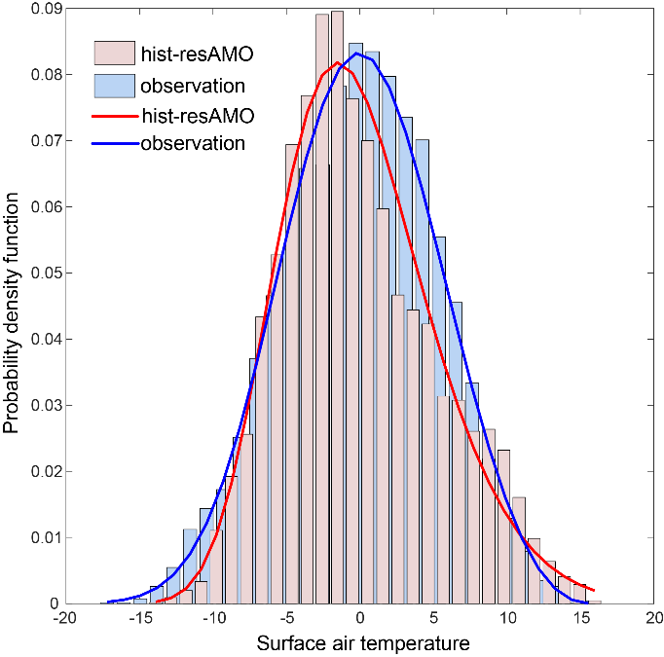
Supplementary Fig. S1 SAT PDFs over northern Eurasia in winter. PDFs of winter SAT over northern Eurasia during 1960-2017 based on the reanalysis and during 1960-2014 based on the multi-model mean of the hist-resAMO runs.

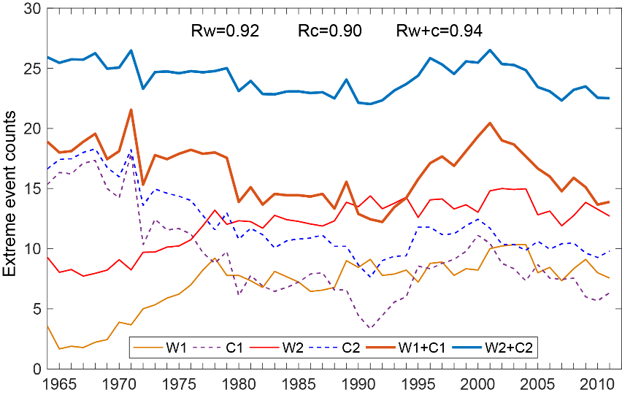
Supplementary Fig. S2 Decadal variations in the frequencies of winter SAT extremes over northern Eurasia. W1 (C1) and W2 (C2) represent warm (cold) extremes defined by D1 and D2. Correlation coefficients are shown at the top. R_{w}, R_{c}, and R_{w+c} are the correlation coefficients of the decadal variations in the frequencies for warm extremes, cold extremes, sum of warm and cold extremes between the definition D1 and D2, respectively.

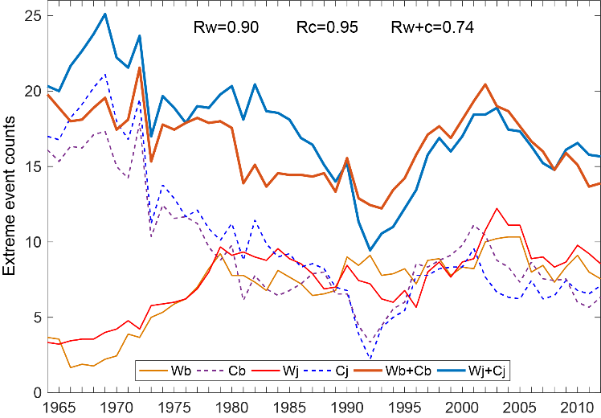
Supplementary Fig. S3 Decadal variations in the frequencies of winter SAT extremes over northern Eurasia. Wb (Cb) and Wj (Cj) represent warm (cold) extremes based on Berkeley earth dataset and JRA55 dataset, respectively. Correlation coefficients are shown at the top. R_{w}, R_{c}, and R_{w+c} are the correlation coefficients of the decadal variations in the frequencies for warm extremes, cold extremes, sum of warm and cold extremes between the two datasets, respectively.

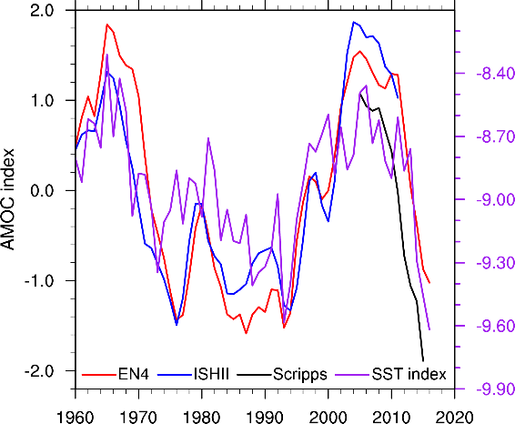
Supplementary Fig. S4 Time series of AMOC proxy indexes. AMOC series of the subpolar upper ocean salinity indexes (units: SV) derived from ISHII (blue), Scripps (black), and EN4 (red) datasets and fingerprint index (purple, units: K). The left y-axis is for the subpolar upper ocean salinity indexes, and the right y-axis is for the fingerprint index.

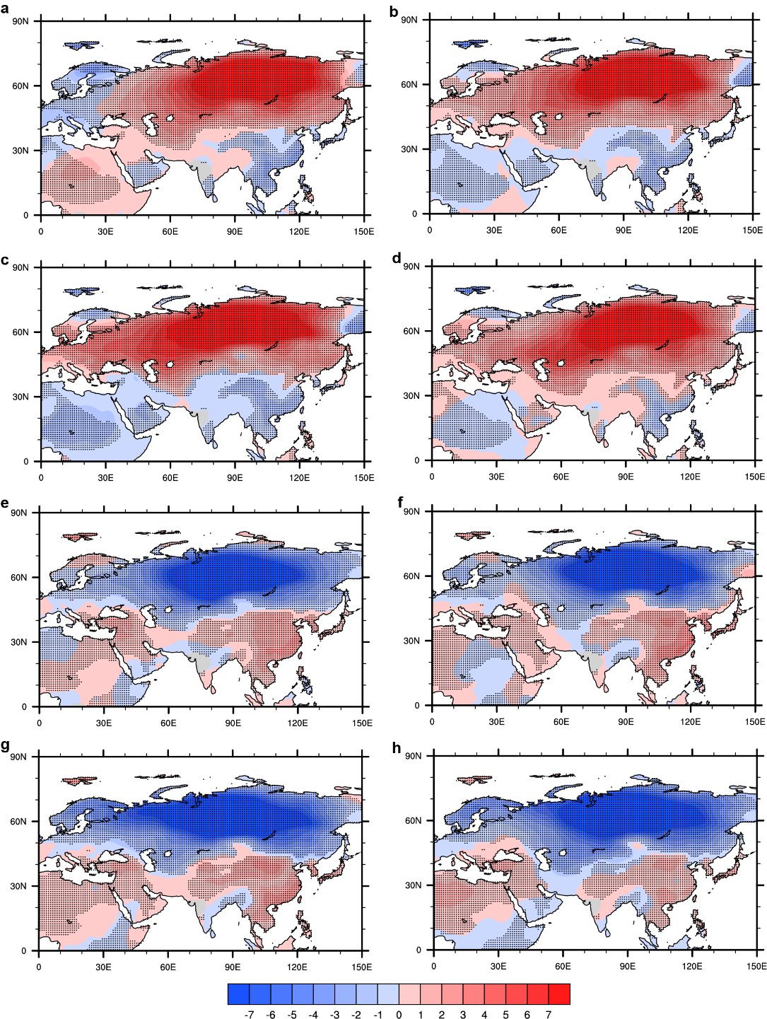Supplementary Fig. S5 Composite distribution of SAT anomalies in winter months. Composite distribution of SAT anomalies (units: °C) when warm (a-d) and cold (e-h) extremes happen in November (a, e), in December (b, f), in January (c, g) and in February (d, h) based on the reanalysis. Stippling indicates areas of statistical significance at the 95% confidence level using a Student’s t-test.

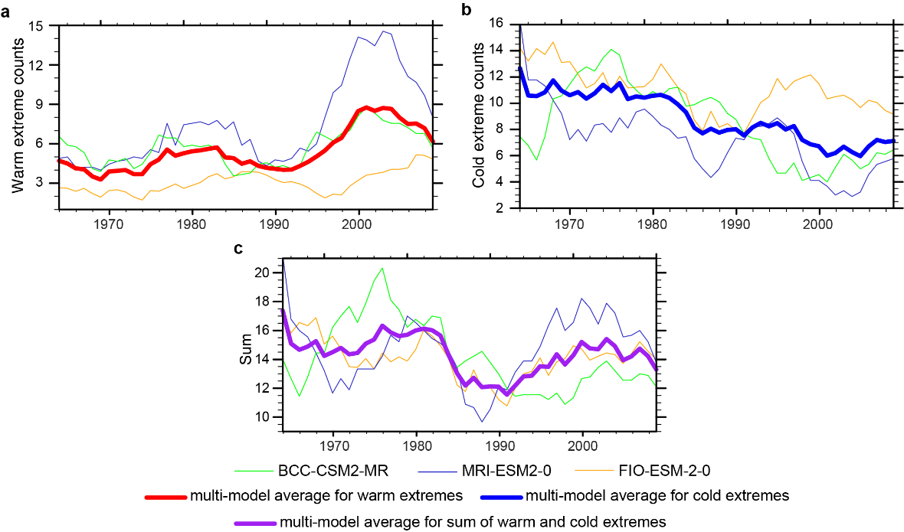
Supplementary Fig. S6 Decadal variations in the frequencies of SAT extremes. Decadal variations in the frequencies of warm extremes (a, thick red line is the multi-model mean), cold extremes (b, thick blue line is the multi-model mean) and sum of warm and cold extremes (c, thick purple line is the multi-model average) over northern Eurasia in winter during 1964-2010 in the hist-resAMO runs.

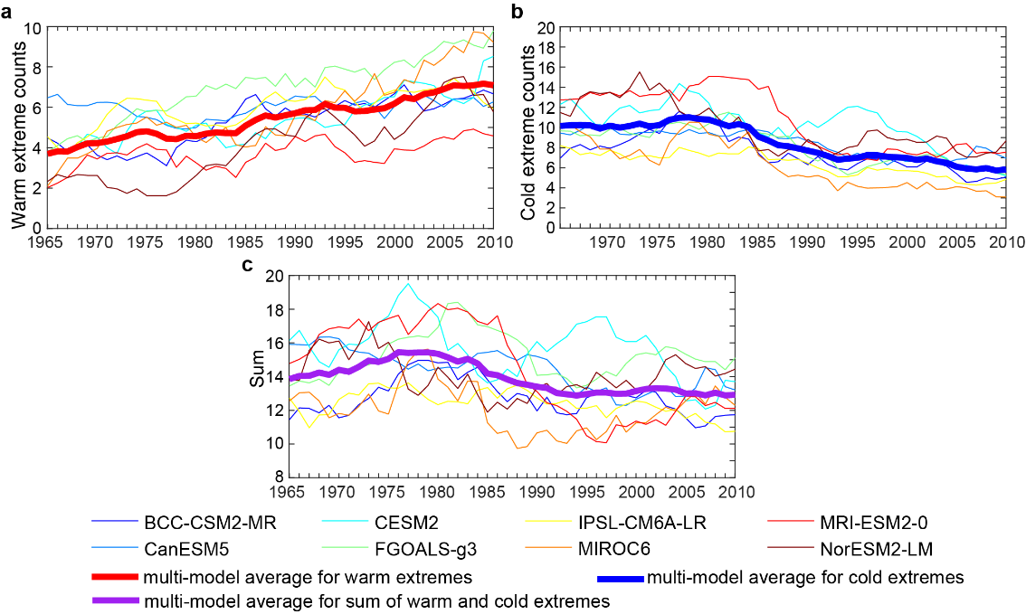
Supplementary Fig. S7 Same as Supplementary Fig. S6 but for different hist-GHG models.

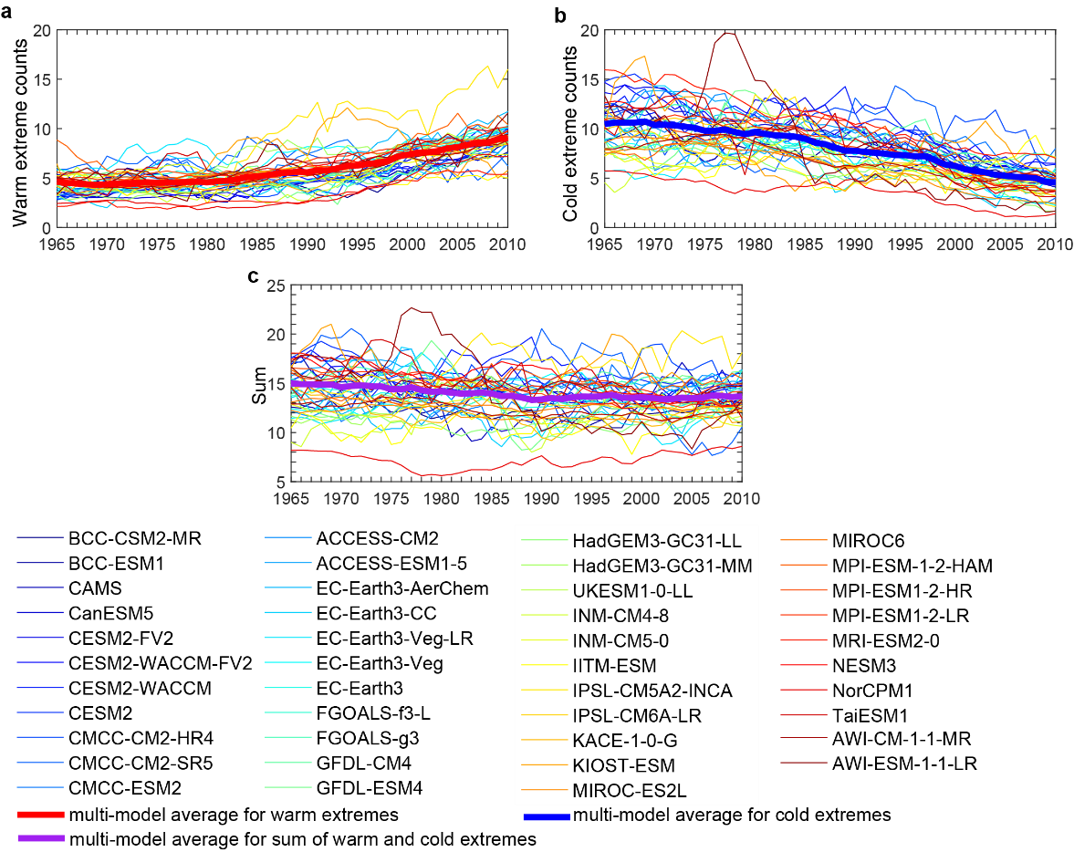
Supplementary Fig. S8 Same as Supplementary Fig. S6 but for different historical runs.

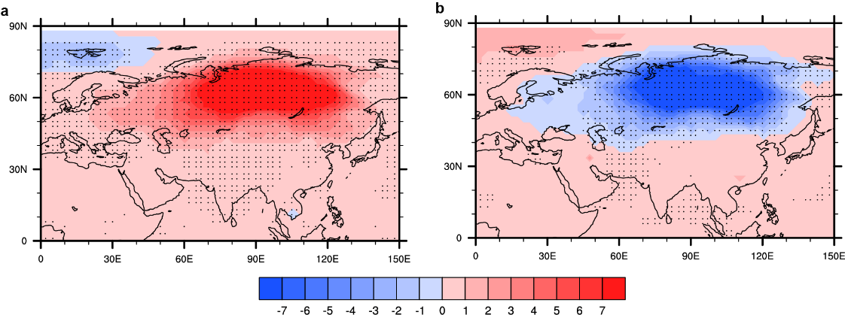
Supplementary Fig. S9 Composite distributions of SAT anomalies in winter. Composite distribution of SAT anomalies in winter (units: °C) when warm (a) and cold (b) extremes happen in the multi-model mean of the hist-resAMO runs. Stippling indicates mutual areas of statistical significance at the 95% confidence level using a Student’s t-test for all the four members of the hist-resAMO runs.

Supplementary Table 1 Correlation coefficients among different AMOC indexes
 | Scripps | EN4 | fingerprint
ISHII | 0.98 | 0.92 | 0.73
Scripps |  | 0.94 | 0.82
EN4 |  |  | 0.76

Supplementary Table 2 Information on the CMIP6 models used in this study
Model name | Experi-ment ID | Institution | No. of grids  (Lat × Lon) | memb-ers per model
ACCESS-CM2 | historical | Commonwealth Scientific and Industrial Research Organisation, Australia | 144×192 | 3
ACCESS-ESM1-5 | historical | Commonwealth Scientific and Industrial Research Organisation, Australia | 145×192 | 29
AWI‐CM‐1‐1‐MR | historical | Alfred Wegener Institute, Helmholtz Centre for Polar and Marine Research, Germany | 192 × 384 | 5
AWI-ESM-1-1-LR | historical | Alfred Wegener Institute, Helmholtz Centre for Polar and Marine Research, Germany | 192 × 384 | 1
BCC‐CSM2‐MR | historical | Beijing Climate Center, China | 160 × 320 | 2
BCC‐ESM1 | historical | Beijing Climate Center, China | 64 × 128 | 3
CAMS | historical | Chinese Academy of Meteorological Sciences, China | 160 × 320 | 1
CanESM5 | historical | Canadian Centre for Climate Modelling and Analysis, Environment and Climate Change Canada, Canada | 64 × 128 | 50
CESM2‐FV2 | historical | National Center for Atmospheric Research, Climate and Global Dynamics Laboratory, USA | 96 × 144 | 3
CESM2‐WACCM‐FV2 | historical | National Center for Atmospheric Research, Climate and Global Dynamics Laboratory, USA | 96 × 144 | 3
CESM2‐WACCM | historical | National Center for Atmospheric Research, Climate and Global Dynamics Laboratory, USA | 192 × 288 | 3
CESM2 | historical | National Center for Atmospheric Research, Climate and Global Dynamics Laboratory, USA | 192 × 288 | 11
CMCC-CM2-HR4 | historical | Fondazione Centro Euro-Mediterraneo sui Cambiamenti Climatici, Italy | 192 × 288 | 1
CMCC-CM2-SR5 | historical | Fondazione Centro Euro-Mediterraneo sui Cambiamenti Climatici, Italy | 192 × 288 | 1
CMCC-ESM2 | historical | Fondazione Centro Euro-Mediterraneo sui Cambiamenti Climatici, Italy | 192 × 288 | 1
EC-Earth-AerChem | historical | Consortium of various institutions from Spain, Italy, Denmark, Finland, Germany, Ireland, Portugal, Netherlands, Norway, UK, Belgium, and Sweden | 256 × 512 | 2
EC-Earth3-CC | historical | Consortium of various institutions from Spain, Italy, Denmark, Finland, Germany, Ireland, Portugal, Netherlands, Norway, UK, Belgium, and Sweden | 256 × 512 | 1
EC-Earth-Veg-LR | historical | Consortium of various institutions from Spain, Italy, Denmark, Finland, Germany, Ireland, Portugal, Netherlands, Norway, UK, Belgium, and Sweden | 160×320 | 1
EC‐Earth3‐Veg | historical | Consortium of various institutions from Spain, Italy, Denmark, Finland, Germany, Ireland, Portugal, Netherlands, Norway, UK, Belgium, and Sweden | 256 × 512 | 3
EC‐Earth3 | historical | Consortium of various institutions from Spain, Italy, Denmark, Finland, Germany, Ireland, Portugal, Netherlands, Norway, UK, Belgium, and Sweden | 256 × 512 | 9
FGOALS‐f3‐L | historical | Chinese Academy of Sciences, China | 180 × 288 | 3
FGOALS‐g3 | historical | Chinese Academy of Sciences, China | 80 × 180 | 5
GFDL‐CM4 | historical | National Oceanic and Atmospheric Administration, Geophysical Fluid Dynamics Laboratory, USA | 90 × 144 | 2
GFDL‐ESM4 | historical | National Oceanic and Atmospheric Administration, Geophysical Fluid Dynamics Laboratory, USA | 180 × 288 | 1
HadGem3-GC31-LL | historical | Met Office Hadley Centre, UK | 144× 192 | 5
HadGem3-GC31-MM | historical | Met Office Hadley Centre, UK | 324× 432 | 3
IITM-ESM | historical | Centre for Climate Change Research, Indian Institute of Tropical Meteorology, India | 94×192 | 1
INM‐CM4‐8 | historical | Institute for Numerical Mathematics, Russian Academy of Science, Russia | 120 × 180 | 1
INM‐CM5‐0 | historical | Institute for Numerical Mathematics, Russian Academy of Science, Russia | 120 × 180 | 10
IPSL-CM5A2-INCA | historical | Institut Pierre Simon Laplace, France | 96× 96 | 1
IPSL‐CM6A‐LR | historical | Institut Pierre Simon Laplace, France | 143 × 144 | 32
KACE-1-0-G | historical | National Institute of Meteorological Sciences/Korea Meteorological Administration, Climate Research Division, Korea | 144×192 | 3
KIOST-ESM | historical | Korea Institute of Ocean Science & Technology, Korea | 96×192 | 1
MIROC-ES2L | historical | JAMSTEC (Japan Agency for Marine-Earth Science and Technology, Japan), AORI (Atmosphere and Ocean Research Institute, The University of Tokyo, Japan), NIES (National Institute for Environmental Studies, Japan), and R-CCS (RIKEN Center for Computational Science, Japan) | 64×128 | 31
MIROC6 | historical | JAMSTEC (Japan Agency for Marine-Earth Science and Technology, Japan), AORI (Atmosphere and Ocean Research Institute, The University of Tokyo, Japan), NIES (National Institute for Environmental Studies, Japan), and R-CCS (RIKEN Center for Computational Science, Japan) | 128 × 256 | 50
MPI‐ESM-1‐2‐HAM | historical | Max Planck Institute for Meteorology, Germany | 96× 192 | 3
MPI‐ESM1‐2‐HR | historical | Max Planck Institute for Meteorology, Germany | 160 × 320 | 10
MPI‐ESM1‐2‐LR | historical | Max Planck Institute for Meteorology, Germany | 96× 192 | 10
MRI-ESM2-0 | historical | Meteorological Research Institute, Japan | 160 × 320 | 7
NESM3 | historical | Nanjing University of Information Science and Technology, China | 96 × 192 | 5
NorCPM1 | historical | NorESM Climate modeling Consortium consisting of CICERO (Center for International Climate and Environmental Research), MET-Norway (Norwegian Meteorological Institute), NERSC (Nansen Environmental and Remote Sensing Cente), NILU (Norwegian Institute for Air Research), UiB (University of Bergen), UiO (University of Oslo) and UNI (Uni Research), Norway | 96 × 144 | 6
TaiESM1 | historical | Research Center for Environmental Changes, Academic Sinica, Taiwan, China | 192× 288 | 1
UKESM1-0-LL | historical | Met Office Hadley Centre, UK | 144× 192 | 17
BCC-CSM2-MR | hist-GHG | Beijing Climate Center, China | 160 × 320 | 3
CanESM5 | hist-GHG | Canadian Centre for Climate Modelling and Analysis, Environment and Climate Change Canada, Canada | 64× 128 | 8
CESM2 | hist-GHG | National Center for Atmospheric Research, Climate and Global Dynamics Laboratory, USA | 192× 288 | 3
FGOALS-g3 | hist-GHG | Chinese Academy of Sciences, China | 80× 180 | 3
IPSL-CM6A-LR | hist-GHG | Institut Pierre Simon Laplace, France | 143× 144 | 6
MIROC6 | hist-GHG | JAMSTEC (Japan Agency for Marine-Earth Science and Technology, Japan), AORI (Atmosphere and Ocean Research Institute, The University of Tokyo, Japan), NIES (National Institute for Environmental Studies, Japan), and R-CCS (RIKEN Center for Computational Science, Japan) | 128× 256 | 3
MRI-ESM2-0 | hist-GHG | Meteorological Research Institute, Japan | 160 × 320 | 5
NorESM2-LM | hist-GHG | NorESM Climate modeling Consortium consisting of CICERO (Center for International Climate and Environmental Research), MET-Norway (Norwegian Meteorological Institute), NERSC (Nansen Environmental and Remote Sensing Cente), NILU (Norwegian Institute for Air Research), UiB (University of Bergen), UiO (University of Oslo) and UNI (Uni Research), Norway | 96× 144 | 3
BCC-CSM2-MR | hist-resAMO | Beijing Climate Center, China | 160 × 320 | 1
FIO-ESM-2-0 | hist-resAMO | First Institute of Oceanography, State Oceanic Administration, China | 192×288 | 1
MRI-ESM2-0 | hist-resAMO | Meteorological Research Institute, Tsukuba, Japan | 160 × 320 | 2

