Supplementary Information
Identification of spatially heterogeneous drivers of lake eutrophication in China with explainable automated machine learning

Wenjie Qin ^{a, b} (Email: qinwj@hust.edu.cn), Yuyi Zhang ^{a, b} (Email: zyy2509744667@gmail.com), Xianghan Zheng ^{a, b} (Email: 1456824420@qq.com), Jingping Hu ^{a, b, c *} (Email: hujp@hust.edu.cn), Huijie Hou ^{a, b *} (Email: houhuijie@hust.edu.cn), Jiakuan Yang ^{a, b, c} (Email: jkyang@mail.hust.edu.cn)

ª Hubei Key Laboratory of Multi-media Pollution Cooperative Control in Yangtze Basin, School of Environmental Science & Engineering, Huazhong University of Science and Technology (HUST), 1037 Luoyu Road, Wuhan, 430074, China
^{b} Hubei Provincial Engineering Laboratory of Solid Waste Treatment, Disposal and Recycling, 1037 Luoyu Road, Wuhan, 430074, China
^{c} State Key Laboratory of Coal Combustion, Huazhong University of Science and Technology (HUST), 1037 Luoyu Road, Wuhan, 430074, China

* Corresponding authors: Prof. Jingping Hu (Email: hujp@hust.edu.cn) & Prof. Huijie Hou (Email: houhuijie@hust.edu.cn)

Contents: Text S1-S2, Tables S1, Fig. S1

Text S1. Traditional machine learning methods
1. Linear Regression
Linear Regression (LR) is a fundamental statistical model used to establish a linear relationship between a dependent variable and one or more independent variables. In this context, for each training pair ($x_{i}, w_{i}$), the probability of the observation $w_{i}$ given the input $x_{i}$ and model parameters $θ$ is modeled as a normal distribution centered around a linear combination of the features:
$Pr\left(w_{i}∣x_{i},θ\right)={Norm}_{w_{i}}\left[ϕ^{T}x_{i},σ^{2}\right]$ (1)
where $w_{i}$ represents the predicted output, $x_{i}$ denotes a vector of observed variables, $ϕ$ is a vector of regression coefficients, and $σ^{2}$ is the variance of the noise. The goal is to find the optimal values for $ϕ$ and $σ^{2}$ that maximize the likelihood of observing the training data (Kleiber and Zeileis 2008).
2. Random Forest
Random Forest (RF) is an ensemble learning method introduced by Breiman that combines multiple decision trees through bootstrap aggregation (Breiman 2001). Each tree is constructed using the Classification and Regression Trees (CART) methodology (Breiman et al. 2017). RF employs a two-stage randomization process: first, bootstrap sampling of the training data creates different subsets for each tree; second, at each node split, only a random subset of features is considered as candidates for splitting criteria. This strategy reduces correlation between trees and minimizes variance in the ensemble.
For classification tasks, the final prediction is determined by majority voting among all trees. This method enhances model robustness against noise and outliers and reduces overfitting compared to a single decision tree.
3. XGBoost
XGBoost is an advanced gradient boosting algorithm introduced by Chen and Guestrin in 2016 (Chen and Guestrin 2016). The algorithm builds a sequence of Classification and Regression Trees (CARTs), where each subsequent tree is trained to minimize the residual errors of previous trees (Xu et al. 2021). Through recursive binary splitting, XGBoost determines the optimal split at each node to construct the most effective model.
The algorithm optimizes an objective function that combines both loss and regularization components:
Objective Function $= ∑_{j=1}^{N} l\left(y_{j},{\overset{ˆ}{y}}_{j}\right)+∑_{j=1}^{K} Ω\left(f_{j}\right)$ (4)
where $l\left(y_{j},{\overset{ˆ}{y}}_{j}\right)$ represents the loss function measuring the discrepancy between actual and predicted values, and $Ω\left(f_{j}\right)=γT+\frac{1}{2}λ∥ω∥^{2}$ is the regularization term. Here, $γ$ controls tree complexity through pruning, $T$ denotes the number of leaf nodes, and $λ$ is the L2 regularization parameter that helps prevent overfitting.
A key advantage of XGBoost is its robustness against outliers and overfitting, which is achieved through its tree-based architecture and regularization mechanism (Chen and Guestrin 2016; Xu et al. 2021). The algorithm’s implementation includes efficient handling of model complexity and automatic pruning, making it particularly effective for various classification tasks.

Text S2. Model evaluation metrics
This study employs five metrics to comprehensively assess model performance: Mean Absolute Error (MAE), Coefficient of Determination (R²), Root Mean Squared Error (RMSE), Mean Relative Difference (MRD), and Root Mean Squared Logarithmic Error (RMSLE). These metrics collectively provide a thorough evaluation of predictive accuracy from different perspectives. The mathematical formulations are as follows:
Mean Absolute Error (MAE): computes the average absolute difference between predictions and observations, calculated as:
$$\begin{aligned}MAE=\frac{1}{N}\sum_{i=1}^{N}{\left|y_{i}-\hat{y_{i}}\right|}\#\left(6\right)\end{aligned}$$
where $N$ is the number of observations, $y_{i}$is the actual value, and $\hat{y_{i}}$ is the predicted value.
Coefficient of Determination (R²): quantifies the proportion of variance explained by the model, ranging from 0 to 1 (perfect fit), calculated as:
$$\begin{aligned}R^{2}=1-\frac{\sum_{i=1}^{N}{{\left(y_{i}-\hat{y_{i}}\right)}^{2}}}{\sum_{i=1}^{N}{{\left(y_{i}-\overline{y}\right)}^{2}}}\#\left(7\right)\end{aligned}$$
where $\overline{y}$ represents mean of actual values.
Root Mean Squared Error (RMSE): Represents the square root of MSE, maintaining the original units of the target variable. Penalizes large errors more severely, calculated as:
$$\begin{aligned}\text{RMSE}=\sqrt{\frac{1}{N}\sum_{i=1}^{N}{{\left(y_{i}-\hat{y_{i}}\right)}^{2}}}\#\left(8\right)\end{aligned}$$
Mean Relative Difference (MRD): evaluates the average percentage error relative to actual values, useful for scale-sensitive applications, calculated as:
$$\begin{aligned}\text{MRD}=\frac{1}{N}\sum_{i=1}^{N}{\left|\frac{y_{i}-\hat{y_{i}}}{y_{i}}\right|}\#\left(9\right)\end{aligned}$$
Root Mean Squared Logarithmic Error (RMSLE): measures logarithmic prediction errors, reducing sensitivity to extreme values through log transformation, calculated as:
$$\begin{aligned}\text{RMSLE}=\sqrt{\frac{1}{N}\sum_{i=1}^{N}{{\left(\log\left(y_{i}+1\right)-\log\left(\hat{y_{i}}+1\right)\right)}^{2}}}\#\left(10\right)\end{aligned}$$

Table S1 Filtered environment variable information
No. | Variable Type | Abbreviation | Description | Unit | Attribute
1 | Climate | TEM | Temperature | ℃ | Dynamic
2 | Climate | PRE | Precipitation | mm/d | Dynamic
3 | Climate | WIN | Wind speed | m/s | Dynamic
4 | Climate | SSD | Sunshine duration | h/d | Dynamic
5 | Climate | PET | Potential evapotranspiration | mm/d | Dynamic
6 | Climate | High_Prec_Freq | High precipitation day frequency (≥5×daily mean) | d/yr | Static
7 | Climate | High_Prec_Dur | Mean duration of high precipitation events (consecutive days ≥5×daily mean) | d | Static
8 | Climate | Low_Prec_Freq | Dry day frequency (<1 mm/d) | d/yr | Static
9 | Climate | Aridity | Aridity index (precipitation/potential evapotranspiration ratio) |  | Static
10 | Topography | Slope | Mean slope | m/km | Static
11 | Land cover | Lai_Max | Maximum monthly mean leaf area index (based on 12-month averages) |  | Static
12 | Land cover | NDVI_Mean | Mean normalized difference vegetation index (NDVI) |  | Static
13 | Geology | Geol_Permeability | Subsurface permeability | m² | Static
14 | Geology | Geol_Porosity | Subsurface porosity (log-10) |  | Static
15 | Soil properties | Por | Porosity |  | Static
16 | Soil properties | SOM | Soil organic matter content | % | Static
17 | Anthropogenic | Scale_A-WWTP | Total capacity of aboveground WWTPs (provincial level) | 10000 m³/d | Static
18 | Anthropogenic | Scale_U-WWTP | Total capacity of underground WWTPs (provincial level) | 10000 m³/d | Static
19 | Anthropogenic | TM_Cereals_P | Total manure phosphorus input for cereals | tons | Static
20 | Anthropogenic | TM_Fruits_P | Total manure phosphorus input for fruits | tons | Static
21 | Anthropogenic | TM_Vegetables_P | Total manure phosphorus input for vegetables | tons | Static
22 | Anthropogenic | TM_Others_P | Total manure phosphorus input for other crops | tons | Static
23 | Anthropogenic | IWW | Industrial water withdrawal (monthly) | m³ | Dynamic
24 | Anthropogenic | TN_UD | Total nitrogen emissions from urban residential areas | Gg | Dynamic
25 | Anthropogenic | TN_RD | Total nitrogen emissions from rural residential areas | Gg | Dynamic
26 | Anthropogenic | TN_ID | Total nitrogen emissions from industry | Gg | Dynamic
27 | Anthropogenic | TN_FD | Total nitrogen emissions from crop cultivation | Gg | Dynamic
28 | Anthropogenic | TN_LD | Total nitrogen emissions from livestock | Gg | Dynamic
29 | Anthropogenic | PIA_Val | Gross output value of agriculture, forestry, animal husbandry and fishery | 100 million yuan | Dynamic
30 | Anthropogenic | Ind_Val | Industrial gross output value | 100 million yuan | Dynamic
31 | Anthropogenic | GDP_PC | Per capita gross regional product | yuan/person | Dynamic
32 | Anthropogenic | Res_Cons_Lvl | Resident consumption level | yuan | Dynamic
33 | Anthropogenic | Pesticide_Use | Pesticide usage | 10⁴ tons | Dynamic
34 | Anthropogenic | Lg_Livestock_YE | Year-end large livestock inventory | 10⁴ heads | Dynamic
35 | Anthropogenic | Aquatic_Prod_Tot | Total aquatic product yield | 10⁴ tons | Dynamic

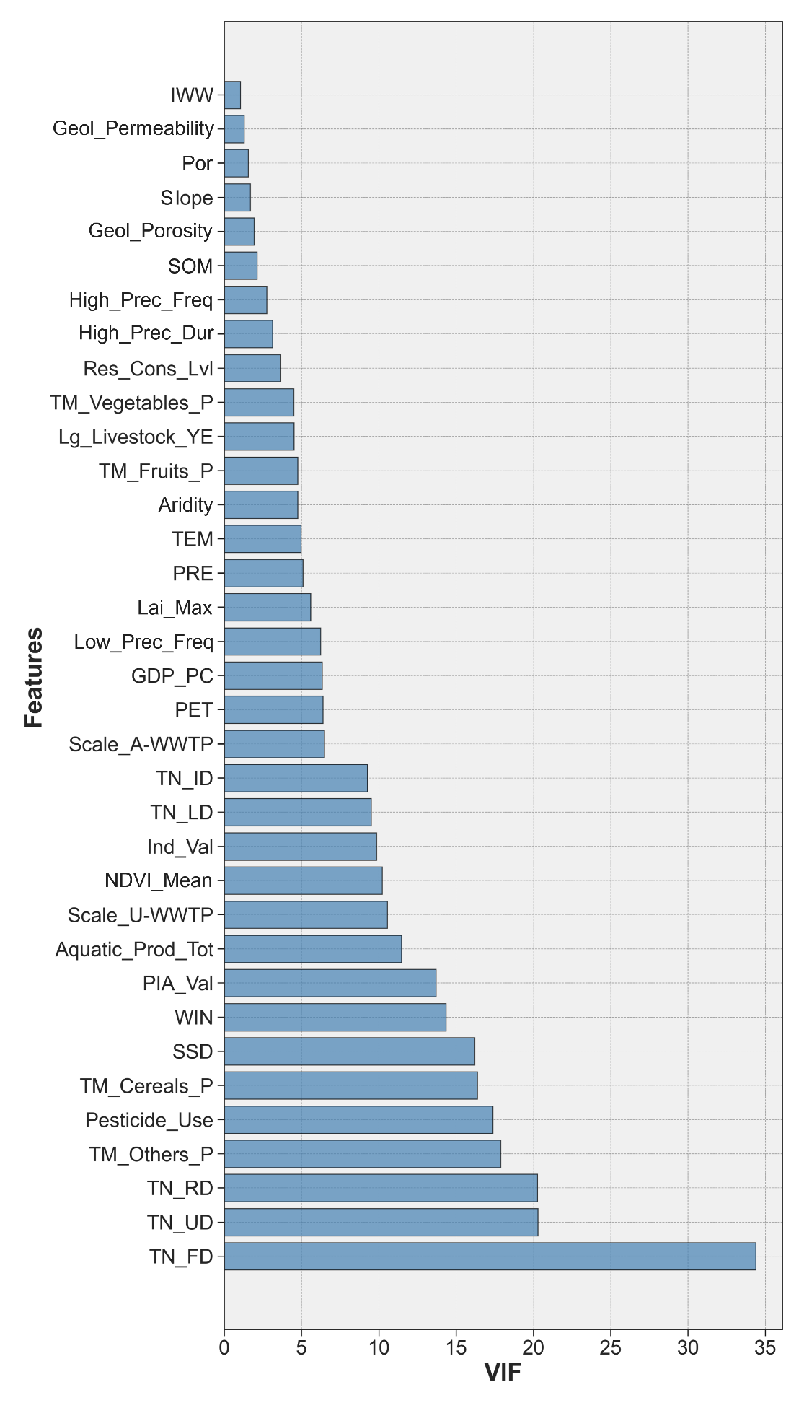
Fig. S1. Distribution of VIF for the final 35 predictor variables selected for modeling.

References
Breiman, L. (2001). Random Forests. Machine Learning, 45(1), 5–32. https://doi.org/10.1023/A:1010933404324
Breiman, L., Friedman, J., Olshen, R. A., & Stone, C. J. (2017). Classification and Regression Trees. New York: Chapman and Hall/CRC. https://doi.org/10.1201/9781315139470
Chen, T., & Guestrin, C. (2016). XGBoost: A Scalable Tree Boosting System. In Proceedings of the 22nd ACM SIGKDD International Conference on Knowledge Discovery and Data Mining (pp. 785–794). New York, NY, USA: Association for Computing Machinery. https://doi.org/10.1145/2939672.2939785
Kleiber, C., & Zeileis, A. (2008). Linear Regression. In Applied Econometrics with R (pp. 1–38). New York, NY: Springer New York. https://doi.org/10.1007/978-0-387-77318-6_3
Xu, C., Liu, X., Wang, H., Li, Y., Jia, W., Qian, W., et al. (2021). A study of predicting irradiation-induced transition temperature shift for RPV steels with XGBoost modeling. Nuclear Engineering and Technology, 53(8), 2610–2615. https://doi.org/10.1016/j.net.2021.02.015

