Supplement

Supplementary Table 1: HILIC elution gradient and solvent flow
 | HILIC Elution Gradient
Flow 0.700mL/min | Phase A (%) | Phase B (%)
Start | 0 | 100
0.10 min | 0 | 100
5.00 min | 20 | 80
6.00 min | 50 | 50
6.50 min | 50 | 50
7.00 min | 0 | 100
10.00 min (end) | 0 | 100

Supplementary Table 2: RPC elution gradient and solvent flow
 | C18 Elution Gradient
Flow 0.400mL/min | Phase A (%) | Phase B (%)
Start | 60 | 40
2.00 min | 57 | 43
2.10 min | 50 | 50
12.00 min | 46 | 54
12.10 min | 30 | 70
18.00 min | 1 | 99
18.10 min | 60 | 40
20.00 min (end) | 60 | 40

Full scan mass spectrometry data were acquired in a mass range of m/z 50-1200. For positive electrospray ionisation, the analyser was set to sensitivity mode, with capillary 2.0kV, sampling cone 30, desolvation temperature 600°C, ion source temperature 120°C and desolvation gas flow 800L/h. For the negative ionisation mode, the analyser was set to sensitivity mode, with capillary 1.5kV, sampling cone 30, desolvation temperature 600°C, ion source temperature 120°C and desolvation gas flow 800L/h.

Supplementary Table 3: Top 50 features different between cases and controls detected using univariate analysis, ranked in order of fold change. Analytical features (Feature) were named according to chromatographic retention time, followed by the reported mass to charge ratio (m/z).
Feature | Mode | Identification | Mass error (ppm) | MetaScope score | Fold change (case/control) | p value
0.65_487.2201m/z | C18 ESI- | 6-bromo-5E,9Z,13Z,24Z-heptacosatetraenoic acid | 1.605 | 28.9 | 14.05 | <0.001
0.46_405.1952m/z | HILIC ESI- | P-[2-(diethylamino)-1,3,2-benzoxazaphosphol-3(2H)-yl]-N,N,N',N'-tetraethylphosphonous diamide | -0.607 | 39.2 | 7.36 | <0.001
0.54_151.0406m/z | C18 ESI- | 4-(methylamino)butyrate | 0.338 | 39.6 | 6.06 | <0.001
 |  | L-valinate | 0.338 | 39.6
 |  | D-valinate | 0.338 | 39.6
 |  | valinate | 0.338 | 39.6
 |  | L-prolinium | 0.338 | 39.6
 |  | D-prolinium | 0.338 | 39.6
 |  | prolinium | 0.338 | 39.6
 |  | (4,4-dimethyl-1,3-oxazolidin-3-yl)oxidanyl | 0.352 | 39.6
0.65_547.2373m/z | C18 ESI- | 2-O-(beta-D-galactopyranosyl-  (1->6)-beta-D-galactopyranosyl)  2S-hydroxyundecanoic acid | 0.223 | 36.7 | 5.85 | <0.001
0.52_447.1983m/z | C18 ESI- | 4-ethyl-5-methyl-2-(  1H-tetrazol-5-yl)-1,2-  dihydro-3H-pyrazol-3-one | 3.067 | 38.6 | 4.80 | <0.001
0.30_246.9561m/z | HILIC ESI- | acesulfame K | 1.190 | 36.6 | 4.67 | <0.001
0.46_375.1850m/z | HILIC ESI- | 1-chloro-2-[2-(2-chloroethoxy)ethoxy]tetradecane | 3.224 | 37.2 | 4.65 | <0.001
0.64_375.1811m/z | C18 ESI- | N-(4-butoxy-3-chloro-5-ethoxybenzyl)-1-hydroxy-2-methyl-2-propanaminium | -0.323 | 38.1 | 4.11 | <0.001
 |  | (2R)-3-(4-chloro-2-isopropyl-5-methylphenoxy)-2-hydroxy-N-[(2S)-1-methoxy-2-propanyl]-1-propanaminium | -0.323 | 38.1
 |  | (2S)-3-(4-chloro-2-isopropyl-5-methylphenoxy)-2-hydroxy-N-[(2S)-1-methoxy-2-propanyl]-1-propanaminium | -0.323 | 38.1
 |  | (2R)-3-(4-chloro-2-isopropyl-5-methylphenoxy)-2-hydroxy-N-[(2R)-1-methoxy-2-propanyl]-1-propanaminium | -0.323 | 38.1
 |  | (2S)-3-(4-chloro-2-isopropyl-5-methylphenoxy)-2-hydroxy-N-[(2R)-1-methoxy-2-propanyl]-1-propanaminium | -0.323 | 38.1
 |  | (2S)-N-[(2S)-3-(4-chloro-2-isopropyl-5-methylphenoxy)-2-hydroxypropyl]-1-hydroxy-2-butanaminium | -0.323 | 38.1
 |  | (2R)-N-[(2S)-3-(4-chloro-2-isopropyl-5-methylphenoxy)-2-hydroxypropyl]-1-hydroxy-2-butanaminium | -0.323 | 38.1
 |  | (2R)-N-[(2R)-3-(4-chloro-2-isopropyl-5-methylphenoxy)-2-hydroxypropyl]-1-hydroxy-2-butanaminium | -0.323 | 38.1
0.62_442.9770m/z | C18 ESI- | 5-(1-carboxy-1-phosphonooxy-ethoxyl)-shikimate-3-phosphate | 1.799 | 37.4 | 3.95 | 0.009
0.65_412.2446n | C18 ESI- | LPC(10:0) | -4.470 | 38.2 | 3.74 | <0.001
0.53_548.1201n | C18 ESI- | N,N'-[1,3-Phenylenebis(methylene)]bis[2-(2,3,5,6-tetrafluorophenyl)hydrazinecarboxamide] | -1.174 | 37.7 | 3.71 | 0.001
0.58_405.0003m/z | C18 ESI- | eckstolonol | -4.379 | 36.4 | 3.19 | <0.001
0.53_321.1285n | C18 ESI- | intriptyline hydrochloride | 0.245 | 33.4 | 3.15 | 0.004
0.66_452.2385n | C18 ESI- | tafluprost | 2.397 | 37.3 | 3.14 | 0.015
0.33_366.9758m/z | HILIC ESI- | L-serine O-sulfate(1-) | -0.266 | 38.6 | 3.14 | <0.001
0.64_218.9831m/z | C18 ESI- | thorium | 4.016 | 39.1 | 3.01 | <0.001
0.33_151.0470m/z | HILIC ESI- | hydroxyurea | -1.979 | 38.2 | 3.00 | <0.001
0.58_90.0319n | C18 ESI- | 1,2-dimethyldisilane | -2.461 | 37.8 | 2.89 | <0.001
 |  | 1,2-ethanediyldisilane | -2.461 | 37.8
 |  | 1,1-dimethyldisilane | -2.461 | 37.8
0.58_472.9879m/z | C18 ESI- | C.I. food red 1 | -1.338 | 35.5 | 2.86 | <0.001
0.62_291.0786m/z | C18 ESI- | 8,9,10,11-tetrafluoro-8E,10E-dodecadien-1-ol | 2.423 | 38.9 | 2.77 | <0.001
0.53_633.2851m/z | C18 ESI- | 3'-amino-3'-deoxy-  N(6),N(6)-dimethyladenosine | -1.985 | 36.7 | 2.70 | <0.001
2.78_386.2864m/z | HILIC ESI+ | spergualin | -2.529 | 35.8 | 2.68 | <0.001
0.66_200.0598m/z | C18 ESI- | 3-(2-methyl-1,3-dioxolan-2-yl)propanoic acid | 0.707 | 38.2 | 2.68 | <0.001
0.52_151.0628n | C18 ESI- | 2-(1,3,2-dioxaphospholan-2-yl)-1,1-dimethylhydrazinium | -1.756 | 38.7 | 2.66 | <0.001
0.37_248.1068n | HILIC ESI- | N-(4-fluorophenyl)-3-(1H-1,2,4-triazol-1-yl)butanamide | -2.101 | 37.8 | 2.64 | 0.006
 |  | N-(4-fluorophenyl)-2-methyl-3-(1H-1,2,4-triazol-1-yl)propanamide | -2.101 | 37.8
 |  | 1-(1,3-dimethyl-1H-pyrazol-4-yl)-3-(4-fluorophenyl)urea | -2.101 | 37.8
 |  | N~2~-{[5-(4-fluorophenyl)-1H-pyrazol-4-yl]methyl}glycinamide | -2.101 | 37.8
 |  | MFCD03933285 | -2.101 | 37.8
 |  | 2-(5-fluoro-2-methylphenyl)-1,5,6,7-tetrahydro[1,2,4]triazolo[4,3-a]pyrimidin-3(2H)-one | -2.101 | 37.8
 |  | 2-{[6-(4-fluorophenyl)-3-methyl-1,2,4-triazin-5-yl]amino}ethanol | -2.101 | 37.8
 |  | 3-(ethylamino)-6-(4-fluorobenzyl)-1,2,4-triazin-5(2H)-one | -2.101 | 37.8
 |  | (3S)-N-(4-fluorophenyl)-3-(1H-1,2,4-triazol-1-yl)butanamide | -2.101 | 37.8
 |  | (3R)-N-(4-fluorophenyl)-3-(1H-1,2,4-triazol-1-yl)butanamide | -2.101 | 37.8
 |  | 1-[1-(4-fluorophenyl)-4,5-dihydro-1H-1,2,3-triazol-5-yl]-2-pyrrolidinone | -2.101 | 37.8
 |  | (6-fluoro-1H-benzimidazol-2-yl)(1-piperazinyl)methanone | -2.101 | 37.8
 |  | 3-{[4-(2-fluoro-4-pyridinyl)-2-pyrimidinyl]amino}-1-propanol | -2.101 | 37.8
0.52_239.0478n | C18 ESI- | S-7H-purin-6-yl-L-cysteine | 0.299 | 37.2 | 2.63 | <0.001
 |  | methyl [(7-amino[1,2,4]triazolo[1,5-c]pyrimidin-5-yl)thio]acetate | 0.299 | 37.2
 |  | (2R)-2-[3-(1H-pyrazol-5-yl)-5-thioxo-1,5-dihydro-4H-1,2,4-triazol-4-yl]propanoic acid | 0.299 | 37.2
 |  | 2-{[5-(2-furyl)-1H-1,2,4-triazol-3-yl]sulfanyl}acetohydrazide | 0.299 | 37.2
 |  | 2-{2-[1-(4-methyl-1,2,5-oxadiazol-3-yl)vinyl]hydrazino}-1,3-thiazol-4(5H)-one | 0.299 | 37.2
 |  | 6-[4-(2-hydroxyethyl)-5-thioxo-4,5-dihydro-1H-1,2,4-triazol-3-yl]-2(1H)-pyrazinone | 0.299 | 37.2
 |  | 3-(4-aminophenyl)-1H-1,2,4-triazole-5-sulfonamide | 0.299 | 37.2
 |  | 1,3-dimethyl-6-(2H-1,2,3-triazol-4-ylsulfanyl)-2,4(1H,3H)-pyrimidinedione | 0.299 | 37.2
 |  | 5-(4-morpholinyl)[1,2,5]thiadiazolo[3,4-d]pyrimidin-7(3H)-one | 0.299 | 37.2
 |  | 7-(4-morpholinyl)[1,2,5]thiadiazolo[3,4-d]pyrimidin-5(3H)-one | 0.299 | 37.2
 |  | propanoic acid, 2-[(6-amino-9H-purin-8-yl)thio]- | 0.299 | 37.2
 |  | 5,7-dimethyl-3-(methylthio)pyrimido[4,5-e][1,2,4]triazine-6,8(5H,7H)-dione | 0.299 | 37.2
 |  | 3-[(2-amino-7H-purin-6-yl)sulfanyl]propanoic acid | 0.299 | 37.2
 |  | N''-(4-nitrobenzylidene)thiocarbonohydrazide | 0.299 | 37.2
 |  | ethyl (7-amino[1,2,3]thiadiazolo[5,4-b]pyridin-5-yl)carbamate | 0.299 | 37.2
 |  | N''-(2-nitrobenzylidene)thiocarbonohydrazide | 0.299 | 37.2
 |  | 1-methyl-5-[(1-methyl-1H-imidazol-2-yl)sulfanyl]-4-nitro-1H-imidazole | 0.299 | 37.2
 |  | N''-(3-nitrobenzylidene)thiocarbonohydrazide | 0.299 | 37.2
 |  | 6-(4-morpholinyl)[1,3]thiazolo[4,5-d][1,2,3]triazin-4(1H)-one | 0.299 | 37.2
 |  | [(6-amino-7-methyl-7H-purin-2-yl)sulfanyl]acetato | 0.299 | 37.2
 |  | 1-[amino(nitroamino)methylene]-3-phenylthiourea | 0.299 | 37.2
 |  | ethyl (4-thioxo-2,4-dihydro-1H-[1,2,3]triazolo[4,5-c]pyridin-6-yl)carbamate | 0.299 | 37.2
 |  | N'-(1,3-benzothiazol-2-yl)-2,2-dihydroxyhydrazinecarboximidamide | 0.299 | 37.2
 |  | 2-[(2-amino-5H-purin-6-yl)sulfanyl]propanoic acid | 0.299 | 37.2
 |  | N-allyl-5H-purine-6-sulfonamide | 0.299 | 37.2
 |  | 2-[(2-amino-7H-purin-6-yl)sulfanyl]propanoic acid | 0.299 | 37.2
 |  | 5-amino-3-[(2-oxopropyl)sulfanyl][1,2,4]triazolo[4,3-a]pyrimidin-7(1H)-one | 0.299 | 37.2
 |  | 1H-pyrazole-3-carboxylic acid, 5-(5-mercapto-4-methyl-4H-1,2,4-triazol-3-yl)-1-methyl- | 0.299 | 37.2
 |  | N-(1H-tetrazol-5-yl)-p-toluenesulfonamide | 0.299 | 37.2
 |  | 2-[3-(1H-pyrazol-3-yl)-5-thioxo-1,5-dihydro-4H-1,2,4-triazol-4-yl]propanoic acid | 0.299 | 37.2
 |  | 4-(4-amino-2H-1,2,3-triazol-2-yl)benzenesulfonamide | 0.299 | 37.2
 |  | 6-(4-nitrophenyl)-1,2,4,5-tetrazinane-3-thione | 0.299 | 37.2
 |  | 2-methyl-5-(1H-tetrazol-1-yl)benzenesulfonamide | 0.299 | 37.2
 |  | N-allyl-7H-purine-6-sulfonamide | 0.299 | 37.2
 |  | 2-{(2Z)-2-[1-(4-methyl-1,2,5-oxadiazol-3-yl)ethylidene]hydrazino}-1,3-thiazol-4(5H)-one | 0.299 | 37.2
 |  | 2-{(2E)-2-[1-(4-methyl-1,2,5-oxadiazol-3-yl)ethylidene]hydrazino}-1,3-thiazol-4(5H)-one | 0.299 | 37.2
 |  | 6-nitro[1,2,4]triazolo[1,5-a]pyrimidin-2-yl propyl sulfide | 0.299 | 37.2
 |  | 2-{2-[1-(4-methyl-1,2,5-oxadiazol-3-yl)ethylidene]hydrazino}-1,3-thiazol-4(5H)-one | 0.299 | 37.2
 |  | N-methyl-2-[(4-oxo-2,4-dihydro-1H-pyrazolo[3,4-d]pyrimidin-6-yl)sulfanyl]acetamide | 0.299 | 37.2
 |  | 2-[(5-methyl-7-oxo-1,7-dihydro[1,2,4]triazolo[4,3-a]pyrimidin-3-yl)sulfanyl]acetamide | 0.299 | 37.2
 |  | methyl [(6-amino-7H-purin-8-yl)sulfanyl]acetate | 0.299 | 37.2
 |  | 6-methyl-3-[(2-oxopropyl)sulfanyl][1,2,4]triazolo[4,3-b][1,2,4]triazin-7(1H)-one | 0.299 | 37.2
 |  | N-[3-(1H-tetrazol-1-yl)phenyl]methanesulfonamide | 0.299 | 37.2
 |  | N-(5-methyl-1,2-oxazol-3-yl)-2-(1H-1,2,4-triazol-5-ylsulfanyl)acetamide | 0.299 | 37.2
 |  | 1,2,4-triazine-3,5-diol, 6-[(3,5-dimethyl-1H-pyrazol-4-yl)thio]- | 0.299 | 37.2
 |  | 3-[(6-amino-1H-purin-8-yl)sulfanyl]propanoic acid | 0.299 | 37.2
 |  | 3-methyl-4-(1H-tetrazol-1-yl)benzenesulfonamide | 0.299 | 37.2
 |  | N''-[(E)-(4-nitrophenyl)methylene]thiocarbonohydrazide | 0.299 | 37.2
 |  | N''-[(E)-(3-nitrophenyl)methylene]thiocarbonohydrazide | 0.299 | 37.2
 |  | N''-[(E)-(2-nitrophenyl)methylene]thiocarbonohydrazide | 0.299 | 37.2
 |  | S-(purin-6-yl)cysteine | 0.299 | 37.2
 |  | (2R,3R,4R)-4-(6-amino-9H-purin-9-yl)-2,3-thietanediol | 0.299 | 37.2
 |  | 2-{[4-amino-5-(2-furyl)-4H-1,2,4-triazol-3-yl]sulfanyl}acetamide | 0.299 | 37.2
 |  | 4-amino-N-(4H-1,2,4-triazol-4-yl)benzenesulfonamide | 0.299 | 37.2
 |  | (2E)-2-[(4-methyl-5-nitro-2-pyridinyl)methylene]hydrazinecarbothioamide | 0.299 | 37.2
 |  | 4-amino-N-[(E)-amino(cyanoamino)methylene]benzenesulfonamide | 0.299 | 37.2
 |  | 4-[(1-methyl-1H-tetrazol-5-yl)sulfonyl]aniline | 0.299 | 37.2
 |  | (2E)-2-[(4-methyl-3-nitro-2-pyridinyl)methylene]hydrazinecarbothioamide | 0.299 | 37.2
0.53_506.1556n | C18 ESI- | darifenacin hydrobromide | -2.458 | 28.5 | 2.58 | <0.001
0.58_233.9877n | C18 ESI- | BGP | -1.678 | 38.9 | 2.57 | <0.001
0.53_539.1387m/z | C18 ESI- | (3-aminopropyl)(L-aspartyl-1-amino)phosphoryl-5'-adenosine | 0.324 | 38.8 | 2.53 | <0.001
2.38_373.3125m/z | HILIC ESI+ | 1-(6-fluorohexyl)-2-methyl-4,5-dihydro-1H-imidazole | -3.252 | 37.1 | 2.49 | <0.001
0.53_326.0873m/z | C18 ESI- | N~2~-(3-bromobenzoyl)-N~5~-(diaminomethylene)-L-ornithyl-N~5~-(diaminomethylene)-L-ornithyl-4-chloro-D-phenylalanyl-L-cysteinyl-L-tryptophanamide | 0.184 | 24 | 2.47 | 0.001
0.59_255.0846m/z | C18 ESI- | indane-1,3-dione, 2-allyl-2-(trimethylsilyloxy)- | -0.328 | 37.5 | 2.47 | <0.001
 |  | 5,5-dimethoxy-5,10-dihydrodibenzo[b,e]siline | -0.370 | 37.5
 |  | 1,3-dioxo-2-[3-(trimethylsilyl)prop-2-ylium-1-yl]-2-indanolate | -0.328 | 37.5
 |  | 2-hydroxy-2-[(2Z)-3-(trimethylsilyl)-2-propen-1-yl]-1H-indene-1,3(2H)-dione | -0.328 | 37.5
 |  | 2-hydroxy-2-[(2E)-3-(trimethylsilyl)-2-propen-1-yl]-1H-indene-1,3(2H)-dione | -0.328 | 37.5
 |  | [4-(1,3-benzodioxol-5-ylmethyl)-3-furyl](trimethyl)silane | -0.328 | 37.5
 |  | [(E)-1,2-diphenylvinyl](methyl)silanediol | -0.370 | 37.5
 |  | 2-hydroxy-2-[(1E)-3-(trimethylsilyl)-1-propen-1-yl]-1H-indene-1,3(2H)-dione | -0.328 | 37.5
 |  | 2-[(trimethylsilyl)oxy]-1(2H)-acenaphthylenone | -0.370 | 37.5
 |  | 2-[dimethyl(phenyl)silyl]benzoic acid | -0.370 | 37.5
 |  | 5-(2-furyl)-2,2-dimethyl-3-phenyl-2,5-dihydro-1,2-oxasilole | -0.370 | 37.5
0.54_199.0073m/z | C18 ESI- | homomethioninate | -0.802 | 37.6 | 0.40 | <0.001
1.71_889.1485m/z | C18 ESI- | 4-{2-[(3-nitrobenzoyl)amino]  phenoxy}phthalic acid | 0.279 | 36.1 | 0.39 | <0.001
5.88_738.5066m/z | C18 ESI- | PC(15:1(9Z)/16:0) | 1.478 | 52.6 | 0.39 | <0.001
6.96_899.5642m/z | C18 ESI- | 2,2'-methylenebis(5,7-dipropyl[1,2,4]triazolo[1,5-a]pyrimidine) | 0.437 | 38.9 | 0.39 | <0.001
 |  | N~4~,N~6~-bis[3-(aminomethyl)benzyl]-N~2~,N~2~-diethyl-1,3,5-triazine-2,4,6-triamine | 0.437 | 38.9
 |  | N,N'-bis(1H-benzotriazol-1-ylmethyl)-N,N'-diisobutylmethanediamine | 0.437 | 38.9
 |  | N,N'-bis(1H-benzotriazol-1-ylmethyl)-N,N'-dibutylmethanediamine | 0.437 | 38.9
 |  | N~2~-(4-aminocyclohexyl)-9-cyclopentyl-N~6~-[2-(3-pyridinyl)ethyl]-9H-purine-2,6-diamine | 0.437 | 38.9
 |  | N~2~-(4-aminocyclohexyl)-N~6~-(1-benzyl-4-piperidinyl)-7H-purine-2,6-diamine | 0.437 | 38.9
 |  | (2S)-3-amino-2-[(8Z)-8-heptadecenoylamino]propyl dihydrogen phosphate | -0.288 | 38.9
 |  | (2R)-3-amino-2-[(8Z)-8-heptadecenoylamino]propyl dihydrogen phosphate | -0.288 | 38.9
 |  | N,N'-(methanediyldicyclohexane-4,1-diyl)dipyrazine-2-carboximidamide | 0.437 | 38.9
3.46_138.0554m/z | HILIC ESI+ | 4-fluoro-L-threonine | -4.982 | 38.1 | 0.39 | <0.001
3.69_512.3341m/z | HILIC ESI+ | PG(O-16:0/0:0) | -1.330 | 38.6 | 0.38 | <0.001
1.71_753.1768m/z | C18 ESI- | 4-[(1,1,1,3,3,3-hexafluoro-2-propanyl)oxy]-6-(4-morpholinyl)-1,3,5-triazin-2-amine | -0.647 | 37.9 | 0.38 | <0.001
1.71_821.1636m/z | C18 ESI- | 3,5-bis(methoxycarbonyl)-4-(2-methoxy-2-oxoethyl)-1,2-oxazol-2(3H)-olate | 0.342 | 38.1 | 0.38 | <0.001
4.62_1061.4775m/z | C18 ESI- | 2-(4-{[1-(difluoromethyl)-1H-imidazol-2-yl]methyl}-1-piperazinyl)-N-(5-methyl-1,2-oxazol-3-yl)acetamide | -0.002 | 39 | 0.38 | <0.001
 |  | 4-({[1-(difluoromethyl)-1H-pyrazol-5-yl]carbonyl}amino)-1-ethyl-N-isobutyl-1H-pyrazole-3-carboxamide | -0.002 | 39
5.45_768.5425m/z | C18 ESI- | N-(2-hydroxyheptadecanoyl)-1-O-beta-D-glucosyl-4-hydroxy-15-methylhexadecasphinganine | 3.692 | 32.4 | 0.38 | <0.001
1.23_240.7703n | C18 ESI- |  |  |  | 0.37 | <0.001
5.56_876.5745m/z | C18 ESI- | phosphatidylserine | 1.087 | 35.2 | 0.37 | <0.001
3.50_540.3651m/z | HILIC ESI+ | PG(O-18:0/0:0) | -1.711 | 36.8 | 0.36 | <0.001
10.34_784.5848m/z | C18 ESI- | 1,1-diiodo-2,2-dinitroethene | -3.873 | 36 | 0.33 | <0.001
3.20_538.3859m/z | HILIC ESI+ | N-cyclohexyl-N'-(2-(4-morpholinyl)ethyl)carbodiimide | 4.087 | 38.2 | 0.33 | <0.001
5.46_857.5566n | C18 ESI- | 6a-(allyloxy)-6-[dodecanoyl(propyl)amino]-1,2-bis(4-hydroxybutyl)-4-(methoxyimino)-1,2,4,5,6,6a,11b,11c-octahydrobenzo[kl]xanthen-10-yl benzylcarbamate | 1.351 | 35 | 0.30 | <0.001
0.52_305.0327m/z | C18 ESI- | 1-C-(6-thioxo-1,2,4,5-tetrazinan-3-yl)pentitol | -0.243 | 38.8 | 0.29 | 0.001
 |  | (5R)-5-C-(6-thioxo-1,2,4,5-tetrazinan-3-yl)-D-ribitol | -0.243 | 38.8
 |  | (5R)-5-C-(6-thioxo-1,2,4,5-tetrazinan-3-yl)-D-arabinitol | -0.243 | 38.8
 |  | (5R)-5-C-(6-thioxo-1,2,4,5-tetrazinan-3-yl)-D-xylitol | -0.243 | 38.8
 |  | (1R)-1-C-(6-thioxo-1,2,4,5-tetrazinan-3-yl)-D-arabinitol | -0.243 | 38.8
0.41_253.0903m/z | HILIC ESI- | ammeline | -4.953 | 36.5 | 0.08 | 0.007

Supplementary Table 4: Top 40 features from oPLS-DA analysis comparing cases to controls for all 4 modes
Feature | Neutral mass (Da) | Charge | m/z | Retention time (min) | Peak width (min) | Fold change | VIP score | Mode
3.39_1072.6252m/z |  | 1 | 1072.6252 | 3.39 | 0.07 | 0.41 | 10.74 | HILIC ESI+
3.37_1164.6230n | 1164.6230 | 1 | 1197.6236 | 3.37 | 0.12 | 0.56 | 10.73 | HILIC ESI+
3.39_1098.6265m/z |  | 1 | 1098.6265 | 3.39 | 0.10 | 0.48 | 9.58 | HILIC ESI+
3.38_1059.6406m/z |  | 2 | 1059.6406 | 3.38 | 0.08 | 0.47 | 9.50 | HILIC ESI+
3.38_789.9845m/z |  | 2 | 789.9845 | 3.38 | 0.07 | 0.50 | 9.41 | HILIC ESI+
3.38_1122.6245m/z |  | 1 | 1122.6245 | 3.38 | 0.07 | 0.46 | 9.40 | HILIC ESI+
3.39_1131.7405m/z |  | 2 | 1131.7405 | 3.39 | 0.06 | 0.46 | 9.25 | HILIC ESI+
3.38_2167.2368n | 2167.2368 | 2 | 1106.6413 | 3.38 | 0.10 | 0.50 | 8.96 | HILIC ESI+
3.38_845.9706m/z |  | 2 | 845.9706 | 3.38 | 0.07 | 0.62 | 8.72 | HILIC ESI+
3.20_538.3859m/z |  | 1 | 538.3859 | 3.20 | 0.14 | 0.33 | 8.70 | HILIC ESI+
3.39_1071.6160m/z |  | 2 | 1071.6160 | 3.39 | 0.07 | 0.50 | 8.66 | HILIC ESI+
2.90_678.2953m/z |  | 1 | 678.2953 | 2.90 | 0.14 | 0.58 | 8.50 | HILIC ESI+
3.38_1093.6312m/z |  | 2 | 1093.6312 | 3.38 | 0.07 | 0.51 | 8.35 | HILIC ESI+
3.38_1015.6684m/z |  | 1 | 1015.6684 | 3.38 | 0.09 | 0.41 | 8.30 | HILIC ESI+
3.37_519.5646n | 519.5646 | 1 | 520.5719 | 3.37 | 0.10 | 0.56 | 8.20 | HILIC ESI+
3.38_823.9698m/z |  | 2 | 823.9698 | 3.38 | 0.06 | 0.61 | 8.12 | HILIC ESI+
3.39_785.9642n | 785.9642 | 2 | 799.9758 | 3.39 | 0.10 | 0.50 | 8.03 | HILIC ESI+
3.37_642.2455m/z |  | 1 | 642.2455 | 3.37 | 0.07 | 0.63 | 7.96 | HILIC ESI+
3.38_659.3982m/z |  | 1 | 659.3982 | 3.38 | 0.14 | 0.55 | 7.65 | HILIC ESI+
3.39_997.6775m/z |  | 1 | 997.6775 | 3.39 | 0.08 | 0.51 | 7.56 | HILIC ESI+
1.47_901.1297m/z |  | 3 | 901.1297 | 1.47 | 0.23 | 1.25 | -1.81 | HILIC ESI+
2.57_314.2306m/z |  | 1 | 314.2306 | 2.57 | 0.19 | 1.13 | -1.81 | HILIC ESI+
1.19_692.4763m/z |  | 2 | 692.4763 | 1.19 | 0.10 | 0.98 | -1.83 | HILIC ESI+
1.57_973.6709m/z |  | 2 | 973.6709 | 1.57 | 0.31 | 1.19 | -1.83 | HILIC ESI+
1.48_651.4093m/z |  | 2 | 651.4093 | 1.48 | 0.13 | 1.06 | -1.84 | HILIC ESI+
0.72_897.6246n | 897.6246 | 1 | 880.6213 | 0.72 | 0.21 | 1.15 | -1.84 | HILIC ESI+
0.74_212.1907n | 212.1907 | 1 | 235.1800 | 0.74 | 0.46 | 0.95 | -1.85 | HILIC ESI+
1.98_774.1788n | 774.1788 | 1 | 792.2126 | 1.98 | 0.15 | 1.38 | -1.87 | HILIC ESI+
1.66_1163.7209m/z |  | 1 | 1163.7209 | 1.66 | 0.06 | 1.91 | -1.88 | HILIC ESI+
1.94_830.9051m/z |  | 3 | 830.9051 | 1.94 | 0.20 | 1.29 | -1.98 | HILIC ESI+
2.39_368.2783m/z |  | 1 | 368.2783 | 2.39 | 0.22 | 1.89 | -2.07 | HILIC ESI+
2.45_343.2699n | 343.2699 | 1 | 344.2772 | 2.45 | 0.18 | 1.48 | -2.07 | HILIC ESI+
0.94_1163.7351m/z |  | 1 | 1163.7351 | 0.94 | 0.03 | 1.56 | -2.19 | HILIC ESI+
1.17_655.9377m/z |  | 2 | 655.9377 | 1.17 | 0.15 | 1.16 | -2.20 | HILIC ESI+
3.53_304.2105m/z |  | 1 | 304.2105 | 3.53 | 0.15 | 1.00 | -2.34 | HILIC ESI+
5.84_287.2436m/z |  | 1 | 287.2436 | 5.84 | 0.09 | 2.22 | -3.02 | HILIC ESI+
2.36_370.2938m/z |  | 1 | 370.2938 | 2.36 | 0.56 | 1.84 | -3.18 | HILIC ESI+
2.32_398.3251m/z |  | 1 | 398.3251 | 2.32 | 0.15 | 2.07 | -3.52 | HILIC ESI+
2.38_373.3125m/z |  | 1 | 373.3125 | 2.38 | 0.07 | 2.49 | -4.58 | HILIC ESI+
2.78_386.2864m/z |  | 1 | 386.2864 | 2.78 | 0.08 | 2.68 | -5.75 | HILIC ESI+
1.22_394.0854n | 394.0854 | 1 | 431.0520 | 1.22 | 0.32 | 0.68 | 2.42 | HILIC ESI-
1.21_356.9903m/z |  | 1 | 356.9903 | 1.21 | 0.07 | 0.67 | 1.88 | HILIC ESI-
1.21_440.9474m/z |  | 3 | 440.9474 | 1.21 | 0.10 | 0.79 | 1.88 | HILIC ESI-
3.36_594.3755m/z |  | 1 | 594.3755 | 3.36 | 0.06 | 0.58 | 1.87 | HILIC ESI-
3.31_232.6621n | 232.6621 | 1 | 524.3365 | 3.31 | 0.11 | 0.53 | 1.83 | HILIC ESI-
1.22_568.9917m/z |  | 2 | 568.9917 | 1.22 | 0.09 | 0.77 | 1.83 | HILIC ESI-
2.55_330.0827m/z |  | 1 | 330.0827 | 2.55 | 0.25 | 0.67 | 1.77 | HILIC ESI-
1.22_542.1477n | 542.1477 | 1 | 541.1405 | 1.22 | 0.26 | 0.63 | 1.74 | HILIC ESI-
3.36_608.3184m/z |  | 1 | 608.3184 | 3.36 | 0.18 | 0.54 | 1.72 | HILIC ESI-
3.64_556.3252m/z |  | 1 | 556.3252 | 3.64 | 0.08 | 0.56 | 1.71 | HILIC ESI-
3.16_541.2657m/z |  | 1 | 541.2657 | 3.16 | 0.13 | 1.50 | 1.71 | HILIC ESI-
1.22_655.9617n | 655.9617 | 1 | 654.9545 | 1.22 | 0.06 | 0.93 | 1.67 | HILIC ESI-
3.00_539.2499m/z |  | 1 | 539.2499 | 3.00 | 0.22 | 1.93 | 1.66 | HILIC ESI-
5.51_131.0895m/z |  | 1 | 131.0895 | 5.51 | 0.50 | 0.74 | 1.64 | HILIC ESI-
3.80_231.0777n | 231.0777 | 1 | 230.0704 | 3.80 | 0.34 | 0.76 | 1.64 | HILIC ESI-
1.22_550.9833m/z |  | 2 | 550.9833 | 1.22 | 0.07 | 0.85 | 1.58 | HILIC ESI-
1.22_291.9878n | 291.9878 | 1 | 336.9860 | 1.22 | 0.09 | 0.76 | 1.57 | HILIC ESI-
3.80_104.0420m/z |  | 1 | 104.0420 | 3.80 | 0.52 | 0.76 | 1.56 | HILIC ESI-
6.15_97.0235n | 97.0235 | 1 | 290.0420 | 6.15 | 0.29 | 0.70 | 1.51 | HILIC ESI-
1.22_572.9891m/z |  | 3 | 572.9891 | 1.22 | 0.05 | 0.80 | 1.50 | HILIC ESI-
3.02_221.0184m/z |  | 1 | 221.0184 | 3.02 | 0.31 | 1.58 | -1.14 | HILIC ESI-
3.13_428.9642m/z |  | 1 | 428.9642 | 3.13 | 0.04 | 1.34 | -1.19 | HILIC ESI-
2.27_857.5112m/z |  | 1 | 857.5112 | 2.27 | 0.06 | 0.73 | -1.20 | HILIC ESI-
2.17_922.6724m/z |  | 1 | 922.6724 | 2.17 | 0.11 | 1.39 | -1.25 | HILIC ESI-
0.40_196.0504m/z |  | 1 | 196.0504 | 0.40 | 0.05 | 2.44 | -1.40 | HILIC ESI-
0.45_471.1655m/z |  | 1 | 471.1655 | 0.45 | 0.04 | 2.37 | -1.45 | HILIC ESI-
0.36_177.0987m/z |  | 1 | 177.0987 | 0.36 | 0.02 | 1.38 | -1.49 | HILIC ESI-
0.38_368.9675m/z |  | 1 | 368.9675 | 0.38 | 0.03 | 1.16 | -1.51 | HILIC ESI-
1.14_689.0200m/z |  | 1 | 689.0200 | 1.14 | 0.28 | 2.21 | -1.59 | HILIC ESI-
0.37_248.1068n | 248.1068 | 1 | 285.0739 | 0.37 | 0.02 | 2.64 | -1.60 | HILIC ESI-
0.52_433.3353m/z |  | 1 | 433.3353 | 0.52 | 0.19 | 1.06 | -1.71 | HILIC ESI-
1.68_358.9624m/z |  | 1 | 358.9624 | 1.68 | 0.31 | 1.92 | -1.82 | HILIC ESI-
0.46_405.1952m/z |  | 1 | 405.1952 | 0.46 | 0.07 | 7.36 | -1.87 | HILIC ESI-
1.14_824.9894m/z |  | 1 | 824.9894 | 1.14 | 0.27 | 1.97 | -1.98 | HILIC ESI-
1.69_426.9484m/z |  | 1 | 426.9484 | 1.69 | 0.25 | 2.21 | -2.27 | HILIC ESI-
1.68_630.9041m/z |  | 1 | 630.9041 | 1.68 | 0.26 | 1.42 | -2.33 | HILIC ESI-
1.14_621.0348m/z |  | 1 | 621.0348 | 1.14 | 0.09 | 1.87 | -2.66 | HILIC ESI-
0.33_151.0470m/z |  | 1 | 151.0470 | 0.33 | 0.05 | 3.00 | -2.86 | HILIC ESI-
0.33_366.9758m/z |  | 1 | 366.9758 | 0.33 | 0.04 | 3.14 | -4.05 | HILIC ESI-
0.30_246.9561m/z |  | 1 | 246.9561 | 0.30 | 0.03 | 4.67 | -4.21 | HILIC ESI-
7.52_184.0743m/z |  | 1 | 184.0743 | 7.52 | 0.02 | 0.67 | 3.87 | C18 ESI+
6.99_412.7783m/z |  | 1 | 412.7783 | 6.99 | 0.19 | 0.64 | 2.26 | C18 ESI+
0.54_226.0458m/z |  | 1 | 226.0458 | 0.54 | 0.07 | 0.60 | 2.12 | C18 ESI+
15.17_580.5308n | 580.5308 | 1 | 603.5336 | 15.17 | 0.94 | 0.59 | 2.07 | C18 ESI+
1.10_476.2743n | 476.2743 | 1 | 459.2486 | 1.10 | 0.16 | 0.66 | 1.98 | C18 ESI+
1.10_495.3344n | 495.3344 | 1 | 496.3417 | 1.10 | 0.19 | 0.64 | 1.92 | C18 ESI+
4.83_769.4779m/z |  | 1 | 769.4779 | 4.83 | 0.31 | 0.68 | 1.92 | C18 ESI+
15.69_886.8003n | 886.8003 | 1 | 909.7896 | 15.69 | 0.21 | 0.65 | 1.92 | C18 ESI+
15.04_891.7422m/z |  | 1 | 891.7422 | 15.04 | 0.23 | 0.61 | 1.90 | C18 ESI+
4.30_846.5239m/z |  | 1 | 846.5239 | 4.30 | 0.16 | 0.59 | 1.85 | C18 ESI+
1.10_563.3190n | 563.3190 | 1 | 586.3082 | 1.10 | 0.10 | 0.74 | 1.80 | C18 ESI+
7.51_901.5789n | 901.5789 | 1 | 902.5862 | 7.51 | 0.49 | 0.75 | 1.78 | C18 ESI+
6.99_785.8770n | 785.8770 | 1 | 786.8842 | 6.99 | 0.31 | 0.68 | 1.74 | C18 ESI+
6.99_753.9476n | 753.9476 | 1 | 787.0094 | 6.99 | 0.27 | 0.70 | 1.73 | C18 ESI+
15.45_884.7802n | 884.7802 | 1 | 902.8188 | 15.45 | 0.24 | 0.67 | 1.73 | C18 ESI+
6.99_184.0745m/z |  | 1 | 184.0745 | 6.99 | 0.26 | 0.70 | 1.72 | C18 ESI+
8.60_877.5805n | 877.5805 | 1 | 878.5878 | 8.60 | 0.64 | 0.74 | 1.69 | C18 ESI+
5.53_873.5471n | 873.5471 | 1 | 874.5544 | 5.53 | 0.25 | 0.75 | 1.68 | C18 ESI+
0.55_572.8345m/z |  | 1 | 572.8345 | 0.55 | 0.07 | 1.02 | 1.66 | C18 ESI+
15.41_290.2863n | 290.2863 | 1 | 603.5363 | 15.41 | 0.26 | 0.70 | 1.63 | C18 ESI+
5.44_883.5530n | 883.5530 | 1 | 848.5391 | 5.44 | 0.36 | 1.17 | -1.06 | C18 ESI+
6.27_694.5135m/z |  | 1 | 694.5135 | 6.27 | 0.30 | 1.27 | -1.15 | C18 ESI+
0.48_895.5466m/z |  | 3 | 895.5466 | 0.48 | 0.08 | 1.10 | -1.22 | C18 ESI+
18.65_436.5737m/z |  | 2 | 436.5737 | 18.65 | 0.10 | 1.12 | -1.31 | C18 ESI+
6.49_867.5457m/z |  | 1 | 867.5457 | 6.49 | 0.14 | 1.17 | -1.37 | C18 ESI+
11.64_833.5924n | 833.5924 | 1 | 856.5814 | 11.64 | 0.24 | 1.06 | -1.37 | C18 ESI+
0.55_333.9299n | 333.9299 | 1 | 378.9010 | 0.55 | 0.06 | 1.27 | -1.39 | C18 ESI+
5.23_889.5309m/z |  | 1 | 889.5309 | 5.23 | 0.14 | 1.16 | -1.42 | C18 ESI+
0.66_573.4055m/z |  | 2 | 573.4055 | 0.66 | 0.14 | 1.09 | -1.71 | C18 ESI+
0.50_794.4864m/z |  | 3 | 794.4864 | 0.50 | 0.06 | 1.11 | -1.72 | C18 ESI+
7.07_893.5607m/z |  | 1 | 893.5607 | 7.07 | 0.19 | 1.19 | -1.79 | C18 ESI+
11.91_809.5929n | 809.5929 | 1 | 810.6002 | 11.91 | 0.26 | 1.20 | -1.83 | C18 ESI+
0.52_249.0871n | 249.0871 | 1 | 282.1206 | 0.52 | 0.03 | 1.49 | -2.01 | C18 ESI+
11.98_836.6237m/z |  | 1 | 836.6237 | 11.98 | 0.14 | 1.32 | -2.14 | C18 ESI+
15.04_189.1648m/z |  | 1 | 189.1648 | 15.04 | 0.03 | 1.05 | -2.23 | C18 ESI+
0.48_847.5108m/z |  | 2 | 847.5108 | 0.48 | 0.08 | 1.13 | -2.33 | C18 ESI+
0.54_1054.6199m/z |  | 2 | 1054.6199 | 0.54 | 0.04 | 1.20 | -2.34 | C18 ESI+
0.48_857.5215m/z |  | 2 | 857.5215 | 0.48 | 0.04 | 1.08 | -2.55 | C18 ESI+
0.48_865.5262m/z |  | 2 | 865.5262 | 0.48 | 0.09 | 1.07 | -2.55 | C18 ESI+
12.09_809.5907n | 809.5907 | 1 | 810.5980 | 12.09 | 0.18 | 1.30 | -3.80 | C18 ESI+
1.71_821.1636m/z |  | 1 | 821.1636 | 1.71 | 0.05 | 0.38 | 7.32 | C18 ESI-
1.71_753.1768m/z |  | 1 | 753.1768 | 1.71 | 0.06 | 0.38 | 6.50 | C18 ESI-
5.46_857.5566n | 857.5566 | 1 | 894.5471 | 5.46 | 0.15 | 0.30 | 6.27 | C18 ESI-
9.24_902.5110m/z |  | 1 | 902.5110 | 9.24 | 0.25 | 0.66 | 6.12 | C18 ESI-
1.23_808.5899m/z |  | 3 | 808.5899 | 1.23 | 0.05 | 0.42 | 6.08 | C18 ESI-
9.24_970.4979m/z |  | 1 | 970.4979 | 9.24 | 0.25 | 0.66 | 5.86 | C18 ESI-
1.23_589.1721m/z |  | 1 | 589.1721 | 1.23 | 0.05 | 0.48 | 5.68 | C18 ESI-
8.48_994.4994m/z |  | 1 | 994.4994 | 8.48 | 0.14 | 0.98 | 5.25 | C18 ESI-
0.66_253.0318m/z |  | 1 | 253.0318 | 0.66 | 0.10 | 1.08 | 5.21 | C18 ESI-
0.63_351.1103m/z |  | 1 | 351.1103 | 0.63 | 0.14 | 0.43 | 5.21 | C18 ESI-
10.34_784.5848m/z |  | 1 | 784.5848 | 10.34 | 0.25 | 0.33 | 5.04 | C18 ESI-
1.29_485.2285m/z |  | 1 | 485.2285 | 1.29 | 0.06 | 0.60 | 5.03 | C18 ESI-
1.71_889.1485m/z |  | 1 | 889.1485 | 1.71 | 0.04 | 0.39 | 4.85 | C18 ESI-
1.03_279.2322m/z |  | 1 | 279.2322 | 1.03 | 0.07 | 0.60 | 4.85 | C18 ESI-
9.24_1038.4845m/z |  | 1 | 1038.4845 | 9.24 | 0.24 | 0.65 | 4.77 | C18 ESI-
5.56_876.5745m/z |  | 1 | 876.5745 | 5.56 | 0.18 | 0.37 | 4.76 | C18 ESI-
0.56_116.0713m/z |  | 1 | 116.0713 | 0.56 | 0.11 | 0.56 | 4.66 | C18 ESI-
1.70_480.3094m/z |  | 1 | 480.3094 | 1.70 | 0.08 | 0.52 | 4.63 | C18 ESI-
1.23_240.7703n | 240.7703 | 1 | 540.5667 | 1.23 | 0.06 | 0.37 | 4.62 | C18 ESI-
9.70_878.5128m/z |  | 1 | 878.5128 | 9.70 | 0.20 | 0.43 | 4.60 | C18 ESI-
5.87_559.4712m/z |  | 1 | 559.4712 | 5.87 | 0.19 | 1.04 | -4.14 | C18 ESI-
0.53_373.0444n | 373.0444 | 1 | 408.0138 | 0.53 | 0.03 | 2.39 | -4.21 | C18 ESI-
6.27_1181.4857m/z |  | 1 | 1181.4857 | 6.27 | 0.08 | 1.30 | -4.37 | C18 ESI-
0.58_233.9877n | 233.9877 | 1 | 700.9107 | 0.58 | 0.08 | 2.57 | -4.45 | C18 ESI-
0.63_419.0125m/z |  | 1 | 419.0125 | 0.63 | 0.05 | 3.16 | -4.57 | C18 ESI-
0.52_447.1983m/z |  | 1 | 447.1983 | 0.52 | 0.02 | 4.80 | -4.61 | C18 ESI-
3.51_473.2846m/z |  | 1 | 473.2846 | 3.51 | 0.09 | 1.73 | -4.74 | C18 ESI-
0.59_255.0846m/z |  | 1 | 255.0846 | 0.59 | 0.05 | 2.47 | -4.92 | C18 ESI-
0.53_326.0873m/z |  | 3 | 326.0873 | 0.53 | 0.04 | 2.47 | -5.11 | C18 ESI-
0.65_487.2201m/z |  | 1 | 487.2201 | 0.65 | 0.05 | 14.05 | -5.25 | C18 ESI-
0.66_200.0598m/z |  | 1 | 200.0599 | 0.66 | 0.16 | 2.68 | -5.50 | C18 ESI-
0.53_346.1081n | 346.1081 | 1 | 327.0903 | 0.53 | 0.04 | 2.46 | -5.83 | C18 ESI-
0.52_151.0628n | 151.0628 | 1 | 150.0556 | 0.52 | 0.05 | 2.66 | -5.96 | C18 ESI-
0.52_166.0494m/z |  | 1 | 166.0494 | 0.52 | 0.04 | 2.18 | -6.21 | C18 ESI-
0.58_472.9879m/z |  | 1 | 472.9879 | 0.58 | 0.04 | 2.86 | -6.41 | C18 ESI-
0.54_151.0406m/z |  | 1 | 151.0406 | 0.54 | 0.14 | 6.06 | -7.83 | C18 ESI-
0.65_547.2373m/z |  | 1 | 547.2373 | 0.65 | 0.13 | 5.85 | -7.98 | C18 ESI-
0.64_218.9831m/z |  | 1 | 218.9831 | 0.64 | 0.14 | 3.01 | -8.74 | C18 ESI-
0.64_375.1811m/z |  | 1 | 375.1811 | 0.64 | 0.11 | 4.11 | -9.32 | C18 ESI-
0.65_412.2446n | 412.2446 | 1 | 449.2181 | 0.65 | 0.14 | 3.74 | -9.89 | C18 ESI-
m/z = mass/charge ratio, n = neutral mass, VIP = variable importance in projection

Supplementary Table 5: Top 20 most frequently used features in randomForests decision trees. Analytical features (Feature) were named according to chromatographic retention time, followed by the reported mass to charge ratio (m/z).
Feature | Mode | Frequency  of selection  (out of 300) | Identification | Mass error (ppm) | MetaScope score | Fold change  (case/control)
1.71_753.1768m/z | C18 ESI- | 294 | 4-[(1,1,1,3,3,3-hexafluoro-2-propanyl)oxy]-6-(4-morpholinyl)-1,3,5-triazin-2-amine | -0.647 | 37.9 | 0.38
3.50_540.3651m/z | HILIC ESI+ | 290 | PG(O-18:0/0:0) | -1.711 | 36.8 | 0.36
3.69_512.3341m/z | HILIC ESI+ | 289 | PG(O-16:0/0:0) | -1.330 | 38.6 | 0.38
1.10_476.2743n | C18 ESI+ | 278 | oxybis(2,1-ethanediyloxy-2,1-ethanediyl) bis[3-(4-morpholinyl)propanoate] | 1.854 | 36.5 | 0.66
0.54_151.0406m/z | C18 ESI- | 273 | 4-(methylamino)butyrate | 0.338 | 39.6 | 6.06
 |  |  | L-valinate | 0.338 | 39.6
 |  |  | D-valinate | 0.338 | 39.6
 |  |  | valinate | 0.338 | 39.6
 |  |  | L-prolinium | 0.338 | 39.6
 |  |  | D-prolinium | 0.338 | 39.6
 |  |  | prolinium | 0.338 | 39.6
 |  |  | (4,4-dimethyl-1,3-oxazolidin-3-yl)oxidanyl | 0.352 | 39.6
5.45_768.5425m/z | C18 ESI- | 271 | N-(2-hydroxyheptadecanoyl)  -1-O-beta-D-glucosyl-4-  hydroxy-15-methylhexadecasphinganine | 3.692 | 32.4 | 0.38
1.10_495.3344n | C18 ESI+ | 265 | PC(O-14:0/2:0) | 3.883 | 38.7 | 0.64
 |  |  | PC(16:0/0:0) | 3.883 | 38.7
 |  |  | PC(0:0/16:0) | 3.883 | 38.7
 |  |  | PE(19:0/0:0) | 3.883 | 38.7
1.71_889.1485m/z | C18 ESI- | 265 | 4-{2-[(3-nitrobenzoyl)amino]  phenoxy}phthalic acid | 0.279 | 36.1 | 0.39
0.63_351.1103m/z | C18 ESI- | 260 | 2-dimethylaminoethyl  phosphonic acid | 3.720 | 38.2 | 0.43
0.66_200.0598m/z | C18 ESI- | 260 | 3-(2-methyl-1,3-dioxolan-2-yl)propanoic acid | 0.707 | 38.2 | 2.68
1.10_563.3190n | C18 ESI+ | 257 | [(3R,4R)-1,1-difluoro-2,4-dihydroxy-4-phenyl-3-(stearoylamino)butyl]phosphonic acid | 0.411 | 37.6 | 0.74
1.71_821.1636m/z | C18 ESI- | 257 | 3,5-bis(methoxycarbonyl)-4-(2-methoxy-2-oxoethyl)-1,2-oxazol-2(3H)-olate | 0.342 | 38.1 | 0.38
5.46_857.5566n | C18 ESI- | 254 | 6a-(allyloxy)-6-[dodecanoyl(propyl)amino]-1,2-bis(4-hydroxybutyl)-4-(methoxyimino)-1,2,4,5,6,6a,11b,11c-octahydrobenzo[kl]xanthen-10-yl benzylcarbamate | 1.351 | 35 | 0.30
1.59_255.1772n | C18 ESI- | 235 | N-butyl-2-[(2S,6S)-2,6-dimethylcyclohexylidene]hydrazinecarbothioamide | 1.230 | 37.9 | 0.50
 |  |  | 1-ethyl-3-{[(2R,4S,5R)-5-ethyl-1-azabicyclo[2.2.2]oct-2-yl]methyl}thiourea | 1.230 | 37.9
 |  |  | 5-undecyl-1,2-dihydro-3H-1,2,4-triazole-3-thione | 1.230 | 37.9
 |  |  | N-isopropyl-2-[(5R)-3,3,5-trimethyl-1-cyclohexen-1-yl]hydrazinecarbothioamide | 1.230 | 37.9
 |  |  | N-isopropyl-2-[(5S)-3,3,5-trimethyl-1-cyclohexen-1-yl]hydrazinecarbothioamide | 1.230 | 37.9
 |  |  | N,N-diethyl-N'-[2-(4-methyl-1,3-thiazol-5-yl)ethyl]-1,3-propanediamine | 1.230 | 37.9
 |  |  | N-ethyl-2-[(4S)-4-(2-methyl-2-propanyl)-1-cyclohexen-1-yl]hydrazinecarbothioamide | 1.230 | 37.9
 |  |  | 2-(4-cyclohexyl-4-methyl-2-pentanylidene)hydrazinecarbothioamide | 1.230 | 37.9
 |  |  | 2-methyl-8-(2-methyl-2-butanyl)-1,2,4-triazaspiro[4.5]decane-3-thione | 1.230 | 37.9
 |  |  | 1-allyl-3-(2,2,6,6-tetramethyl-4-piperidinyl)thiourea | 1.230 | 37.9
 |  |  | 1-methyl-3-(9-propyl-9-azabicyclo[3.3.1]non-3-yl)thiourea | 1.230 | 37.9
 |  |  | 7-methyl-2-(3-methylbutyl)-1,2,4-triazaspiro[4.5]decane-3-thione | 1.230 | 37.9
 |  |  | 2-(3-methylbutyl)-1,2,4-triazaspiro[4.6]undecane-3-thione | 1.230 | 37.9
 |  |  | 4-{[2-(diethylamino)ethyl]amino}-6,6-dimethyl-5,6-dihydro-2(1H)-pyridinethione | 1.230 | 37.9
 |  |  | N-isopropyl-2-(3,3,5-trimethylcyclohexylidene)hydrazinecarbothioamide | 1.230 | 37.9
 |  |  | 5-undecyl-1,3,4-thiadiazol-2-amine | 1.230 | 37.9
 |  |  | 2-(1-cyclododecen-1-yl)hydrazinecarbothioamide | 1.230 | 37.9
 |  |  | N-ethyl-2-[4-(2-methyl-2-propanyl)cyclohexylidene]hydrazinecarbothioamide | 1.230 | 37.9
 |  |  | 1-(1-azepanyl)-3-cyclohexylthiourea | 1.230 | 37.9
 |  |  | (2Z)-2-(4-cyclohexyl-4-methyl-2-pentanylidene)hydrazinecarbothioamide | 1.230 | 37.9
 |  |  | (2E)-2-(4-cyclohexyl-4-methyl-2-pentanylidene)hydrazinecarbothioamide | 1.230 | 37.9
 |  |  | (2E)-N-isopropyl-2-(3,3,5-trimethylcyclohexylidene)hydrazinecarbothioamide | 1.230 | 37.9
 |  |  | 2-[(1,7,7-trimethylbicyclo[2.2.1]hept-2-yl)amino]ethyl carbamimidothioate | 1.230 | 37.9
 |  |  | 2-(4-cyclohexyl-4-methyl-2-penten-2-yl)hydrazinecarbothioamide | 1.230 | 37.9
 |  |  | (2Z)-N-isopropyl-2-[(5S)-3,3,5-trimethylcyclohexylidene]hydrazinecarbothioamide | 1.230 | 37.9
 |  |  | (2Z)-N-isopropyl-2-[(5R)-3,3,5-trimethylcyclohexylidene]hydrazinecarbothioamide | 1.230 | 37.9
 |  |  | MFCD00029056 | 1.230 | 37.9
 |  |  | 1-cyclohexyl-3-(1-methyl-4-piperidinyl)thiourea | 1.230 | 37.9
 |  |  | (2Z)-2-[(2R)-2-methylcyclohexylidene]-N-pentylhydrazinecarbothioamide | 1.230 | 37.9
 |  |  | (2Z)-2-[(2S)-2-methylcyclohexylidene]-N-pentylhydrazinecarbothioamide | 1.230 | 37.9
 |  |  | (2Z)-2-[(3S)-3-methylcyclohexylidene]-N-pentylhydrazinecarbothioamide | 1.230 | 37.9
 |  |  | (2Z)-2-[(3R)-3-methylcyclohexylidene]-N-pentylhydrazinecarbothioamide | 1.230 | 37.9
 |  |  | (2Z)-N-ethyl-2-[(2S,5R)-2-isopropyl-5-methylcyclohexylidene]hydrazinecarbothioamide | 1.230 | 37.9
 |  |  | (2Z)-N-ethyl-2-[(2S,5S)-2-isopropyl-5-methylcyclohexylidene]hydrazinecarbothioamide | 1.230 | 37.9
 |  |  | (2Z)-N-ethyl-2-[(2R,5R)-2-isopropyl-5-methylcyclohexylidene]hydrazinecarbothioamide | 1.230 | 37.9
 |  |  | (2Z)-N-ethyl-2-[(2R,5S)-2-isopropyl-5-methylcyclohexylidene]hydrazinecarbothioamide | 1.230 | 37.9
 |  |  | N-butyl-2-[(2R,6R)-2,6-dimethylcyclohexylidene]hydrazinecarbothioamide | 1.230 | 37.9
 |  |  | (2Z)-N-butyl-2-[(2R,6S)-2,6-dimethylcyclohexylidene]hydrazinecarbothioamide | 1.230 | 37.9
 |  |  | N-butyl-2-cyclooctylidenehydrazinecarbothioamide | 1.230 | 37.9
 |  |  | (2Z)-N-cyclohexyl-2-[(3R)-3-methyl-2-pentanylidene]hydrazinecarbothioamide | 1.230 | 37.9
 |  |  | (2Z)-N-cyclohexyl-2-[(3S)-3-methyl-2-pentanylidene]hydrazinecarbothioamide | 1.230 | 37.9
 |  |  | (2Z)-N-cyclohexyl-2-(2-methyl-3-pentanylidene)hydrazinecarbothioamide | 1.230 | 37.9
 |  |  | (5R,7S)-7-methyl-2-(3-methylbutyl)-1,2,4-triazaspiro[4.5]decane-3-thione | 1.230 | 37.9
 |  |  | (5R,7R)-7-methyl-2-(3-methylbutyl)-1,2,4-triazaspiro[4.5]decane-3-thione | 1.230 | 37.9
 |  |  | (5S,7S)-7-methyl-2-(3-methylbutyl)-1,2,4-triazaspiro[4.5]decane-3-thione | 1.230 | 37.9
 |  |  | (5S,7R)-7-methyl-2-(3-methylbutyl)-1,2,4-triazaspiro[4.5]decane-3-thione | 1.230 | 37.9
 |  |  | 1-[2-(1-cyclohexen-1-yl)ethyl]-3-[2-(dimethylamino)ethyl]thiourea | 1.230 | 37.9
 |  |  | N-cyclohexyl-4-ethyl-1-piperazinecarbothioamide | 1.230 | 37.9
 |  |  | N-[(1R,2R)-2-methylcyclohexyl]-2-(3-pentanylidene)hydrazinecarbothioamide | 1.230 | 37.9
 |  |  | N-[(1S,2R)-2-methylcyclohexyl]-2-(3-pentanylidene)hydrazinecarbothioamide | 1.230 | 37.9
 |  |  | N-[(1R,2S)-2-methylcyclohexyl]-2-(3-pentanylidene)hydrazinecarbothioamide | 1.230 | 37.9
 |  |  | N-[(1S,2S)-2-methylcyclohexyl]-2-(3-pentanylidene)hydrazinecarbothioamide | 1.230 | 37.9
 |  |  | 8-methyl-2-(3-methylbutyl)-1,2,4-triazaspiro[4.5]decane-3-thione | 1.230 | 37.9
 |  |  | 1-cyclopropyl-3-(2,2,6,6-tetramethyl-4-piperidinyl)thiourea | 1.230 | 37.9
 |  |  | 3-(decylsulfanyl)-5-methyl-1H-1,2,4-triazole | 1.230 | 37.9
4.34_848.5436m/z | C18 ESI- | 232 |  |  |  | 0.41
10.34_784.5848m/z | C18 ESI- | 229 | 1,1-diiodo-2,2-dinitroethene | -3.873 | 36 | 0.33
1.71_508.3395m/z | C18 ESI- | 226 | N-(7-aminoheptyl)glycyl-N~2~-(4-aminobutyl)-N-[(2R)-6-amino-1-(carbamoyloxy)-2-hexanyl]glycinamide | 2.337 | 39.4 | 0.53
 |  |  | L-lysyl-N-[(2R)-6-amino-1-(carbamoyloxy)-2-hexanyl]-N~2~-(7-aminoheptyl)glycinamide | 2.337 | 39.4
 |  |  | N-(7-aminoheptyl)glycyl-N~2~-(4-aminobutyl)-N-[(2S)-6-amino-1-(carbamoyloxy)-2-hexanyl]glycinamide | 2.337 | 39.4
 |  |  | D-lysyl-N-[(2S)-6-amino-1-(carbamoyloxy)-2-hexanyl]-N~2~-(7-aminoheptyl)glycinamide | 2.337 | 39.4
 |  |  | N-(7-aminoheptyl)glycyl-N-[(2R)-6-amino-1-(carbamoyloxy)-2-hexanyl]-L-lysinamide | 2.337 | 39.4
 |  |  | D-lysyl-N-[(2R)-6-amino-1-(carbamoyloxy)-2-hexanyl]-N~2~-(7-aminoheptyl)glycinamide | 2.337 | 39.4
 |  |  | L-lysyl-N-[(2S)-6-amino-1-(carbamoyloxy)-2-hexanyl]-N~2~-(7-aminoheptyl)glycinamide | 2.337 | 39.4
 |  |  | N-(4-aminobutyl)glycyl-N-[(2R)-6-amino-1-(carbamoyloxy)-2-hexanyl]-N~2~-(7-aminoheptyl)glycinamide | 2.337 | 39.4
1.72_599.3568n | C18 ESI- | 223 | 6-{[(benzyloxy)carbonyl]amino}-2-{[2-(2-{[1-(hydroxymethyl)cyclopentyl]amino}-2-oxoethyl)-4-pentenoyl]amino}hexyl 5-hexenoate | -0.465 | 36.1 | 0.44
 |  |  | 1-(2-amino-3,6-di-O-decanoyl-2-deoxyhexopyranosyl)-5-fluoro-2,4(1H,3H)-pyrimidinedione | -2.400 | 36.1
 |  |  | 6-{[(benzyloxy)carbonyl]amino}-2-[(2-{2-[2-(hydroxymethyl)-1-pyrrolidinyl]-2-oxoethyl}-4-pentenoyl)amino]hexyl 6-heptenoate | -0.465 | 36.1
 |  |  | 4-hydroxy-N-(2-hydroxyethyl)-3-({[(2-isopropyl-5-methylcyclohexyl)oxy]acetyl}[2-(4-morpholinyl)ethyl]amino)-3,4,4a,9b-tetrahydrodibenzo[b,d]furan-1-carboxamide | -0.465 | 36.1
 |  |  | 2-methyl-2-propanyl [(2S,3S,5R)-3-hydroxy-5-(4-methoxybenzyl)-6-({(2S)-1-[(2-methoxyethyl)amino]-3-methyl-1-oxo-2-butanyl}amino)-6-oxo-1-phenyl-2-hexanyl]carbamate | -0.465 | 36.1
 |  |  | 2-methyl-2-propanyl [(2S,3S,5R)-3-hydroxy-5-(3-methoxybenzyl)-6-({(2S)-1-[(2-methoxyethyl)amino]-3-methyl-1-oxo-2-butanyl}amino)-6-oxo-1-phenyl-2-hexanyl]carbamate | -0.465 | 36.1
 |  |  | 2-methyl-2-propanyl [(2S,3S,5R)-3-hydroxy-5-(2-methoxybenzyl)-6-({(2S)-1-[(2-methoxyethyl)amino]-3-methyl-1-oxo-2-butanyl}amino)-6-oxo-1-phenyl-2-hexanyl]carbamate | -0.465 | 36.1
 |  |  | 1-hydroxy-2-methyl-2-propanyl [(2S,3R)-3-hydroxy-4-{[(2R,3S)-2-hydroxy-3-{[(1-hydroxy-2,2-dimethylcyclopentyl)carbonyl]amino}-4-phenylbutyl]amino}-1-phenyl-2-butanyl]carbamate | -0.465 | 36.1
 |  |  | 1-(2-amino-3,6-di-O-decanoyl-2-deoxy-beta-D-allopyranosyl)-5-fluoro-2,4(1H,3H)-pyrimidinedione | -2.400 | 36.1
 |  |  | N~2~-[(2R,4S,5S)-2-benzyl-4-hydroxy-5-({[(2-methyl-2-propanyl)oxy]carbonyl}amino)-6-phenylhexanoyl]-N-(2,3-dihydroxypropyl)-L-isoleucinamide | -0.465 | 36.1
 |  |  | N~2~-[(2R,4S,5S)-2-benzyl-4-hydroxy-5-({[(2-methyl-2-propanyl)oxy]carbonyl}amino)-6-phenylhexanoyl]-N-(2,3-dihydroxypropyl)-L-isoleucinamide | -0.465 | 36.1
 |  |  | N~2~-[(2R,4S,5S)-2-benzyl-4-hydroxy-5-({[(2-methyl-2-propanyl)oxy]carbonyl}amino)-6-phenylhexanoyl]-N-(2,3-dihydroxypropyl)isoleucinamide | -0.465 | 36.1
 |  |  | (2S)-6-{[(benzyloxy)carbonyl]amino}-2-{[(2R)-2-(2-{[1-(hydroxymethyl)cyclopentyl]amino}-2-oxoethyl)-4-pentenoyl]amino}hexyl 5-hexenoate | -0.465 | 36.1
 |  |  | (2S)-6-{[(benzyloxy)carbonyl]amino}-2-{[(2R)-2-{2-[(2S)-2-(hydroxymethyl)-1-pyrrolidinyl]-2-oxoethyl}-4-pentenoyl]amino}hexyl 6-heptenoate | -0.465 | 36.1
 |  |  | (3R,4S,4aS,9bS)-4-hydroxy-N-(2-hydroxyethyl)-3-{({[(1S,2R,5S)-2-isopropyl-5-methylcyclohexyl]oxy}acetyl)[2-(4-morpholinyl)ethyl]amino}-3,4,4a,9b-tetrahydrodibenzo[b,d]furan-1-carboxamide | -0.465 | 36.1
 |  |  | bis(2-methyl-2-propanyl) (2S,3aR,8aR)-2-{[(2R,3S)-1-methoxy-3-methyl-1-oxo-2-pentanyl]carbamoyl}-3a-(2-methyl-3-buten-2-yl)-2,3,3a,8a-tetrahydropyrrolo[2,3-b]indole-1,8-dicarboxylate | -0.465 | 36.1
1.22_1176.8417m/z | C18 ESI- | 222 | ethyl 3-[4-(benzyloxy)-3,5-diiodophenyl]-2-cyanoacrylate | -0.393 | 38.4 | 0.45
1.72_523.3634n | C18 ESI- | 221 | (2S)-2-acetoxy-3-(hexadecyloxy)propyl 2-(trimethylammonio)ethyl phosphate | -0.675 | 39.5 | 0.53
 |  |  | (2S)-3-hydroxy-2-(stearoyloxy)propyl 2-(trimethylammonio)ethyl phosphate | -0.675 | 39.5
 |  |  | 2-hydroxy-3-(stearoyloxy)propyl 2-(trimethylammonio)ethyl phosphate | -0.675 | 39.5
 |  |  | 2-{2-[(2-propyltetradecanoyl)oxy]ethoxy}ethyl 2-(trimethylammonio)ethyl phosphate | -0.675 | 39.5
 |  |  | 2-hydroxy-3-[(7-oxooctadecyl)oxy]propyl 2-(trimethylammonio)ethyl phosphate | -0.675 | 39.5
 |  |  | (2R)-1-acetoxy-3-(hexadecyloxy)-2-propanyl 2-(trimethylammonio)ethyl phosphate | -0.675 | 39.5
 |  |  | Platelet-activating factor | -0.675 | 39.5
 |  |  | PC(O-16:0/2:0) | -0.713 | 39.5
 |  |  | PC(18:0/0:0) | -0.713 | 39.5
 |  |  | PC(0:0/18:0) | -0.713 | 39.5
 |  |  | PE(21:0/0:0) | -0.713 | 39.5

Supplementary Table 6: Features significant in univariate analysis, multivariate analysis and predictive modelling. Analytical features (Feature) were named according to chromatographic retention time, followed by the reported mass to charge ration (m/z).
Feature | Mode | Identification | Mass error (ppm) | MetaScope score | Fold change (case/control)
0.54_151.0406m/z | C18 ESI- | 4-(methylamino)butyrate | 0.338 | 39.6 | 6.06
 |  | L-valinate | 0.338 | 39.6
 |  | D-valinate | 0.338 | 39.6
 |  | valinate | 0.338 | 39.6
 |  | L-prolinium | 0.338 | 39.6
 |  | D-prolinium | 0.338 | 39.6
 |  | prolinium | 0.338 | 39.6
 |  | (4,4-dimethyl-1,3-oxazolidin-3-yl)oxidanyl | 0.352 | 39.6
1.71_508.3395m/z | C18 ESI- | N-(7-aminoheptyl)glycyl-N~2~-(4-aminobutyl)-N-[(2R)-6-amino-1-(carbamoyloxy)-2-hexanyl]glycinamide | 2.337 | 39.4 | 0.53
 |  | L-lysyl-N-[(2R)-6-amino-1-(carbamoyloxy)-2-hexanyl]-N~2~-(7-aminoheptyl)glycinamide | 2.337 | 39.4
 |  | N-(7-aminoheptyl)glycyl-N~2~-(4-aminobutyl)-N-[(2S)-6-amino-1-(carbamoyloxy)-2-hexanyl]glycinamide | 2.337 | 39.4
 |  | D-lysyl-N-[(2S)-6-amino-1-(carbamoyloxy)-2-hexanyl]-N~2~-(7-aminoheptyl)glycinamide | 2.337 | 39.4
 |  | N-(7-aminoheptyl)glycyl-N-[(2R)-6-amino-1-(carbamoyloxy)-2-hexanyl]-L-lysinamide | 2.337 | 39.4
 |  | D-lysyl-N-[(2R)-6-amino-1-(carbamoyloxy)-2-hexanyl]-N~2~-(7-aminoheptyl)glycinamide | 2.337 | 39.4
 |  | L-lysyl-N-[(2S)-6-amino-1-(carbamoyloxy)-2-hexanyl]-N~2~-(7-aminoheptyl)glycinamide | 2.337 | 39.4
 |  | N-(4-aminobutyl)glycyl-N-[(2R)-6-amino-1-(carbamoyloxy)-2-hexanyl]-N~2~-(7-aminoheptyl)glycinamide | 2.337 | 39.4
1.71_753.1768m/z | C18 ESI- | 4-[(1,1,1,3,3,3-hexafluoro-2-propanyl)oxy]-6-(4-morpholinyl)-1,3,5-triazin-2-amine | -0.647 | 37.9 | 0.38
1.71_821.1636m/z | C18 ESI- | 3,5-bis(methoxycarbonyl)-4-(2-methoxy-2-oxoethyl)-1,2-oxazol-2(3H)-olate | 0.342 | 38.1 | 0.38
1.71_889.1485m/z | C18 ESI- | 4-{2-[(3-nitrobenzoyl)amino]  phenoxy}phthalic acid | 0.279 | 36.1 | 0.39
5.46_857.5566n | C18 ESI- | 6a-(allyloxy)-6-[dodecanoyl(propyl)amino]-1,2-bis(4-hydroxybutyl)-4-(methoxyimino)-1,2,4,5,6,6a,11b,11c-octahydrobenzo[kl]xanthen-10-yl benzylcarbamate | 1.351 | 35 | 0.30
10.34_784.5848m/z | C18 ESI- | 1,1-diiodo-2,2-dinitroethene | -3.873 | 36 | 0.33

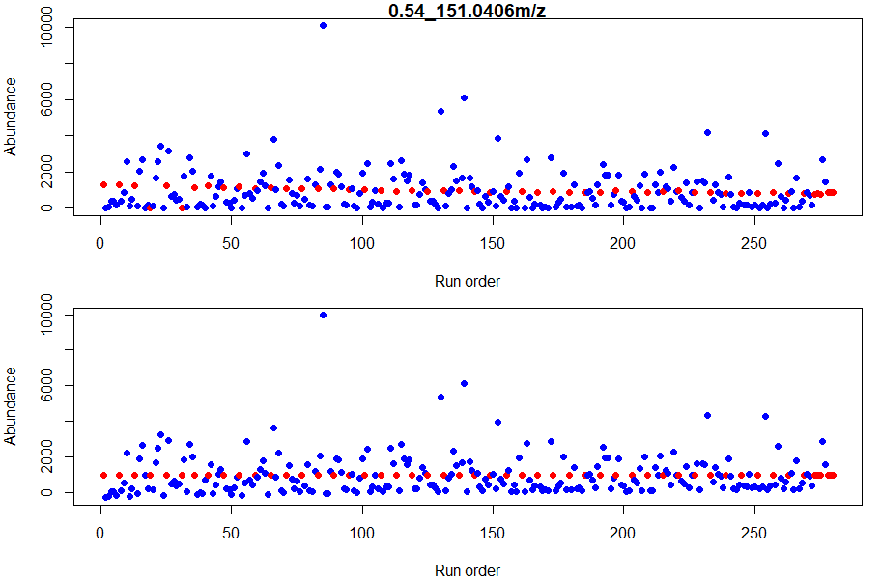

Supplementary Figure 1: Original (top) and QC-corrected (bottom) abundances. Sample abundances are represented in blue, whereas pooled QC abundances are shown in red.

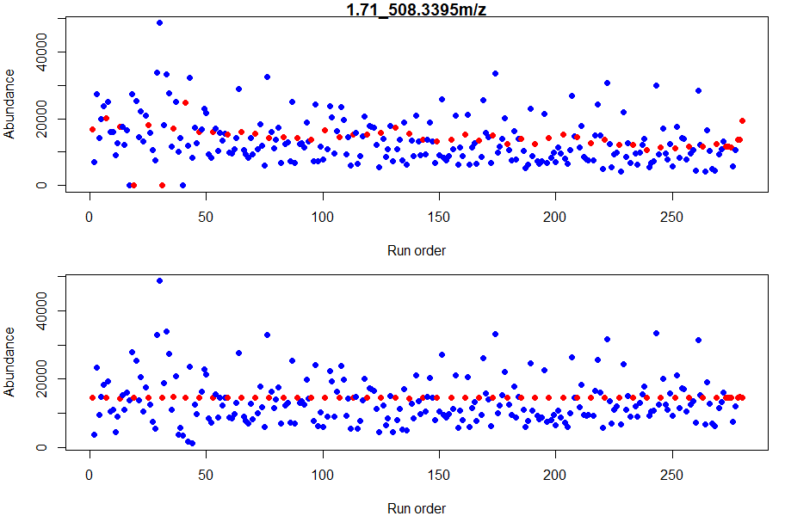
Supplementary Figure 2: Original (top) and QC-corrected (bottom) abundances. Sample abundances are represented in blue, whereas pooled QC abundances are shown in red.

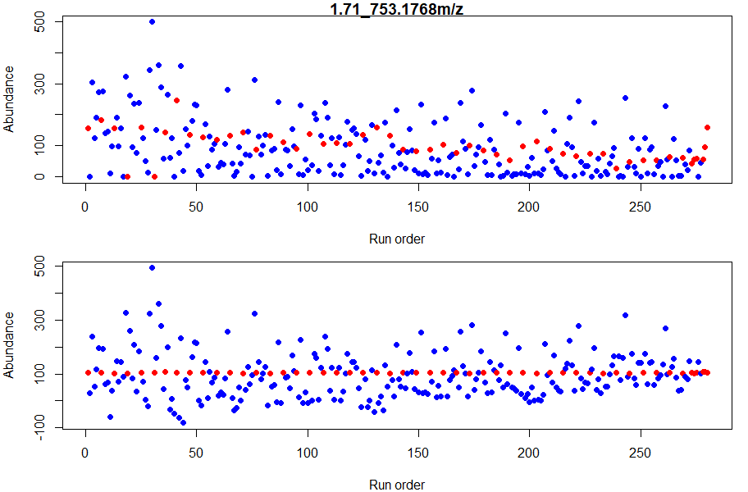

Supplementary Figure 3: Original (top) and QC-corrected (bottom) abundances. Sample abundances are represented in blue, whereas pooled QC abundances are shown in red.

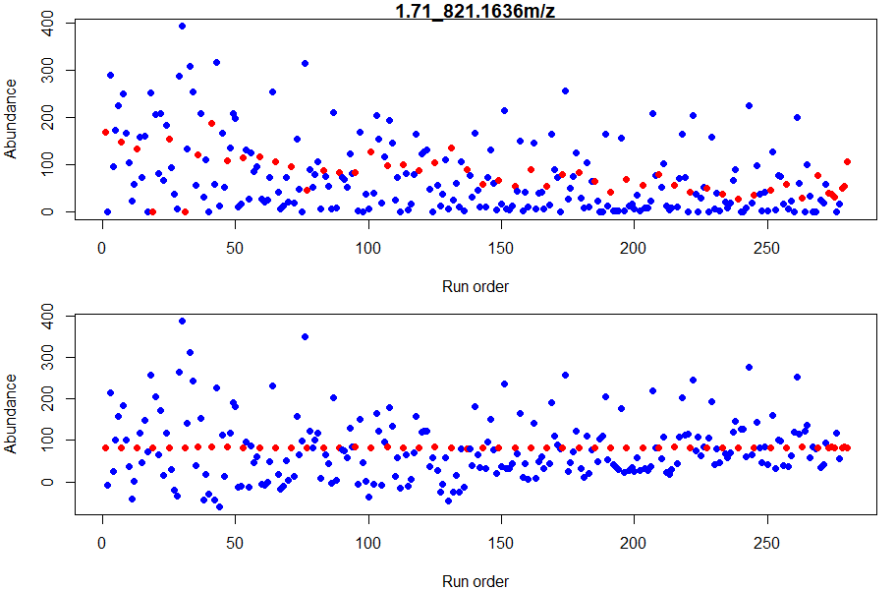
Supplementary Figure 4: Original (top) and QC-corrected (bottom) abundances. Sample abundances are represented in blue, whereas pooled QC abundances are shown in red.

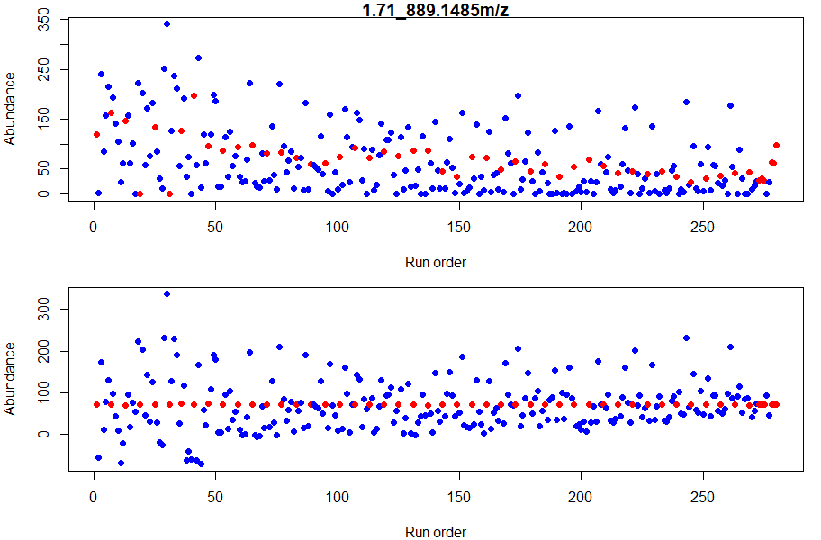

Supplementary Figure 5: Original (top) and QC-corrected (bottom) abundances. Sample abundances are represented in blue, whereas pooled QC abundances are shown in red.

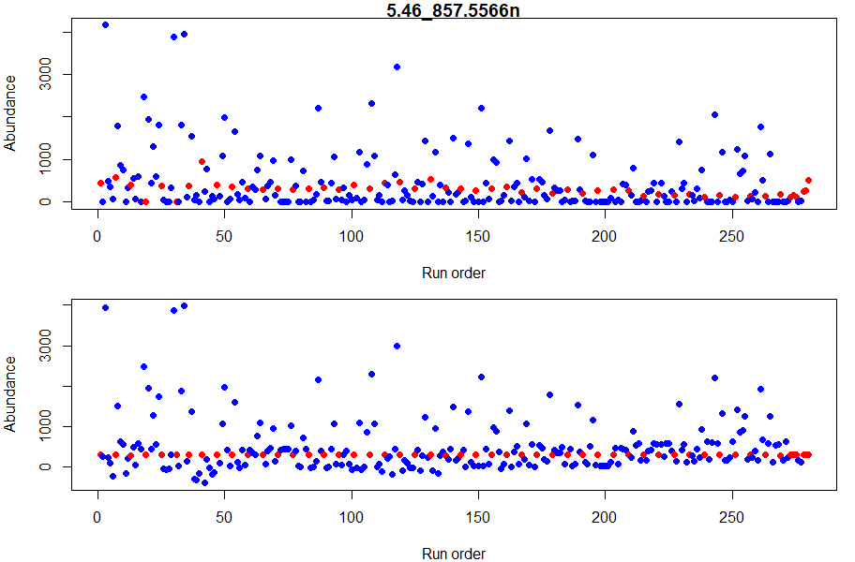

Supplementary Figure 6: Original (top) and QC-corrected (bottom) abundances. Sample abundances are represented in blue, whereas pooled QC abundances are shown in red.

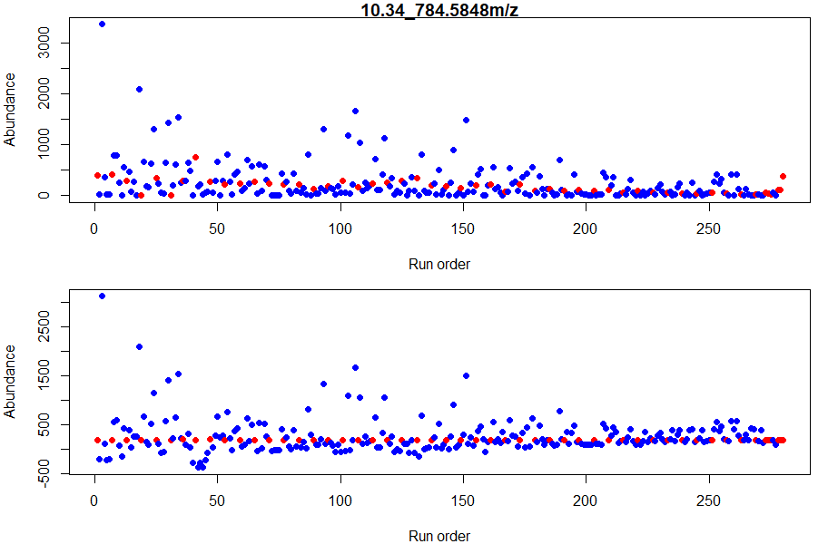

Supplementary Figure 7: Original (top) and QC-corrected (bottom) abundances. Sample abundances are represented in blue, whereas pooled QC abundances are shown in red.

