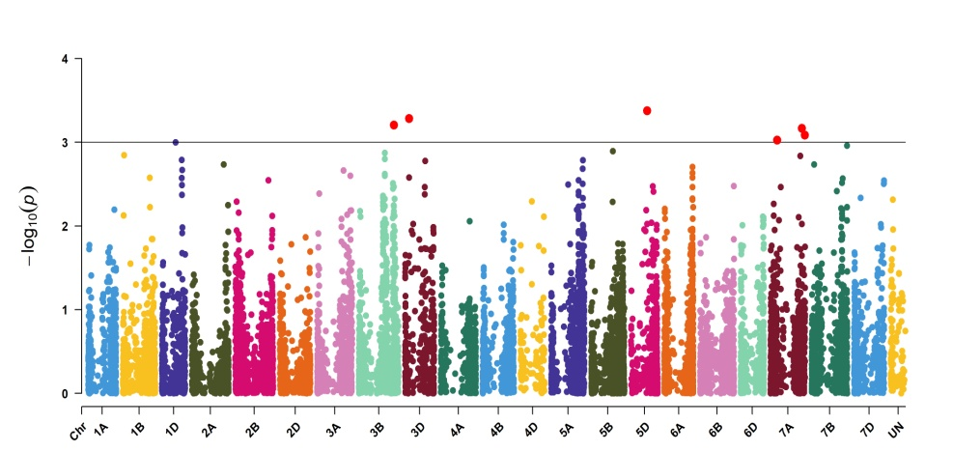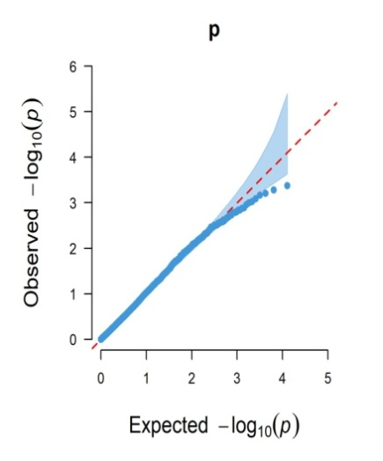
Adet 2023
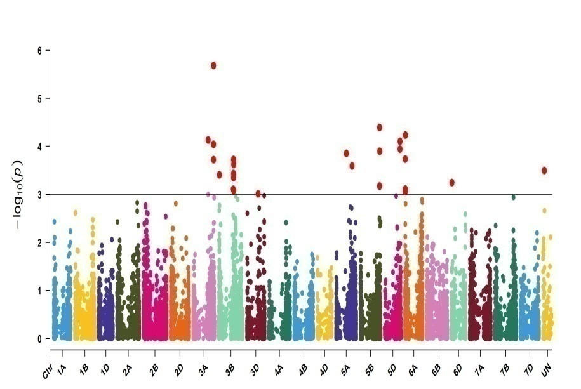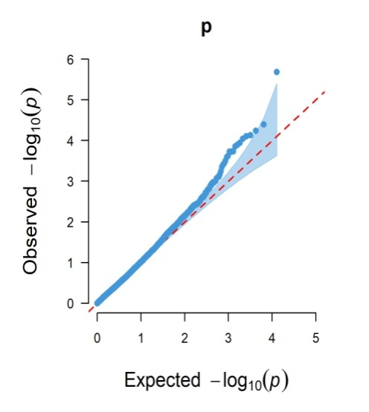
Dabat 2023
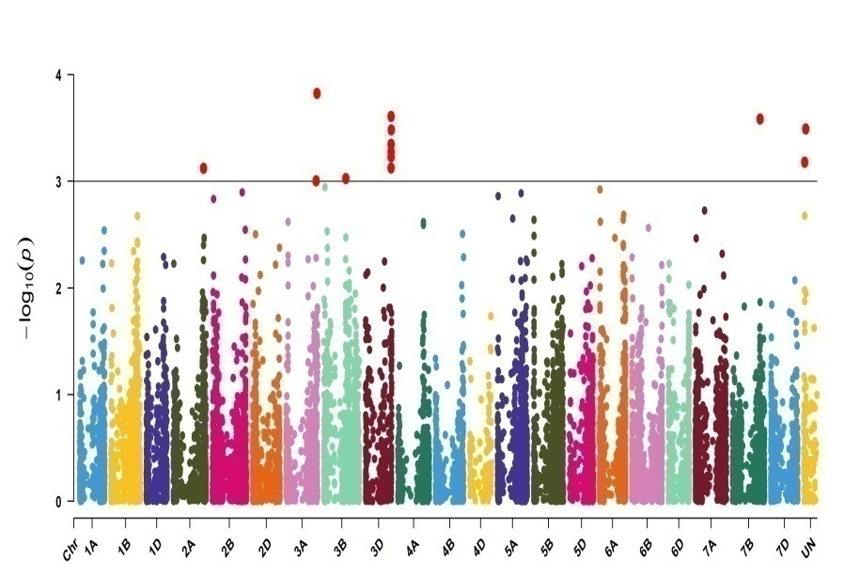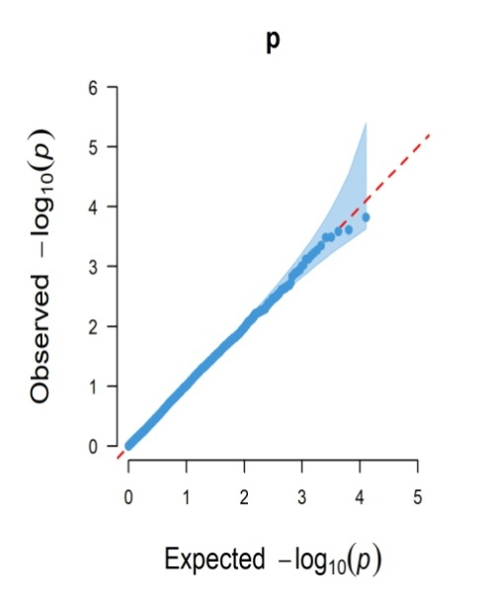
Koga 2023
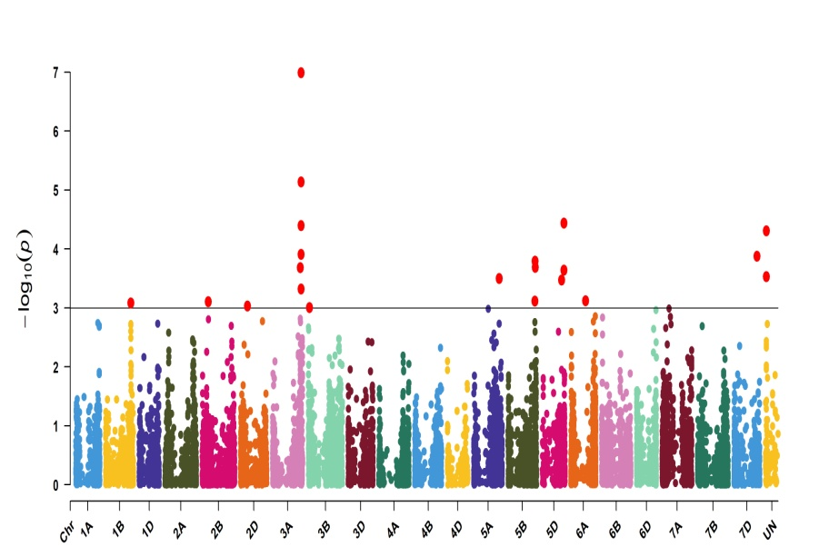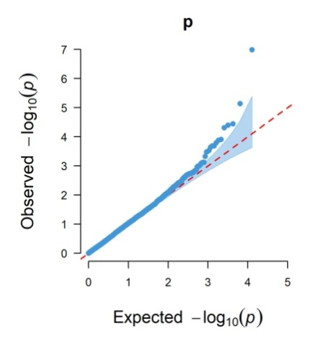
Kulumsa 2023
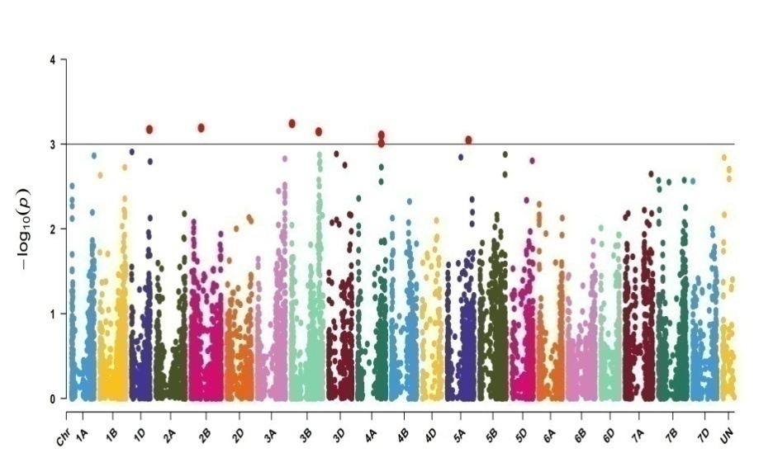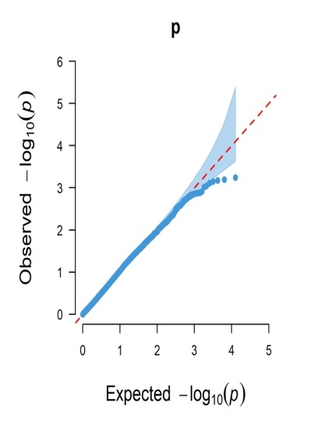
Kulumsa 2024
Additional file 2: Supplementary Fig.1. Manhattan plot and Q-Q plot of the GWAS result for yellow rust resistance in 186 bread wheat lines in five testing environments (Adet2023, Dabat2023, Koga2023, Kulumsa2023, and Kulumsa2024). Each dot represents a single SNP. On the left side is the Manhattan plot of the –log¹⁰ of the p-values versus genomic distance of the SNPs significantly associated with yellow rust resistance at thresholds above 3 indicates significant SNPs. The Q-Q plots on the right side of the Manhattan plots shows how well the GWAS model accounted population structure and kinship for CI for yellow rust.

