ENSO diversity in climate models within the recharge oscillator framework

Supplementary figures:

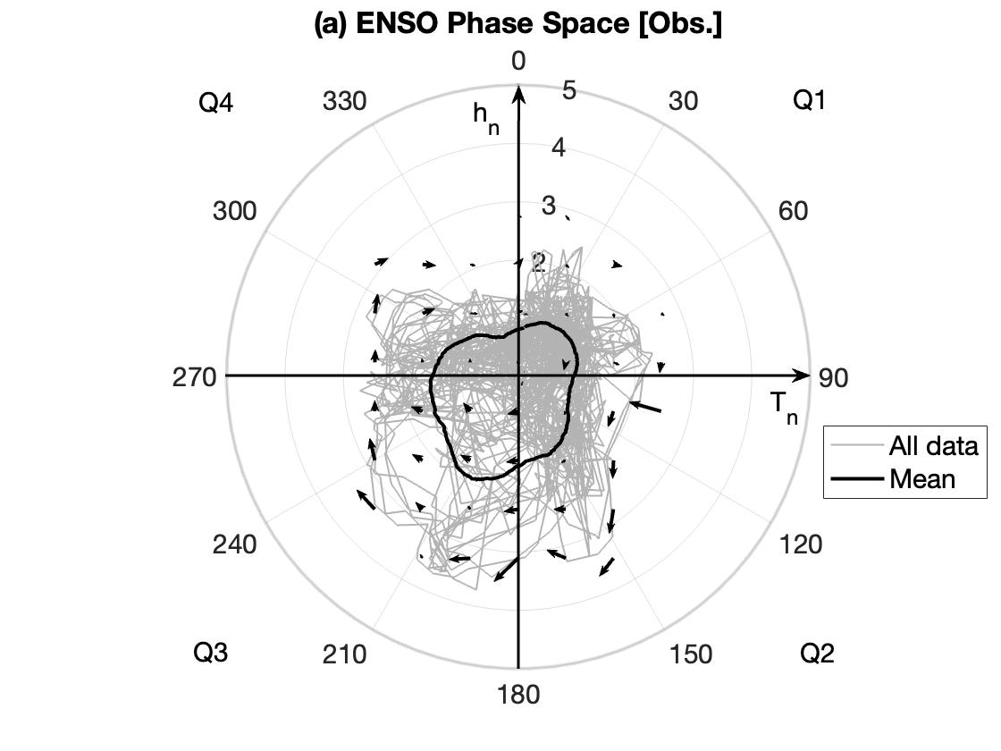
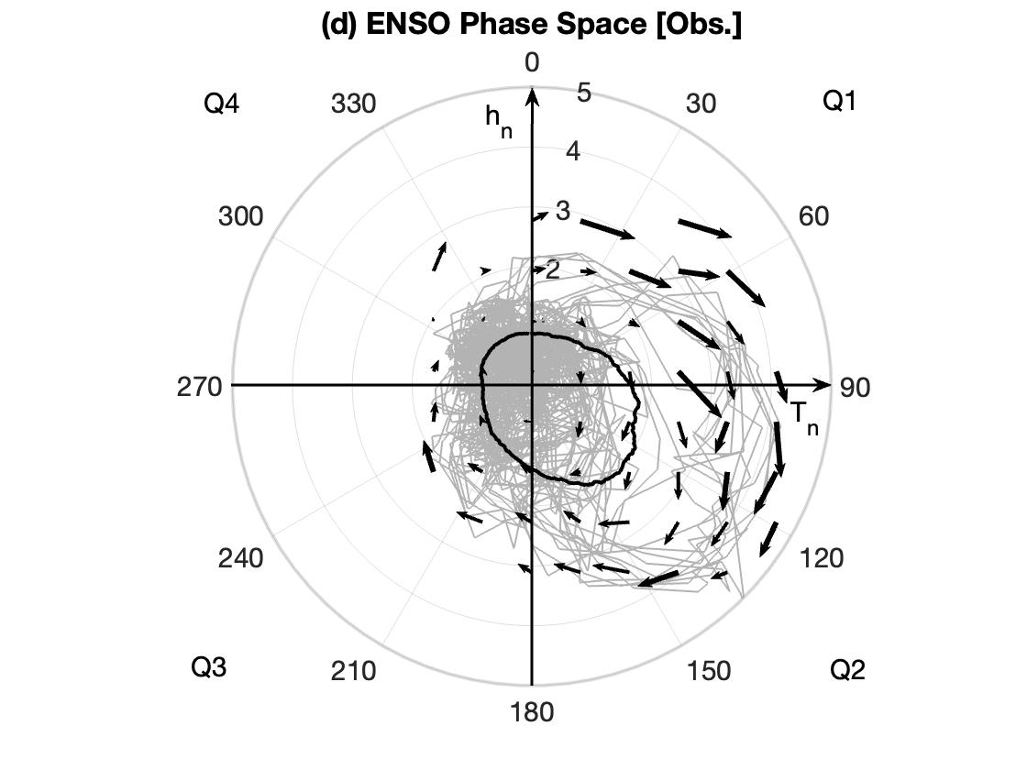
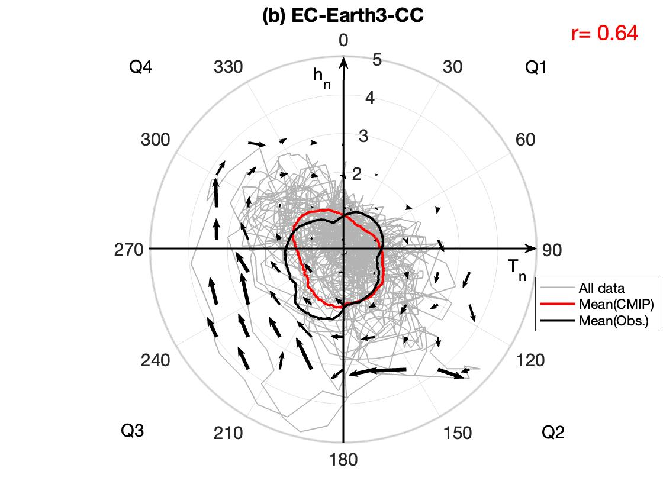
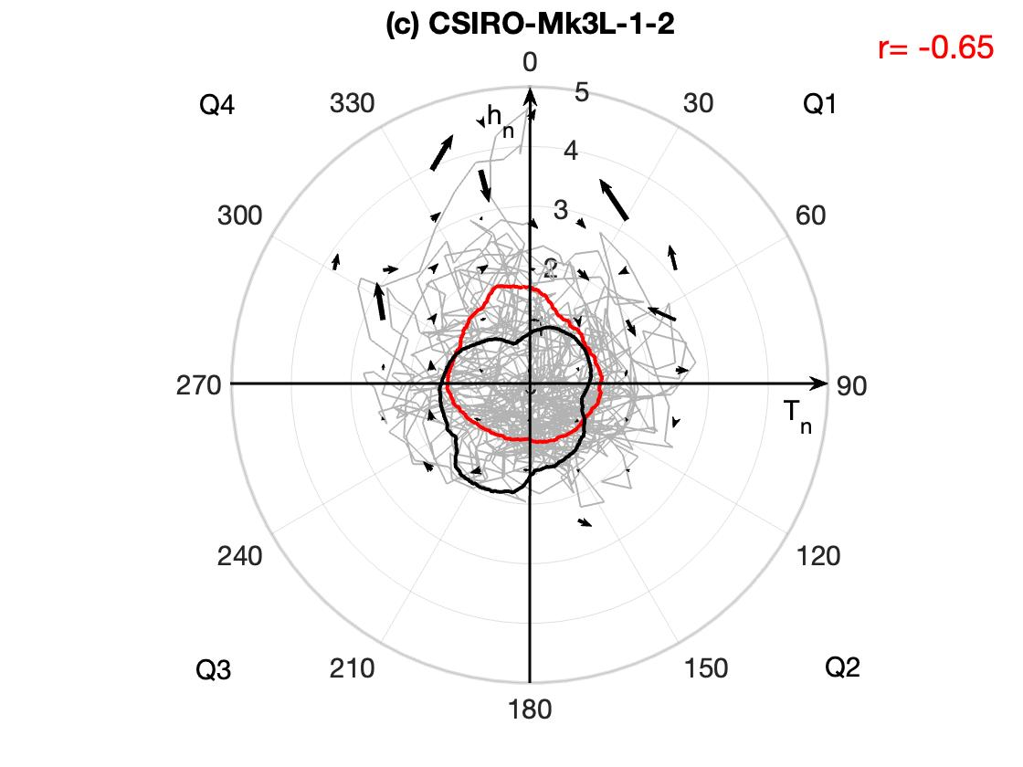
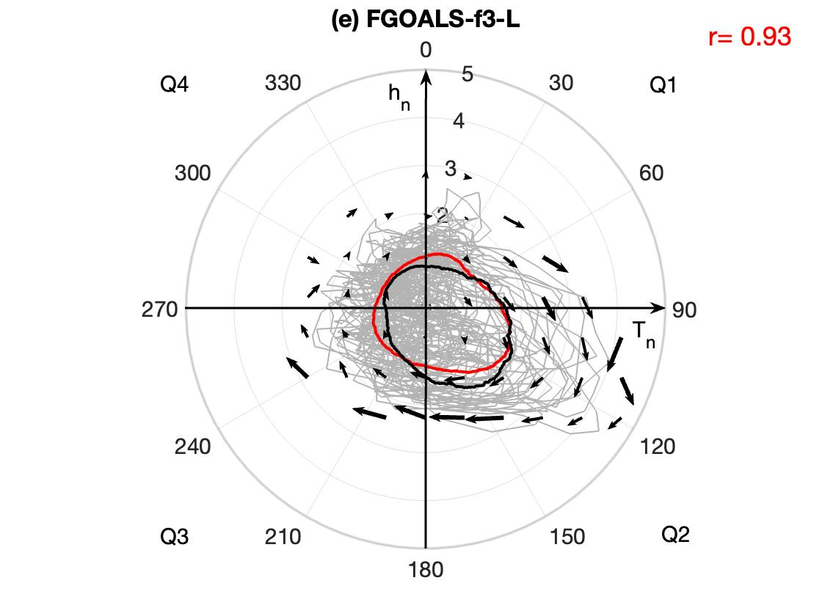
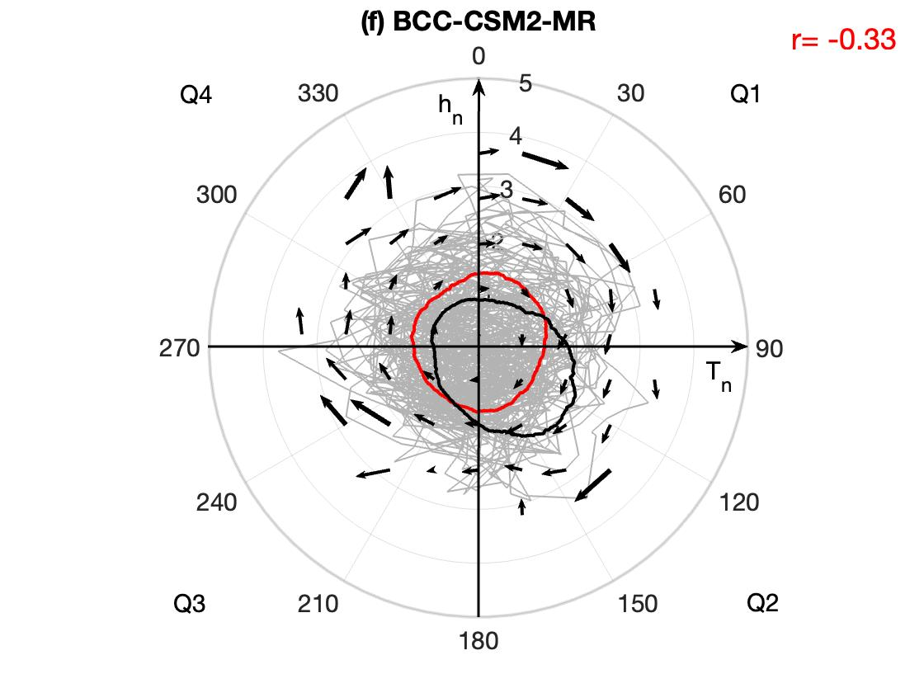
CMIP based on h
EP
CP

SFig. 1 ENSO phase space for CP (left panels) (a) observation, with two CMIP models based on h (b) EC-Earth3-CC, and (c) CSIRO-Mk3L-1-2. Right panels are similar to left panels, but for EP (d) observation, (e) FGOALS-f3-L, and (f) BCC-CSM2-MR. All data (grey), mean as a function of phase space for observation (black), and CMIP (red). The black arrow denotes the tendency vectors of the mean tendencies of T_{n} and h_{n} across the range of ±0.4, with the vector origin represents the phase space reference point. A vector with a unit length represents a tendency of 1mon⁻¹, and its scale is proportional to the magnitude of the tendencies. Vectors for S < 3.5 are only shown when data is available. The correlation coefficient between observations and CMIP models for CP and EP is presented here for each panel (red numbers)

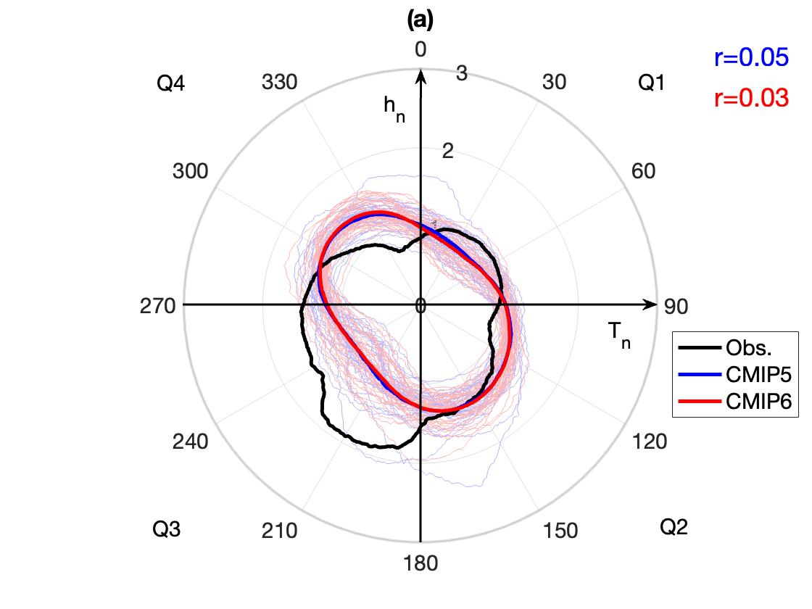
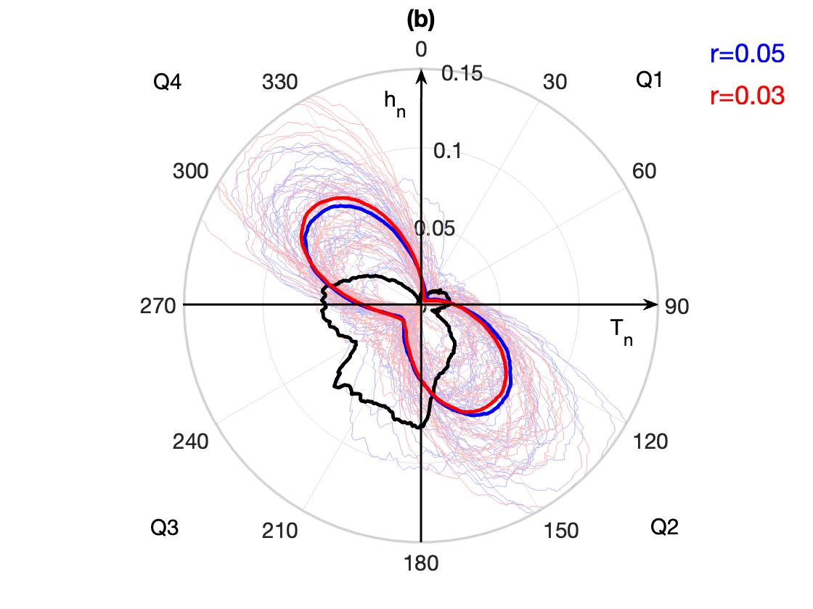
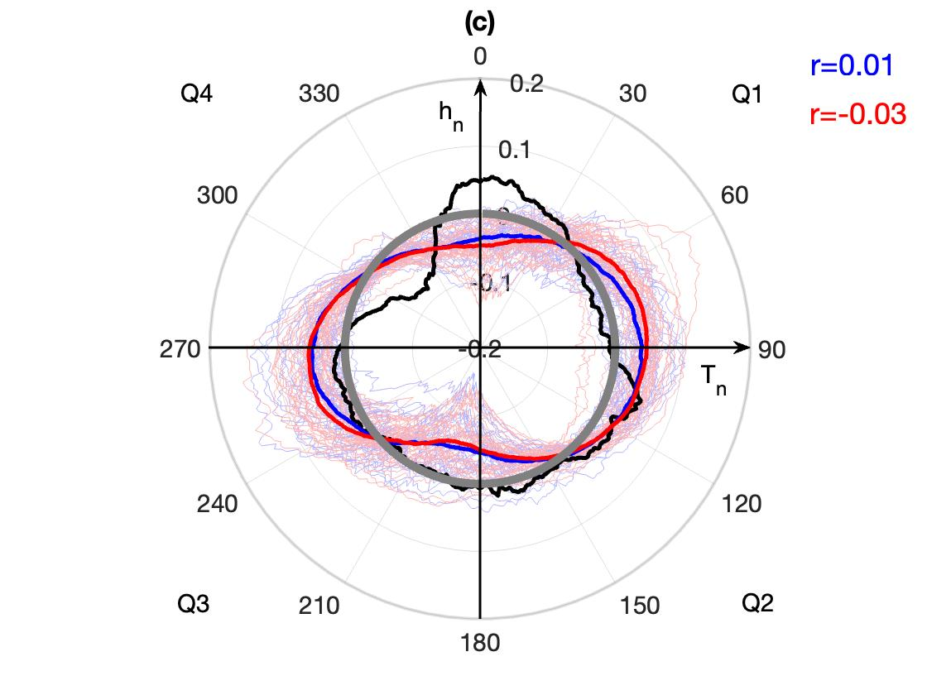
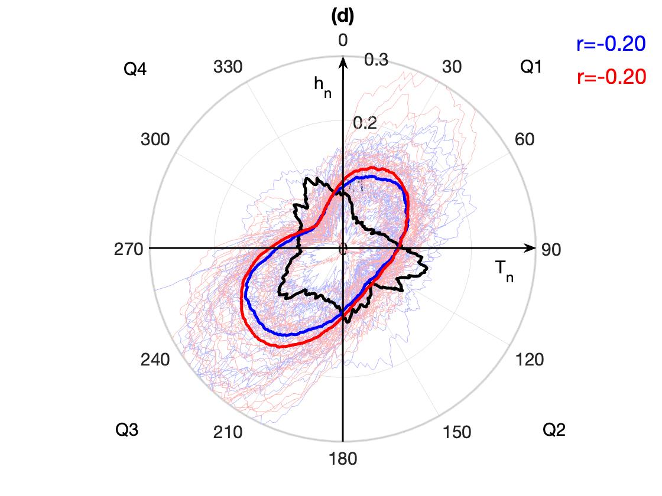
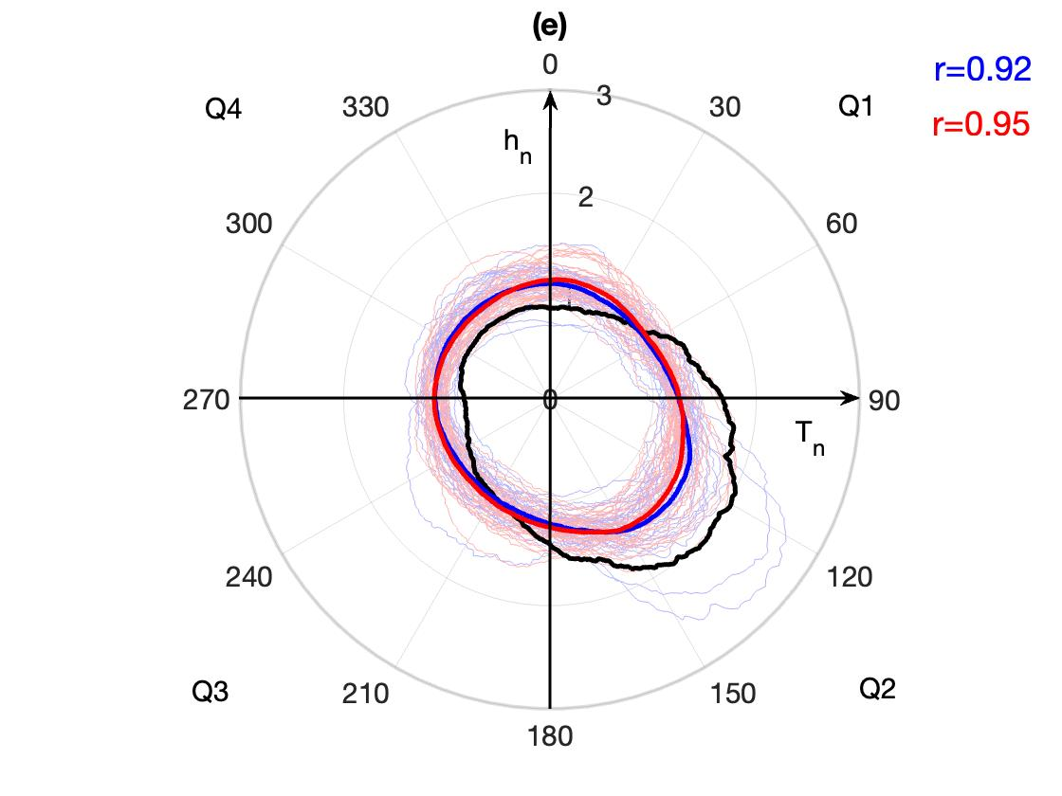
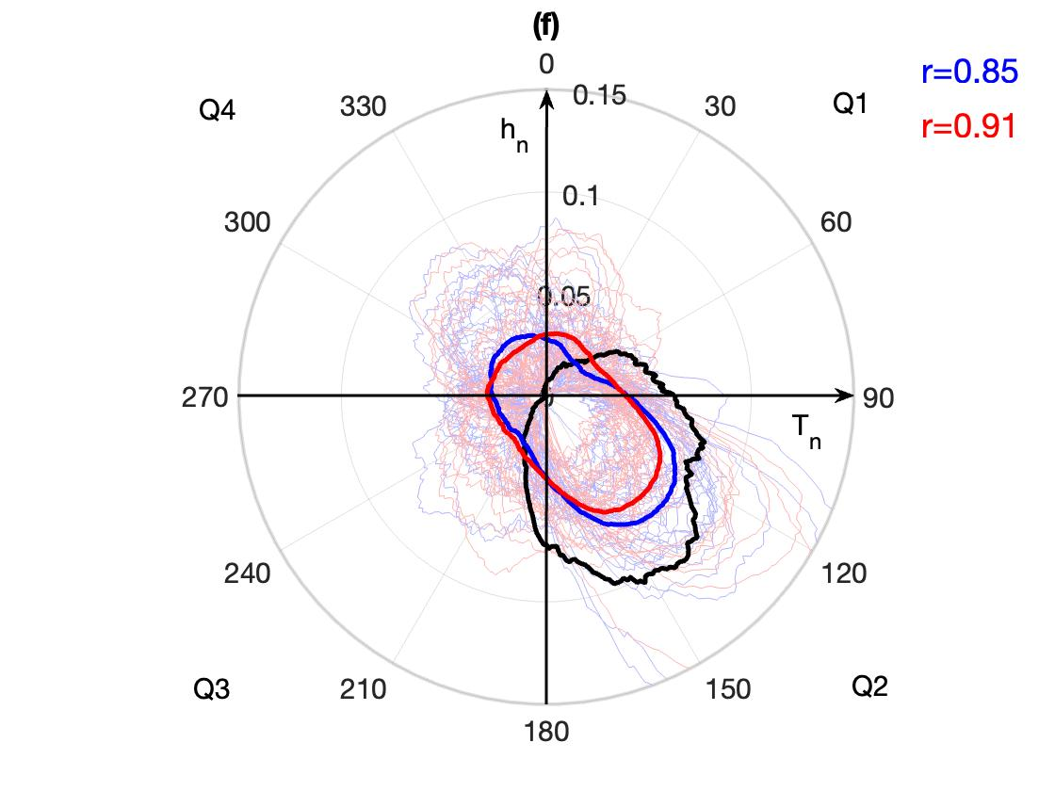
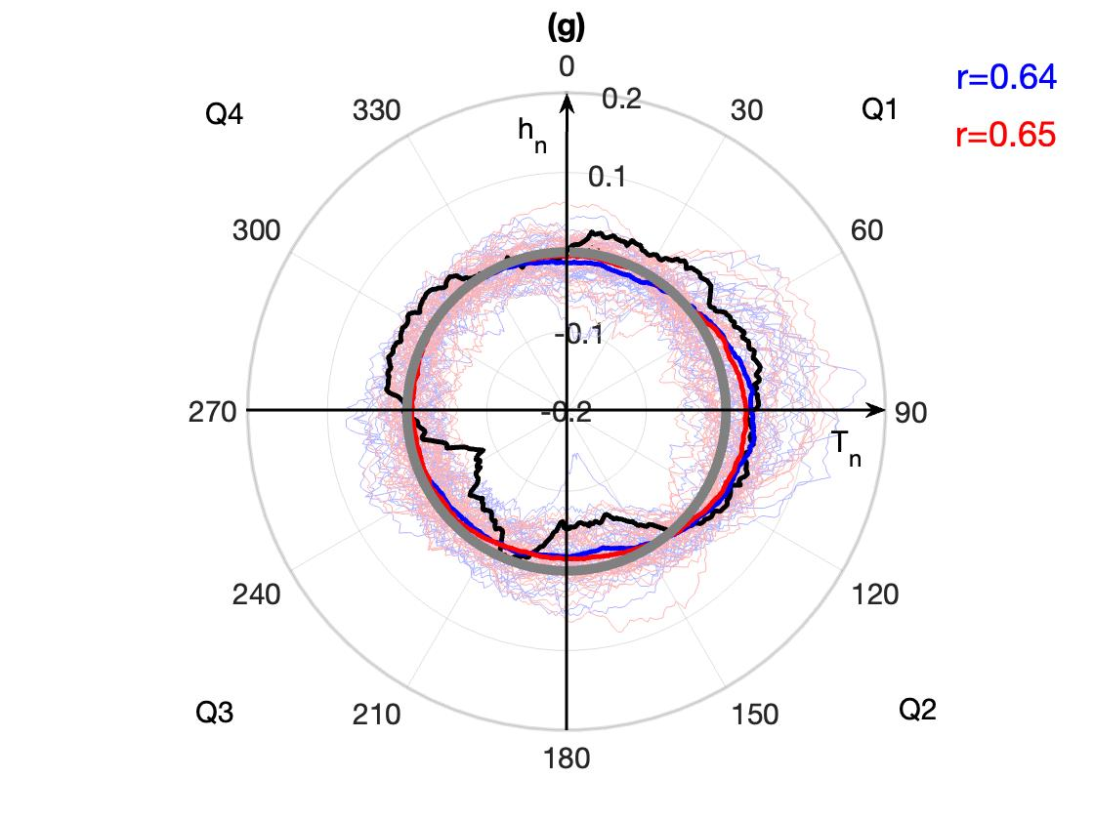
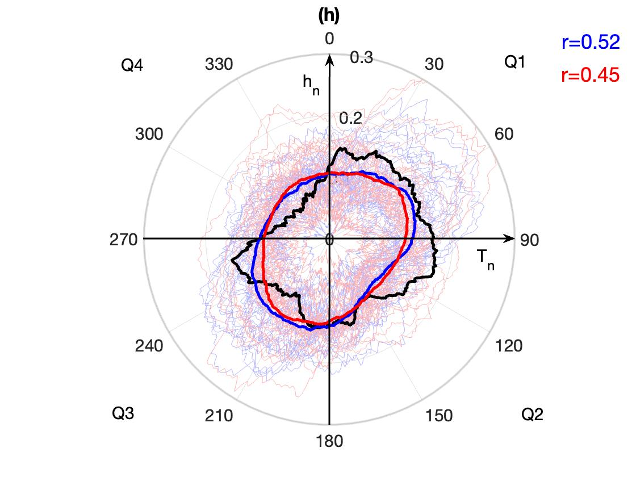
EP
CP
Mean S
Prob. dist. S >2
Growth rate
Phase speed

SFig. 2 Statistics of the ENSO phase for CP (left panels) and EP (right panels) based on h for CMIP (a, e) mean S, (b, f) probability distribution of S > 2, (c, g) growth rate, and (d, h) phase speed. Observed (black), CMIP5 MMM (blue), CMIP6 MMM (red), individual CMIP5 models (light blue), individual CMIP6 models (light red). In panels (c) and (g), the grey circle signifies zero growth, values inside the circle indicate negative growth rates, and values outside the circle indicate positive growth rates. The correlation values between observations and CMIP models are shown for each panel for CMIP5 (blue) and CMIP6 (red)

