SUPPLEMENTARY MATERIALS
Dataset Used
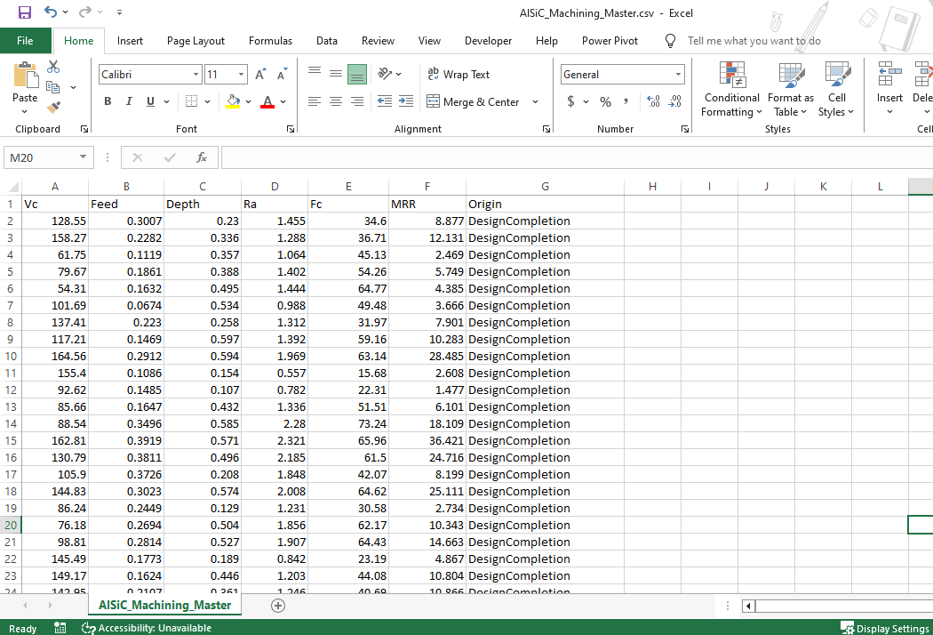
Formulas Used in Modeling
$$x_{scaled}= \frac{x- μ​}{σ}$$
where μ is the mean and σ is the standard deviation of the feature.
$$w_{i}= \frac{1}{{RMSE}_{i}} and {\hat{y}}_{hyd}= \frac{w_{ANN} . {\hat{y}}_{ANN} . w_{SVM} . {\hat{y}}_{SVM}}{w_{ANN} . w_{SVM}}$$
ANN Model Configuration
Model Type: Multi-output Regression Neural Network
Framework: TensorFlow
Architecture Details:
- Input Layer:
  - 3 Neurons for input features:
    - Cutting Speed (Vc)
    - Feed Rate (f)
    - Depth of Cut (d)
- Hidden Layers:
  - Hidden Layer 1: 100 neurons, ReLU activation
  - Hidden Layer 2: 100 neurons, ReLU activation
  - Hidden Layer 3: 50 neurons, ReLU activation
- Output Layer:
  - 3 Neurons for predicted outputs:
    - Surface Roughness (Ra)
    - Cutting Force (Fc)
    - Material Removal Rate (MRR)
  - Activation: Linear (default for regression)
Hyperparameters:
- Loss Function: Mean Squared Error (MSE)
- Optimizer: Adam
- Batch Size: 32
- Epochs: 300
- Validation Split: 15%
- Normalization: Z-score standardization applied to input features
- Early Stopping: Enabled (to prevent overfitting)
SVM Model Configuration
Model Type: Support Vector Regression (SVR)
Framework: Scikit-learn
Modeling Approach:
- Separate SVR models were trained individually for each output:
  - Surface Roughness (Ra)
  - Cutting Force (Fc)
  - Material Removal Rate (MRR)
Kernel & Parameters:
- Kernel Function: Radial Basis Function (RBF)
- Regularization Parameter (C): 100
- Epsilon (ε-insensitive loss): 0.1
- Gamma: ‘scale’ (i.e., 1 / (n_features × variance))
- Hyperparameter Tuning: Grid Search with Cross-validation
Code snippets
