Supplementary information
Figure 2A. Uncropped western blot images (Full blots)
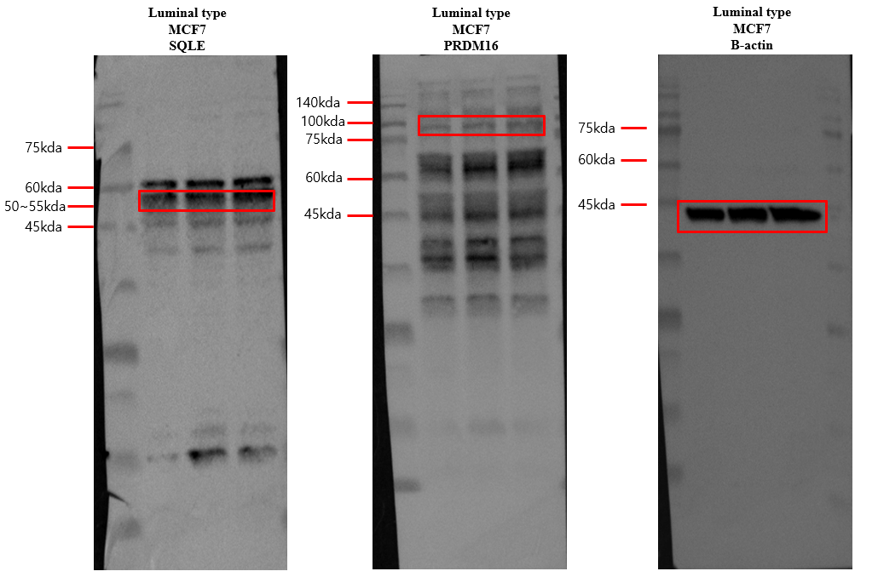
Figure 2A. Uncropped western blot images.
Full-length blots corresponding to the main figure are shown. Lanes represent MCF7 cells cultured under different conditions in the following order: control, co-culture with 3T3-L1, and co-culture with NIH-3T3. The red boxes indicate the regions displayed in the main figure.

Figure 2B. Uncropped western blot images (Full blots)
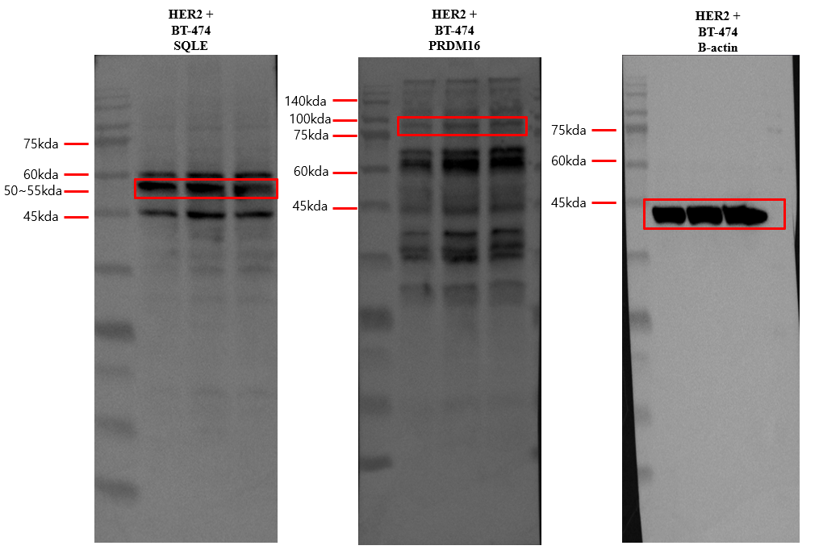
Figure 2B. Uncropped western blot images.
Full-length blots corresponding to the main figure are shown. Lanes represent BT-474 cells cultured under different conditions in the following order: control, co-culture with 3T3-L1, and co-culture with NIH-3T3. The red boxes indicate the regions displayed in the main figure.

Figure 2C. Uncropped western blot images (Full blots)
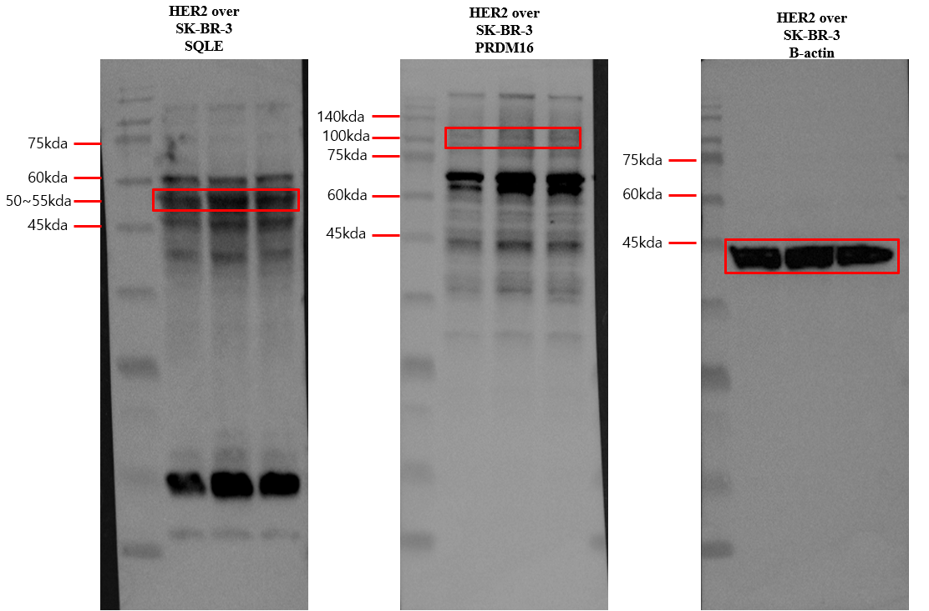
Figure 2C. Uncropped western blot images.
Full-length blots corresponding to the main figure are shown. Lanes represent SK-BR-3 cells cultured under different conditions in the following order: control, co-culture with 3T3-L1, and co-culture with NIH-3T3. The red boxes indicate the regions displayed in the main figure.

Figure 2D. Uncropped western blot images (Full blots)
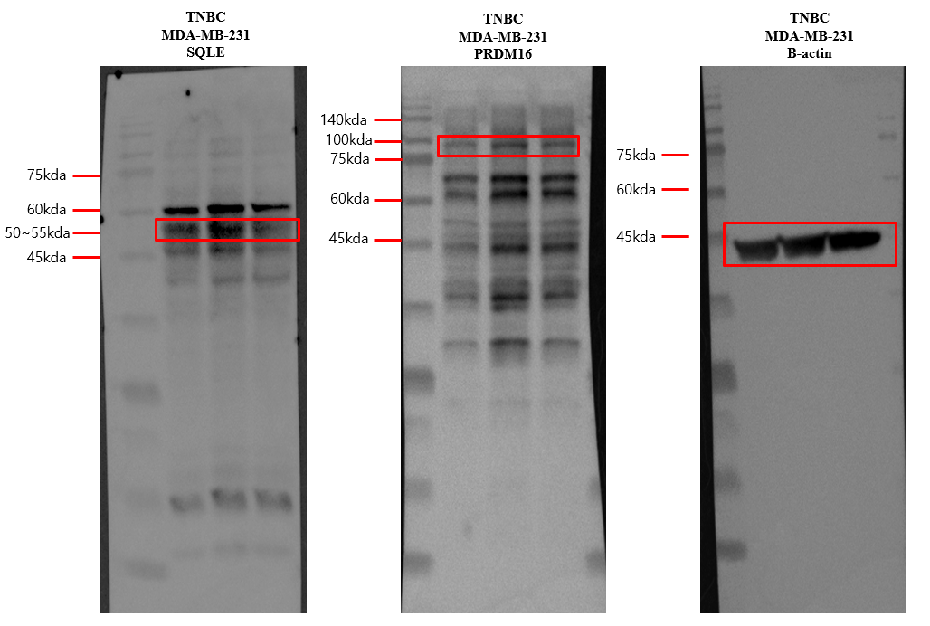 Figure 2D. Uncropped western blot images.
Full-length blots corresponding to the main figure are shown. Lanes represent MDA-MB-231 cells cultured under different conditions in the following order: control, co-culture with 3T3-L1, and co-culture with NIH-3T3. The red boxes indicate the regions displayed in the main figure.

