Appendix
Highly efficient anogenital transmission of clade Ia mpox virus associated with increased shedding.
Franziska K. Kaiser¹, Reshma K. Mukesh¹, Shane Gallogly¹, Jonathan Schulz¹, Sarah van Tol¹, Natalie McCarthy¹, Missiani Ochwoto¹, Claude Kwe Yinda¹, Atsushi Okumura¹, Lara Myers², Aaron Carmody², Brian J. Smith³, Greg Saturday³, Carl Shaia³, Kyle Rosenke¹, Julia R. Port⁴, Vincent J. Munster¹*
¹Laboratory of Virology, Division of Intramural Research, National Institute of Allergy and Infectious Diseases, National Institutes of Health, Rocky Mountain Laboratories, Hamilton, MT, USA
²Research and Technologies Branch, Division of Intramural Research, National Institute of Allergy and Infectious Diseases, National Institutes of Health, Hamilton, MT, USA
³Rocky Mountain Veterinary Branch, Division of Intramural Research, National Institute of Allergy and Infectious Diseases, National Institutes of Health, Rocky Mountain Laboratories, Hamilton, MT, USA
⁴Laboratory of Transmission Immunology, Helmholtz Centre for Infection Research (HZI), Braunschweig, Germany
*Corresponding author: Vincent J Munster, 903 South 4th Street, Hamilton, MT, USA. vincent.munster@nih.gov
Supplemental Figures:

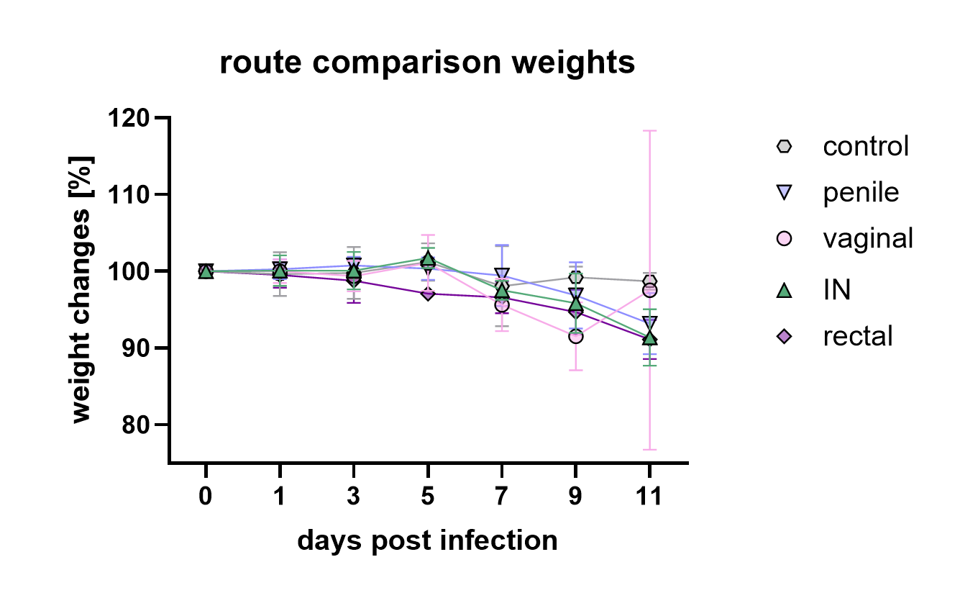
Supplemental Figure 1. Body weight changes in dependence of inoculation route after MPXV exposure (n=4). Symbols show means and error bars indicate standard deviation.

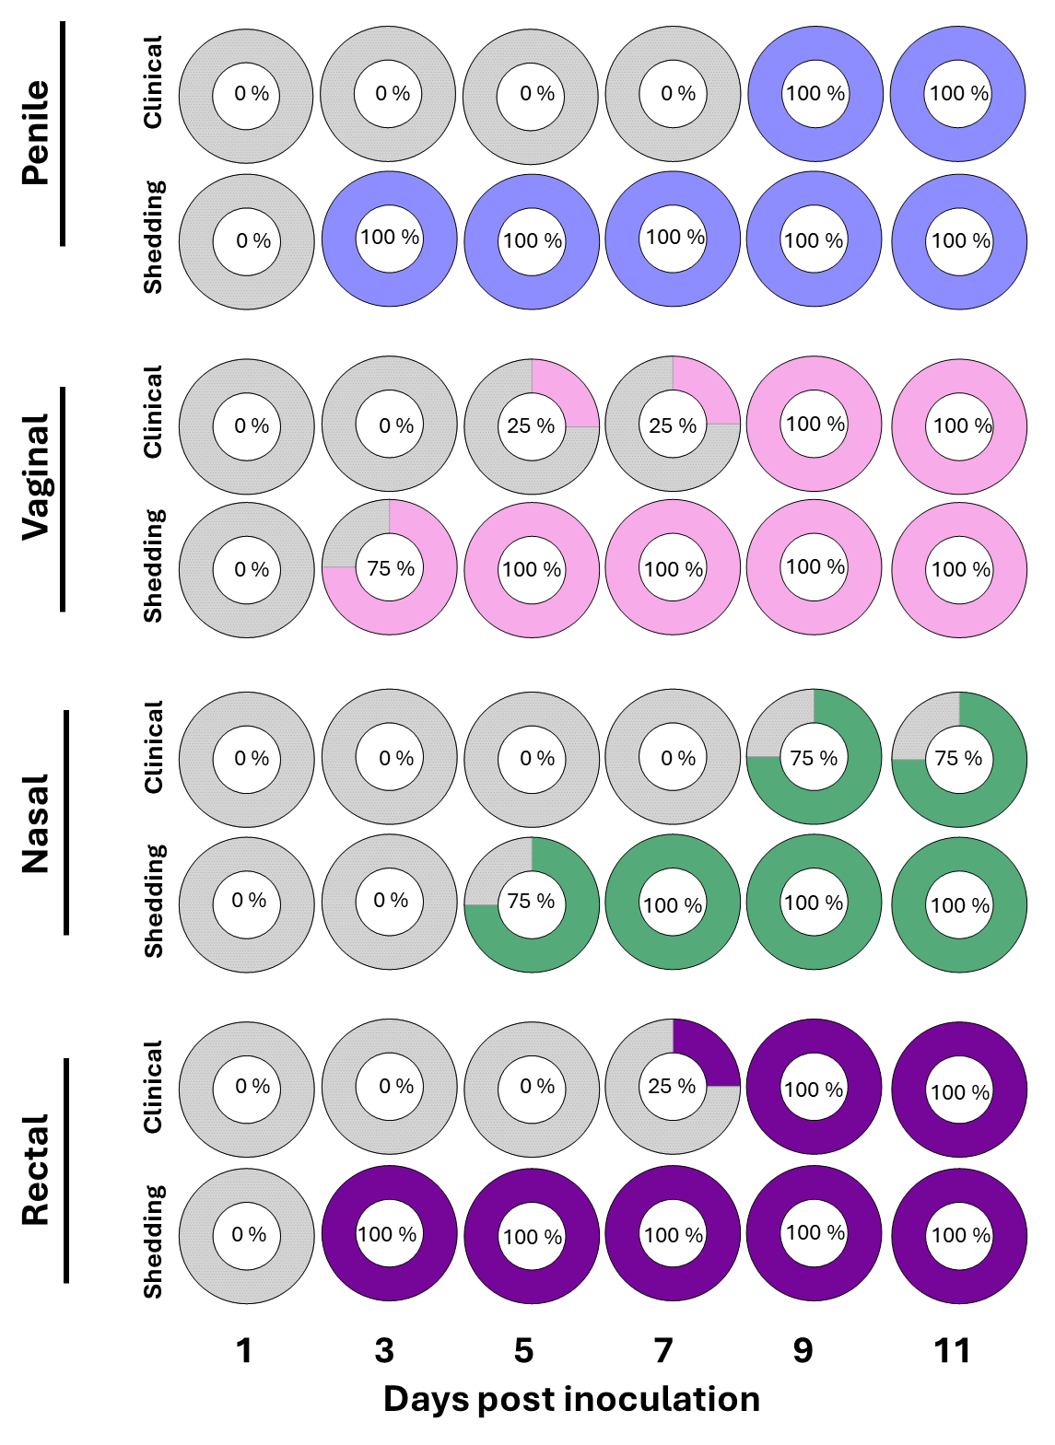
Supplemental Figure 2: Temporal connection between onset of clinical signs and infectious virus shedding after different exposure routes. Animals (n=4) after penile, vaginal, nasal, or rectal inoculation. Percentage of animals displaying clinical signs during exam, including localized inflammation (swelling or redness), or generalized lesions. Percentage of animals with at least one positive swab sample (oropharyngeal, nasal, urogenital, or rectal) with infectious virus.

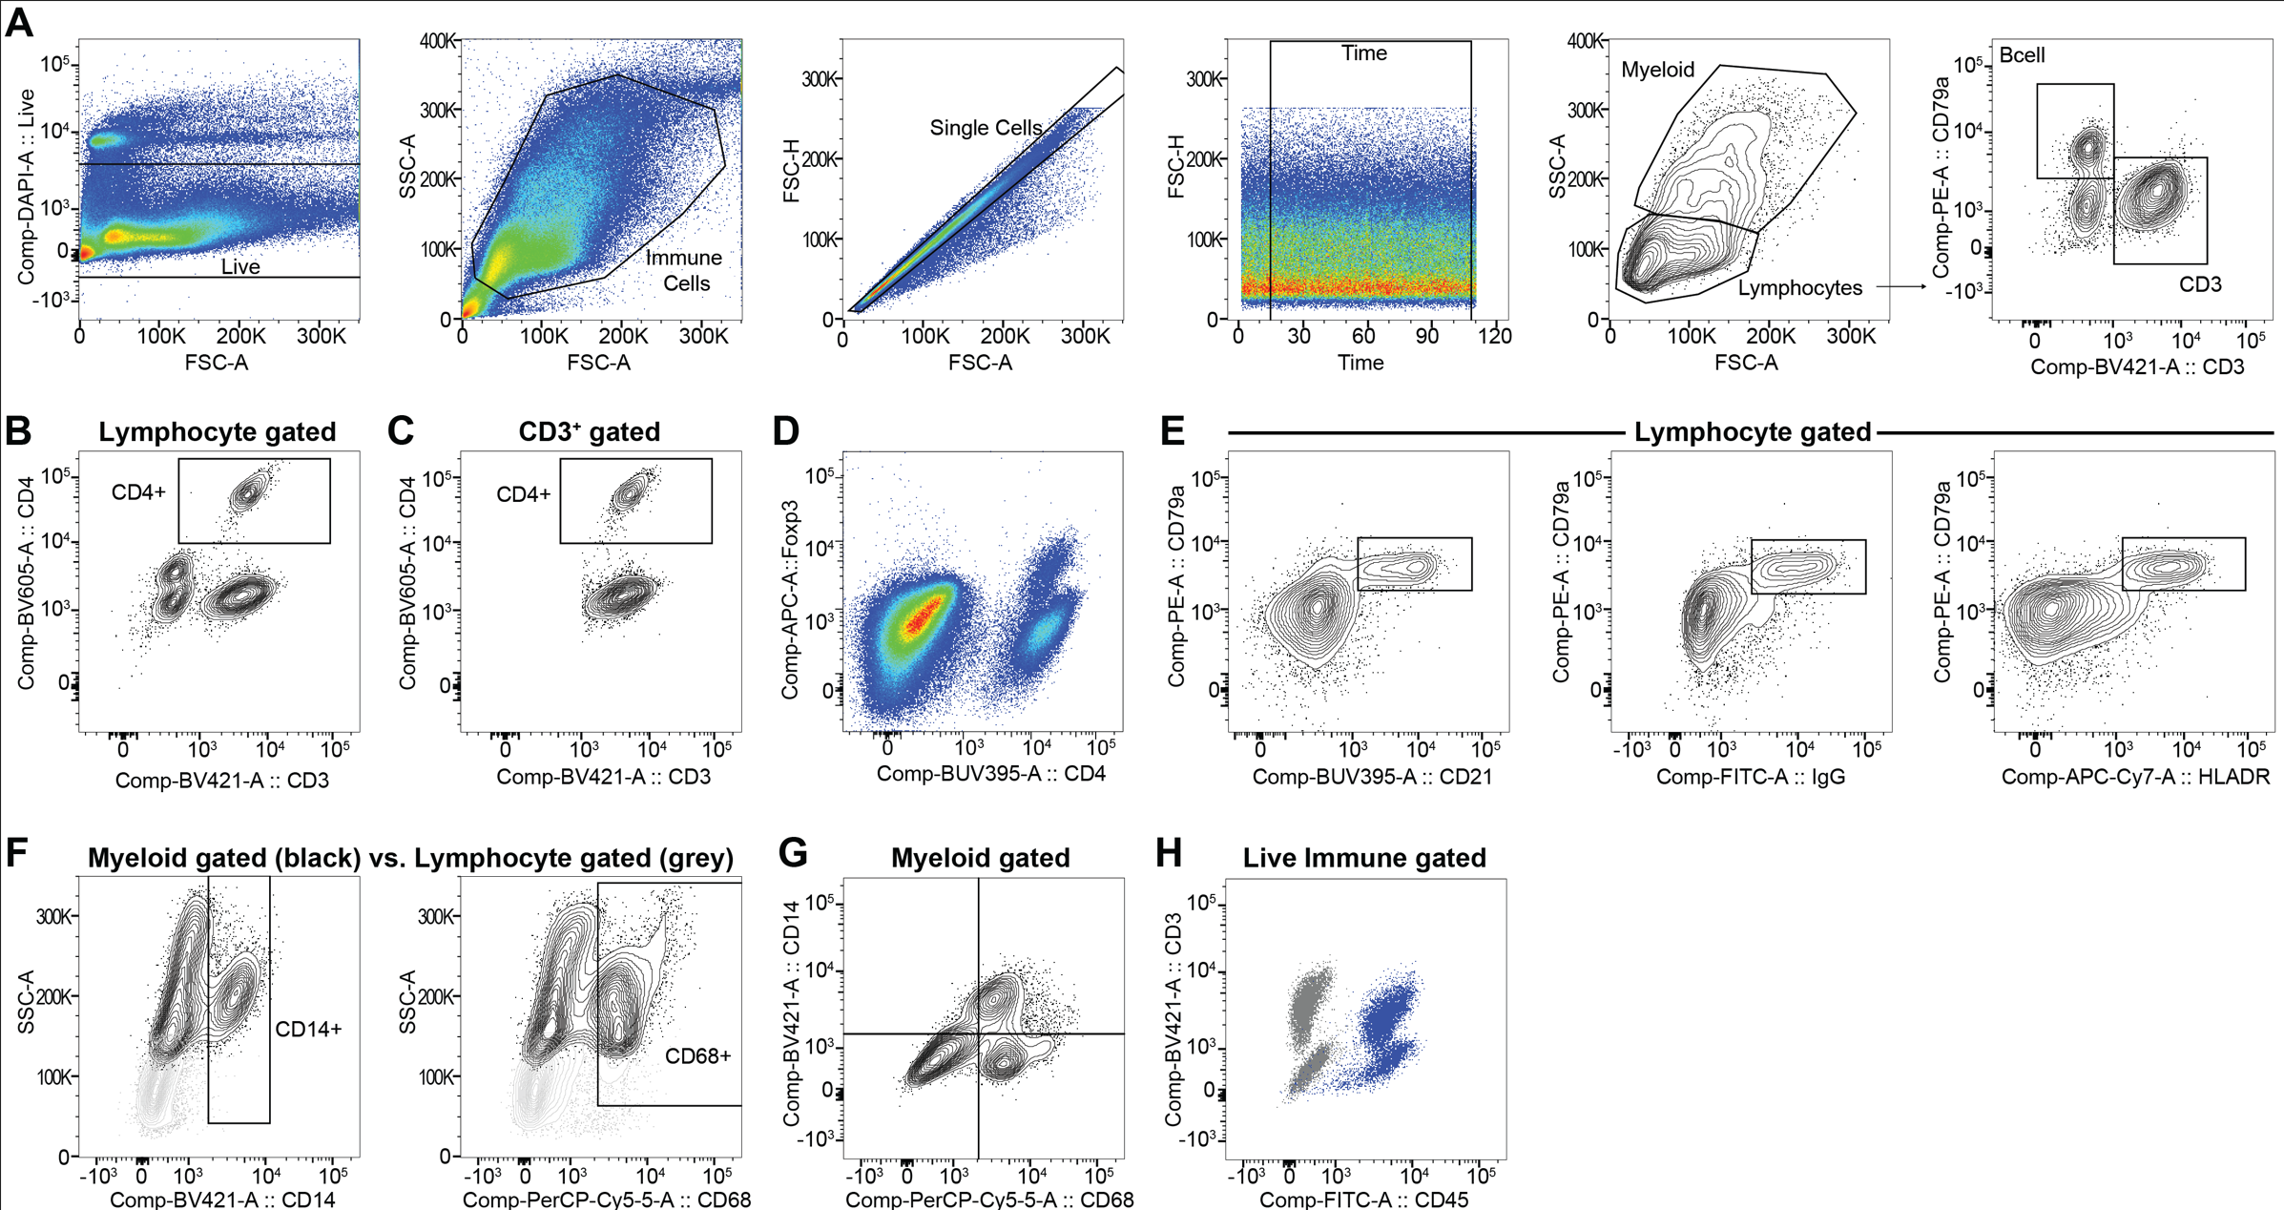
Supplemental Figure 3. Representative gating strategies for flow analysis of splenocytes from prairie dogs infected by MPXV at 11dpi. (A) Live splenocytes were first gated with a dead cell exclusion gate using Fixable Blue vs FSC-A. Total immune cells were then gated using SSC-A vs FSC-A, followed by a single cell gate using FSC-H vs FSC-A and then a time gate to exclude possible erratic sample flow. This population was further analyzed by SSC-A vs FSC-A to identify the myeloid and lymphocyte immune cells, which were further analyzed by cross-reactive clones that were identified in prairie dogs (see Supplemental Table 1 for clone information). The lymphocytes were stained using intracellular CD79a and an intracellular epitope for CD3. Lymphocytes were further characterized by (B) surface staining with a cross-reactive surface CD4 antibody, which (C) identified CD4⁺ T cells that dually stained with CD3⁺. (D) CD4⁺ cells co-stained with intracellular Foxp3. Lymphocytes were further analyzed for cross-reactive B cell markers and (E) CD79a⁺ cells stained with cross-reactive clones for CD21, IgG and HLA-DR, which further corroborate the identification of B cells. (F) The SSC-A^{hi} myeloid population (black) stained with cross-reactive clones for CD14 and CD68, compared to lymphocyte gated cells (light gray), as depicted in representative over-layed FACS plots. (G) A representative co-staining plot of CD68 and CD14 for myeloid-gated immune cells. (H) A representative overlay plot of total live immune cells stained with live/dead only (gray) and CD45 and CD3 (blue).
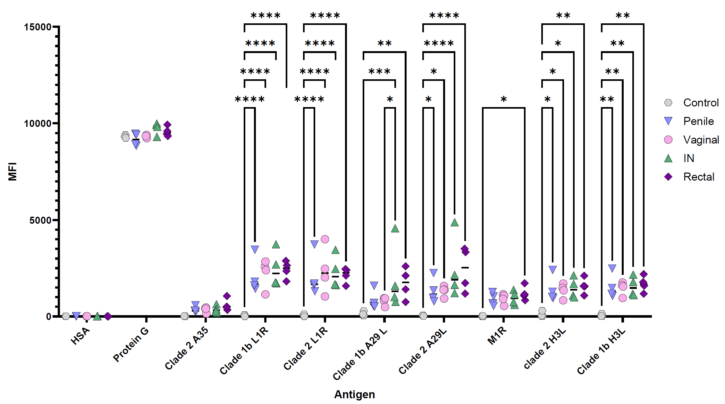Supplemental Figure 4: Antibody titers against selected MPXV antigens on day 11 post inoculation. A semi-quantitative bead based multiplex assay was developed to analyze antibody binding using Luminex MagPlex C microspheres coupled to the indicated recombinant antigen. Protein G beads act as a positive internal control, and beads coupled to human serum albumin act as a negative internal control. Data is shown as median fluorescence intensity (MFI), and route of infection is indicated in figure key. P-values were calculated with a two-way ANOVA and Tukey’s multiple comparisons test. * P < 0.05, ** P < 0.01, *** P < 0.001, **** P < 0.0001

Supplemental Figure 5. Infectious virus on transfer swabs from donor animals after they have been used to transfer mucus to sentinels.

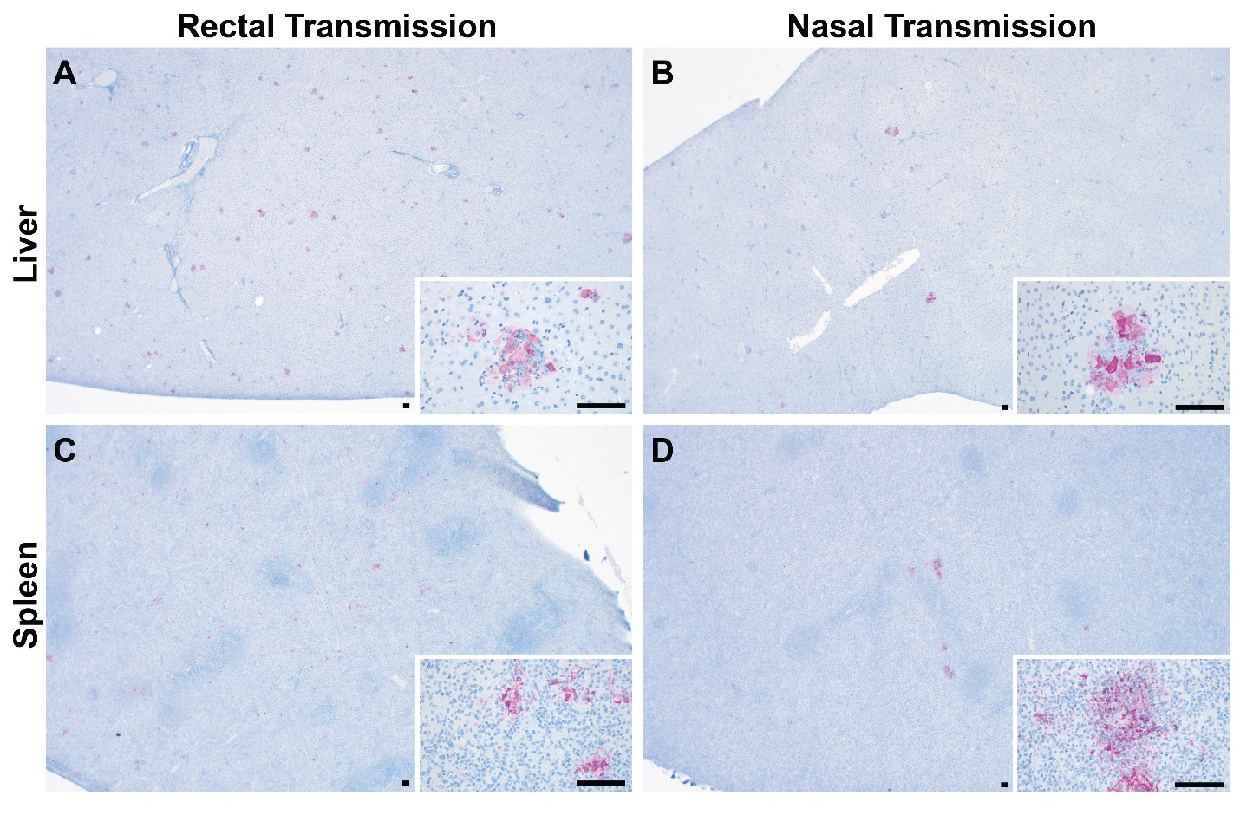
Supplemental Figure 6: Immunohistochemistry of liver and spleen lesions after systemic virus spread in sentinel animals following rectal or nasal transmission. All images taken at 20x magnification; all insets at 400x magnification. Scale bars indicate 100µm.

Supplemental Table 1: Screening process of antibodies for basic immune cell identification and phenotyping
Marker | Clone **yes (gray highlight & bold) *maybe: needs confirmation | Isotype | Company | Comments
Leukocyte Common Antigen
CD45 | ** 30-F11 | Rat IgG2b, κ | BD Biosciences | see Supp. Fig. 3g
CD45 | IH-1 | mouse IgG1 | BioRad & Fisher Scientific
CD45 | HI30 | Mouse IgG1, κ | BioLegend
CD45 | DO58-1283 | Mouse IgG1, κ | BD Biosciences
T cell
CD3 | ** CD3-12 | Rat / IgG1 | BioRad | see Fig. 4c & Supp. Fig.3a,b,c,g
CD3 | OKT3 | CAF1 IgG2a, κ | BD Biosciences
CD3 | 145-2C11 | Armenian Hamster IgG1, κ | BD Biosciences
TCRβ chain | H57-597 | Armenian Hamster IgG2, ƛ1 | BD Biosciences
CD8 T cell
CD8 | CT6 | mouse IgG1 | BioRad
CD8 | 341 | Mouse BALB/c IgG1, κ | BD Biosciences
CD8 | SK1 | Mouse BALB/c IgG1, κ | BD Biosciences
CD8 | RPA-T8 | Mouse IgG1, κ | BD Biosciences
CD8 | 53-6.7 | Rat LOU IgG2a, κ | BD Biosciences
CD8 | OKT8 | CAF1 IgG2a, κ | BD Biosciences
CD8 | HIT8a | Mouse IgG1, κ | BD Biosciences
CD8 | G28 | Mouse IgG2a, κ | BioLegend
CD4 T cell
CD4 | ** L200 | Mouse BALB/c IgG1, κ | BD Biosciences | see Fig.4c & Supp. Fig. 3b,c,d
CD4 | CT7 | mouse IgG1 | BioRad
CD4 | GK1.5 | Rat IgG2b, κ | BioLegend
CD4 | OKT4 | Mouse IgG2b, κ | BioLegend
CD4 | RM4-5 | Rat IgG2a, κ | BioLegend
CD4 | OX-35 | Mouse BALB/c IgG2a, κ | BD Biosciences
CD4 | W3/25 | Mouse BALB/c IgG2a, κ | BD Biosciences
CD4 | OX-38 | Mouse BALB/c IgG2a, κ | BD Biosciences
Regulatory T cell (Foxp3)
Foxp3 | ** FJK-16s | Rat / IgG2a, kappa | Invitrogen | see Supp. Fig. 3d
Foxp3 | * 150D | Mouse IgG1, κ | BioLegend | possible signal but requires further validation
Foxp3 | 259D/C7 | Mouse BALB/c IgG1 | BD Biosciences
Foxp3 | PCH101 | Rat IgG2a, κ | Invitrogen
B cell
CD19 | 1D3/CD19 | Rat IgG2a, κ | BioLegend
CD19 | 6D5 | Rat IgG2a | BioLegend
CD19 | SJ25C1 | Mouse IgG1, κ | BioLegend
CD19 | HIB19 | Mouse IgG1, κ | BioLegend
CD20 | 2H7 | Mouse IgG2b, κ | BD Biosciences
CD21 | ** B-ly4 | Mouse IgG1, κ | BD Biosciences | see Supp. Fig. 3e
CD24 | M1/69 | Rat IgG2b, κ | BioLegend
CD79a | ** HM47 | Mouse BALB/c IgG1, κ | BD Biosciences | see Fig 4c & Supp. Fig. 3a,e
B220/CD45R | RA3-6B2 | Rat IgG2a, κ | BioLegend
anti-Guinea Pig IgG (H/L) | * goat polyclonal IgG | goat polyclonal IgG | BioRad | possible signal but requires further validation
IgD | 11-26c.2a | Rat IgG2a, κ | BD Biosciences
IgM | II/41 | Rat IgG2a, κ | BD Biosciences
Myeloid Cells
CD11b | M1/70 | Rat IgG2b, κ | BioLegend
CD11b | ICRF44 | Mouse IgG1, κ | BioLegend
CD11c | HL3 | Armenian Hamster IgG1, λ2 | BD Biosciences
CD11c | N418 | Armenian Hamster IgG2 | BD Biosciences
CD11c | 3.9 | Mouse IgG1, κ | BD Biosciences
CD11b/c | * OX-42 | Mouse IgG2a, κ | BioLegend | possible signal but requires further validation
CD14 | ** Tuk4 | Mouse IgG2a | Invitrogen | see Supp. Fig. 3f
CD14 | M5E2 | Mouse IgG2a, κ | BD Biosciences
CD14 | rmC5-3 | Rat LOU IgG1, κ | BD Biosciences
CD14 | Sa14-2 | Rat IgG2a, κ | BD Biosciences
CD14 | 61D3 | Mouse IgG1, κ | Invitrogen
CD68 | ** FA-11 | Rat IgG2a | BioLegend | see Supp. Fig. 3f
CD68 | ED1 | mouse IgG1 | Novus
F4/80 | BM8 | Rat IgG2a | BioLegend
Ly6G/Ly6C (GR1) | RB6-8C5 | Rat IgG2b | BioLegend
Ly6G | IA8 | Rat / IgG2a, κ | BD Biosciences
SIRP⍺ | P84 | Rat IgG1, κ | BioLegend
Natural Killer Cells
NK1.1 | PK136 | Mouse IgG2a, κ | BioLegend
CD56 | HCD56 | Mouse IgG1, κ | BioLegend
CD93 | AA4.1 | Rat IgG2b, κ | BioLegend
CD94 | 18d3 | Rat IgG2a, κ | BioLegend
Major Histocompatibility Complex
HLA-DR | ** LN3 | Mouse IgG2b, κ | BioLegend | see Fig 4H & Supp. Fig. 3e
HLA-DR | L243 | Mouse IgG2a, κ | BioLegend
MHCII (I-Ek) | 14-4-4s | Mouse IgG2a, κ | BD Biosciences
MHCII (I-A/I-E) | M5/114.15.2 | Rat IgG2b, κ | BD Biosciences
MHCII (I-A/I-E) | 2G9 | DA/HA IgG2a, κ | BD Biosciences
Cell Phenotyping
CD11a | 2D7 | Rat IgG2a, κ | BioLegend
CD25 | OX-39 | Mouse IgG1, κ | BioLegend
CD25 | PC61 | Rat IgG1, κ | BioLegend
CD27 | * LG.7F9 | Armenian hamster IgG | Invitrogen | possible signal but requires further validation
CD27 | * LG.3A10 | Armenian Hamster IgG | BioLegend | possible signal but requires further validation
CD27 | * M-T271 | Mouse IgG1, κ | BioLegend | possible signal but requires further validation
CD27 | * O323 | Mouse IgG1, κ | BioLegend | possible signal but requires further validation
CD28 | CD28.2 | Mouse IgG1, κ | BioLegend
CD28 | 37.51 | Syrian hamster IgG | BioLegend
CD40 | * 3/23 | Rat IgG2a, κ | BioLegend | possible signal but requires further validation
CD40 | * HB14 | Mouse IgG1, κ | BioLegend | possible signal but requires further validation
CD43 | 1B11 | Rat IgG2a, κ | BioLegend
CD44 | IM7 | Rat IgG2a, κ | BioLegend
CD45RA | 5H9 | Mouse IgG1, κ | BD Biosciences
CD45RB | * 16A | Rat IgG2a, κ | BD Biosciences | possible signal but requires further validation
CD62L | MEL-14 | Rat IgG2a, κ | BioLegend
CD62L | OX-85 | Mouse IgG1, κ | BioLegend
CD69 | H1.2F3 | Armenian Hamster IgG | BioLegend
CD69 | FN50 | Mouse IgG1, κ | BioLegend
CD154 (CD40L) | MR1 | Armenian hamster IgG | BioLegend
CD154 (CD40L) | 24-31 | Mouse IgG1, κ | BioLegend
CD95 (Fas) | DX2 | Mouse IgG1, κ | BioLegend
CD134 (OX-40) | OX-86 | Rat IgG1, κ | BioLegend
CD279 (PD-1) | EH12.2H7 | Mouse IgG1, κ | BioLegend
CD279 (PD-1) | J43 | Armenian Hamster IgG2, κ | BD Biosciences
CD304 (neuropilin-1) | 3E12 | Rat IgG2a, κ | BioLegend
KLRG1 | 2F1/KLRG1 | Syrian hamster IgG | BioLegend
TIGIT (Vstm3) | 1G9 | Mouse IgG1, κ | BD Biosciences
Transcription Factors
Tbet | * 4B10 | Mouse IgG1, κ | BD Biosciences | possible signal but requires further validation
EOMES | Dan11mag | Rat IgG2a, κ | Invitrogen
Helios | * 22F6 | Armenian Hamster IgG | BD Biosciences | possible signal but requires further validation
Proliferation
Ki-67 | ** B56 | Mouse IgG1, κ | BD Biosciences
Ki-67 | * SolA15 | Rat IgG2a, κ | Invitrogen | possible signal but requires further validation
Ki-67 | 16A8 | Rat IgG2a, κ | BioLegend
Cytokines
IL-2 | JES6-5H4 | Rat IgG2b, κ | BioLegend
IL-2 | MQ1-17H12 | Rat IgG2a, κ | Invitrogen
IL-10 | JES5-16E3 | Rat IgG2b, κ | BioLegend
IFNg | XMG1.2 | Rat IgG1, κ | BioLegend
IFNg | B27 | Mouse IgG1, κ | BioLegend
IFNg | 4S.B3 | Mouse IgG1, κ | BioLegend
IFNg | DB-1 | Mouse IgG1, κ | BioLegend
anti-Guinea Pig TNFa | * goat polyclonal IgG | polyclonal IgG | BioRad | possible signal but requires further validation
TNFa | MAb11 | Mouse IgG1, κ | BioLegend
TNFa | MP6-XT22 | Rat IgG1, κ | BioLegend
Cytotoxic Molecules
Granzyme A | * GzA-3G8.5 | Mouse IgG2b, κ | Invitrogen | possible signal but requires further validation
Granzyme B | GB11 | Mouse IgG1 | Invitrogen
Granzyme B | NGZB | Rat IgG2a, κ | Invitrogen
Granzyme B | QA16A02 | Mouse IgG1, κ | BioLegend
Perforin | S16009B | Rat IgG2a, κ | BioLegend
Perforin | B-D48 | Mouse IgG1 | BioLegend

