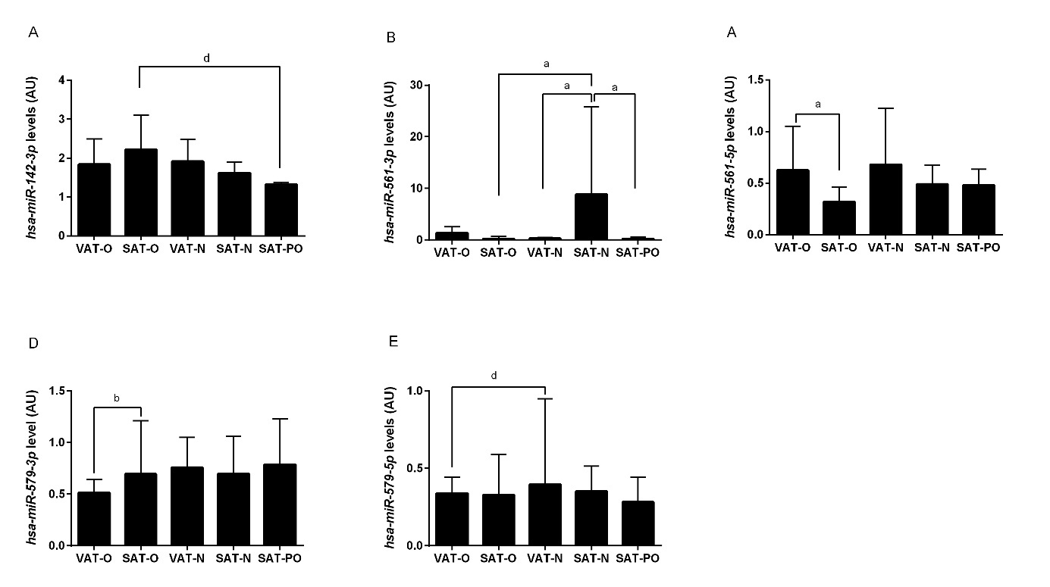

Supplementary Figure S1. Expression of hsa-miR-142-3p (A), hsa-miR-561-3p (B), hsa-miR-561-5p (C), hsa-miR-579-3p (D) and hsa-miR-579-5p (E) in the visceral (VAT) and subcutaneous (SAT) adipose tissues of the obese individuals before (O) and after surgically induced weight loss (PO) and in the normal-weight subjects (N). Results normalized to hsa-miR-103a-3p concentration are presented as the median with the interquartile range. “a” p < 0.0001; “b” p < 0.001; “d” p <

