Supplementary material for the following study:

A comparison of clinical and cardiac biomarker profiles of patients with SARS-CoV-2-negative community-acquired pneumonia and with COVID-19 pneumonia in a high HIV prevalence adult population.

Authors
Murimisi Mukansi¹, Helen C. Steel², Theresa M. Rossouw², Ismail Kalla¹, Colin Menezes¹, Martin Nieuwoudt³, Ronald Anderson², Charles Feldman¹

Affiliation
- Department of Internal Medicine, Faculty of Health Sciences, University of the Witwatersrand, Johannesburg, South Africa
- Department of Immunology, School of Medicine, Faculty of Health Sciences, University of Pretoria, Pretoria 0001, South Africa
- Institute for Biomedical Engineering, Faculty of Engineering, University of Stellenbosch, Stellenbosch, South Africa

Corresponding author:
Murimisi Mukansi
ORCID: 0000-0002-7013-9070

Supplementary Table 1: Multivariable logistic regression analysis of clinical variables in patients with CAP and COVID-19.

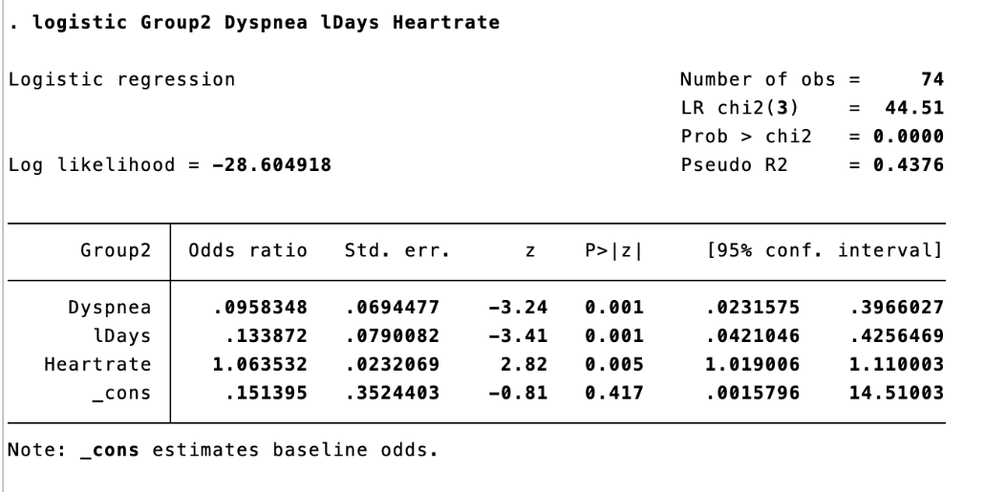
Explanation: Group categories: CAP = 0; COVID-19 = 1
Logarithmic transformation of Days (duration of symptoms)

Supplementary Table 2: Multivariable logistic regression analysis of routine laboratory variables in patients with CAP and COVID-19.
Explanation: Group categories: CAP = 0; COVID-19 = 1
Logarithmic transformation of SpO2 (peripheral oxygen saturation), CRP (C-reactive protein) and CrCL (Creatinine clearance)

Supplementary Table 3: Multivariable logistic regression analysis of study-specific cardiac variables in patients with CAP and COVID-19.
Explanation: Group categories: CAP = 0; COVID-19 = 1
Logarithmic transformation of NTproBNP (N-terminal pro-brain natriuretic peptide) and troponin I

Supplementary Table 4. Analysis of levels of cardiac biomarkers in CAP and COVID-19 pneumonia groups by sex.
 | CAP |  |  | COVID-19 pneumonia
Biomarkers | Male  (n=27) | Female  (n=31) | P-value | Male  (n=36) | Female  (n=38) | P-value
BNP | 69.81 (44.87 – 19.10) | 81.00 (54.74 – 111.51) | 0.178 | 63.89 (63.89 – 91.76) | 71.30 (63.89 – 232.92) | 0.075
NT-pro BNP | 203.85 (168.17 – 547.46) | 226.87 (146.99 – 496.29) | 0.429 | 232.08 (134.71 – 359.28) | 262.80 (184.10 – 424.90) | 0.155
CK-MB | 2,418.95 (1,149.60 – 5,390.09) | 3,276.22 (2,065.44 – 11,640.56) | 0.054 | 3,946.62 (2,983.94 – 7,674.85) | 4,681.20 (2,708.19 – 9,295.14) | 0.451
Troponin I | 68.59 (68.59 – 477.80) | 183.96 (68.59 – 335.60) | 0.256 | 240.62 (119.94 – 553.52) | 458.64 (250.19 – 951.45) | 0.005
Endocan-1 | 1,588.82 (910.67 – 2,119.70) | 1,901.95 (1,295.73 – 3,114.76) | 0.191 | 1,554.34 (661.78 – 3,374.17) | 2,490.41 (1,295.80 – 3,844.90) | 0.065

Abbreviations: BNP: B-Type natriuretic peptide; CAP: community-acquired pneumonia; CK-MB: creatinine kinase-myoglobin binding; COVID-19: coronavirus disease-19; n: number; NT-proBNP: N-terminal prohormone of brain natriuretic peptide.

Supplementary Table 5. Analysis of levels of cardiac biomarkers in CAP ad COVID-19 groups by HIV status.
Biomarker | CAP |  |  | COVID
 | HIV-positive  (n=27) | HIV-negative  (n=23) | P- value | HIV-positive  (n=24) | HIV-negative  (n=49) | P- value
BNP | 78.26 (41.39 – 109.10) | 78.26 (54.74 – 109.10) | 0.244 | 104.23 (63.89 – 297.11) | 63.89 (56.06 – 91.76) | 0.009
NT-pro BNP | 203.85 (146.99-544.40) | 226.87 (168.17 – 547.46) | 0.196 | 272.56 (184.10 – 440.63) | 209.31 (139.11 – 363.38) | 0.077
CK-MB | 2,769.82 (1,741.37 – 6,521.26) | 3,086.83 (1,838.89 – 7,037.52) | 0.469 | 3,946.62 (2,983.94 – 7,674.85) | 3,697 (2,177.50 – 4,832.24) | 0.130
Troponin I | 109.94 (68.59 – 683.16) | 183.96 (68.59 – 572.26) | 0.282 | 458.64 (292.39 – 1,215.38) | 268.68 (145.13 – 654.37) | 0.016
Endocan-1 | 1,735.86 (910.67 – 2,566.36) | 2,657.02 (979.06 – 2,076.91) | 0.389 | 2,657.02 (1,472.44 – 3,842.20) | 1,924.86 (637.42 – 3,440.47) | 0.019

Abbreviations: BNP: B-type natriuretic peptide; CAP: community-acquired pneumonia; CK-MB: creatinine kinase-myoglobin binding; COVID-19: coronavirus disease-19; n: number; NT-pro BNP: N-terminal prohormone of brain natriuretic peptide

Abbreviations:
ACEI: angiotensin-converting enzyme inhibitors,
ALT: Alanine transaminase.
AST: Aspartate transaminase
BNP: B-type natriuretic peptide.
BP: Blood pressure
BUN: Blood urea nitrogen
CAP: Community-acquired pneumonia.
CD4: Cluster of differentiation 4
CK-MB: Creatinine kinase-myoglobin binding.
cTnI: Cardiac troponin I
COPD: Chronic obstructive pulmonary disease
COVID-19: Coronavirus disease-19.
CRP: C-reactive protein
CrCL: Creatinine clearance
CVEs: Cardiovascular events.
FiO₂: Fraction of inspired oxygen
GGT: Gamma-glutaryl transaminase
HCO3: Bicarbonate.
HIV: Human immunodeficiency virus
K: Potassium
N: Number.
Na: Sodium
NT-pro BNP: N-terminal prohormone of brain natriuretic peptide.
PaO₂: Partial pressure of oxygen;
PCR: Polymerase chain reaction.
PCT: Procalcitonin
PMN: Polymorphonuclear leukocyte count
PLR: Platelet lymphocyte ratio
SARS-CoV-2: Severe acute respiratory syndrome coronavirus 2.
SD: Standard deviation.
SpO2: Peripheral oxygen saturation,
VS: Versus.
WBC: White blood cell.

