Advanced thermal interface materials based on ultra-thin and ultra-strong metal-gel

Zilong Xie^{1,2,3} , Hui Zhou¹, Runlai Li¹, Xizhi Chen¹, Zirui Wang¹, Weizhi Lin¹, Zhengli Dou¹, Kai Wu¹, Qiang Fu¹*

¹College of Polymer Science and Engineering, State Key Laboratory of Polymer Materials Engineering, Sichuan University, Chengdu, 610065, China
²College of Advanced Interdisciplinary Studies, National University of Defense Technology, Changsha, 410073, China
³Nanhu Laser Laboratory, National University of Defense Technology, Changsha, 410073, China

*Corresponding author.
E-mail: (Q. Fu) qiangfu@scu.edu.cn

Supplementary Figures

Supplementary Figure 1. SEM images of Au-UPE at sputtering time of 20 s.

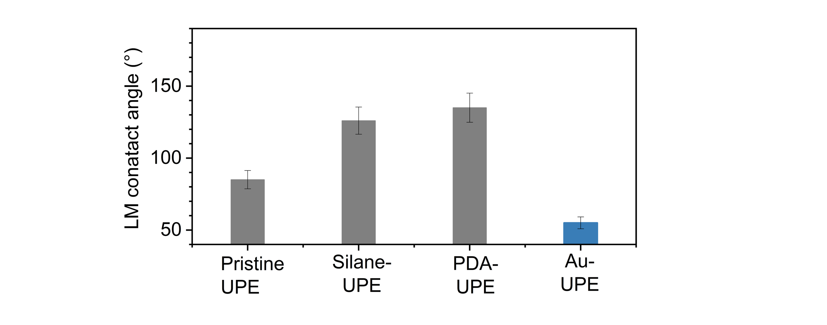
Supplementary Figure 2. Contact angles of LM on UPE films treated with different methods, including no treatment, Silane treatment, polydopamine (PDA), and Au particles

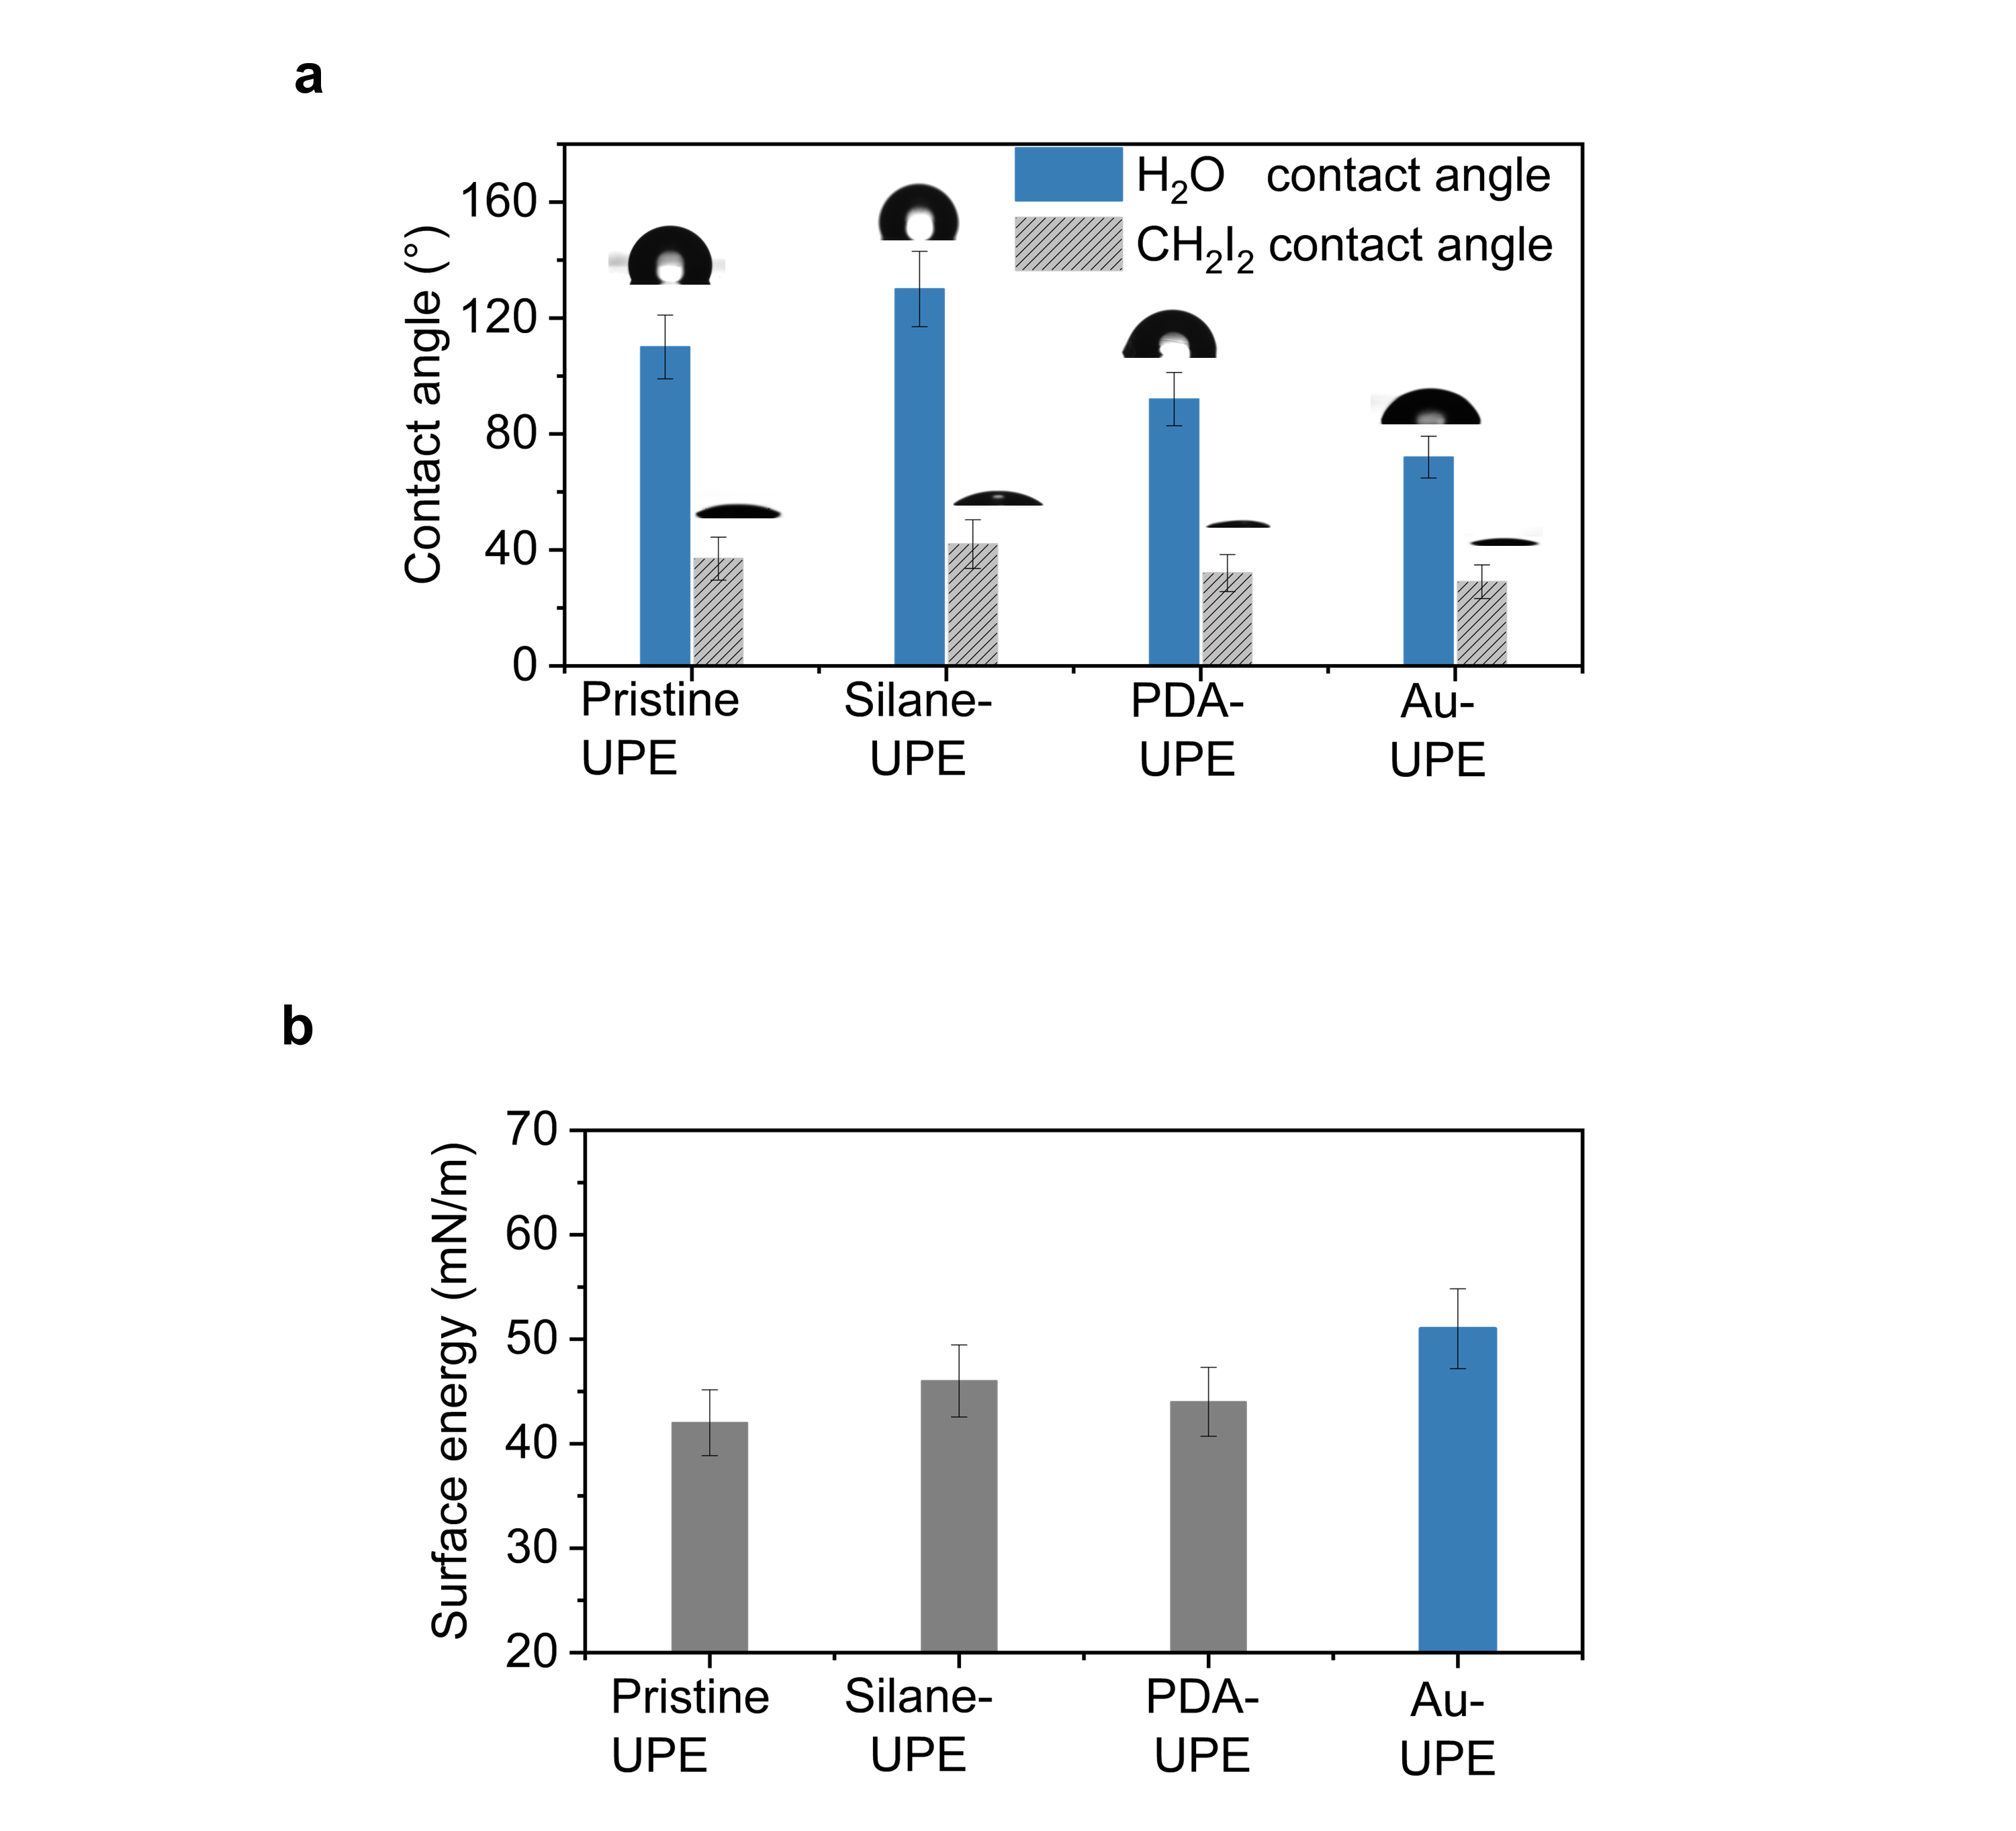
Supplementary Figure 3. (a) Water contact angles, CH₂I₂ contact angles and (b) surface energy of UPE films treated with different methods, including no treatment, Silane treatment, polydopamine (PDA), and Au particles
.

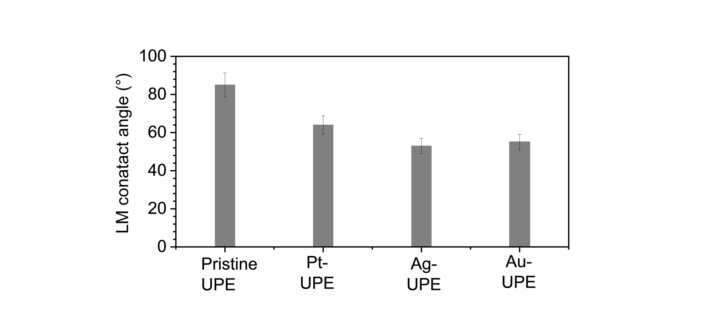
Supplementary Figure 4. Contact angles of LM on UPE films treated with different methods, including no treatment, Pt particles, Ag particles, and Au particles

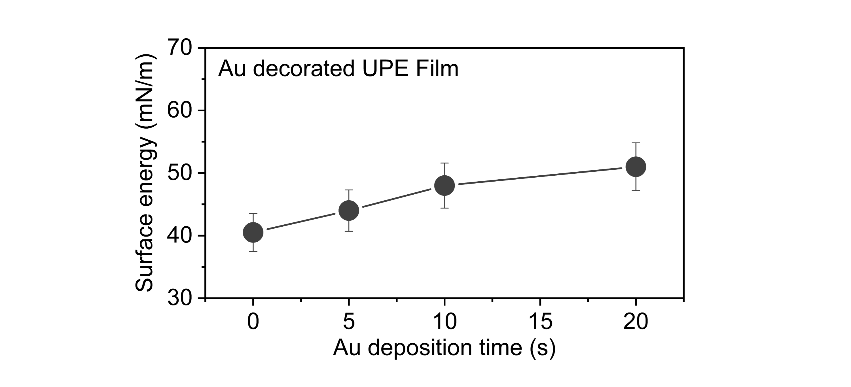
Supplementary Figure 5. Surface energies of Au-UPE films with different Au sputtering times.

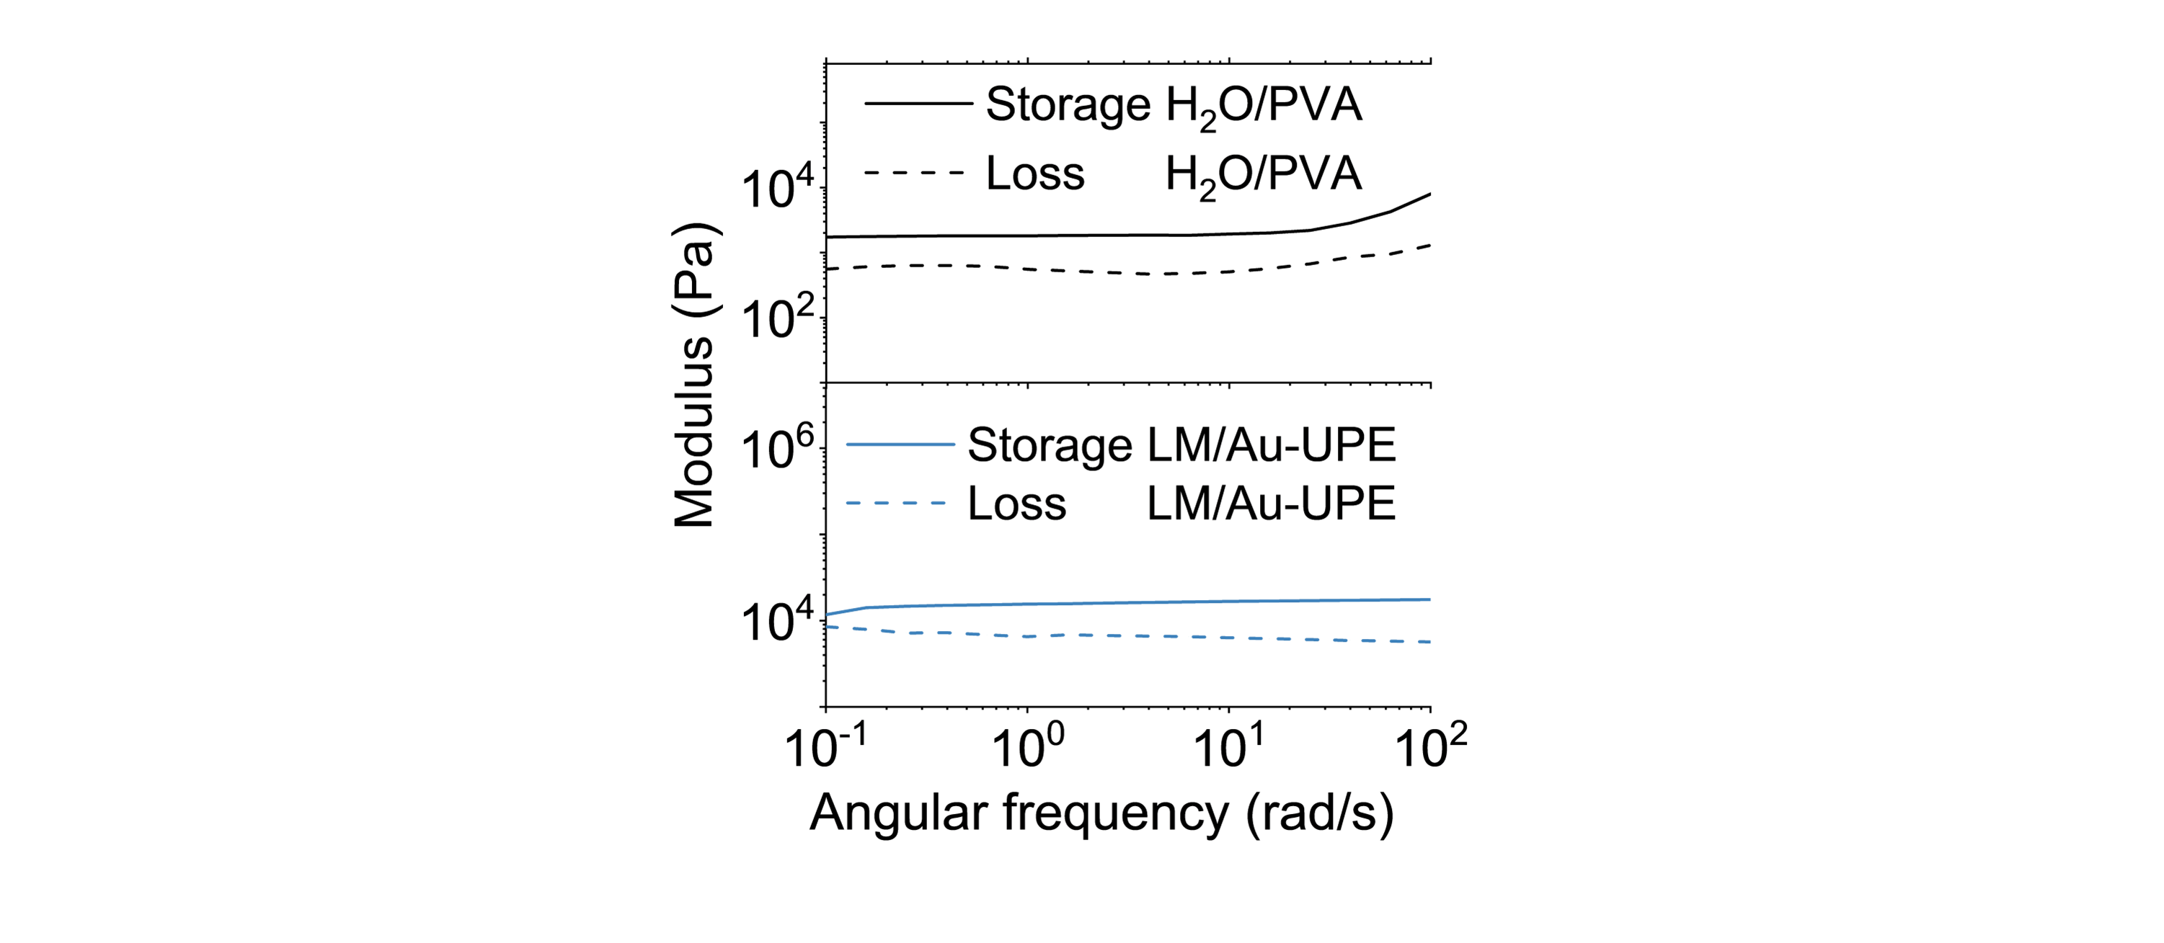
Supplementary Figure 6. Rheology curves comparison between LM/Au-UPE gel and H₂O/PVA gel at the same liquid contents (90 vol%) with different angular frequency.

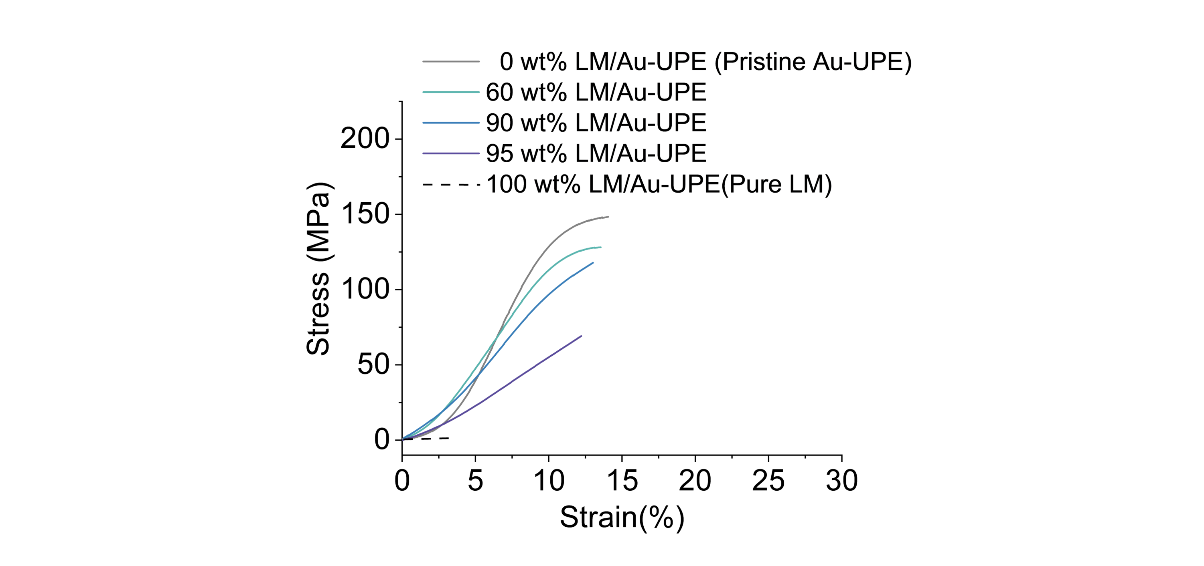
Supplementary Figure 7. Strain-stress curves comparison of LM/Au-UPE gels with different LM contents.
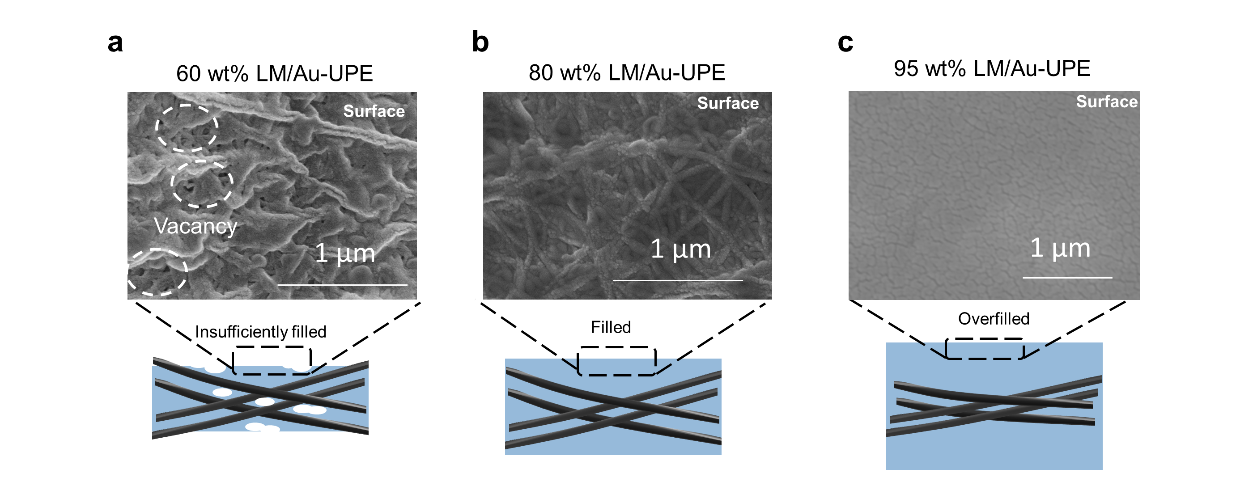
Supplementary Figure 8. SEM images and schematic illustration detailing the structure of LM/Au-UPE gel at different LM contents: (a) 60 wt% LM; (b) 80 wt% LM; (c) 95 wt% LM.

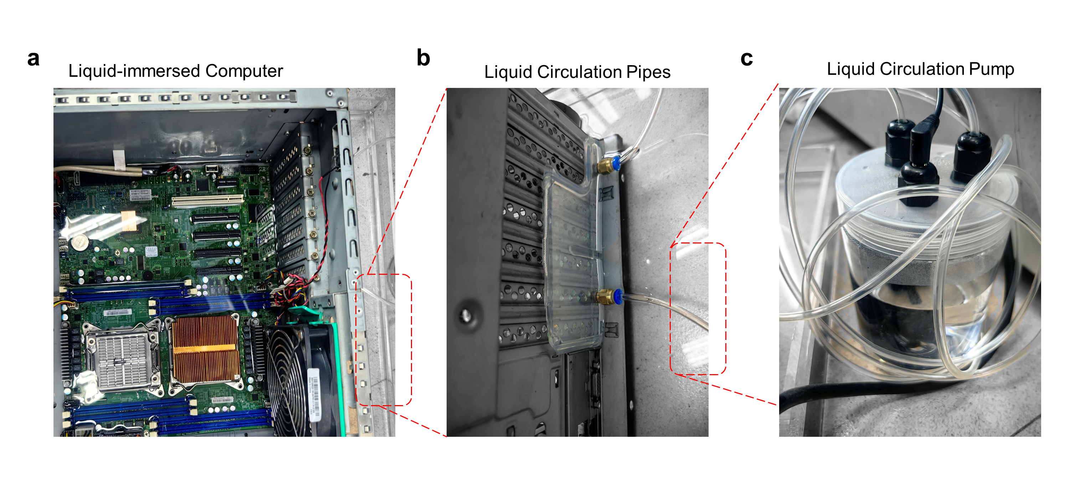
Supplementary Figure 9. Optical photographs of custom liquid cooling loop around computer chip, incorporating the (a) liquid-immersed computer, (b) liquid circulation pipes, and (c) circulation pump.


Supplementary Figure 10. Thermal distribution images of the heat sink captured by infrared thermal imaging, suggesting the cooling performance of LM/Au-UPE is as good as commercial LM TIMs.

Table S1. Comparison of the mechanical strength and the interface thermal resistance for the LM/Au-UPE gel film with the representative thermal interface materials in previous literatures.
Materials | Mechanical tensile strength  (MPa) | Interface thermal resistance  (mm²·K·W⁻¹) | Ref
Polymer composites thermal grease
PDMS/Al₂O₃/ZnO | 0.00024  （yield strength） | 9.2 | ¹
PDMS/SAMs-Al₂O₃ | 4.9 | 16.9 | ²
PDMS/LM-Al₂O₃ | 4.6 | 36.0 | ³
Polymer composites thermal pad
Acrylate polymer/BNNS | 3.2 | 25.8 | ⁴
SIBS/Al₂O₃ | 2.2 | 85.0 | ⁵
PDMS/Al | 0.4 | 10.4 | ⁶
PDMS/LM | 0.18 | 28.0 | ⁷
LM and its composites
GaInSn | / | 2.5 | ⁸
GaInSn/AlN | / | 0.4 | ⁹
LM/Cu array | / | 0.7 | ¹⁰
Sn/Bi | / | 5.7 | ¹¹
In/Bi | / | 8.1 | ¹¹
Sn/In | / | 7.2 | ¹¹
Vertically arranged carbon materials
Graphene monolith | 0.5  (compressive strength) | 26.9 | ¹²
Graphene array | / | 11.8 | ¹³
CNTs array | / | 77.0 | ¹⁴
This work
LM/Au-UPE (90 wt% LM) | 117 | 7.7 | /
Note:
PDMS: Polydimethylsiloxane; SAMs-Al₂O₃: Self-Assembled monolayers-modified alumina particles; LM: Liquid metal; BNNS: Boron nitride nano sheets; SIBS: Poly (styrene-block-isobutylene-block-Styrene); CNTs: Carbon nanotubes.

Table S2. Comparison analysis of the experimental performances of four kinds of mainstream TIMs, suggesting the unique advantage of LM gels in balancing the strength and thermal resistance.
Type | Materials | Tensile strength  (MPa) | Interface thermal resistance  (mm²·K·W⁻¹) | Bond line thickness  (μm) | Ref
LM Gel | LM/Au-UPE (This work) | 117 | 7~8 | 1~3 | /
LM based composites | Thermalright Silver King  (Commercial product) | 0 | 3~6 | 46 | /
Polymer composite thermal grease | Shin-Etsu X-23  (Commercial product) | 0 | 40 | 100 | ⁹
Polymer composite thermal pad | Bergquist 5000S35  (Commercial product)) | 4 | 63 | 100 | ⁹
Note:
Shin-Etsu X-23 and Bergquist 5000S35 are commercial thermal grease and thermal pads, obtained from Alibaba. Thermalright Silver King is a commercial LM alloy paste, obtained from Amazon. Their mechanical properties are tested in the lab for comparative studies. The thermal properties of Thermalright Silver King are tested in the lab for comparative studies.

Supplemental References
1. Dou Z, Zhang B, Xu P, Fu Q, Wu K. Dry-Contact Thermal Interface Material with the Desired Bond Line Thickness and Ultralow Applied Thermal Resistance. ACS Appl Mater Interfaces 15, 57602-57612 (2023).
2. He X, et al. Simultaneous Reduction of Bulk and Contact Thermal Resistance in High-Loading Thermal Interface Materials Using Self-Assembled Monolayers. Advanced Functional Materials 34, 2402276 (2024).
3. Xie Z, et al. Joint-inspired liquid and thermal conductive interface for designing thermal interface materials with high solid filling yet excellent thixotropy. Advanced Functional Materials 33, 2214071 (2023).
4. Zhan K, et al. Low thermal contact resistance boron nitride nanosheets composites enabled by interfacial arc-like phonon bridge. Nature Communications 15, 2905 (2024).
5. Zhi Y, et al. Stretchable composites with high oxide loading. Nature Communications 16, 3562 (2025).
6. Zhang Z, et al. Thermal interface materials with low modulus and high thermal conductivity by manipulating multi-branched PDMS network: The disentanglement and entanglement effect of dangling chain. Chem Eng J (Lausanne) 495, 153352 (2024).
7. Zhao L, et al. Liquid metal nano/micro-channels as thermal interface materials for efficient energy saving. J Mater Chem C 6, 10611-10617 (2018).
8. Gao Y, Liu J. Gallium-based thermal interface material with high compliance and wettability. Applied Physics A 107, 701-708 (2012).
9. Wu K, et al. Mechanochemistry-mediated colloidal liquid metals for electronic device cooling at kilowatt levels. Nature Nanotechnology 20, 104-111 (2025).
10. Cheng R, et al. Liquid-infused nanostructured composite as a high-performance thermal interface material for effective cooling. Nature Communications 16, 794 (2025).
11. Chiu C-P, Maveety JG, Tran QA. Characterization of solder interfaces using laser flash metrology. Microelectron Reliab 42, 93-100 (2002).
12. Dai W, et al. Metal-Level Thermally Conductive yet Soft Graphene Thermal Interface Materials. ACS Nano 13, 11561-11571 (2019).
13. Xu S, et al. Electric-Field-Assisted Growth of Vertical Graphene Arrays and the Application in Thermal Interface Materials. Advanced Functional Materials 30, 2003302 (2020).
14. Sun L, et al. Wafer-scale vertically aligned carbon nanotubes for broadband terahertz wave absorption. Carbon 154, 503-509 (2019).

