Figure 1：Root tip cells at mitotic metaphase

(A) Pollen mother cell chromosomal configurations at meiotic metaphase
（A）

(B). Pollen mother cell chromosomal configurations at anaphase I
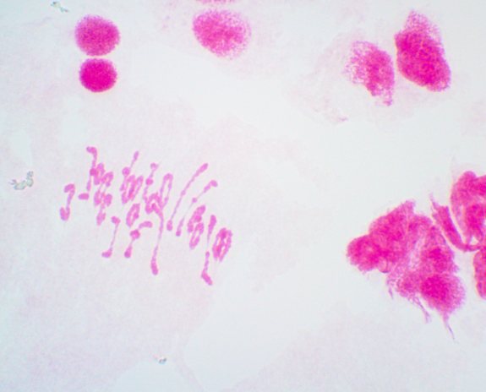
(B)
（C）Chromosome characteristics of W19513, 2n = 22I + 22I.
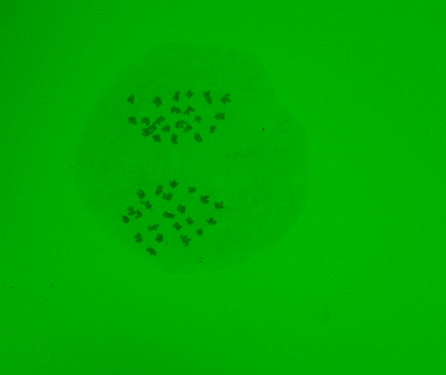
(C)

Figure 2. Karyotypes with the genomic composition variation of W19513, which was obtained by using GISH analysis.

(A)

(A). SY159 genomic DNA

(B)

(C)

(B). The DNA of Ae.comosa.
(C). The DNA of Ae.umbrellata. The red arrow indicates the introduction of alien chromosomes of Ae.geniculate.

Figure 3. PLUG and EST–STS functional molecular marker analysis of W19513. (M) DL2000 (2kb DNA ladder), (1). CS, (2). SY159, (3). W19513.
A
B
M 1 2 3

C
D

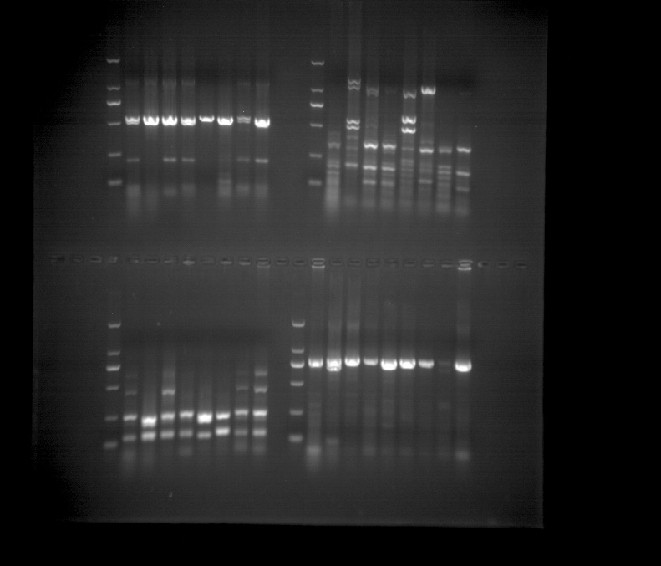
E

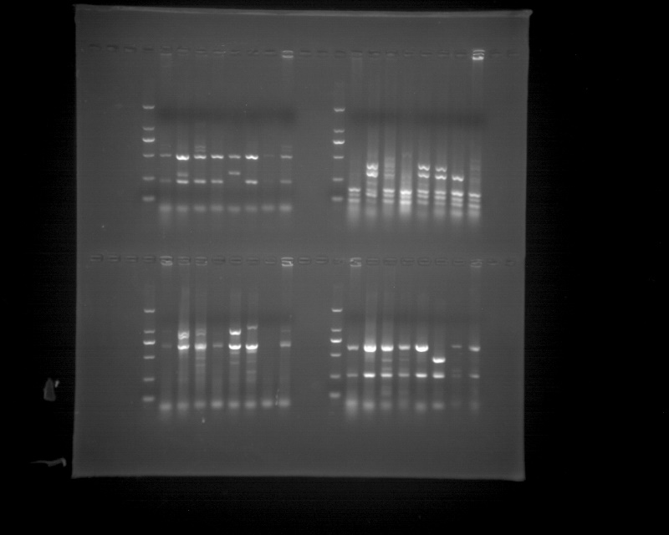
F
G

(Ａ-G). The PLUG markers amplification results with TNAC1300, TNAC1341, TNAC1383, TNAC1627, TNAC1364，TNAC1383, TNAC1627. (A-D). The TaqI digestion；(E-G). The HAEII digestion

H-L The EST–STS markers amplification results with BM134465, CD343475, BQ169491, CD452844, BF429203.
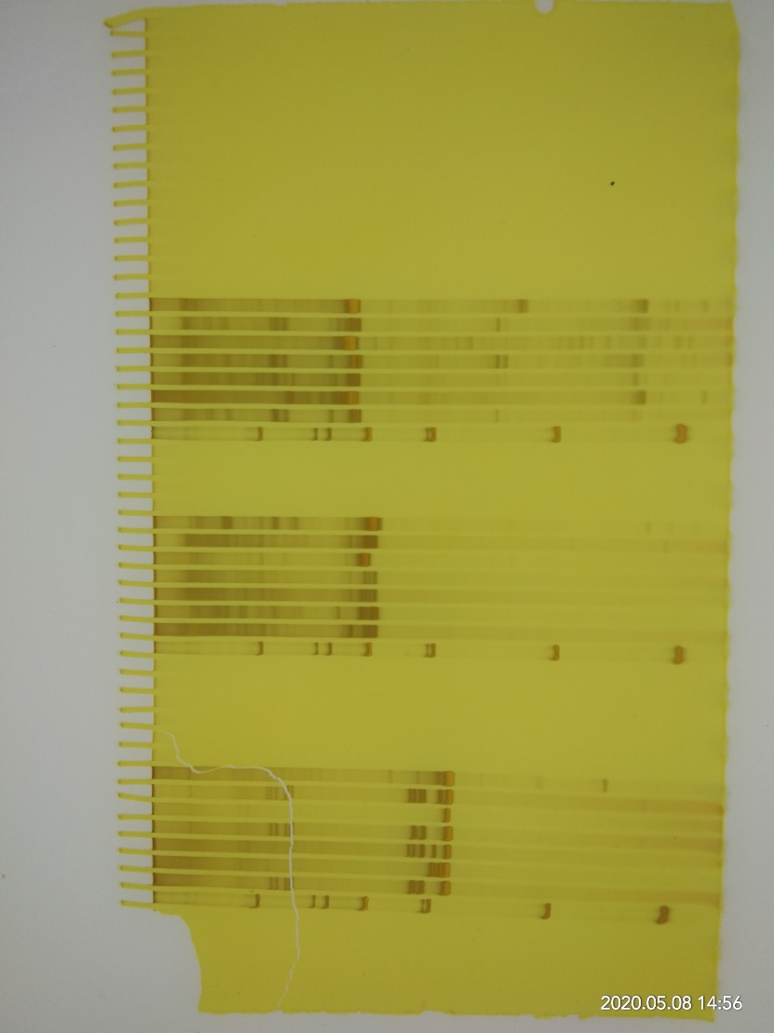
I
J
K

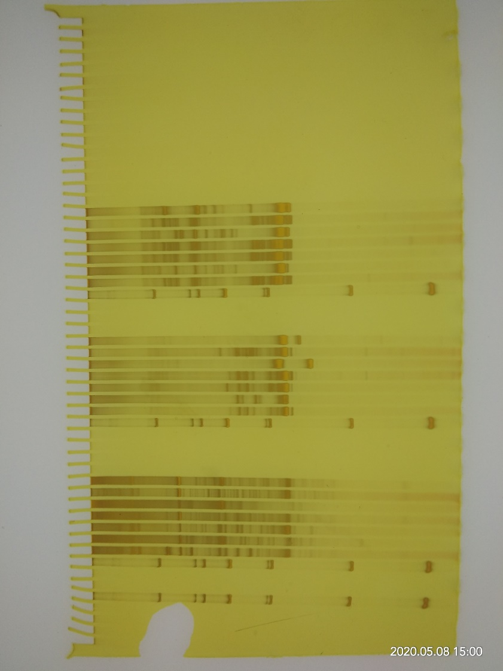
H
L

Figure 4. Karyotypes with the genomic composition variation of W19513，which was obtained by using FISH.

Sequential FISH-GISH analysis.

Analysis of CS by FISH

Figure 5. Amplification patterns of Aegilops accessions using W19513. SLAF markers M124, M39, M52 and M23. (M) DL2000 (2 kb DNA ladder). (1). CS. (2) SY159. (3). Ae. comosa. (4). Ae. umbellulate. (5). W19513.

M124

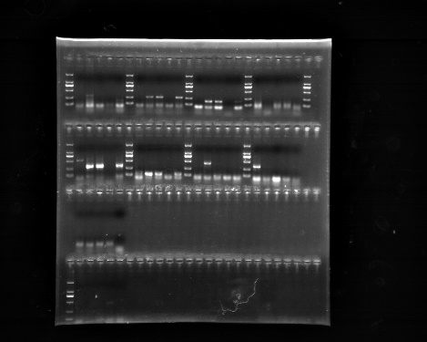
M39
M 1 2 3 4 5

M52

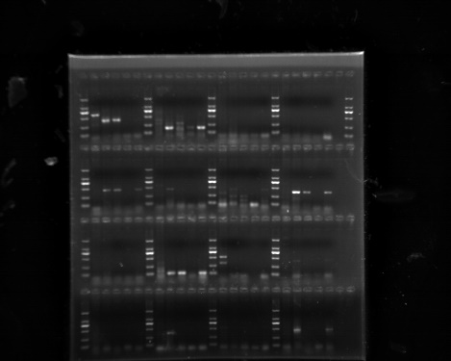
M23

