Supplementary Information for:
Single-crystalline TiO₂ Nanoparticles for Narrowing the Scalability Gap towards Stable and Efficient Perovskite Modules
Yong Ding^{1,2,†}, Bin Ding^{2,†}, Hiroyuki Kanda², Onovbaramwen Jennifer Usiobo³, Thibaut Gallet⁴, Zhenhai Yang⁵, Yan Liu⁶, Hao Huang⁷, Jiang Sheng⁵, Cheng Liu^{1,2}, Yi Yang^{1,2}, Valentin Ianis Emmanuel Queloz², Xianfu Zhang¹, Jean-Nicolas Audinot³, Alex Redinger⁴, Wei Dang⁷, Edoardo Mosconic⁸, Wen Luo², Filippo De Angelis^{9,10,11}, Mingkui Wang¹², Jihuai Wu¹³, Guanjun Yang^{6,*}, Songyuan Dai^{1,*}, Paul J. Dyson^{14,*}, and Mohammad Khaja Nazeeruddin^{2,*}
Affiliations:
¹State Key Laboratory of Alternate Electrical Power System with Renewable Energy Sources, North China Electric Power University, Beijing 102206, P. R. China.
²Group for Molecular Engineering of Functional Materials, Institute of Chemical Sciences and Engineering, EPFL VALAIS, Sion 1950, Switzerland.
³Advanced Instrumentation for Nano-Analytics (AINA), Materials Research and Technology Department, Luxembourg Institute of Science and Technology (LIST), L-4422 Belvaux, Luxembourg.
⁴Department of Physics and Materials Science, University of Luxembourg, Luxembourg City L-1511, Luxembourg.
⁵Ningbo Institute ofMaterials Technology and Engineering, Chinese Academy of Sciences (CAS), Ningbo 315201, China.
⁶State Key Laboratory for Mechanical Behavior of Materials, Xi'an Jiaotong University, Xi'an 710049, China.
⁷Hebei Key Lab of Optic-Electronic Information and Materials, College of Physics Science and Technology, Hebei University, Baoding 071002, China.
⁸Computational Laboratory for Hybrid/Organic Photovoltaics (CLHYO), Istituto CNR di Scienze e Tecnologie Chimiche “Giulio Natta” (CNR-SCITEC), Via Elce di Sotto 8, 06123 Perugia, Italy.
⁹Department of Chemistry, Biology and Biotechnology, University of Perugia, Via Elce di Sotto 8, 06123 Perugia, Italy.
¹⁰CompuNet, Istituto Italiano di Tecnologia, Via Morego 30, 16163 Genova, Italy.
¹¹Department of Mechanical Engineering, College of Engineering, Prince Mohammad Bin Fahd University, P.O. Box 1664 Al Khobar 31952, Kingdom of Saudi Arabia.
¹²Wuhan National Laboratory for Optoelectronics, School ofOptoelectronic Science and Engineering, Huazhong University ofScience and Technology, Wuhan 430074, China.
¹³Eng. Res. Centre of Environment-Friendly Functional Materials, Ministry of Education, Fujian Eng. Res. Centre of Green Functional Materials, Huaqiao University, Xiamen 361021, China.
¹⁴Institute of Chemical Sciences and Engineering, École Polytechnique Fedérale de Lausanne, 1015 Lausanne, Switzerland.
†These authors contributed equally: Yong Ding and Bin Ding.
*E-mail: ygj@mail.xjtu.edu.cn, sydai@ncepu.edu.cn, paul.dyson@epfl.ch, and mdkhaja.nazeeruddin@epfl.ch
1. Experimental Section
1.1. Materials and chemicals
Isopropyl alcohol, acetone, ethylenediamine and tetrabutyl titanate were purchased from Sinopharm Chemical Reagent Co., Ltd. Titanium diisopropoxide bis(acetylacetonate), dimethylformamide (DMF), dimethyl sulfoxide (DMSO), bis(trifluoromethane)sulfonimide lithium salt and cobalt‐complex (FK209) were purchased from Sigma-Aldrich. Methylammonium iodide (MAI), formamidinium iodide (FAI), methylammonium cloride (MACl), phenethylammonium iodide (PEAI) and TiO₂ paste (Dyesol-30NR-D) were purchased from Greatcell. PbI₂ was purchased from TCI Europe, and Spiro-OMeTAD, CsCl, and PTAA were bought from Xi’an Polymer Light Technology in China.
1.2 TiO₂ nanoparticles synthesis
Single-crystal TiO₂ rhombus-like nanoparticles: Single-crystal TiO₂ rhombus-like nanoparticles were prepared by a one-step solvothermal method. In a typical synthetic procedure, 2.0 mL tetrabutyl titanate, 40 mL isopropyl alcohol, and 10 mL acetone were mixed together in a flask under vigorous stirring at ambient temperature for 15 min. Then, 2 mL ethylenediamine was injected into the flask, and the mixture was magnetically stirred for another 15 min to ensure homogeneity. Subsequently, the obtained solution was transferred to a 100 mL Teflon-lined autoclave, which was then heated at 200 °C for 20 h. After the autoclave cooled to ambient temperature, the as-obtained product was washed with ethanol several times. As illustrated in our previous work to prepare paste ¹, single-crystal TiO₂ nanoparticles (1.0 g) was mixed with terpilenol (0.2 g) and ethyl cellulose (5.0 g), and ethanol was removed to obtain paste.
Conventional TiO₂ nanoparticles: TiO₂ nanoparticles were usually synthesized by a modified sol-gel method, including hydrolysis process of titanium alkoxide, Sol-Gel process and hydrothermal treatment. Titanium isopropoxide (60 mL, Sigma-Aldrich) was added dropwise into 200 mL of deionized water under vigorous stirring for 3h, and the formed precipitate solution was washed three times with deionized water. Then, the precipitate was transferred to a Teflon round container, which contained a certain amount of ammonium solution to adjust the pH (pH=~12), and the solution was stirred for 12 h at a temperature of 85 ºC to form a transparent sol. Afterwards, the solution was transferred into sealed Titanium autoclave, and hydrothermally treated at 200 ºC for 16 h to obtain the gel. The latter gel was washed with ethanol three times to obtain the TiO₂ nanoparticles. The procedures were identical to the previously reported work.² This method is highly costly and time-consuming, thus it is necessary to search for a facile method that can be scalable to fabricate it.
1.3 Small-sized Solar Cell Fabrication
The device with an architecture of FTO glass/compact TiO₂ layer (c-TiO₂) /mesoporous TiO₂ layer (m-TiO₂)/Rb_{0.03}Cs_{0.05}MA_{0.05}FA_{0.9}PbI₃ (PVK)/spiro-OMeTAD (HTM)/Au structure was fabricated, as follows: Firstly. FTO glass (TEC9AX, 15×25 mm²) was sequentially cleaned with soap (5% Hellmanex in water), deionized water, acetone, and isopropanol. Then, a c-TiO₂ blocking layer was deposited on the FTO glass by spray-coating the precursor solution consisting of a titanium diisopropoxide bis(acetylacetonate) solution in isopropanol (5% v/v), followed by sintering at 450 °C for 20 min (c-TiO₂). After cooling, single-crystal TiO₂ paste and commercial Dyesol paste were spin-coated on the compact TiO₂ layer to prepare m-TiO₂ layer, and then sintered in air at 500 °C for 30 min, thereby obtaining the SC and NP, respectively. After sintering, the c-TiO₂/m-TiO₂ were ready to use and transferred into a glovebox for preparing the perovskite layer. The perovskite precursor solution (1.4 M) was prepared by adding 645.4 mg of PbI₂, 216.7 mg of formamidium iodide (FAI), 11.1 mg of methylamonium iodide (MAI), 11.8 mg of CsCl and 8.9 mg of RuI into 200 μL of N, N'-dimethylsulfoxide (DMSO) and 800 μL of dimethyformamide (DMF) mixture. Before each step, we have used UV-ozone treatment of the substrates for 15 min at room temperature. Afterwards, 40 μL of perovskite precursor solution was spin-coated on top of the c-TiO₂/m-TiO₂ substrate through a two-step process. The first step was 1000 rpm for 10 s with an acceleration of 200 rpm/s. The second step was 4000 rpm for 20 s with a ramp-up of 1000 rpm/s. 100 uL of chlorobenzene (CBZ) was dropped on the spinning substrate during the second spin-coating process at 10 s before the end of the procedure. Afterwards, the substrate was put onto the hotplate and heated at 100 °C for 1 h and 150 °C for 10 min. After cooling down to room temperature, 60 uL of phenethylammonium iodide (PEAI) solution (5 mg/mL in isopropanol) was dropped on the spinning perovskite layer at 5000 rpm for 20 s. Then, 30 μL of Spiro-OMeTAD solution, dissolving 100 mg of Spiro-OMeTAD with Li-TFSI (23 uL from a 520 mg mL⁻¹ stock solution in acetonitrile), TBP (39.0 uL) and Co(II)TFSI (18 uL from a 376 mg·mL⁻¹ stock solution in acetonitrile) as dopants into 1.279 mL of CBZ, was spin-coated onto the perovskite layer at 3,000 r.p.m. for 20 s. Finally, a 70 nm-thickness gold layer was evaporated.
1.4 Module Fabrication
The illustration of fabrication procedure, including all deposition process and scribing steps, are as follows (Supplementary Fig.28 and Fig. 29). Firstly, FTO glass (6.5×7.0 cm²) was etched by a laser process with a power of 80 W and a width of 60 μm (P1). The subsequent processes for the preparation of c-TiO₂/m-TiO₂ substrates are the same than the small-area device procedures. Besides, the perovskite precursor deposition was also similar to that of the small solar cells except for the concentration of perovskite precursor. In brief, 1.2~1.4 M of perovskite precursor was employed to do the perovskite layer by using spin-coated method and custom-made gas-induced pump method. More detains of this pump method is reported in our previous literature³. The perovskite precursor was spin-coated on the c-TiO₂/m-TiO₂ substrates with a two-step process. The first step was 1000 rpm for 5 s with an acceleration of 200 rpm/s. The second step was 4000 rpm for 20 s with a ramp-up of 1000 rpm/s. The as-obtained liquid perovskite film was put into a sample chamber which is connected with a pump system. Once valve is turned on, the DMF and DMSO solvent evaporate rapidly under a low pressure maintained at 10 Pa for 10 s. After turning off the valve, the brown and transparent perovskite film is placed onto the hot plate. The perovskite films were annealed at 100 ºC for 1 h and 150 ºC for 10 min. After cooling down to room temperature, the procedures to spin-coat PEAI passivation layer and the Spiro-OMeTAD layer are similar with those of the small-size devices. After that, the P2 laser scribing process was conducted on the above FTO/c-TiO₂/m-TiO₂/PVK/PEAI/HTM samples with a power of 50 W and a scribing width of 600 μm, and the distance between P1 and P2 was ~100 μm. After the P2 laser process, 70-nm thickness of Au layer was thermally evaporated and scribed by a laser with a power of 30 W and a width of 200 μm (P3). The distance between P2 and P3 was about ~100 μm.
1.5. Characterization
J-V characterization: The current density-voltage (J-V) measurements were performed on a Keithley model 2400 digital source meter controlled by Test point software under a xenon lamp (450 W Xenon, AAA class). The light intensity was calibrated with a NREL-certified KG5-filtered Si reference diode. The active areas of small cells and mini-modules were masked with a metal aperture of 0.09 cm² and 24.63 cm². An anti-reflection coating layer was employed for measuring devices. All J-V curves of small devices were measured using a reverse scan (from 1.20 V to 0 V) and a forward scan (from 0 V to 1.2 V) under a constant scan speed of 10 mV/s. While the modules were measured using a reverse scan (from 11.0 V to 0 V) and a forward scan (from 0 V to 11.0 V) under a constant scan speed of 100 mV/s.
EQE characterization: The incident photon-to-current conversion (IPCE) values were confirmed as a function of wavelength from 300 to 900 nm (IQE200B, Oriel) for devices without bias light. In order to evaluate the optical properties of the device, no anti-reflection layer was used.
C-V characterization: Intensity dependent capacitance-voltage (C-V) measurements were performed at various modulation frequencies from 1MHz to 1 kHz under dark condition and simulated AM 1.5 illumination with different intensity. For transient photovoltage measurements, the devices were measured using a step function illumination of the cells (on the period of 20 s). The voltage decay after switching the light off was measured using Zahner electrochemical workstation.
Morphological characterization: The morphology of single-crystal TiO₂ nanoparticles was investigated by using scanning electron microscopy (SEM, S-4800, HITACHI, Japan) and field emission transmission electron microscopy (FE-TEM, JEM-2100F, JEOL, Japan). The integrated Differential Phase Contrast (iDPC) technique based on aberration-corrected (Cs) field emission Scanning Transmission Electron Microscope (STEM) (FEI Themis Z 300kV) was performed to achieve atomic resolution imaging, in which the light atoms (Oxygen element) are shown clearly. The collection angle of iDPC image is β<4.9 mrad in this experiment. Powder X-ray diffraction (XRD, MXPAHF, Mark Corp., Japan) was used to determine crystalline phase and calculate crystal sizes of the samples.
Electronic state and band structure characterization: X-ray photoelectron spectroscopy (XPS) and ultraviolet photoelectron spectroscopy (UPS) measurements of FTO/m-TiO₂ were carried out on an XPS machine (Escalab 250 Xi, Thermo Fisher), with a monochromatic Al Kα (1486.7 eV) X-ray source for XPS and a He I (21.2 eV) gas discharge lamp for UPS. UV-vis diffused absorption spectra were obtained by using a PerkinElmer lambda 850 with 150 mm InGaAs integration sphere.
Morphological and surface potential characterization: The amplitude-modulation scanning Kelvin probe force microscopy (SKPM) was performed combined with a Cypher atomic force microscopy (AFM; Asylum Research, Oxford Instruments) and a HF2LI Lock-in amplifier (Zurich Instruments). The resonance frequency ω₀ and spring constant of AFM conducting tips are ~127 kHz and 5.0 N·m⁻¹, respectively. Hall Effect and resistivity measurements were operated with the four contacts van der Pauw method using Lake Shore 7704A. Note that the structure of sample for Hall Effect measurement was Glass/SC (or NP)/Au, where the thickness of SC (or NP) and gold contact are about 100 nm and 200 nm, respectively. Current (10 nA) reversal was used to remove the unwanted thermal-electric effects. The magnetic field was kept between 0.1–0.4 T, positive to negative, through the measurement to remove the influence misalignment voltage.
Work function and grain boundary band bending measurements: Frequency Modulation Kelvin Probe Force Microscopy (FM-KPFM) measurements were carried out using an ultra-high-vacuum VT-AFM system (Omicron) operated in the low 10⁻¹¹ mbar pressure range. Topography and potential information were measured simultaneously by using the cantilever resonance frequency as feedback with two independent lock-in amplifiers. The applied AC voltage ranged from 0.2 V to 0.4 V at 1.25 kHz. The used probes were Pt/Ir PPP-EFM (nanosensors) with a resonance frequency between 70 kHz and 90 kHz. The work function of the samples was obtained by calibrating the tip work function using an HOPG reference sample before and after the measurements of the studied sample. The samples were measured in the dark and without air exposure by using nitrogen sealing and an inert-gas transfer from the glovebox to the measurement chamber. This enabled to access the sample’s work function without it being altered by air or moisture after deposition.
Interfacial charge transfers and charge extraction characterization: Steady-state PL mapping was carried out with a laser confocal Raman spectrometer (Princeton Instruments, Acton Standard Series SP-2558), a digital charge-coupled device (CCD) (PIXIS: 100B_eXcelon), and a 488 nm laser (PicoQuant LDH-P-C-485, 0.4mW with a 1% optical density filter), using a home-built confocal microscope on an area of 10×10 μm². Time-resolved photoluminescence (TR-PL) spectra were recorded on a Horiba Fluorolog-3, with a PMT as detector in Time Correlated Single Photon Counting (TCSPC) mode. The excitation source for the TCSPC is a Horiba nanoLED-370 with an excitation wavelength of 369 nm, a pulse duration of 1.3 ns and a repetition rate of 100 MHz. Femtosecond transient absorption measurements were conducted using a Spirtfire ACE 100F (800 nm, pulse width 100 fs, 1 kHz repetition rate, Spectra-Physics) and an ultrafast spectroscopic system (Harpia, Light Conversion). The output of the fundamental laser was split into pump (90%) and probe (10%) beams. The pump beam was directed through an optical parametric amplification system (TOPAS Prime-F) to generate a 500 nm pump beam, while the probe beam was passed through an optical delay rail and focused onto a Ti:sapphire crystal to generate a white light continuum. The angle between polarization directions of the pump beam and probe beam was set as a magic angle of 54.7°, and the optical delay stage provided a probe time window of 8 ns. The samples were excited with the excitation wavelength of 500 nm with the energy of 120 nJ, and the fractional change in transmission was detected in the probe range from 450 nm to 850 nm at several time delays. Analysis of the kinetic traces derived from time-resolved spectra was performed using biexponential fitting method.
1.6. Device stability test
Long-term operation stability tests were performed in a sealed cell holder flushed with a flow of nitrogen (30 mL·min⁻¹) and the temperature was ambient. J-V curves were measured by an electronic system using a 22-bit delta-sigma analog-to-digital converter, tested every 2 h. For J-V curve measurement, a scan rate of 25 mVs⁻¹ with a step of 5 mV was employed. Devices were maintained at the maximum power point (MPP) using a MPP tracking algorithm under 100 mW cm⁻². A reference Si photodiode was placed in the holder to check the stability of the light.
For humidity stability tests, the encapsulated devices were kept in a thermo-hygrostat (BG/TH-150, SH Guangpin test equipment manufacturing Co., Ltd) which was set under 85% relative humidity at 25 °C. For dry stability test, the bare devices were kept in a drying box maintained with a humidity of below 5.0%. We have used a glass-glass encapsulation technology combined with an edge seal (UV Curing Sealant, Three bond) to seal the device under UV light illumination (LED flood lamp, DELOLUX 20). The UV light was set at 25% maximum power for 120 s in the glove box to induce the cross-linking in sealant with a glass. They put the encapsulated device into the water to test the encapsulation effect. No obvious color change of the device was observed after being immersed into the water for 10 min (Supplementary Video, 5 times of fast forward). Before and after encapsulation, the performance of the devices was the same, indicating that this material can protect the devices against the humidity influence and maintain the original performance.
1.7. Density Functional Theory Calculations
To gain insight into the nature of the interface between the perovskite and the SC TiO₂ we performed DFT calculation evaluating the stability and the structure of the interaction at the (001) facets with respect to the (101). In our previous work, the interaction between the MAPbI₃ and the (101)-TiO₂ anatase was studied by evaluating the energetics, the electronic properties, and the role of Cl doping^{4,5,6,7}. In addition, the interface involving the (001)-TiO₂ anatase was also studied by Geng et al.⁸ Here we extend our analysis by comparing the energetic of the interface between MAPbI₃ and (101) and (001)-TiO₂ following the same approach reported in previous literature⁴.
To model the interface, we adopted a 3×3×3 tetragonal perovskite slab oriented along the 001 direction and we deposited this on top to a 7×7×2 (001)-TiO₂ slab. The final cell parameters on the a and b directions are 26.40 Å providing a lattice mismatch lower than 1%. Geometry optimizations have been carried out at PBE-GGA⁹ level with SIESTA 4.1 program package¹⁰ using a DZ basis set along with nonrelativistic pseudopotentials for Ti, O, C, N, and H atoms. Pb atoms are treated with the WC-GGA¹¹ relativistic pseudopotential. Electrons from O, N, and C 2s and 2p; H 1s; Ti 4s and 3d; and Pb 6s, 6p, and 5d shells are explicitly included in the calculations. Spin orbit interactions are not included in SIESTA calculations. A value of (100) Ry is used as plane-wave cutoff for the grid.
The adsorption energy (E_{ads}) is evaluated as a difference of the energy of the interface and the sum of the energies. To compare the E_{ads} of the (001)- and (101)-TiO₂ interfaces we normalized this value by dividing it by the number of I undercoordinated atoms of the perovskite slabs. Concerning the (101)-TiO₂ perovskite interface with (001)-MAPbI₃ slab⁴.
The electronic structure analyses were performed at the same PBE-GGA level used for geometry optimizations, with the Quantum-Espresso program package¹² on the structures optimized by SIESTA. Electron–ion interactions were described by ultrasoft pseudopotentials with electrons from S 3s and 3p; O, N, and C 2s and 2p; H 1s; Ti 3s, 3p, 3d, and 4s; and Pb 6s, 6p, and 5d shells explicitly included in the calculations. Plane-wave basis set cutoffs for the smooth part of the wave functions and the augmented density were 25 and 200 Ry, respectively. Electronic structure calculations and DOS calculations were performed at the scalar relativistic level and reported in Supplementary Fig. 9.
1.8. Numerical simulation
An electrical simulation was performed to determine the effect of the density of trap states and electron mobility of TiO₂ on photovoltaic performance based on the Poisson and drift-diffusion equations, as follows:
$-∇∙\left(ε_{r}∇V\right)=q(p-n+N_{d}-N_{a}+n_{t}^{+}-n_{t}^{-})$ (1)
$\frac{∂_{n}}{∂_{t}}=\frac{1}{q}∇∙J_{n}+G-R$ (2)
$J_{n}=qnμ_{n}ε+qD_{n}∇_{n}$ (3)
Where ε_{r} is the dielectric constant of the TiO₂, V is the electrostatic potential, n/p is the electron/hole concentration ratio, N_{d}/N_{a} is donor/acceptor concentration ratio, n_{t}⁺/n_{t}⁻ is the ionized donor/acceptor trap density ratio, J_{n} is the electron current density, m_{n} is the electron mobility, D_{n} is the electron diffusion coefficient, which can be estimated by Einstein’s relation, i.e., D_{n}=μ_{n}k_{B}T/q with k_{B} Boltzmann’s constant and T the temperature (Set to be 300 K in the simulation), ε is the electric field, which can be calculated using ε=-$∇$V, and ∂_{n}/∂_{t} is the transient electron concentration change (Set to be 0). While R is the total charge recombination rate, including the radiative or direct recombination rate (R_{rad}), the Auger recombination rate (R_{Aug}), the Shockley-Read-Hall recombination rate (R_{SRH}), and the surface recombination rate (R_{sur}), as follows:
$R=R_{rad}+R_{Aug}+R_{SRH}+R_{sur}$ (4)
$R_{rad}=B_{rad}(np-n_{i}^{2})$ (5)
$R_{Aug}=(A_{n}n+A_{p}p)(np-n_{i}^{2})$ (6)
$R_{SRH}=\frac{np-n_{i}^{2}}{τ_{p}\left(n+n_{t}\right)+τ_{n}(p+p_{t})}$ (7)
$R_{sur}=\frac{np-n_{i}^{2}}{\left(n+n_{ts}\right)/S_{n}+(p+p_{ts})/S_{p}}$ (8)
Where B_{rad} is the radiative recombination coefficient, A_{n}/A_{p} is the ratio of electron/hole Auger recombination coefficient, τ_{n}/τ_{p} is the electron/hole lifetime ratio, S_{n}/S_{p} is the ratio of surface recombination velocity of the electrons/holes, n_{i} is the intrinsic carrier concentration, n_{t}/p_{t} is the ratio of bulk electron/hole concentration of the trap states, and n_{ts}/p_{ts} is the corresponding surface trap state concentration ratio. A good estimation was assumed by setting the bulk and interface states of all energies into a single energy at the middle level of the bandgap. Thus, n_{t} = n_{ts} = p_{t} = p_{ts} = n_{i}. R_{SRH} and R_{sur} can be expressed by the interface and bulk defect densities (D_{it} and N_{t}), respectively, with D_{it}=v_{th}σ_{n}S_{n} and N_{t}=1/(v_{th}τ_{n}σ_{n}), where v_{th} is the thermal velocity and σ is the relevant capture cross-section for the charge carriers. The relevant parameters used in this simulation are listed in Supplementary Table 6.

2 Supplementary Note
Supplementary Note 1: Defects in TiO₂ nanoparticles
Accounting for the low external oxygen partial pressure, TiO₂ is easy to lose oxygen and form electronic disorder. This possible reduction is：
$2O_{O}→O_{2}+2V_{O}^{∙∙}+4e^{'}$ (9)
For each molecule of oxygen lost, one couple of oxygen vacancies ($V_{O}^{∙∙}$) is formed and four electrons are produced. If an occupied Ti_{Ti} and unoccupied interstitial V_{Ti} are considered into the equation (9), the new substitution for $V_{O}^{∙∙}$ can react to obtain an alternative reaction:
${Ti}_{Ti}+2O_{O}+V_{Ti}→O_{2}+{Ti}_{i}^{4∙}+4e^{'}$ (10)
An interstitial Ti ion may form with the loss of oxygen from the lattice. In both cases, electrons might reduce a Ti⁴⁺ ion into a Ti³⁺ ion, as follows:
$2O^{2-}+{4Ti}^{4+}→O_{2}+{4Ti}^{3+}+V_{O}^{∙∙}$ (11)
Thus, the Ti³⁺ and $V_{O}^{∙∙}$ should appear or disappear simultaneously. Both intrinsic defects play an important role in photo-catalysis, which could not only provide more reactive sites for photocatalytic reactions, but also enhance incident light absorption¹³. Unfortunately, in terms of solar cell devices, the intrinsic defects will act as carrier recombination centers which increase the trap-assisted recombination and has a negative impact on the performance and stability of PSC devices^{13,14}.

Supplementary Note 2: Calculating fill factor (FF) with different m-TiO₂ layer.
In a solar cell, the resistive loss is typically composed of series resistance (R_{s}) and shunt resistance (R_{sh}). R_{s} arises from the resistance of each layer and resistive contacts, whereas R_{sh} is related to the current leakage through the device, such as carrier recombination in bulk and interface, the contact between electron transport material and perovskite, and between perovskite and hole transport material, and leakage around the edges of the devices¹⁵. In order to estimate the loss of FF, an equivalent circuit model was proposed to calculate the diode parameters, such as R_{s}, R_{sh} and saturation current density at reverse bias (J₀), as follows¹⁵:
$J=J_{0}\left\{\exp\left[\frac{e\left(V-JR_{s}\right)}{n_{id}k_{B}T}\right]-1\right\}+\frac{V-JR_{s}}{R_{sh}}-J_{ph}$ (12)
where e is the elementary charge, n_{id} is the ideality factor, k_{B} is the Boltzmann constant, T is the absolute temperature, and J_{ph} is the photocurrent density. R_{sh} can be determined by the slope of J-V curve near the short-circuit current point using CurVA software to fit^{16,17}, while other intrinsic parameters can be extracted from equation (12), and it can be derived¹⁸:
$-\frac{dV}{dJ}=\frac{n_{id}k_{B}T}{e}{\left(J_{sc}-J\right)}^{-1}+R_{s}$ (13)
$\ln\left(J_{sc}-J\right)=\frac{e}{n_{id}k_{B}T}\left(V-R_{s}J\right)+ln⁡J_{0}$ (14)
According to the above two equations, it can be found that there is a good linear relationship between –dV/dJ and (J_{sc}-J), and between ln(J_{sc}-J) and (V-R_{s}J) under light illumination condition, thereby we can obtain the R_{s} and J₀ (Supplementary Table 7). In addition, the n_{id} can be extracted from J-V characteristics with different light intensities (Supplementary Fig. 3) based on the following equation¹⁹:
$V_{oc}=\frac{n_{id}k_{B}T}{e}ln⁡(\frac{J_{sc}}{J_{0}})$ (15).
To clarify how the diode parameter influences the FF, the empirical equation based on M. Green^{20, 21} has been used to calculate the FF combining with the experiment data. When the negligibly small R_{s} (R_{s}≈0) and ideal R_{sh} (R_{sh}→0) are considered, the FF can be represented by:
$FF=\frac{ν_{oc}-\ln{(V_{oc}+0.72)}}{ν_{oc}+1}$ (16)
where ν_{oc} is the V_{oc} normalized by the thermal energy, n_{id}k_{B}T/e. While in the practical photovoltaic devices, the FF is dependent on both R_{s} and R_{sh} and thus can be expressed by:
$FF={FF}_{s}(1-\frac{ν_{oc}+0.7}{ν_{oc}}\frac{{FF}_{s}}{r_{sh}})$ (17)
Here FF_{s} is given by:
${FF}_{s}={FF}_{0}\left(1-1.1r_{s}\right)+\frac{r_{s}^{2}}{5.4}$ (18)
Where r_{s} and r_{sh} are the normalized resistance, which are given by r_{s}=J_{sc}R_{s}/V_{oc} and r_{sh}=J_{sc}R_{sh}/V_{oc}, respectively. Therefore, The FF can be computed from the diode parameters and compared with experiment value (Supplementary Table 7). It can be found that the FF calculated is in line with the FF measured with an error of less than about 1%, indicating that this empirical equation is authentic for the estimation of FF and the FF is mainly subjected to the R_{s}.

Supplementary Note 3: Trap density calculation from SCLC measurement
To quantitatively calculate the density of defects, we fabricate electron-only devices with a structure of FTO/c-TiO₂/m-TiO₂/perovskite/PCBM/Ag. The evolution of the space-charge-limited current as a function of bias voltage was measured (Supplementary Fig. 25). At a low bias voltage, the linear J–V curve is the ohmic region. At an intermediate bias voltage, a trap-filled region is reached at a voltage (V_{TFL}) where the current shows a rapid nonlinear rise and transfers into a trap-filled limit (TFL). During this regime, all the trap states were filled by the injected carriers. The relationship between trap density and the trap-filled-limit (TFL) regime is expressed as:
$n_{traps}=\frac{2V_{TFL}εε_{0}}{eL^{2}}$ (19)
Where V_{TFL} is the TFL voltage, ε is the relative dielectric constant of perovskite (46.5)²², ε₀ is the vacuum permittivity, e is the electronic charge, and L is the thickness of perovskite.

3 Supplementary Data

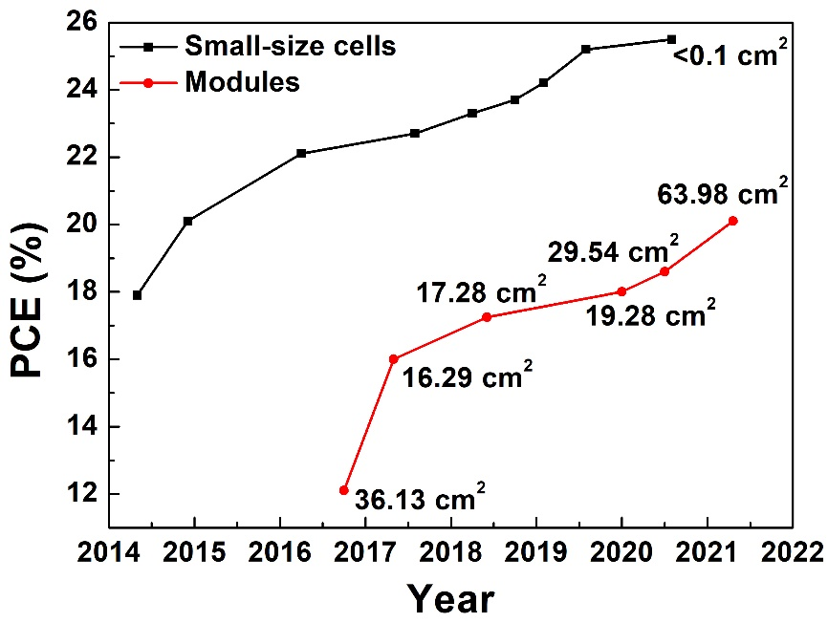
Supplementary Fig. 1 | The certified efficiency of small-size PSC devices and modules. Note: All statistical data of the certified efficiencies come from “Solar cell efficiency tables” from Version 42 to Version 58²³. Except from the small-size devices, designated area for all the modules have been used to calculate their current density. As illustrated in this figure, the cell-to-module efficiency gap is still very large, reaching over 20% at the highest certified small-size cells (25.5%) and modules (20.1%). This large gap in efficiency can be ascribed to multiple factors²⁴. The decrease of J_{sc} is due to the unavoidable dead area and interconnections. The non-uniformity of perovskite layers, including the pinholes and cracks, can lead to drops in the V_{oc}. However, the degradation in FF is known to be related to the increased resistance loss, and unremoved layers after scribing process as well as the damage to each layer from this scribing process. The latter reason can be mitigated by using appropriate parameters during scribing. Concerning the former reason, high mobility of charge extraction materials can be used to accelerate charge transport and charge collection.

Supplementary Fig. 2 | The role of electron mobility of TiO₂-based ETL and D_{it} on the efficiency loss. Dependence of the (a) J_{sc}, (b) V_{oc}, and (c) PCE on electron mobility of TiO₂-based ETL. Effect of D_{it} on the (d) J_{sc}, (e) V_{oc}, and (f) PCE.

Supplementary Fig. 3 | Morphological images of conventional TiO₂ nanoparticles based on the modified Sol-Gel method. a, SEM images. b, TEM images. The inset in (b) is high-resolution TEM of TiO₂ nanoparticles. The morphology of TiO₂ nanoparticles is an irregular sphere, and the particle size is in the range of 15 nm to 25 nm. Considering the smaller size of conventional TiO₂ nanoparticles, we have used commercial TiO₂ nanoparticles (Bought from Dyesol company, Dyesol-30NR-D) as the reference in the next section.

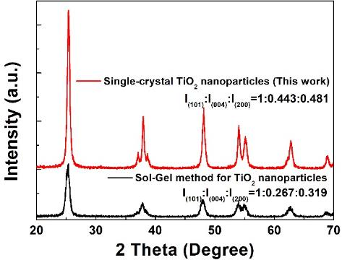
Supplementary Fig. 4 | Powder X-ray diffraction patterns of the SC and conventional TiO₂ nanoparticles based on the Sol-Gel modified method. Since commercial TiO₂ nanoparticles without annealing at high temperature were not available, the modified Sol-Gel method was thus employed to prepare them for comparison with the SC. We note that both powders were obtained by washing three times with ethanol and drying at 60 ºC for 12 h.

Supplementary Fig. 5 | Cross-sectional SEM images with different thicknesses of m-TiO₂ layer from (a) 180 nm, (b) 130 nm, (c) 100 nm, to (d) 60 nm.

Supplementary Fig. 6 |Photovoltaic performances based on different thicknesses of m-TiO₂ films. The device performance statistics for 16 cells based on the four thicknesses of the SC films. a, J_{sc}. b, V_{oc}. c, FF. d, PCE. In a typical box plot, the line in the box is the median line, and the square in the center of the box is the average point.

Supplementary Fig. 7 | Morphological images of m-TiO₂ films. a, Top-surface SEM image of the FTO/c-TiO₂/NP film. b, AFM image of the FTO/c-TiO₂/NP film with the roughness of 27.9 nm. c, Top-surface SEM image of FTO/c-TiO₂/SC film. d, AFM image of FTO/c-TiO₂/SC film with the roughness of 27.7 nm.

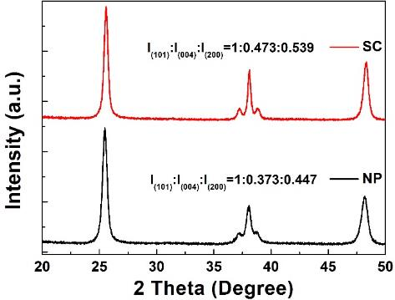
Supplementary Fig. 8 | Powder X-ray diffraction patterns of NP and SC. Note that both powders were obtained by annealing the paste at 500 ºC for 1 hour to remove the organic components, and the as-obtained TiO₂ powder was used to measure powder X-ray diffraction.

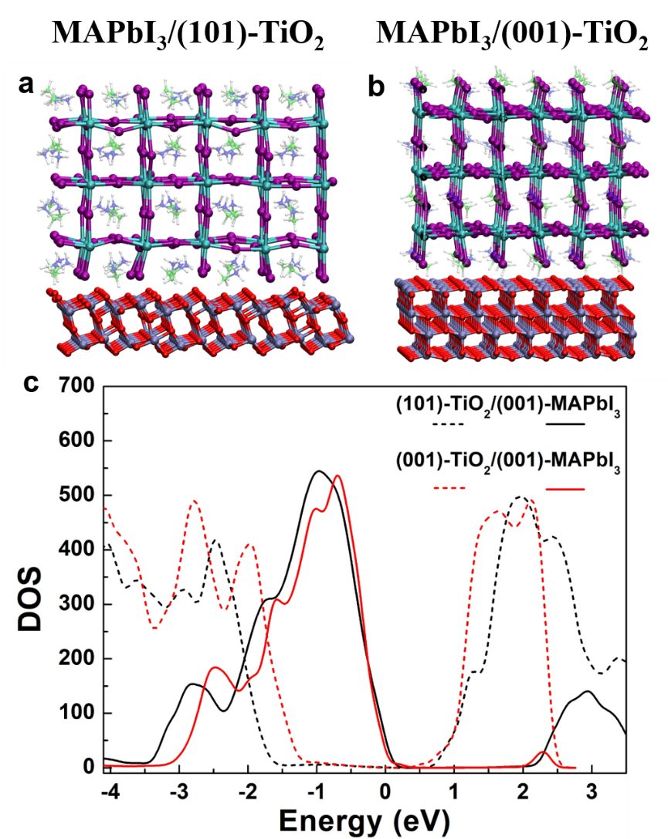
Supplementary Fig. 9 | Optimized structure and partial density of states (PDOS) of TiO₂/MAPbI₃ interfaces. a, (101)-TiO₂/(001)-MAPbI₃ interface. b, (001)-TiO₂/(001)-MAPbI₃ interface. c, Aligned Density of states of the two interfaces.

Supplementary Fig. 10 | UV-vis diffused absorption spectra of m-TiO₂ and perovskite films for determining the optical band gap. a, UV-vis absorbance spectra of the NP and SC films, with the inset being the transmittance spectra of the NP and SC films. b, The relationship of (αhν)^{1/2} versus hν of the NP and SC films. c, UV-vis absorbance spectra of the perovskite film. d, The relationship of (αhν)² versus hν of the perovskite film. The bandgap of the NP, SC, and perovskite films is 3.16 eV, 3.27 eV, and 1.54 eV, respectively.

Supplementary Fig. 11 | Ultraviolet photoelectron spectroscopy (UPS) spectra of m-TiO₂ and perovskite films. a and b, The secondary electron cut-off region and valence band region for the NP and SC films; c and d, The secondary electron cut-off region and valence band cut-off region for the perovskite film. The work function (W_{s}) of the measured samples can be calculated from the equation: W_{s}=21.22-E_{max-cutoff}, while the conduction band is calculated from the equation: E_{c}=W_{s}+E_{min-cutoff}-E_{g}, where E_{max-cutoff} is the secondary electron cutoff shown in the a and c figures, and the E_{min-cutoff} is the valence band cutoff shown in b and d figures. Thus, the E_{c} of the NP, SC, and perovskite films is 4.10 eV, 4.01 eV, and 3.88 eV, respectively. The corresponding schematic diagram of band alignment is draw in Fig. 3a of manuscript.

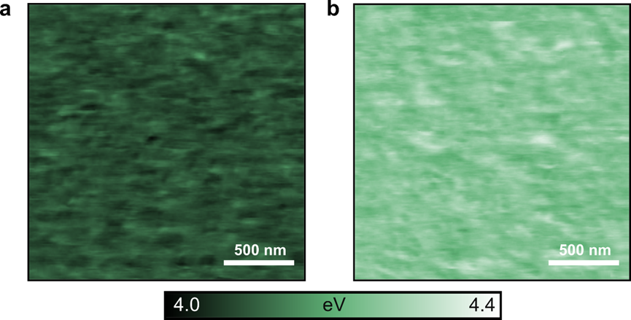
Supplementary Fig. 12 | Calibrated work function map of m-TiO₂ films measured by Kelvin probe force microscopy (KPFM) under UHV condition. a, FTO/c-TiO₂/NP film. b, FTO/c-TiO₂/SC film. From the work function maps, a work function of 4.09 eV ± 0.04 eV for the NP film and a work function of 4.25 eV ± 0.02 eV for the SC film were contracted.

Supplementary Fig. 13 | High-resolution XPS spectra of Ti 2p_{3/2} in TiO₂ powder. a, the NP powder. b, the SC powder. The Ti2p_{3/2} peak of the NP is deconvoluted into two peaks which are located at 457.97 eV and 459.55 eV, corresponding to the Ti³⁺ and Ti⁴⁺ states of TiO₂, respectively.²⁵ While the SC only have one peak about 459.23 eV that is Ti⁴⁺ state of TiO₂, indicating that the content of defects (i.e., Ti³⁺ or oxygen vacancy) of the SC is much lower than that of the NP.

Supplementary Fig. 14 | Cross-sectional SEM images of the NP and SC-based devices. a and b, FTO/c-TiO₂/NP/perovskite/HTM/Au structure. c and d, FTO/c-TiO₂/SC/perovskite/HTM/Au structure. Both of them exhibit a similar thickness of the m-TiO₂ film (~ 100 nm).

Supplementary Fig. 15 | Top-surface SEM images and ambient atomic force microscopy (AFM) images of the perovskite deposited on the NP and SC substrates. a and b, the perovskite deposited on the FTO/c-TiO₂/NP substrate. c and d, the perovskite deposited on the FTO/c-TiO₂/SC substrate. Similar morphologies are observed, indicating that the type of m-TiO₂ substrate does not affect the surface appearance of perovskite films. Grains larger than 1,0 μm were formed, along with a compact morphology and full surface coverage, without pinholes. Uniform and dense perovskite films lay the foundation for high-performance devices.

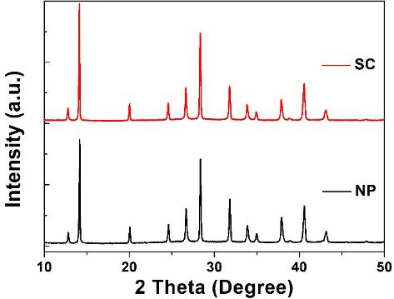
Supplementary Fig. 16 | XRD patterns of perovskite films on FTO/c-TiO₂/NP and FTO/c-TiO₂/SC substrates. All diffraction peaks are originated from α-phase perovskite, only a weak PbI₂ diffraction peak located at 12.8º is observed which is due to the long annealing process. Therefore, the different substrates exhibit the same crystallinity of perovskite film.

Supplementary Fig. 17 | Work function and grain boundary band bending of the perovskite films. a, Calibrated work function map of FTO/c-TiO₂/NP/perovskite film. b, Calibrated work function map of FTO/c-TiO₂/SC/perovskite. c, Grain boundary band bending of FTO/c-TiO₂/NP/perovskite film; d, Grain boundary band bending FTO/c-TiO₂/SC/perovskite film. As a reminder, the work functions extracted from the substrates were 4.09±0.04 eV for the NP film and 4.25±0.02 eV for the SC film. In addition, the average work function of the SC/perovskite (4.36 eV) was larger than the NP/perovskite (4.21 eV). The difference between the two perovskite films may be induced by the underlying substrates and their quasi-similar work function difference (~160 meV), as already observed by several other groups^{26,27}. In addition, both perovskite films did not exhibit much difference in the grain boundary band bending. According to the statistics, 80% of the band bending for both of perovskite films was within ±40 mV, indicating that there is no real barrier at the grain boundaries (k_{B}T at operating solar cell conditions is around 30 meV). Grains with higher work functions (bright grains, +200-250 meV compared to the average surface) represent 7 to 8% of the surface and were linked to PbI₂ grains using HIM-SIMS (Supplementary Fig. 18).
Supplementary Fig. 18 | Topography map and HIM-SIMS of the FTO/c-TiO₂/SC/perovskite film. a, AFM image. b, The corresponding compositional map of the ²⁰⁸Pb element. c, Helium Ion Microscopy image. d, Compositional map of the ¹³³Cs element. Note that HIM-SIMS was carried out on the FTO/c-TiO₂/SC/perovskite film to identify the chemical origin of the work function variations. A non-uniform signal intensity of the ²⁰⁸Pb is observed, along with the existence of Cs-depleted regions, representing 6-7% of the surface. These elemental variations combined with the high work function of grains suggest that the smaller grains are PbI₂ or PbI₂-rich grains²⁸, corroborated by the intensity ratio of PbI₂ phase/perovskite ratio of about 1/8 in the XRD pattern (Supplementary Fig. 16). Thus, the Cs-depleted regions are full of Pb-rich regions, suggesting PbI₂-rich grains.²⁹ Herein, PbI₂ was used to passivate defects at grain boundaries and boost the performance of the devices.³⁰

Supplementary Fig. 19 | Hysteresis study and dark current of devices. a, J-V curves of devices under reverse scan (RS) and forward scan (FS). b, J-V curves measured under dark condition.
Supplementary Fig. 20 | Optoelectronic properties of different substrates. a, Light harvesting efficiency (LHE) of FTO/c-TiO₂/m-TiO₂/perovskite/spiro-MeOTAD films based on the NP and SC substrates. b, Absorbed photon-to-current conversion efficiency (APCE) of the NP and SC-based devices. Note that the optical properties are used to evaluate the similar J_{sc} of the NP and SC-based devices. The LHE was calculated from the absorbance and reflectance of the FTO/c-TiO₂/m-TiO₂/perovskite/spiro-MeOTAD films using equation³¹:
$LHE=\left(1-R\right)×\left(1-{10}^{-a}\right)$ (20)
As can been seen in LHE curve, the NP film shows a little lower value than that of the SC film due to the larger size of single-crystal TiO₂ nanoparticles which sacrifice a little of perovskite grain in the mesoporous layer. In addition, the APCE was calculated from LHE and EQE based on the following equation^{1, 31}:
$APCE\left(\%\right)=EQE(\%)/LHE(\%)$ (21)
$APCE=φ_{inj}×φ_{coll}$ (22)
where φ_{inj} is electron injection efficiency, and φ_{coll} is electron collection efficiency. Considering that the shallower conduction band leads to lower φ_{inj}, the higher APCE of the SC-based device is ascribed to the enhanced φ_{coll}, as a result of the increased contact area between single-crystal TiO₂ nanoparticles and perovskite grains, as well as high electron mobility of the SC film for fast electron extraction and transport³².

Supplementary Fig. 21 | Device performance distribution of 65 devices fabricated with NP and SC substrates. In a typical box plot, the line in the box is the median line, and the square in the center of the box is the average point. All the data are summarized in Supplementary Table 2 and Table 3.


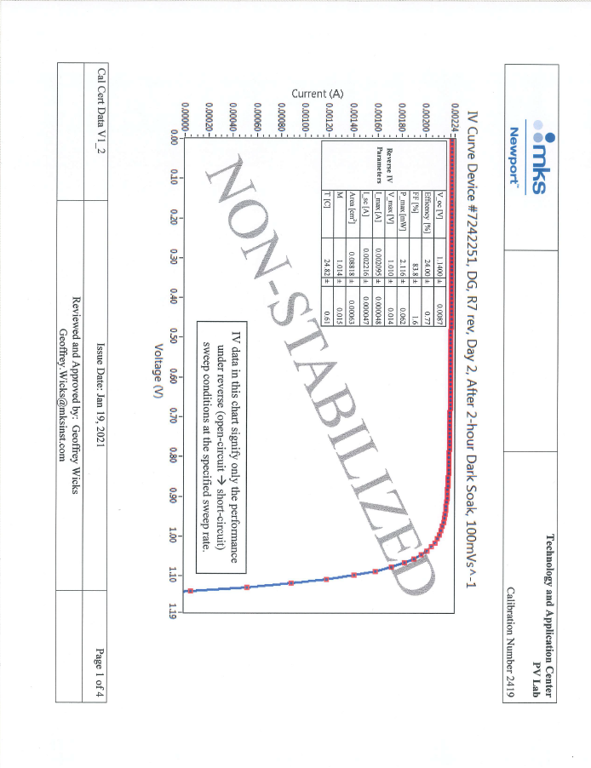
Supplementary Fig. 22 | Certification of small-size device efficiency exhibiting a quasi-steady-state (QSS) efficiency of 22.71% and a reverse scan efficiency of 23.50% obtained from the SC-based device.

Supplementary Fig. 23 | J-V curves at different light intensities for each device. a, The NP-based device. b, The SC-based device. c, J_{sc} vs. light intensity for the NP and SC-based devices.

Supplementary Fig. 24 | Diode parameters of the devices. a, Plots of -dV/dJ vs (J_{sc}-J)⁻¹ and the linear fitting curves; b, plots of ln(J_{sc}-J) against V-R_{s}J and the linear fitting curves. Empty square or circles and solid lines represent the measured data and fit results, respectively.

Supplementary Fig. 25 | Space-charge-limited current (SCLC) model for estimating the trap density. The electron-only device of FTO/ETL/perovskite/PCBM/Ag was fabricated based on the (a) NP and (b) SC substrates, from which the trap-filled limit voltage (V_{TFL}) and trap density (N_{trap}) are determined;

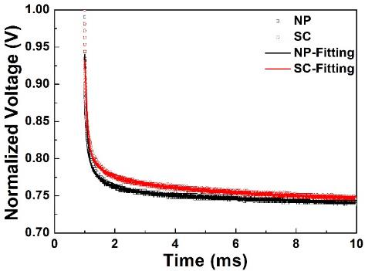
Supplementary Fig. 26 | Transient photovoltage decay curves for the NP and SC-based devices.

Supplementary Fig. 27 | Capacitance-voltage (C-V) characteristics of devices measured under AM 1.5G simulated sunlight with various intensities. a, The NP-based device; b, The SC-based device. 1.0 Sun is 100 mW cm⁻². The V_{peak} shift in the C-V curves is related to the charge accumulation at the charge extraction layer/perovskite interface^{33,34}. Large and small shifts correspond to high and low charge accumulation at the charge extraction layer/perovskite interface. Thus, the SC-based device shows a larger V_{peak} and a slight V_{peak} shift, indicating less charge accumulation than that with the NP-based device.

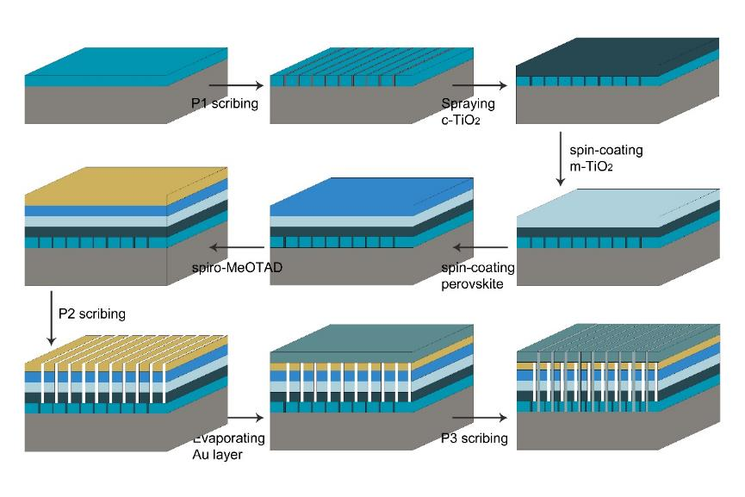
Supplementary Fig. 28 | Schematic illustration of module fabrication procedure, including all scribing and deposition steps.

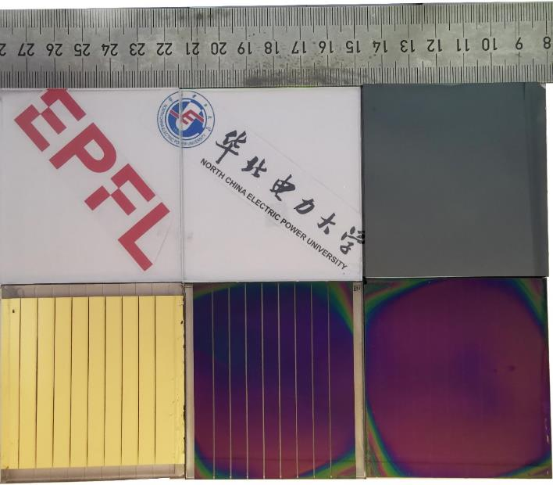
Supplementary Fig. 29 | The corresponding films, including the c-TiO₂, m-TiO₂ (SC), perovskite, HTM, and Au layer, in the fabrication module process.

Supplementary Fig. 30 | Optical photo of patterning for sub-cell separation in modules and the masks for J-V characterization. a, The distance between the adjacent P1 is 6,000 μm, and the geometric fill factor (GFF) is about 0.82. b, Metal mask with an area of 24.63 cm² covered the film for measuring photovoltaic performance.

Supplementary Fig. 31 | The performance of our modules was validated at the Photovoltaic Laboratory of the Institute of Micro Technique (IMT), Neuchâtel, Switzerland. Note that we have used different concentration of perovskite precursor and achieved the J_{sc} from 2.66 mAcm⁻² (1.2 M) to 2.80 mAcm⁻² (1.4 M). The latter J_{sc} is near the average J_{sc} measured in our laboratory (Supplementary Table 4).

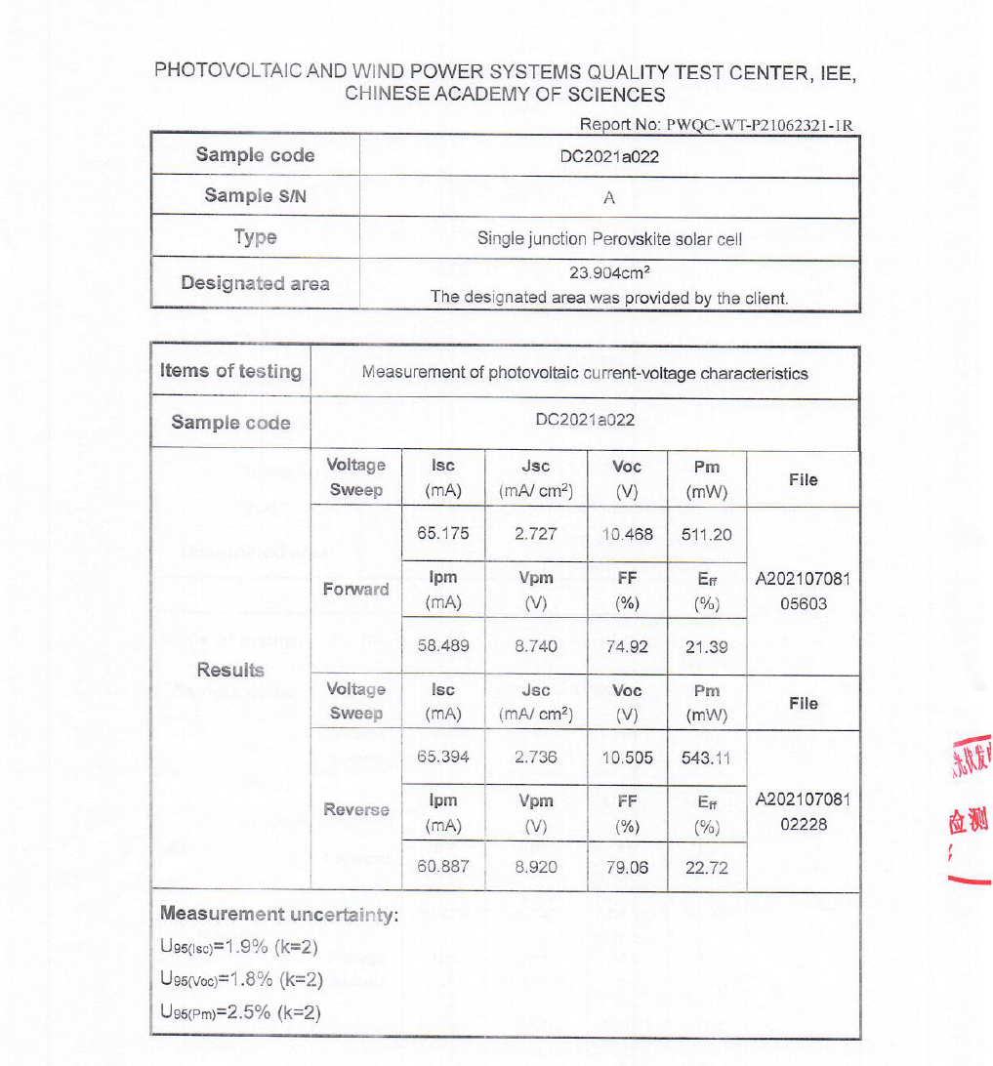
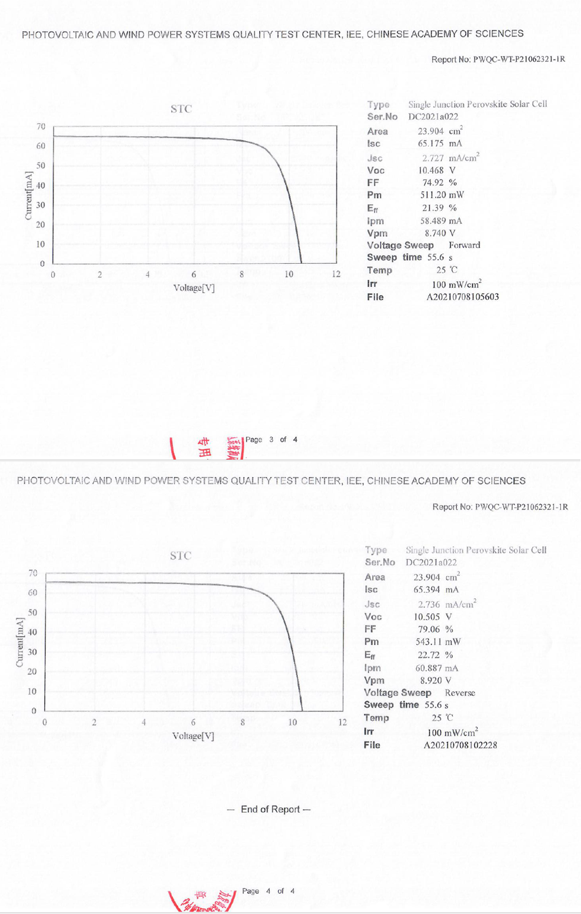
Supplementary Fig. 32 | One of the champion modules was confirmed by the Photovoltaic and Wind Power Systems Quality Test Center, IEE, Chinese Academy of Sciences, Beijing, China.
Supplementary Fig. 33 | Evolution of the contact potential difference (CPD) in the dark and under illumination (white LED 10 mW/cm²). a, FTO/c-TiO₂/NP/perovskite. b, FTO/c-TiO₂/SC/perovskite. After 30 minutes of illumination, both samples display a decrease of their CPD by 85-90 mV. Afterwards, the CPD stabilizes for the SC/perovskite whereas it continues to drop for the FTO/c-TiO₂/NP/perovskite, suggesting an enhanced stability under illumination for the SC-based perovskite films.^{35, 36}

Supplementary Table:
Supplementary Table 1 | Hall effect measurement of the NP and SC film.
Type | Carrier density (cm⁻³) | Resistance (Ω cm) | Carrier mobility (cm²/Vs)
NP | 7.1×10¹⁵ | 749.7 | 1.17
SC | 6.9×10¹⁵ | 250.3 | 3.59

Supplementary Table 2 | Photovoltaic performance of the NP-based devices.
Num. | J_{sc} (mA·cm⁻²) | V_{oc} (V) | FF (%) | PCE (%)
1 | 25.29 | 1.097 | 78.9 | 21.90
2 | 25.30 | 1.103 | 80.1 | 22.34
3 | 25.27 | 1.106 | 80.6 | 22.51
4 | 25.27 | 1.100 | 79.4 | 22.07
5 | 25.32 | 1.099 | 79.6 | 22.16
6 | 25.37 | 1.104 | 80.3 | 22.48
7 | 25.43 | 1.100 | 79.2 | 22.16
8 | 25.25 | 1.104 | 80.5 | 22.45
9 | 25.35 | 1.097 | 78.3 | 21.78
10 | 25.32 | 1.108 | 80.7 | 22.65
11 | 25.30 | 1.106 | 80.6 | 22.56
12 | 25.27 | 1.102 | 79.6 | 22.18
13 | 25.26 | 1.106 | 80.6 | 22.53
14 | 25.33 | 1.102 | 79.7 | 22.25
15 | 25.36 | 1.102 | 79.6 | 22.24
16 | 25.43 | 1.106 | 80.3 | 22.60
17 | 25.34 | 1.100 | 78.7 | 21.96
18 | 25.38 | 1.109 | 80.9 | 22.75
19 | 25.32 | 1.106 | 80.4 | 22.52
20 | 25.30 | 1.107 | 80.3 | 22.47
21 | 25.33 | 1.102 | 79.2 | 22.09
22 | 25.44 | 1.106 | 79.9 | 22.49
23 | 25.19 | 1.110 | 80.9 | 22.62
24 | 25.27 | 1.111 | 81.1 | 22.78
25 | 25.27 | 1.107 | 80.2 | 22.43
26 | 25.33 | 1.103 | 79.1 | 22.11
27 | 25.34 | 1.107 | 80.4 | 22.55
28 | 25.35 | 1.103 | 79.6 | 22.27
29 | 25.35 | 1.107 | 80.3 | 22.54
30 | 25.33 | 1.103 | 79.5 | 22.23
31 | 25.36 | 1.103 | 79.4 | 22.21
32 | 25.36 | 1.106 | 79.8 | 22.40
33 | 25.36 | 1.102 | 79.0 | 22.08
34 | 25.37 | 1.107 | 79.8 | 22.41
35 | 25.10 | 1.106 | 80.2 | 22.27
36 | 25.35 | 1.107 | 80.3 | 22.53
37 | 25.35 | 1.108 | 80.4 | 22.58
38 | 25.24 | 1.111 | 81.0 | 22.72
39 | 25.35 | 1.108 | 80.2 | 22.52
40 | 25.39 | 1.104 | 79.3 | 22.23
41 | 25.39 | 1.104 | 79.2 | 22.20
42 | 25.30 | 1.105 | 79.1 | 22.12
43 | 25.28 | 1.112 | 80.8 | 22.72
44 | 25.18 | 1.111 | 80.9 | 22.63
45 | 25.19 | 1.108 | 80.2 | 22.38
46 | 25.30 | 1.103 | 79.2 | 22.09
47 | 25.32 | 1.103 | 79.4 | 22.19
48 | 25.43 | 1.108 | 80.0 | 22.55
49 | 25.39 | 1.102 | 78.8 | 22.04
50 | 25.26 | 1.106 | 79.8 | 22.32
51 | 25.33 | 1.103 | 78.8 | 22.00
52 | 25.28 | 1.110 | 80.2 | 22.51
53 | 25.47 | 1.108 | 79.5 | 22.44
54 | 25.33 | 1.113 | 80.9 | 22.82
55 | 25.42 | 1.103 | 78.3 | 21.95
56 | 25.26 | 1.108 | 79.9 | 22.38
57 | 25.26 | 1.103 | 78.9 | 21.99
58 | 25.22 | 1.105 | 79.8 | 22.24
59 | 25.33 | 1.108 | 80.2 | 22.52
60 | 25.30 | 1.109 | 80.3 | 22.53
61 | 25.34 | 1.105 | 79.3 | 22.22
62 | 25.32 | 1.111 | 80.4 | 22.63
63 | 25.20 | 1.102 | 78.6 | 21.81
64 | 25.21 | 1.106 | 79.7 | 22.22
65 | 25.38 | 1.106 | 79.6 | 22.36
Aver. | 25.32 | 1.105 | 79.8 | 22.35

Supplementary Table 3 | Photovoltaic performance of the SC-based devices.
Num. | J_{sc} (mA·cm⁻²) | V_{oc} (V) | FF (%) | PCE (%)
1 | 25.30 | 1.114 | 83.7 | 23.58
2 | 25.32 | 1.114 | 83.6 | 23.60
3 | 25.26 | 1.125 | 84.4 | 24.00
4 | 25.21 | 1.122 | 84.4 | 23.86
5 | 25.27 | 1.123 | 84.5 | 23.97
6 | 25.26 | 1.123 | 84.3 | 23.89
7 | 25.18 | 1.119 | 84.2 | 23.72
8 | 25.16 | 1.117 | 84.1 | 23.65
9 | 25.21 | 1.110 | 83.8 | 23.45
10 | 25.25 | 1.096 | 82.8 | 22.92
11 | 25.34 | 1.107 | 83.5 | 23.42
12 | 25.38 | 1.113 | 84.0 | 23.71
13 | 25.33 | 1.114 | 83.8 | 23.64
14 | 25.31 | 1.120 | 84.3 | 23.90
15 | 25.14 | 1.127 | 84.3 | 23.88
16 | 25.18 | 1.128 | 84.5 | 24.01
17 | 25.30 | 1.131 | 84.4 | 24.15
18 | 25.11 | 1.133 | 84.7 | 24.09
19 | 25.36 | 1.129 | 84.6 | 24.20
20 | 25.23 | 1.122 | 84.2 | 23.84
21 | 25.32 | 1.123 | 84.1 | 23.92
22 | 25.21 | 1.124 | 84.5 | 23.93
23 | 25.23 | 1.123 | 84.3 | 23.90
24 | 25.30 | 1.114 | 83.7 | 23.57
25 | 25.33 | 1.113 | 83.8 | 23.63
26 | 25.37 | 1.123 | 84.4 | 24.03
27 | 25.35 | 1.123 | 84.5 | 24.07
28 | 25.32 | 1.119 | 84.2 | 23.87
29 | 25.26 | 1.120 | 84.4 | 23.89
30 | 25.41 | 1.112 | 83.8 | 23.69
31 | 25.35 | 1.114 | 83.8 | 23.67
32 | 25.36 | 1.118 | 84.2 | 23.84
33 | 25.31 | 1.111 | 83.7 | 23.55
34 | 25.40 | 1.115 | 83.7 | 23.69
35 | 25.36 | 1.117 | 84.1 | 23.83
36 | 25.34 | 1.115 | 84.1 | 23.74
37 | 25.36 | 1.116 | 84.0 | 23.77
38 | 25.32 | 1.116 | 84.1 | 23.77
39 | 25.35 | 1.121 | 84.1 | 23.89
40 | 25.36 | 1.122 | 84.3 | 23.98
41 | 25.32 | 1.124 | 84.4 | 24.03
42 | 25.27 | 1.125 | 84.4 | 23.98
43 | 25.38 | 1.122 | 84.1 | 23.94
44 | 25.34 | 1.113 | 83.7 | 23.61
45 | 25.38 | 1.107 | 83.4 | 23.44
46 | 25.27 | 1.107 | 83.7 | 23.41
47 | 25.29 | 1.106 | 83.6 | 23.38
48 | 25.32 | 1.110 | 83.5 | 23.48
49 | 25.28 | 1.114 | 83.7 | 23.58
50 | 25.22 | 1.118 | 84.1 | 23.70
51 | 25.30 | 1.120 | 84.1 | 23.85
52 | 25.32 | 1.121 | 84.0 | 23.85
53 | 25.12 | 1.134 | 84.6 | 24.11
54 | 25.18 | 1.136 | 84.4 | 24.15
55 | 25.34 | 1.120 | 84.6 | 24.02
56 | 25.35 | 1.121 | 84.7 | 24.05
57 | 25.41 | 1.118 | 84.7 | 24.06
58 | 25.40 | 1.119 | 84.6 | 24.02
59 | 25.33 | 1.120 | 84.6 | 24.01
60 | 25.31 | 1.130 | 83.0 | 23.73
61 | 25.31 | 1.130 | 83.3 | 23.84
62 | 25.36 | 1.132 | 83.4 | 23.92
63 | 25.21 | 1.132 | 83.7 | 23.90
64 | 25.30 | 1.133 | 83.5 | 23.91
65 | 25.26 | 1.120 | 83.7 | 23.68
Aver. | 25.30 | 1.120 | 84.1 | 23.80

Supplementary Table 4 | Kinetic fitting parameters of TRPL and TA spectra. Note that the perovskite films were deposited on different substrates. The TRPL and TA curves were fitted according to the Equation:$Y={Y_{0}+A}_{1}e^{\frac{-t}{τ_{1}}}+A_{2}e^{\frac{-t}{τ_{2}}}$, where Y₀ is a constant for the baseline offset, A₁ and A₂ are the decay amplitudes, and 𝜏₁ and 𝜏₂ are the decay lifetimes.
Substrates | TRPL |  |  |  | TA
Substrates | A₁ | 𝜏₁ (ns) | A₂ | 𝜏₂ (ns) | A₁ | 𝜏₁ (ps) | A₂ | 𝜏₂ (ps)
FTO | 0.5 | 293.0 | 0.7 | 1590.2 | - | - | - | -
FTO/c-TiO₂/NP | 20.2 | 37.9 | 1.6 | 154.0 | 0.8 | 15.3 | 0.3 | 71.0
FTO/c-TiO₂/SC | 48.1 | 34.4 | 1.2 | 126.6 | 0.8 | 23.7 | 0.3 | 146.8

Supplementary Table 5 | Photovoltaic performance of the SC-based modules. Note that the J_{sc} is normalized by the active area.
Num. | J_{sc} (mA·cm⁻²) | V_{oc} (V) | FF (%) | PCE (%)
1 | 2.68 | 9.838 | 82.2 | 21.68
2 | 2.69 | 9.749 | 82.0 | 21.47
3 | 2.81 | 10.265 | 78.4 | 22.55
4 | 2.83 | 10.003 | 79.9 | 22.62
5 | 2.80 | 10.003 | 80.2 | 22.49
6 | 2.83 | 10.108 | 81.0 | 23.13
7 | 2.82 | 9.993 | 80.2 | 22.54
8 | 2.81 | 10.158 | 79.1 | 22.56
9 | 2.81 | 10.060 | 79.1 | 22.36
10 | 2.84 | 10.116 | 79.2 | 22.75
11 | 2.83 | 10.017 | 80.1 | 22.68
12 | 2.81 | 10.308 | 80.5 | 23.37
13 | 2.77 | 10.120 | 69.4 | 19.43
14 | 2.75 | 10.254 | 78.9 | 22.23
15 | 2.77 | 10.188 | 77.2 | 21.84
16 | 2.78 | 9.944 | 76.9 | 21.27
17 | 2.81 | 10.363 | 77.7 | 22.64
18 | 2.80 | 10.172 | 78.6 | 22.42
19 | 2.83 | 10.277 | 79.3 | 23.08
20 | 2.79 | 10.029 | 79.9 | 22.30
21 | 2.83 | 10.111 | 78.9 | 22.57
22 | 2.83 | 10.196 | 76.8 | 22.16
23 | 2.75 | 10.155 | 82.0 | 22.87
24 | 2.66 | 10.118 | 81.2 | 21.82^{CE}
25 | 2.80 | 9.781 | 80.5 | 22.06^{CE}
Aver. | 2.79 | 10.093 | 79.2 | 22.28

Supplementary Table 6 | Relevant parameters of numerical simulation.
Material parameters | ETL | Perovskite | Spiro
Thickness, nm | 125 | 800 | 220
Electron affinity, χ (eV) | 4 | 3.9 | 2.2
Bandgap energy, E_{g} (eV) | Exp. | 1.54 | 2.91
Relative dielectric permittivity, 𝜀_{r} | 9 | 30 | 12
Effective conduction band density,  N_{c} (cm^{–3}) | 2×10²⁰ | 2.2×10¹⁸ | 1×10¹⁸
Effective valence band density, N_{v} (cm^{–3}) | 1×10²¹ | 1.8×10¹⁹ | 1×10¹⁸
Donor doping concentration, N_{d} (cm^{–3}) | 5×10¹⁹ | / | /
Acceptor doping concentration, N_{a} (cm^{–3}) | / | / | 1×10¹⁸
Mobility of electron/hole, µ_{n}/µ_{p} (cm²/Vs) | Exp. | 10/10 | 0.001/0.001
SRH life time, τ_{n}/τ_{p} (s) | / | / | 1×10^{–5}/1×10^{–6}
Radiative recombination coefficient,  C_{Rad} (cm³s^{–1}) | / | 5×10^{–11} | /
Auger recombination coefficient,  A_{n}/A_{p} (cm⁶s^{–1}) | / | 2.3×10^{–29} | /
Bulk, N_{t}, cm^{–3} | 1×10¹³ | 1×10¹³ | /
Trap density, D_{id} (cm⁻²) | / | 1×10⁹ | 1×10⁹

Supplementary Table 7 | One of NP and SC-based device performances and the corresponding diode parameters. Note that the R_{s}, R_{sh}, and J₀ are obtained from the slope of the J-V characteristics measured under AM1.5 illumination condition; ª The n_{id} is evaluated from a slope, where the V_{oc} is plotted against the logarithm of light intensity; FF_{cal} is computed based on the equation (17), and the error is $\frac{{FF}_{cal}-FF}{FF}$.
Condition | J_{sc}  (mA·cm⁻²) | V_{oc}  (V) | FF  (%) | PCE  (%) | R_{s}  (Ω·cm⁻²) | R_{sh}  (Ω·cm⁻²) | J₀  (mA·cm⁻²) | n_{id}ª | FF_{cal}  (%) | Error  (%)
NP | 25.36 | 1.109 | 80.6 | 22.67 | 1.31 | 2150 | 3.44×10⁻⁷ | 1.46 | 81.3 | 0.9%
SC | 25.33 | 1.120 | 84.6 | 24.02 | 0.49 | 3010 | 4.08×10⁻¹⁰ | 1.26 | 85.0 | 0.5%

Supplementary Table 8 | Previously reported photovoltaic performance of mini-modules. Note that the PCE are normalized by the active area unless otherwise specified, the V_{oc} is normalized by the number of sub-cell, and the J_{sc} is normalized by the area for each sub-cell. Abbreviation: ac, active area; ap, aperture area; da, designated area. CE: certified efficiency. ITO, indium tin oxide; FTO, fluorine doped tin oxide; c-TiO₂, compact TiO₂; m-TiO₂, mesoporous TiO₂; MA, methyammonium; FA, formamidinium; spiro-MeOTAD, 2,2′,7,7′-tetrakis(N,N-di-4-methoxyphenylamino)-9,9′-spirobifluorene; PCBM, [6,6]-phenylC60,61 butyric acid methyl ester; PTAA, poly[bis(4-phenyl)(2,4,6-trimethylphenyl)amine]; PEDOT:PSS, poly(3,4-ethylenedioxythiophene):poly(styrenesulfonate); P3HT, poly(3hexylthiophene-2,5-diyl) regioregular; PC71BM, [6,6]-phenyl C71 butyric acid methyl ester; BCP, bathocuproine; 5-AVA, 5-aminovaleric acid.
Device structure | Module  size  (cm×cm) | Area  (cm²) | Sub-unit  Cell | J_{sc}  (mAcm⁻²) | V_{oc} | FF | PCE | Ref.
ITO/PEDOT:PSS/MAPbI₃/PCBM/LiF/Al | 10×10 | 60.0^{ac} | 10 | 19.00 | 0.81 | 57.0 | 8.70 | 37
ITO/PEDOT:PSS/MAPbI₃/PCBM/Au | 10×10 | 40.0^{ac} | 10 | 20.00 | 1.01 | 63.7 | 12.90 | 38
FTO/TiO₂/MAPbI_{3-x}Cl_{x}/PTAA/Au | 10×10 | 40.0^{ac} | 10 | 21.04 | 1.05 | 70.2 | 15.50 | 39
FTO/c-TiO₂/(m-TiO₂/m-ZrO₂/m-Carbon)/(5-AVA)_{x}(MA)_{1-x}PbI₃ | 5×10 | 31.0^{ac} | 10 | 17.72 | 0.96 | 62.9 | 10.75 | 40
 | 10×10 | 70.0^{ac} | 4 | 19.60 | 0.93 | 57.5 | 10.46 | 40
FTO/c-TiO₂/m-TiO₂/Graphene/MAPbI₃/Spiro-MeOTAD/Au | 10×10 | 50.6^{ac} | 8 | 18.15 | 1.07 | 64.6 | 12.60 | 41
FTO/SnO₂/K_{x}Cs_{0.05}(FA_{0.85}MA_{0.15})_{0.92}Pb(I_{0.85}Br_{0.15})₃/spiro-MeOTAD/Au | 6×6 | 20.0^{ac} | 6 | 21.42 | 1.13 | 65.0 | 15.76 | 42
FTO/c-TiO₂/m-TiO₂/MAPbI₃/spiro-MeOTAD/Au | 8×8 | 36.13^{da} | 10 | 20.20 | 0.84 | 71.5 | 12.10^{CE} | 43
FTO/NiO/MAPbI_{3-x}Cl_{x}/PC₆₁BM/PEI/Ag | 5×5 |  | 8 | 20.80 | 1.00 | 58.2 | 12.00 | 44
ITO/PTAA/MAPbI₃/C₆₀/BCP/Cu | 6×15 | 33.0^{ap} | 17 | 19.38 | 1.07 | 72.1 | 15.00 | 45
ITO/PTAA/MAPbI₃/C₆₀/BCP/Cu | 6×15 | 57.2^{ap} | 16 | 20.32 | 1.07 | 68.9 | 15.00 | 45
ITO/C₆₀/MAPbI₃/spiro-MeOTAD/Au | 10×10 | 31.7^{ac} | 14 | 18.62 | 1.01 | 74.5 | 13.98^{CE} | 46
FTO/SnO₂/Cs_{x}FA_{1-x}PbI_{3-y}Br_{y}/Spiro-MeOTAD/Au | 8×8 | 41.25^{ac} | 9 | 20.25 | 1.02 | 52.8 | 12.24 | 47
FTO/SnO₂/MAPbI₃/Spiro-MeOTAD/Au | 5×5 | 22.8^{ap} | 6 | 20.28 | 0.97 | 61.3 | 12.03 | 48
FTO/NiO/FA_{0.85}MA_{0.15}Pb(I_{0.85}Br_{0.15})₃/G-PCBM/BCP/Ag | 6×6 | 35.8^{da} | 10 | 18.40 | 1.08 | 71.5 | 14.17^{CE} | 49
FTO/SnO₂/K_{0.03}Cs_{0.05}(FA_{0.85}MA_{0.15})_{0.92}Pb(I_{0.85}Br_{0.15})₃/spiro-MeOTAD/Au | 10×10 | 53.64^{ap} | 12 | 21.96 | 1.16 | 68.2 | 17.40^{CE} | 50
FTO/SnO₂/K_{0.03}Cs_{0.05}(FA_{0.85}MA_{0.15})_{0.92}Pb(I_{0.85}Br_{0.15})₃/spiro-MeOTAD/Au | 7×7 | 20.78^{ap} | 7 | 21.77 | 1.13 | 70.0 | 17.27^{CE} | 51
ITO/PTAA/MAPbI₃/C₆₀/BCP/Cu (Flexible) |  | 42.9^{ap} | 12 | 19.68 | 1.10 | 73.5 | 15.86 | 52
FTO/c-TiO₂/m-TiO₂/(FAPbI₃)_{0.95}(MAPbBr₃)_{0.05}/WBH/P3HT/Au | 7×7 | 24.94^{da} | 8 | 21.76 | 1.10 | 71.7 | 17.10 | 53
FTO/SnO₂/Cs_{0.1}FA_{0.9}PbI_{2.9}Br_{0.1}/Spiro-MeOTAD/Au | 10×10 | 91.8^{da} | 14 | 16.24 | 0.97 | 59.6 | 9.34 | 54
FTO/SnO₂/FACsPbI₃/Spiro-MeOTAD/Au | 10×10 | 49.0^{ac} | 14 | 23.38 | 1.02 | 58.0 | 13.84 | 55
ITO/PEN/SnO₂/Zn₂SnO₄/(FAPbI₃)_{0.95}(MAPbBr₃)_{0.05}/Spiro-OMeTAD (Flexible) | 12×12 | 90.0^{ap} | 15 | 21.60 | 1.11 | 74.8 | 17.90 | 56
ITO/PTAA/MAPbI₃/C₆₀/BCP/Cu |  | 21.5^{ap} | 6 |  |  |  | 17.80 | 57
FTO/SnO₂(TiO₂)/PCBM/MAPbI₃/Spiro-MeOTAD/Au |  | 21.0^{ac} | 6 | 22.08 | 1.12 | 73.4 | 18.13 | 58
ITO/SnO₂/Cs_{0.05}FA_{0.54}MA_{0.41}Pb(I_{0.98}Br_{0.02})₃/spiro-MeOTAD-P3HT/Au | 5×5 | 22.4^{da} | 7 | 20.93 | 1.09 | 72.9 | 16.60 | 59
FTO/SnO₂/(CsPbI₃)_{0.05}((FAPbI₃)_{1-x}(MAPbBr₃)_{x})_{0.95}/spiro-MeOTAD/Au | 7×7 | 25.49^{ap} | 7 | 21.14 | 1.07 | 78.6 | 17.88^{CE} | 60
ITO/PTAA/MA_{0.7}FA_{0.3}PbI₃/C₆₀/BCP/Cu | 5.5×6.5 | 35.8^{ap} | 10 | 20.40 | 1.17 | 77.3 | 18.50 | 61
 |  | 19.28^{da} | 7 | 21.42 | 1.07 | 78.4 | 18.00^{CE} | 62
FTO/NiMgLiO/FA_{0.83}Cs_{0.17}PbI_{2.83}Br_{0.17}/LiF/C60/BCP/  Bi/Ag | 6.7×6.7 | 20.77^{ac} | 8 | 20.64 | 1.09 | 74.3 | 16.63^{CE} | 63
FTO/SnO₂/FA_{0.83}Cs_{0.17}PbI_{3-x}Cl_{x}/KPF6/Spiro-MeOTAD/Au | 10×10 | 65.0^{ac} | 14 | 23.38 | 1.10 | 75.3 | 19.54 | 64
 |  | 63.98^{da} | 12 | 23.09 | 1.155 | 75.4 | 20.10^{CE} | 23
FTO/c-TiO₂/m-TiO₂/Rb_{0.03}Cs_{0.05}MA_{0.05}FA_{0.9}PbI₃/Spiro-MeOTAD/Au | 6.5×7 | 23.904^{ac} | 9 | 24.62 | 1.167 | 79.1 | 22.72^{CE} | This work

References:
1. Ding Y, Zhou L, Mo Le, Jiang L, Hu L, Li Z, et al. TiO₂ Microspheres with Controllable Surface Area and Porosity for Enhanced Light Harvesting and Electrolyte Diffusion in Dye-Sensitized Solar Cells. Adv. Funct. Mater. 2015, 25(37): 5946-5953.
2. Shi X, Ding Y, Zhou S, Zhang B, Cai M, Yao J, et al. Enhanced Interfacial Binding and Electron Extraction Using Boron-Doped TiO₂ for Highly Efficient Hysteresis-Free Perovskite Solar Cells. Adv. Sci. 2019, 6(21): 1901213.
3. Ding B, Huang S-Y, Chu Q-Q, Li Y, Li C-X, Li C-J, et al. Low-temperature SnO₂-modified TiO₂ yields record efficiency for normal planar perovskite solar modules. J. Mater. Chem. A 2018, 6(22): 10233-10242.
4. Mosconi E, Ronca E, De Angelis F. First-Principles Investigation of the TiO₂/Organohalide Perovskites Interface: The Role of Interfacial Chlorine. J. Phys. Chem. Lett. 2014, 5(15): 2619-2625.
5. Roiati V, Mosconi E, Listorti A, Colella S, Gigli G, De Angelis F. Stark effect in perovskite/TiO₂ solar cells: evidence of local interfacial order. Nano Lett. 2014, 14(4): 2168-2174.
6. Colella S, Mosconi E, Pellegrino G, Alberti A, Guerra VL, Masi S, et al. Elusive Presence of Chloride in Mixed Halide Perovskite Solar Cells. J. Phys. Chem. Lett. 2014, 5(20): 3532-3538.
7. Mosconi E, Grancini G, Roldán-Carmona C, Gratia P, Zimmermann I, Nazeeruddin MK, et al. Enhanced TiO₂/MAPbI₃ Electronic Coupling by Interface Modification with PbI₂. Chem. Mater. 2016, 28(11): 3612-3615.
8. Geng W, Tong CJ, Liu J, Zhu W, Lau WM, Liu LM. Structures and Electronic Properties of Different CH₃NH₃PbI₃/TiO₂ Interface: A First-Principles Study. Sci. Rep. 2016, 6: 20131.
9. Perdew JP, Burke K, Ernzerhof M. Generalized Gradient Approximation Made Simple. Phys. Rev. Lett. 1996, 77(18): 3865-3868.
10. Soler JM, Artacho E, Gale JD, García A, Junquera J, Ordejón P, et al. The SIESTA method forab initioorder-Nmaterials simulation. J. Phys. Condens. Matter 2002, 14(11): 2745-2779.
11. Wu Z, Cohen RE. More accurate generalized gradient approximation for solids. Phys. Rev. B 2006, 73(23): 235116.
12. Giannozzi P, Baroni S, Bonini N, Calandra M, Car R, Cavazzoni C, et al. QUANTUM ESPRESSO: a modular and open-source software project for quantum simulations of materials. J. Phys. Condens. Matter 2009, 21(39): 395502.
13. Zhang F, Ma W, Guo H, Zhao Y, Shan X, Jin K, et al. Interfacial Oxygen Vacancies as a Potential Cause of Hysteresis in Perovskite Solar Cells. Chem. Mater. 2016, 28(3): 802-812.
14. Bharti B, Kumar S, Lee H-N, Kumar R. Formation of oxygen vacancies and Ti³⁺ state in TiO₂ thin film and enhanced optical properties by air plasma treatment. Sci. Rep. 2016, 6(1): 32355.
15. Kim HD, Ohkita H. Potential Improvement in Fill Factor of Lead-Halide Perovskite Solar Cells. Solar RRL 2017, 1(6): 1700027.
16. Sites JR, Mauk PH. Diode Quality Factor Determination for Thin-Film Solar-Cells. Sol. Cells 1989, 27(1-4): 411-417.
17. Hegedus SS, Shafarman WN. Thin-film solar cells: device measurements and analysis. Prog. Photovolt. Res. Appl. 2004, 12(23): 155-176.
18. Shi J, Dong J, Lv S, Xu Y, Zhu L, Xiao J, et al. Hole-conductor-free perovskite organic lead iodide heterojunction thin-film solar cells: High efficiency and junction property. Appl. Phys. Lett. 2014, 104(6): 063901.
19. Stolterfoht M, Wolff CM, Amir Y, Paulke A, Perdigón-Toro L, Caprioglio P, et al. Approaching the fill factor Shockley-Queisser limit in stable, dopant-free triple cation perovskite solar cells. Energy Environ. Sci. 2017, 10(6): 1530-1539.
20. Green MA. Solar cell fill factors: General graph and empirical expressions. Solid State Electron. 1981, 24(8): 788-789.
21. Green MA. Accuracy of analytical expressions for solar cell fill factors. Sol. Cells 1982, 7(3): 337-340.
22. Liu Y, Zhang Y, Zhu X, Yang Z, Ke W, Feng J, et al. Inch-sized high-quality perovskite single crystals by suppressing phase segregation for light-powered integrated circuits. Sci. Adv. 2021, 7(7): eabc8844.
23. Green MA, Dunlop ED, Hohl‐Ebinger J, Yoshita M, Kopidakis N, Hao X. Solar cell efficiency tables (Version 58). Prog. Photovolt. Res. Appl. 2021, 29(7): 657-667.
24. Li Z, Klein TR, Kim DH, Yang M, Berry JJ, van Hest MFAM, et al. Scalable fabrication of perovskite solar cells. Nat. Rev. Mater.2018, 3(4): 18017.
25. Ha S-J, Heo JH, Im SH, Moon JH. Mesoscopic CH₃NH₃PbI₃ perovskite solar cells using TiO₂ inverse opal electron-conducting scaffolds. J. Mater. Chem. A 2017, 5(5): 1972-1977.
26. Olthof S, Meerholz K. Substrate-dependent electronic structure and film formation of MAPbI₃ perovskites. Sci. Rep. 2017, 7: 40267.
27. Schulz P, Whittaker-Brooks LL, MacLeod BA, Olson DC, Loo Y-L, Kahn A. Electronic Level Alignment in Inverted Organometal Perovskite Solar Cells. Adv. Mater. Interfaces 2015, 2(7): 1400532.
28. Usiobo OJ, Kanda H, Gratia P, Zimmermann I, Wirtz T, Nazeeruddin MK, et al. Nanoscale Mass-Spectrometry Imaging of Grain Boundaries in Perovskite Semiconductors. J. Phys. Chem. C 2020, 124(42): 23230-23236.
29. Gratia P, Grancini G, Audinot JN, Jeanbourquin X, Mosconi E, Zimmermann I, et al. Intrinsic Halide Segregation at Nanometer Scale Determines the High Efficiency of Mixed Cation/Mixed Halide Perovskite Solar Cells. J. Am. Chem. Soc. 2016, 138(49): 15821-15824.
30. Zhao Y, Li Q, Zhou W, Hou Y, Zhao Y, Fu R, et al. Double-Side-Passivated Perovskite Solar Cells with Ultra-low Potential Loss. Solar RRL 2019, 3(2): 1800296.
31. Lee J-W, Lee SH, Ko H-S, Kwon J, Park JH, Kang SM, et al. Opto-electronic properties of TiO₂ nanohelices with embedded HC(NH₂)₂PbI₃ perovskite solar cells. J. Mater. Chem. A 2015, 3(17): 9179-9186.
32. Lv Y, Yuan R, Cai B, Bahrami B, Chowdhury AH, Yang C, et al. High-Efficiency Perovskite Solar Cells Enabled by Anatase TiO₂ Nanopyramid Arrays with an Oriented Electric Field. Angew. Chem. Int. Ed. 2020, 59(29): 11969-11976.
33. Wu T, Hsiao Y-C, Li M, Kang N-G, Mays JW, Hu B. Dynamic Coupling between Electrode Interface and Donor/Acceptor Interface via Charge Dissociation in Organic Solar Cells at Device-Operating Condition. J. Phys. Chem. C 2015, 119(5): 2727–2732.
34. Boix PP, Ajuria J, Etxebarria I, Pacios R, Garcia-Belmonte G, Bisquert J. Role of ZnO Electron-Selective Layers in Regular and Inverted Bulk Heterojunction Solar Cells. J.Phys. Chem. Lett. 2011, 2(5): 407-411.
35. Zhang F, Ullrich F, Silver S, Kerner RA, Rand BP, Kahn A. Complexities of Contact Potential Difference Measurements on Metal Halide Perovskite Surfaces. J. Phys. Chem. Lett. 2019, 10(4): 890-896.
36. Gallet T, Poeira RG, Lanzoni EM, Abzieher T, Paetzold UW, Redinger A. Co-evaporation of CH₃NH₃PbI₃: How Growth Conditions Impact Phase Purity, Photostriction, and Intrinsic Stability. ACS Appl. Mater. Interfaces 2021, 13(2): 2642-2653.
37. Seo J, Park S, Chan Kim Y, Jeon NJ, Noh JH, Yoon SC, et al. Benefits of very thin PCBM and LiF layers for solution-processed p-i-n perovskite solar cells. Energy Environ. Sci. 2014, 7(8): 2642-2646
38. Heo JH, Han HJ, Kim D, Ahn TK, Im SH. Hysteresis-less inverted CH₃NH₃PbI₃ planar perovskite hybrid solar cells with 18.1% power conversion efficiency. Energy Environ. Sci. 2015, 8(5): 1602-1608.
39. Heo JH, Lee MH, Jang MH, Im SH. Highly efficient CH₃NH₃PbI_{3-x}Cl_{x} mixed halide perovskite solar cells prepared by re-dissolution and crystal grain growth via spray coating. J. Mater. Chem. A 2016, 4(45): 17636-17642.
40. Priyadarshi A, Haur LJ, Murray P, Fu D, Kulkarni S, Xing G, et al. A large area (70 cm²) monolithic perovskite solar module with a high efficiency and stability. Energy Environ. Sci. 2016, 9(12): 3687-3692.
41. Agresti A, Pescetelli S, Palma AL, Del Rio Castillo AE, Konios D, Kakavelakis G, et al. Graphene Interface Engineering for Perovskite Solar Modules: 12.6% Power Conversion Efficiency over 50 cm² Active Area. ACS Energy Lett. 2017, 2(1): 279-287.
42. Bu TL, Liu XP, Zhou Y, Yi JP, Huang X, Luo L, et al. A novel quadruple-cation absorber for universal hysteresis elimination for high efficiency and stable perovskite solar cells. Energy Environ. Sci. 2017, 10(12): 2509-2515.
43. Chen H, Ye F, Tang W, He J, Yin M, Wang Y, et al. A solvent- and vacuum-free route to large-area perovskite films for efficient solar modules. Nature 2017, 550(7674): 92-95.
44. Liao H-C, Guo P, Hsu C-P, Lin M, Wang B, Zeng L, et al. Enhanced Efficiency of Hot-Cast Large-Area Planar Perovskite Solar Cells/Modules Having Controlled Chloride Incorporation. Adv. Energy Mater. 2017, 7(8): 1601660.
45. Deng Y, Zheng X, Bai Y, Wang Q, Zhao J, Huang J. Surfactant-controlled ink drying enables high-speed deposition of perovskite films for efficient photovoltaic modules. Nat. Energy 2018, 3(7): 560-566.
46. Li K, Xiao J, Yu X, Bu T, Li T, Deng X, et al. Influence of Hot Spot Heating on Stability of Large Size Perovskite Solar Module with a Power Conversion Efficiency of ∼14%. ACS Appl. Energy Mater. 2018, 1(8): 3565-3570.
47. Luo L, Zhang Y, Chai N, Deng X, Zhong J, Huang F, et al. Large-area perovskite solar cells with CsxFA_{1-x}PbI_{3-y}Br_{y} thin films deposited by a vapor–solid reaction method. J. Mater. Chem. A 2018, 6(42): 21143-21148.
48. Qiu L, Liu Z, Ono LK, Jiang Y, Son DY, Hawash Z, et al. Scalable Fabrication of Stable High Efficiency Perovskite Solar Cells and Modules Utilizing Room Temperature Sputtered SnO₂ Electron Transport Layer. Adv. Funct. Mater. 2018, 29(47): 1806779.
49. Bi E, Tang W, Chen H, Wang Y, Barbaud J, Wu T, et al. Efficient Perovskite Solar Cell Modules with High Stability Enabled by Iodide Diffusion Barriers. Joule 2019, 3(11): 2748-2760.
50. Bu T, Liu X, Li J, Huang W, Wu Z, Huang F, et al. Dynamic Antisolvent Engineering for Spin Coating of 10×10 cm² Perovskite Solar Module Approaching 18%. Solar RRL 2019, 4(2): 1900263.
51. Bu T, Liu X, Li J, Li W, Huang W, Ku Z, et al. Sub-sized monovalent alkaline cations enhanced electrical stability for over 17% hysteresis-free planar perovskite solar mini-module. Electrochim. Acta 2019, 306: 635-642.
52. Dai X, Deng Y, Van Brackle CH, Chen S, Rudd PN, Xiao X, et al. Scalable Fabrication of Efficient Perovskite Solar Modules on Flexible Glass Substrates. Adv. Energy Mater. 2019, 10(1): 1903108.
53. Jung EH, Jeon NJ, Park EY, Moon CS, Shin TJ, Yang TY, et al. Efficient, stable and scalable perovskite solar cells using poly(3-hexylthiophene). Nature 2019, 567(7749): 511-515.
54. Qiu L, He S, Jiang Y, Son D-Y, Ono LK, Liu Z, et al. Hybrid chemical vapor deposition enables scalable and stable Cs-FA mixed cation perovskite solar modules with a designated area of 91.8 cm² approaching 10% efficiency. J. Mater. Chem. A 2019, 7(12): 6920-6929.
55. Chen R, Wu Y, Wang Y, Xu R, He R, Fan Y, et al. Crown Ether‐Assisted Growth and Scaling Up of FACsPbI₃ Films for Efficient and Stable Perovskite Solar Modules. Adv. Funct. Mater. 2020, 31(11): 2008760.
56. Chung J, Shin SS, Hwang K, Kim G, Kim KW, Lee DS, et al. Record-efficiency flexible perovskite solar cell and module enabled by a porous-planar structure as an electron transport layer. Energy Environ. Sci. 2020, 13(12): 4854-4861.
57. Deng Y, Ni Z, Palmstrom AF, Zhao J, Xu S, Van Brackle CH, et al. Reduced Self-Doping of Perovskites Induced by Short Annealing for Efficient Solar Modules. Joule 2020, 4(9): 1949-1960.
58. Li J, Wang H, Chin XY, Dewi HA, Vergeer K, Goh TW, et al. Highly Efficient Thermally Co-evaporated Perovskite Solar Cells and Mini-modules. Joule 2020, 4(5): 1035-1053.
59. Liu Z, Qiu L, Ono LK, He S, Hu Z, Jiang M, et al. A holistic approach to interface stabilization for efficient perovskite solar modules with over 2,000-hour operational stability. Nat. Energy 2020, 5(8): 596-604.
60. Ren A, Lai H, Hao X, Tang Z, Xu H, Yu Jeco BMF, et al. Efficient Perovskite Solar Modules with Minimized Nonradiative Recombination and Local Carrier Transport Losses. Joule 2020, 4(6): 1263–1277.
61. Chen S, Xiao X, Gu H, Huang J. Iodine reduction for reproducible and high-performance perovskite solar cells and modules. Sci. Adv. 2021, 7(10): eabe8130.
62. Green MA, Dunlop ED, Hohl‐Ebinger J, Yoshita M, Kopidakis N, Hao X. Solar cell efficiency tables (version 56). Prog. Photovolt. Res. Appl. 2020, 28(7): 629-638.
63. Yang Z, Zhang W, Wu S, Zhu H, Liu Z, Liu Z, et al. Slot-die coating large-area formamidinium-cesium perovskite film for efficient and stable parallel solar module. Sci. Adv. 2021, 7(18): eabg3749.
64. Bu T, Li J, Li H, Tian C, Su J, Tong G, et al. Lead halide–templated crystallization of methylamine-free perovskite for efficient photovoltaic modules. Science 2021, 372(6548): 1327-1332.

