Additional Information:
Selective immobilization of fluorescent dye and photosensitizers on dumbbell like magnetite-gold nanoparticles for improved tumor theranostics.
Iuliia Chudosai ¹, Petr Ostroverkhov ⁴, Ekaterina Plotnikova ^{4,5}, Kseniya Stepanova ³, Nelli Chmelyuk ^{2,3}, Elizaveta Ivanova ^{2,3}, Mihail A. Grin ⁴, Olga Fedorova ⁶, Natalia Klyachko ¹, Vladimir P. Chekhonin ^{2,3}, Maxim Abakumov ^{2,3,*}.
¹ Department of Chemistry, Lomonosov Moscow State University, Moscow 119991, Russia
² Pirogov Russian National Research Medical University, Ostrovitianov Str. 1, 117997 Moscow, Russia
³ National Research Technological University “MISIS”, Biomedical Nanomaterials, Leninskiy prospekt 4, 119049 Moscow, Russia
⁴ Russian Technological University (MIREA), 86 Vernadsky Avenue, 119571 Moscow, Russia
⁵ National Medical Research Radiological Centre of the Ministry of Health of the Russian Federation, P.A. Hertsen Moscow Oncology Research Institute, 125284 Moscow, Russia
⁶ A. N. Nesmeyanov Institute of Organoelement Compounds, Russian Academy of Sciences, 119334 Moscow, Russian Federation
* abakumov1988@gmail.com

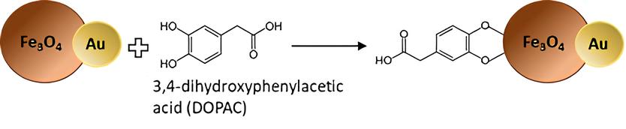
- Scheme of DOPAC coating with Fe₃O₄-Au NPs (NP/DOPAC)
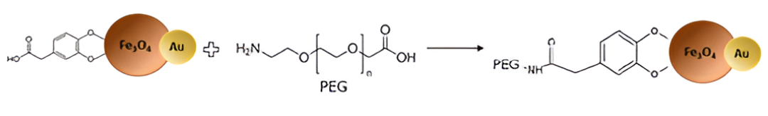
- Scheme of PEG coating of NP/DOPAC (NP/DOPAC/PEG)

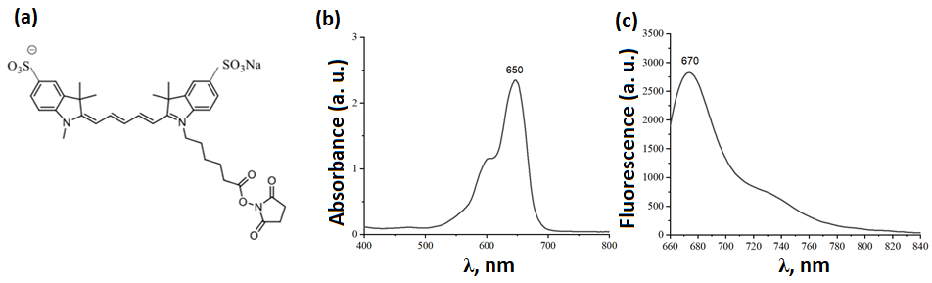
- (a) structure of FP; (b) absorbtion spectra of FP; (c) fluorescence spectra of FP (excitation wavelength = 650 nm)

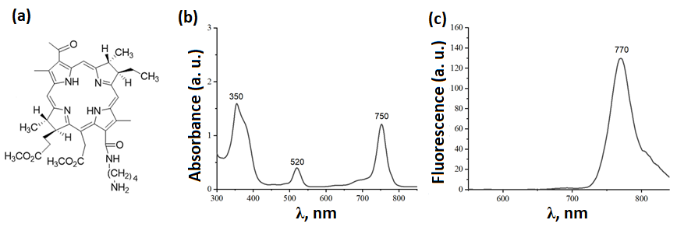
- (a) structure of PS; (b) absorbtion spectra of PS; (c) fluorescence spectra of PS (excitation wavelength = 520 nm)
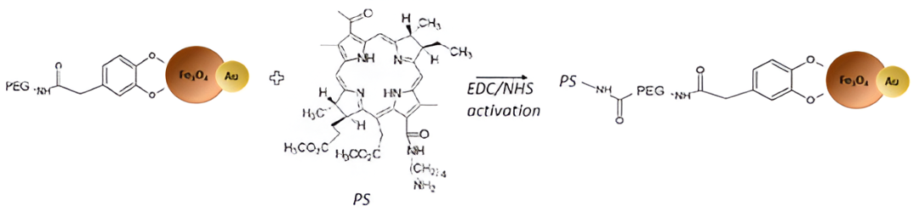
- Scheme of covalent conjugation of NP/DOPAC/PEG with PS (NP/PS)
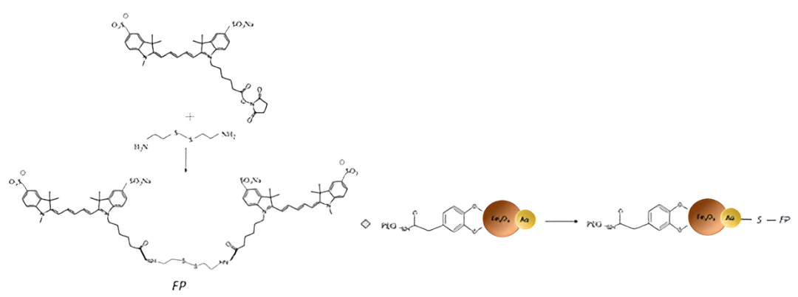
- Scheme of covalent conjugation of NP/DOPAC/PEG with FP (NP/FP)
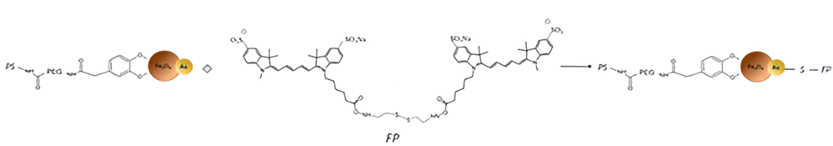
- NP/PS/FP synthesis scheme

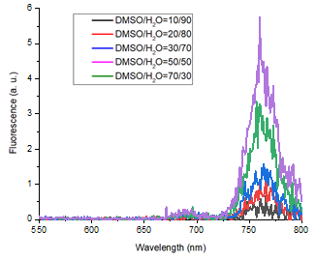
- Fluorescence spectra of PS in solutions with different DMSO/H₂O (excitation wavelength 530 nm)

