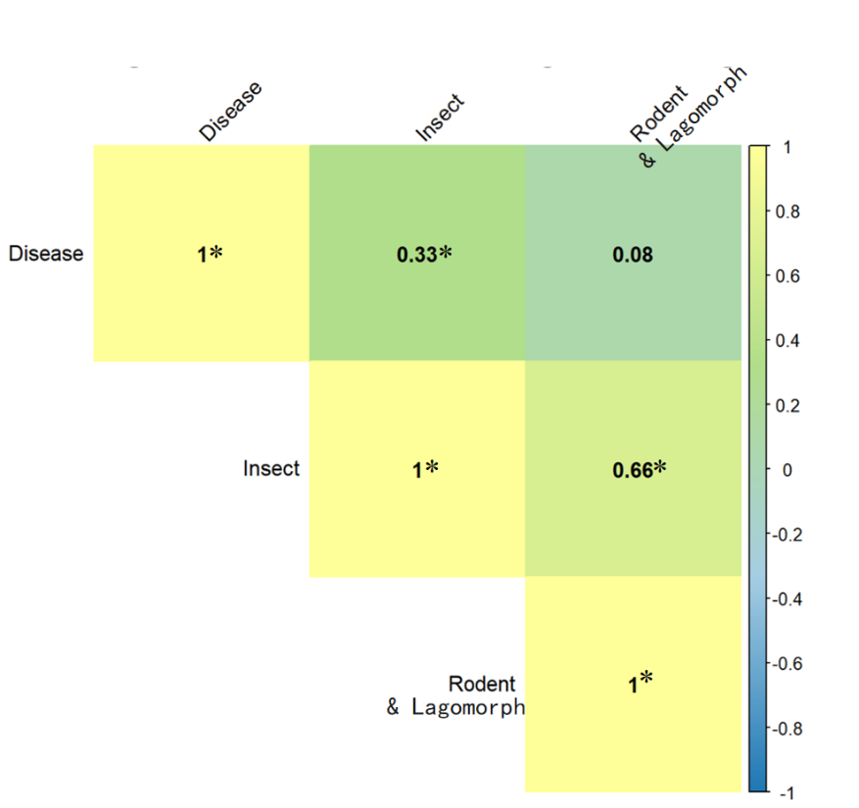
Fig S1 Pearson correlation among unit-area damage rates of forest diseases, insect pests, and rodent pests across Chinese provinces.

Table S1 Summary of GLMM results for the effects of extreme climate frequencies on forest pest damages in China (2014–2023).
Pest Type | Predictor | Estimate | Std. Error | 95% CI Lower | 95% CI Upper | P-value | Signif.
Disease | (Intercept) | -0.138 | 0.24 | -0.608 | 0.331 | 0.5633
Disease | Drought_Freq | 0.013 | 0.002 | 0.01 | 0.016 | <0.001 | ***
Disease | Extreme_Rain | 0.091 | 0.023 | 0.047 | 0.136 | <0.001 | ***
Insect | (Intercept) | 5.527 | 1.044 | 3.48 | 7.574 | <0.001 | ***
Insect | Drought_Freq | 0 | 0.002 | -0.004 | 0.004 | 0.9368
Insect | Extreme_Rain | 0.064 | 0.031 | 0.004 | 0.125 | 0.038 | *
Rodent & lagomorph | (Intercept) | 2.758 | 0.958 | 0.879 | 4.636 | 0.004 | **
Rodent & lagomorph | Drought_Freq | -0.006 | 0.002 | -0.01 | -0.001 | 0.014 | *
Rodent & lagomorph | Extreme_Rain | -0.079 | 0.052 | -0.18 | 0.022 | 0.1266

