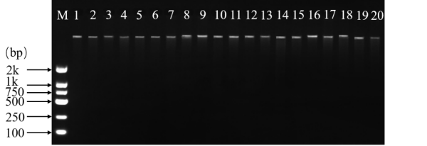
Fig. S1 PCR amplification detection of Lotus corniculatus genomic DNA

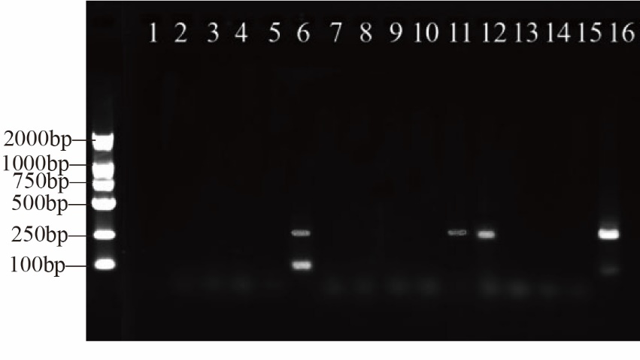

Fig. S2 Gel electrophoresis profiles for optimization of the SSR-PCR reaction system

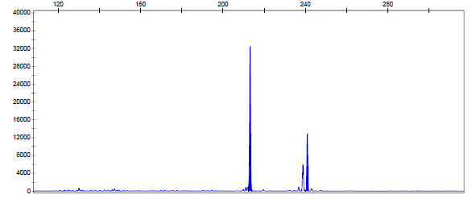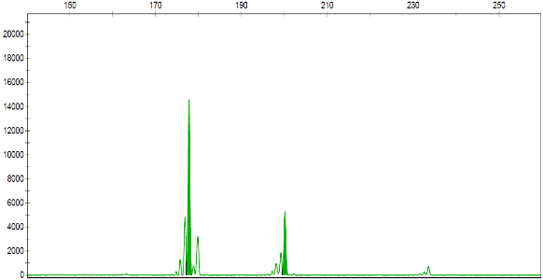
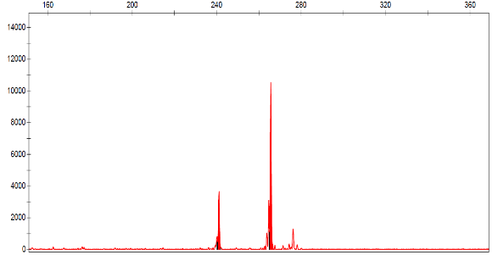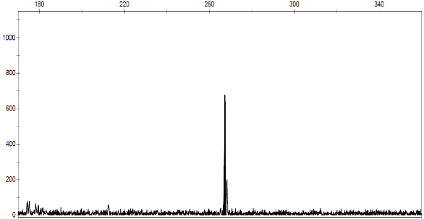
Fig. S3 Representative capillary electrophoresis peak profiles for SSR markers labeled with FAM (blue), HEX (green), ROX (red), and TAMRA (black)

