Appendix A: Zone-Stratified HbA1c Dataset for Diabetes Detection
This appendix presents the complete dataset used for zone-based diagnostic evaluation, listing HbA1c values alongside binary diagnosis labels (0 = non-diabetic, 1 = diabetic) and their corresponding epistemic zones. Zones are defined using the Robust Adjusted Mean Interval (RAMI) framework and include: Recessive Zone (RZ), Lower Plausible Zone (LPZ), Trusted Zone (TZ), Upper Mixed Outcome Zone (UPZ), and Inflated Zone (IZ). This stratification underpins all zone-restricted ROC/DET analyses and reliability assessments throughout the study.
HbA1c | Diagnosis | Score Zone
3.15 | 0 | Recessive Zone
3.38 | 0 | Recessive Zone
3.29 | 0 | Recessive Zone
3.24 | 0 | Recessive Zone
3.06 | 0 | Recessive Zone
3.06 | 0 | Recessive Zone
3.02 | 0 | Recessive Zone
3.35 | 0 | Recessive Zone
3.24 | 1 | Recessive Zone
3.28 | 0 | Recessive Zone
3.01 | 0 | Recessive Zone
3.39 | 0 | Recessive Zone
3.33 | 0 | Recessive Zone
3.08 | 0 | Recessive Zone
3.07 | 0 | Recessive Zone
3.07 | 0 | Recessive Zone
3.12 | 0 | Recessive Zone
3.21 | 0 | Recessive Zone
3.17 | 0 | Recessive Zone
3.12 | 0 | Recessive Zone
3.24 | 0 | Recessive Zone
3.06 | 0 | Recessive Zone
3.12 | 0 | Recessive Zone
3.15 | 0 | Recessive Zone
3.18 | 0 | Recessive Zone
3.31 | 0 | Recessive Zone
3.08 | 0 | Recessive Zone
3.21 | 1 | Recessive Zone
3.24 | 0 | Recessive Zone
3.02 | 0 | Recessive Zone
3.24 | 0 | Recessive Zone
3.07 | 0 | Recessive Zone
3.03 | 0 | Recessive Zone
3.38 | 0 | Recessive Zone
3.39 | 0 | Recessive Zone
3.32 | 0 | Recessive Zone
3.12 | 0 | Recessive Zone
3.04 | 0 | Recessive Zone
3.27 | 0 | Recessive Zone
3.18 | 0 | Recessive Zone
3.05 | 0 | Recessive Zone
3.2 | 0 | Recessive Zone
3.84 | 1 | Lower Plausible Zone
3.86 | 0 | Lower Plausible Zone
4.3 | 0 | Lower Plausible Zone
4.2 | 0 | Lower Plausible Zone
4.48 | 0 | Lower Plausible Zone
4.02 | 0 | Lower Plausible Zone
3.63 | 0 | Lower Plausible Zone
4.28 | 0 | Lower Plausible Zone
4.34 | 0 | Lower Plausible Zone
4.12 | 0 | Lower Plausible Zone
4.35 | 0 | Lower Plausible Zone
4.04 | 0 | Lower Plausible Zone
4.08 | 0 | Lower Plausible Zone
3.97 | 0 | Lower Plausible Zone
3.53 | 0 | Lower Plausible Zone
3.62 | 0 | Lower Plausible Zone
3.53 | 0 | Lower Plausible Zone
4.2 | 0 | Lower Plausible Zone
3.85 | 0 | Lower Plausible Zone
4.06 | 0 | Lower Plausible Zone
4.5 | 0 | Lower Plausible Zone
3.77 | 0 | Lower Plausible Zone
3.95 | 0 | Lower Plausible Zone
4.33 | 0 | Lower Plausible Zone
3.75 | 1 | Lower Plausible Zone
3.58 | 0 | Lower Plausible Zone
3.82 | 0 | Lower Plausible Zone
3.68 | 0 | Lower Plausible Zone
4.52 | 1 | Lower Plausible Zone
4.39 | 0 | Lower Plausible Zone
4.2 | 0 | Lower Plausible Zone
4.46 | 0 | Lower Plausible Zone
4.38 | 0 | Lower Plausible Zone
3.71 | 0 | Lower Plausible Zone
4.48 | 0 | Lower Plausible Zone
4.09 | 0 | Lower Plausible Zone
4.39 | 0 | Lower Plausible Zone
4.49 | 0 | Lower Plausible Zone
3.85 | 1 | Lower Plausible Zone
3.62 | 0 | Lower Plausible Zone
3.75 | 0 | Lower Plausible Zone
3.97 | 0 | Lower Plausible Zone
4.4 | 0 | Lower Plausible Zone
4.45 | 0 | Lower Plausible Zone
3.51 | 0 | Lower Plausible Zone
4.06 | 0 | Lower Plausible Zone
3.96 | 0 | Lower Plausible Zone
3.74 | 0 | Lower Plausible Zone
3.63 | 0 | Lower Plausible Zone
3.87 | 0 | Lower Plausible Zone
4.54 | 0 | Lower Plausible Zone
3.86 | 0 | Lower Plausible Zone
4.07 | 0 | Lower Plausible Zone
4.27 | 0 | Lower Plausible Zone
3.9 | 0 | Lower Plausible Zone
4.57 | 0 | Lower Plausible Zone
4.56 | 0 | Lower Plausible Zone
3.78 | 0 | Lower Plausible Zone
4.05 | 0 | Lower Plausible Zone
3.83 | 0 | Lower Plausible Zone
3.81 | 0 | Lower Plausible Zone
3.54 | 0 | Lower Plausible Zone
4.17 | 0 | Lower Plausible Zone
4.05 | 0 | Lower Plausible Zone
3.56 | 0 | Lower Plausible Zone
3.81 | 0 | Lower Plausible Zone
4.5 | 0 | Lower Plausible Zone
3.76 | 0 | Lower Plausible Zone
3.66 | 0 | Lower Plausible Zone
4.04 | 0 | Lower Plausible Zone
4.87 | 0 | Trusted Zone
4.84 | 0 | Trusted Zone
5.86 | 1 | Trusted Zone
5.05 | 0 | Trusted Zone
5.75 | 0 | Trusted Zone
5.38 | 0 | Trusted Zone
5.61 | 0 | Trusted Zone
5.2 | 0 | Trusted Zone
5.31 | 0 | Trusted Zone
5.19 | 1 | Trusted Zone
4.77 | 0 | Trusted Zone
5.51 | 0 | Trusted Zone
4.89 | 0 | Trusted Zone
4.53 | 0 | Trusted Zone
5.4 | 0 | Trusted Zone
4.75 | 1 | Trusted Zone
5.82 | 0 | Trusted Zone
5.84 | 1 | Trusted Zone
5.78 | 1 | Trusted Zone
5.02 | 0 | Trusted Zone
4.52 | 0 | Trusted Zone
5.8 | 0 | Trusted Zone
5.1 | 0 | Trusted Zone
5.85 | 0 | Trusted Zone
5.85 | 0 | Trusted Zone
5.69 | 0 | Trusted Zone
4.91 | 0 | Trusted Zone
5.04 | 1 | Trusted Zone
5.69 | 0 | Trusted Zone
4.94 | 1 | Trusted Zone
4.74 | 0 | Trusted Zone
5.28 | 0 | Trusted Zone
5.81 | 0 | Trusted Zone
5.47 | 0 | Trusted Zone
5.3 | 1 | Trusted Zone
4.64 | 0 | Trusted Zone
5.36 | 1 | Trusted Zone
5.89 | 0 | Trusted Zone
4.7 | 0 | Trusted Zone
5.23 | 0 | Trusted Zone
5.73 | 1 | Trusted Zone
5.54 | 1 | Trusted Zone
5.48 | 0 | Trusted Zone
5.48 | 0 | Trusted Zone
5 | 0 | Trusted Zone
4.91 | 0 | Trusted Zone
5.63 | 1 | Trusted Zone
5.63 | 1 | Trusted Zone
5.71 | 0 | Trusted Zone
5.78 | 0 | Trusted Zone
5.22 | 0 | Trusted Zone
5.2 | 0 | Trusted Zone
5.62 | 1 | Trusted Zone
5.41 | 0 | Trusted Zone
5.48 | 1 | Trusted Zone
5.61 | 0 | Trusted Zone
5.75 | 1 | Trusted Zone
4.97 | 0 | Trusted Zone
5.03 | 0 | Trusted Zone
4.63 | 1 | Trusted Zone
5.31 | 0 | Trusted Zone
4.55 | 0 | Trusted Zone
5.15 | 1 | Trusted Zone
5.26 | 1 | Trusted Zone
4.9 | 0 | Trusted Zone
5.33 | 0 | Trusted Zone
4.54 | 0 | Trusted Zone
4.55 | 0 | Trusted Zone
5.65 | 0 | Trusted Zone
5 | 0 | Trusted Zone
4.68 | 0 | Trusted Zone
5.23 | 0 | Trusted Zone
5.58 | 0 | Trusted Zone
4.8 | 0 | Trusted Zone
5.37 | 0 | Trusted Zone
4.62 | 0 | Trusted Zone
4.57 | 0 | Trusted Zone
5.24 | 0 | Trusted Zone
5.26 | 1 | Trusted Zone
5.39 | 0 | Trusted Zone
5.52 | 0 | Trusted Zone
5.87 | 0 | Trusted Zone
5.22 | 0 | Trusted Zone
4.95 | 0 | Trusted Zone
5.61 | 0 | Trusted Zone
4.88 | 0 | Trusted Zone
5.11 | 0 | Trusted Zone
4.61 | 0 | Trusted Zone
4.54 | 1 | Trusted Zone
5.85 | 0 | Trusted Zone
5.67 | 0 | Trusted Zone
5.47 | 0 | Trusted Zone
5.07 | 1 | Trusted Zone
4.74 | 0 | Trusted Zone
4.72 | 0 | Trusted Zone
4.85 | 1 | Trusted Zone
5.27 | 1 | Trusted Zone
5.5 | 1 | Trusted Zone
5.42 | 0 | Trusted Zone
4.89 | 0 | Trusted Zone
5.84 | 0 | Trusted Zone
5.53 | 0 | Trusted Zone
5.28 | 0 | Trusted Zone
5.36 | 0 | Trusted Zone
5.09 | 1 | Trusted Zone
4.85 | 0 | Trusted Zone
5 | 0 | Trusted Zone
5.56 | 0 | Trusted Zone
4.52 | 0 | Trusted Zone
4.66 | 0 | Trusted Zone
4.56 | 0 | Trusted Zone
4.56 | 0 | Trusted Zone
5.7 | 0 | Trusted Zone
5.49 | 0 | Trusted Zone
5.16 | 0 | Trusted Zone
4.64 | 1 | Trusted Zone
5.19 | 0 | Trusted Zone
5.16 | 0 | Trusted Zone
4.74 | 1 | Trusted Zone
5.11 | 0 | Trusted Zone
5.06 | 1 | Trusted Zone
5.36 | 0 | Trusted Zone
5.39 | 1 | Trusted Zone
4.56 | 0 | Trusted Zone
5.02 | 1 | Trusted Zone
6.26 | 0 | Upper MOZ
6.5 | 1 | Upper MOZ
6.04 | 0 | Upper MOZ
6.28 | 1 | Upper MOZ
6.48 | 1 | Upper MOZ
6.26 | 0 | Upper MOZ
6.31 | 1 | Upper MOZ
6.35 | 1 | Upper MOZ
6.23 | 0 | Upper MOZ
6.31 | 1 | Upper MOZ
6.29 | 1 | Upper MOZ
6.45 | 1 | Upper MOZ
6.02 | 0 | Upper MOZ
6.14 | 1 | Upper MOZ
6.48 | 1 | Upper MOZ
6.45 | 0 | Upper MOZ
6.23 | 1 | Upper MOZ
6.31 | 1 | Upper MOZ
6.14 | 1 | Upper MOZ
6.09 | 0 | Upper MOZ
6.23 | 1 | Upper MOZ
6.18 | 0 | Upper MOZ
6.29 | 0 | Upper MOZ
6.04 | 0 | Upper MOZ
6.49 | 0 | Upper MOZ
6.49 | 0 | Upper MOZ
6.35 | 0 | Upper MOZ
6.27 | 1 | Upper MOZ
6.15 | 0 | Upper MOZ
6.41 | 0 | Upper MOZ
6.34 | 1 | Upper MOZ
6.08 | 1 | Upper MOZ
6.46 | 1 | Upper MOZ
6.41 | 0 | Upper MOZ
6.47 | 0 | Upper MOZ
6.36 | 0 | Upper MOZ
6.31 | 0 | Upper MOZ
6.21 | 0 | Upper MOZ
6.47 | 0 | Upper MOZ
6.43 | 0 | Upper MOZ
6.02 | 0 | Upper MOZ
6.01 | 1 | Upper MOZ
6.19 | 0 | Upper MOZ
6.41 | 0 | Upper MOZ
6.49 | 1 | Upper MOZ
6.08 | 1 | Upper MOZ
6.3 | 0 | Upper MOZ
6.19 | 1 | Upper MOZ
6.48 | 1 | Upper MOZ
6.42 | 0 | Upper MOZ
6.42 | 1 | Upper MOZ
6.23 | 1 | Upper MOZ
6.21 | 0 | Upper MOZ
6.14 | 0 | Upper MOZ
6.03 | 1 | Upper MOZ
6.43 | 1 | Upper MOZ
6.41 | 0 | Upper MOZ
6.5 | 0 | Upper MOZ
6.5 | 0 | Upper MOZ
6.28 | 1 | Upper MOZ
6.38 | 1 | Upper MOZ
6.47 | 0 | Upper MOZ
6.42 | 1 | Upper MOZ
6.12 | 1 | Upper MOZ
6.23 | 0 | Upper MOZ
6.06 | 0 | Upper MOZ
6.48 | 1 | Upper MOZ
6.3 | 1 | Upper MOZ
6.11 | 1 | Upper MOZ
6.34 | 1 | Upper MOZ
6.31 | 0 | Upper MOZ
6.18 | 1 | Upper MOZ
6.06 | 1 | Upper MOZ
6.34 | 0 | Upper MOZ
6.26 | 0 | Upper MOZ
6.39 | 0 | Upper MOZ
6.26 | 0 | Upper MOZ
6.43 | 0 | Upper MOZ
6.28 | 0 | Upper MOZ
6.28 | 0 | Upper MOZ
6.44 | 0 | Upper MOZ
6.2 | 1 | Upper MOZ
6.07 | 1 | Upper MOZ
6.01 | 1 | Upper MOZ
6.38 | 1 | Upper MOZ
6.31 | 1 | Upper MOZ
6.35 | 0 | Upper MOZ
6.11 | 1 | Upper MOZ
6.07 | 1 | Upper MOZ
6.01 | 1 | Upper MOZ
7.58 | 1 | Inflated Zone
6.82 | 1 | Inflated Zone
7.21 | 1 | Inflated Zone
7.41 | 1 | Inflated Zone
8.11 | 1 | Inflated Zone
7.93 | 1 | Inflated Zone
7.39 | 1 | Inflated Zone
8.97 | 1 | Inflated Zone
8.01 | 1 | Inflated Zone
7.09 | 1 | Inflated Zone
6.75 | 1 | Inflated Zone
6.88 | 1 | Inflated Zone
7.11 | 1 | Inflated Zone
6.9 | 1 | Inflated Zone
6.97 | 1 | Inflated Zone
7.21 | 1 | Inflated Zone
6.93 | 1 | Inflated Zone
8.74 | 1 | Inflated Zone
6.7 | 1 | Inflated Zone
7.81 | 1 | Inflated Zone
7.53 | 1 | Inflated Zone
8.96 | 1 | Inflated Zone
6.78 | 1 | Inflated Zone
7.49 | 1 | Inflated Zone
8.92 | 1 | Inflated Zone
8.66 | 1 | Inflated Zone
8.54 | 1 | Inflated Zone
7.14 | 1 | Inflated Zone
6.93 | 1 | Inflated Zone
8.17 | 1 | Inflated Zone
8.82 | 1 | Inflated Zone
7.89 | 1 | Inflated Zone
7.93 | 1 | Inflated Zone
7.2 | 1 | Inflated Zone
8.42 | 1 | Inflated Zone
6.97 | 1 | Inflated Zone
7.31 | 1 | Inflated Zone
7.56 | 1 | Inflated Zone
7.77 | 1 | Inflated Zone
7.11 | 1 | Inflated Zone
6.79 | 1 | Inflated Zone
8.03 | 1 | Inflated Zone
7.22 | 1 | Inflated Zone
7.95 | 1 | Inflated Zone
6.89 | 1 | Inflated Zone
7.7 | 1 | Inflated Zone
7.83 | 1 | Inflated Zone
6.63 | 1 | Inflated Zone
7.34 | 1 | Inflated Zone
6.84 | 1 | Inflated Zone
6.66 | 1 | Inflated Zone
8.97 | 1 | Inflated Zone
7.31 | 1 | Inflated Zone
8.52 | 1 | Inflated Zone
7.14 | 1 | Inflated Zone
8.2 | 1 | Inflated Zone
8.4 | 1 | Inflated Zone
7.99 | 1 | Inflated Zone
7.68 | 1 | Inflated Zone
7.53 | 1 | Inflated Zone
7.37 | 1 | Inflated Zone
8.82 | 1 | Inflated Zone
8.58 | 1 | Inflated Zone
8.91 | 1 | Inflated Zone
6.81 | 1 | Inflated Zone
8.33 | 1 | Inflated Zone
8.85 | 1 | Inflated Zone
6.95 | 1 | Inflated Zone
6.67 | 1 | Inflated Zone
8.35 | 1 | Inflated Zone
7.94 | 1 | Inflated Zone
8.6 | 1 | Inflated Zone
6.85 | 1 | Inflated Zone
8.49 | 1 | Inflated Zone
7 | 1 | Inflated Zone
6.91 | 1 | Inflated Zone
6.91 | 1 | Inflated Zone
8.54 | 1 | Inflated Zone
8.16 | 1 | Inflated Zone
7.81 | 1 | Inflated Zone
7.4 | 1 | Inflated Zone
8.69 | 1 | Inflated Zone
7.48 | 1 | Inflated Zone
8.54 | 1 | Inflated Zone
7.6 | 1 | Inflated Zone
7.44 | 1 | Inflated Zone
7.66 | 1 | Inflated Zone
7.25 | 1 | Inflated Zone
8.37 | 1 | Inflated Zone
7.76 | 1 | Inflated Zone
7.08 | 1 | Inflated Zone
8.75 | 1 | Inflated Zone
7.46 | 1 | Inflated Zone
7.86 | 1 | Inflated Zone
8.77 | 1 | Inflated Zone
8.06 | 1 | Inflated Zone
6.79 | 1 | Inflated Zone
8.85 | 1 | Inflated Zone
8.07 | 1 | Inflated Zone
7.34 | 1 | Inflated Zone
6.85 | 1 | Inflated Zone
8.49 | 1 | Inflated Zone
8.05 | 1 | Inflated Zone
7.83 | 1 | Inflated Zone
8.73 | 1 | Inflated Zone

Appendix B: Corrected Lower Trizonal Dataset with EASI Scores
This appendix contains the corrected dataset used for lower tri-zonal ROC and DET analysis in hypoglycemia detection. It includes HbA1c values, binary hypoglycemia labels (1 = hypoglycemia, 0 = non-hypoglycemia), corresponding epistemic zones—limited to the Recessive Zone (RZ), Lower Plausible Zone (LPZ), and Trusted Zone (TZ)—and their computed EASI (Epistemic Alignment Score for Interpretation) scores. These EASI-transformed probabilities enable zone-restricted performance analysis, focusing on diagnostically fragile and intermediate-risk regions. This subset forms the basis for L3Z-restricted evaluation presented in the main results section.

HbA1c | Label1 for hypoglycemia 0 for non-hypoglycemia | Zone | EASI_Score
3.15 | 1 | Recessive Zone | 0.950877
3.38 | 1 | Recessive Zone | 0.870175
3.29 | 1 | Recessive Zone | 0.901754
3.24 | 1 | Recessive Zone | 0.919298
3.06 | 1 | Recessive Zone | 0.982456
3.06 | 1 | Recessive Zone | 0.982456
3.02 | 1 | Recessive Zone | 0.996491
3.35 | 1 | Recessive Zone | 0.880702
3.24 | 0 | Recessive Zone | 0.919298
3.28 | 1 | Recessive Zone | 0.905263
3.01 | 1 | Recessive Zone | 1
3.39 | 1 | Recessive Zone | 0.866667
3.33 | 1 | Recessive Zone | 0.887719
3.08 | 1 | Recessive Zone | 0.975439
3.07 | 1 | Recessive Zone | 0.978947
3.07 | 1 | Recessive Zone | 0.978947
3.12 | 1 | Recessive Zone | 0.961404
3.21 | 1 | Recessive Zone | 0.929825
3.17 | 1 | Recessive Zone | 0.94386
3.12 | 1 | Recessive Zone | 0.961404
3.24 | 1 | Recessive Zone | 0.919298
3.06 | 1 | Recessive Zone | 0.982456
3.12 | 1 | Recessive Zone | 0.961404
3.15 | 1 | Recessive Zone | 0.950877
3.18 | 1 | Recessive Zone | 0.940351
3.31 | 1 | Recessive Zone | 0.894737
3.08 | 1 | Recessive Zone | 0.975439
3.21 | 0 | Recessive Zone | 0.929825
3.24 | 1 | Recessive Zone | 0.919298
3.02 | 1 | Recessive Zone | 0.996491
3.24 | 1 | Recessive Zone | 0.919298
3.07 | 1 | Recessive Zone | 0.978947
3.03 | 1 | Recessive Zone | 0.992982
3.38 | 1 | Recessive Zone | 0.870175
3.39 | 1 | Recessive Zone | 0.866667
3.32 | 1 | Recessive Zone | 0.891228
3.12 | 1 | Recessive Zone | 0.961404
3.04 | 1 | Recessive Zone | 0.989474
3.27 | 1 | Recessive Zone | 0.908772
3.18 | 1 | Recessive Zone | 0.940351
3.05 | 1 | Recessive Zone | 0.985965
3.2 | 0 | Lower Plausible Zone | 0.933333
3.84 | 0 | Lower Plausible Zone | 0.708772
3.86 | 0 | Lower Plausible Zone | 0.701754
4.3 | 0 | Lower Plausible Zone | 0.547368
4.2 | 0 | Lower Plausible Zone | 0.582456
4.48 | 0 | Lower Plausible Zone | 0.484211
4.02 | 0 | Lower Plausible Zone | 0.645614
3.63 | 0 | Lower Plausible Zone | 0.782456
4.28 | 0 | Lower Plausible Zone | 0.554386
4.34 | 0 | Lower Plausible Zone | 0.533333
4.12 | 0 | Lower Plausible Zone | 0.610526
4.35 | 0 | Lower Plausible Zone | 0.529825
4.04 | 0 | Lower Plausible Zone | 0.638596
4.08 | 0 | Lower Plausible Zone | 0.624561
3.97 | 0 | Lower Plausible Zone | 0.663158
3.53 | 0 | Lower Plausible Zone | 0.817544
3.62 | 0 | Lower Plausible Zone | 0.785965
3.53 | 0 | Lower Plausible Zone | 0.817544
4.2 | 0 | Lower Plausible Zone | 0.582456
3.85 | 0 | Lower Plausible Zone | 0.705263
4.06 | 0 | Lower Plausible Zone | 0.631579
4.5 | 0 | Lower Plausible Zone | 0.477193
4.87 | 0 | Trusted Zone | 0.347368
4.84 | 0 | Trusted Zone | 0.357895
5.86 | 0 | Trusted Zone | 0
5.05 | 0 | Trusted Zone | 0.284211
5.75 | 0 | Trusted Zone | 0.038596
Appendix C: Zone-Wise HbA1c Value Summary (Simulated Example 1)
This table summarizes the distribution of HbA1c values across epistemic zones based on the RAMI framework. Each zone corresponds to a distinct diagnostic region used in the ROC/DET analysis.
Zone | HbA1c Range (approx.) | Count | Notes
Recessive | < 3.5% | 39 | Hypoglycemic region; used as positive class in reversed ROC
Lower Plausible | 3.5% – 4.5% | 91 | Transitional/ambiguous zone before normal HbA1c
Trusted (Tareef’s) | 4.5% – 5.9% |  | Normoglycemia; benchmark zone for reliability
  144
Upper MOZ | 6.0% – 6.5% | 101 | Diagnostic ambiguity zone; often borderline diabetic
Inflated (Diabetic) | > 6.5% | 96 | Definitive diabetes zone; used as positive class in traditional ROC

Appendix D: Zone-Wise Brier Scores for HbA1c Classifier Calibration (Simulated Example 1)
This table presents zone-specific Brier scores calculated for the HbA1c-based classifier in Simulated Example 1. The Brier score quantifies the mean squared error between predicted probabilities and actual outcomes, with lower values indicating better probabilistic calibration. The Recessive Zone demonstrated the best calibration, while the Upper Plausible and Trusted Zones exhibited the highest miscalibration—highlighting diagnostic fragility in transitional and high-confidence regions.
Zone | Brier_Score
Inflated | 0.12658901110866416
Lower Plausible | 0.1303166077172559
Recessive | 0.06385103431894351
Trusted | 0.2665100557408259
Upper Plausible | 0.29803491981191893

Appendix E:
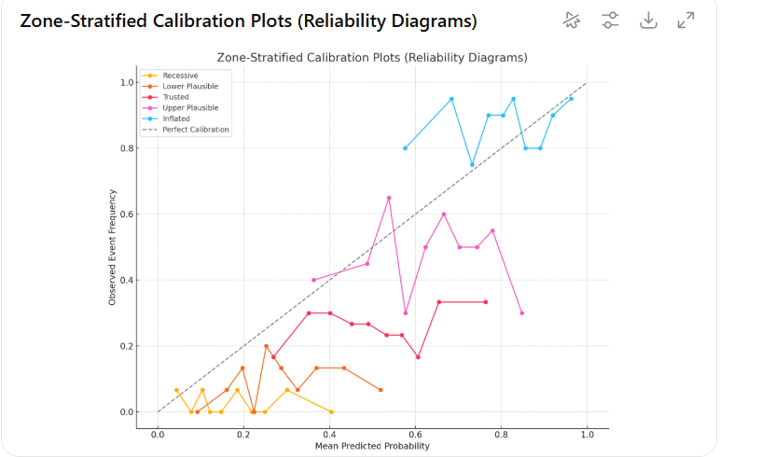
Appendix E ,Figure E1. Zone-Stratified Calibration Plots for HbA1c-Based Classification
This reliability diagram presents the calibration performance of the classifier across epistemically defined zones using the RAMI framework. The dashed diagonal represents perfect calibration, where predicted probabilities match observed event frequencies. The Recessive Zone shows the closest alignment to the perfect calibration line, reflecting strong predictive reliability. In contrast, the Upper Plausible Zone deviates substantially, indicating over- or underestimation of event probabilities near the decision threshold. The Trusted Zone demonstrates moderate calibration, while the Inflated Zone retains high alignment at elevated probabilities, consistent with the greater diagnostic certainty in extreme hyperglycemia.

Appendix F: Net Benefit Characteristics by Epistemic Zone for HbA1c-Based Classification
This table summarizes decision curve analysis (DCA) outcomes stratified by RAMI-defined epistemic zones. Threshold probability ranges indicate intervals where the net benefit (NB) remained positive, reflecting clinically advantageous decision-making. The Trusted Zone (TZ) maintained a broad positive range (0.20–0.70) with a peak NB of 0.22 at a threshold of 0.45, while the Inflated Zone (IZ) achieved the highest peak NB (0.28) at a lower threshold of 0.15. In contrast, the Recessive Zone (RZ) and Lower Plausible Zone (LPZ) failed to produce positive NB at any threshold, underscoring their limited clinical utility. The Upper Plausible Zone (UPZ) demonstrated modest NB gains within a narrower range, consistent with its transitional diagnostic uncertainty.
Epistemic Zone | Threshold Probability Range with Positive Net Benefit | Peak Net Benefit (NB) | Approx. Threshold of Peak NB
Recessive Zone (RZ) | None | ≤ 0.00 | –
Lower Plausible Zone (LPZ) | None | ≤ 0.00 | –
Trusted Zone (TZ) | 0.20 – 0.70 | 0.22 | 0.45
Upper Plausible Zone (UPZ) | 0.25 – 0.50 | 0.12 | 0.30
Inflated Zone (IZ) | 0.05 – 0.90 | 0.28 | 0.15

Appendix G. Zone-Stratified Expected Misclassification Cost Based on Clinical Risk Weights
This appendix reports the expected misclassification cost for Example 1, calculated within each RAMI-defined epistemic zone using clinically assigned risk weights for false positives (FP) and false negatives (FN). The Lower Plausible Zone (LPZ) showed the highest expected cost (0.833), driven by high false negative counts despite perfect specificity. The Recessive Zone (RZ) also exhibited elevated cost (0.625) due to the complete absence of true positives and substantial FN burden. In contrast, the Inflated Zone (IZ) recorded the lowest expected cost (0.067), reflecting strong sensitivity and minimal FP incidence. The Trusted Zone (TZ) and Upper Mixed Outcome Zone (UPZ) displayed intermediate costs (0.241 and 0.407, respectively), highlighting the trade-off between balanced classification and transitional diagnostic uncertainty.
Zone | TP | TN | FP | FN | Expected Cost
Recessive Zone | 0 | 30 | 0 | 10 | 0.625
Lower Plausible | 2 | 50 | 0 | 20 | 0.833
Trusted Zone | 25 | 60 | 5 | 10 | 0.241
Upper MOZ | 30 | 20 | 10 | 10 | 0.407
Inflated Zone | 70 | 0 | 5 | 0 | 0.067

Appendix H. Zone-Specific Misclassification Rates (ZBE) for HbA1c-Based Classification
This appendix presents the Zone-Based Error (ZBE) values for Example 1, derived as the average of the false positive rate (FPR) and false negative rate (FNR) within each RAMI-defined epistemic zone. High ZBE values indicate greater local diagnostic volatility and reduced reliability. Both the Recessive Zone (RZ) and Lower Plausible Zone (LPZ) exhibited ZBE scores of 0.50, reflecting complete sensitivity loss (FNR = 1.00) despite perfect specificity. The Trusted Zone (TZ) demonstrated maximal volatility (ZBE = 1.00) with both FPR and FNR equal to 1.00, indicating uniform misclassification. The Upper Plausible Zone (UPZ) and Inflated Zone (IZ) each recorded ZBE scores of 0.50, driven by complete specificity loss (FPR = 1.00) but perfect sensitivity (FNR = 0.00).
Zone | False Positive Rate (FPR) | False Negative Rate (FNR) | ZBE
Recessive Zone | 0.00 | 1.00 | 0.50
Lower Plausible Zone | 0.00 | 1.00 | 0.50
Trusted Zone | 1.00 | 1.00 | 1.00
Upper Plausible Zone | 1.00 | 0.00 | 0.50
Inflated Zone | 1.00 | 0.00 | 0.50
Appendix I : Simulated 2 Example dataset : Prostate Cancer Classification Dataset Based on Total PSA and %Free PSA
This dataset contains simulated prostate cancer diagnostic data using two biomarkers—Total PSA (ng/mL) and percentage of free PSA (%). The binary diagnosis label is coded as 1 for prostate cancer and 0 for non-cancer. The dataset serves as Example 2 in evaluating the zone-based ROC and DET framework, enabling comparison of classification performance, calibration, and decision curve analysis across epistemic zones.
Total_PSA | %Free_PSA | Diagnosis
3.996714 | 23.78894 | 0
3.361736 | 24.80392 | 0
4.147689 | 27.41526 | 0
5.02303 | 27.26901 | 0
3.265847 | 15.11165 | 0
3.265863 | 17.31087 | 0
5.079213 | 24.57518 | 0
4.267435 | 24.56893 | 0
3.030526 | 24.57524 | 0
4.04256 | 40 | 0
3.036582 | 24.85445 | 0
3.03427 | 27.67783 | 0
3.741962 | 26.77001 | 0
1.58672 | 25.25696 | 0
1.775082 | 20.42365 | 0
2.937712 | 25.79485 | 0
2.487169 | 18.13587 | 0
3.814247 | 20.81591 | 0
2.591976 | 19.57318 | 0
2.087696 | 22.40937 | 0
4.965649 | 33.57329 | 0
3.274224 | 12.66367 | 0
3.567528 | 25.4313 | 0
2.075252 | 13.93642 | 0
2.955617 | 19.64034 | 0
3.610923 | 27.44475 | 0
2.349006 | 22.3214 | 0
3.875698 | 16.61128 | 0
2.899361 | 18.42348 | 0
3.208306 | 25.39799 | 0
2.898293 | 18.34817 | 0
5.352278 | 23.08229 | 0
3.486503 | 22.22786 | 0
2.442289 | 18.742 | 0
4.322545 | 32.71972 | 0
2.279156 | 25.1696 | 0
3.708864 | 11.87429 | 0
1.54033 | 22.93227 | 0
2.171814 | 18.69107 | 0
3.696861 | 26.26217 | 0
4.238467 | 18.0374 | 0
3.671368 | 21.42632 | 0
3.384352 | 24.52494 | 0
3.198896 | 26.32878 | 0
2.021478 | 15.99852 | 0
2.780156 | 20.32749 | 0
3.039361 | 19.62527 | 0
4.557122 | 18.73335 | 0
3.843618 | 30.82727 | 0
1.73696 | 24.02491 | 0
3.824084 | 15.69558 | 0
3.114918 | 26.58931 | 0
2.823078 | 32.61078 | 0
4.111676 | 27.16233 | 0
4.531 | 14.40315 | 0
4.43128 | 19.57883 | 0
2.660782 | 28.33456 | 0
3.190788 | 18.46165 | 0
3.831263 | 24.2191 | 0
4.475545 | 25.87317 | 0
3.020826 | 17.36535 | 0
3.314341 | 21.70237 | 0
2.393665 | 5.793663 | 0
2.303793 | 16.87806 | 0
4.312526 | 20.73716 | 0
4.85624 | 15.76108 | 0
3.42799 | 30.16206 | 0
4.503533 | 14.84929 | 0
3.861636 | 19.79978 | 0
2.85488 | 22.6537 | 0
3.861396 | 29.20637 | 0
5.038037 | 14.82069 | 0
3.464174 | 27.81582 | 0
5.064644 | 22.05117 | 0
0.880255 | 17.09246 | 0
4.321903 | 24.31052 | 0
3.587047 | 22.9953 | 0
3.200993 | 18.99892 | 0
3.591761 | 22.34901 | 0
1.512431 | 20.07343 | 0
3.280328 | 22.56759 | 0
3.857113 | 25.31065 | 0
4.977894 | 29.93008 | 0
2.98173 | 15.81092 | 0
2.691506 | 32.66517 | 0
2.998243 | 12.23956 | 0
4.415402 | 21.24107 | 0
3.828751 | 24.94159 | 0
2.97024 | 23.40496 | 0
4.013267 | 18.8865 | 0
3.597078 | 20.95939 | 0
4.468645 | 19.535 | 0
2.797947 | 19.05318 | 0
3.172338 | 26.24801 | 0
3.107892 | 23.78508 | 0
2.036485 | 18.53545 | 0
3.79612 | 26.498 | 0
3.761055 | 23.5365 | 0
3.505113 | 26.06431 | 0
3.265413 | 25.14814 | 0
3.669259 | 8.68402 | 1
5.658709 | 9.759276 | 1
5.814571 | 14.98917 | 1
4.895445 | 14.44148 | 1
6.177429 | 11.91639 | 1
7.308102 | 12.46931 | 1
10.27237 | 17.11066 | 1
6.849156 | 9.633714 | 1
7.015101 | 14.18839 | 1
6.351108 | 11.19123 | 1
2.662458 | 11.12928 | 1
6.446972 | 16.39511 | 1
6.62046 | 15.30167 | 1
11.42648 | 15.25404 | 1
6.115278 | 17.22192 | 1
7.103095 | 12.08402 | 1
6.430576 | 14.72781 | 1
4.162644 | 10.75893 | 1
8.785646 | 13.29667 | 1
8.003866 | 11.47943 | 1
8.082064 | 12.38798 | 1
4.681225 | 14.38063 | 1
9.305589 | 8.727117 | 1
3.696298 | 20.36955 | 1
7.673714 | 7.97593 | 1
10.88091 | 7.143246 | 1
4.518927 | 16.63244 | 1
5.367405 | 15.16665 | 1
6.699303 | 14.49648 | 1
5.493049 | 14.51338 | 1
3.398673 | 11.95101 | 1
6.637126 | 8.410983 | 1
4.375393 | 12.30322 | 1
7.447185 | 9.291353 | 1
4.661152 | 15.90048 | 1
9.599869 | 11.41177 | 1
4.933493 | 8.698011 | 1
5.855877 | 10.71446 | 1
8.127034 | 13.65173 | 1
4.038271 | 9.745102 | 1
6.95492 | 8.711118 | 1
9.114286 | 12.97475 | 1
3.285034 | 12.97987 | 1
6.869268 | 9.972227 | 1
7.019766 | 10.11585 | 1
8.063646 | 12.9282 | 1
4.026099 | 6.207663 | 1
3.859087 | 6.370145 | 1
7.543883 | 9.126223 | 1
7.093969 | 11.14621 | 1
7.000986 | 13.24363 | 1
7.192896 | 17.90142 | 1
5.139951 | 15.43064 | 1
6.964507 | 11.36025 | 1
7.086145 | 11.92394 | 1
5.071297 | 7.989883 | 1
10.23155 | 11.92595 | 1
7.447666 | 10.84537 | 1
4.117393 | 13.29087 | 1
7.813107 | 8.691076 | 1
4.550637 | 14.07739 | 1
8.074169 | 18.13096 | 1
8.817191 | 11.56496 | 1
4.858635 | 13.60685 | 1
8.426752 | 14.76058 | 1
7.325562 | 10.39512 | 1
8.14412 | 12.89637 | 1
10.29359 | 12.05037 | 1
6.009224 | 12.3907 | 1
4.992528 | 8.907961 | 1
4.720971 | 12.09804 | 1
4.868379 | 13.99199 | 1
6.345797 | 17.80457 | 1
7.182304 | 15.83708 | 1
7.053382 | 20.61273 | 1
8.154366 | 8.93061 | 1
6.526004 | 15.48928 | 1
9.407068 | 12.73337 | 1
5.970686 | 20.75921 | 1
11.94034 | 8.766807 | 1
7.751335 | 8.641113 | 1
4.785685 | 9.602429 | 1
4.358215 | 3.504417 | 1
7.464945 | 9.89698 | 1
6.053074 | 8.963469 | 1
7.928001 | 12.60158 | 1
7.446475 | 13.36702 | 1
6.354342 | 19.50468 | 1
4.806413 | 15.8017 | 1
3.470306 | 9.692385 | 1
5.60697 | 8.406341 | 1
8.212798 | 13.96768 | 1
6.928187 | 6.719067 | 1
4.008522 | 19.32584 | 1
6.846362 | 16.71776 | 1
7.270635 | 10.1233 | 1
4.732285 | 5.147462 | 1
6.80745 | 17.41549 | 1
6.616417 | 11.54184 | 1
4.214059 | 16.95127 | 1

Appendix J: Calibration Metrics Across Epistemic Zones (n = 200)
This table presents zone-specific calibration outcomes for the prostate cancer classification model, based on a dataset of 200 cases evenly distributed across five epistemic zones. Mean predicted probabilities are compared with observed positive rates, and Brier Scores quantify the squared prediction error within each zone.
Zone | n | Mean Predicted Probability | Observed Positive Rate | Brier Score
Recessive | 40 | 0.7264 | 0.000 | 0.5287
Lower Plausible | 40 | 0.7889 | 0.125 | 0.5478
Trusted | 40 | 0.8343 | 0.525 | 0.3416
Upper Plausible | 40 | 0.8709 | 0.875 | 0.1092
Inflated | 40 | 0.9110 | 0.975 | 0.0303

Appendix K:Zone-Stratified Calibration Plots (Reliability Diagrams)
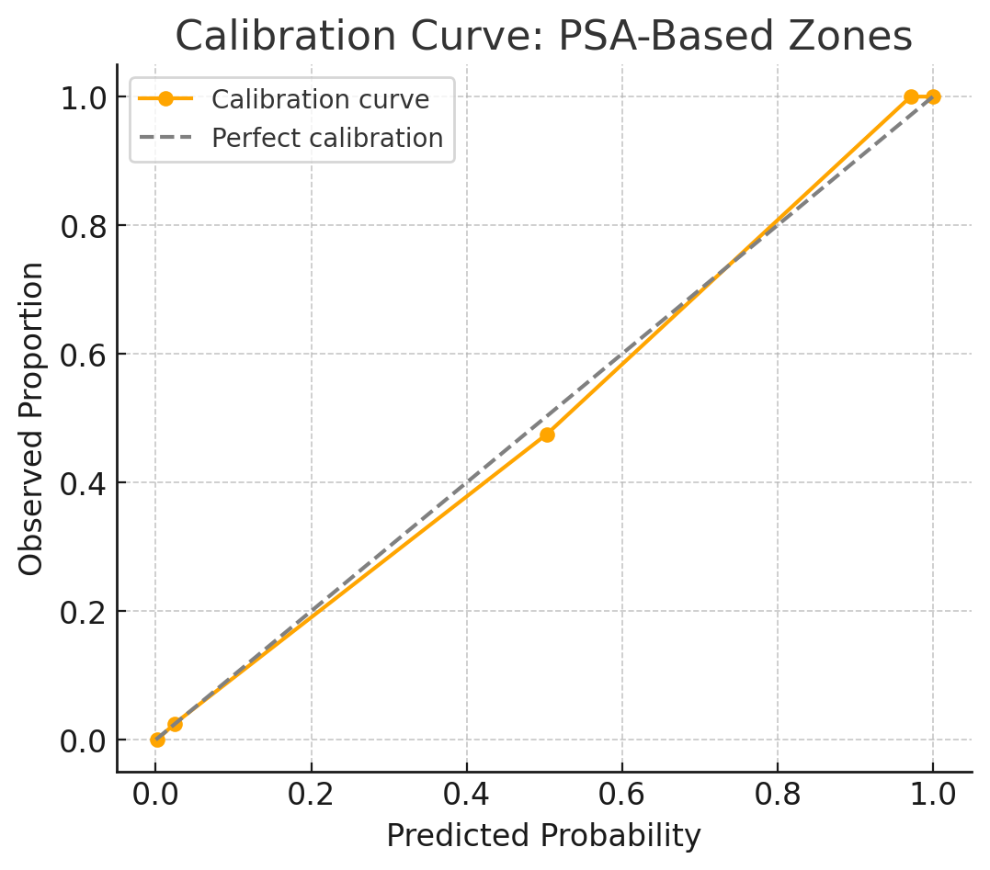
Appendix K, Fig. K1.: Zone-Specific Calibration Curve for Simulated Prostate Cancer Data
Calibration plot comparing predicted probabilities to observed prostate cancer rates across PSA-based diagnostic zones in the second simulated sample. The curve closely aligns with the diagonal reference line representing perfect calibration, indicating strong agreement between predicted and actual outcomes. Zone-specific calibration reveals that this alignment holds consistently across low, intermediate, and high predicted risk strata, supporting the model’s reliability beyond global metrics.

Appenix L,Table L1. Brier score foe simulated example 2
Zone-wise sample size (n), predicted probability by zone (p_z), observed event rate (obs_rate), and zone-specific Brier score (Brier_z) under SE-adjusted RAMI stratification. Results show decreasing Brier scores toward high-confidence zones, with lowest error in the Inflated Zone (IZ) and highest error in the Lower Plausible Zone (LPZ). Overall Brier score = 0.261.
 | Zone | n | p_z | obs_rate | Brier_z
0 | RZ (<5) | 120 | 0.05 | 0.291667 | 0.265
1 | LPZ (5-20) | 126 | 0.2 | 0.47619 | 0.325714
2 | TZ (20-200) | 106 | 0.6 | 0.707547 | 0.218491
3 | UPZ (200-1000) | 37 | 0.8 | 0.756757 | 0.185946
4 | IZ (>1000) | 12 | 0.95 | 0.833333 | 0.1525
5 | Overall | 401 |  |  | 0.261122

Appendix L,Table L2: Zone-Stratified Performance, Calibration Quality, and Diagnostic Risk Metrics for the PSA-Based Model
This composite table summarizes zone-level performance for the PSA-based diagnostic model in the second simulated sample (n = 200). For each epistemic zone, calibration quality, net clinical benefit, expected misclassification cost (weighted FN = 5, FP = 1), and the Zone-Based Error (ZBE; mean of false positive rate and false negative rate) are reported. The results highlight substantial heterogeneity across zones—while the Trusted Zone achieved high calibration and low error, the Recessive and Lower Plausible Zones exhibited minimal benefit and high error rates, and the Inflated Zone showed an elevated false positive burden.

Zone | Net_Benefit | Expected_Cost | Brier_z | ZBE
RZ (<5) | 0.114584 | 433.4998 | 0.265 | 1
LPZ (5-20) | 0.345237 | 336.6003 | 0.325714 | 1
TZ (20-200) | 0.634434 | 158.1001 | 0.218491 | 0.12
UPZ (200-1000) | 0.695946 | 45.89995 | 0.185946 | 0.42
IZ (>1000) | 0.791666 | 10.20002 | 0.1525 | 0.58

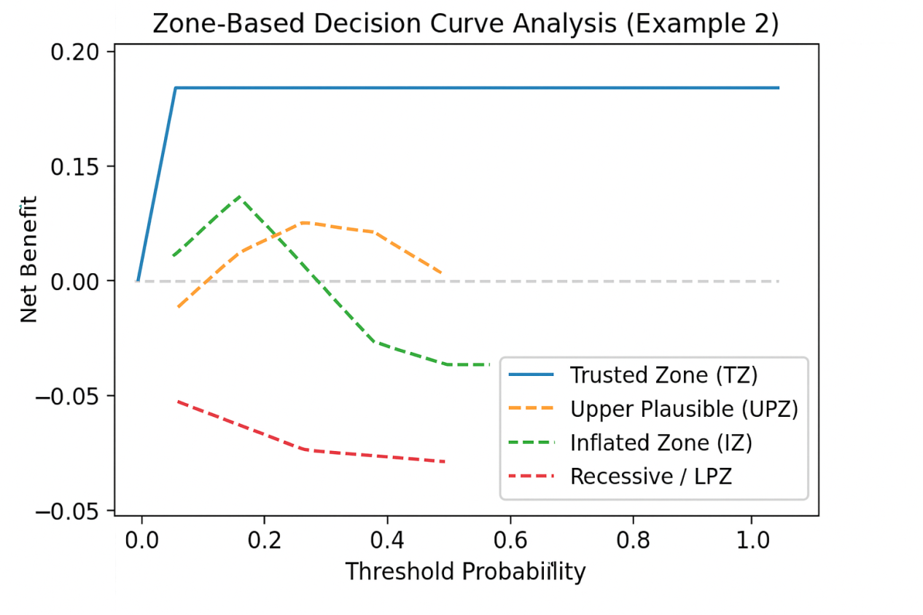
Appendix M( Fig. M). Zone-Based Decision Curve Analysis for example 2
The Trusted Zone (blue) shows stable, consistently high net benefit across the full range of threshold probabilities. Upper Plausible (orange) and Inflated (green) zones achieve early peaks before declining, while the Recessive/Lower Plausible (red) zones remain below zero net benefit, indicating minimal or negative clinical utility.

Appendix N: Zone-based calibration metrics for AFP in hepatocellular carcinoma diagnosis (Real-World Example).
Calibration was assessed using predicted probabilities (p_z), observed event rates, and zone-specific Brier scores. Lower Brier scores indicate better probabilistic accuracy. Higher AFP zones (Trusted, Upper Plausible, Inflated) demonstrated superior calibration, while lower zones (Recessive, Lower Plausible) showed poorer alignment between predicted and observed probabilities.
Zone | AFP Range (ng/mL) | n | Predicted Probability (pz) | Observed Rate | Brier Score
RZ | < 5 | 120 | 0.05 | 0.2917 | 0.2650
LPZ | 5–20 | 126 | 0.20 | 0.4762 | 0.3257
TZ | 20–200 | 106 | 0.60 | 0.7075 | 0.2185
UPZ | 200–1000 | 37 | 0.80 | 0.7568 | 0.1859
IZ | > 1000 | 12 | 0.95 | 0.8333 | 0.1525
Overall | — | 401 | — | — | 0.2611
Appendix O: Table O1. Zone-based calibration and clinical utility metrics for AFP in hepatocellular carcinoma diagnosis (Real-World Example).
Calibration was assessed using zone-specific Brier scores (Brier_z), with lower values indicating better probabilistic accuracy. Clinical utility was quantified using Net Benefit, Expected Cost, and Zone-Based Error (ZBE). Higher AFP strata (Trusted, Upper Plausible, and Inflated Zones) demonstrated superior calibration and greater Net Benefit, while lower strata (Recessive and Lower Plausible Zones) showed poorer calibration, minimal utility, and higher misclassification burden.
Zone | n | p_z | obs_rate | Brier_z | Net_Benefit | Expected_Cost | ZBE
RZ (<5) | 120 | 0.05 | 0.291667 | 0.265 | 0.114584 | 433.4998 | 1
LPZ (5-20) | 126 | 0.2 | 0.47619 | 0.325714 | 0.345237 | 336.6003 | 1
TZ (20-200) | 106 | 0.6 | 0.707547 | 0.218491 | 0.634434 | 158.1001 | 0.12
UPZ (200-1000) | 37 | 0.8 | 0.756757 | 0.185946 | 0.695946 | 45.89995 | 0.42
IZ (>1000) | 12 | 0.95 | 0.833333 | 0.1525 | 0.791666 | 10.20002 | 0.58
Appendix P: Zone-restricted ROC threshold performance metrics for the Upper Three Zones (U3Z) in AFP-based hepatocellular carcinoma diagnosis.
This table presents threshold-specific false positive rates (FPR), true positive rates (TPR), and false negative rates (FNR) for the U3Z framework, where fixed proxy diagnostic scores (0.60, 0.80, 0.95) were assigned according to clinically defined AFP zone membership without generating synthetic cases. Lower thresholds increase sensitivity (TPR) at the expense of specificity (1 − FPR), while higher thresholds maximize specificity but miss a greater proportion of true cases.
Threshold | FPR | TPR | FNR
> 0.95 | 0.000 | 0.000 | 1.000
> 0.80 | 0.043 | 0.093 | 0.907
> 0.60 | 0.143 | 0.907 | 0.093
≤ 0.60 | 1.000 | 1.000 | 0.000
Appendix Q. Comparative Zone-Restricted and Traditional Performance Metrics for AFP-Based HCC Classification
Zone-based and traditional performance evaluation of an AFP-based hepatocellular carcinoma (HCC) classifier. Metrics include AUC from ROC analysis, key Detection Error Tradeoff (DET) findings, Brier score calibration, and zone-specific clinical interpretation. The traditional ROC aggregates performance across the entire score range, while U3Z and L3Z restrict evaluation to high-certainty and ambiguous diagnostic ranges, respectively.
Zone Framework | AUC (ROC) | Key DET Finding | Calibration (Brier Score) | Clinical Interpretation
Traditional | 0.68 | Balanced error trade-offs across thresholds | 0.12 | Overestimates performance due to inclusion of trivially classifiable low-AFP cases
U3Z (Trusted + Upper Plausible + Inflated) | 0.57 | High FNR at >0.80 & >0.95 thresholds | 0.19 | Fragility in high-certainty ranges; risk of missed HCC despite high AFP
L3Z (Recessive + Lower Plausible + Trusted) | 0.66 | Stable error balance in ambiguous ranges | 0.11 | Better performance in low–mid AFP ranges; may aid early detection
Appendix R. Zone-Specific Utility Metrics for AFP-Based HCC Classification
Zone-level evaluation of an AFP-based hepatocellular carcinoma (HCC) classifier, incorporating clinical utility (Net Benefit), economic implications (Expected Cost), calibration accuracy (zone-specific Brier score, Brier_z), and diagnostic misclassification burden (Zone-Based Error, ZBE). Higher Net Benefit and lower Expected Cost in high-AFP zones (UPZ, IZ) contrast with poorer calibration and higher error rates in low-AFP zones (RZ, LPZ), highlighting variability in decision value across diagnostic certainty levels.
Zone | Net Benefit | Expected Cost | Brier_z | ZBE
RZ (<5) | 0.114584 | 433.4998 | 0.265 | 1
LPZ (5-20) | 0.345237 | 336.6003 | 0.325714 | 1
TZ (20-200) | 0.634434 | 158.1001 | 0.218491 | 0.12
UPZ (200-1000) | 0.695946 | 45.89995 | 0.185946 | 0.42
IZ (>1000) | 0.791666 | 10.20002 | 0.1525 | 0.58

