Table 1. Summary of the phenotypes and CNVs of patients in this study.
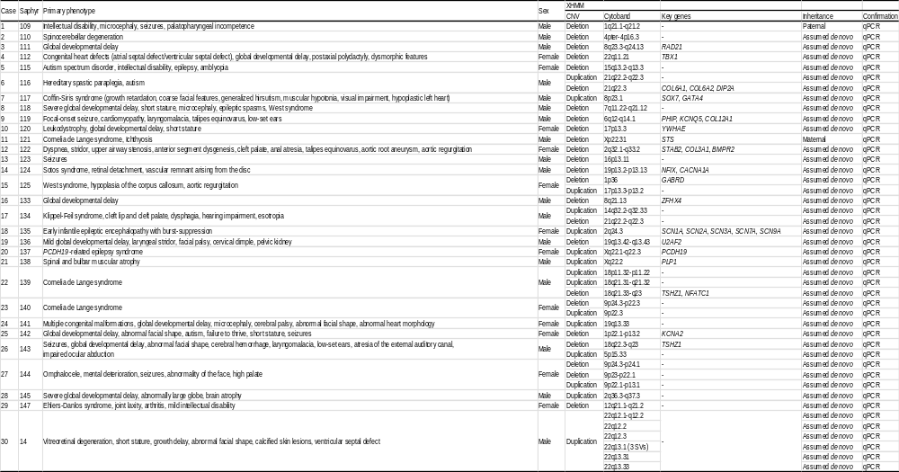
CNV, copy number variant; qPCR, quantitative polymerase chain reaction; SVs, structural variants; XHMM, whole exome sequencing data analyzed using the eXome Hidden Markov Model (XHMM).
Table 2. Overview of structural variants identified by OGM in this study
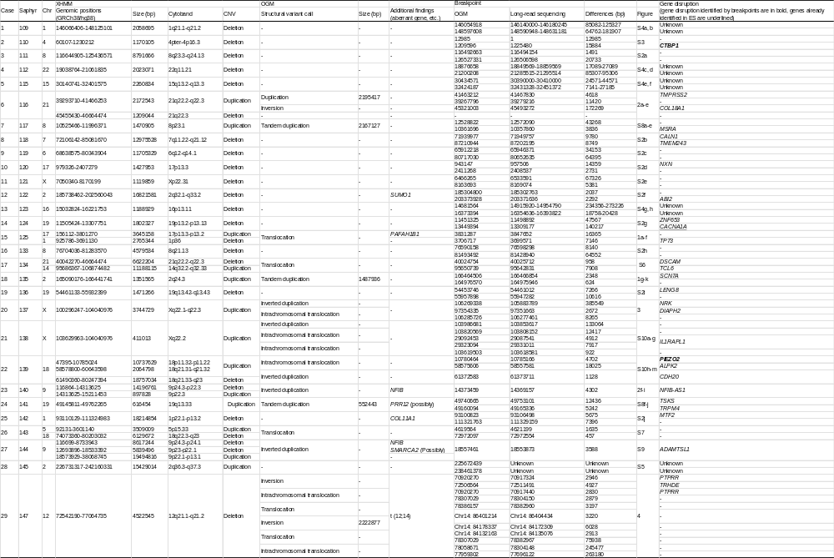
Chr, chromosome; CNV, copy number variant; ES, exome sequencing; OGM, optical genome mapping; XHMM, whole exome sequencing data analyzed using the eXome Hidden Markov Model (XHMM).
Table 3. Overview of chromothripsis in Case 30.
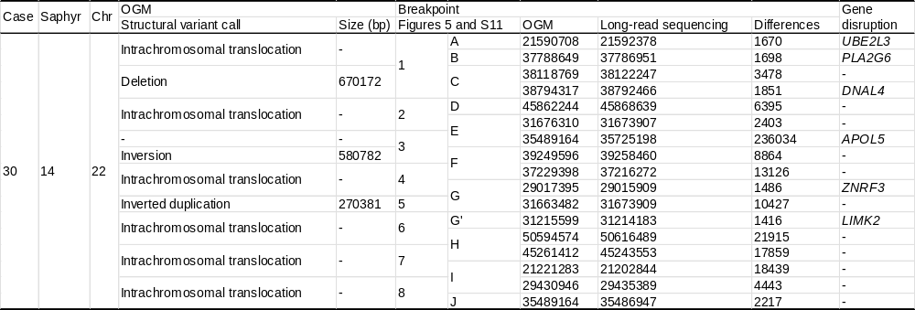
Chr, chromosome; OGM, optical genome mapping.

