Supplementary Table 1. Characteristics of the participants in our study

Study | FA Patients | Controls
N | 9 | 3
Female:Male | 6:3 | 2:1
Age (in years) - Mean  (range) | 42.79  (24 – 63) | 29.33  (25 - 56)
SARA -Mean  (range) | 12.35  (4 - 34) | 0  (0 - 0)
SCAFI -Mean  (range) | -0.68  (-1.69 - 0.16) | 0.95  (0.56 - 1.34)
8MW (in seconds) - Mean  (range) | 11.07  (5.5 - 26.9) | 6.55  (5.4 - 8.0)
9HPT – Dom. Hand (in seconds) – Mean  (range) | 53.72  (30.1 - 88.6) | 20.32  (17.8 - 22.8)
9HPT – Non-Dom. Hand (in seconds) – Mean  (range) | 65.68  (23.4 - 178.2) | 24.57  (22.6 – 27.9)
PATA Mean  (range) | 18.73  (14 - 25) | 28.30  (25 - 30)

Supplementary Table 2. Characteristics of the EFACTS study participants included in our study analysis

EFACTS data
SARA (n=425) - Mean  (range) | 22.5  (1.5 - 40)
SCAFI (n=302) -Mean  (range) | -0.20  (-1.94 to 1.85) )
8MW (in seconds) - Mean  (range) | 12.10  (3.5 - 127.5)
9HPT – Dom. Hand (in seconds) – Mean  (range) | 62.09  (11.6 - 263)
9HPT – Non-Dom. Hand (in seconds) – Mean  (range) | 69.13  (17.1 – 342)
PATA Mean  (range) | 18.99  (2.5 - 39)

Supplementary Figures

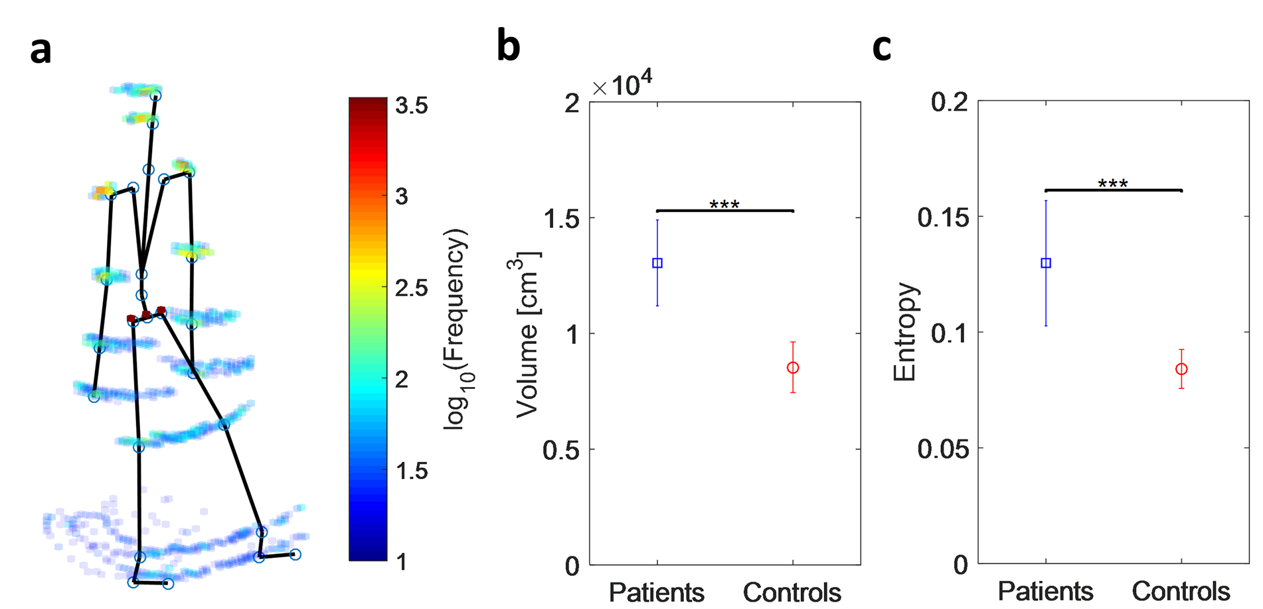
Supplementary Fig. 1 | a. The density plot generated using the 3D location of joints from a typical FA patient. The space is segmented in blocks of size 2 x 2 x 2cm. Note that the colour bar is in log10 scale. b. The workspace volume calculated using the density plot is significantly higher for FA Patients than Controls suggesting a more irregular movement with more compensatory mechanisms in place. c. The FA Patients’ entropy showing a significant increase with respect to Controls thus suggesting a more disordered and less predictable walking pattern. The error bars represent standard deviation (SD).

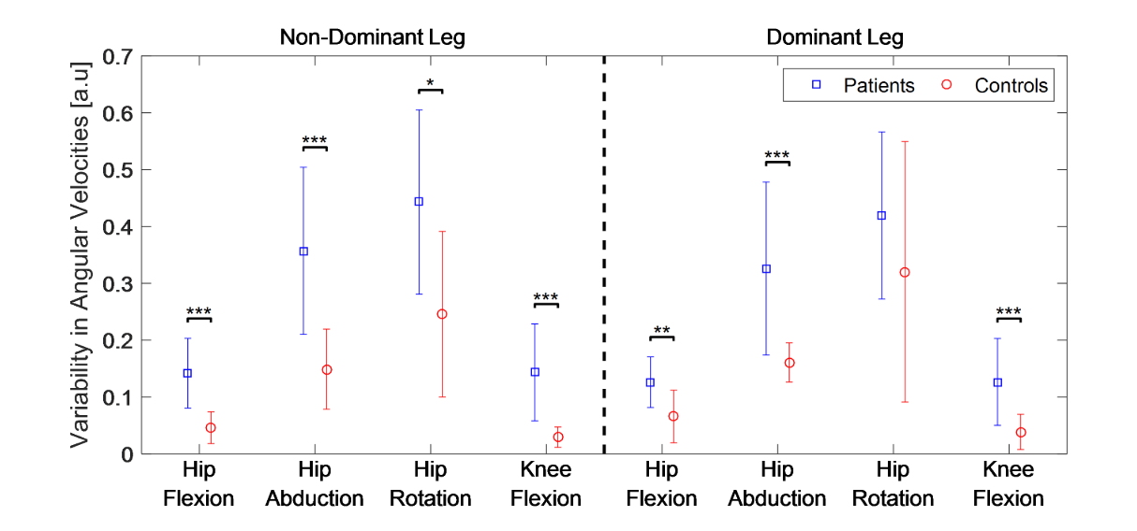
Supplementary Fig. 2 | The average variability in the joint velocities during the 8MW showing a statistical difference between FA Patients and Controls (Kruskal-Wallis one-way ANOVA). The error bars represent standard deviation.

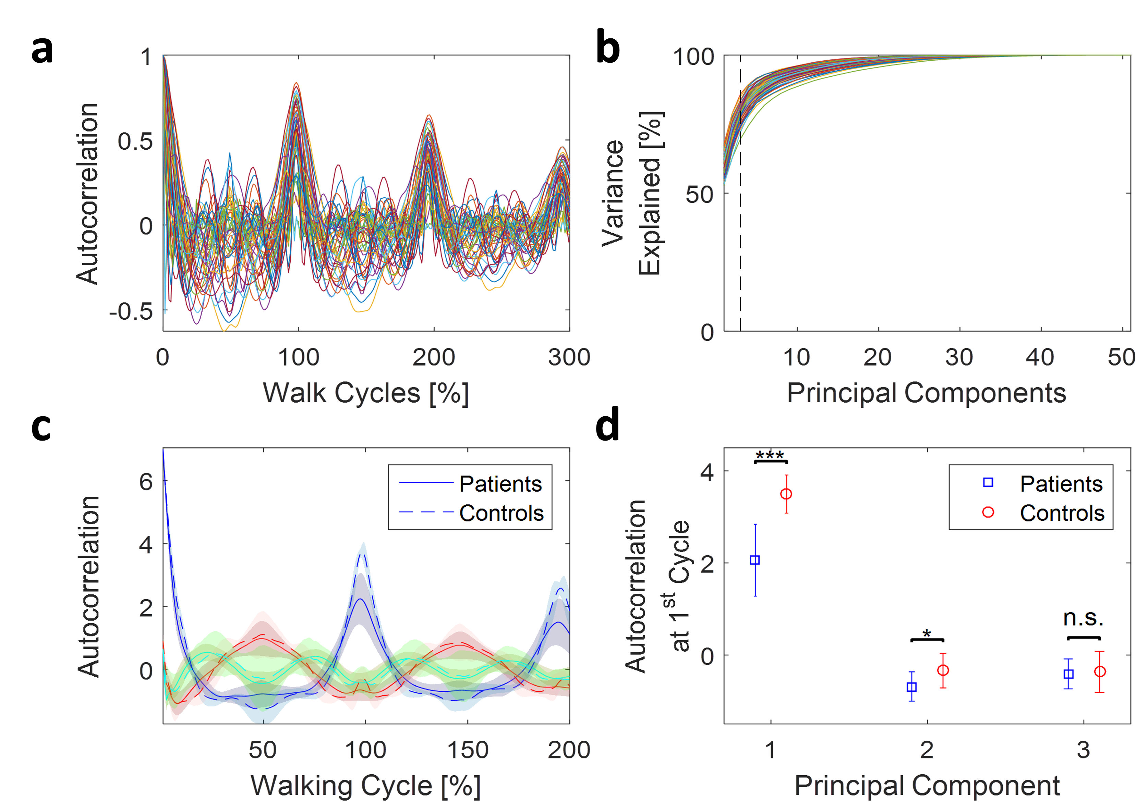
Supplementary Fig. 3 | a. The autocorrelation of a typical FA patient performing the 8MW task calculated from the suits’ 51 DoF for up to a lag of 3 walk cycles. b. The variability explained when applying a PCA analysis on the autocorrelation signals showing that the first three Principal Components (PCs) can explain more than 80% of the variability in data. c. The first three PCs of the autocorrelation signal (1st - blue, 2nd - red, 3rd - green) for FA Patients (solid lines) and Controls (dashed lines). d. A comparison of the value of the autocorrelation PCs after the 1st walk cycle, showing a significant difference between FA Patients and Controls for the 1st (p ≤ 0.001) and 2nd (p ≤ 0.05) PCs but not the 3rd (p = 0.93, Kruskal-Wallis one-way ANOVA). The error bars represent standard deviation.

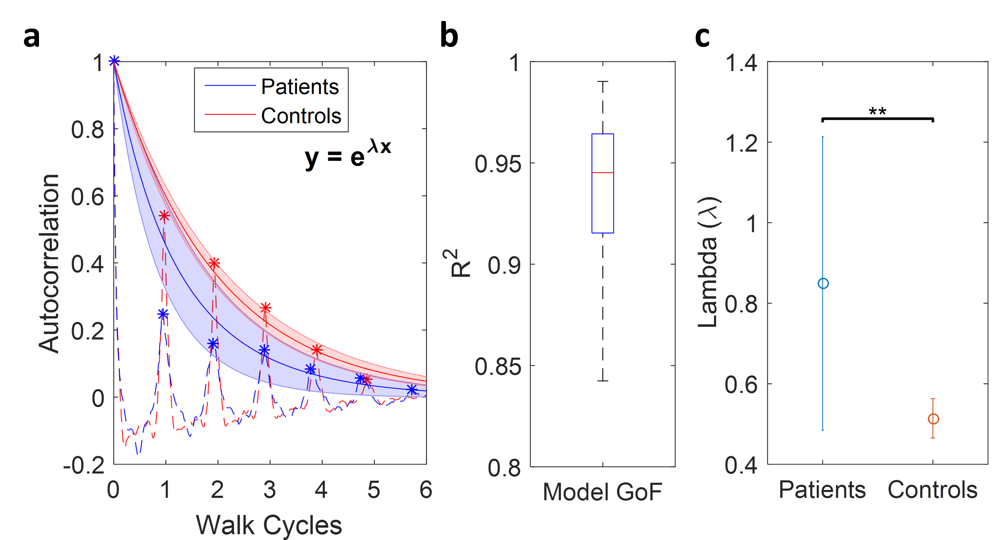

Supplementary Fig. 4 | a. The 1st PCs of the autocorrelation signals of a typical FA Patient and Control subject (dashed lines). The PCs have been re-sampled so the subjects’ walk cycles are aligned. The peaks observed at each walk cycle (∗) have been fitted with an exponential curve (y = e^{−λx}) and the two shade plots show the averaged fitted curve for FA Patients and Controls respectively. The shaded area represents the standard deviation (SD). b. The exponential fit has been found to provide the best Goodness of Fit (average GoF = 0.94). c. The decay value (λ) of the exponential fit has been calculated for all subjects. This shows that FA Patients have a statistically higher λ, meaning that their autocorrelation is decaying faster than the Controls. The error bars represent standard deviation.

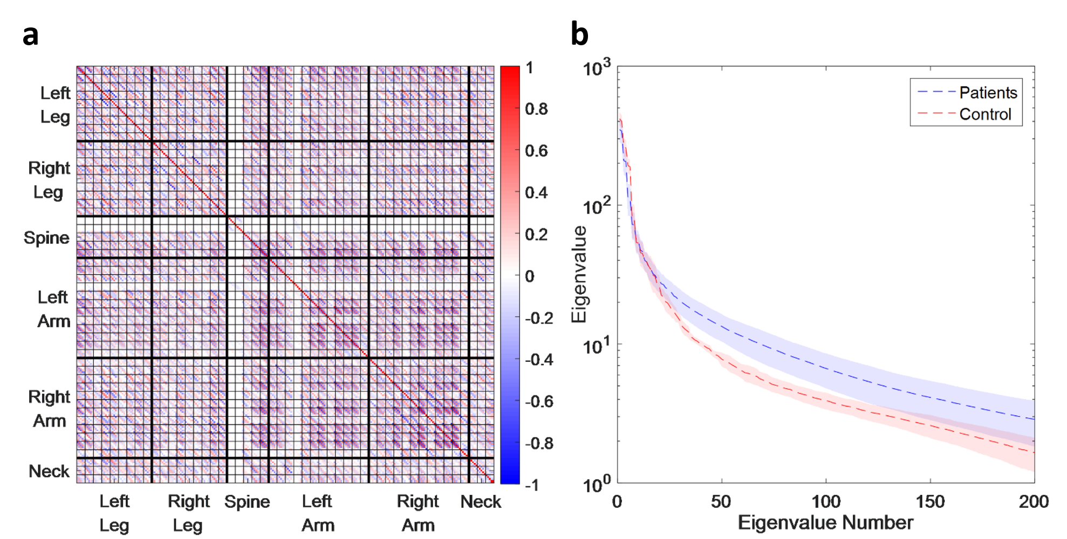
Supplementary Fig. 5 | a. The channel delay cross-correlation matrix for a typical FA patient. It is a 51 x 51 block matrix where the blocks along diagonal contain the joint angular velocity within- channel correlations and off-diagonal blocks contain the correlations across different joints. Within each block, the correlations are calculated for 10 different lags (linearly spaced from zero up to the subject’s average walk cycle). b. The average eigen spectrum for FA Patients and Controls showing a decreased power in the patients’ lower eigenvalues that reflects the increased dynamical complexity in their walk. The shade along line represents the standard deviation.

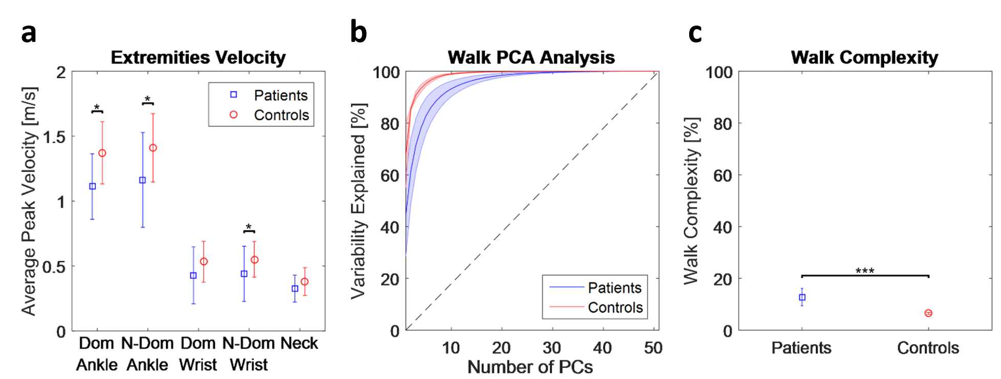
Supplementary Fig. 6 | a. The averaged peak velocity of subjects’ extremities during the 8MW task showing a statistical difference between FA Patients and Controls on the D & ND ankles and also on the ND wrist (Kruskal-Wallis one-way ANOVA). b. The variability explained by combining a different number of PCs based on a PCA analysis of the subjects’ angular velocities. The blue and red lines represent the result obtained for the FA Patients and Controls respectively while the shade along the lines represents the standard deviation (SD). c. Our human movement complexity metric applied to all subjects showing a statistically higher walk complexity in the FA Patients than Controls (Kruskal-Wallis one-way ANOVA). The error bars in plots A&C represent standard deviation.
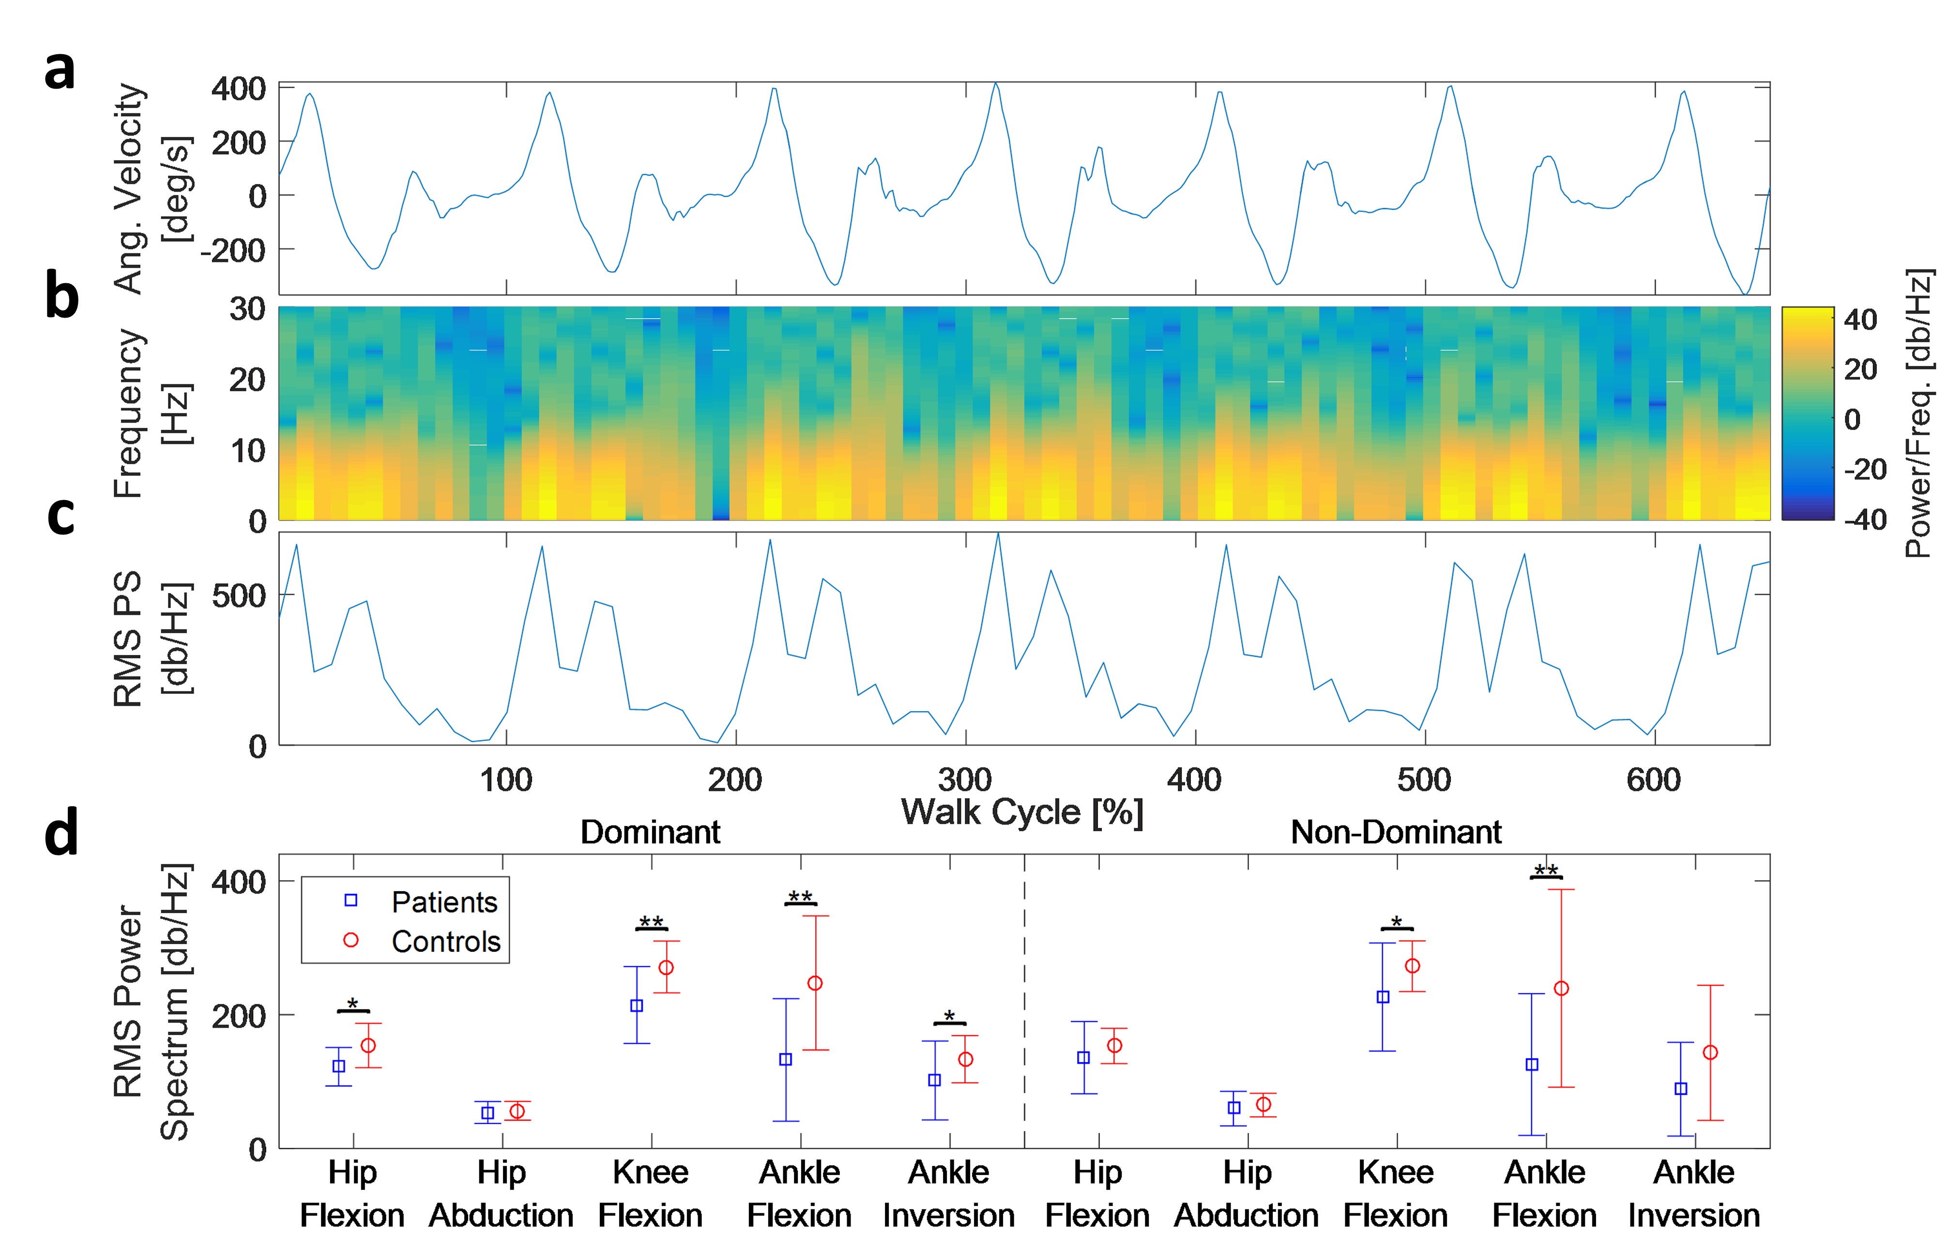
Supplementary Fig. 7 | a. The angular velocity from the knee joint of a typical FA patient performing the 8MW task. b. The Short-Time Fourier Transform (STFT) of the joint velocities on a 200 ms window with 100 ms overlap. c. The RMS of the power spectrum coefficients on each window which summarises the information of the power spectrum. d. A comparison between the average energy per walk cycle of FA Patients and Controls per individual joint, showing a statistically higher energy on the D hip & knee flexion and the ND knee flexion of Controls (Kruskal-Wallis one-way ANOVA). The error bars represent standard deviation.

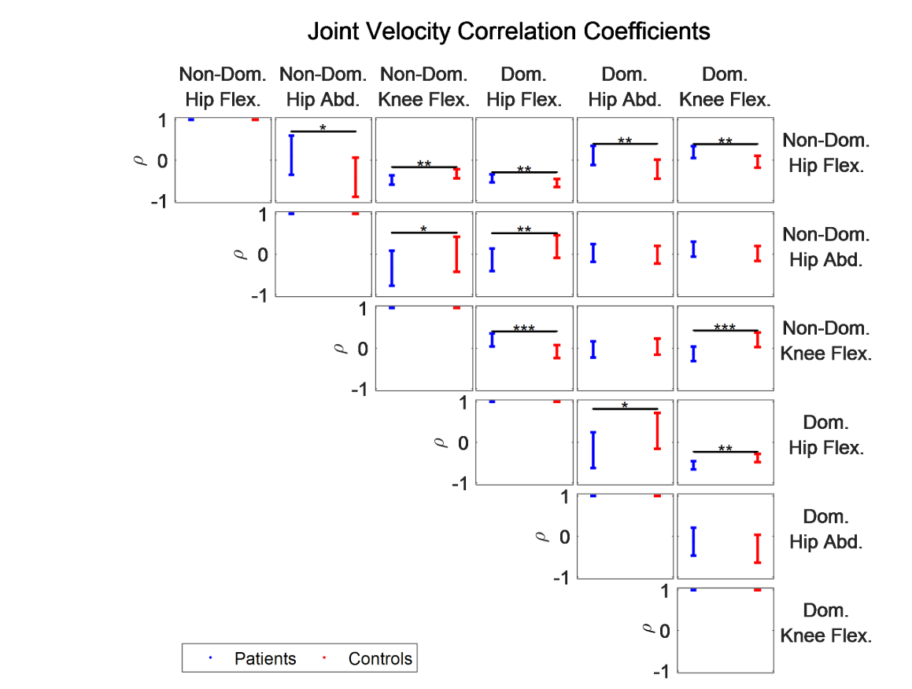
Supplementary Fig. 8 | The Pearson’s product-moment correlation coefficients (ρ) between different lower- body joints separated by leg dominance with most showing a statistical difference between FA Patients and Controls (Kruskal-Wallis one-way ANOVA). The error bars represent standard deviation.

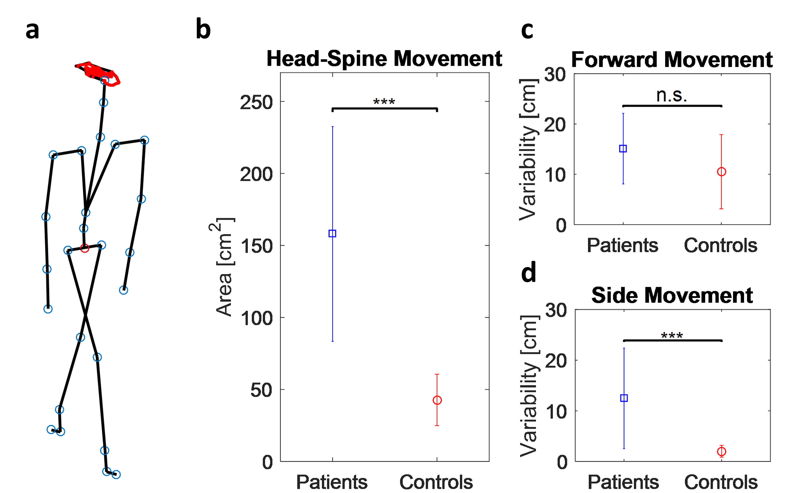
Supplementary Fig. 9 | a. The head movement trajectory from a typical FA patient (red line) with respect to a fixed hip during the 8MW task. b. The FA Patients’ head movements exhibit a statistically higher area than the Controls. c-d. Observing the head movements on the frontal and sideways plane independently shows that there is a statistical difference between FA Patients and Controls only when the variability of sideways movements is considered. The error bars in all plots represent standard deviation.

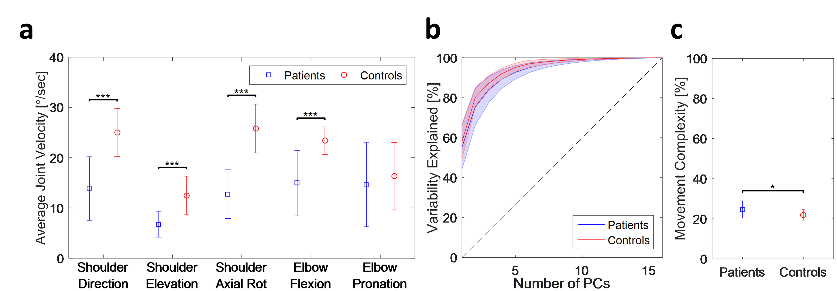
Supplementary Fig. 10 | a. The average joint velocity of FA Patients and Controls during the 9HPT. The patients exhibit significantly slower velocities in all joints except the elbow pronation. b. A PCA analysis of the angular velocities of the upper body showing the variability explained by having a different number of PCs. FA Patients require slightly more PCs to explain the variability in their movements than the Controls. c. Our complexity metric showing an increased complexity in the FA Patients during the 9HPT. All error bars and shades express the standard deviation of each population group.

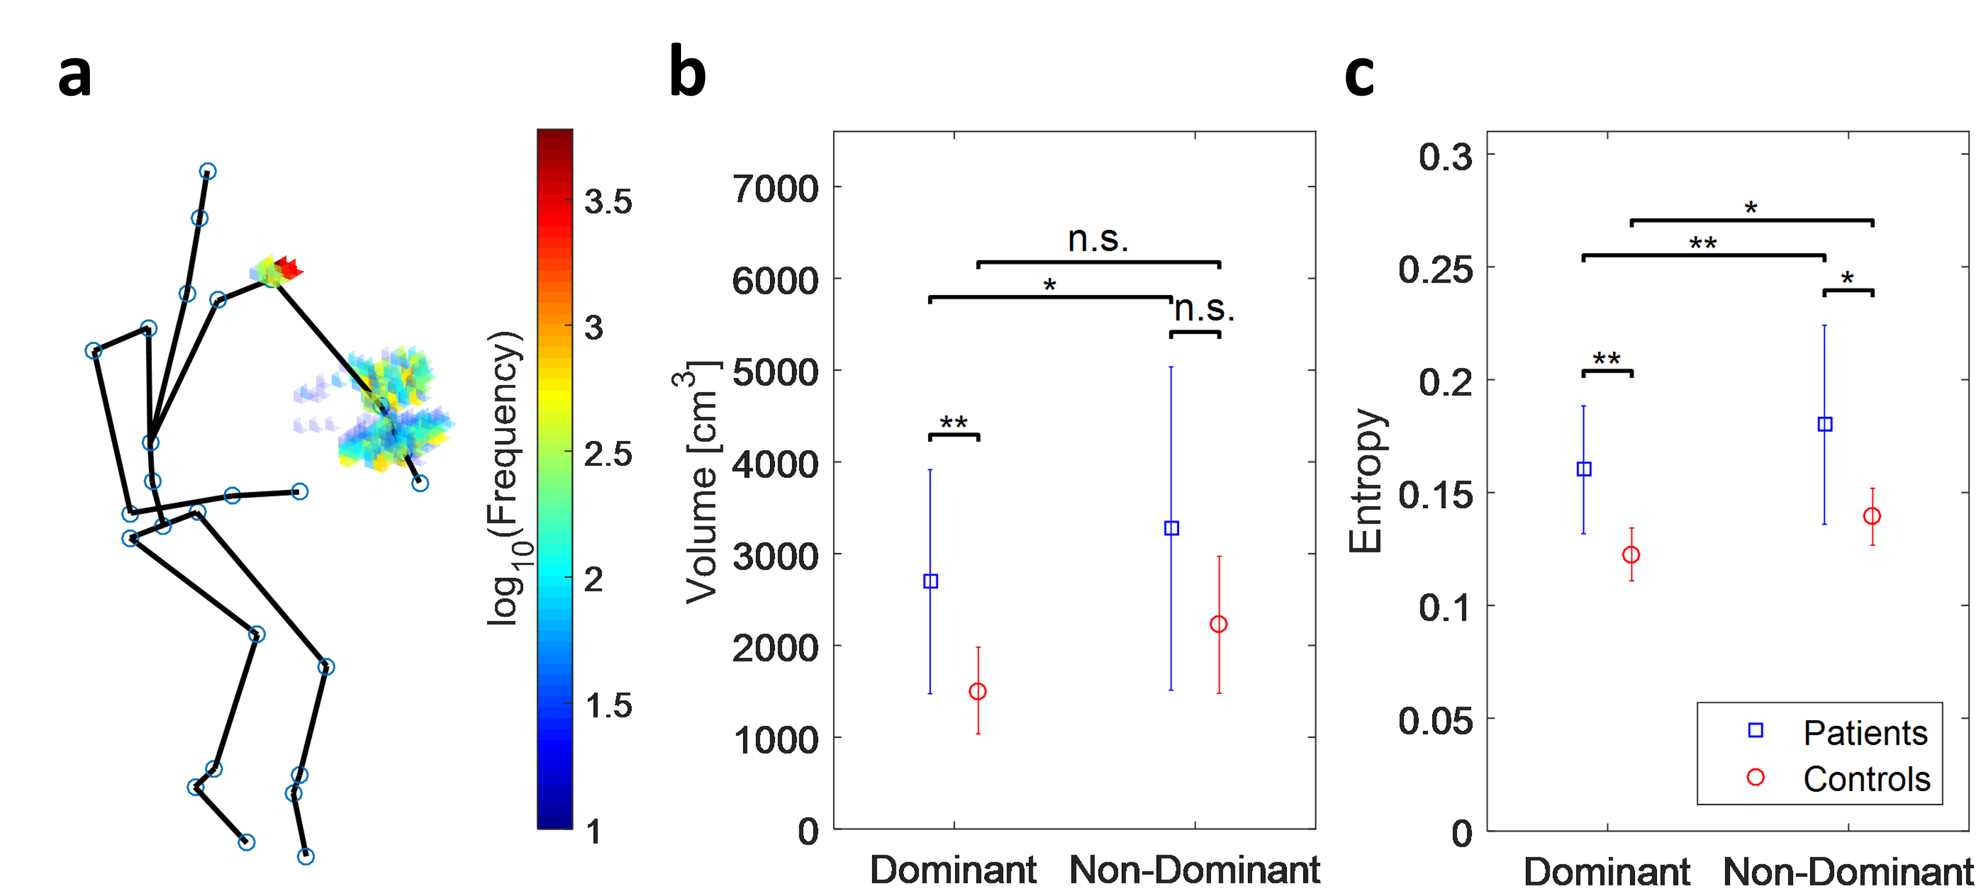

Supplementary Fig. 11 | a. A density plot generated using the kinematics of a typical FA patient during the 9HPT. The space was separated in 2x2x2cm blocks and the colour of each block represents the time any joint (blue circles) spent in that area. Note that the colour bar is on log10 scale. b. The workspace volume generated from the subjects’ density plot comparing the performance of FA Patients and Controls when performing the task with either hand. The plot shows a statistical difference between the two hands of FA Patients as well as a significant difference between the workspace volume generated by the FA Patients’ and Controls’ dominant hand. c. The entropy of subjects’ density plots as a measure of their disorder showing that FA Patients have a lot more disorder than Controls across both hands. The error bars in plots B & C represent standard deviation.

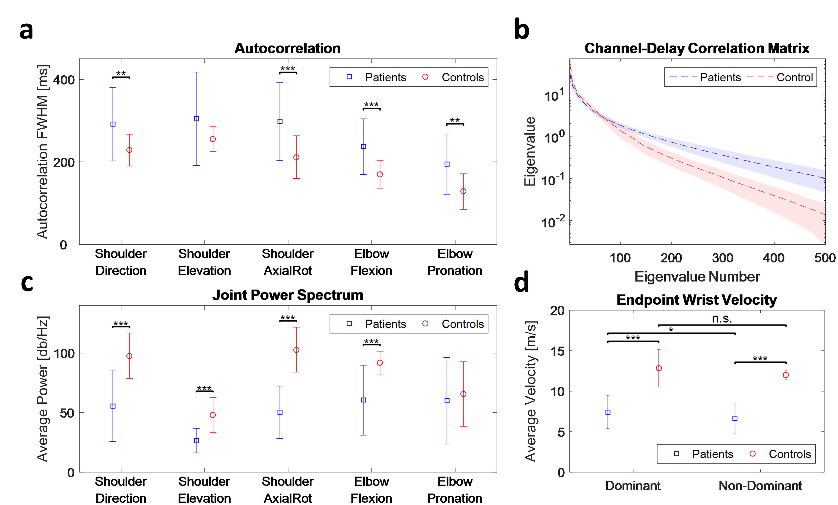

Supplementary Fig. 12 | a. The autocorrelation full-width at half-maximum (FWHM) of the subjects upper body joints showing a significantly slower drop for the FA Patients than the Controls in most joints’ dimensions. b. The averaged eigen spectrum based on the subjects’ channel delay cross-correlation matrices, showing that FA Patients have a decreased power in the left end and increased power in the right end. This implies that they have an increased complexity in their movements with respect to the Controls. c. A comparison on the average energy of the upper body joints between FA Patients and Controls, showing a statistically lower energy in all FA Patient joints except the elbow pronation. d. The subjects’ average wrist speed during the 9HPT task showing a statistical difference between FA Patients and Controls but also a difference between the D and ND hand of FA Patients. The error bars and shades shown in all plots represent standard deviation.

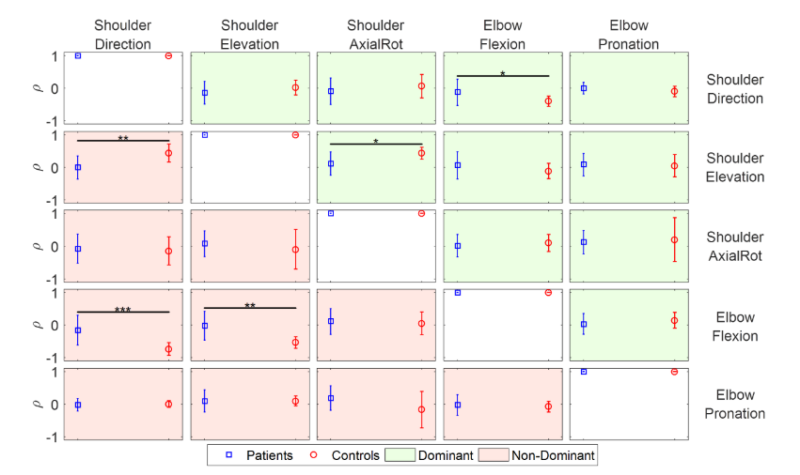
Supplementary Fig. 13 | The Pearson’s product-moment correlation coefficients (ρ) between the shoulder and elbow joints for subjects’ Dominant (green) and Non-Dominant (orange) hand. The plots reveal a significant reduction in the correlations of Elbow Flexion vs Shoulder Direction and Shoulder Axial Rotation vs Shoulder Elevation in the FA Patients’ dominant arm than the Controls and also a reduction in the correlations of Shoulder Direction vs Shoulder Elevation, Shoulder Direction vs Elbow Flexion and Shoulder Elevation vs Elbow Flexion in the FA Patients’ non-dominant hand. The error bars represent standard deviation.

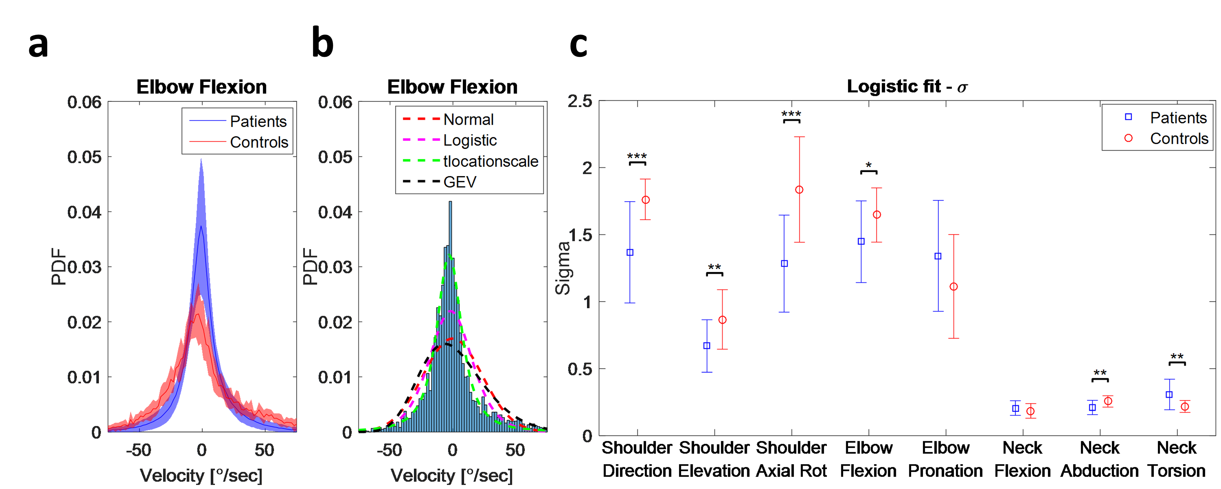

Supplementary Fig. 14 | a. A comparison between the probability density functions (PDF) of angular velocities for a typical joint (elbow flexion) showing a much wider spread in Controls than the FA Patients. This effect has been consistently observed across all upper body joints. The shaded area around the lines represents the standard deviation in each population group. b. We fitted various parametric probability distributions on the joints’ angular velocities, and we found that a logistic distribution can provide the best fit in the data. c. A comparison between the variability (σ) of the logistic fit between the FA Patients and Controls after applying it on all upper body joints independently. The results reveal a much larger σ in some of the Controls’ joints meaning that they used a much wider range of velocities during the 9HPT than the FA Patients. The error bars represent standard deviation.

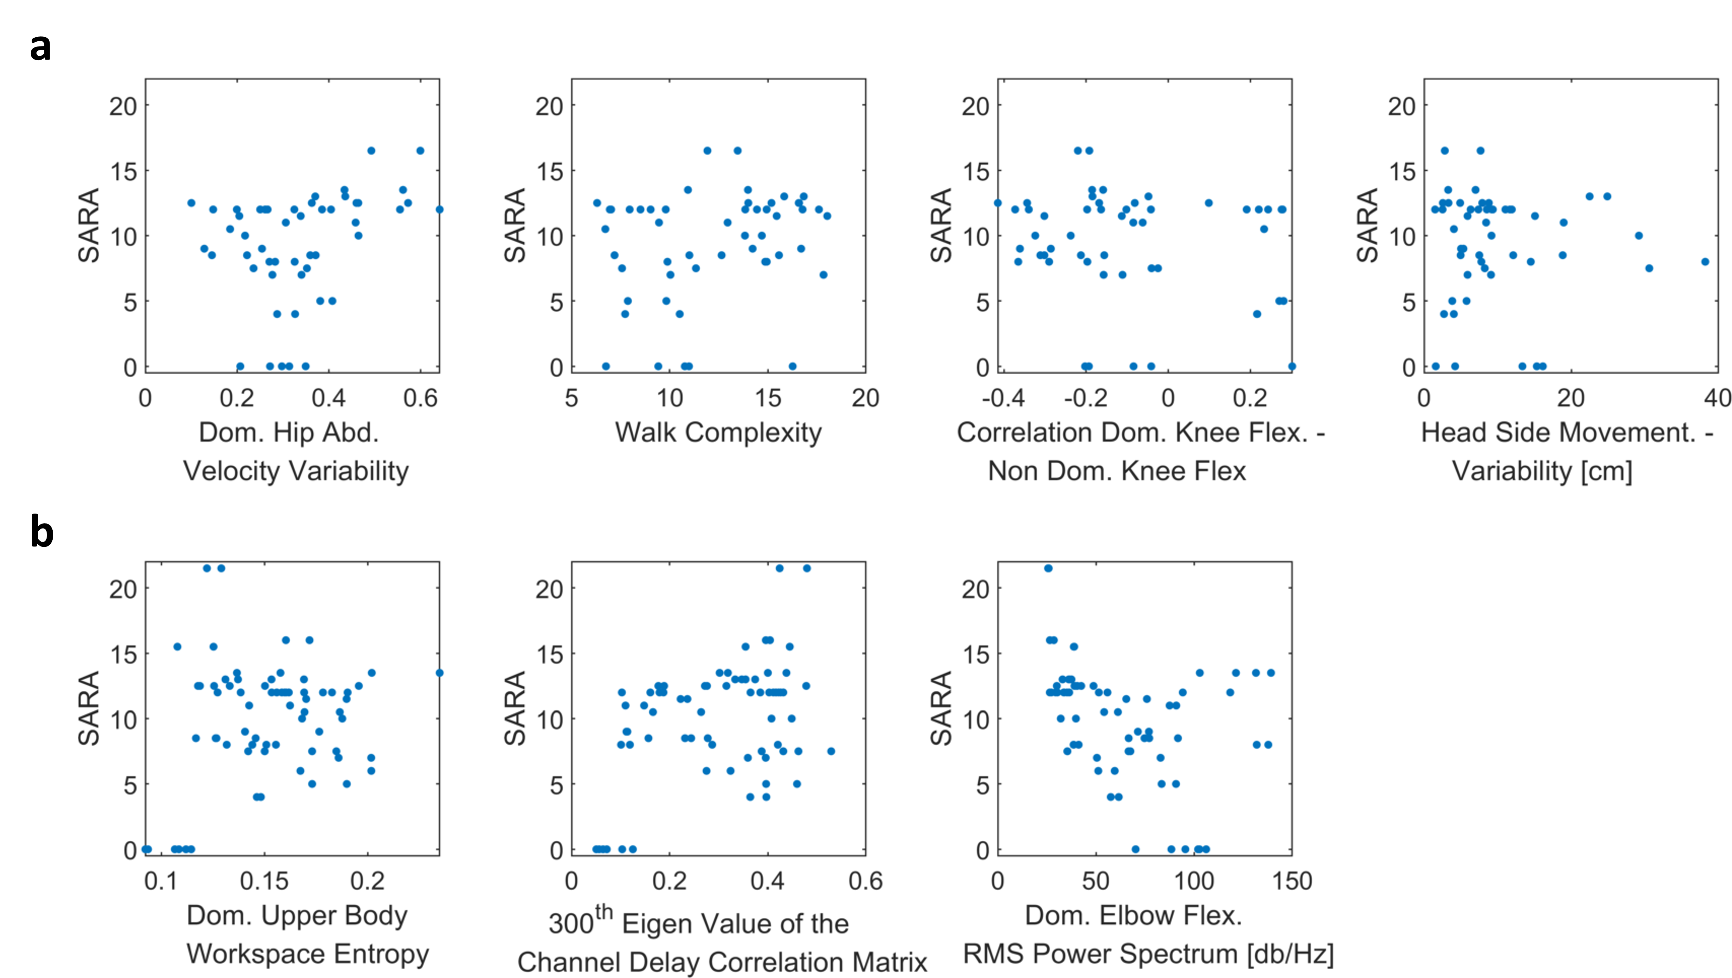
Supplementary Fig. 15 | Suit features selected by feature selection algorithm for cross sectional predictions of SARA. Scatter plot of the selected suit features of 8MW (a) and 9HPT (b) against SARA.

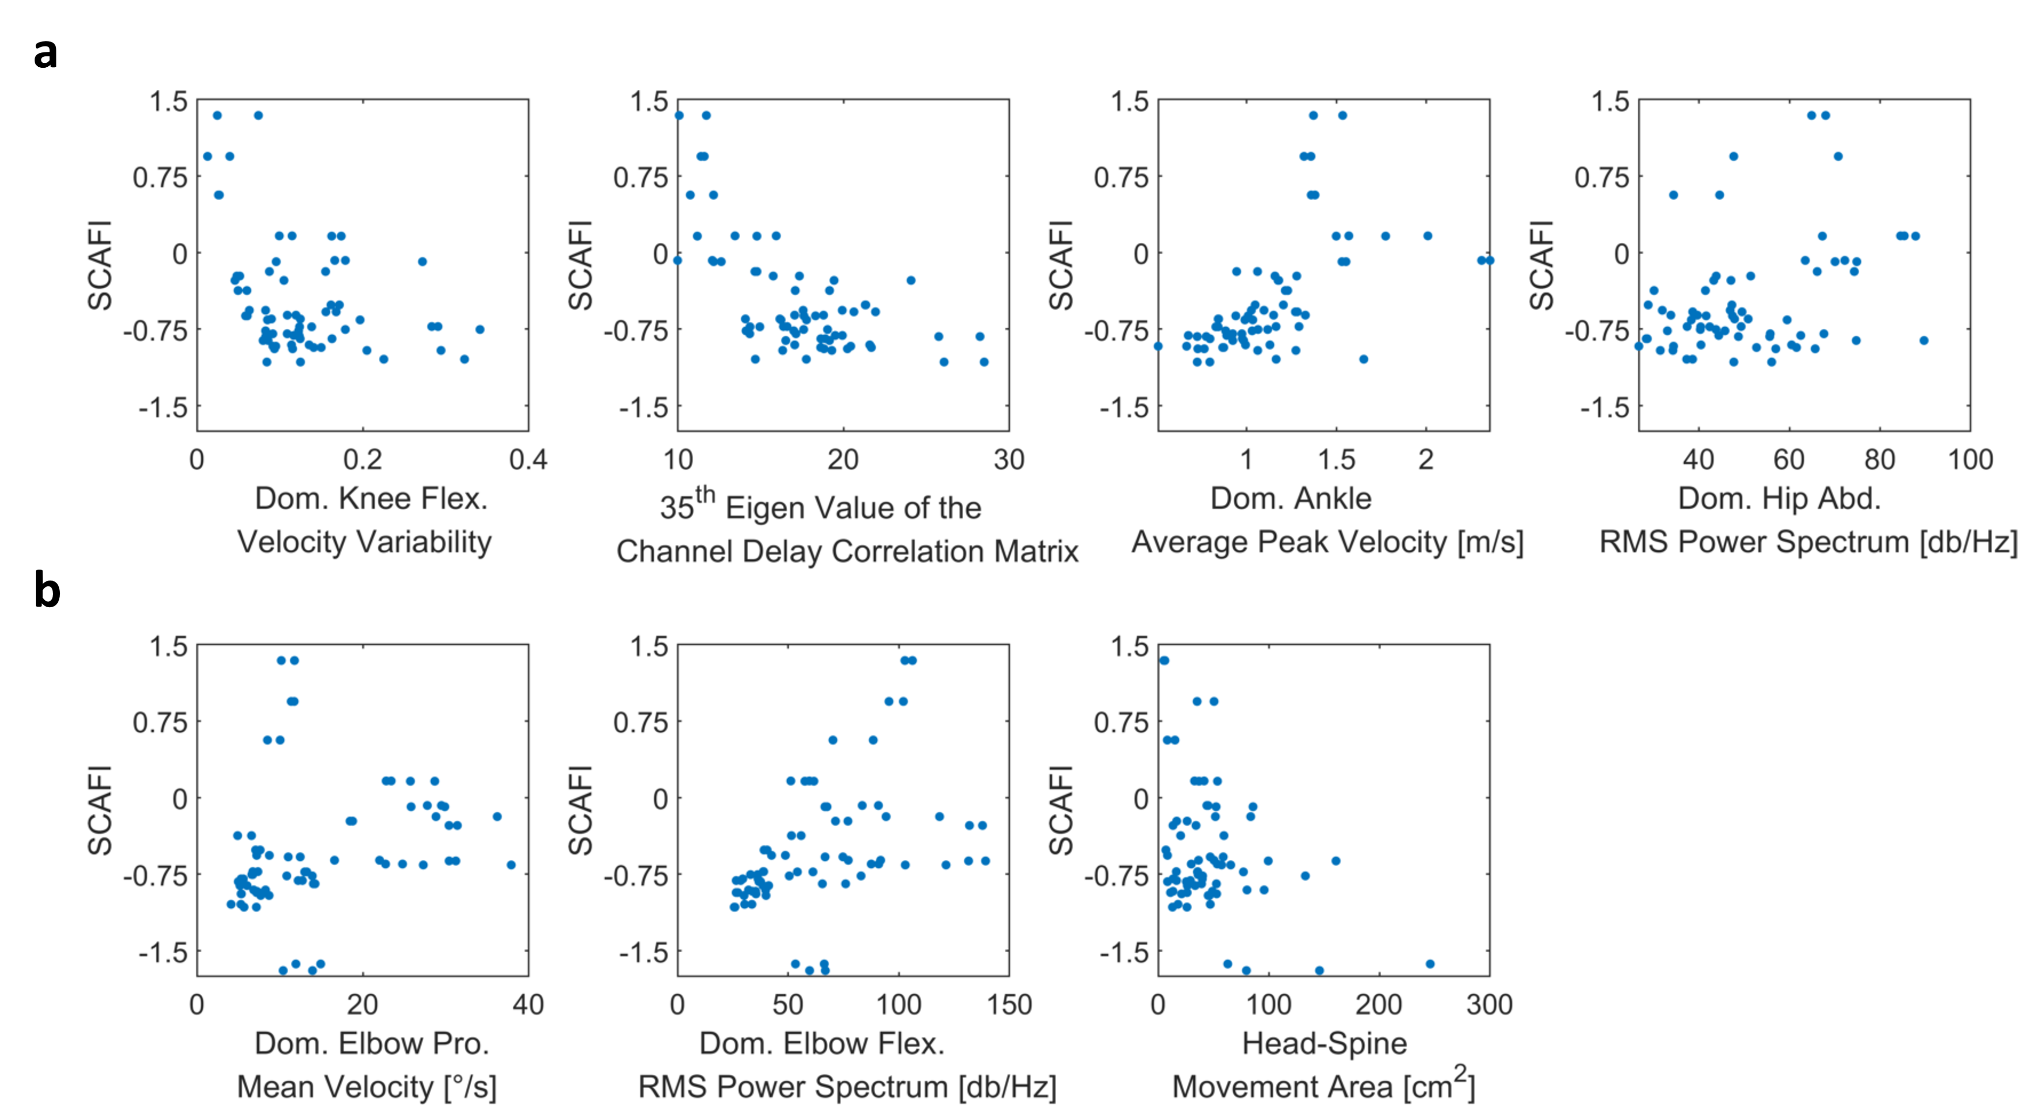
Supplementary Fig. 16 | Suit features selected by feature selection algorithm for cross sectional predictions of SCAFI. Scatter plot of the selected suit features of 8MW (a) and 9HPT (b) against SCAFI.

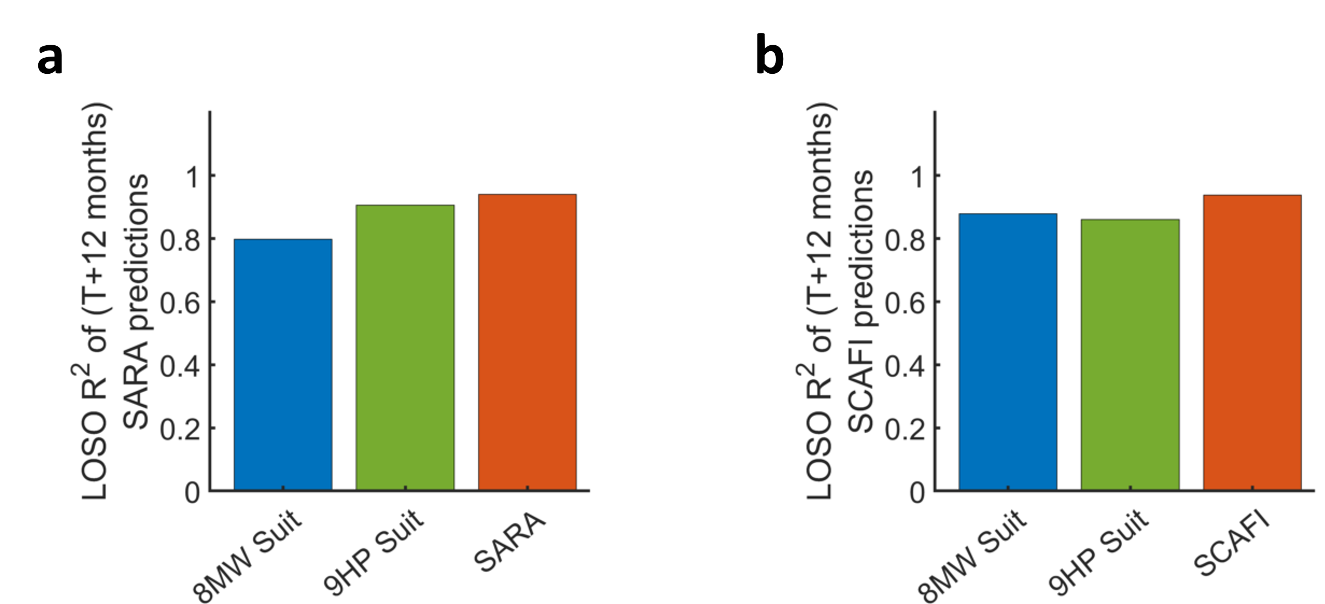
Supplementary Fig. 17 | Longitudinal predictions of the clinical scales a.
Comparison of the aggregate R² of the leave-one-subject-out cross-validated predictions of the SARA at T+ 9 months by the suit features of 8MW and 9HPT tasks from visit T of our study and SARA at T+ 12 months predicted using SARA at visit T from EFACTS study. b is the corresponding plot for the longitudinal predictions of SCAFI.

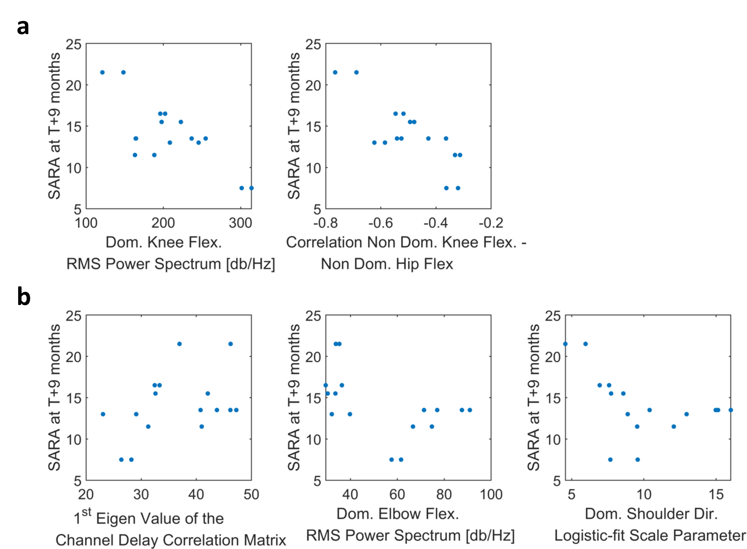
Supplementary Fig. 18 | Fingerprints selected by feature selection algorithm for longitudinal predictions of SARA. Scatter plot of the selected suit features of 8MW (a) and 9HPT (b) at time T against SARA at visit T+9 months.

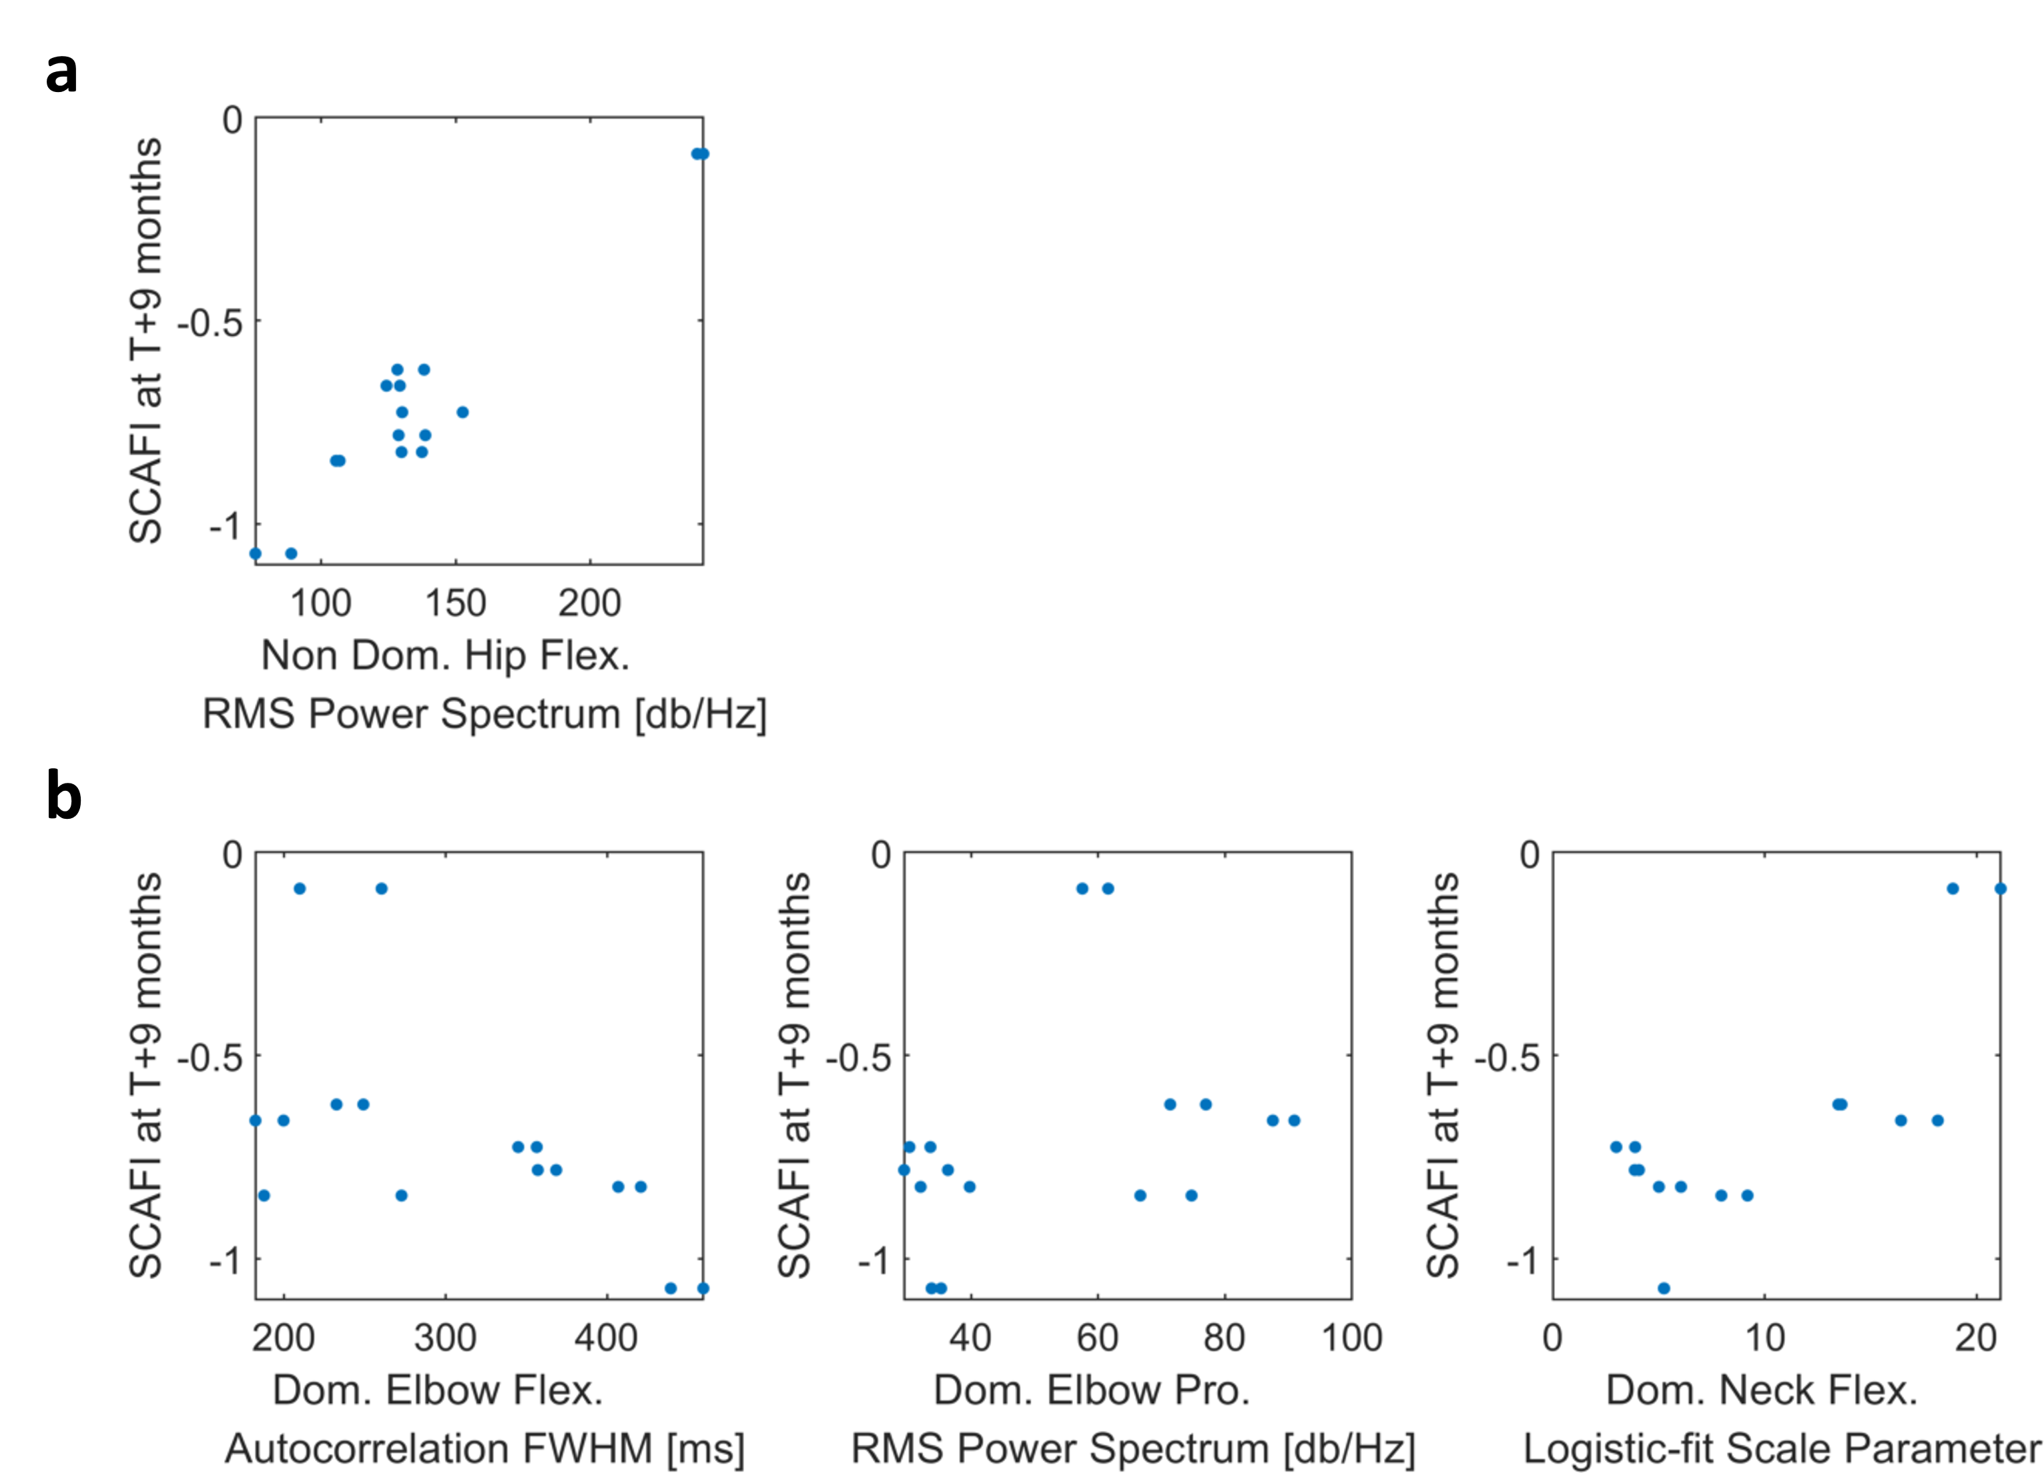
Supplementary Fig. 19 | Fingerprints selected by feature selection algorithm for longitudinal predictions of SCAFI. Scatter plot of the selected suit features of 8MW (a) and 9HPT (b) at time T against SCAFI at visit T+9 months.

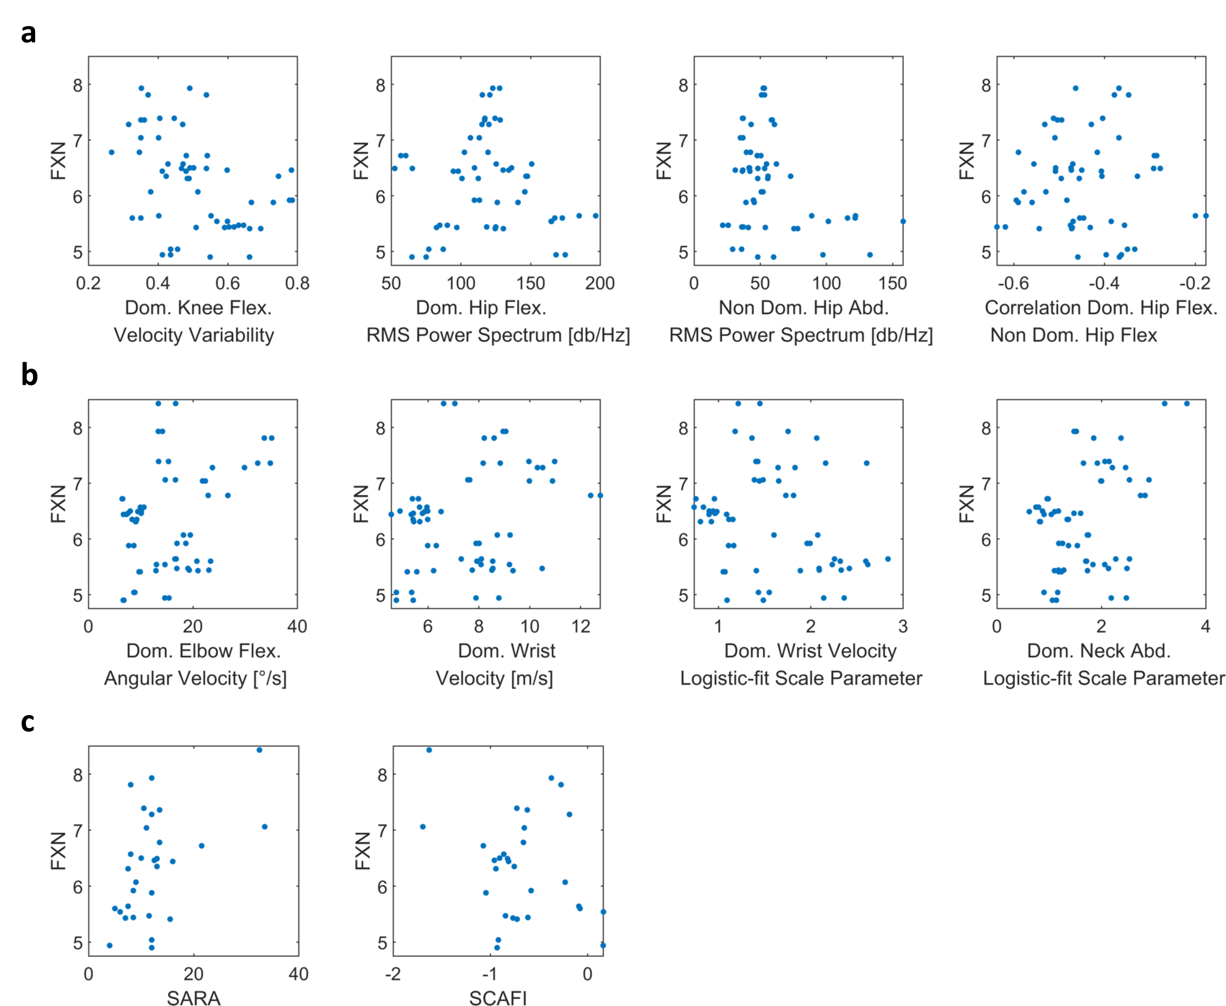
Supplementary Fig. 20 | Suit features selected by feature selection algorithm for predictions of FXN. Scatter plot of the selected suit features of 8MW (a) and 9HPT (b) against FXN. (c) Scatter plot of the FXN against SARA and SCAFI. FXN mRNA was measured by Q-RTPCR and the CT values normalised to TBP are plotted.

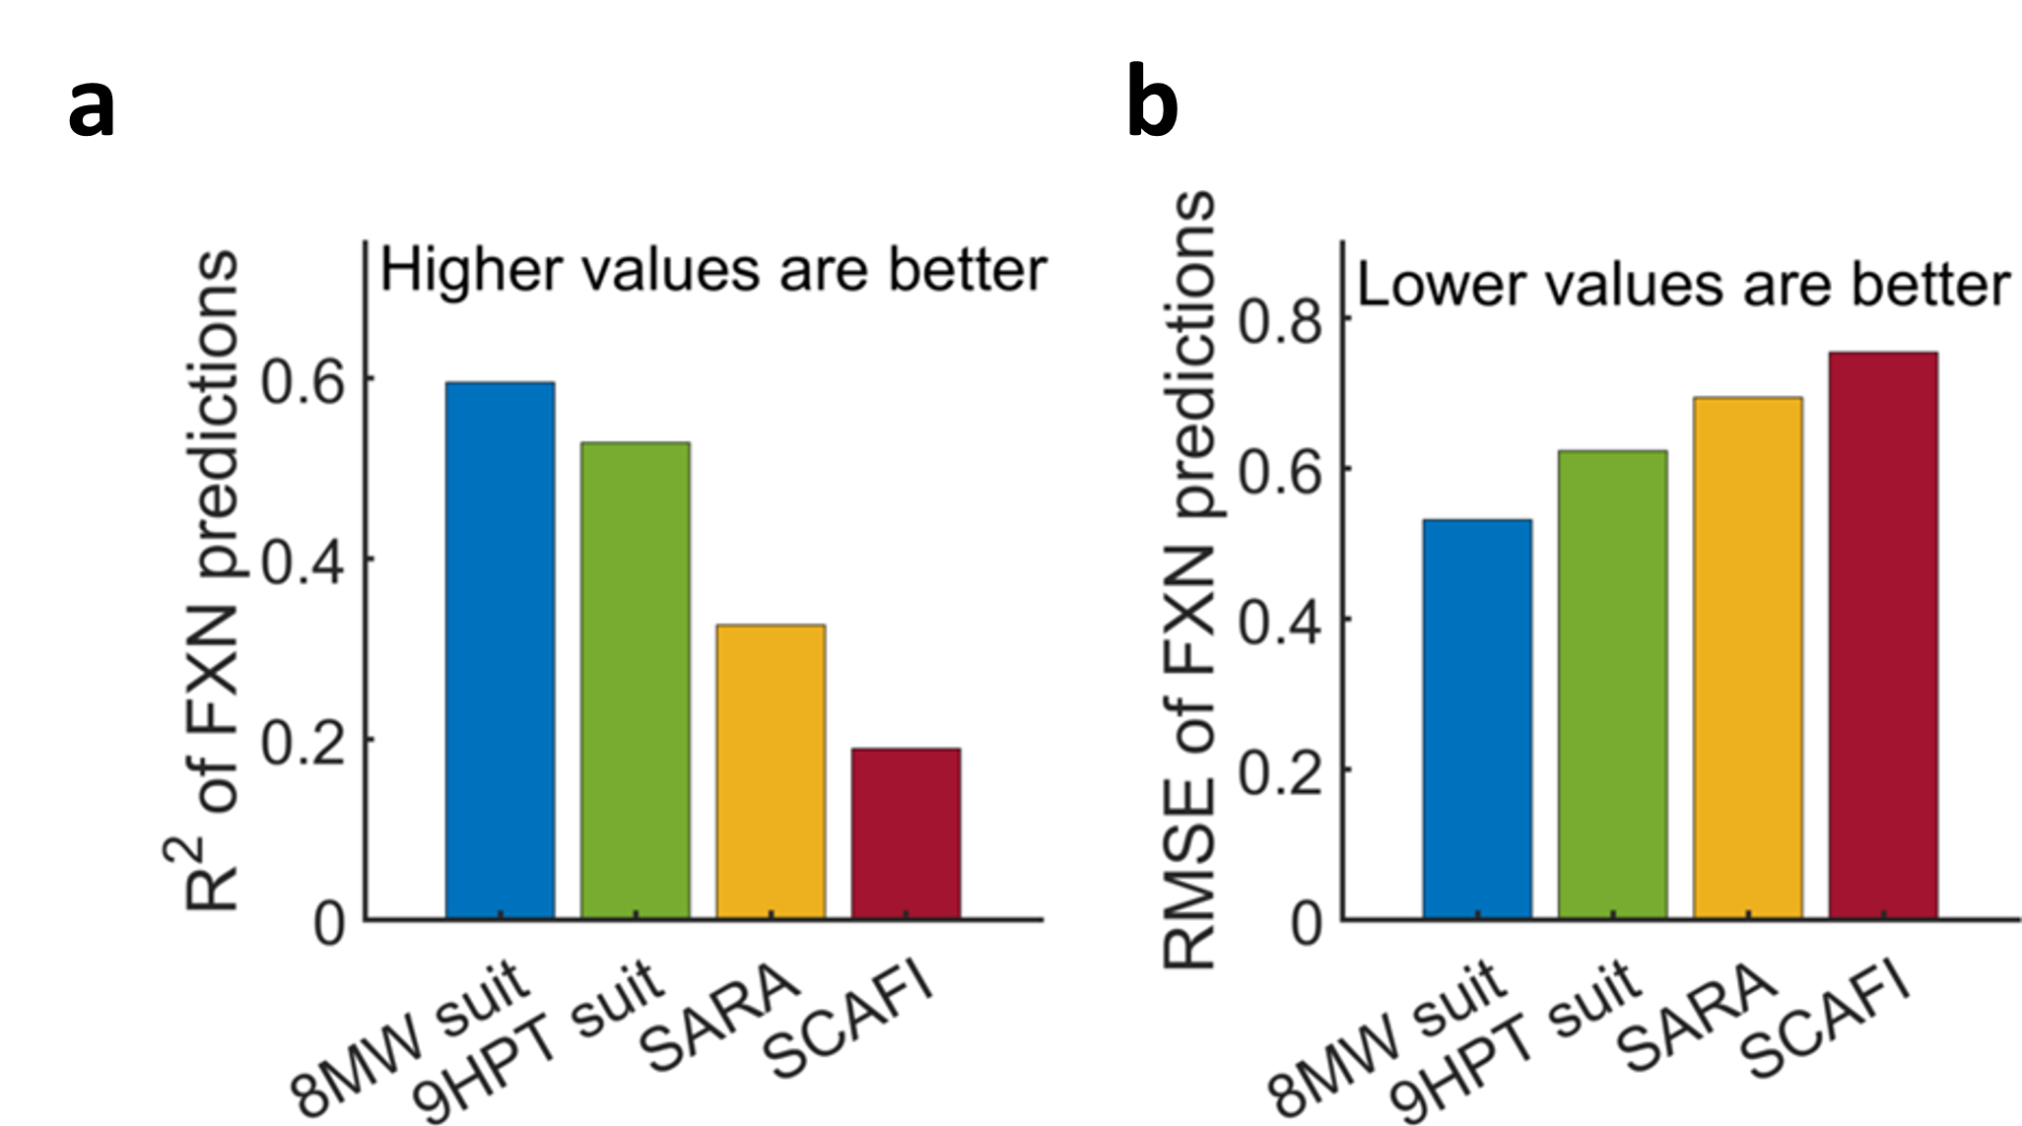

Supplementary Fig. 21 | Cross sectional predictions of FXN gene expression: FXN mRNA levels were predicted using the following 4 sets of predictors: suit features from the 8MW task, suit features from the 9HPT task, individual components of SARA score and individual Z score components of SCAFI scores. a & b. Leave-one-subject-out cross-validated R² and RMSE of the predictions by the 4 set of predictors. GP regression models using the features of the suit data of 8MW and 9HPT tasks as predictors perform better vis-a-vis GP regression models using the individual components of the SARA and SCAFI scales as predictors.

