Supporting Information
Title: The Coordination Restraint of Rh-Cu Di-Atomic Catalyst and Oxygen Insertion into C-H Bond for the Synthesis of Methanol

Yanling Gao^{1,#}, Haobo Zhao^{1,2,#}, Wang Yi¹, Nianbing Li^{1,}*, Jingyu Ran^{2,}*, Haojie Geng^{1,}*

- School of Chemistry and Chemical Engineering, Chongqing Key Laboratory of Soft-Matter Material Chemistry and Function Manufacturing, Southwest University, Chongqing 400715, China
- School of Energy and Power Engineering, Key Laboratory of Low-grade Energy Utilization Technologies and Systems, Ministry of Education, Chongqing University, Chongqing 400044, China

Contents
S1.1 Material Synthesis 4
S1.2 Kinetic Analysis Methodology 5
S1.3 Characterizations 5
S1.4 DFT calculation 7
Figure S1 10
Figure S2 11
Figure S3 12
Figure S4 13
Figure S5 14
Figure S6 15
Figure S7 16
Figure S8 17
Figure S9 18
Figure S10 19
Figure S11 20
Figure S12 21
Figure S13 23
Figure S14 24
Figure S15 25
Figure S16 26
Figure S17 27
Figure S18 28
Figure S19 29
Figure S20 30
Figure S21 31
Figure S22 32
Figure S23 33
Figure S24 34
Figure S25 35
Figure S26 36
Figure S27 37
Figure S28 38
Figure S29 39
Figure S30 40
Figure S31 41
Figure S32 42
Figure S33 43
Figure S34 44
Figure S35 45
Figure S36 46
Figure S37 47
Figure S38 48
Figure S39 49
Figure S40 50
Figure S41 51
Figure S42 52
Figure S43 53
Table S1. 55
Table S2. 56
Table S3. 57
Table S4. 58
Table S5. 59
Table S6. 60
Reference 61

S1.1 Material Synthesis
Chemicals: Analytical grade Copper nitrate trihydrate (Cu(NO₃)₂·3H₂O), Zinc nitrate hexahydrate (Zn(NO₃)₂·6H₂O), 2-methylimidazole (MeIM), Rhodium trichloride (RhCl₃·xH₂O), Methanol and Hexane were purchased from Shanghai Chemical Reagent. All the chemicals used in the experiment were of analytical grade and used without further purification.
Synthesis of ZIF-8: In a typical procedure, according to the reaction ratio Zn/MeIM=1/4, 0.595g Zn(NO₃)₂·6H₂O was completely dissolved in 20mL methanol solution to obtain solution A; 0.657g 2-methylimidazole was added to 20mL of methanol with vigorous stirring and completely dissolved to obtain solution B. Slowly add solution B into solution A, and stir at room temperature for 24 hours. The obtained precipitate was centrifuged and washed with methanol three times, and then dried in vacuum at 333K overnight.
Synthesis of ZnCu-MOF: In a typical procedure, The feed ratio of ZnCu-MOF was Zn/Cu/MeIM=3/1/12, 0.595g Zn(NO₃)₂·6H₂O and 0.161g Cu(NO₃)₂·3H₂O are completely dissolved in 20mL methanol to form solution A; 0.657g 2-methylimidazole was then completely dissolved in 20mL of methanol to obtain solution B. Slowly add solution B into solution A, and stir at room temperature for 24 hours. The obtained precipitate was centrifuged and washed with methanol three times, and then dried in vacuum at 333K overnight.
Synthesis of NC: The prepared precursor ZIF-8 sample was put into a tube furnace, then heated to the desired temperature (1173K) in flowing N₂ gas at a heating rate of 278 K/min, kept for 2 hours, and then naturally cooled to room temperature to obtain NC sample.
Synthesis of Zn SACs: The prepared precursor ZIF-8 sample was put into a tube furnace, then heated to the desired temperature (673K) in flowing N₂ gas at a heating rate of 278 K/min, kept for 2 hours, and then naturally cooled to room temperature to obtain Zn-NC sample (Figure S1).
Synthesis of Cu SACs: The prepared precursor ZnCu-MOF sample was put into a tube furnace, then heated to the desired temperature (1173K) in flowing N₂ gas at a heating rate of 278 K/min, kept for 2 hours, and then naturally cooled to room temperature to obtain Cu-NC sample (Figure S3).
Synthesis of Rh SACs: Normally, 200mg ZIF-8 was dispersed in 30mL of hexane by sonication for 1 h at room temperature. 100uL of RhCl₃·xH₂O (10 mg·ml⁻¹) was added dropwise to the above solution, and ultrasonic dispersion was carried out at room temperature for 30 minutes. The flask containing the suspension was stirred at room temperature for 2 hours. The impregnated ZIF-8 sample was centrifuged and dried in vacuum at 333 K for overnight to obtain Rh@ZIF-8. The powder of the Rh@ZIF-8 sample was put into a tube furnace, then heated to the desired temperature (1173K) in flowing N₂ gas at a heating rate of 278K/min, kept for 2 hours, and then naturally cooled to room temperature to obtain Rh-NC sample (Figure S4).
Synthesis of Rh NPs： An incipient wetness impregnation method was employed to synthesize Rh nano-particles (NPs). Generally, 200 mg of NC carrier is dispersed in 30 ml of deionized water by ultrasonic treatment at room temperature for 1 hour. 1000 μL RhCl₃·xH₂O (10 mg·ml⁻¹) was added dropwise to the above solution, and ultrasonic dispersion was carried out at room temperature for 30 minutes. The flask containing the suspension was stirred at room temperature for 2 hours. The impregnated sample was centrifuged and vacuum dried at 333 K overnight to obtain Rh@NC. Put the powder of Rh@NC sample into a tube furnace, then heat it to the required temperature (673K) at a heating rate of 278K/min in flowing N₂ gas, keep it for 2 hours, and then naturally cool it to room temperature to obtain S Rh NPs sample. As shown in Figure S6. The morphological characterization of Rh NPs is shown in Figure S7.

S1.2 Kinetic Analysis Methodology
Kinetic analysis is critical for evaluating catalytic performance. Under differential kinetic conditions (CH₄ conversion, x < 5%), the CH₄ consumption rate ($r_{{CH}_{4}}$)was calculated as:
$$r_{{CH}_{4}}=F_{{CH}_{4}}^{in}-F_{{CH}_{4}}^{out}=x∙F_{{CH}_{4}}^{in}（x<5\%）$$
Where $F_{{CH}_{4}}^{in}$and $F_{{CH}_{4}}^{out}$ represent the molar flow rates of CH₄ at the reactor inlet and outlet, respectively. The macroscopic reaction rate was normalized by the number of active sites per unit mass of catalyst to derive intrinsic catalytic efficiency.
For a general catalytic reaction 𝑎A+𝑏B→𝑐C+𝑑D, under low conversion with approximately constant volumetric flow rates, the kinetic equation is expressed as:
$$r_{A}=A_{0}e^{\left(-\frac{Ea}{RT}\right)}∙{\left(C_{A}^{in}\right)}^{a}∙{{(C}_{B}^{in})}^{b}$$
Taking the natural logarithm yields:
$$\ln{r_{A}}=lnA_{0}-\frac{Ea}{RT}+alnC_{A}^{in}+b{lnC}_{B}^{in}$$
Under steady-state conditions, by maintaining constant inlet reactant concentrations and progressively reducing the temperature, the apparent activation energy (𝐸𝑎) and pre-exponential factor ($A_{0}$) were determined from the slope and intercept of the linear relationship between $\ln{r_{A}}$ and 1/𝑇. All kinetic calculations were strictly confined to CH₄ conversions below 5% to ensure intrinsic kinetic control, thereby obtaining reliable catalytic reaction parameters.

S1.3 Characterizations
X-ray diffraction (XRD) was employed to characterize the phase composition and crystal structure of the Rh-based catalysts. The experiments were conducted using an XD-6 automated powder X-ray diffractometer (Beijing Puxi General Instrument Co., Ltd.) equipped with a Cu Kα radiation source (λ = 0.15406 nm), operating at 36 kV and 20 mA. The scanning range was set from 10° to 60° with a scanning speed of 2°/min.
The specific surface area and pore size distribution of the samples were measured using a physical adsorption analyzer (Micromeritics ASAP 2020 PLUS HD88, USA). Pretreatment prior to analysis: Approximately 100 mg of the sample was pretreated under a He atmosphere at 350°C for 4 h to remove moisture and impurities from the surfaces. Adsorption-desorption testing: The pretreated sample was analyzed in a liquid nitrogen environment at approximately −196°C. The Brunauer-Emmett-Teller (BET) equation was applied to calculate the specific surface area.
The microstructure and elemental distribution of the catalytic materials were characterized using a FEI Talos F200X TEM (operated at 200 kV accelerating voltage) equipped with high-angle annular dark-field scanning transmission electron microscopy (HAADF-STEM) and energy-dispersive X-ray spectroscopy (EDS). The acquired images were processed with false-color enhancement to visualize structural and compositional features. Additionally, a Hitachi HD3000C STEM (200 kV accelerating voltage) was employed for simultaneous secondary electron and HAADF-STEM imaging, achieving a spatial resolution below 0.2 nm to obtain high-resolution microstructural information.
X-ray photoelectron spectroscopy (XPS) was conducted in a commercial SPECS XPS chamber equipped with an MCD-10 analyzer and a monochromatic X-ray source (Al Kα, hv=1486.6 eV). The catalyst powder (100 mg) was pressed onto a flat plate and loaded into the XPS chamber. The XPS spectra of the Rh 3d and Cu 2p regions were collected under the reduction, reaction conditions and o-covered conditions. The XPS peaks were deconvoluted using the Peak-Fit software (version 6.0), and the full width at half heights (FWHHs) and center positions of the different species were obtained from published results.
The K-edge in-situ X-ray absorption spectroscopy (XAS) of single/diatomic catalyst metals was acquired at the Beijing National Synchrotron Radiation Facility using beamlines 8-ID (IS, 10¹⁴ph/s, 10 keV) and 8-BM (QA, 2×10¹² ph/s, 10 keV). For each in-situ XAS measurement, 100 mg of catalyst sample was loaded into a copper reaction cell sealed with graphite paper and quartz wool. Fresh catalysts were first subjected to reduction treatment and then exposed to reactive atmospheres. X-ray absorption near-edge structure (XANES) spectra were collected during the reaction, while extended X-ray absorption fine structure (EXAFS) spectra were recorded after maintaining the sample under vacuum for 1 h post-reaction.XANES analysis provided insights into the chemical valence states and local structural information of elements in diatomic catalysts. EXAFS data, combined with density functional theory (DFT) calculations, elucidated the local chemical environments and bonding characteristics of single/diatomic materials. XAS spectra were collected at a scanning rate of 2 scans per minute, and scans with similar features were averaged to enhance signal-to-noise ratios. Energy calibration and passive electron attenuation factor determination were performed using rhodium and copper foils as standard references. Comparative studies were conducted on oxygen-covered catalysts to analyze differences in XANES spectral features.
In situ Fourier transform infrared (FTIR) spectroscopy was performed using a transmission attachment installed on an FTIR spectroscope (PerkinElmer, FTIR, MCT detector, 0.2 cm⁻¹ resolution). The RhCu DAC was compressed 5 into a disk with a diameter of approximately 1 cm and loaded onto an FTIR transmission attachment. In each experiment, in situ catalysis was conducted under heating for 2 h. After the reaction, the reaction chamber was degassed for 1 h, and CO pulses were introduced at room temperature for chemical adsorption. During the measurement, the residual gas inside the reactor was continuously pumped out using a vacuum pump. CO was adsorbed as a monolayer on the active sites of the RhCu surface. The IR spectrum was collected in the wavenumber range of 650–4300 cm⁻¹ and a resolution of 0.1 cm⁻¹.
Raman spectroscopy analysis was performed using a confocal micro-Raman spectroscopy system (Xplora Plus, HORIBA Scientific, France). In each experiment, a silicon wafer was employed to calibrate the Raman frequency. A 532 nm excitation laser (laser power: 2.8 mW) was used as the light source, and the laser beam was focused through a 50× microscope objective with a numerical aperture (NA) of 0.55. Five measurements were conducted with an acquisition time of 2 s per scan.
The H₂ chemisorption test (H₂-TPR) was performed using a Micromeritics AutoChem II 2920 chemisorption apparatus (USA). Testing method: 50 mg of catalyst sample was placed on a U-shaped reactor bed (packed with quartz wool, approximately 8 mm in height), pretreated with 50 cm³/min He for 10 min, cooled to -50°C under He purging, purged with 50 cm³/min 10% H₂-Ar until the baseline stabilized, and data recording began. The temperature was raised to 900°C at a heating rate of 10°C/min. H₂ consumption was detected by a thermal conductivity detector (TCD), with liquid nitrogen as the cooling medium to collect water vapor in the gas stream. H2 consumption was calibrated using Ag₂O.
Nitrogen vacancies were detected using an EMXplus 10/12 electron paramagnetic resonance (EPR) spectrometer (Bruker, Germany). The electron paramagnetic resonance of the sample was measured at 77 K in an acetonitrile/iodobenzene solution. The experimental conditions were set as follows: frequency 9.853 GHz, microwave power 20.0 mW, center magnetic field 3510 G, modulation amplitude 2.0 G, time constant 40.96 ms.

S1.4 DFT calculation
All density functional theory (DFT) calculations in this work were performed using the Vienna Ab initio Simulation Package (VASP)^{[1]} software within the Atomic Simulation Environment (ASE)^{[2]}. The exchange-correlation functional was described by the Perdew-Burke-Ernzerhof (PBE) generalized gradient approximation (GGA-PBE) ^{[3]}, a widely used exchange-correlation model that balances high accuracy with computational efficiency. The interactions between electrons and ions were modeled using the projector augmented wave (PAW) pseudopotentials ^{[4, 5]}, which accurately describe electron-nucleus interactions and enhance the characterization of system properties. A plane-wave cutoff energy of 400 eV was employed to ensure sufficient expansion of the electronic wavefunctions. This value is sufficiently high to prevent the loss of critical electronic energy level information during calculations. No important electronic energy level information was omitted in the calculations. Additionally, spin polarization and dipole corrections were enabled to ensure computational accuracy. Transition states were identified using the climbing image nudged elastic band (CI-NEB) method, and the validity of the transition state structures was confirmed by verifying the presence of a single imaginary frequency ^{[6]}.
All calculations in this work utilized periodic models. The single-atom catalytic structure model—mononuclear Rh/Cu embedded in N-doped graphene—was constructed using a 5×5 supercell of single-layer graphene. The dual-atom catalytic structure model—heteronuclear Rh-Cu metal dimers embedded in N-doped graphene—was built on a 6×6 supercell of pristine single-layer graphene. For simulating the single-layer graphene structure, a vacuum layer of 15 Å was applied along the vertical direction of the two-dimensional monolayer to eliminate interactions between adjacent periodic images, thereby improving simulation accuracy. A 3×3×1 Monkhorst-Pack k-point grid ^{[7]} was used for most calculations. A 4×4×1 Monkhorst-Pack k-point grid was adopted for Gibbs free energy calculations, and a 6×6×1 k-point sampling was applied for projected density of states (PDOS) analysis. This approach ensures accurate electronic state descriptions and reliable predictions of material electronic properties. Atomic coordinates were optimized to achieve bond length and bond angle accuracies of 0.1 Å and 1.0°, respectively. The optimization process adhered to strict convergence criteria, including a maximum force tolerance of 0.05 eV/Å, maximum pressure tolerance of 0.1 GPa, maximum displacement tolerance of 1×10⁻³ Å, maximum energy change per atom of 1×10⁻⁵ eV, and a self-consistent field (SCF) tolerance of 1×10⁻⁵ eV ^{[8]}. These criteria ensured stability and accuracy during optimization. For Gibbs free energy calculations, entropy-related contributions and zero-point energy (ZPE) were incorporated in addition to electronic structure energy. In DFT, entropy is typically associated with electron distribution and arrangement, while ZPE represents the energy of a system at absolute zero due to quantum mechanical uncertainty. These factors are critical for accurately predicting material stability and reactivity.
The adsorption energy ( E_{ads} ) for each structural model was calculated as follows:
$$E_{ads}=E_{AB}-E_{A}-E_{B}$$
where $E_{ads}$ is the adsorption energy, $E_{AB}$ is the total energy of the adsorbed system, $E_{A}$ is the energy of the adsorbate molecule, and $E_{B}$is the energy of the empty substrate. A more negative $E_{ads}$ indicates stronger interaction, greater heat release, and higher product stability.
The Gibbs free energy G at different temperatures was calculated using Equation:
$$G=E_{DFT}+E_{ZPE}+∫C_{P}d_{T}-TS$$
Where $E_{DFT}$ is the surface energy from DFT, $E_{ZPE}$ is the zero-point energy, $∫C_{P}d_{T}$ is the constant-pressure heat capacity integral, and T and S represent temperature and entropy, respectively. The harmonic approximation and ideal gas approximation were used to calculate enthalpy and entropy for surface and gas-phase species.
The thermodynamic stability of the catalysts was further investigated through binding energy (E_{b}) calculations , defined as:
$$E_{b}=E_{M-NC}-E_{M}-{xE}_{C}-{yE}_{N}$$
where $E_{M-NC}$ is the total energy of the structure with anchored metal atoms, $E_{M}$ is the energy of a single metal atom (or the sum of energies for dual metal atoms), $E_{C}$ is the energy of a carbon atom (derived from the energy of pristine graphene divided by the number of atoms), and $E_{N}$ is the energy of a nitrogen atom (half the energy of an N₂ molecule). x and y denote the number of participating carbon and nitrogen atoms, respectively. A more negative $E_{b}$ indicates stronger binding between metal atoms and the substrate, enhancing structural stability.

Figure S1
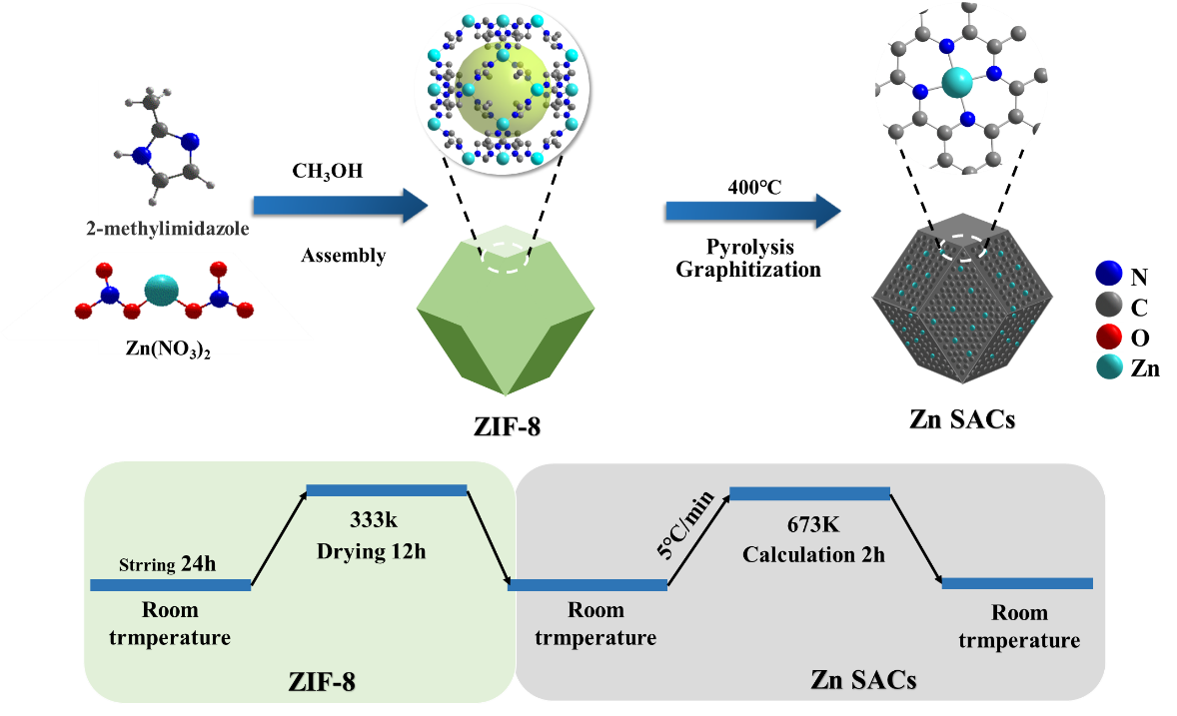
Figure S1. Synthesis method of the Zn SACs sample.

Figure S2
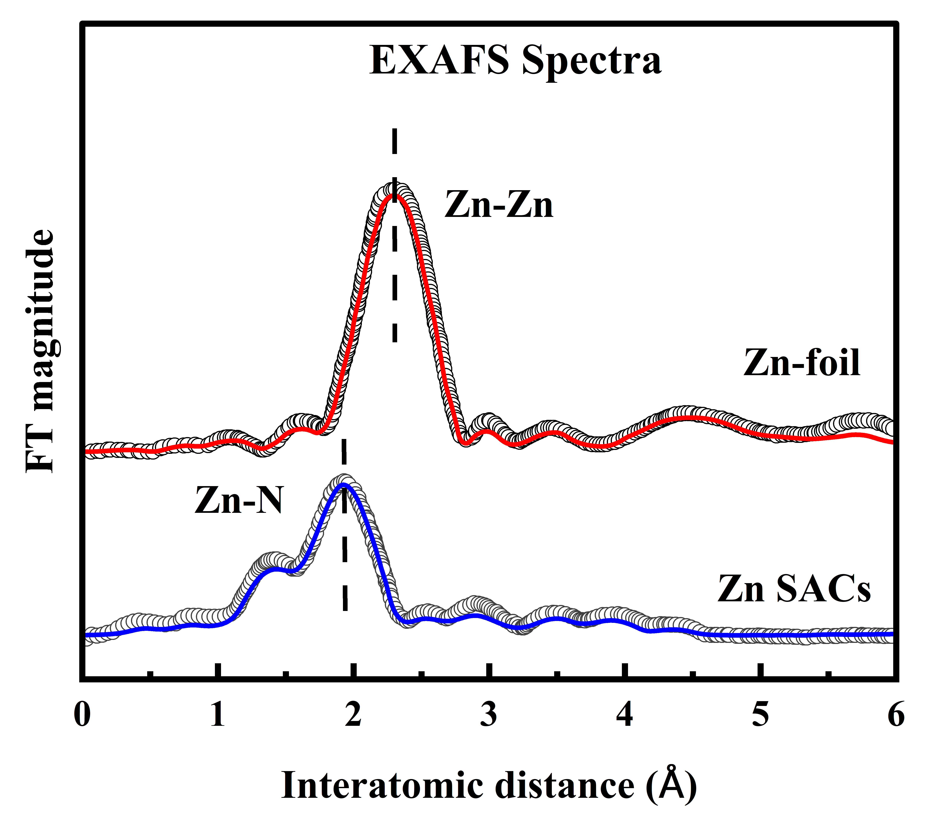
Figure S2. EXAFS spectra characterized for Zn SACs sample. Fitting data are summarized in Table S1.

Figure S3
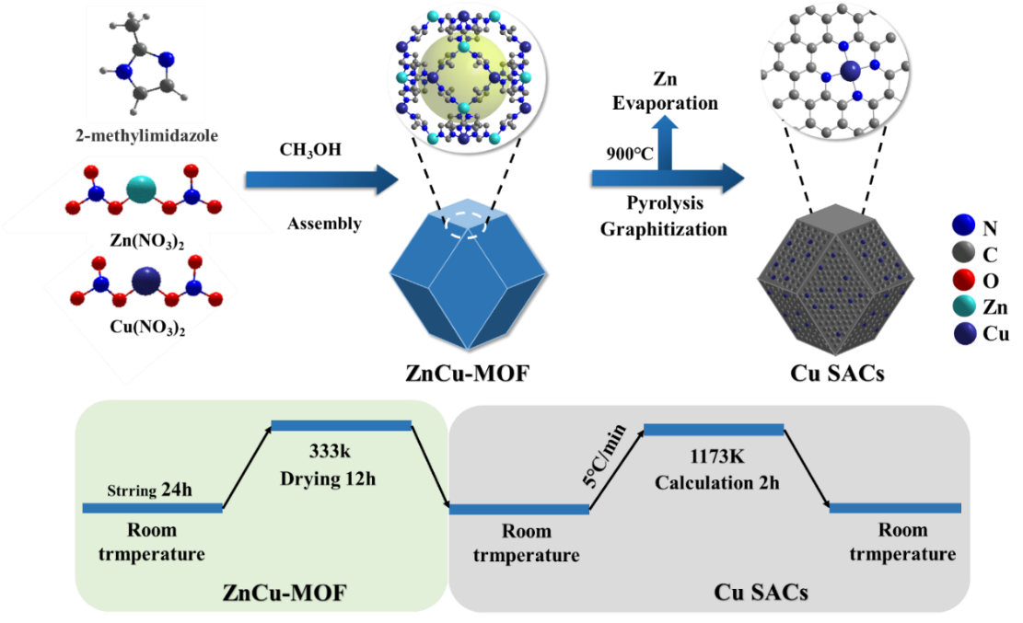
Figure S3. Synthesis method of the Cu SACs sample.

Figure S4
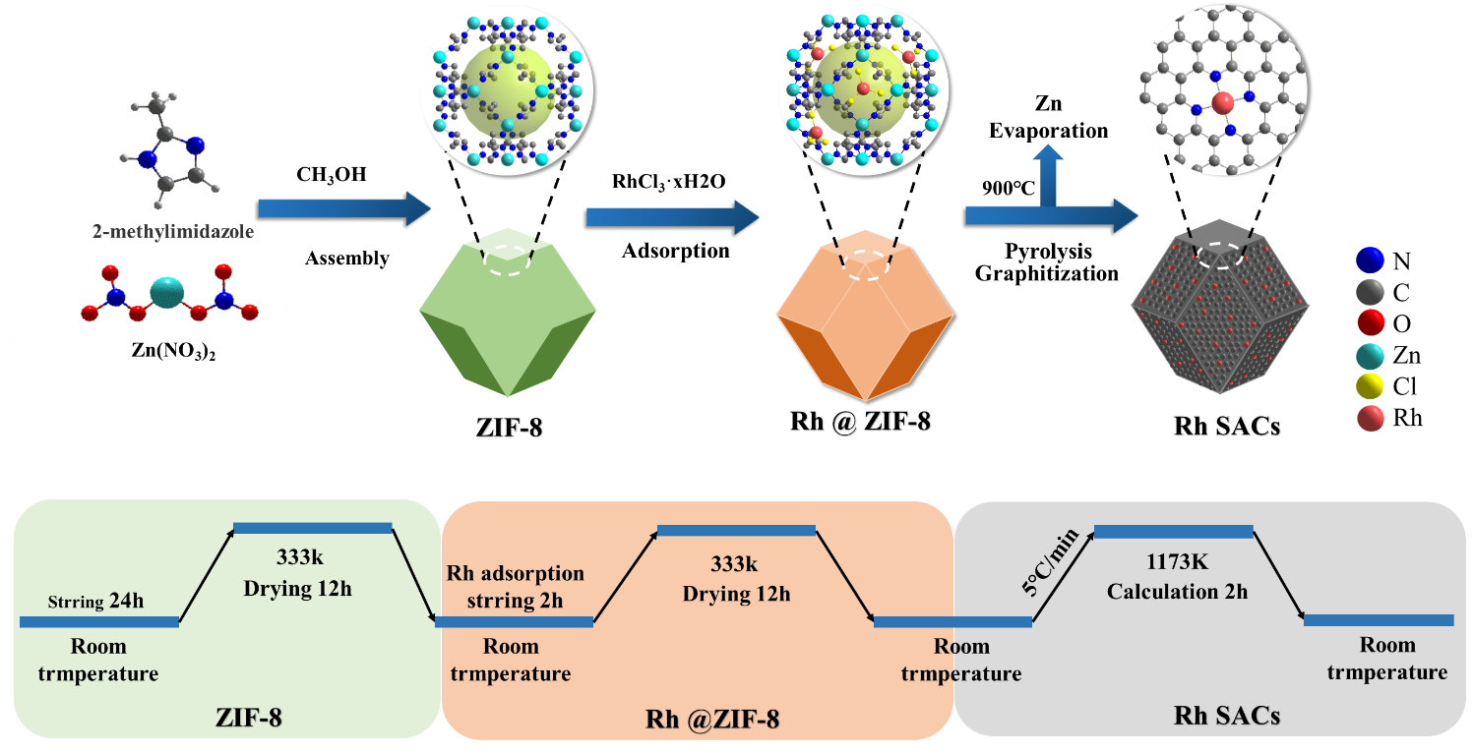
Figure S4. Synthesis method of the Rh SACs sample.

Figure S5
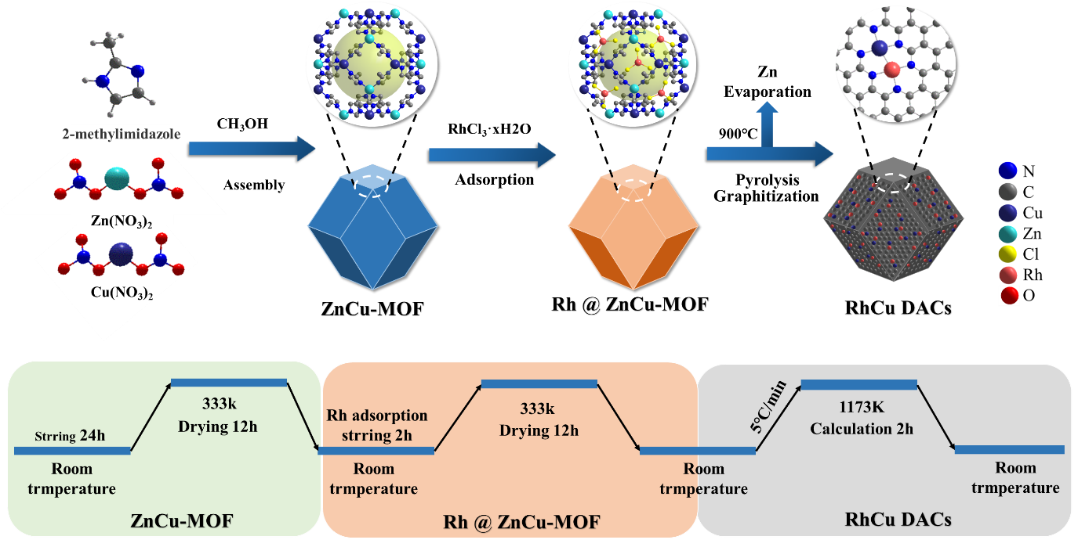
Figure S5. Synthesis method of the RhCu DACs sample.

Figure S6
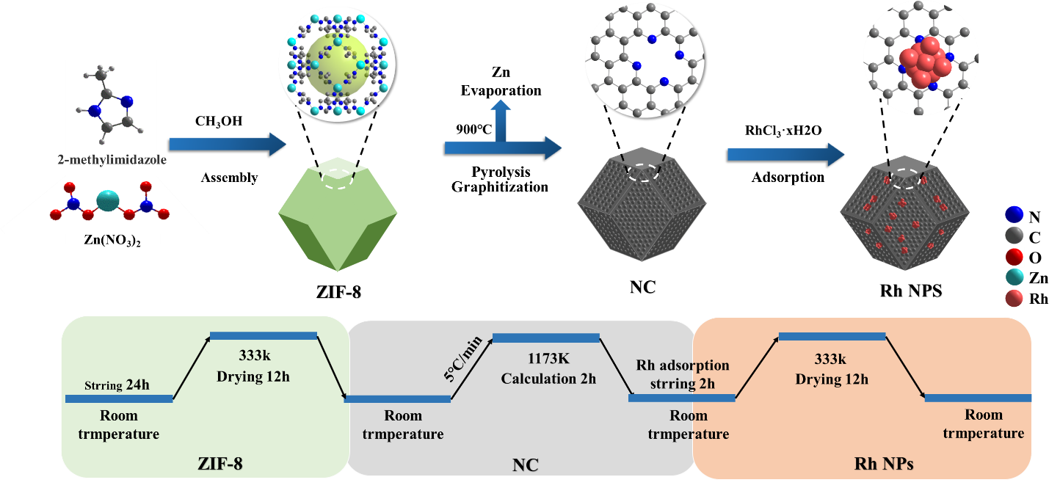
Figure S6. Synthesis method of the Rh NPs sample.

Figure S7
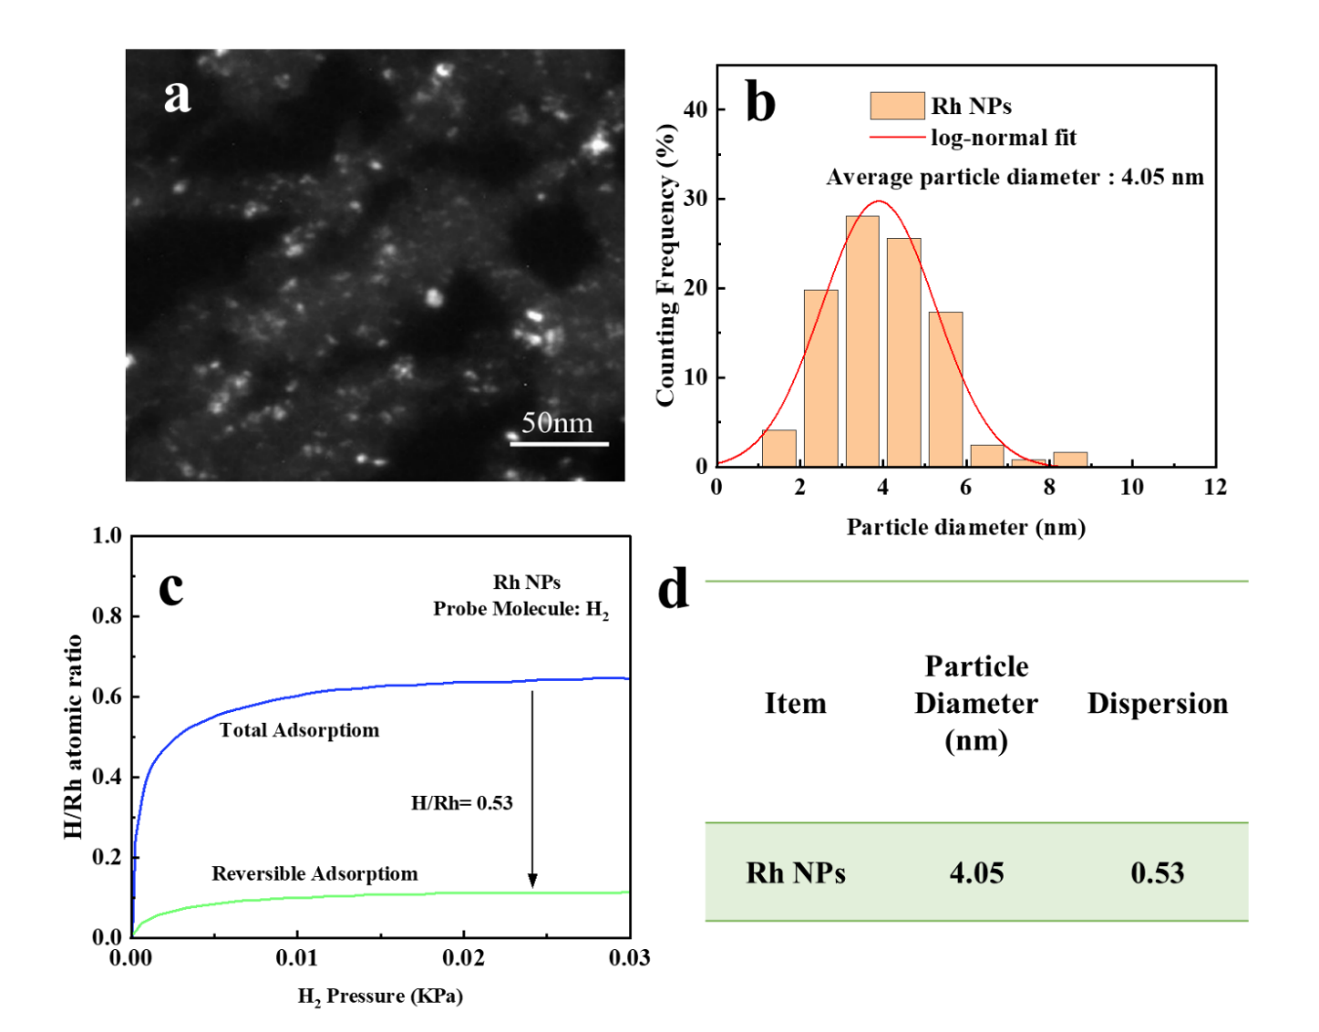
Figure S7. (a) TEM images of Rh NPs catalyst; (b) Particle diameter distributions of Rh NPs catalyst; (c) Adsorption isotherm of hydrogen adsorbed onto surface active sites of Rh NPs catalyst; (d) Detailed parameters of the self-made Rh NPs catalyst.

Figure S8
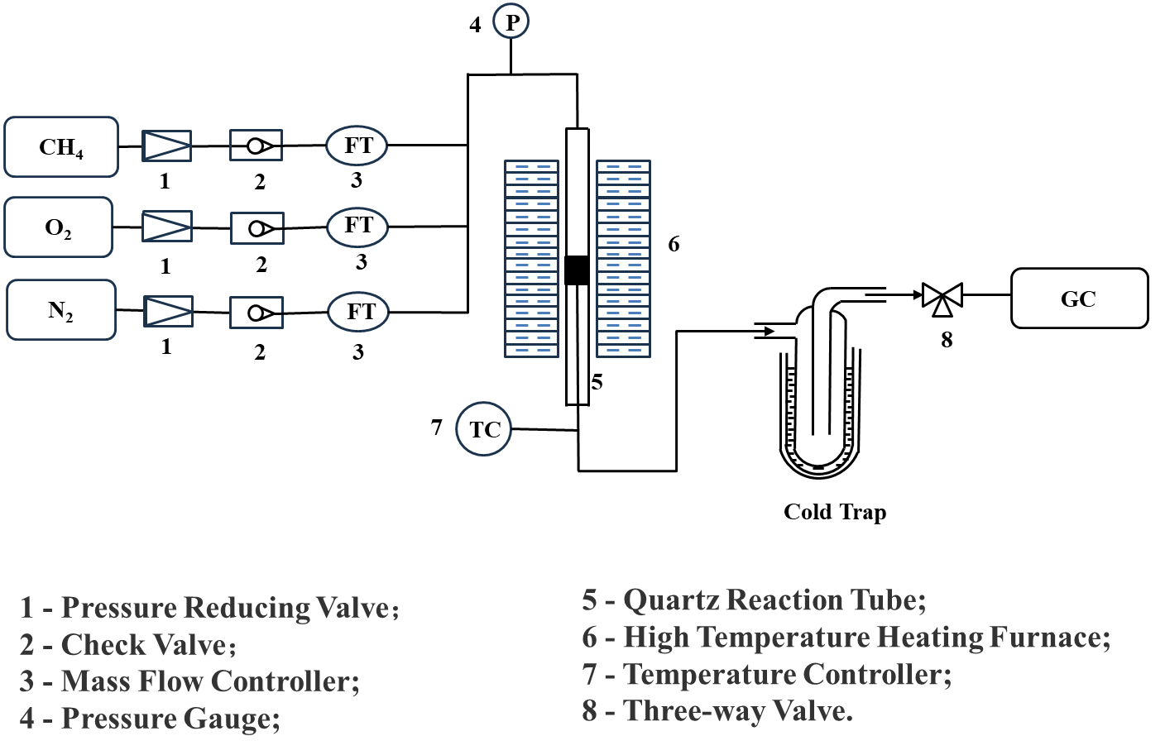
Figure S8. Schematic diagram of the catalytic oxidation reaction device for CH_{4.}

Figure S9
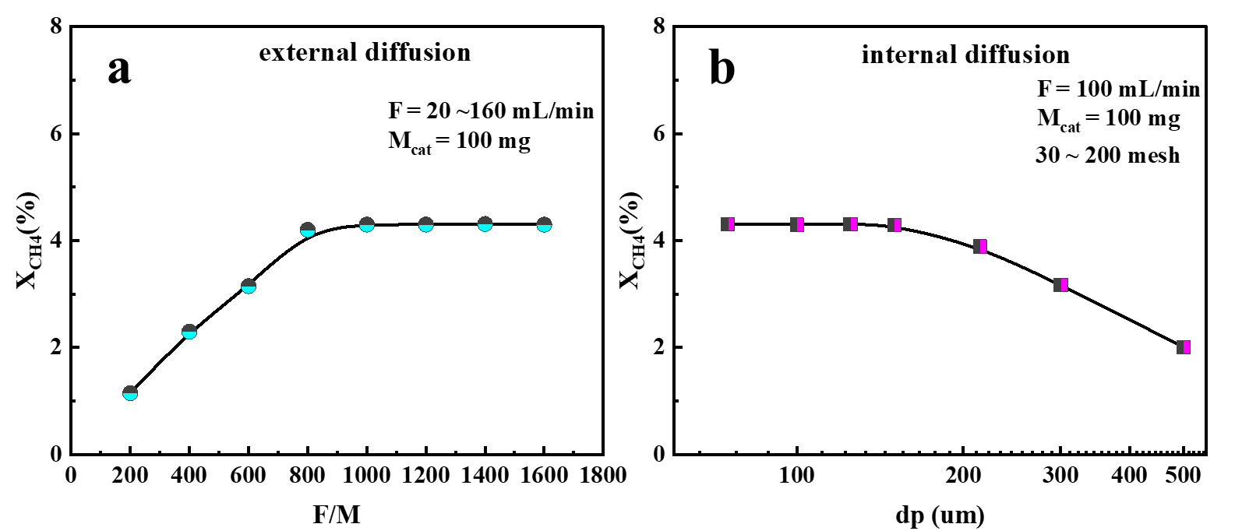
Figure S9. (a) The relationship between the space velocity (F/M) and the methane conversion rate to exclude the influence of external diffusion; (b) The influence of the particle size (dp) of the reaction catalyst on the methane conversion rate, with the influence of internal diffusion already excluded. Here, dp = N/15000, and N represents the number of mesh.

Figure S10
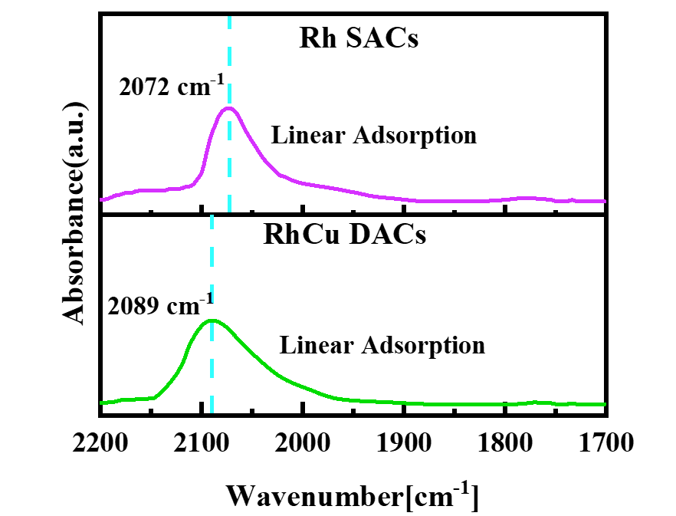
Figure S10. FTIR spectra of CO adsorbed on Rh SACs and RhCu DACs.
Figure S10 shows the infrared spectral curves of the adsorption of CO on the surfaces of the Rh SACs and RhCu DACs catalysts. Both catalysts have a linear adsorption region at a relatively high vibration frequency, and the adsorption of CO is linear. At this time, the adsorption of CO on the surfaces of the metal sites of the elements Rh or Cu follows an adsorption ratio of 1:1. Among them, due to the interaction between Rh and Cu in the RhCu DACs catalyst, when CO is adsorbed, the bond energy of C transferred to the metal is weakened, and the vibration frequency of CO is higher. The linear adsorption peak is at 2089 cm⁻¹.

Figure S11
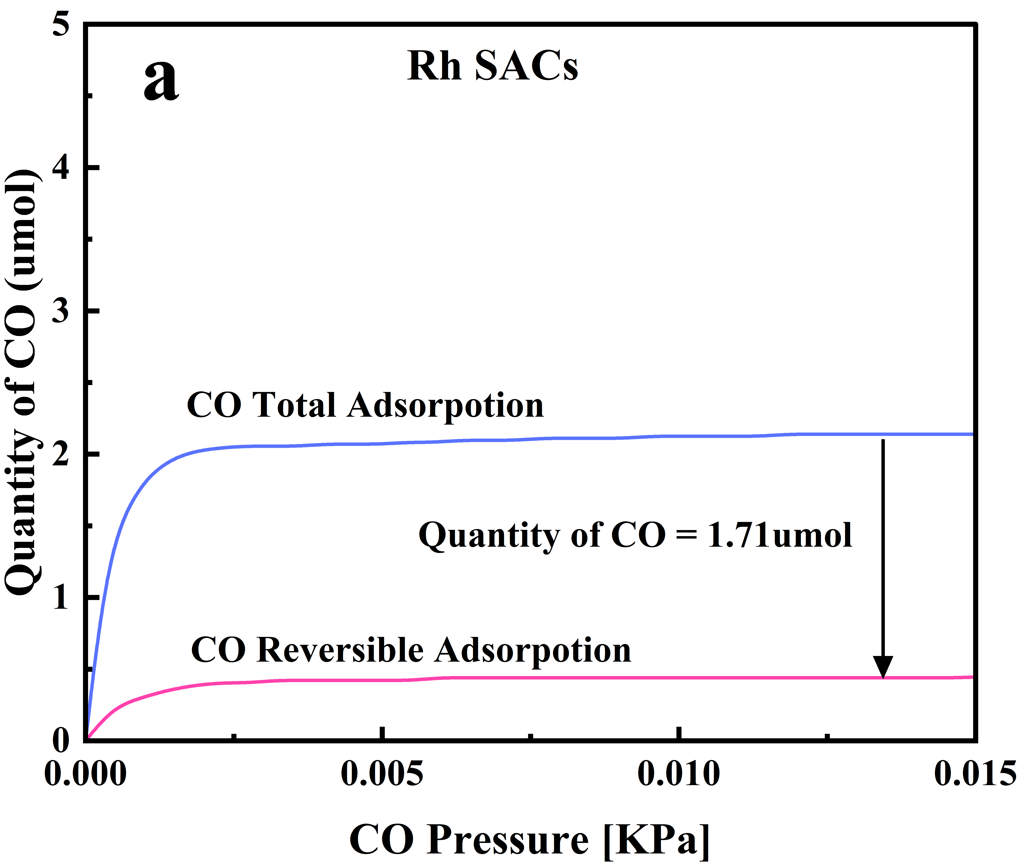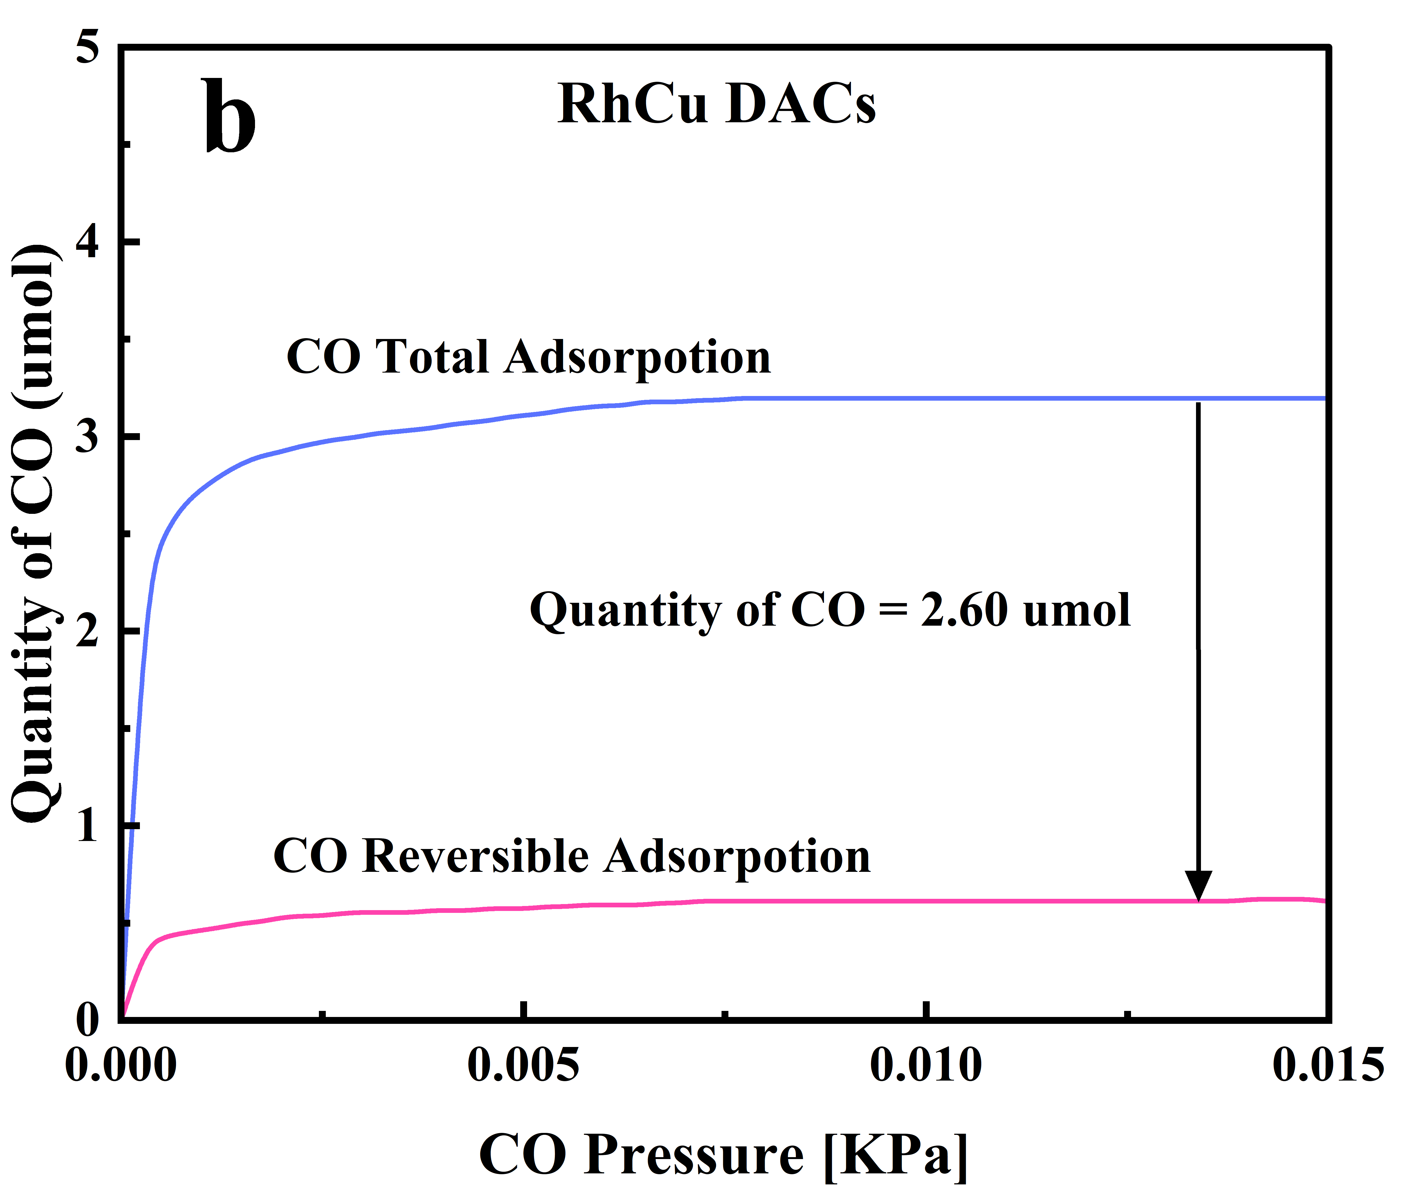
Figure S11. CO adsorption profiles: (a) Rh SACs, (b) RhCu DACs.
The principle of measuring the active sites on the catalyst surface by chemical adsorption is to measure the molar amount of gas adsorbed on the active sites. As shown in Figure S11, the chemical adsorption curves of CO molecules on the single-atom catalyst Rh SACs and the heteronuclear diatomic catalyst RhCu DACs are presented respectively. The blue curve in the figure represents the change in the total amount of CO molecules adsorbed, and the red curve represents the reversible adsorption of CO. The number of surface sites of the catalyst is obtained by subtracting the reversible adsorption part from the total adsorption of the gas. When performing the calculation, a part of the adsorption curve within the same pressure range and in a stable state is selected. At this time, for the Rh SACs catalyst, the amount of adsorbed CO molecules is equal to the number of sites of the metal Rh (the metal in the catalyst is monodispersed and there are no Rh metal particles present). However, for the RhCu DACs catalyst at this time, the amount of adsorbed CO molecules is equal to the total number of surface metal sites.

Figure S12
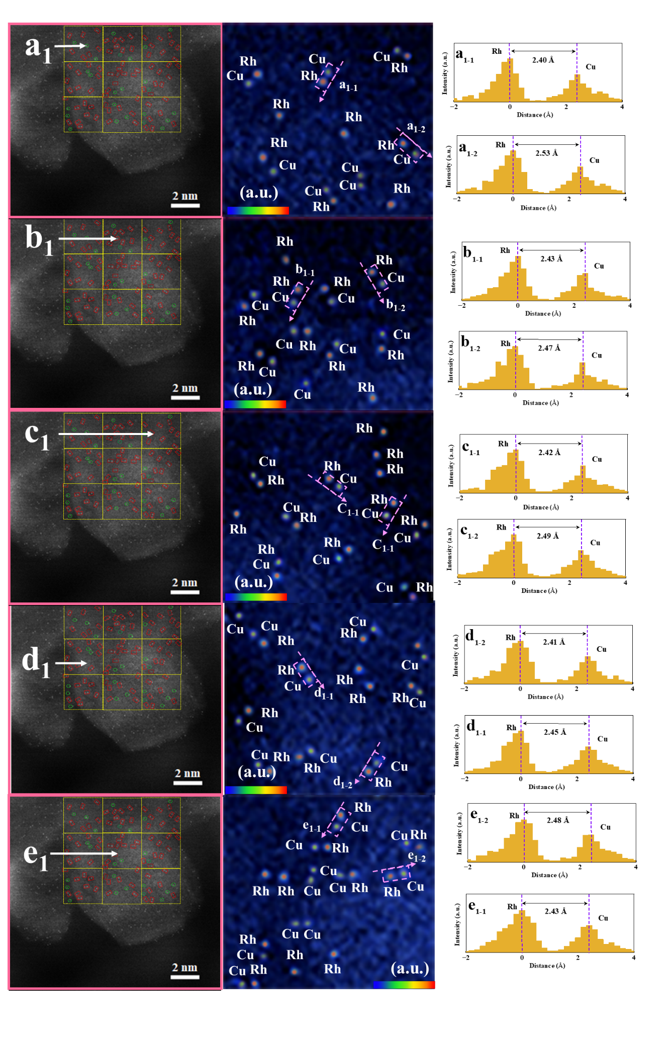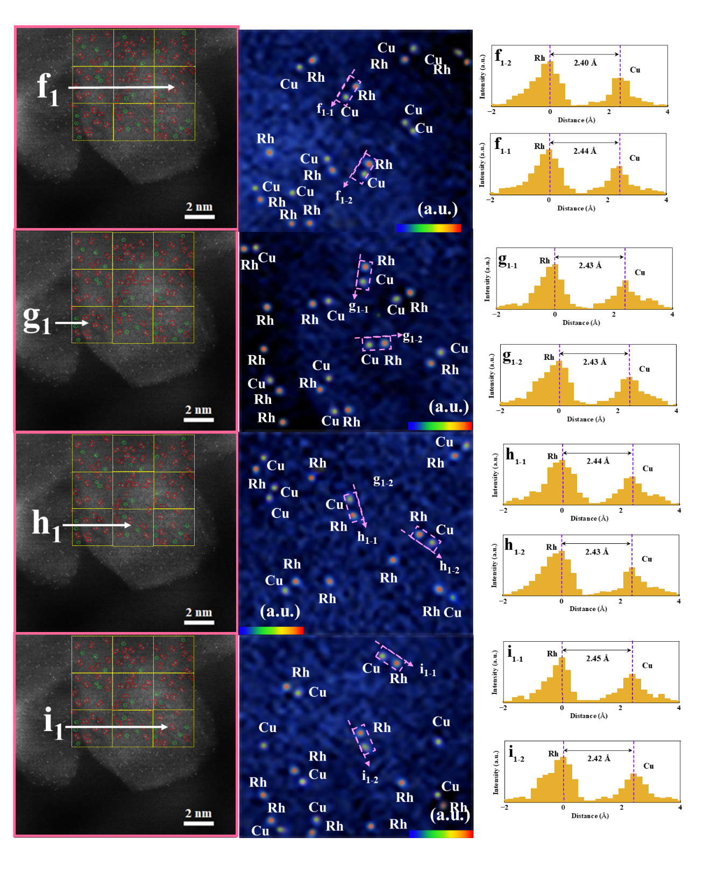
Figure S12. HAADF-STEM images and corresponding metal center distribution of RhCu DACs.
The HAADF-STEM image of the bimetallic RhCu DACs catalyst was randomly divided into a nine-square grid to calculate the number of paired sites and the proportion of sites per unit (Figure S12). In the figure, the red square represents the paired metal sites, and the green circle represents the single-metal sites. The formula for calculating the percentage (X) of the paired sites of the metals Rh and Cu is: X = (A/B)%. In this formula, A is the number of pairs of RhCu paired sites, and B is the total number of sites of all types counted. Here, the total number of all sites counted (Rh, Cu, Rh-Rh, Rh-Cu, Cu-Cu) is 100, among which the number of Rh-Cu paired sites is 67. Through calculation, the percentage of the heteronuclear bimetallic RhCu sites at this time is obtained as 67%.

Figure S13
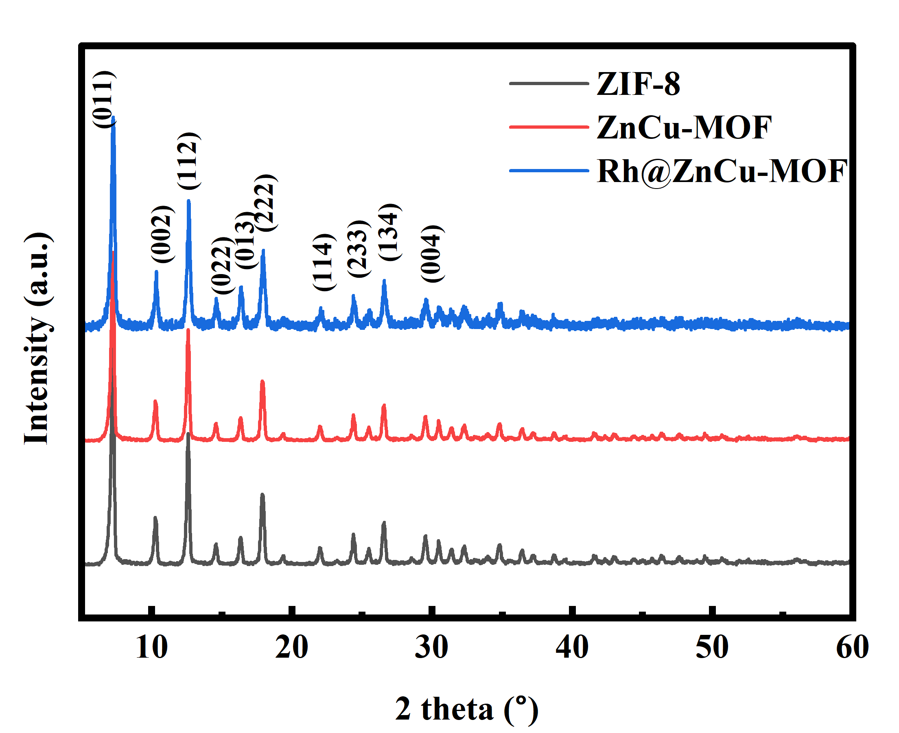
Figure S13. XRD images of ZIF-8, ZnCu-MOF and Rh@ZnCu-MOF.
The X-ray diffraction patterns of ZIF-8, ZnCu-MOF and Rh@ZnCu-MOF samples are shown in Figure S13. By comparison, it is found that the XRD patterns of ZnCu-MOF and Rh@ZnCu-MOF are highly consistent with the diffraction peaks of ZIF-8. This indicates that when a small amount of the second metal Cu is added during the preparation of ZIF-8 and after coating with Rh, the crystal structure is basically not affected.

Figure S14
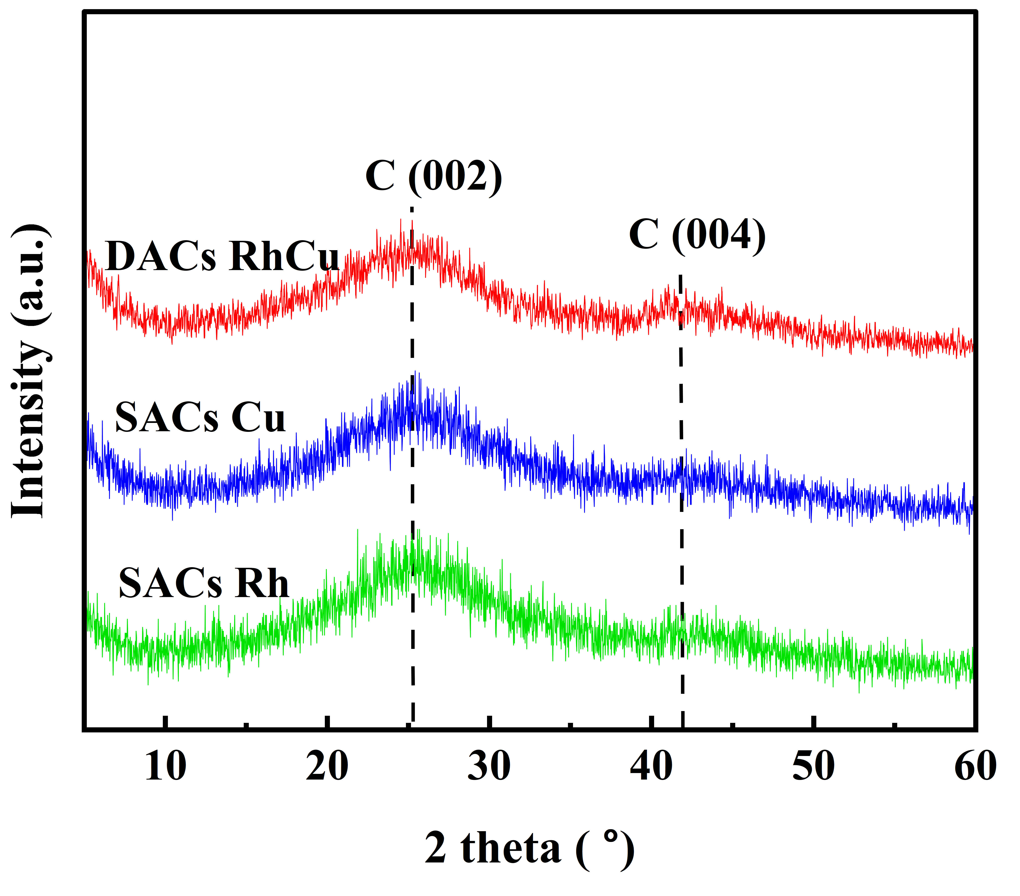
Figure S14. XRD images of Cu SACs, Rh SACs and RhCu DACs.
The X-ray diffraction (XRD) patterns of Cu SACs, Rh SACs and RhCu DACs exhibit two broad peaks at 26.5° and 44.2°, corresponding to the (002) and (101) planes of carbon, respectively. This indicates that the precursors have been completely carbonized to form nitrogen-doped carbon (N-C) species. Furthermore, no characteristic peak of crystalline Rh is observed, which indicates that the Rh species are dispersed in an atomic form due to the spatial confinement effect and anchoring ability of the nitrogen atoms.

Figure S15
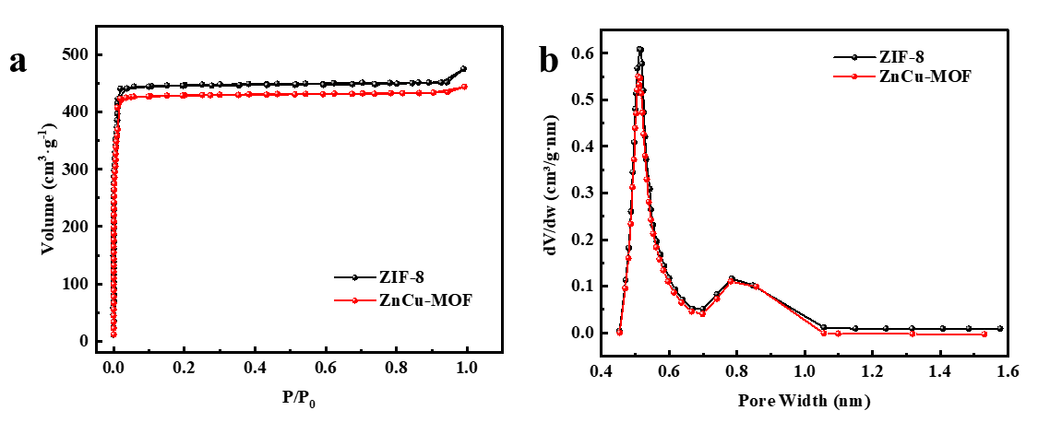
Figure S15. N₂ adsorption-desorption isotherms and pore size distributions of ZIF-8 and ZnCu-MOF.
As can be seen from Figure S15, the sample exhibits a Type I adsorption isotherm. From the specific surface area and pore size data (as shown in Table S1), it can be observed that the sample has abundant cavities and a pore size ranging from 0.55 to 0.6 nm. During the preparation of Rh SACs and RhCu DACs, ZIF-8 and ZnCu-MOF can be used as nanoscale cages to adsorb and encapsulate Rh salt ions (with an ion diameter of less than 4 Å).

Figure S16
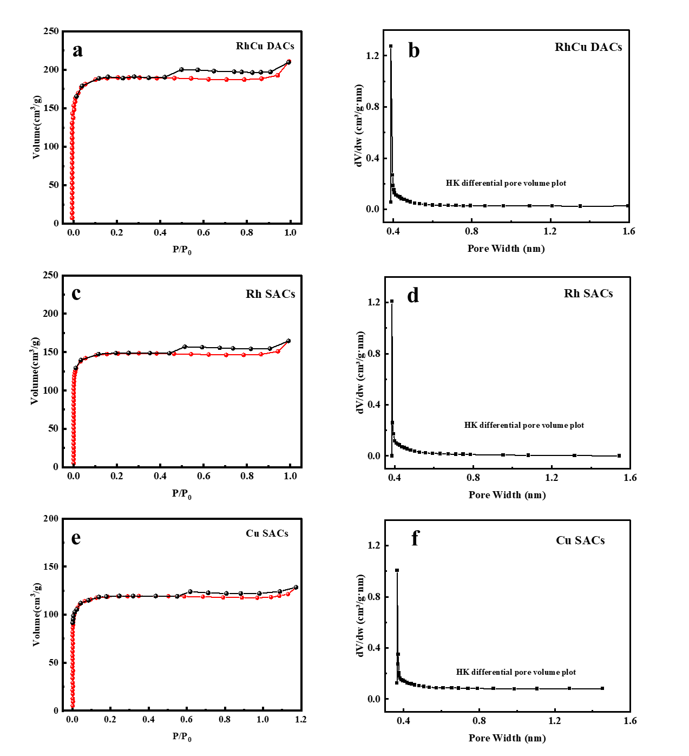
Figure S16. N₂ adsorption-desorption isotherms and pore size distributions of RhCu DACs (a,b), Rh SACs (c,d) and Cu SACs (e,f) catalysts.
As shown in Figure S16, the Rh SACs, Cu SACs and RhCu DACs catalysts prepared after high-temperature calcination exhibit a Type IV isotherm. The data of their specific surface areas and pore sizes are shown in Table S2.

Figure S17
Figure S17. HAADF-STEM characterization of Rh SACs.

Figure S18
Figure S18. TEM images and EDS spectra of the RhCu DACs catalyst.

Figure S19
Figure S19. TEM images and EDS spectra of Rh SACs catalyst.

Figure S20
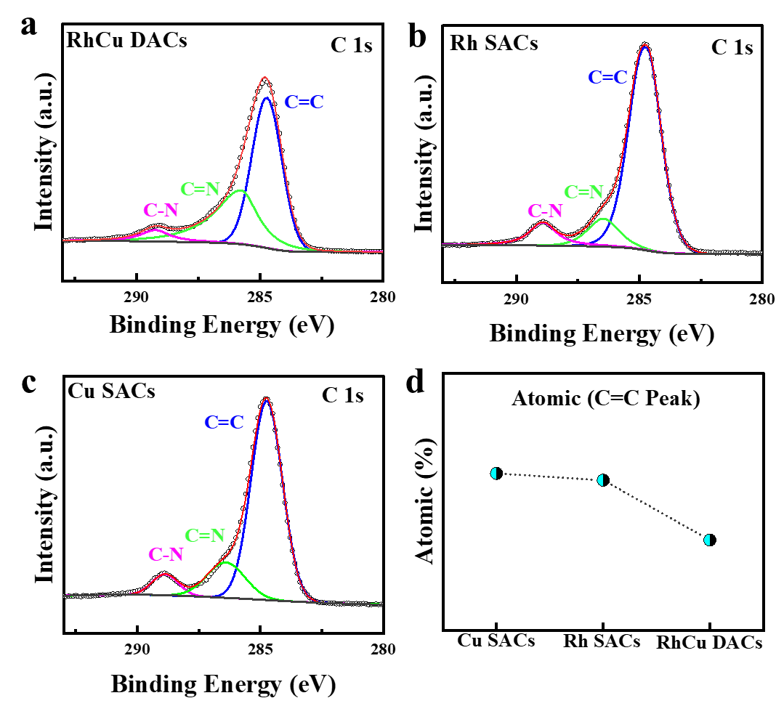
Figure S20. X-ray photoelectron spectroscopy (C 1s) of each atomic catalyst Rh SACs, Cu SACs and RhCu DACs: (a) RhCu DACs, (b) Rh SACs, (c) Cu SACs and (d) the proportion of the C=C state in the total carbon species

Figure S21
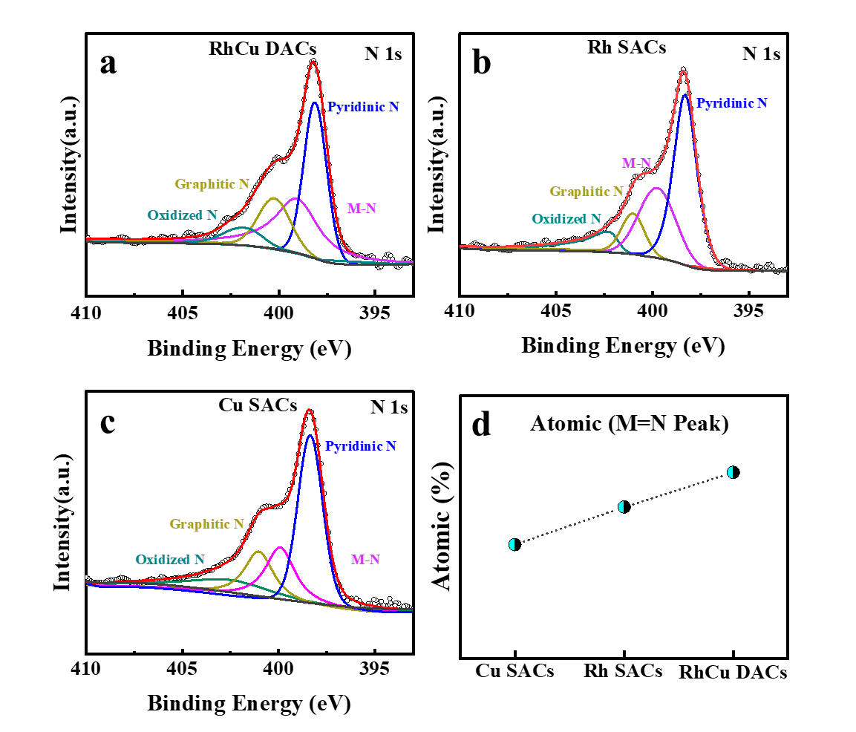
Figure S21. X-ray photoelectron spectroscopy (N 1s) of each atomic catalyst Rh SACs, Cu SACs and RhCu DACs: (a) RhCu DACs, (b) Rh SACs, (c)Cu SACs and (d) the proportion of the metal-nitrogen (Rh/Cu-M) state in the total nitrogen species.

Figure S22
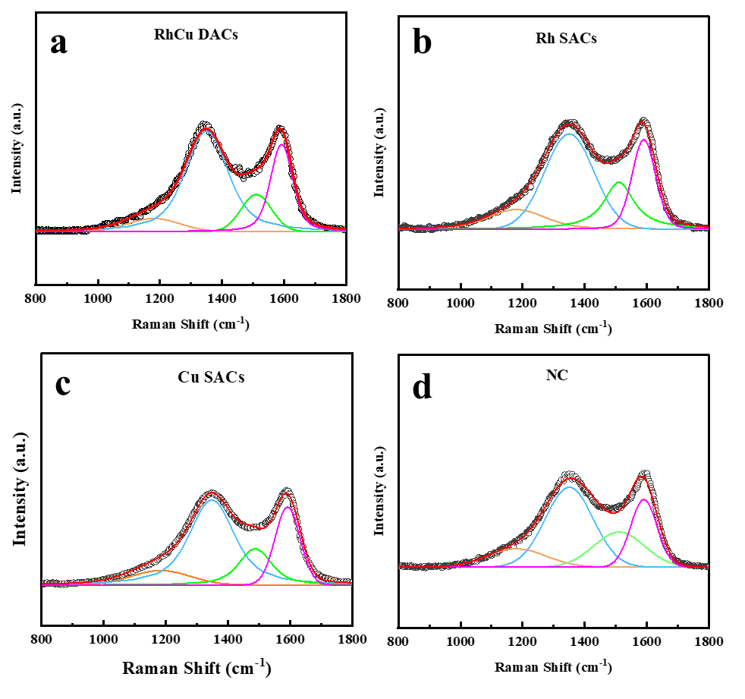
Figure S22. Peak-fitting curves of the D-band and G-band in the Raman spectra of the catalysts Rh SACs, Cu SACs, RhCu DACs, and the NC sample: (a)RhCu DACs, (b)Rh SACs, (c)Cu SACs, and (d) the NC structure.

Figure S23
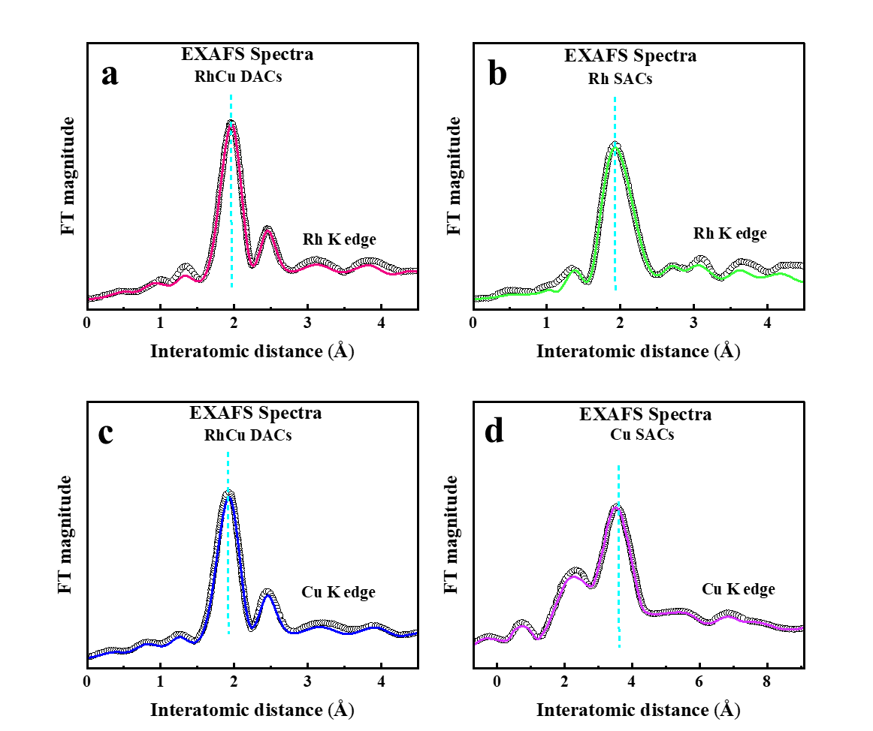
Figure S23. R-space diagrams of the Extended X-ray Absorption Fine Structure (EXAFS) spectra of the catalysts Rh SACs, Cu SACs, and RhCu DACs: (a,b) R-space diagrams of the Rh K-edge for the RhCu DACs and Rh SACs catalysts;(c,d) R-space diagrams of the Cu K-edge for the RhCu DACs and Cu SACs catalysts. EXAFS fitting data are summarized in Table S3.

Figure S24
a
b
Figure S24. CH₄ conversion rate over RhCu DACs under high O₂ pressure: (a) as a function of O₂ partial pressure ª; (b) as a function of CH₄ partial pressure ^{b}.
ª100 mg催化剂，$P_{{CH}_{4}}$=3.0 KPa，N₂平衡，总流速为100 mL/min，300 ℃；
^{b}100 mg催化剂，$P_{O_{2}}$=10.0 KPa，N₂平衡，总流速为100 mL/min，300 ℃；

Figure S25
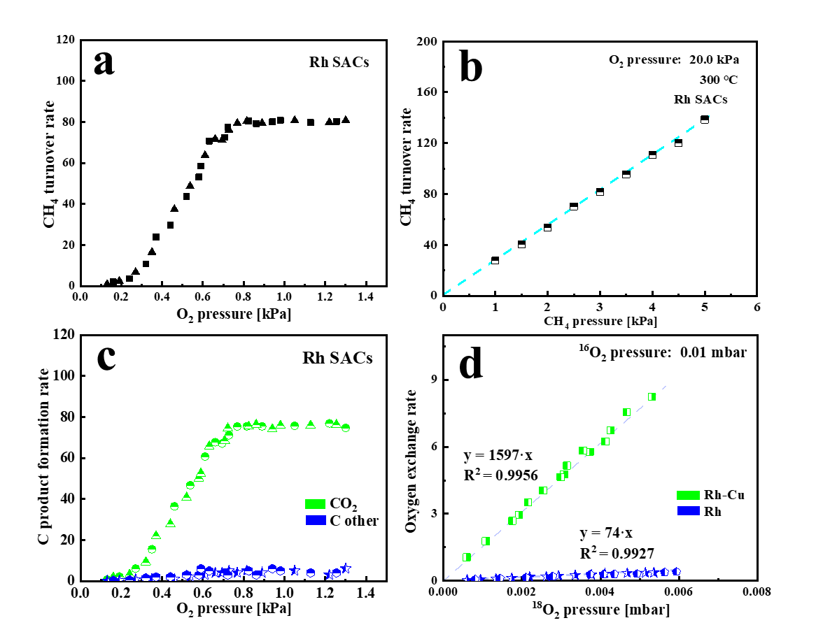
Figure S25. Activity evaluation of the catalytic oxidation of CH₄ by Rh SACs: (a) the conversion rate of CH₄ under low oxygen partial pressure and (c) the production rate of products; (b) the conversion rate of CH₄ under high oxygen partial pressure; (d) the results of isotope tracing experiments for RhCu DACs and Rh SACs catalysts.

Figure S26
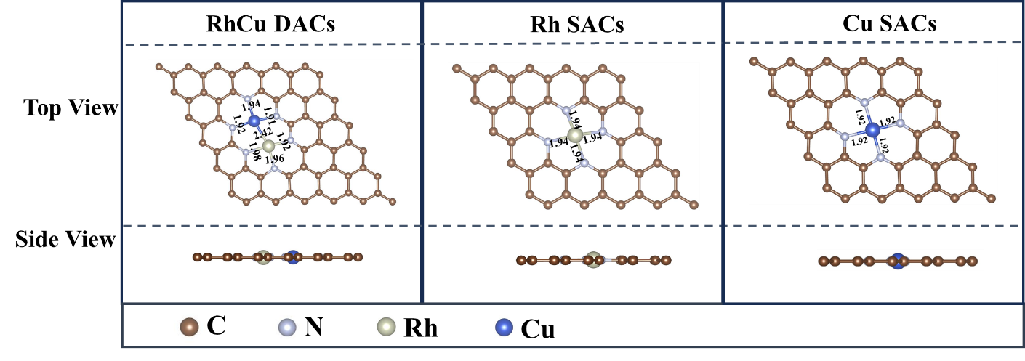
Figure S26. Structural models of the catalysts RhCu DACs, Rh SACs and Cu SACs.

Figure S27
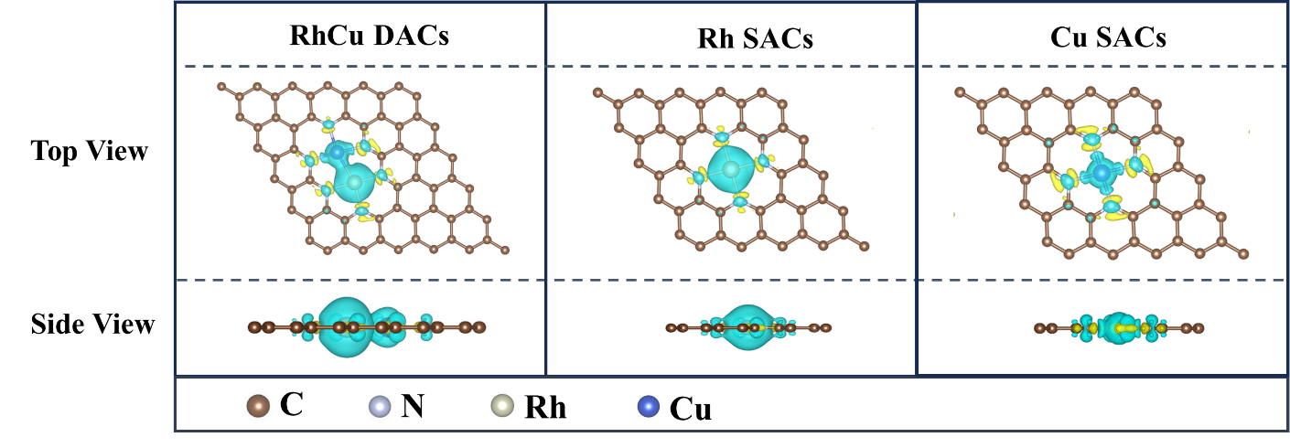
Figure S27. Differential charge density diagrams of the catalysts RhCu DACs, Rh SACs and Cu SACs (The turquoise color represents the loss of electrons, and the golden yellow color represents the gain of electrons).

Figure S28
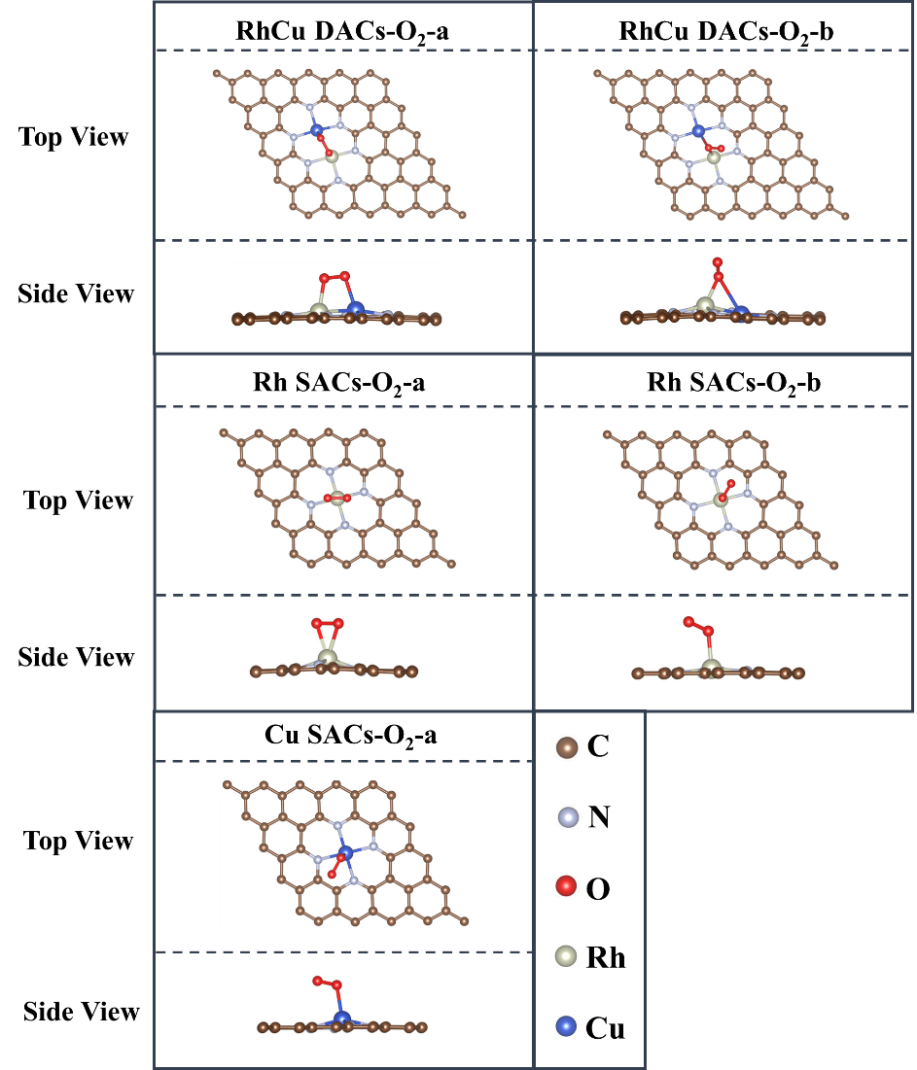
Figure S28. Structural models of adsorbed oxygen on the Rh SACs, Cu SACs and RhCu DACs catalysts.

Figure S29
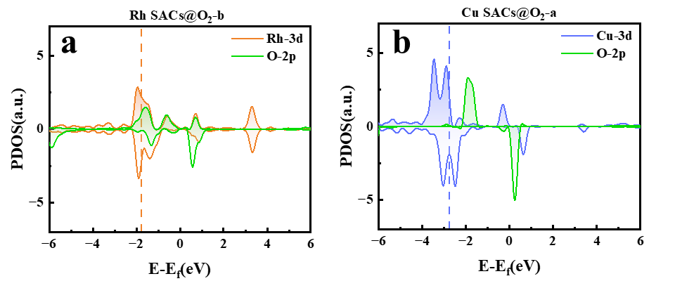
Figure S29. Plots of the projected density of states for the adsorbed oxygen on the Rh SACs and Cu SACs: (a) The adsorbed state of Rh SACs, Rh SACs@O₂-b; (b) The adsorbed state of Cu SACs, Cu SACs@O₂-a.

Figure S30
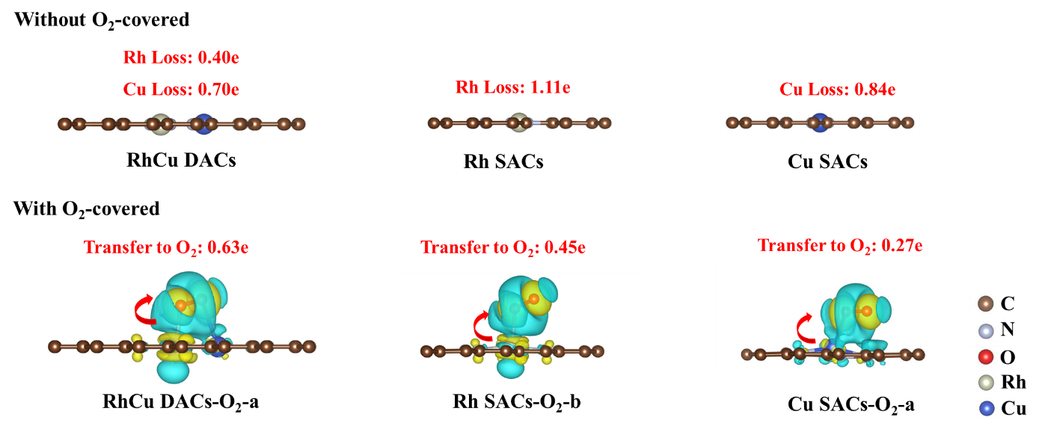
Figure S30. Structures and electron transfer of Rh SACs, Cu SACs and RhCu DACs with and without the adsorption of oxygen molecules (O₂) obtained from the Density Functional Theory (DFT) simulation.

Figure S31
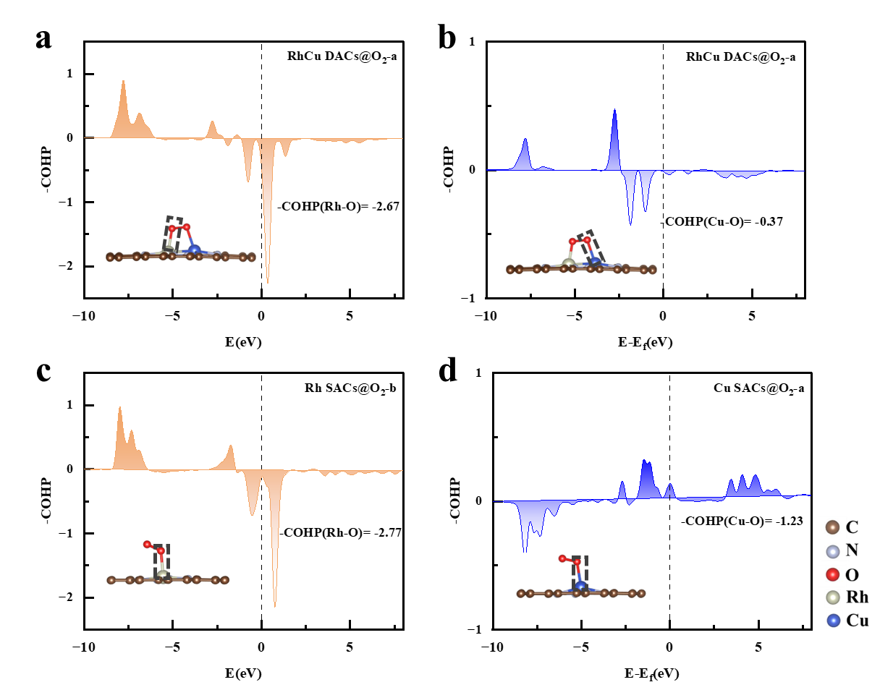
Figure S31. The -ICOHP results diagram of the metal-O (Rh/Cu) bond in the optimal adsorbed state corresponding to the catalysts Rh SACs, Cu SACs and RhCu DACs: (a) the Rh-O results of the RhCu DACs-O₂-a structure; (b) the Cu-O results of the RhCu DAC-O₂-b structure; (c) the Rh-O results of the Rh SACs-O₂-b structure (Figure c); (d) the Cu-O results of the Cu SACs-O₂-a structure.

Figure S32
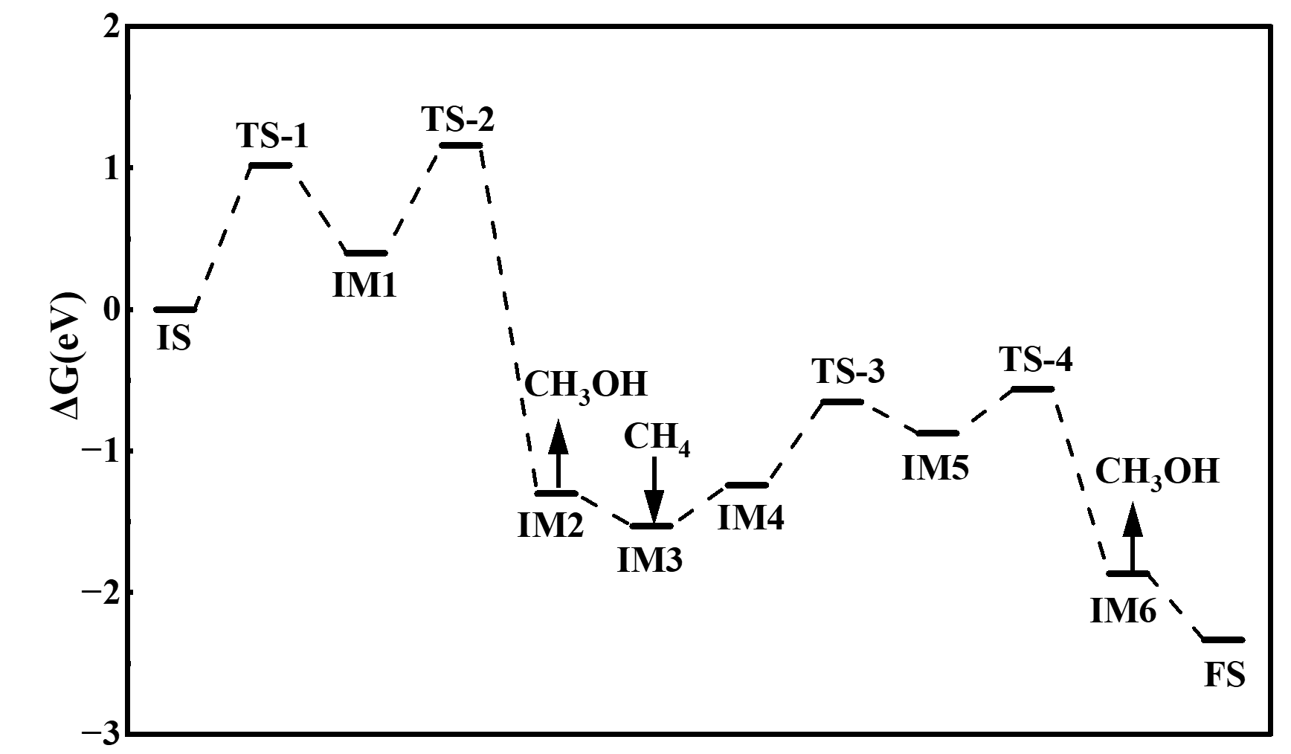
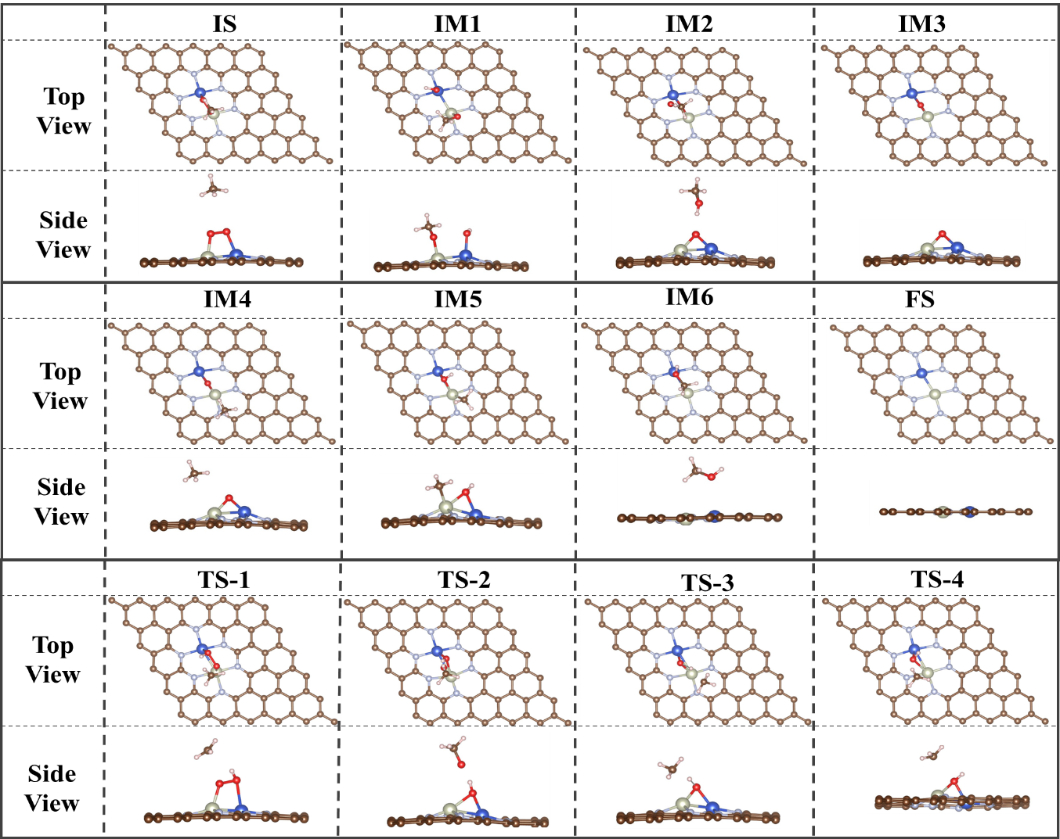
Figure S32. The reaction pathway for the selective oxidation of CH₄ to CH₃OH catalyzed by RhCu DACs@O₂-a under the adsorbed state obtained through DFT calculation simulation.

Figure S33
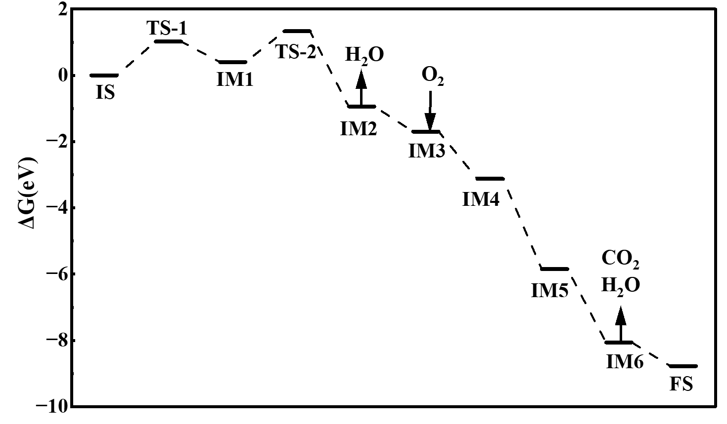
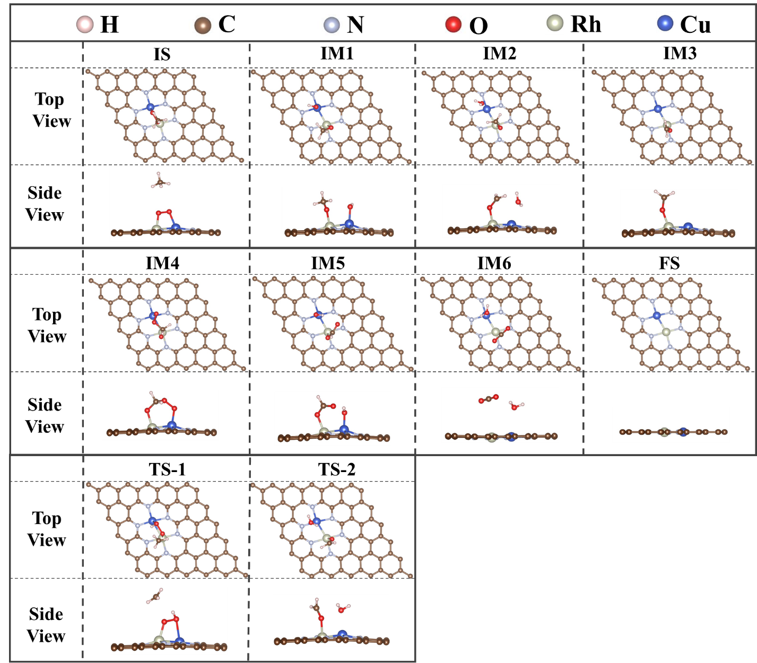
Figure S33. The pathway for the complete oxidation of CH₄ to CO₂ catalyzed by RhCu DACs@O₂-a under the adsorbed state obtained through DFT calculation simulation.

Figure S34
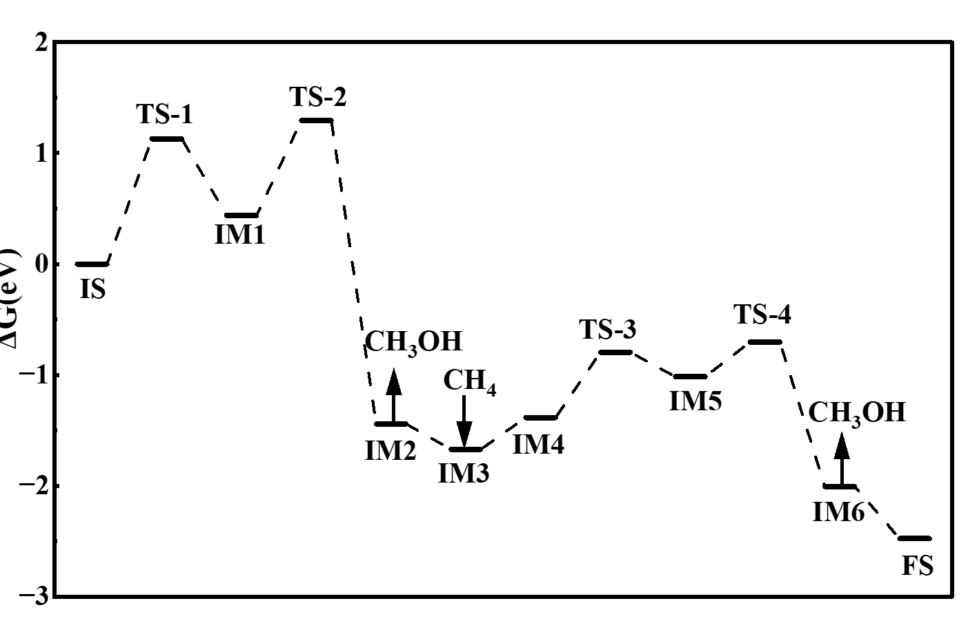
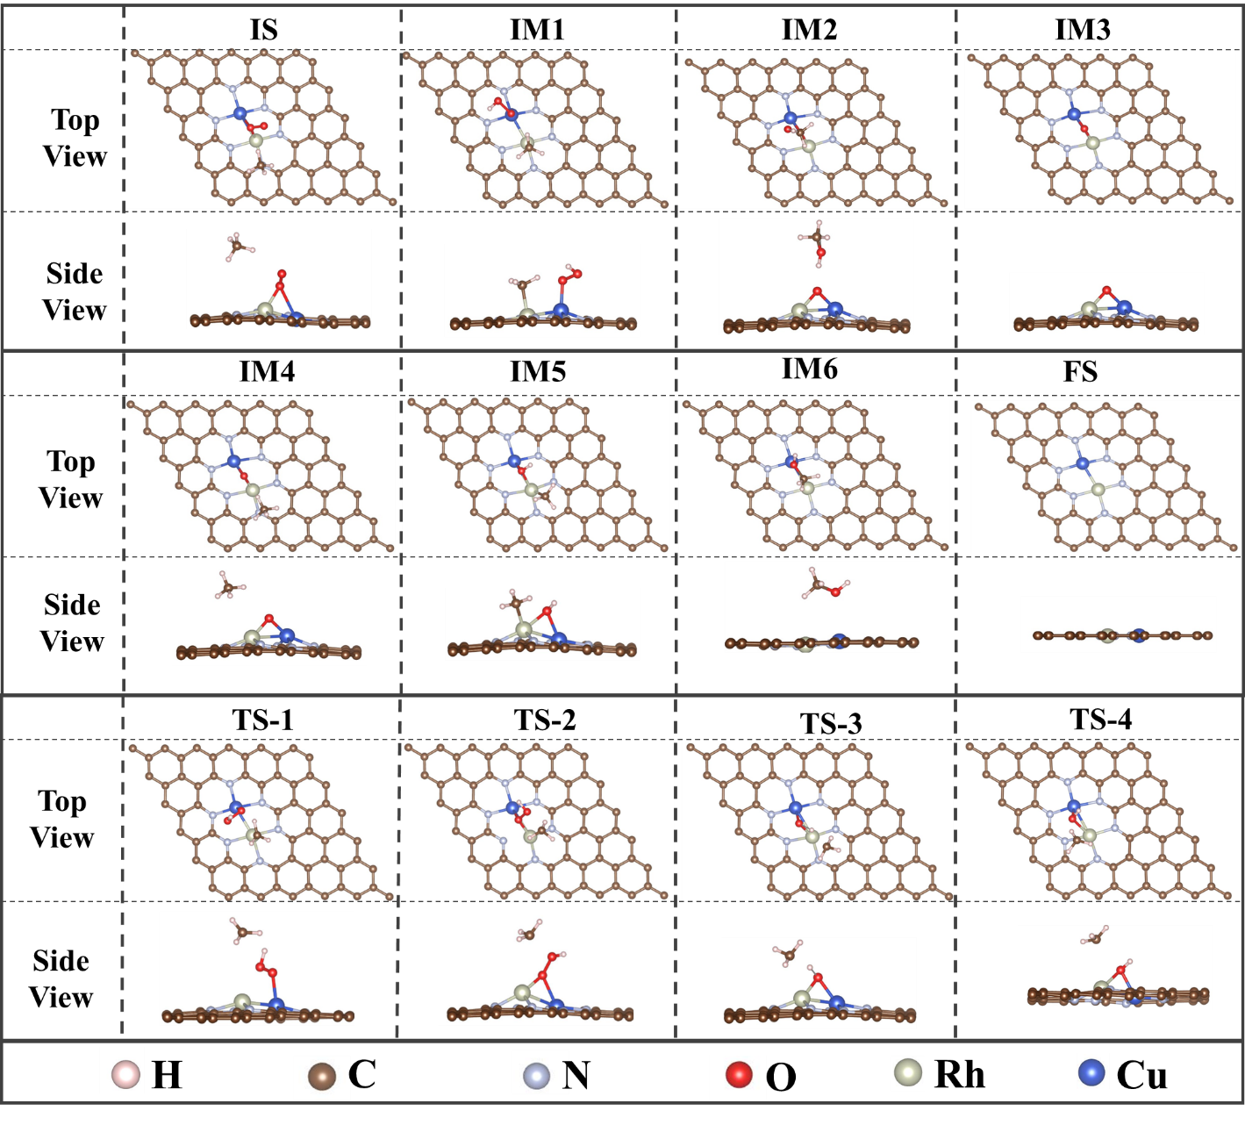
Figure S34. The reaction pathway for the selective oxidation of CH₄ to CH₃OH catalyzed by RhCu DACs@O₂-b under the adsorbed state obtained through DFT calculation simulation.

Figure S35
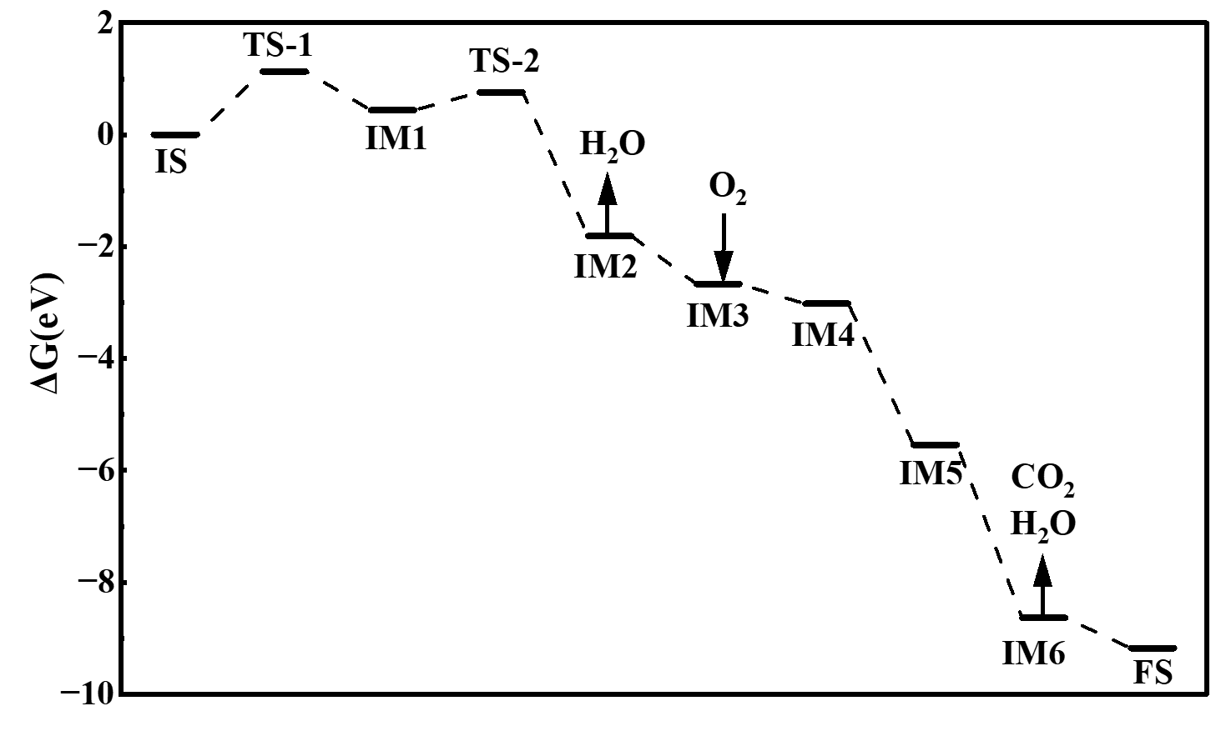
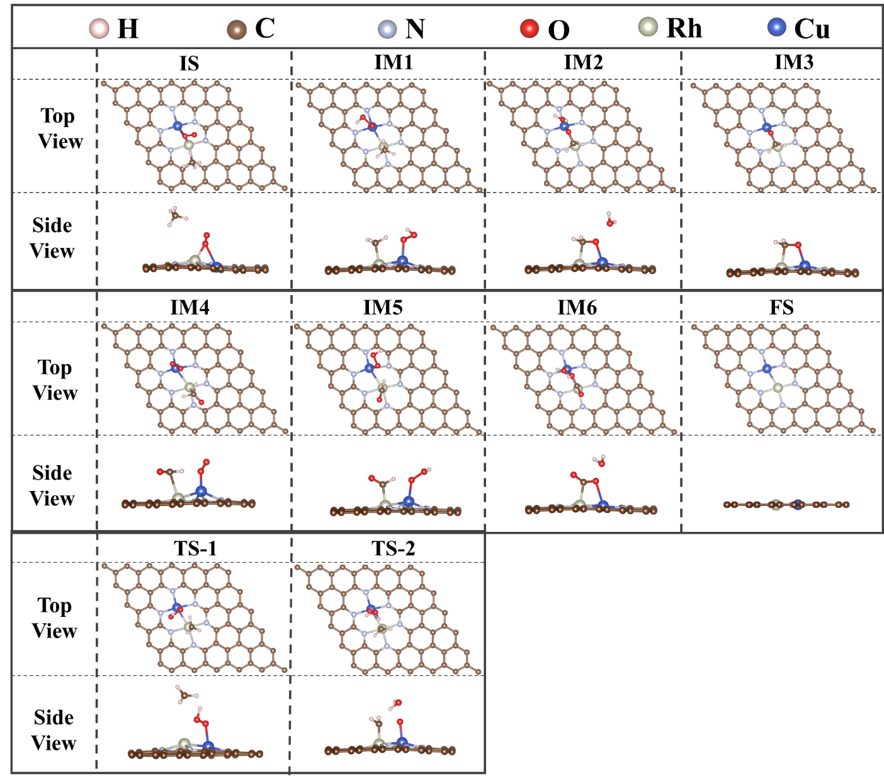
Figure S35. The pathway for the complete oxidation of CH₄ to CO₂ catalyzed by RhCu DACs@O₂-b under the adsorbed state obtained through DFT calculation simulation.

Figure S36
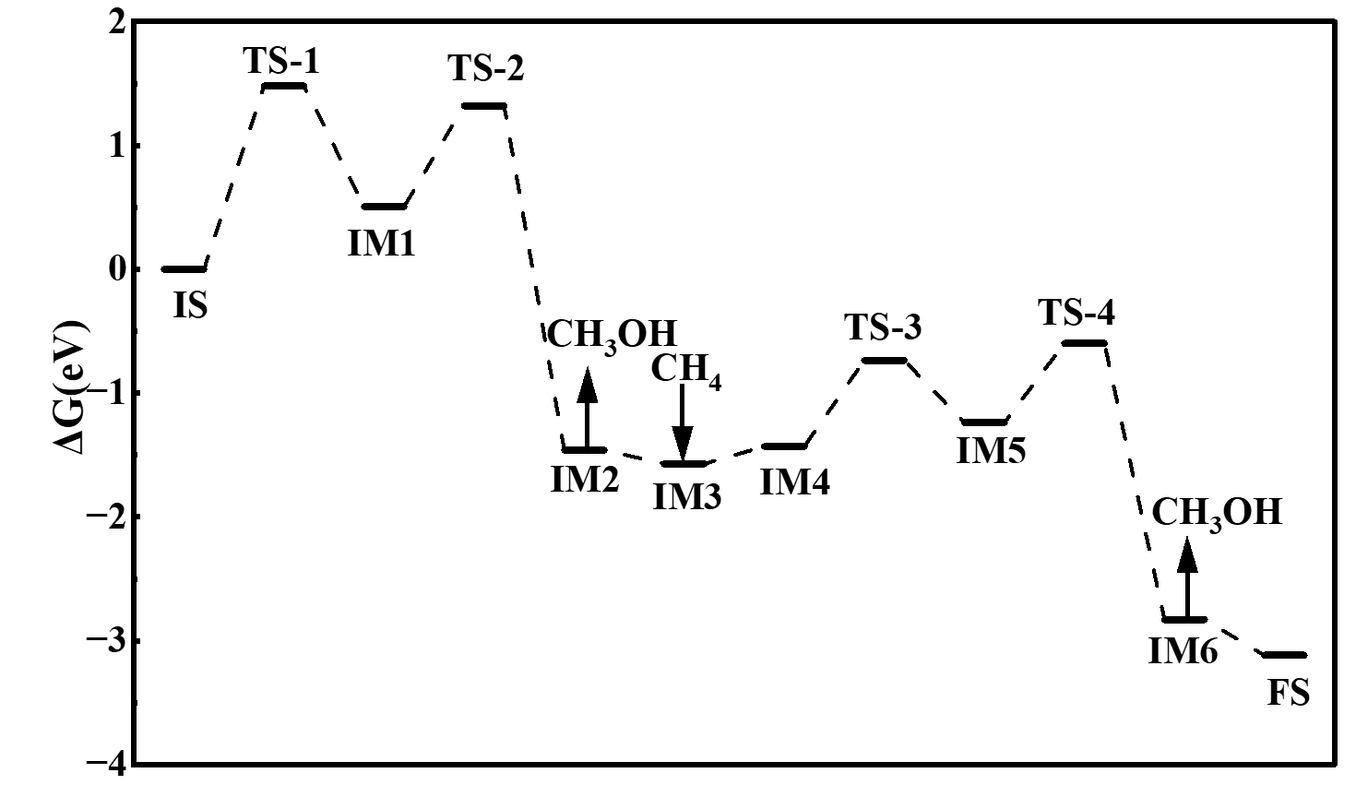
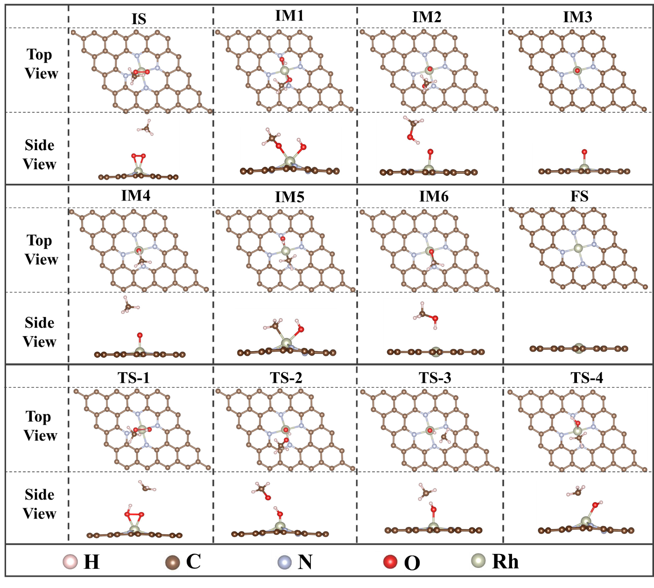
Figure S36. The reaction pathway for the selective oxidation of CH₄ to CH₃OH catalyzed by Rh SACs@O₂-a under the adsorbed state obtained through DFT calculation simulation.

Figure S37
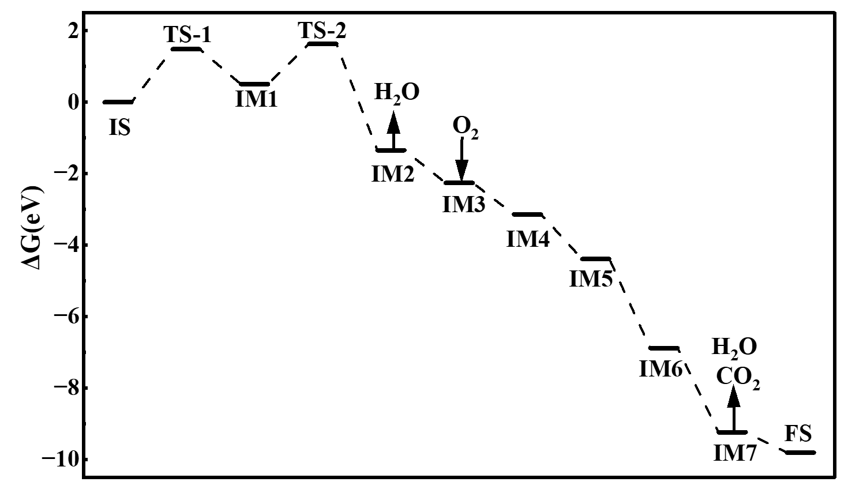
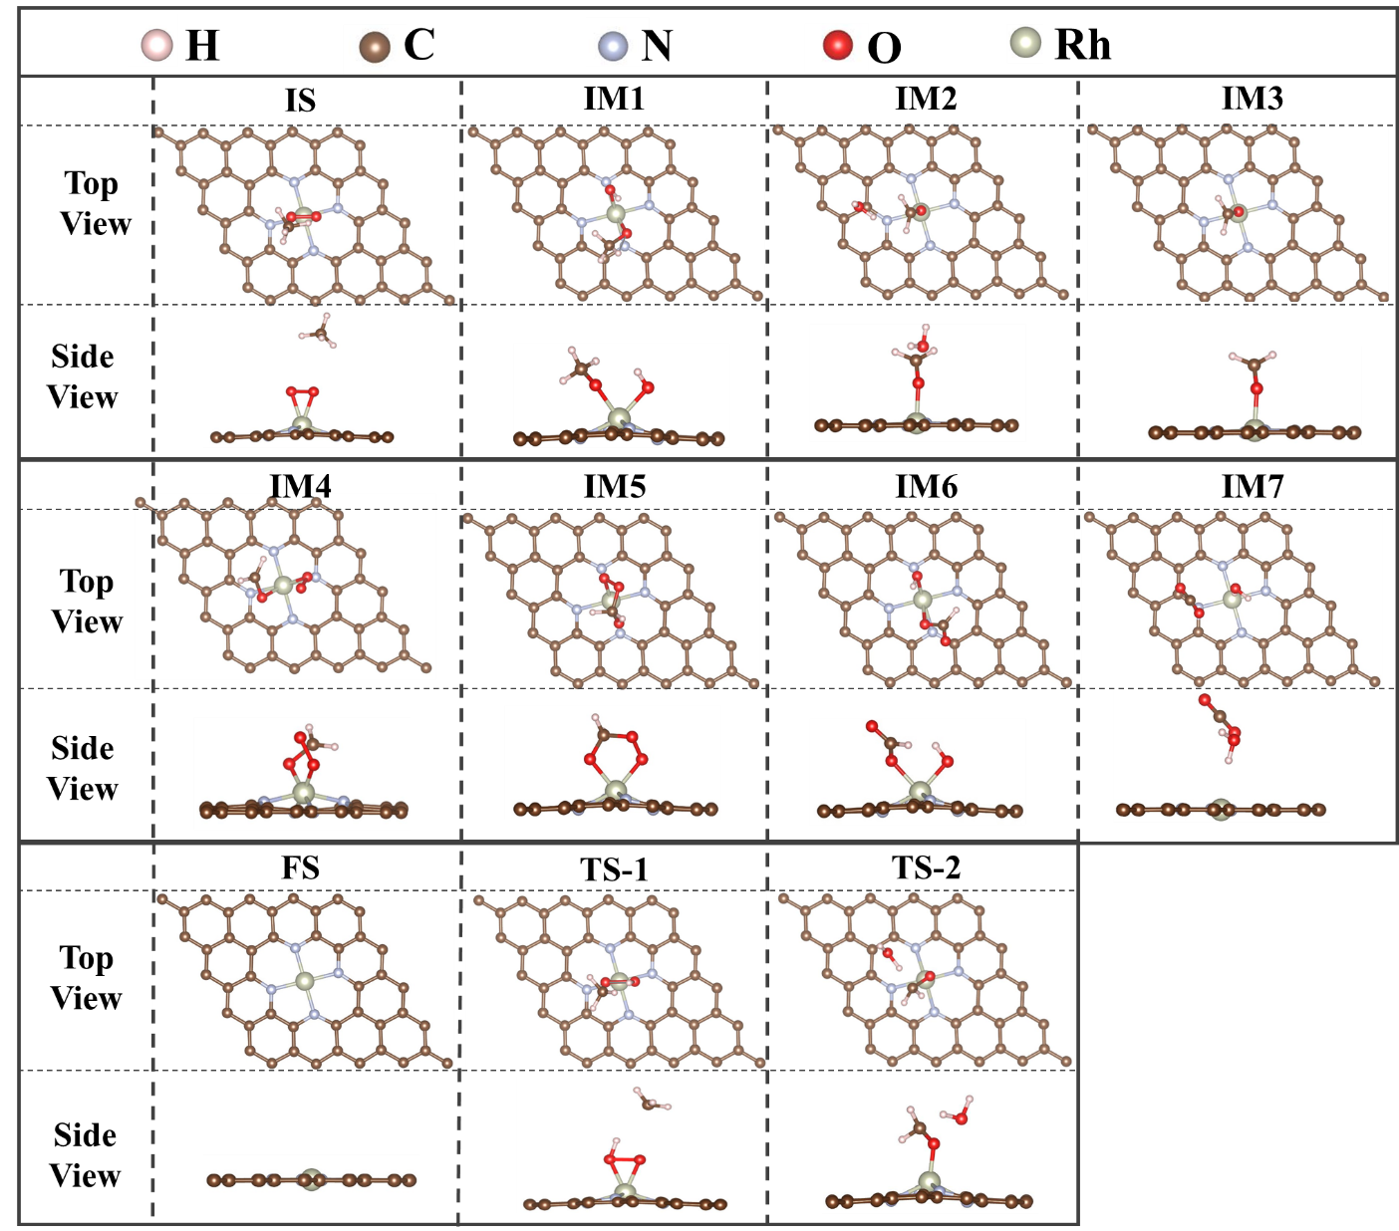
Figure S37. The pathway for the complete oxidation of CH₄ to CO₂ catalyzed by Rh SACs@O₂-a under the adsorbed state obtained through DFT calculation simulation.

Figure S38
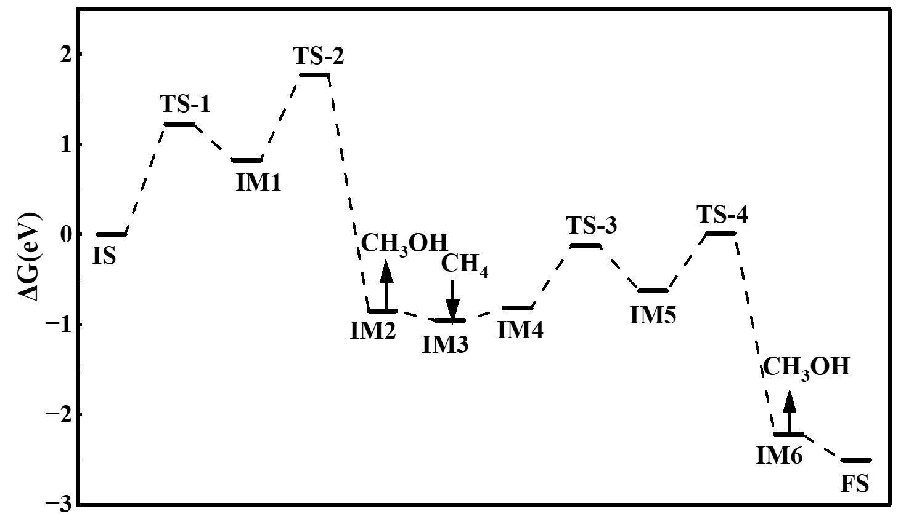
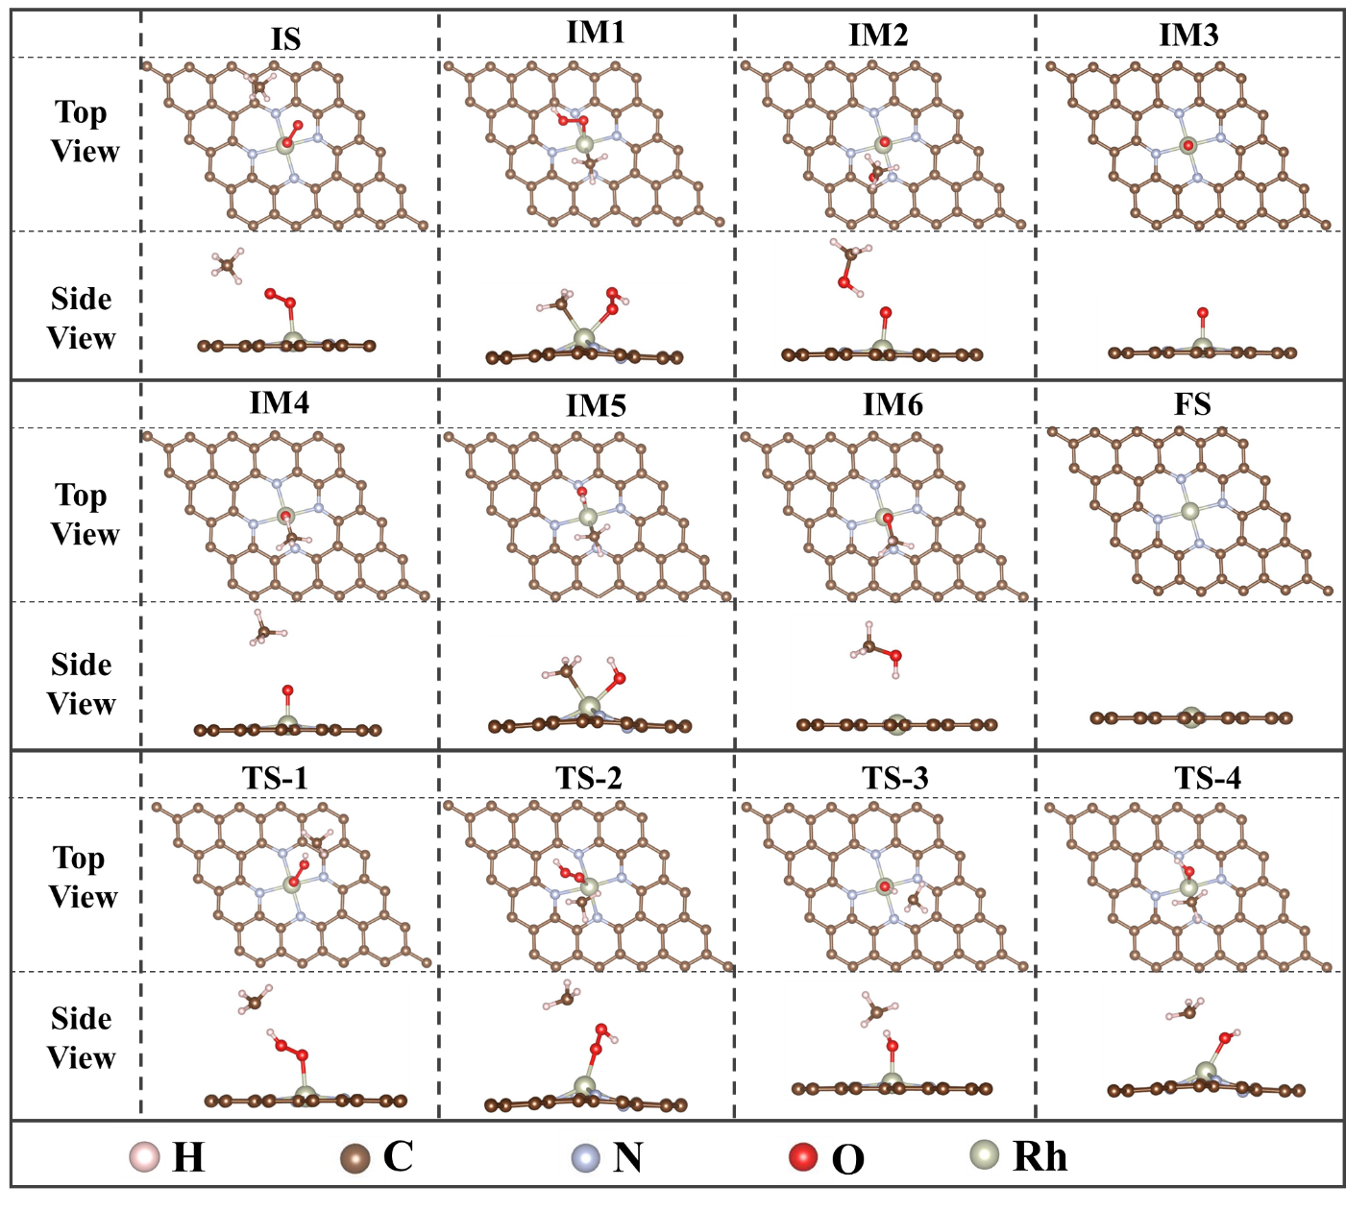
Figure S38. The reaction pathway for the selective oxidation of CH₄ to CH₃OH catalyzed by Rh SACs@O₂-b under the adsorbed state obtained through DFT calculation simulation.

Figure S39
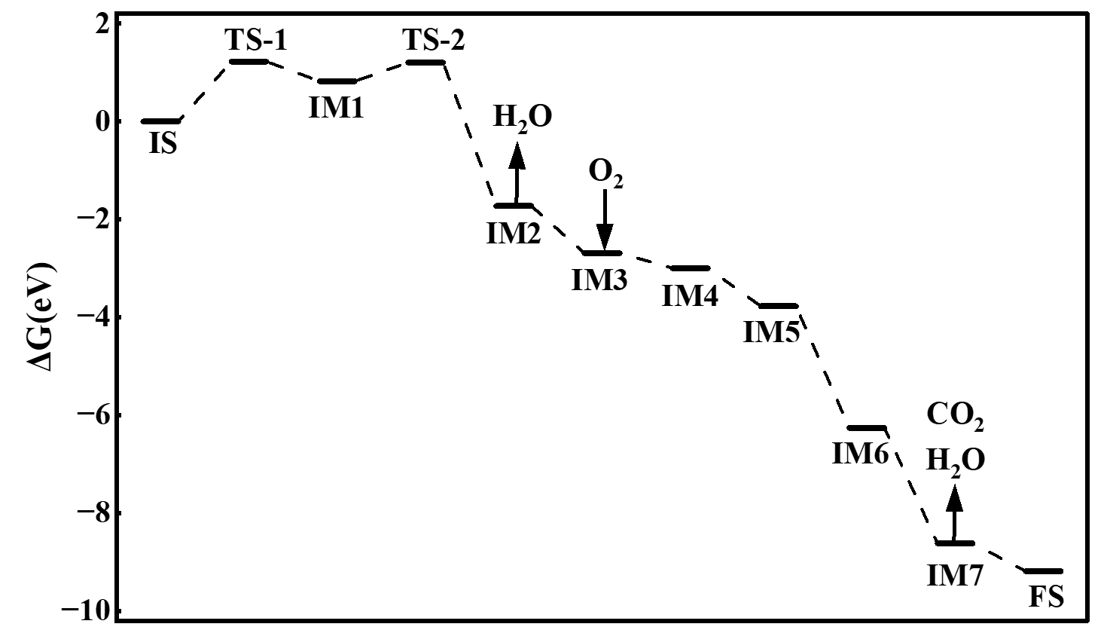
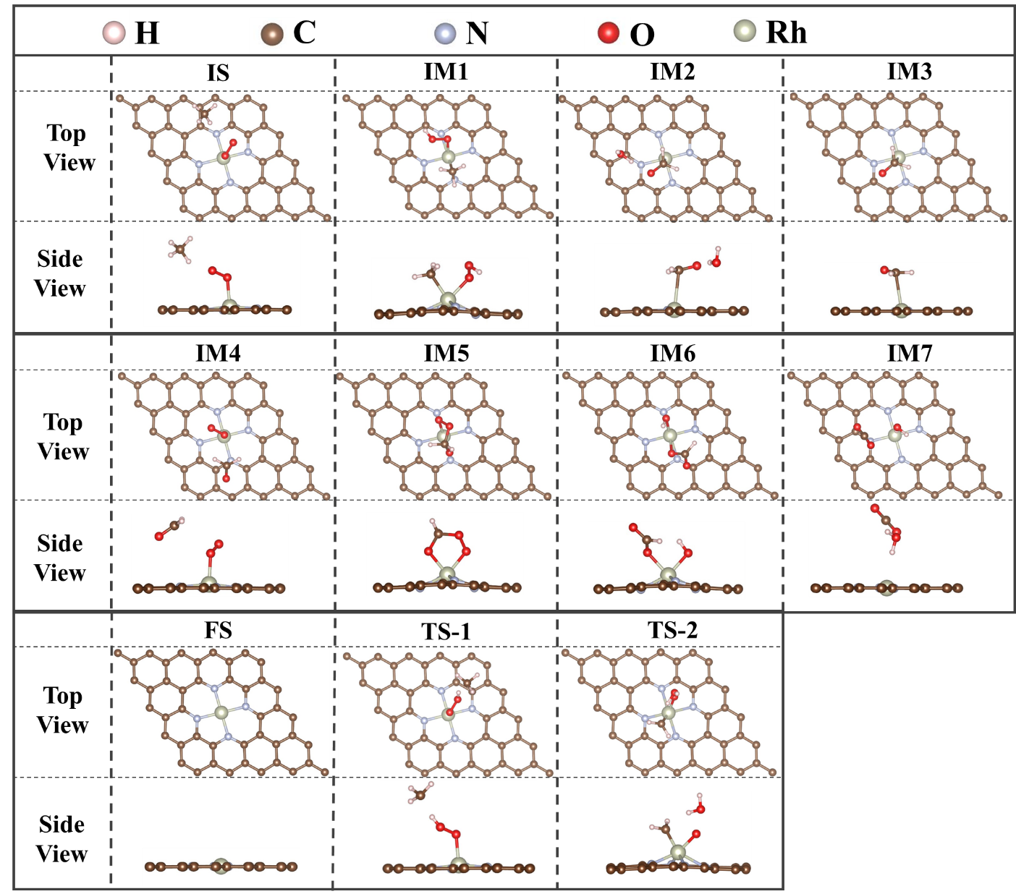
Figure S39. The pathway for the complete oxidation of CH₄ to CO₂ catalyzed by Rh SACs@O₂-b under the adsorbed state obtained through DFT calculation simulation.

Figure S40
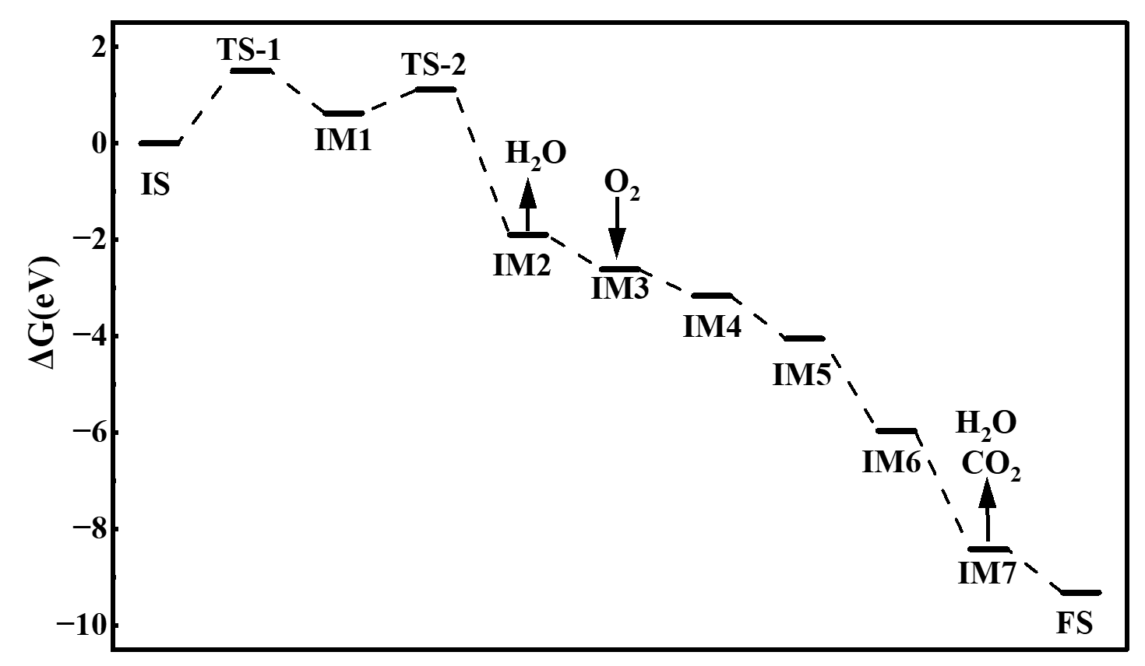
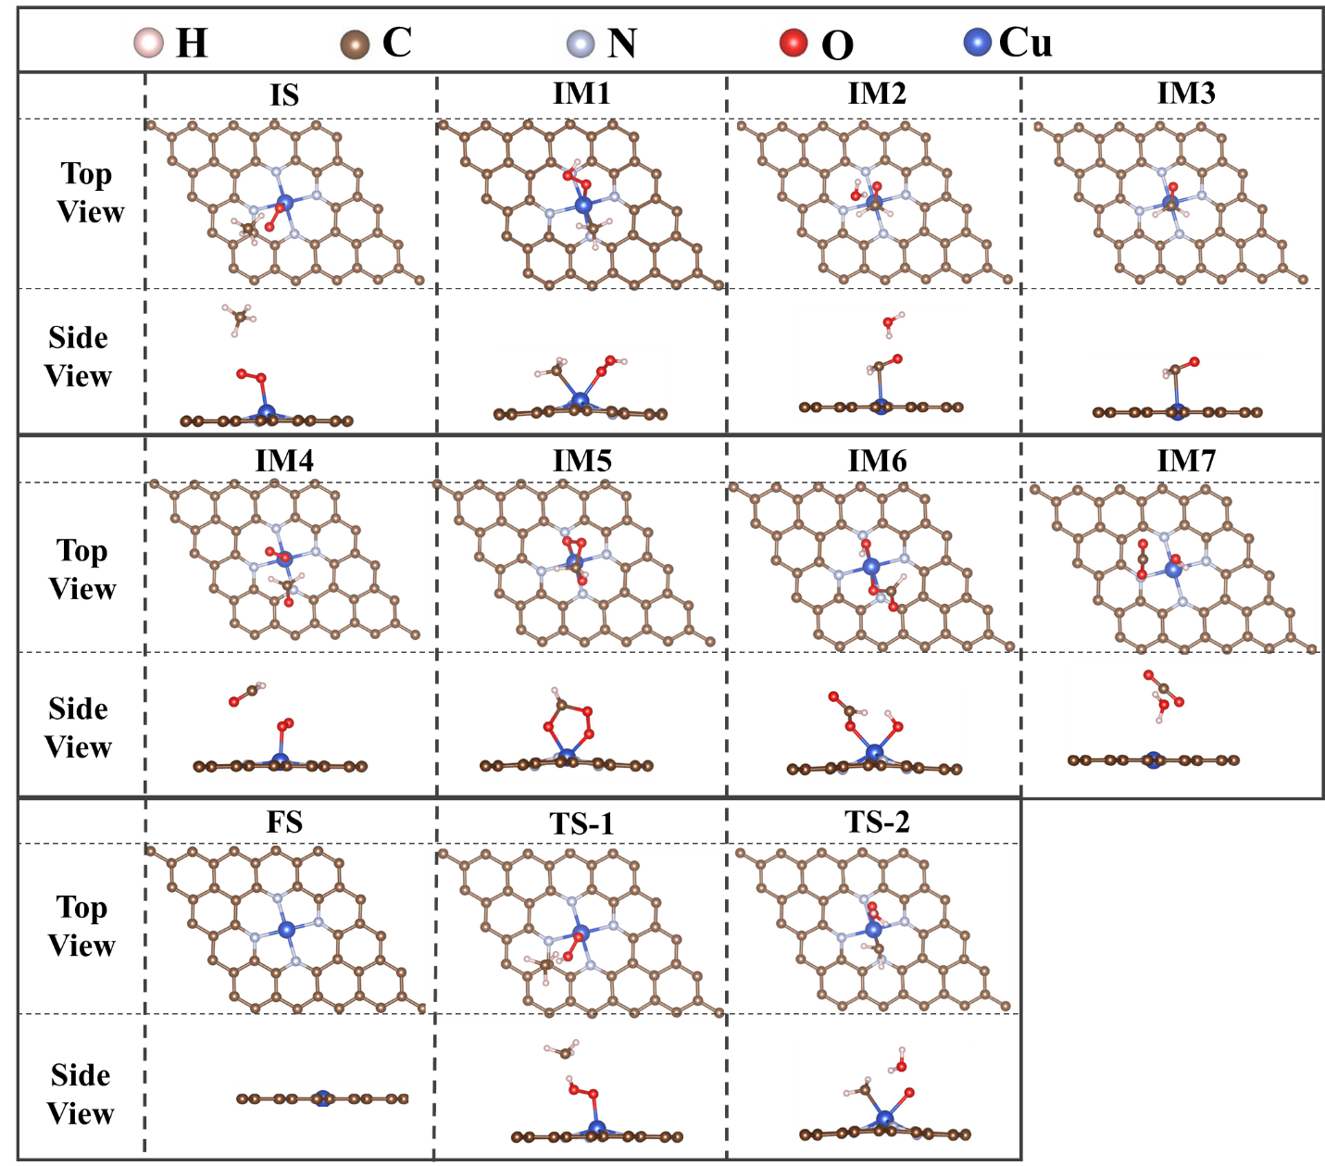
Figure S40. The reaction pathway for the selective oxidation of CH₄ to CH₃OH catalyzed by Cu SACs@O₂-a under the adsorbed state obtained through DFT calculation simulation.

Figure S41
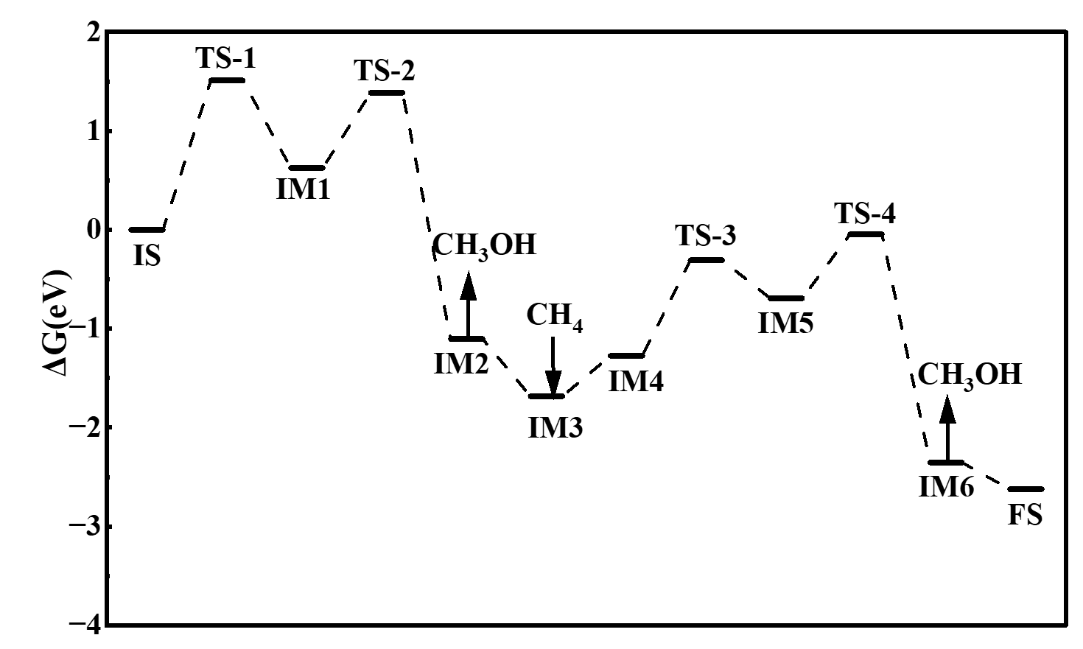
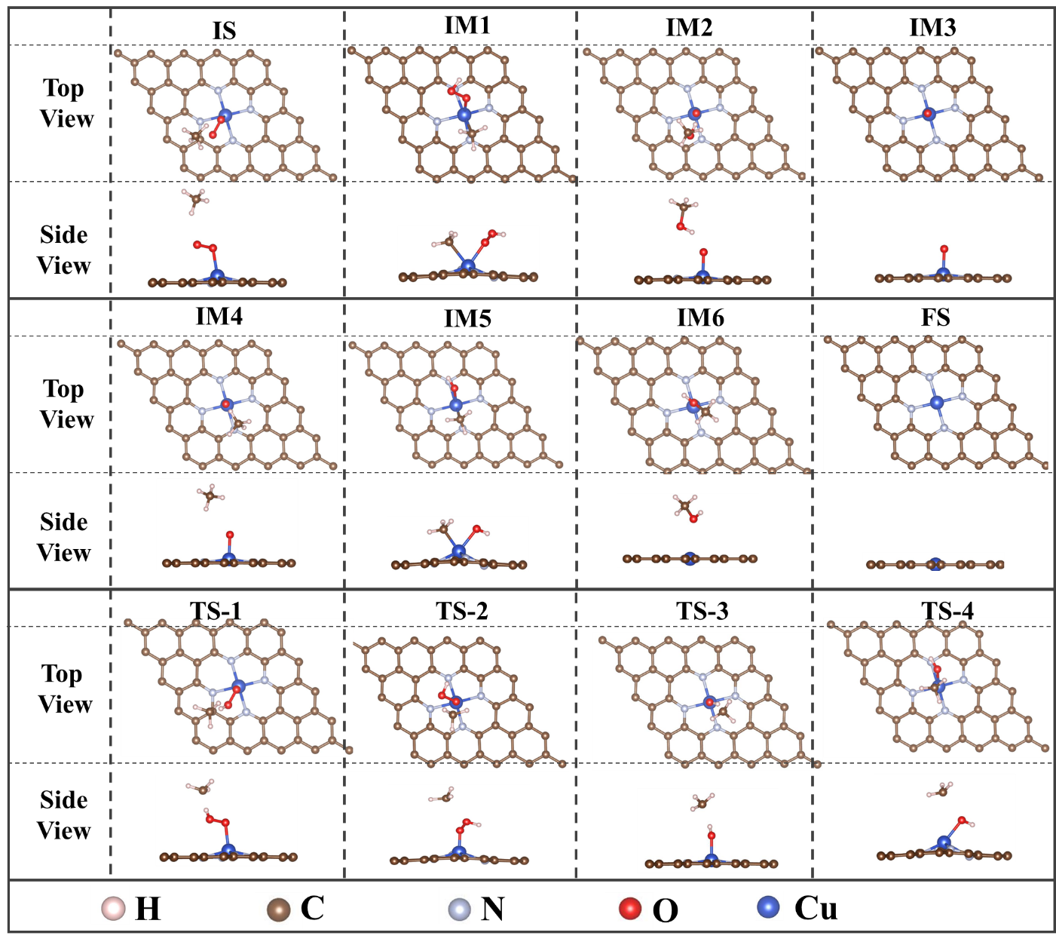
Figure S41. The pathway for the complete oxidation of CH₄ to CO₂ catalyzed by Cu SACs@O₂-a under the adsorbed state obtained through DFT calculation simulation.

Figure S42
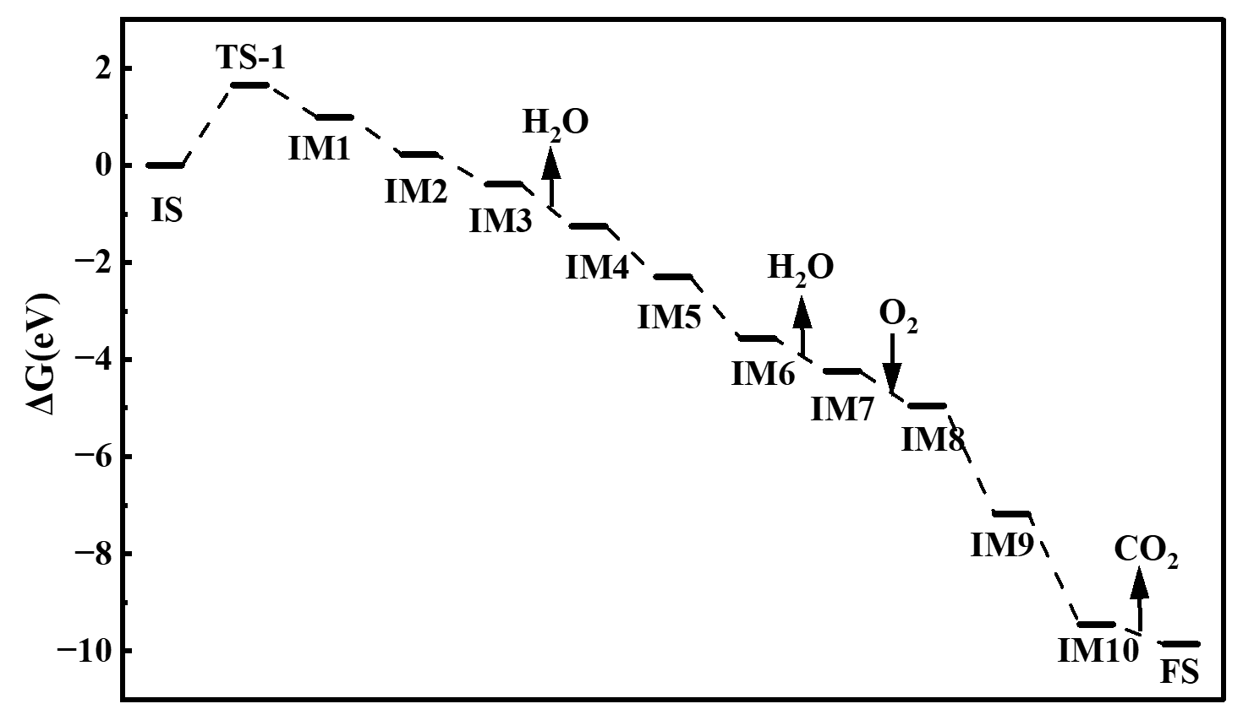
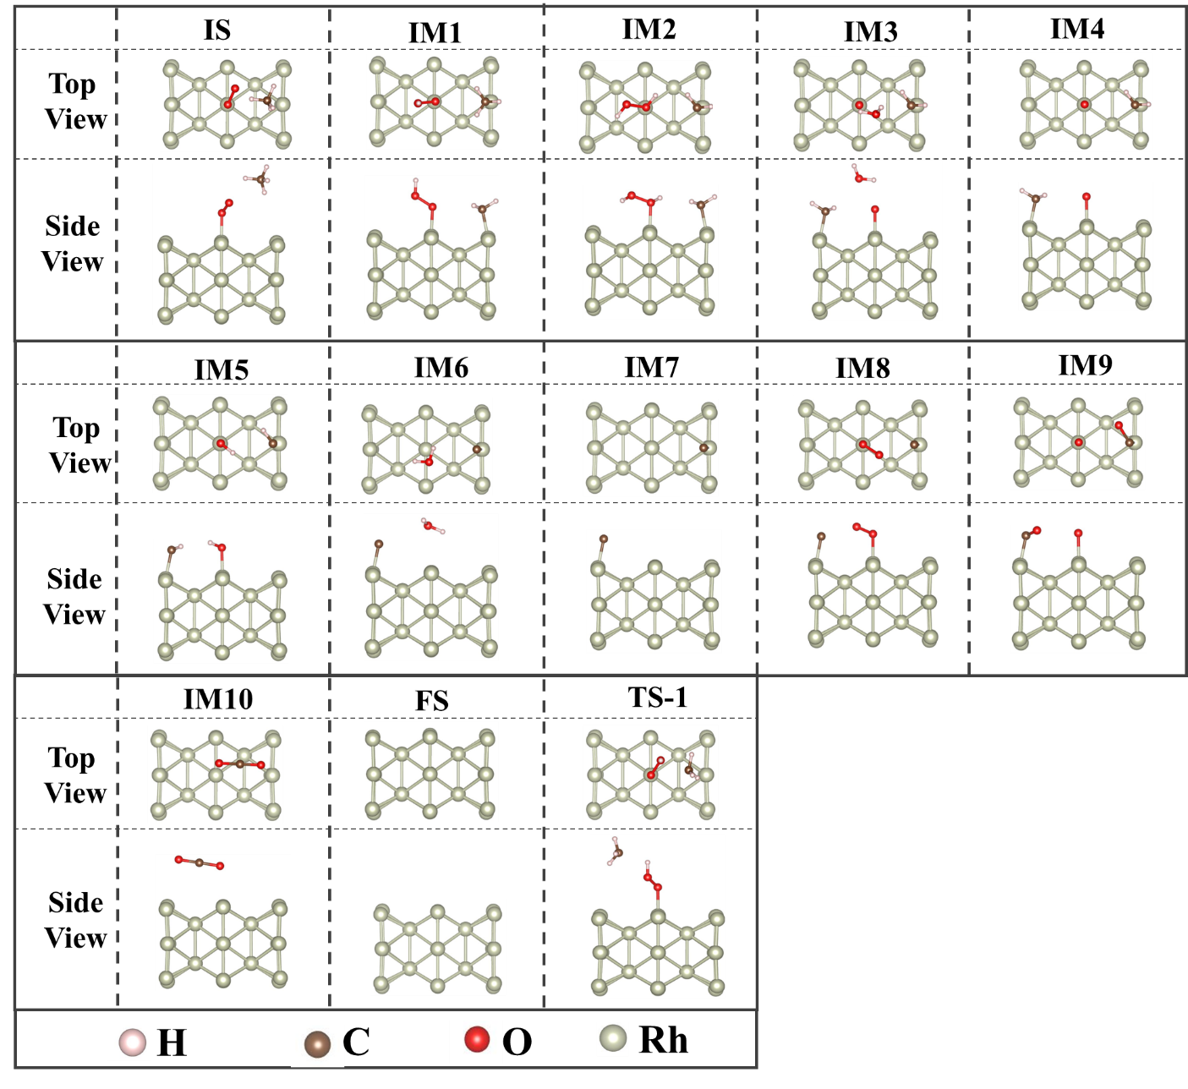
Figure S42. The pathway for the complete oxidation of CH₄ to CO₂ catalyzed by Rh NPs under the adsorbed state obtained through DFT calculation simulation.

Figure S43
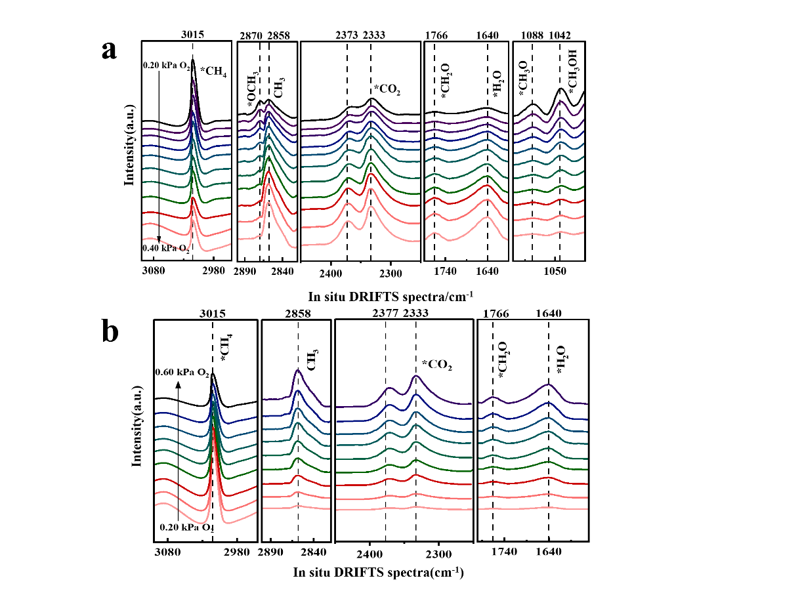
Figure S43. DRIFTS spectra of the catalytic oxidation of methane by RhCu DACs under a high-oxygen state (a); DRIFTS spectra of the catalytic oxidation of methane by Rh SACs (b).

Table S1.
Table S1. Properties of Zn SACs sample obtained by EXAFS spectra.
Sample | Shell | C.N. | R(Å) | 𝝈^{𝟐} ( Å^{𝟐} ) | ∆𝑬_{𝟎} ( 𝒆𝑽 )
Zn foil | Zn-Zn | 6.0 | 2.38 | 0.009 | 3.3
Zn SACs | Zn-N | 3.9 | 1.92 | 0.006 | 2.6
Note: C.N. indicates the coordination number; R indicates the interatomic distances.

Table S2.
Table S2. Specific surface area and pore size data of various samples measured by N₂ physical adsorption.
Samples | Specific surface area (m²/g) | Pore diameter(nm)
ZIF-8 | 1480.43 | 0.60
ZnCu-MOF | 1352.75 | 0.55
RhCu DACs | 628.70 | 0.46
Rh SACs | 509.30 | 0.43
Cu SACs | 470.09 | 0.41

Table S3.
Table S3. Structure parameters extracted from the EXAFS fitting of Rh/Cu K-edge.
Sample | Shell | C.N. | R(Å) | 𝝈^{𝟐} ( Å^{𝟐} ) | ∆𝑬_{𝟎} ( 𝒆𝑽 )
RhCu DACs | Rh-N | 3.3 | 1.92 | 0.010 | 3.5
RhCu DACs | Cu-N | 3.2 | 1.96 | 0.007 | 4.3
RhCu DACs | Rh-Cu | 0.9 | 2.45 | 0.004 | 2.7
Rh SACs | Rh-N | 3.9 | 1.96 | 0.006 | 3.5
Cu SACs | Cu-N | 4.1 | 1.92 | 0.005 | 2.6

Table S4.
Table S4. Calculated binding energy data of various samples.
 | M-NC  (eV) | Graphene  (eV) | C  (eV) | N₂  (eV) | N  (eV) | Rh  (eV) | Cu  (eV) | Formula | Formation energy  (eV)
RhCu DACs | -629.49 | -295.35 | -9.23 | -16.95 | -8.48 | -0.95 | -0.03 | C62  N6  Rh1  Cu1 | -5.37
Rh  SACs | -278.24 | -295.35 | -9.23 | -16.95 | -8.48 | -0.95 | --- | C26  N4  Rh1 | -3.39
Cu  SACs | -274.68 | -295.35 | -9.23 | -16.95 | -8.48 | --- | -0.03 | C26  N4  Cu1 | -0.75

Table S5.
Table S5. Electron transfer of various catalysts with and without oxygen (O₂) adsorption obtained through Density Functional Theory (DFT) simulation.
Electron Transfer (e) |  | RhCu DACs | Rh SACs | Cu SACs
Without O₂- covered | N Received | 4.19 | 3.02 | 2.58
Without O₂- covered | Rh Loss | 0.40 | 1.11 | ---
Without O₂- covered | Cu Loss | 0.70 | --- | 0.84
Without O₂- covered | M(Rh/Cu)→N | 1.10 | 1.11 | 0.84
With O₂- covered | N Received | 3.95 | 2.56 | 2.26
With O₂- covered | Rh Loss | 0.93 | 0.75 | ---
With O₂- covered | Cu Loss | 0.71 | --- | 0.75
With O₂- covered | O₂ Received | 0.63 | 0.45 | 0.27
With O₂- covered | M(Rh/Cu)→N | 1.00 | 0.30 | 0.48

Table S6.
Table S6. Comparison of the selectivities of various catalysts for the selective oxidation of methane to methanol.
Item | Space velocity  （mL/(h·g_{cat}） | Temperature  （K） | Feeds | CH₃OH  Selectivity | Ref.
PCN-250 | 155555 | 393 | CH₄/N₂O/Ar | 68.5% | ^{[9]}
Cu-ZSM-5 | 12000 | 573 | N₂O/CH₄/H₂O/He | 67.1% | ^{[10]}
Cu-CHA | 12000 | 572 | CH₄/H₂O/O₂ | 91% | ^{[11]}
Cu-H-MOR | 18000 | 623 | CH₄/H₂O/N2 | 84.7% | ^{[12]}
Cu-BEA | 12000 | 593 | N₂O/CH₄/H₂O/He | 71.6% | ^{[13]}
RhCu DACs | 60000 | 573 | CH₄/O₂/N₂ | 81.0% | This work

Reference
[1] Kresse G, Hafner J. Ab initiomolecular dynamics for liquid metals [J]. Physical Review B, 1993, 47(1): 558-61.
[2] Kresse G, Furthmüller J. Efficient iterative schemes forab initiototal-energy calculations using a plane-wave basis set [J]. Physical Review B, 1996, 54(16): 11169-86.
[3] Perdew J P, Burke K, Ernzerhof M. Generalized Gradient Approximation Made Simple [J]. Physical Review Letters, 1996, 77(18): 3865-8.
[4] Levämäki H, Kuisma M, Kokko K. Space partitioning of exchange-correlation functionals with the projector augmented-wave method [J]. The Journal of Chemical Physics, 2019, 150(5).
[5] Fang C, Zhou J, Zhang L, et al. Synergy of dual-atom catalysts deviated from the scaling relationship for oxygen evolution reaction [J]. Nature Communications, 2023, 14(1).
[6] Zhang H, Qiu L, Hu D. Finite‐Temperature Dimer Method for Finding Saddle Points on Free Energy Surfaces [J]. Journal of Computational Chemistry, 2019, 40(18): 1701-6.
[7] Ramíarez R, Böhm M C. Simple geometric generation of special points in brillouin‐zone integrations. Two‐dimensional bravais lattices [J]. International Journal of Quantum Chemistry, 2004, 30(3): 391-411.
[8] Jiao Y, Zheng Y, Jaroniec M, et al. Origin of the Electrocatalytic Oxygen Reduction Activity of Graphene-Based Catalysts: A Roadmap to Achieve the Best Performance [J]. Journal of the American Chemical Society, 2014, 136(11): 4394-403.
[9] Dinh K T, Sullivan M M, Serna P, et al. Viewpoint on the Partial Oxidation of Methane to Methanol Using Cu- and Fe-Exchanged Zeolites [J]. ACS Catalysis, 2018, 8(9): 8306-13.
[10] Dai C, Zhang Y, Liu N, et al. Mechanistic insight into the effect of active site motif structures on direct oxidation of methane to methanol over Cu-ZSM-5 [J]. Physical Chemistry Chemical Physics, 2023, 25(36): 24894-903.
[11] Sun L, Wang Y, Wang C, et al. Water-involved methane-selective catalytic oxidation by dioxygen over copper zeolites [J]. Chem, 2021, 7(6): 1557-68.
[12] Jeong Y R, Jung H, Kang J, et al. Continuous Synthesis of Methanol from Methane and Steam over Copper-Mordenite [J]. ACS Catalysis, 2021, 11(3): 1065-70.
[13] Xu R, Liu N, Dai C, et al. H2O‐Built Proton Transfer Bridge Enhances Continuous Methane Oxidation to Methanol over Cu‐BEA Zeolite [J]. Angewandte Chemie, 2021, 133(30): 16770-6.

Corresponding author: * Name: Haojie Geng, Ph.D, Associate Professor, Email: hjgeng@swu.edu.cn; * Name: Nianbing Li, Ph.D, Professor, Email: linb@swu.edu.cn;
* Name: Jingyu Ran, Ph.D, Professor, Email: ranjy@cqu.edu.cn;
# Yanling Gao and Haobo Zhao contributed equally to this paper.

