Supplementary Information
Development of a psychrotolerant composite microbial agent for nitrogen removal and its nitrogen metabolism pathways
Yihua Dong¹ · Jing Xu¹ · Feng Chen² · Liang Li³ · Guangsheng Qian⁴ · Peng Zhang⁵
¹Key Laboratory of Ecological Restoration of Regional Contaminated Environment, Ministry of Education, College of Environment, Shenyang University, Shenyang 110044, China
²Liaoning Huadian Tieling Power Generation Co., Ltd.‌‌, Tieling 112008, Liaoning, China
³Department of Environmental Engineering, School of Resources & Civil Engineering, Northeastern University, Shenyang 110819, China
⁴Datang Environmental Protection Technology Research Institute, Datang Environment Industry Group Co., Ltd., Beijing, 100097, China.
⁵Liaoning Huikang Testing and Evaluation Technology Co., Ltd, Shenyang 110017, Liaoning, China
Corresponding author: Yihua Dong
E-mail addresses: harvesttime@163.com
Tel: +86-13516093662
ORCID: 0000-0002-1305-5604

Table S1 PCR primer list
Target gene | Primer sequence (5’ to 3’)
16S rDNA | 27F:AGTTTGATCMTGGCTCAG  1492R:GGTTACCTTGTTACGACTT
hao | hao-F:GTTTCGGCATGGATACGCT  hao-R:CCAGGCATCAAAGAATACCC
napA | napA-F:CATTGCCGACTATGAAGCTCAGG  napA-R:AAAATATAGCGACTATTGATCTCTTGCAGAAAATATAGCGACTATTGATCTCTTGCAG
nirS | nirS-cd3aF:GTSAACGTSAAGGARACSGG  nirS-R3cd:GASTTCGGRTGSGTCTTGA
nirK | nirK-F:CGAACAAGGCAAGGATTTG  nirK-R:ACTGTCAACACACCGCTCA
cnorB | cnorB-F:CGNGARTTYCTSGARCARCC  cnorB-R:CRTADGCVCCRWAGAAVGC
nosZ | nosZ-F:CCCGCTGCACACC(A/G)CCTTCGA  nosZ-R:CGTCGCC(C/G)GAGATCTCGATCA

Table S2 Levels and coded values of process variables for the Box-Behnken design
Variables | Symbols | Levels ª
Variables | Symbols | -1 | 0 | 1
C/N | A | 5 | 6 | 7
Temperature (℃) | B | 7 | 10 | 13
pH | C | 6.5 | 7.5 | 8.5
Shaking speed (rpm) | D | 140 | 160 | 180
ª low level (−1), center level (0), and high level (+1).

Table S3 Reaction system and process of PCR amplification for function genes
PCR reaction system | Reaction component |  | Volume (μL)
PCR reaction system | 10 X PCR Buffer |  | 2.5
PCR reaction system | dNTP (each 10 mM) |  | 1
PCR reaction system | Taq Plus DNA Polymerase（5 U/μL） |  | 0.2
PCR reaction system | 50mM MgSO₄ |  | 12.5
PCR reaction system | Primers (10 µM) |  | 1
PCR reaction system | Primers 1492R (10 µM) |  | 1
PCR reaction system | Template (DNA) |  | 1
PCR reaction system | ddH₂O |  | 9.5
PCR reaction process | Process | Temperature (℃) | Time | Cycles
PCR reaction process | Pre-denaturation | 94 | 4 min
PCR reaction process | Denaturation | 94 | 45 s | 30
PCR reaction process | Annealing | 55 | 45 s | 30
PCR reaction process | Extension | 72 | 1 min | 30
PCR reaction process | Further extension | 72 | 10 min

Table S4 Experimental matrices based on Box-Behnken design and their respective responses
Run | Independent variables |  |  |  | Response variable (Y)
Run | A-C/N | B-Temperature (℃) | C-pH | D-shaking speed (r/min) | TN removal efficiency (%)
1 | 5 | 7 | 7.5 | 160 | 80.76
2 | 7 | 7 | 7.5 | 160 | 76.08
3 | 5 | 13 | 7.5 | 160 | 82.05
4 | 7 | 13 | 7.5 | 160 | 80.24
5 | 6 | 10 | 6.5 | 140 | 83.55
6 | 6 | 10 | 8.5 | 140 | 75.01
7 | 6 | 10 | 6.5 | 180 | 81.72
8 | 6 | 10 | 8.5 | 180 | 74.17
9 | 5 | 10 | 7.5 | 140 | 86.09
10 | 7 | 10 | 7.5 | 140 | 83.91
11 | 5 | 10 | 7.5 | 180 | 83.78
12 | 7 | 10 | 7.5 | 180 | 80.89
13 | 6 | 7 | 6.5 | 160 | 77.97
14 | 6 | 13 | 6.5 | 160 | 79.87
15 | 6 | 7 | 8.5 | 160 | 67.75
16 | 6 | 13 | 8.5 | 160 | 70.35
17 | 5 | 10 | 6.5 | 160 | 85.56
18 | 7 | 10 | 6.5 | 160 | 82.37
19 | 5 | 10 | 8.5 | 160 | 76.31
20 | 7 | 10 | 8.5 | 160 | 71.85
21 | 6 | 7 | 7.5 | 140 | 79.58
22 | 6 | 13 | 7.5 | 140 | 80.83
23 | 6 | 7 | 7.5 | 180 | 72.61
24 | 6 | 13 | 7.5 | 180 | 79.18
25 | 6 | 10 | 7.5 | 160 | 90.67
26 | 6 | 10 | 7.5 | 160 | 89.20
27 | 6 | 10 | 7.5 | 160 | 89.28
28 | 6 | 10 | 7.5 | 160 | 88.36
29 | 6 | 10 | 7.5 | 160 | 89.64

Table S5 Base length of functional genes for key enzyme of isolated strains
Strains | hao | napA | nirS | nirK | conrB | nosZ
Pseudomonas veronii HN1 | 282bp |  |  |  |  | 396bp
Pseudomonas poae HN2 | 265bp |  |  |  |  | 352bp
Pseudomonas peli HN3 | 1752bp |  |  |  |  | 298bp
Aeromonas sp. AD1 |  | 471bp | 394bp | 413bp | 624bp | 314bp
Pseudomonas extremaustralis AD2 |  | 482bp | 395bp | 686bp | 616bp | 539bp
Serratia liquefaciens AD3 |  | 891bp | 374bp | 198bp | 592bp | 281bp

Fig. S1 Cell morphology of isolated strains by SEM
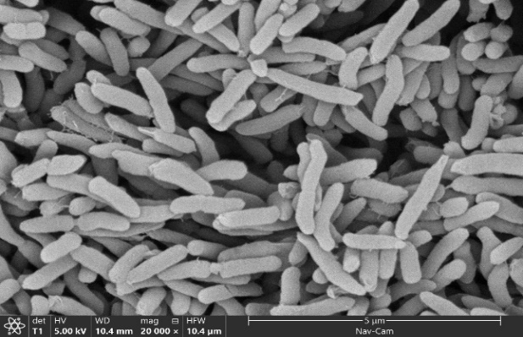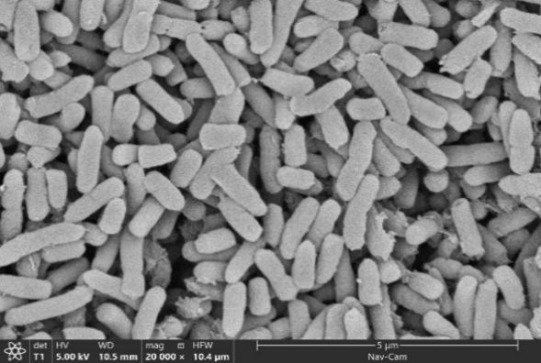
(A) HN1 (B) HN2
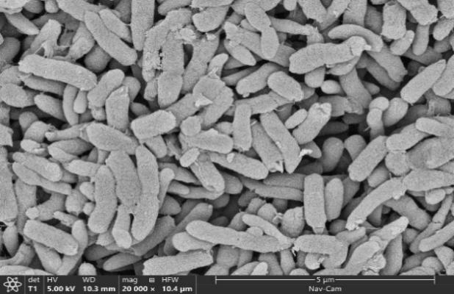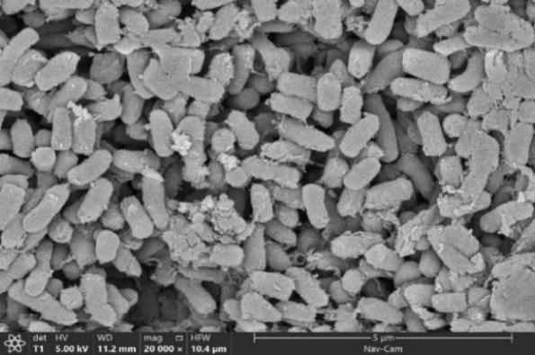
(C) HN3 (D) AD1
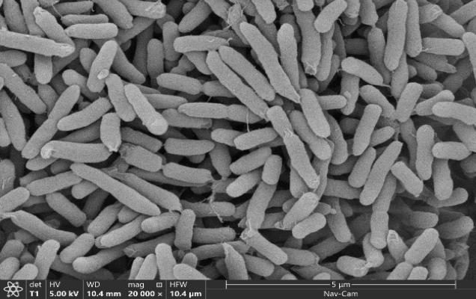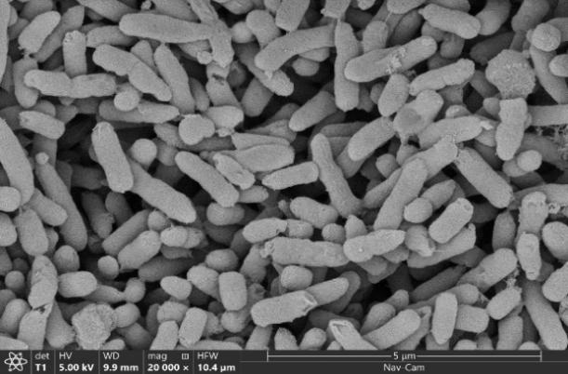
(E) AD2 (F) AD3

Fig. S2 Phylogenetic tree constructed with the neighbor-joining method from six isolated strains and reference strains. 0.005 presents the genetic distance
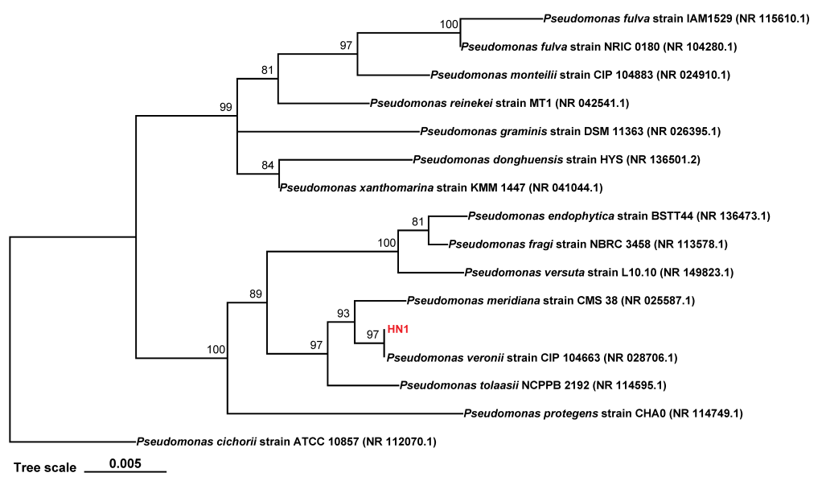
(A) HN1
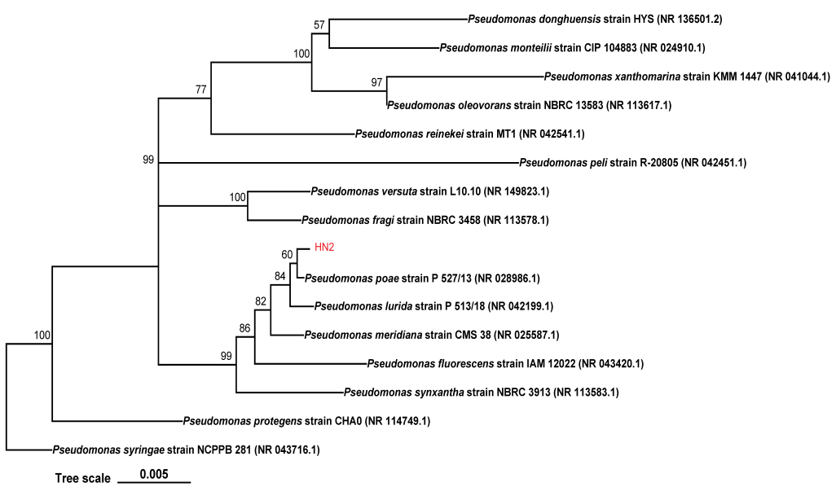
(B) HN2
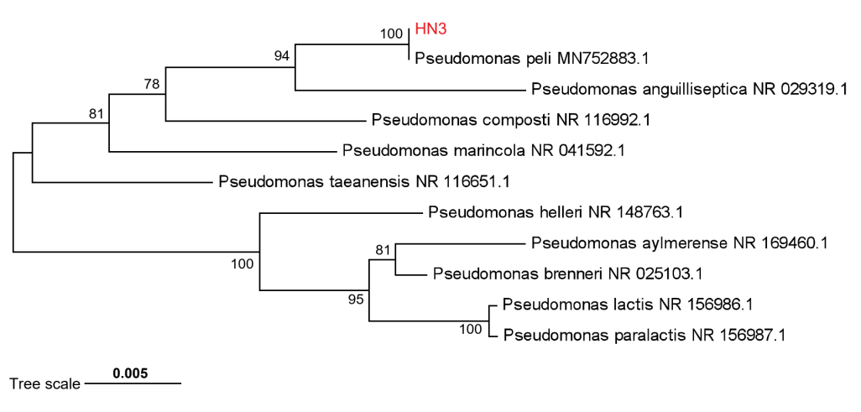
(C) HN3

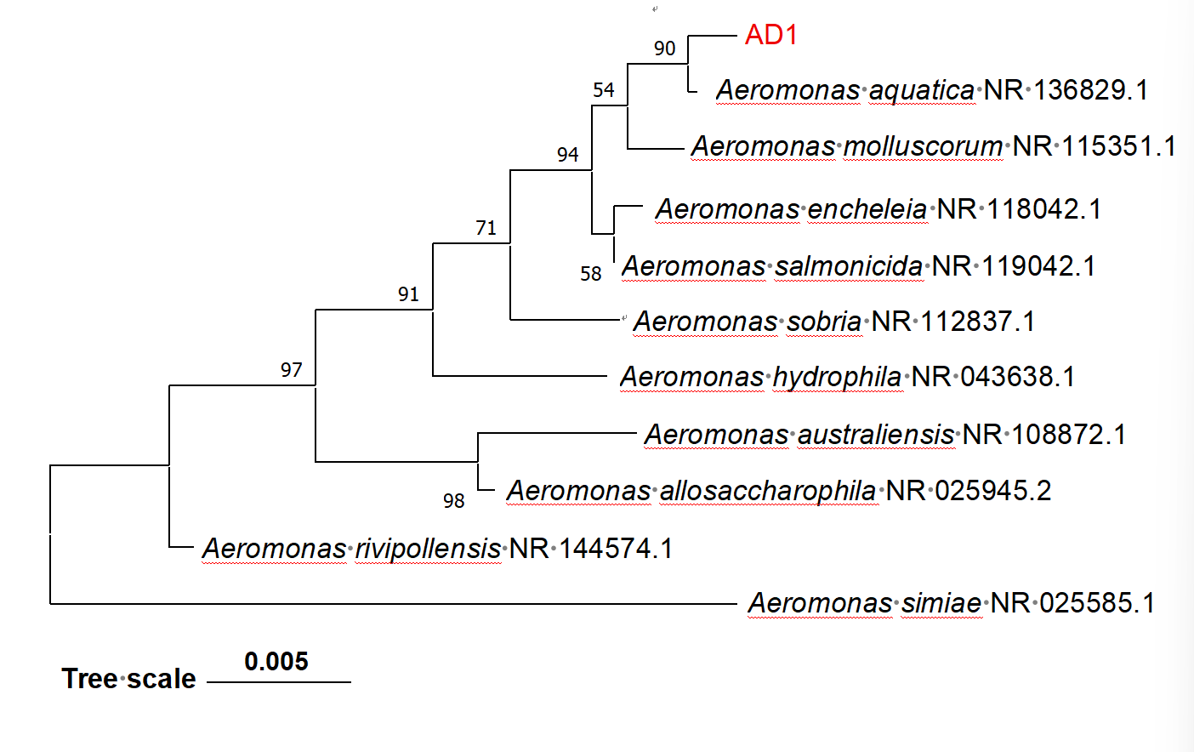
(D) AD1

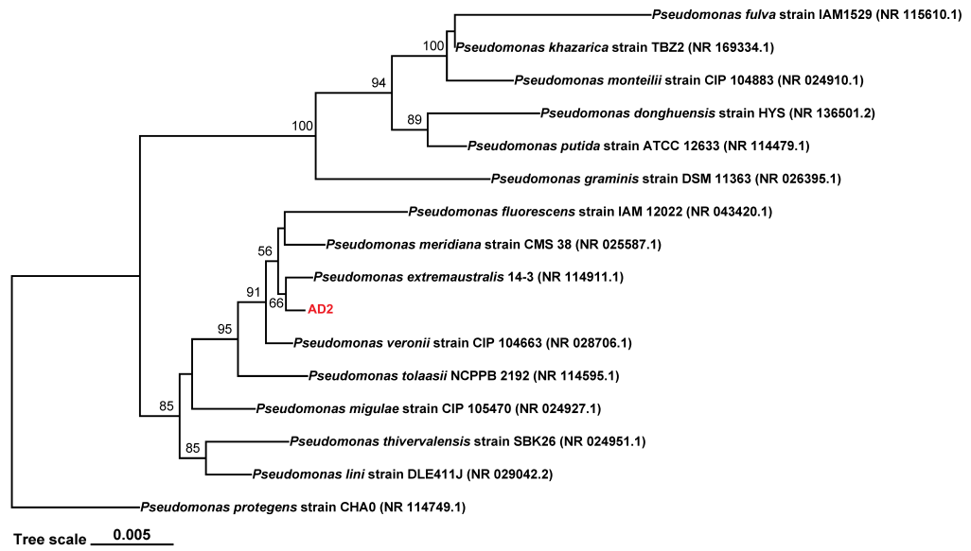
(E) AD2

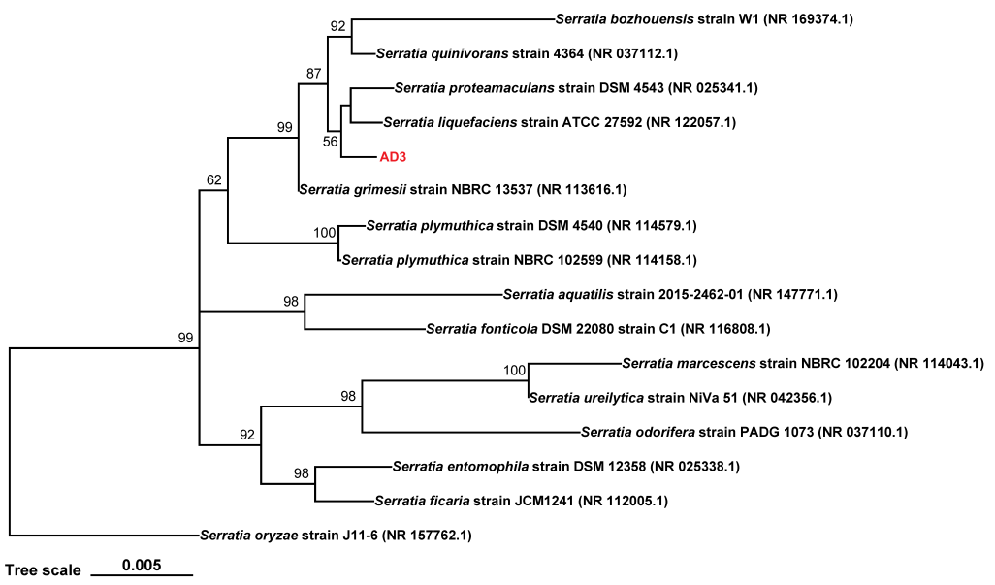
(F) AD3

