Urbanity in the countryside: interaction of livelihood, lifestyle, connectivity and rural greening

Results sections

Interaction of urbanity, population dynamics, household shifts, and ecological outcomes

Distribution of urbanity index in urban-rural typology
Although the median urbanity index remained lower in rural areas than in urban zones, some villages and rural centers exhibited urbanity levels that surpassed the medians of urban and town areas, suggesting that urbanization had significantly penetrated traditional rural regions (Appendix Fig. 1). The mapping process of the urbanity index is described in Section 2.1: Mapping urbanity index.
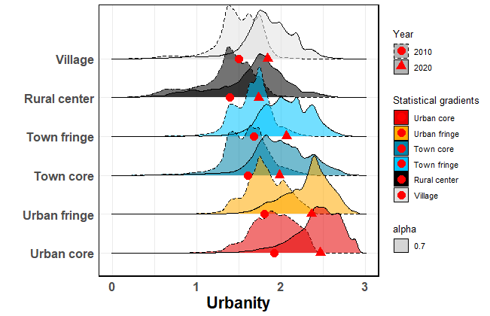
Appendix Fig. 1: Distribution of urbanity index in urban-rural typology. Red circles indicate the median values in 2010, and red triangles represent the median values in 2020.

Distribution of tree cover, food production and cropland ratio in urban-rural typology
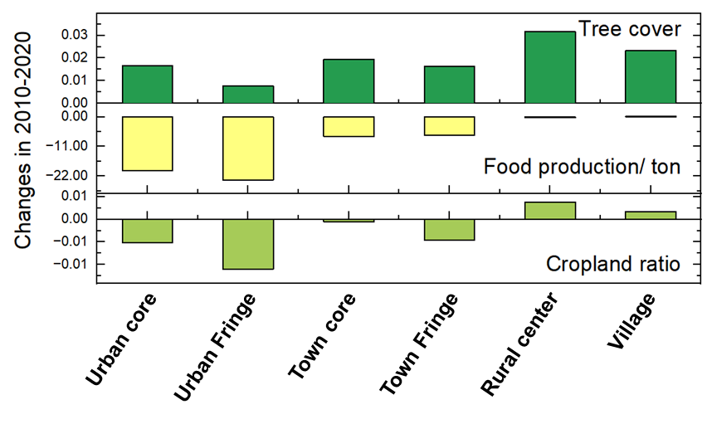
Appendix Fig. 2: Distribution of tree cover, cropland ratio, and food production in urban-rural typology.

Result of partial correlation
See detail in the Appendix Table 1-Partial correlation results.xlsx

Results of LMMs
See detail in the Appendix Table 2-Fixed effects based on LMMs.xlsx
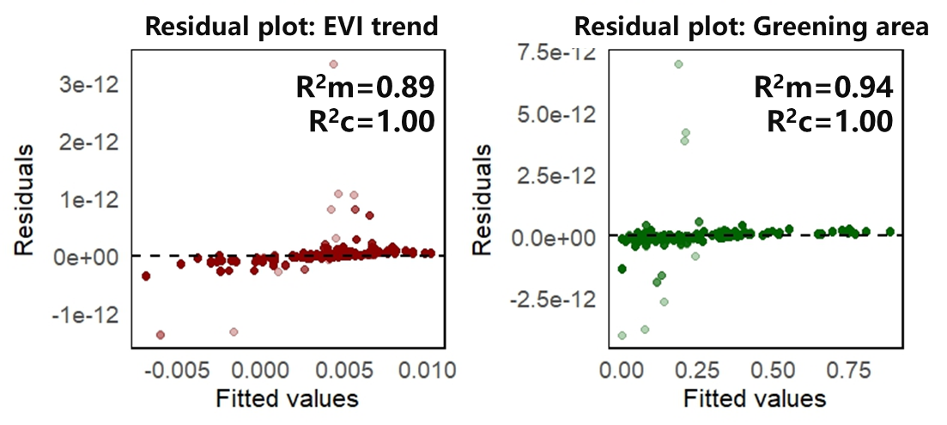
Appendix Fig. 3: Residual distribution of LMMs.

Comparison of socio-ecological factors in areas with co-varying population and EVI
The results reveal opposite spatial patterns of population and EVI changes along the urban–rural typology (Appendix Fig. 4a, b). Approximately 35.0% of the study area exhibited significantly increasing EVI trends (0.0038/year), with 50.0% of these greening zones classified as PopDe-G, mostly located in rural centers and villages. Additionally, 29.4% of rural areas fell under the PopIn-G category, whereas 34.7% of urban areas were dominated by the PopIn-G type. These findings indicate that rural regions are the primary zones of vegetation recovery, particularly in areas experiencing population decline. This underscores the need to compare socio-ecological conditions across rural interaction types.

Based on the dynamics of population density and EVI change, we classified the rural area that including rural center and village into four interaction types: (1) Rural population decreases with EVI greening (RPopDe-G), (2) Rural population increases with EVI greening (RPopIn-G), (3) Rural population decreases with EVI browning (RPopDe-B), and (4) Rural population increases with EVI browning (RPopIn-B). Significant differences in socio-ecological variables were found among the four interaction types in rural areas (Appendix Fig. 4c–j and Appendix Fig. 5).

In rural areas, the four combined categories of population and vegetation change exhibit significant differences in socio-ecological factors (Appendix Fig. 4c–j). Results from the Kruskal–Wallis and Dunn's post-hoc tests (Appendix Table 3: Kruskal–Wallis and Dunn test.xlsx) show that the urbanity index increased more significantly in areas with population growth, with the highest median value observed in the RPopIn-B type (0.42) and the lowest in the RPopDe-G type (0.35) (Fig. 2c). This suggests that low levels of urbanization and lagging socioeconomic development are important background conditions for population outmigration.

In terms of land management, the RPopDe-G regions showed increasing trends in tree cover, cropland ratio, and food production, reaching the highest median values of 2.58%, –0.0002, and 1.72 t, respectively. In contrast, the RPopIn-B areas experienced a decline in cropland ratio (–0.02) and a sharp reduction in food production (–16.91 t). These differences indicate that population decline areas have achieved ecological restoration through land-use improvements, such as maintaining cropland and enhancing vegetation and productivity, whereas population increase areas face dual pressures of land scarcity and reduced agricultural output.

Regarding natural conditions, RPopDe-G regions are often located in areas with steeper terrain (median slope = 1.14°), while RPopIn-B regions are the flattest (0.29°). In terms of climate, vegetation browning areas experienced more pronounced warming, with RPopIn-B showing the greatest increase in annual temperature (0.68 °C) and the highest rise in precipitation (39.79 mm). Additionally, increases in CO₂ emissions were aligned with population growth, with RPopIn-B again showing the largest rise (0.00024). These results suggest that population growth combined with climate stress and anthropogenic emissions may be key drivers of vegetation degradation.
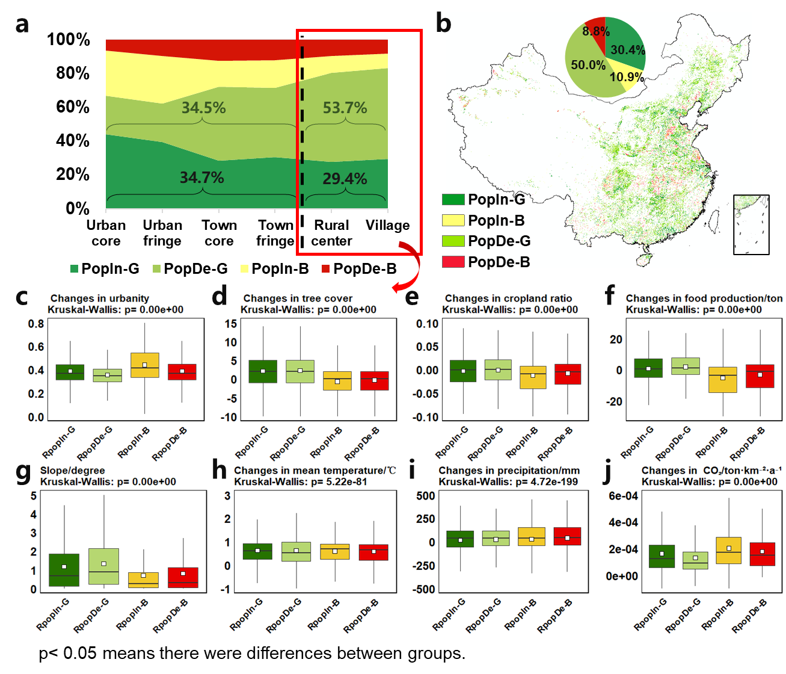
Appendix Fig. 4: Comparison among drivers in areas of rural population change and EVI change. a, Percentage and b, spatial distribution of population change and EVI change areas across urban-rural typology. c-j, Comparison among changes in urbanity, tree cover ratio, cropland ratio, food production, slope, annual average precipitation and temperature, and CO₂ in rural area (include the rural center and village).
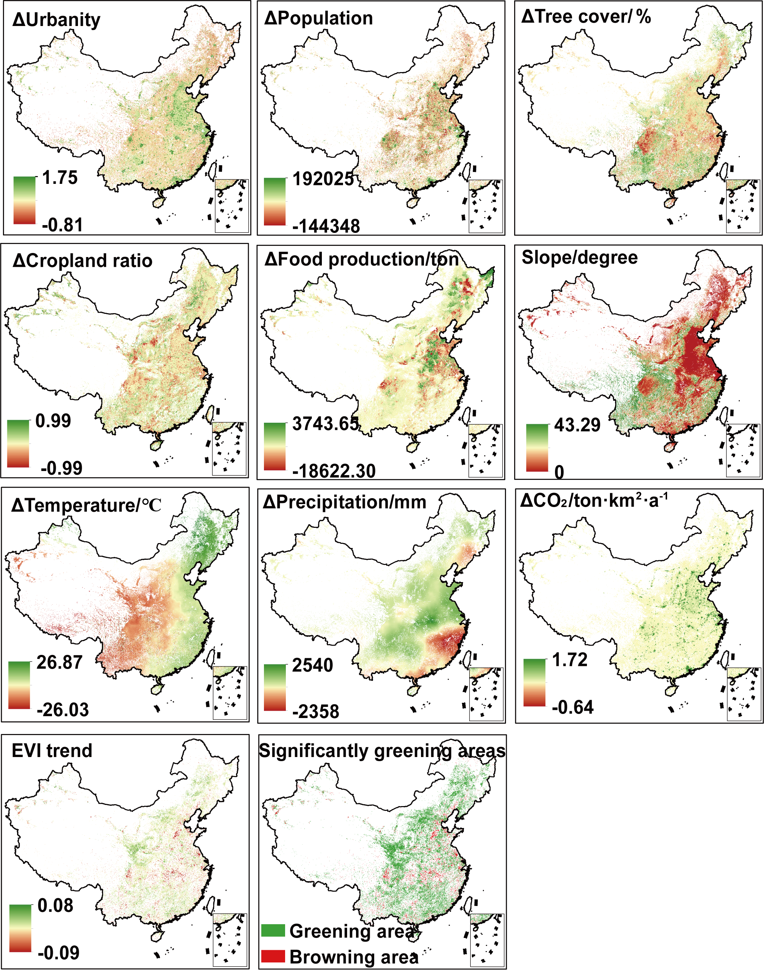
Appendix Fig. 5: Spatial distribution of changes in various factors.

Path analysis of the exogenous-endogenous hypothesis
See detail in the Appendix Table 4-Exogenous_pathways.xlsx
See detail in the Appendix Table 5-Endogenous_pathways.xlsx

Data sections

Mapping urbanity index

Mapping process
First, the proportion of built-up land in the 1000m grid of the study area was calculated and then stored in the personal database assets of GEE uniformly with the population density, nightlight, elevation, and slope (Appendix Fig. 6a). 1000m POIs kernel density subset raster were generated for the corresponding POIs categories in ArcGIS 10.4, respectively, and then summed up to get the kernel density raster for livelihood infrastructure (healthcare, financial institutions, businesses, factories, and scientific education), lifestyle infrastructure (leisure and entertainment, shopping, and dining.), and connectivity infrastructure (highways, primary, secondary, and tertiary roads, railways, train stations, airports, telecommunications outlets, and courier stations), respectively, and finally uploaded to the personal database of GEE (Appendix Fig. 6b, c).

Taking the livelihood infrastructure raster as an example, since it is continuous data, the random forest adopts the parameter setting of "regression". Considering the computing memory and data volume of GEE, we set up 100 regression trees, and separated the feature variables and target variables into 70% as training samples and 30% as validation samples to test the accuracy of the regression results of random forest (Appendix Fig. 6d). The metrics for outcome assessment were used as RMSE, R-squared for linear fit between observed and predicted variables (Appendix Fig. 6e). Finally, the predicted layers, urbanity index raster was obtained by using the summation of livelihood infrastructure index, lifestyle infrastructure index, and connectivity infrastructure index (Appendix Fig. 6f).
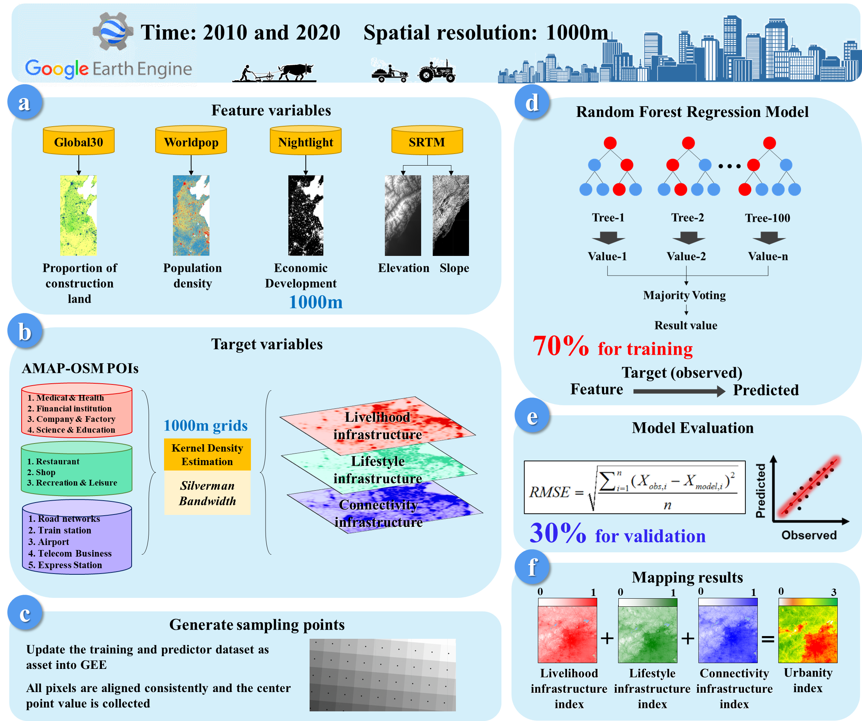
Appendix Fig. 6: Workflow for mapping the urbanity index.

Model evaluation
To evaluate the robustness of the spatial random forest regression models, we divided the dataset into 70% training samples and 30% validation samples, and calculated both R² and RMSE between the feature variables and the target variables for each subset. The results showed that all six models (across three dimensions for 2010 and 2020) achieved R² values above 0.85, and the RMSE for training samples was lower than that for validation samples, indicating strong model robustness (Appendix Fig. 7a, b).

In addition, the relative importance of feature variables revealed that elevation was the most influential factor, followed by population density, night-time light intensity, urban construction land ratio, and slope. This suggests that among topographic factors, elevation differences, rather than slope variability, exert the greatest influence on livelihoods, lifestyles, and connectivity. Furthermore, population aggregation and economic development played key roles in shaping both the levels and spatial distribution of these urban-rural interaction dimensions (Appendix Fig. 7c).
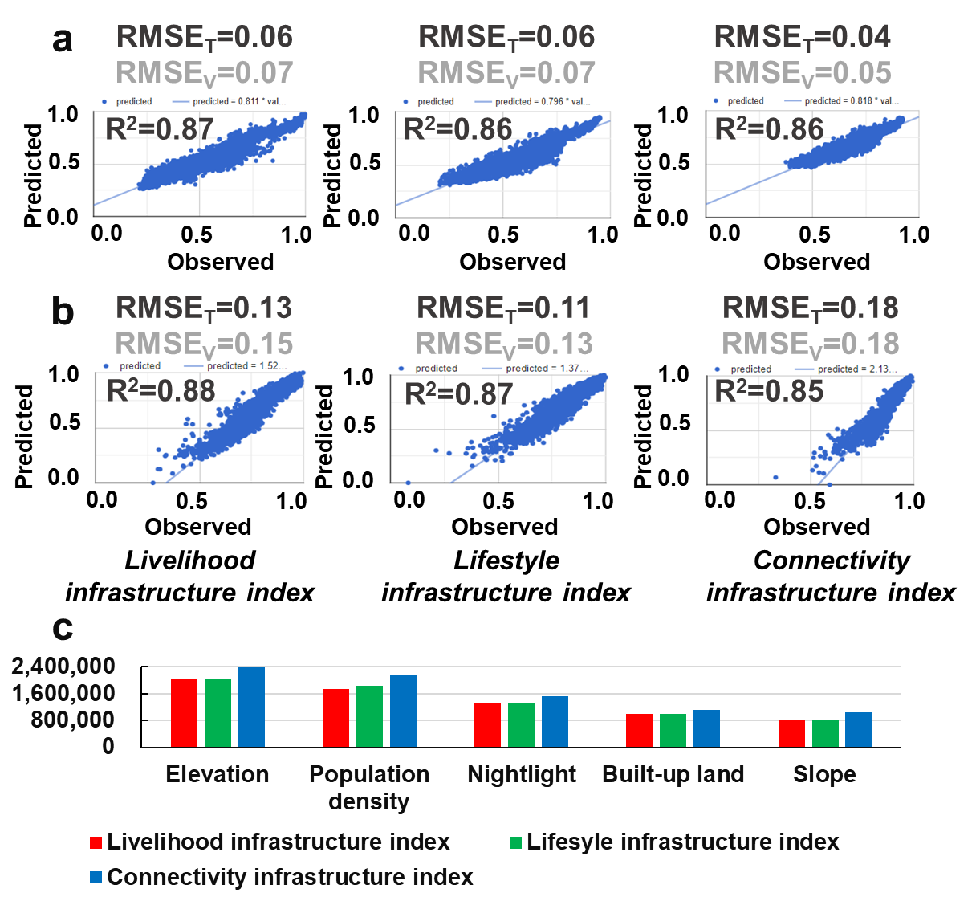
Appendix Fig. 7: Workflow for mapping the urbanity index. a and b, Model evaluation results for six random forest models representing the livelihood infrastructure index, lifestyle infrastructure index, and connectivity infrastructure index in 2010 and 2020, respectively. c, Relative importance of feature variables in predicting the target variables (2020 results shown as representative due to consistent patterns across years).

Comparison with other products
We conducted a comparative analysis between our urbanity index and three representative global urban products based on different urban-rural frameworks: the Global Urban Boundary (GUB) based on a binary urban–rural model ¹, the Global Human Settlement Layer (GHSL) based on an urban–rural gradient model ², and the Urban–Rural Catchment (URC) map based on an urban–rural continuum framework ³ (Appendix Fig. 8 and Appendix Fig. 9).

The GUB dataset integrates multiple urban growth models to delineate global urban boundaries from 1990 to 2020. It fills internal “holes” in urban areas and smooths fragmented edges using morphological operations, resulting in vector-based urban boundaries at a spatial resolution of 30 m. To ensure consistency with the urbanity index, we rasterized the GUB data and resampled it to 1000 m resolution. The dataset distinguishes between urban influence areas (GUB areas) and urban influence-free areas (non GUB areas) (Appendix Fig. 8a and Appendix Fig. 9a).

The GHSL dataset is generated based on 2020 population density and built-up area classification rules, with a spatial resolution of 1000 m. It contains seven urban–rural gradient classes: Urban centre, Dense urban cluster, Semi-dense urban cluster, Suburban, Rural cluster, Low-density rural, and Very low-density rural. Among them, the first four classes are defined as urban influence areas, while the last three represent urban influence-free areas (Appendix Fig. 8b and Appendix Fig. 9b).

The Urban–Rural Catchment (URC) map builds on the urban–rural continuum concept, using a least-cost path algorithm to estimate travel time to cities of different sizes ⁴. The classification includes 14 types, from Large city, Intermediate city, and Small city to <1 hour to large city, <1 hour to intermediate city, <1 hour to small city, and 1–2 hours to large city. Types 1 through 13 are considered urban influence areas, while Type 14 represents urban influence-free areas (Appendix Fig. 8c and Appendix Fig. 9c).

The results show that the GUB product represents a discrete, binary spatial configuration of urbanization. While it captures the spatial footprint of urban entities, it fails to reflect the degree of urbanization or characteristics of urbanization beyond physical city boundaries (Appendix Fig. 8a). Notably, some areas outside GUB-defined boundaries exhibit urbanity index values comparable to those within GUB regions (e.g., values of 2-3), indicating urban influence (Appendix Fig. 8a). Moreover, GUB-defined urban influence areas cover only 2.7% of the national grid, substantially lower than the 50% coverage represented by urbanity-based areas (based on median threshold). The remaining 97.3% of grid cells, many of which show moderate to high urbanity levels, reveal the limitations of binary urban–rural models in capturing urban influence outside core urban entities (Appendix Fig. 9a, d, and e).

From the perspective of urban–rural gradient models, the GHSL product captures multiple levels of urbanization intensity, from high to low (Appendix Fig. 8b). However, comparisons reveal that the urbanity index does not strictly follow the monotonic spatial decay typically assumed in traditional gradient models. For example, areas classified as Rural cluster have a median urbanity index of 2.04, which is similar to Semi-dense urban cluster (2.15) and even higher in some Suburban zones (2.24) than in small urban centers. Spatially, GHSL-defined urban influence areas cover 7.2% of the national grid—larger than GUB’s but still notably smaller than that of urbanity areas (Appendix Fig. 9b, d, and e).

The Urban–Rural Catchment (URC) product, based on the urban–rural continuum framework, captures urban influence over a broader spatial range extending beyond urban cores. Urbanity index values generally decrease along the URC hierarchy: from Large city, Intermediate city, and Small city zones to increasingly distant hinterland categories, reflecting a near-linear spatial trend consistent with urban–rural transitions (Appendix Fig. 8c). This alignment indicates that URC and the urbanity index share a high level of conceptual consistency. However, at the tail end of the continuum, areas classified as Dispersed towns still exhibit relatively high urbanity values, deviating from the expected decay pattern. This suggests that the urbanity index is able to detect latent urbanization features even at the far edges of the urban–rural continuum.

In terms of spatial extent, URC-defined urban influence areas cover 53.7% of the national grid, exceeding the coverage represented by urbanity areas (Appendix Fig. 9c, d, and e). This highlights that least-cost path–based travel time metrics can capture a wider set of potential urban influence areas. However, the URC product also presents data gaps in certain mountainous or infrastructure-poor regions, due to limitations in topography and road network coverage, resulting in higher spatial heterogeneity. Furthermore, as a categorical product, URC lacks the flexibility of the urbanity index to support both classification and continuous-variable statistical analysis.

In summary, while existing products are useful for delineating physical urban extents or categorical urban–rural transitions, the urbanity index offers a more flexible and continuous representation. It not only identifies current urban entities, but also reveals emerging urban influence characteristics in surrounding rural areas, thereby supporting finer-scale assessments of urbanization's impacts on rural social–ecological systems.
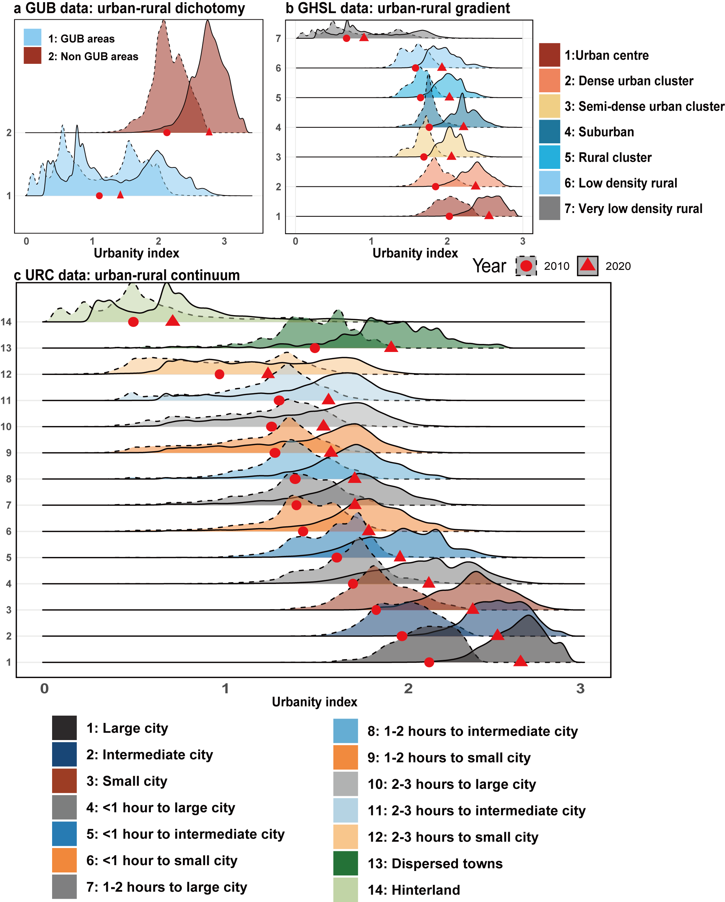
Appendix Fig. 8: Distribution of urbanity index in different urban-rural models. Red circles indicate the median values in 2010, and red triangles represent the median values in 2020.
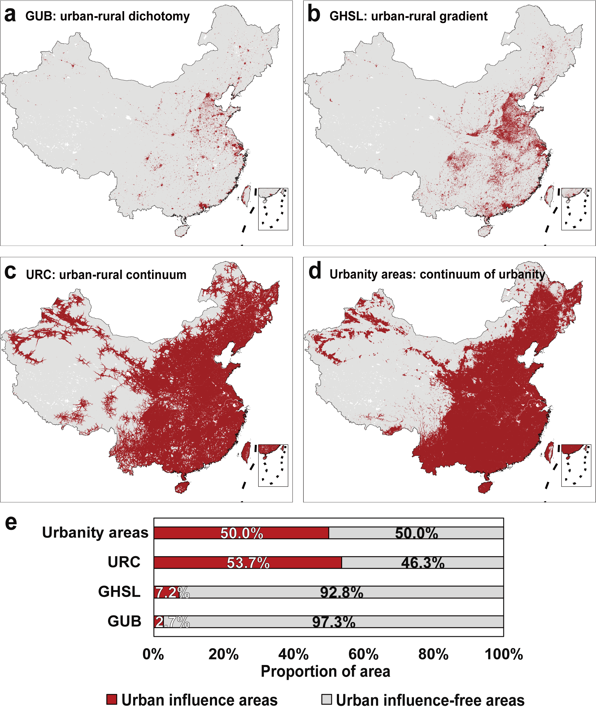
Appendix Fig. 9: Four models of urban-influenced areas. urban influenced areas. a, Urban-influenced areas defined by the Global Urban Boundary (GUB) based on a binary urban–rural framework. b, Urban influenced areas derived from the Global Human Settlement Layer (GHSL) based on an urban-rural gradient perspective. c, Urban influenced areas represented by the Urban-Rural Catchment (URC) product based on an urban-rural continuum framework. d, Urbanity-based urban influenced areas mapped using the continuum of urbanity, in which grid cells were classified into two categories based on the median value of the urbanity index due to its multimodal distribution. e, Comparison of the proportion of urban-influenced grids under the four models.

Calibrated with national census data at county level
Given the need to measure rural population change and migration dynamics, a secondary calibration of gridded population data is essential. Existing studies have widely used and compared major global population datasets such as WorldPop, GWP, GRUMP, LandScan, and GHS-POP for their suitability in different contexts ⁵⁻⁸. Among them, GHS-POP and WorldPop offer relatively comprehensive coverage and detailed information. Therefore, this study selected the GHS-POP product as the primary source of spatial population distribution. We further calibrated the dataset using county-level census data for the years 2010 and 2020 in China, deriving correction coefficients to more accurately reflect the actual population distribution across space.

First, we aggregated the original GHS-POP raster values within each county boundary to calculate the raw population sum for each unit. Then, we derived a correction coefficient for each county by dividing the census-reported population by the corresponding GHS-POP total. This coefficient represents the proportional difference between the raster-derived and census-reported population figures.

Finally, we applied the county-specific correction coefficient to all GHS-POP grid cells within the corresponding administrative unit, ensuring that the adjusted population raster totals match the census data exactly at the county level.

First, we aggregated the original GHS-POP raster values within each county boundary to calculate the raw population sum for each administrative unit. Let $P_{r}^{raw}$ denote the original GHS-POP population value in raster cell r, and let $S_{z}^{raw}$be the sum of all raster values within county z, i.e.,
$S_{z}^{raw}=\sum_{r∈z}{ }P_{r}^{raw}$ （1）
We then derived a correction coefficient $α_{z}$ for each county by comparing the census-reported population $P_{z}^{census}$ with the GHS-POP total:
$α_{z}=\frac{P_{z}^{census}}{S_{z}^{raw}}$ （2）
Finally, we applied this correction factor to all raster cells within the corresponding county, generating a calibrated population raster:
$P_{r}^{corrected}=α_{z}⋅P_{r}^{raw},where r∈z$ （3）
This calibration ensures that the total population in each county-level unit exactly matches the census-reported value, while preserving the spatial heterogeneity of the original GHS-POP dataset. The resulting corrected population surface provides a more reliable basis for subsequent spatial analyses involving population distribution.

Spatialized food production layers
To construct spatially explicit food production layers for the years 2010 and 2020, we generated 1-km resolution gridded maps of crop yield based on county-level grain production statistics and satellite-derived vegetation indicators. Specifically, we used fused MOD13A2 and MYD13A2 NDVI data as a proxy for the vegetation coverage index (VCI) to estimate crop productivity within cropland areas.

Cropland extents were identified using land use data from the China Annual Cropland Dataset (CACD), which provides national-scale cropland distributions with consistent annual coverage ⁹ . NDVI values during the main growing season were extracted for cropland pixels, and for each county, the total grain yield was allocated to individual pixels in proportion to their NDVI values. The gridded food production $FS_{(x)}$ at pixel x was calculated as:
$FS_{(x)}=cropYield_{sum}×\frac{NDVI_{x}}{NDVI_{sum}}$ （4）
where $cropYield_{sum}$ is the total grain yield reported for each county; $NDVI_{x}$ is the NDVI value of pixel x; and $NDVI_{sum}$ is the sum of NDVI values across all cropland pixels within the county. This method assumes that pixels with higher vegetation activity (as indicated by NDVI) contribute more to total yield, thereby producing a continuous surface of estimated food production.

Methods sections

Statistically based urban-rural typology
The urban-rural typology was defined based on basic administrative unit points. These units include urban core (code 111), urban fringe (112), town core (121), town fringe (122), rural center (210) and village (220). Codes beginning with “1” represent urban statistical areas as defined by the National Bureau of Statistics, while codes beginning with “2” represent rural statistical areas.

ArcMap 10.8's Focal Statistic tool was used to rasterize these administrative units for spatial alignment. A search radius of 5×5 pixels was used and the majority rule was applied to assign values. For instance, if the majority code within the 5×5 grid around a given pixel is 220 (village), the pixel is classified as a village (Appendix Fig. 10). The 5×5 pixel search radius was chosen based on the Marchetti constant ¹⁰, which reflects the typical range of daily human activities.
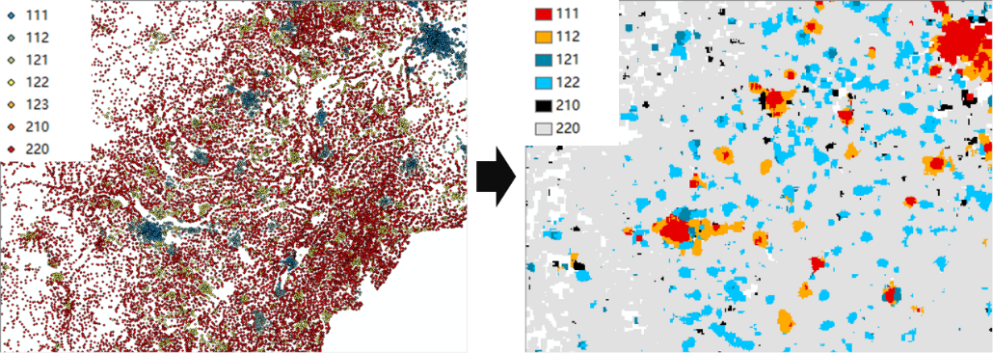
Appendix Fig. 10: Conversion of urban and rural basic administrative units into grids.

Calculating livelihoods and quality of life in rural household surveys

The definition and evolution of livelihoods
This study utilized the urban and rural household survey data from the China Family Panel Studies (CFPS) ¹¹. CFPS, initiated by Peking University, is a nationally representative longitudinal survey focusing on Chinese society, families, and residents. Using CFPS data from 2010 and 2020, we extracted rural household samples corresponding to rural centers and villages in the statistical urban-rural typology, resulting in a total of 9,324 matched households. The data are from China Family Panel Studies (CFPS), funded by Peking University and the National Natural Science Foundation of China. The CFPS is maintained by the Institute of Social Science Survey of Peking University.

We defined livelihood types based on the income structure of rural households. Agricultural income was calculated as the difference between total income and non-agricultural income. The proportions of agricultural and non-agricultural income were then computed, and rural household livelihood types were classified into four categories—agriculture-dominated, agriculture-dominated with non-agriculture, non-agriculture-dominated with agriculture, and non-agriculture-dominated—using K-means clustering ¹² (Table A1).

Tabe A1: Livelihood types of rural household samples from 2010 to 2020.
Livelihoods in 2010 | Livelihoods in 2020 | Number of households
Agri. Dom. | Agri. Dom. | 104
Agri. Dom. | Agri.+Non-Agri | 99
Agri. Dom. | Non.Agri.+Agri | 146
Agri. Dom. | Non -Agri. Dom. | 560
Agri.+Non-Agri | Agri. Dom. | 78
Agri.+Non-Agri | Agri.+Non-Agri | 104
Agri.+Non-Agri | Non.Agri.+Agri | 131
Agri.+Non-Agri | Non -Agri. Dom. | 626
Non.Agri.+Agri | Agri. Dom. | 87
Non.Agri.+Agri | Agri.+Non-Agri | 108
Non.Agri.+Agri | Non.Agri.+Agri | 188
Non.Agri.+Agri | Non -Agri. Dom. | 884
Non -Agri. Dom. | Agri. Dom. | 128
Non -Agri. Dom. | Agri.+Non-Agri | 118
Non -Agri. Dom. | Non.Agri.+Agri | 194
Non -Agri. Dom. | Non -Agri. Dom. | 1107
Furthermore, we used a transition matrix algorithm to identify four types of livelihood transition for rural households from 2010 to 2020: Farming Stable (FS), indicating a main dependence on agricultural income; Re-agrarianized (RA): households' income shifted from non-agricultural to mainly agricultural. De-agrarianized (DA) households experienced a transition from agricultural to non-agricultural income. Non-Farming Stable (NFS) households were mainly dependent on non-agricultural income (Table A2).

Tabe A2: Classification of the four livelihood types after their mutual changes in 2010-2020.
Abbreviation | Types of livelihood changes | Description | Number of households
FS | Farming Stable | Mainly dependent on agricultural income | 208
RA | Re-agrarianized | Income shifted from non-agricultural to mainly agricultural | 713
DA | De-agrarianized | Transition from agricultural income to non-agricultural income | 2446
NFS | Non-Farming Stable | Mainly dependent on non-agricultural income | 1295

The definition of quality of life
The proportion of food consumption expenditure in total consumption expenditure is used to express the Engel coefficient. The inverse of the Engel coefficient (IEC) indicates that positive changes indicate higher quality of life and more urbanized lifestyles for rural households ¹³⁻¹⁵.

Statistical analysis

Test for homogeneity of variances
Testing for homogeneity or heterogeneity of variance is critical for determining whether to use parametric or non-parametric methods in subsequent analyses of differences. In this study, Levene’s test was used to assess the homogeneity of variance. If the test result is not significant, it indicates homogeneity of variance, and parametric ANOVA is applied for variance analysis. Conversely, if the result is significant, it suggests heterogeneity of variance, and non-parametric methods are employed for subsequent difference tests.

Multiple groups and pairwise tests
The Kruskal-Wallis test and Dunn's test are commonly used non-parametric methods to compare the effects of different driving factors on vegetation change ¹⁶. The Kruskal-Wallis test evaluates whether multiple factors are from the same group. If 𝑝≥0.05, it indicates no significant differences between groups. If 𝑝<0.05, the null hypothesis is rejected, indicating that at least two groups differ. To identify specific pairwise differences, Dunn's test is used, which considers unequal sample sizes and heterogeneity of variance. The Benjamini-Hochberg method adjusts significance levels for multiple comparisons. These analyses were performed using the kruskal.test and Dunn. Test functions in R.

References
1 Li, X. et al. Mapping global urban boundaries from the global artificial impervious area (GAIA) data. Environmental Research Letters 15, 094044, doi:10.1088/1748-9326/ab9be3 (2020).
2 Schiavina, M. et al. GHSL Data Package 2022. (2022).
3 Cattaneo, A., Nelson, A. & McMenomy, T. Global mapping of urban-rural catchment areas reveals unequal access to services. P Natl Acad Sci USA 118, doi:10.1073/pnas.2011990118 (2021).
4 Weiss, D. J. et al. Global maps of travel time to healthcare facilities. Nature Medicine 26, 1835-1838, doi:10.1038/s41591-020-1059-1 (2020).
5 Xu, Y., Ho, H. C., Knudby, A. & He, M. Comparative assessment of gridded population data sets for complex topography: a study of Southwest China. Population and Environment 42, 360-378, doi:10.1007/s11111-020-00366-2 (2021).
6 Karagiorgos, K. et al. Global population datasets overestimate flood exposure in Sweden. Scientific Reports 14, 20410, doi:10.1038/s41598-024-71330-5 (2024).
7 Yin, X. et al. Which Gridded Population Data Product Is Better? Evidences from Mainland Southeast Asia (MSEA). ISPRS International Journal of Geo-Information 10 (2021).
8 Láng-Ritter, J., Keskinen, M. & Tenkanen, H. Global gridded population datasets systematically underrepresent rural population. Nature Communications 16, 2170, doi:10.1038/s41467-025-56906-7 (2025).
9 Tu, Y. et al. A 30 m annual cropland dataset of China from 1986 to 2021. Earth Syst. Sci. Data 16, 2297-2316, doi:10.5194/essd-16-2297-2024 (2024).
10 Injong, R. et al. On the Levy-Walk Nature of Human Mobility. IEEE/ACM Transactions on Networking 19, 630-643, doi:10.1109/TNET.2011.2120618 (2011).
11 Institute of Social Science Survey, P. U. (ed Peking University Institute of Social Science Survey) (Peking University Open Research Data Platform, Peking University, Beijing, 2015).
12 Cui, H., Wang, Y., Wang, W. & Liu, C. Rural households' livelihood transitions in China: processes, drivers and outcomes. China Agricultural Economic Review 17, 171-190, doi:10.1108/CAER-11-2023-0346 (2025).
13 Wang, Z. et al. Escaping social–ecological traps through ecological restoration and socioeconomic development in China's Loess Plateau. People and Nature 5, 1364-1379, doi:https://doi.org/10.1002/pan3.10513 (2023).
14 Ritchie, H. Engel's Law: Richer people spend more money on food, but it makes up a smaller share of their income, <https://ourworldindata.org/engels-law-food-spending> (2023).
15 Yang, M., Zhang, X., Zhang, Y. & Fath, B. D. Consistence of structural changes in food nitrogen consumption between rural and urban residents in the context of rapid urbanization. Ecological Modelling 471, 110057, doi:https://doi.org/10.1016/j.ecolmodel.2022.110057 (2022).
16 Hu, T. et al. Social-ecological heterogeneity drove contrasting tree cover restoration in South China Karst. Communications Earth & Environment 5, 484, doi:10.1038/s43247-024-01641-y (2024).

