Supplementary Information

Designing stable viologen anolytes for aqueous organic redox flow battery by enhancing electron donor−acceptor interactions

Manrong Song^{1,2}, Honglin Chen^{1,2}, Meiling Huang^{1,2}, Youke Chen^{1,2}, Xiaocong Zhou^{1,2}, Jiaheng Hu^{1,2}, Jing Sun³, Qinping Jian³, Jiayou Ren³, Yilin Wang^{1,2}, Bin Liu^{3*}, Tianshou Zhao^{1,2,3*}
¹Department of Mechanical and Energy Engineering, Southern University of Science and Technology, Shenzhen 518055, China
²Joint Research Center on Energy Storage Technology in Salt Caverns, Shenzhen 518055, China
³Department of Mechanical and Aerospace Engineering, The Hong Kong University of Science and Technology, Hong Kong SAR, China

Chemicals
4,4'-bipyridine and 1-methylimidazole were purchased from TCI and Bide Pharmatech, respectively. 1,2-dichloroethane,1,3-dibromopropane, 1,4-dibromobutane and Amberlite® IRA-900 chloride were purchased from Macklin. Ferrocene, AlCl₃, NaBH₄, trimethylamine and 3-chloropropanyl chloride were purchased from Sigma-Aldrich. D₂O and DMSO-d₆ were purchased from Adamas and Macklin, respectively. All reagents were used without further purification. Solvents for chromatography and reaction were obtained by passing commercially available.

Instrumentation
NMR spectra were collected on Bruker AVANCE Ⅲ 400 or AVANCE Ⅲ 500 instrument and calibrated by using residual deuterium Oxide (δH = 4.79 ppm), or dimethyl-d6 sulfoxide (δH = 4.79 ppm) or DMSO-d6 (δC = 39.60 ppm) as internal references. The following abbreviations are used to designate multiplicities: s = singlet, d = doublet, t = triplet, q = quartet, m = multiplet, quint = quintet, br = broad. UV−vis spectra were recorded on a PerkinElmer Lambda 365 spectrometer. High−resolution mass spectra (HRMS) were recorded on a Thermo Scientific Q Exactive Hybrid QuadrupoleOrbitrap mass spectrometer. X-Ray crystallographic analysis was performed on a Bruker D8 Venture diffractometer with PHOTON II detector in shutterless mode with an incoat microfocus source equipped with an Oxford 800 Plus liquid nitrogen vapor cooling device. The flow cell was galvanostatically charged/discharged at room temperature on an Arbin LBT battery tester (Arbin Instruments) at current densities ranging from 20 to 80 mA cm⁻². Electrochemical measurements including cyclic voltammetry (CV) and linear sweep voltammetry were recorded by an electrochemical analyzer from CH instruments CHI 706E with a three−electrode system (one glassy carbon working electrode, one platinum counter electrode and one Ag/AgCl reference electrode). RDE setup was purchased from PINE Instrument Company.

Synthetic procedures

Scheme 1. Synthesis of C_{n}ViIm (x=2,3,4) electrolyte.
Synthesis of 1-(2-Chloroethyl)-3-methylimidazolium chloride.
1-(2-Chloroethyl)-3-methylimidazolium chloride was synthesized using procedures previously reported by Li et al¹.
¹H NMR (400 MHz, Deuterium Oxide, 298 K) δ 8.86 (s, 1H), 7.57 (d, J = 1.9 Hz, 1H), 7.49 (d, J = 1.9 Hz, 1H), 4.61 – 4.58 (m, 2H), 4.01 – 3.98 (m, 2H), 3.93 (s, 3H).
¹³C NMR (400 MHz, Deuterium Oxide, 298 K) δ 136.65, 123.71, 122.37, 50.80, 42.68, 35.80.

Synthesis of 1,1'-bis(2-(1-methyl-imidazolium)ethyl)-4,4'-bipyridinium chloride (C₂ViIm)
To a solution of compound 4,4'-Bipyridine (4.80 g, 20.0 mmol, 1.0 equiv) and 1-(2-Chloroethyl)-3-methylimidazolium chloride (11.0 g, 60.0 mmol, 3.0 equiv) in H₂O (5 mL), the mixed solution was reacted in a hydrothermal autoclave at 120°C for 48 hours. After the reaction, ethanol and then acetone were added to the resultant aqueous solution in sequential order in a 1:5:10 (product:ethanol:acetone) volume ratio to precipitate out the pure product. The product was filtered, washed with DMF, MeCN, and acetone in sequence. At last, the residue was concentrated in vacuo to give compound C₂ViIm.
¹H NMR (400 MHz, Deuterium Oxide, 298 K) δ 9.03 (d, J = 6.6 Hz, 4H), 8.53 (d, J = 6.5 Hz, 4H), 7.44 (d, J = 2.0 Hz, 2H), 7.39 (d, J = 2.0 Hz, 2H), 5.19 (t, J = 6.2 Hz, 4H), 4.90 (t, J = 6.2 Hz, 4H), 3.81 (s, 6H).
¹³C NMR (400 MHz, Deuterium Oxide, 298 K) δ 150.95 , 145.98 , 136.85 , 127.75 , 124.75 , 122.18 , 60.38 , 48.58 , 36.03 .
HRMS (ESI, Pos) m/z: [M]⁴⁺ Calcd for C₂₂H₂₈N₆ 94.0588, Found 94.0590.

Synthesis of 1-(2-Bromopropyl)-3-methylimidazolium chloride.
The preparation of 1-(2-Bromopropyl)-3-methylimidazolium bromide complexe followed the similar procedures as described for 1-(2-Chloroethyl)-3-methylimidazolium chloride.
¹H NMR (400 MHz, Deuterium Oxide, 298 K) δ 8.78 (s, 1H), 7.51 (d, J = 2.0 Hz, 1H), 7.44 (d, J = 2.0 Hz, 1H), 4.39 (t, J = 6.7 Hz, 2H), 3.89 (s, 3H), 3.44 (t, J = 6.2 Hz, 2H), 2.41 (p, J = 6.5 Hz, 2H).

Synthesis of 1,1'-bis(3-(1-methyl-imidazolium)propyl)-4,4'-bipyridinium chloride (C₃ViIm)
The preparation of C₃ViIm electrolyte followed the similar procedures as described for C₂ViIm. Ion exchange of C₃ViIm to its chloride salt was performed by flushing an aqueous solution of C₃ViIm over an ion-exchange column filled with Amberlite IRA-900 ion exchange resin. The absence of bromide was verified by CV.
¹H NMR (500 MHz, Deuterium Oxide, 298 K) δ 9.16 (d, J = 6.4 Hz, 4H), 8.85 (s, 1H), 8.68 – 8.56 (m, 4H), 7.57 (t, J = 2.0 Hz, 2H), 7.49 (d, J = 1.9 Hz, 2H), 4.91 – 4.81 (m, 4H), 4.44 (t, J = 7.4 Hz, 4H), 3.91 (s, 6H), 2.72 (p, J = 7.6 Hz, 4H).
¹³C NMR (500 MHz, Deuterium Oxide, 298 K) δ 150.35 , 145.64 , 136.26 , 127.30 , 124.02 , 122.07 , 58.53 , 45.97 , 35.78 , 30.86 .
HRMS (ESI, Pos) m/z: [M]⁴⁺ Calcd for C₂₄H₃₂N₆ 101.0667, Found 101.0665.

Synthesis of 1-(2-Bromobutyl)-3-methylimidazolium bromide.
The preparation of 1-(2-Bromobutyl)-3-methylimidazolium bromide complexe followed the similar procedures as described for 1-(2-Chloroethyl)-3-methylimidazolium chloride. The same procedure was used until the colloidal form 1-(2-Bromobutyl)-3-methylimidazolium bromide was obtained. The obtained product has no dicationic byproduct.
¹H NMR (400 MHz, Deuterium Oxide, 298 K) δ 8.80 (s, 1H), 7.60 – 7.45 (m, 2H), 4.30 (dd, J = 8.2, 5.9 Hz, 2H), 3.94 (s, 3H), 3.56 (t, J = 6.4 Hz, 2H), 2.18 – 2.01 (m, 2H), 2.01 – 1.87 (m, 2H).
¹³C NMR (400 MHz, Deuterium Oxide, 298 K) δ 135.91 , 123.62 , 122.18 , 48.74 (d, J = 4.3 Hz), 35.79 , 33.49 , 28.64 , 28.08 , 26.25 .

Synthesis of 1,1'-bis(4-(1-methyl-imidazolium)butyl)-4,4'-bipyridinium chloride (C₄ViIm).
The preparation of C₄ViIm compound followed the similar procedures as described for C₂ViIm. Ion exchange of C₄ViIm to its chloride salt was performed by flushing an aqueous solution of C₄ViIm over an ion-exchange column filled with Amberlite IRA-900 ion exchange resin. The absence of bromide was verified by CV.
¹H NMR (400 MHz, Deuterium Oxide, 298 K) δ 9.16 – 9.09 (m, 4H), 8.75 (s, 2H), 8.56 (d, J = 6.5 Hz, 4H), 7.49 (d, J = 1.9 Hz, 2H), 7.45 (d, J = 2.0 Hz, 2H), 4.77 (d, J = 8.0 Hz, 4H), 4.29 (t, J = 7.0 Hz, 4H), 3.89 (s, 6H), 2.13 (t, J = 8.2 Hz, 4H), 2.03 (dt, J = 8.8, 6.4 Hz, 4H).
¹³C NMR (400 MHz, Deuterium Oxide, 298 K) δ 150.17 , 145.46 , 127.07 , 123.68 , 121.97 , 61.13 , 48.49 , 35.60 , 27.40 , 26.12 .
HRMS (ESI, Pos) m/z: [M]⁴⁺ Calcd for C₂₆H₃₈N₆ 108.5784, Found 108.5786.

Synthesis of bis((3-trimethylammonio)propyl)ferrocene (BTMAP-Fc).
1,1-bis(3-chloropropyl)ferrocene was synthesized using procedures previously reported by Xu et al² and Aziz et al³.
10.9 g (24.0 mmol) of pure 1,1-bis(3-chloropropyl)ferrocene was dissolved in about 100 mL of 4.2 M trimethylamine in ethanol. The solution was sealed in a thick-walled glass tube and heated to 60 °C for more than 5 days. Then, all volatile materials were removed in vacuo to obtain a yellow oil. The oil was stirred in H₂O (~150 mL) and filtered to remove unreacted ferrocene and other water-insoluble impurities. The filtrate was evaporated in vacuo to obtain pure BTMAP-Fc.
¹H NMR (400 MHz, Deuterium Oxide, 298 K) δ 4.22 – 4.14 (m, 8H), 3.35 – 3.27 (m, 4H), 3.09 (s, 18H), 2.50 (t, J = 7.3 Hz, 4H), 1.98 (p, J = 7.5 Hz, 4H).
The single crystals of the C2ViIm, C3ViIm and C4ViIm were prepared by slow diffusion of hexane solvent into an ethanol solution of the C2ViIm, C3ViIm and C4ViIm, respectively.
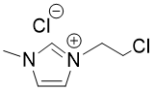
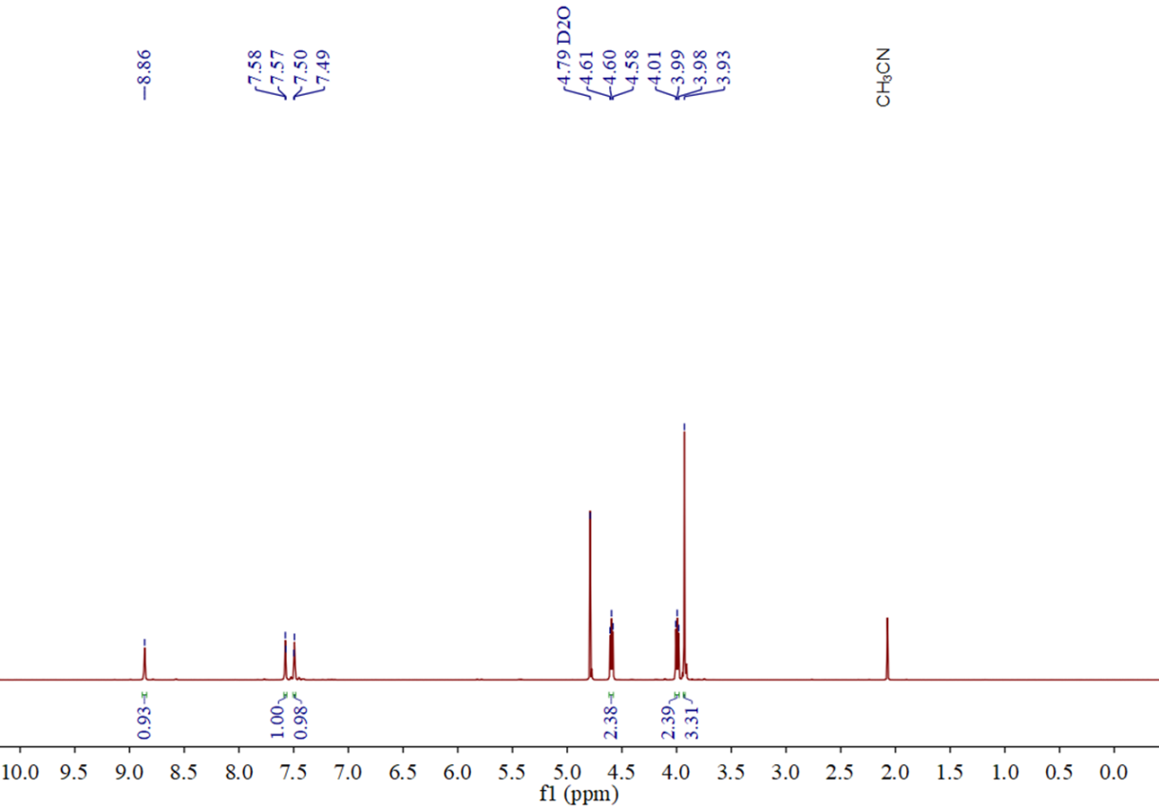
Supplementary Figure 1. The ¹H NMR spectrum of 1-(2-chloroethyl)-3-methylimidazolium chloride. ¹H NMR (400 MHz, Deuterium Oxide) δ 8.86 (s, 1H), 7.57 (d, J = 1.9 Hz, 1H), 7.49 (d, J = 1.9 Hz, 1H), 4.61 – 4.58 (m, 2H), 4.01 – 3.98 (m, 2H), 3.93 (s, 3H).
Supplementary Figure 2. ¹³C NMR spectrum of 1-(2-chloroethyl)-3-methylimidazolium chloride. ¹³C NMR (101 MHz, Deuterium Oxide) δ 136.65 , 123.71 , 122.37 , 50.80 , 42.68 , 35.80 .
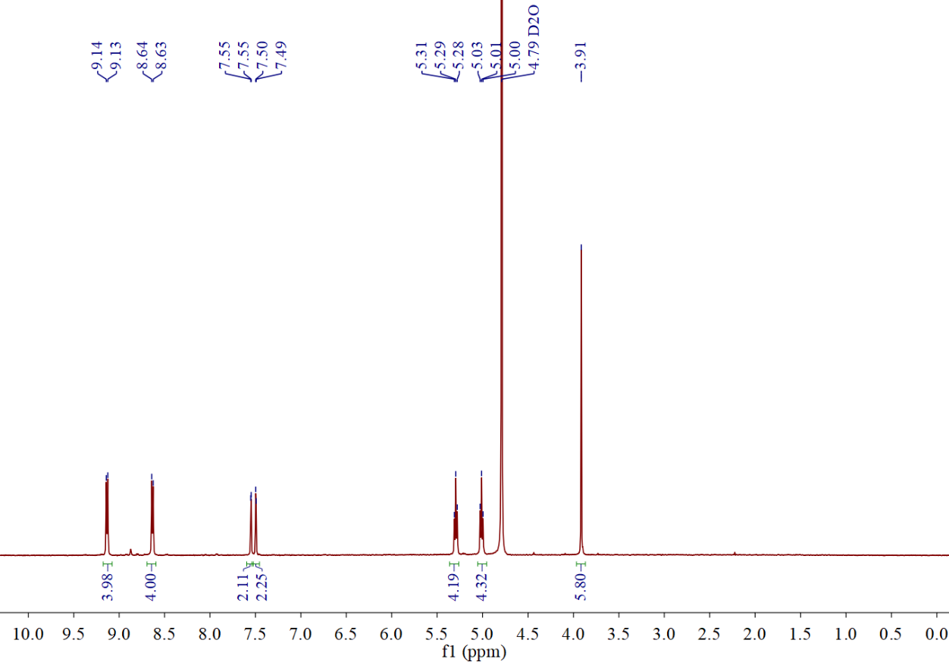
Supplementary Figure 3. The ¹H NMR spectrum of C₂ViIm. 1H NMR (400 MHz, Deuterium Oxide) δ 9.03 (d, J = 6.6 Hz, 4H), 8.53 (d, J = 6.5 Hz, 4H), 7.44 (d, J = 2.0 Hz, 2H), 7.39 (d, J = 2.0 Hz, 2H), 5.19 (t, J = 6.2 Hz, 4H), 4.90 (t, J = 6.2 Hz, 4H), 3.81 (s, 6H).
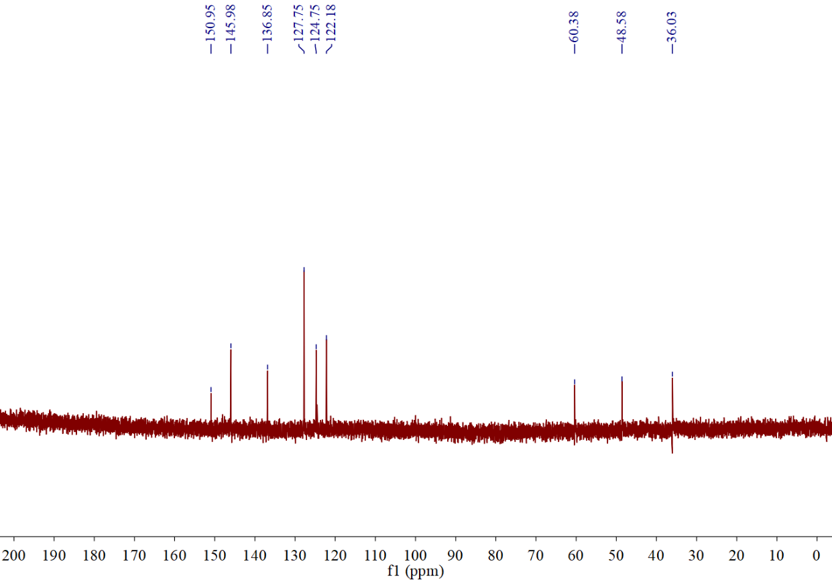
Supplementary Figure 4. ¹³C NMR spectrum of C₂ViIm. ¹³C NMR (101 MHz, Deuterium Oxide) δ 150.95 , 145.98 , 136.85 , 127.75 , 124.75 , 122.18 , 60.38 , 48.58 , 36.03 .
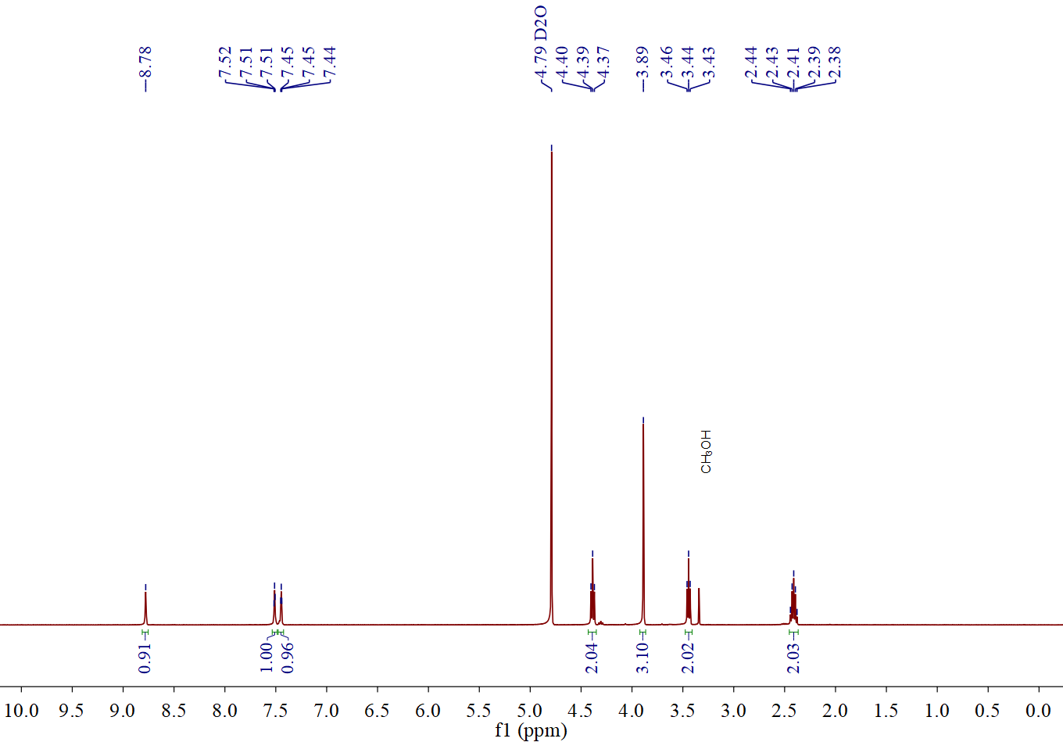
Supplementary Figure 5. ¹H NMR spectrum of 1-(2-Bromopropyl)-3-methylimidazolium chloride. ¹H NMR (400 MHz, Deuterium Oxide) δ 8.78 (s, 1H), 7.51 (d, J = 2.0 Hz, 1H), 7.44 (d, J = 2.0 Hz, 1H), 4.39 (t, J = 6.7 Hz, 2H), 3.89 (s, 3H), 3.44 (t, J = 6.2 Hz, 2H), 2.41 (p, J = 6.5 Hz, 2H).
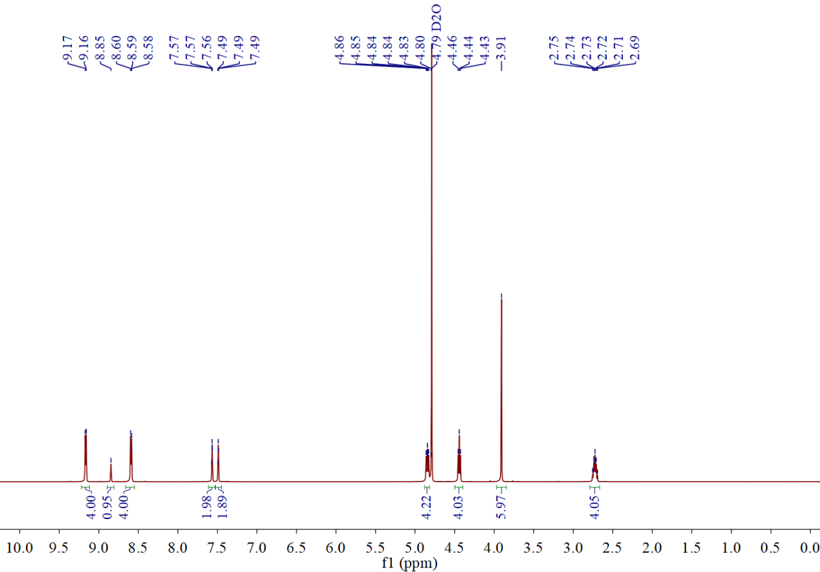
Supplementary Figure 6. The ¹H NMR spectrum of C₃ViIm. ¹H NMR (500 MHz, Deuterium Oxide) δ 9.16 (d, J = 6.4 Hz, 4H), 8.85 (s, 1H), 8.68 – 8.56 (m, 4H), 7.57 (t, J = 2.0 Hz, 2H), 7.49 (d, J = 1.9 Hz, 2H), 4.91 – 4.81 (m, 4H), 4.44 (t, J = 7.4 Hz, 4H), 3.91 (s, 6H), 2.72 (p, J = 7.6 Hz, 4H).
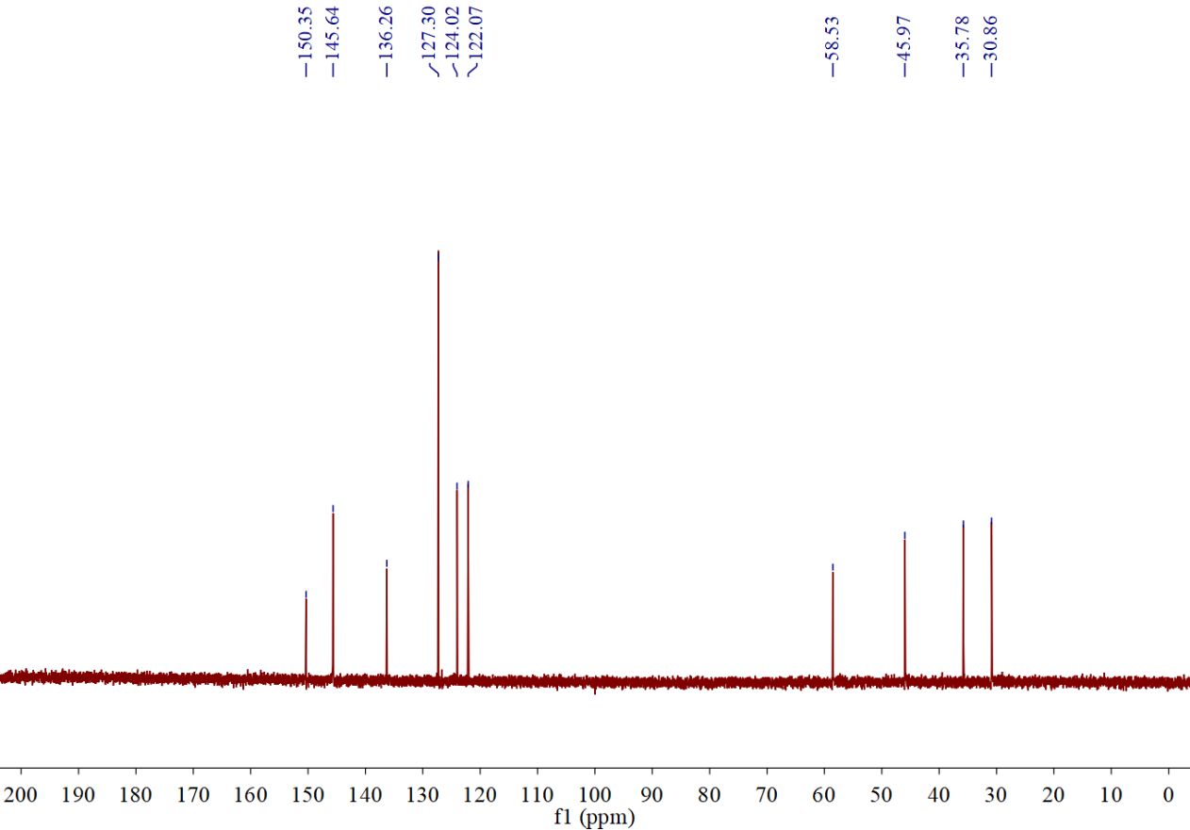
Supplementary Figure 7. ¹³C NMR spectrum of C₃ViIm. ¹³C NMR (126 MHz, Deuterium Oxide) δ 150.35 , 145.64 , 136.26 , 127.30 , 124.02 , 122.07 , 58.53 , 45.97 , 35.78 , 30.86 .
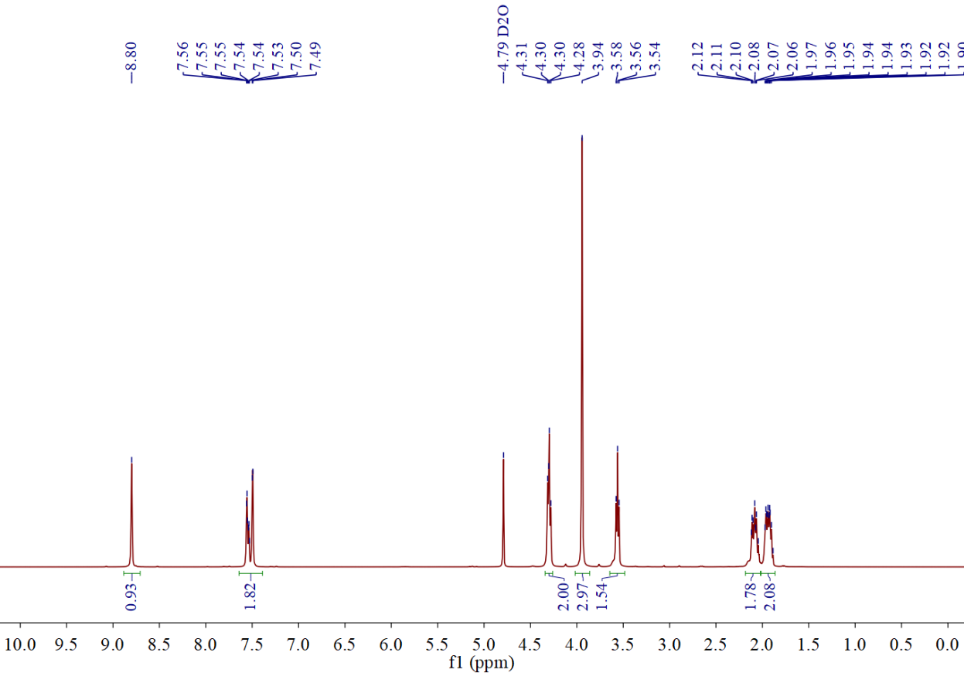 Supplementary Figure 8. ¹H NMR spectrum of 1-(2-Bromobutyl)-3-methylimidazolium bromide. 1H NMR (400 MHz, Deuterium Oxide) δ 8.80 (s, 1H), 7.60 – 7.45 (m, 2H), 4.30 (dd, J = 8.2, 5.9 Hz, 2H), 3.94 (s, 3H), 3.56 (t, J = 6.4 Hz, 2H), 2.18 – 2.01 (m, 2H), 2.01 – 1.87 (m, 2H).

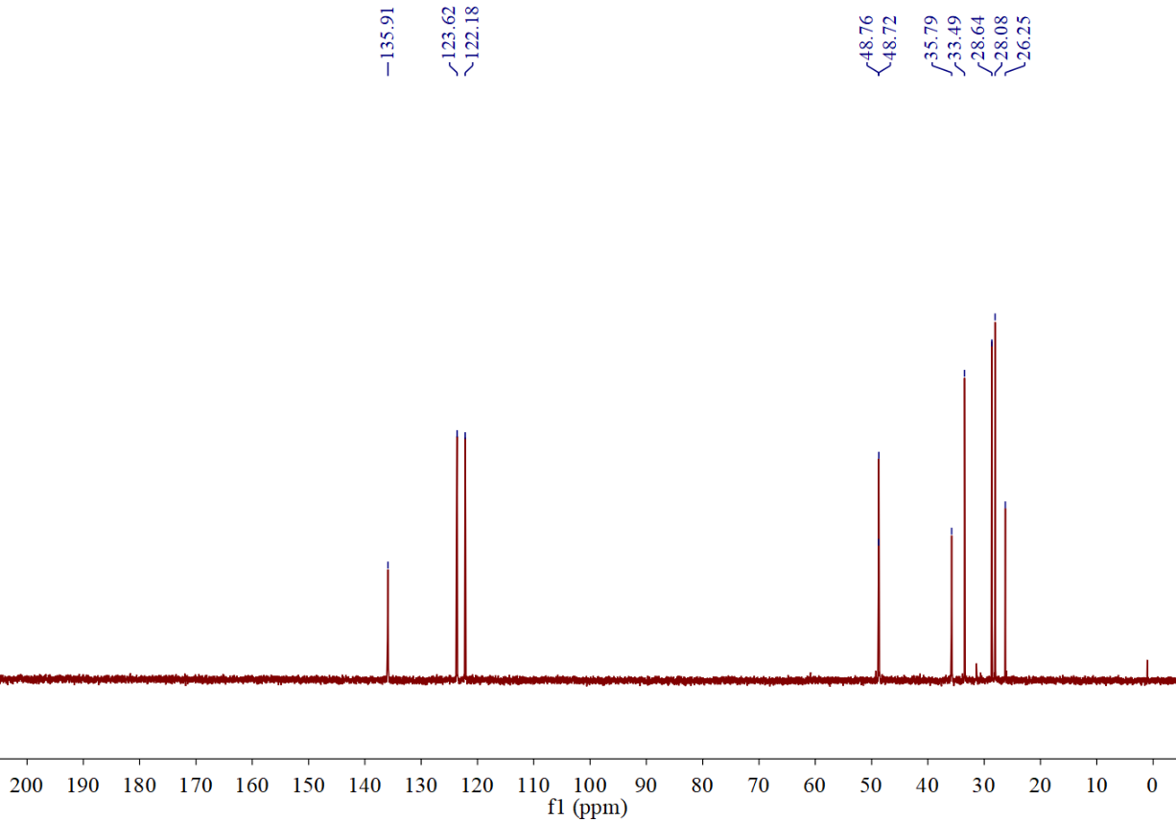
Supplementary Figure 9. ¹H NMR spectrum of 1-(2-Bromobutyl)-3-methylimidazolium bromide. ¹³C NMR (400 MHz, Deuterium Oxide) δ 135.91 , 123.62 , 122.18 , 48.74 (d, J = 4.3 Hz), 35.79 , 33.49 , 28.64 , 28.08 , 26.25 .
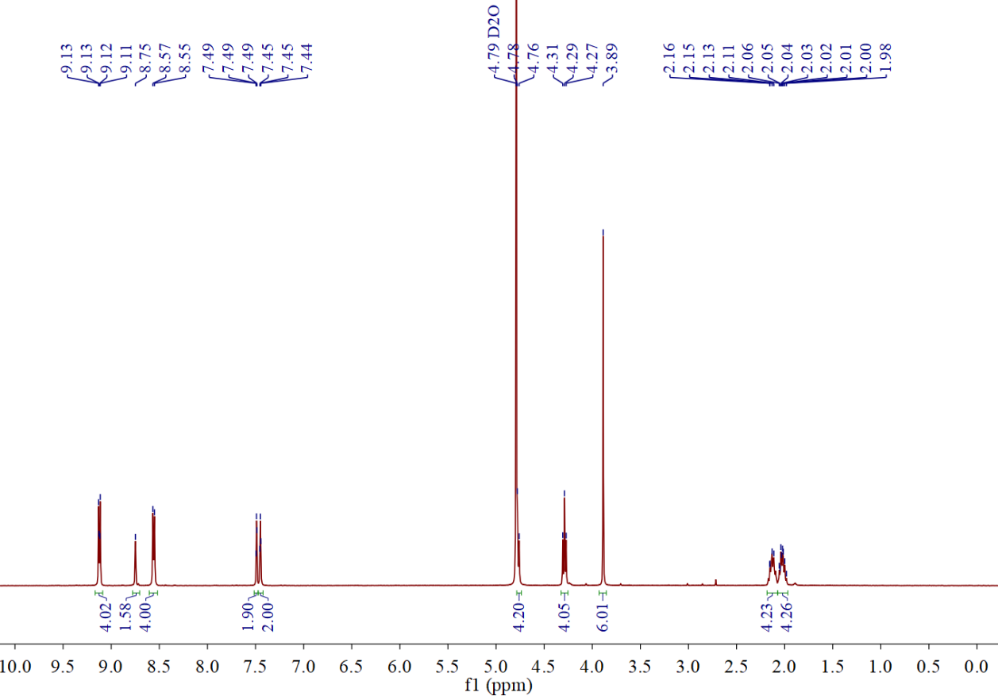
Supplementary Figure 10. ¹H NMR spectrum of C₄ViIm. ¹H NMR (400 MHz, Deuterium Oxide) δ 9.16 – 9.09 (m, 4H), 8.75 (s, 2H), 8.56 (d, J = 6.5 Hz, 4H), 7.49 (d, J = 1.9 Hz, 2H), 7.45 (d, J = 2.0 Hz, 2H), 4.77 (d, J = 8.0 Hz, 4H), 4.29 (t, J = 7.0 Hz, 4H), 3.89 (s, 6H), 2.13 (t, J = 8.2 Hz, 4H), 2.03 (dt, J = 8.8, 6.4 Hz, 4H).
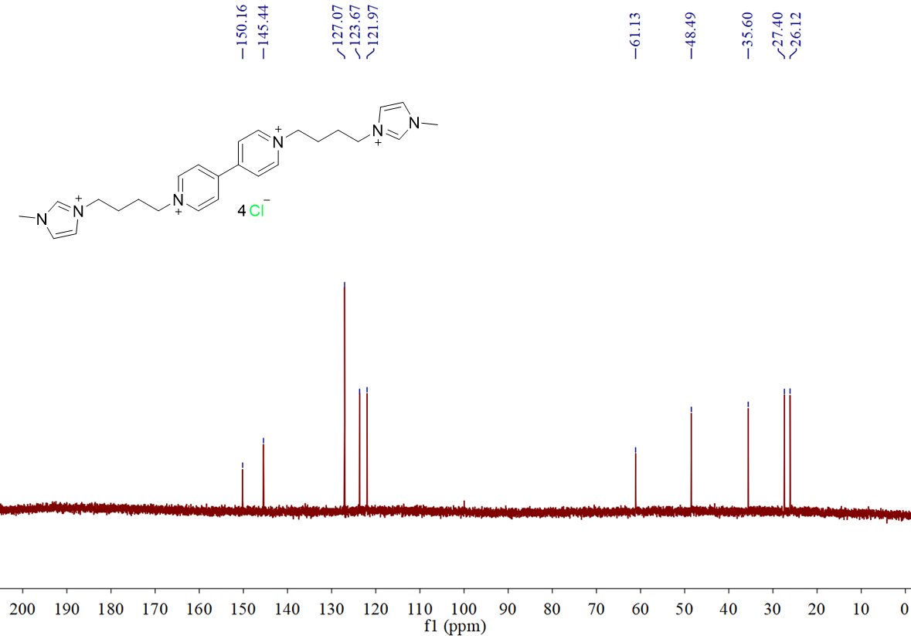
Supplementary Figure 11. ¹³C NMR spectrum of C₄ViIm. ¹³C NMR (101 MHz, Deuterium Oxide) δ 150.17 , 145.46 , 127.07 , 123.68 , 121.97 , 61.13 , 48.49 , 35.60 , 27.40 , 26.12 .

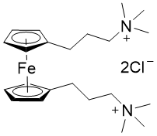
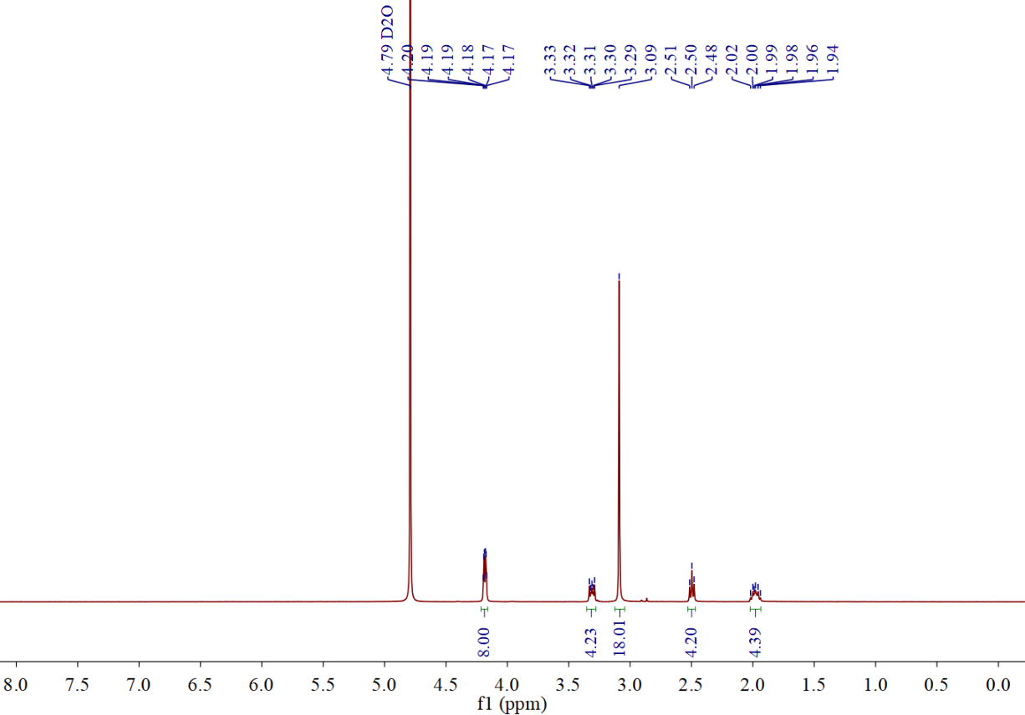
Supplementary Figure 12. ¹H NMR spectrum of BTMAP-Fc. ¹H NMR (400 MHz, Deuterium Oxide) δ 4.22 – 4.14 (m, 8H), 3.35 – 3.27 (m, 4H), 3.09 (s, 18H), 2.50 (t, J = 7.3 Hz, 4H), 1.98 (p, J = 7.5 Hz, 4H).

Computational methods:
All the quantum calculations were performed using the density functional theory (DFT), implemented in the Gaussian 09 software package⁴, with the default convergence criteria. All transition state searches, geometry optimization and frequency calculations were performed at the medium computational level based on Solvation Model Density (SMD)⁵. The use of the hybrid density functional B3LYP with the 6-31G(d) basis sets reduced computational costs and the difficulty of geometric optimization convergence⁶. Minimum energy points were identified as those with only positive eigenvalues, while first-order saddle points (TS) were identified as those with only one negative eigenvalue. In addition, intrinsic reaction coordinate (IRC)⁷ calculations were performed to confirm that each transition structure connects the precedent reactants to their respective products. Thermodynamic parameters were computed at 298 K and 1 atm, after frequency calculation in the default configuration using the standard statistical thermodynamic equations⁸. To accurately describe energy changes^{9,10}, the hybrid exchange-correlation functional M06-2X¹¹ was combined with the Ahlrichs 4-zeta def2-TZVPP basis set¹² for single-point energy calculations of reactants, transition states, and products. The M06-2X, a highly-nonlocal functional that incorporates the double amount of nonlocal exchange (2X), was selected as the density functional due to its widespread applications in exploring reaction mechanism, especially when accounting for the solvent effects¹³. In addition, the introduction of Grimme's zero damping DFT-D3 method further compensates for the lack of long-range dispersion effects in M06-2X itself¹⁴. The Gibbs free energy (ΔG) is obtained through thermal correction of the electronic energy, further reflecting the differences in reaction energy barriers.

Supplementary Figure 13. Chemical/electrochemical properties of C_{n}ViIm (n=2,3,4) and resulting chemical bond length of synthesized viologen derivatives. a, Comparison of the bond lengths of N−C bonds in synthetic viologens and quaternary ammonium, quaternary-N−C bond length is generally 1.512 Å¹⁵. b, Comparison of the bond lengths of C−C bonds in synthetic viologens and C_{sp}³−C_{sp}³, the C_{sp}³−C_{sp}³ bond length is generally 1.54 Å¹⁶.

Supplementary Table 1. Crystal data and structure refinement for C₂ViIm. CCDC#2455722
Empirical formula | C₂₂H₂₈N₆Cl₄
Formula weight | 571.34
Temperature/K | 200.0(2)
Crystal system | monoclinic
Space group | C2/c
a/Å | 17.9612(6)
b/Å | 6.2392(2)
c/Å | 25.2772(9)
α/° | 90
  β/°
  102.543(1)
γ/° | 90
Volume/Å³ | 2765.05(16)
Z | 4
ρ_{calc} g/cm³ | 1.372
μ/mm^{‑1} | 0.463
F(000) | 1196.0
Crystal size/mm³ | 0.42 × 0.38 × 0.06
Radiation | MoKα (λ = 0.71073)
2θ range for data collection/° | 4.646 to 61.804
Index ranges | -25 ≤ h ≤ 23, -9 ≤ k ≤ 9, -36 ≤ l ≤ 36
Reflections collected | 48489
Independent reflections | 4355 [R_{int} = 0.0870, R_{sigma} = 0.0418]
Data/restraints/parameters | 4355/0/163
Goodness-of-fit on F² | 1.025
Final R indexes [I>=2σ (I)] | R₁ = 0.0462 wR₂ = 0.1110
Final R indexes [all data] | R₁ = 0.0667, wR₂ = 0.1238
Largest diff. peak/hole / e Å⁻³ | 0.51/-0.45

Supplementary Table 2. Crystal data and structure refinement for C₃ViIm. CCDC #2464546
Empirical formula | C₂₈H₄₂N₆Cl₄
Formula weight | 309.21
Temperature/K | 200.0(2)
Crystal system | monoclinic
Space group | P2₁/n
a/Å | 12.0206(5)
b/Å | 7.2406(3)
c/Å | 17.8219(6)
α/° | 90
  β/°
  103.6110(10)
γ/° | 90
Volume/Å³ | 1507.59(10)
Z | 4
ρ_{calc} g/cm³ | 1.362
μ/mm^{‑1} | 0.433
F(000) | 652.0
Crystal size/mm³ | 0.36 × 0.28 × 0.06
Radiation | MoKα (λ = 0.71073)
2θ range for data collection/° | 4.642 to 60.99
Index ranges | -16 ≤ h ≤ 17, -10 ≤ k ≤ 10, -25 ≤ l ≤ 25
Reflections collected | 34460
Independent reflections | 4579 [R_{int} = 0.0790, R_{sigma} = 0.0480]
Data/restraints/parameters | 4579/0/180
Goodness-of-fit on F² | 1.030
Final R indexes [I>=2σ (I)] | R₁ = 0.0450, wR₂ = 0.0980
Final R indexes [all data] | R₁ = 0.0786, wR₂ = 0.1126
Largest diff. peak/hole / e Å⁻³ | 0.39/-0.28

Supplementary Table 3. Crystal data and structure refinement for C₄ViIm. CCDC#2455762
Empirical formula | C₂₈H₄₂N₆Cl₄
Formula weight | 666.54
Temperature/K | 100.0(2)
Crystal system | triclinic
Space group | P-1
a/Å | 9.4745(5)
b/Å | 9.6049(5)
c/Å | 10.6530(6)
α/° | 63.718(2)
  β/°
  78.672(2)
γ/° | 83.915(2)
Volume/Å³ | 852.09(8)
Z | 1
ρ_{calc} g/cm³ | 1.299
μ/mm^{‑1} | 0.384
F(000) | 354.0
Crystal size/mm³ | 0.25 × 0.23 × 0.19
Radiation | MoKα (λ = 0.71073)
2θ range for data collection/° | 4.326 to 61.056
Index ranges | -13 ≤ h ≤ 13, -13 ≤ k ≤ 13, -15 ≤ l ≤ 15
Reflections collected | 32874
Independent reflections | 5207 [R_{int} = 0.0636, R_{sigma} = 0.0408]
Data/restraints/parameters | 5207/1/205
Goodness-of-fit on F² | 1.134
Final R indexes [I>=2σ (I)] | R₁ = 0.0430, wR₂ = 0.0890
Final R indexes [all data] | R₁ = 0.0561, wR₂ = 0.0932
Largest diff. peak/hole / e Å⁻³ | 0.43/-0.35

Supplementary Table 4. Bond lengths for C₂ViIm.
Atom | Atom | Length/Å |  | Atom | Atom | Length/Å
N1 | C1 | 1.461(2) |  | N3 | C9 | 1.341(2)
N1 | C2 | 1.324(2) |  | C3 | C4 | 1.509(2)
N1 | C11 | 1.371(2) |  | C5 | C6 | 1.378(2)
N2 | C2 | 1.327(2) |  | C6 | C7 | 1.399(2)
N2 | C3 | 1.465(2) |  | C7 | C7¹ | 1.483(3)
N2 | C10 | 1.377(2) |  | C7 | C8 | 1.392(2)
N3 | C4 | 1.479(2) |  | C8 | C9 | 1.375(2)
N3 | C5 | 1.346(2) |  | C10 | C11 | 1.352(3)

Supplementary Table 5. Bond angles for C₂ViIm.
Atom | Atom | Atom | Angle/˚ |  | Atom | Atom | Atom | Angle/˚
C2 | N1 | C1 | 124.74(17) |  | N3 | C4 | C3 | 109.38(14)
C2 | N1 | C11 | 108.87(15) |  | N3 | C5 | C6 | 120.40(15)
C11 | N1 | C1 | 126.34(16) |  | C5 | C6 | C7 | 119.77(15)
C2 | N2 | C3 | 124.86(15) |  | C6 | C7 | C7¹ | 121.09(17)
C2 | N2 | C10 | 108.92(14) |  | C8 | C7 | C6 | 118.03(14)
C10 | N2 | C3 | 126.15(16) |  | C8 | C7 | C7¹ | 120.88(17)
C5 | N3 | C4 | 119.93(14) |  | C9 | C8 | C7 | 119.90(14)
C9 | N3 | C4 | 118.97(14) |  | N3 | C9 | C8 | 120.68(14)
C9 | N3 | C5 | 121.10(14) |  | C11 | C10 | N2 | 106.56(16)
N1 | C2 | N2 | 108.44(15) |  | C10 | C11 | N1 | 107.21(15)
N2 | C3 | C4 | 109.80(14)

Supplementary Table 6. Bond lengths for C₃ViIm.
Atom | Atom | Length/Å |  | Atom | Atom | Length/Å
N1 | C1 | 1.461(2) |  | C3 | C4 | 1.517(2)
N1 | C2 | 1.325(2) |  | C4 | C5 | 1.519(2)
N1 | C11 | 1.370(2) |  | C6 | C7 | 1.377(2)
N2 | C2 | 1.326(2) |  | C7 | C8 | 1.390(2)
N2 | C3 | 1.466(2) |  | C8 | C8¹ | 1.486(3)
N2 | C12 | 1.372(2) |  | C8 | C9 | 1.397(2)
N3 | C5 | 1.485(2) |  | C9 | C10 | 1.375(2)
N3 | C6 | 1.337(2) |  | C11 | C12 | 1.350(3)
N3 | C10 | 1.345(2)

Supplementary Table 7. Bond angles for C₃ViIm.
Atom | Atom | Atom | Angle/˚ |  | Atom | Atom | Atom | Angle/˚
C2 | N1 | C1 | 125.53(16) |  | C3 | C4 | C5 | 106.37(15)
C2 | N1 | C11 | 108.47(15) |  | N3 | C5 | C4 | 112.98(14)
C11 | N1 | C1 | 125.84(16) |  | N3 | C6 | C7 | 120.63(16)
C2 | N2 | C3 | 124.39(16) |  | C6 | C7 | C8 | 120.46(16)
C2 | N2 | C12 | 108.57(15) |  | C7 | C8 | C8¹ | 121.39(19)
C12 | N2 | C3 | 126.99(16) |  | C7 | C8 | C9 | 117.36(15)
C6 | N3 | C5 | 119.75(15) |  | C9 | C8 | C8¹ | 121.24(19)
C6 | N3 | C10 | 120.68(15) |  | C10 | C9 | C8 | 120.10(16)
C10 | N3 | C5 | 119.51(15) |  | N3 | C10 | C9 | 120.71(16)
N1 | C2 | N2 | 108.77(16) |  | C12 | C11 | N1 | 107.25(16)
N2 | C3 | C4 | 112.44(16) |  | C11 | C12 | N2 | 106.93(16)

Supplementary Table 8. Bond lengths for C₄ViIm.
Atom | Atom | Length/Å |  | Atom | Atom | Length/Å
O1 | C14 | 1.435(16) |  | N3 | C7 | 1.3458(19)
O1A | C14A | 1.424(16) |  | N3 | C11 | 1.3426(19)
C14 | C15 | 1.501(6) |  | C3 | C4 | 1.520(2)
C14A | C15A | 1.494(6) |  | C4 | C5 | 1.530(2)
N1 | C1 | 1.469(2) |  | C5 | C6 | 1.517(2)
N1 | C2 | 1.327(2) |  | C7 | C8 | 1.372(2)
N1 | C12 | 1.377(2) |  | C8 | C9 | 1.398(2)
N2 | C2 | 1.331(2) |  | C9 | C9¹ | 1.488(3)
N2 | C3 | 1.4695(19) |  | C9 | C10 | 1.396(2)
N2 | C13 | 1.380(2) |  | C10 | C11 | 1.376(2)
N3 | C6 | 1.4821(19) |  | C12 | C13 | 1.355(2)

Supplementary Table 9. Bond angles for C₄ViIm.
Atom | Atom | Atom | Angle/˚ |  | Atom | Atom | Atom | Angle/˚
O1 | C14 | C15 | 107.9(19) |  | C3 | C4 | C5 | 113.50(13)
O1A | C14A | C15A | 110.5(17) |  | C6 | C5 | C4 | 111.96(14)
C2 | N1 | C1 | 124.35(14) |  | N3 | C6 | C5 | 110.35(13)
C2 | N1 | C12 | 108.98(13) |  | N3 | C7 | C8 | 120.68(14)
C12 | N1 | C1 | 126.59(14) |  | C7 | C8 | C9 | 120.01(14)
C2 | N2 | C3 | 125.06(13) |  | C8 | C9 | C9¹ | 120.80(16)
C2 | N2 | C13 | 108.57(13) |  | C10 | C9 | C8 | 117.81(13)
C13 | N2 | C3 | 126.35(13) |  | C10 | C9 | C9¹ | 121.38(16)
C7 | N3 | C6 | 119.73(13) |  | C11 | C10 | C9 | 119.93(14)
C11 | N3 | C6 | 119.40(13) |  | N3 | C11 | C10 | 120.70(14)
C11 | N3 | C7 | 120.87(13) |  | C13 | C12 | N1 | 106.86(14)
N1 | C2 | N2 | 108.56(14) |  | C12 | C13 | N2 | 107.03(14)
N2 | C3 | C4 | 110.40(12)

Supplementary Figure 14. DFT calculations of the strong donor-acceptor interaction-induced dipole moment (μ).

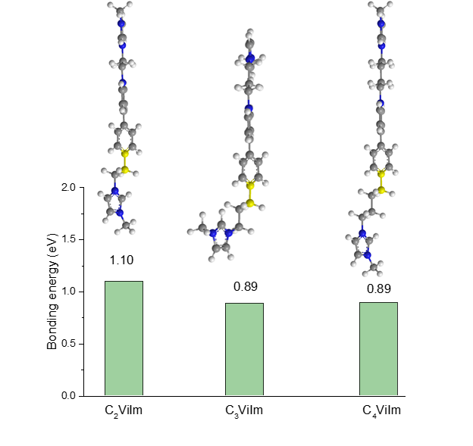
Supplementary Figure 15. DFT calculations showing the C−N of electrolytes with the binding energy.

Supplementary Figure 16. Cyclic voltammetry of C₂ViIm, C₃ViIm and C₄ViIm in 0.5 M NaCl (scanned at 100 mV s⁻¹).

Supplementary Figure 17. UV–Vis spectrum of C₂ViIm, C₃ViIm and C₄ViIm in water.

Supplementary Figure 18. (a) The corresponding charge curve of BTMAP−Fc/C₂ViIm flow battery. (b) Ultraviolet-visible (UV−Vis) spectroscopy measurement at charge state of C₂ViIm.

Notes: The stability of C₂ViIm in the charging state was tested by ex-situ UV−Vis. The BTMAP−Fc/C₂ViIm flow battery was first charged to 0.9 V, and then UV−Vis was tested at 0, 3 and 6 hours. The results showed no significant changes, indicating that C₂ViIm has good stability in the charging state.

Solubility measurements
The solubility of C_{n}ViIm was measured by adding excess electrolytes into deionized water to form saturated solution with precipitation, and then measured by UV-vis spectrophotometry according to the established absorbance concentration calibration curves.

Permeability measurements
The membrane permeability of C_{n}ViIm was tested with a H-typed electrolytic cell setup, which is separated by a piece of fresh treated anion-exchange DSV membrane. 5 mL solution of 0.1 M C_{n}ViIm in 2 M NaCl was placed on one storage tank as the donating side, while the other storage tank filled with 5 mL 2 M NaCl was used as the receiving side. The crossover of the C_{n}ViIm species was periodically monitored by measuring the concentration of C_{n}ViIm in the receiving side by UV-vis. The permeability of each redox active species was calculated using Fick’s Law¹⁷:
$$P=\frac{∆\ln\left(1-\frac{2C_{t}}{C_{O}}\right)\left(\frac{V_{O}L}{2A}\right)}{∆t}$$
where P is the permeability (cm² s⁻¹), C_{t} is the C_{n}ViIm concentration measured at the receiving side at time t, C₀ is the initial concentration of C_{n}ViIm on the donating side, in our case 0.1 M. V₀ is the initial volume on either the receiving or donating sides, since they are equal. In this case 5 mL. A is the effective area of the membrane (0.785 cm²), L is the thickness of the membrane (50 μM for anion-exchange DSV) and t is time (s). Note that for C_{x}ViIm with DSV membrane, the crossover was detected after over 4 months, resulting in insignificant permeability coefficient on the order of magnitude 10⁻¹¹ or 10⁻¹².

Electrochemical studies
All electrochemical tests were performed before nitrogen removal of oxygen from the solution. The CV was recorded with a three-electrode cell equipped with glassy carbon working electrode (diameter: 3 mm), platinum column counter electrode and Ag/AgCl reference electrode. The glassy carbon working electrode was polished with 0.3 μm alumina powder and washed in DI water before the experiment. The redox active species were dissolved in 0.5 M NaCl aqueous solution for CV testing an electrochemical station from CH Instrument Inc (CHI 706E) recorded CV data at a scan rate of 100 mV s⁻¹.
The rotating disc electrode (RDE, Pine MSR) was employed to measure the diffusion coefficients. Glassy carbon disk with a 5-mm-diameter was used as the working electrode. Platinum column and Ag/AgCl electrode were used counter electrode and reference electrode, respectively. The experiments were measured in 0.5 M NaCl aqueous solution. Linear sweeping voltammetry (LSV) data were collected at a scan rate of 5 mV s⁻¹. The Levich equation was applied to determine the diffusion coefficients.

$${i_{lim}=0.620nFACD}^{2/3}ω^{1/2}ν^{-1/6}$$
where the electron transfer number n = 2, F = 96485 C mol⁻¹, C₀ = 1.0 × 10⁻⁶ mol cm⁻³, A = 0.1963 cm², and the kinematic viscosity ν = 0.01 cm² s⁻¹ for a 0.5 M NaCl solution (T = 293 K). The diffusion coefficient (D) was calculated for C_{x}ViIm.

$$\frac{1}{i}=\frac{1}{i_{k}}+\frac{1}{i_{lim}}=\frac{1}{i_{k}}+\frac{1}{{0.620nFACD}^{2/3}ω^{1/2}ν^{-1/6}}$$
The kinetics-controlled current, represented by i_{k}, was obtained by taking the reciprocal of the vertical axis intercepts from the linear relationship between i⁻¹ and ω^{−1/2} against the overpotentials. A Tafel plot was generated by plotting log(i_{k}) at different overpotentials, which resulted in a y-axis intercept equal to the log(i₀). The reaction rate constant (k₀) was then determined using Equation.
$$i_{0}=nFAk^{0}C$$

Flow battery testing
For the symmetric cell measurements, all measurements of battery test were performed in an argon-filled glovebox (O₂ < 0.1 ppm). The flow cell was assembled with pretreated Selemion DSV or AMV membrane, home-made poly(tetrafluoroethylene) (PTFE) frame, three pieces of 39AA carbon paper electrodes (size 4 cm², thickness of 3.2 mm, AvCarb Material Solutions Co.), Poco graphite plate with single serpentine channel (Fuel Cell Technologies Inc.) and cupper current collector. Before the cell assembly, DSV or AMV membrane were soaked in 2 M NaCl aqueous solution for 48 h. The carbon paper electrodes were pretreated at 400 ℃ in air for 6 h before use. The Longer peristaltic pump is used to circulate active electrolytes (46 mL min⁻¹).

In symmetrical cell, 0.1 M C_{n}ViIm dissolved in 2 M NaCl (precharged to 50% SOC of first electron reduction, using BTMAP-Fc as counter cathode in bulk electrolysis) was used on both sides, separated by a Selemion AMV anion exchange membrane. Galvanostatic cycling with potential limitation was used in the symmetric cell cycling test with a current density of 2.5 mA·cm⁻² and a voltage cutoff of ±0.125 V to avoid triggering the second redox state.

For the full cell measurements, all measurements of battery test follow the symmetric cell measurements. The flow cell was assembled with pretreated DSV membrane. The flow cell was galvanostatically charged and discharged at assigned current density under room temperature on an Arbin LBT battery tester (Arbin Instruments). All post analysis in full cell is done by discharging the flow battery until the voltage is lower than the open circuit voltage.

Supplementary Figure 19. (a) Cyclic voltammograms of 1.0 mM C₂ViIm in 0.5 M NaCl at various scan rates from 20 to 500 mV s⁻¹. (b) Corresponding plots of I_{pa} and I_{pc} versus the square root of scan rates.

Supplementary Figure 20. LSV measurements of C₂ViIm. (a) Current versus potential at rotation rates from 300 to 2400 rpm with potential sweeping rate of 5 mV s⁻¹. (b) Levich plot (limiting current versus square root of rotation rate). (c) Koutecky-Levich plot at different overpotentials. (d) Tafel plot, the logarithm of kinetically limited current versus overpotential. According to the experimental data, the D₀ and k₀ of C₂ViIm are 4.01×10⁻⁶ cm² s⁻¹ and 0.0230 cm s⁻¹, respectively.

Supplementary Figure 21. (a) UV-Vis spectra of C₂ViIm at various concentrations in H₂O. (b) The fitted calibration curve of 0.01, 0.02, 0.03, 0.04, and 0.05 mM concentrations. The green dot represents the solubility for the tested sample.

Supplementary Figure 22. (a) Cyclic voltammograms of 1.0 mM C₃ViIm in 0.5 M NaCl at various scan rates from 20 to 500 mV s⁻¹. (b) Corresponding plots of I_{pa} and I_{pc} versus the square root of scan rates.

Supplementary Figure 23. LSV measurements of C₃ViIm. (a) Current versus potential at rotation rates from 300 to 2400 rpm with potential sweeping rate of 5 mV s⁻¹. (b) Levich plot (limiting current versus square root of rotation rate). (c) Koutecky-Levich plot at different overpotentials. (d) Tafel plot, the logarithm of kinetically limited current versus overpotential. According to the experimental data, the D₀ and k₀ of C₃ViIm are 3.37×10⁻⁶ cm² s⁻¹ and 0.014 cm s⁻¹, respectively.

Supplementary Figure 24. (a) UV-Vis spectra of C₃ViIm at various concentrations in H₂O. (b) The fitted calibration curve of 0.01, 0.02, 0.03, 0.04, and 0.05 mM concentrations. The green dot represents the solubility for the tested sample.

Supplementary Figure 25. (a) Cyclic voltammograms of 1.0 mM C₄ViIm in 0.5 M NaCl at various scan rates from 20 to 500 mV s⁻¹. (b) Corresponding plots of I_{pa} and I_{pc} versus the square root of scan rates.

Supplementary Figure 26. LSV measurements of C₄ViIm. (a) Current versus potential at rotation rates from 300 to 2400 rpm with potential sweeping rate of 5 mV s⁻¹. (b) Levich plot (limiting current versus square root of rotation rate). (c) Koutecky-Levich plot at different overpotentials. (d) Tafel plot, the logarithm of kinetically limited current versus overpotential. According to the experimental data, the D₀ and k₀ of C₄ViIm are 3.35×10⁻⁶ cm² s⁻¹ and 0.0060 cm s⁻¹, respectively.

Supplementary Figure 27. (a) UV-Vis spectra of C₄ViIm at various concentrations in H₂O. (b) The fitted calibration curve of 0.01, 0.02, 0.03, 0.04, and 0.05 mM concentrations. The orange-red dot represents the solubility for the tested sample.

Supplementary Table 10. Summary of the physicochemical and electrochemical properties of C₂ViIm, C₃ViIm and C₄ViIm.
compound | Solubility  (mol L^{–1}) | E_{1/2},V (Ag/AgCl) | D,cm² s^{–1} | k₀,cm s^{–1} | Permeability (cm² s^{–1})
C₂ViIm | 1.65 | –0.447 | 4.01×10^{–6} | 2.30×10^{–2} | 4.10×10^{–11}
C₃ViIm | 1.63 | –0.549 | 3.37×10^{–6} | 1.40×10^{–2} | 2.47×10^{–11}
C₄ViIm | 1.62 | -0.604 | 3.35×10^{–6} | 0.60×10^{–2} | 4.53×10^{–12}
In 0.5 M NaCl, performed at room temperature. Solubility in H₂O. E_{1/2}, redox potential. D, diffusion coefficient. k₀, electron-transfer rate constant.

Supplementary Figure 28. Charge/discharge profiles of the C₄ViIm symmetric AORFB at first cycle. The symmetric AORFB at 2.5 mA cm⁻² with 0.1 M C₄ViIm (supporting electrolyte, 2 M NaCl) electrolyte symmetric cell, the capacity limiting side consisting of 7 mL solution and the noncapacity limiting side consisting of 12 mL solution.

Notes: The symmetric flow battery was assembled with 0.1 M C₄ViIm using a Selemion AMV membrane to evaluate the reliability and electrochemical stability of the C₄ViIm in the charge/discharge cycling process at 2.5 mA cm⁻². The 0.1 M C₄ViIm symmetric flow battery produced a capacity of 2.34 Ah L⁻¹ with a capacity retention of 75.1% (capacity fading rate of 0.274% per cycle) after 91 cycles (over 10 days) (Fig 3d). The Coulombic efficiency of the symmetric flow cell at 2.5 mA cm⁻² current density is nearly 100%.

Supplementary Figure 29. Charge/discharge profiles of the C₃ViIm symmetric AORFB at first cycle. The symmetric AORFB at 2.5 mA cm⁻² with 0.1 M C₃ViIm (supporting electrolyte, 2 M NaCl) electrolyte symmetric cell, the capacity limiting side consisting of 7 mL solution and the noncapacity limiting side consisting of 12 mL solution.

Notes: The symmetric flow battery was assembled with 0.1 M C₃ViIm using a Selemion AMV membrane to evaluate the reliability and electrochemical stability of the C₃ViIm in the charge/discharge cycling process at 2.5 mA cm⁻². The 0.1 M C₃ViIm symmetric flow battery produced a capacity of 2.30 Ah L⁻¹ with a capacity retention of 81.9% (capacity fading rate of 0.113% per cycle) after 160 cycles (over 18 days) (Fig 3c). The Coulombic efficiency of the symmetric flow cell at 2.5 mA cm⁻² current density is nearly 100%.

Supplementary Figure 30. Charge/discharge profiles of the C₂ViIm symmetric AORFB at first cycle. The symmetric AORFB at 2.5 mA cm⁻² with 0.1 M C₂ViIm (supporting electrolyte, 2 M NaCl) electrolyte symmetric cell, the capacity limiting side consisting of 8 mL solution and the noncapacity limiting side consisting of 12 mL solution.

Notes: The symmetric flow battery was assembled with 0.1 M C₂ViIm using a Selemion AMV membrane to evaluate the reliability and electrochemical stability of the C₂ViIm in the charge/discharge cycling process at 2.5 mA cm⁻². The 0.1 M C₂ViIm symmetric flow battery produced a capacity of 2.40 Ah L⁻¹ with a capacity retention of 87.2% (capacity fading rate of 0.018% per cycle) after 680 cycles (over 134 days) (Fig 3b). The Coulombic efficiency of the symmetric flow cell at 2.5 mA cm⁻² current density is nearly 100%. The battery capacities of both C₃ViIm and C₄ViIm symmetric flow batteries were less than symmetric the capacity of the C₂ViIm symmetric flow battery.

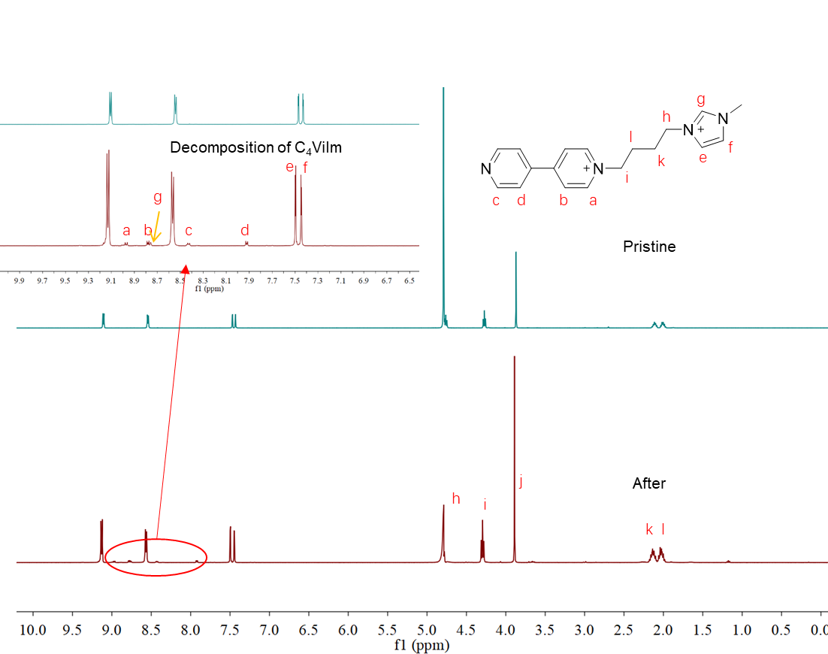
Supplementary Figure 31. ¹H NMR (400MHz, D₂O, 298 K) spectra comparison for symmetric C₄ViIm anolyte AORFB after 90 cycles (0.1 M flow cell).
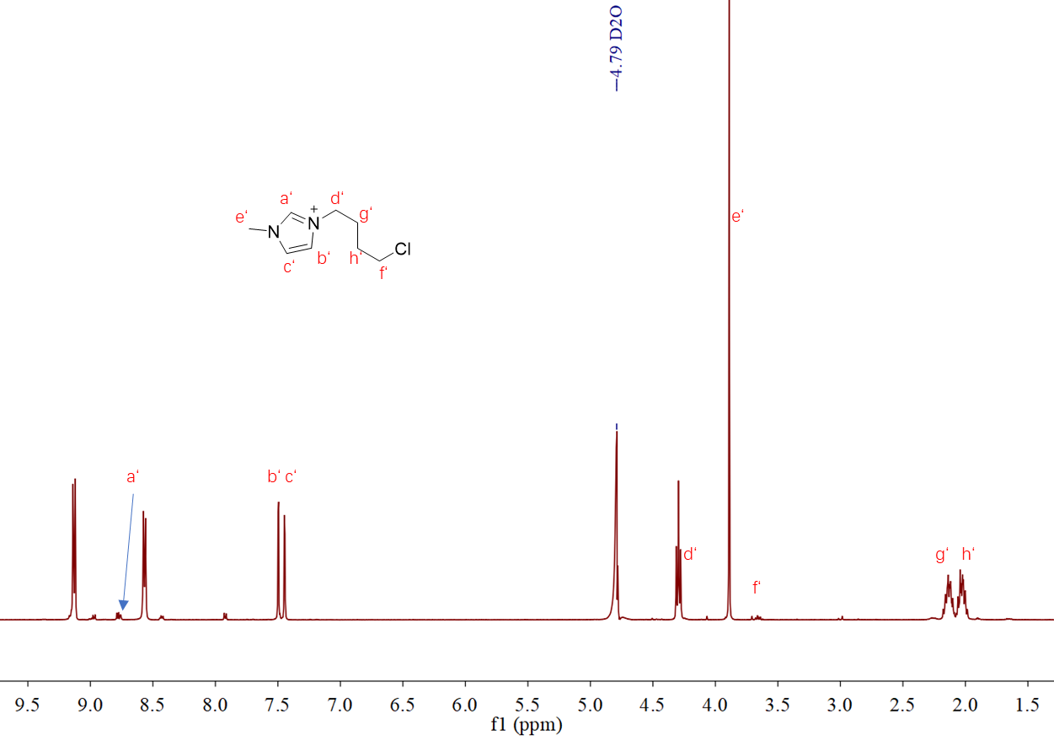Supplementary Figure 32. ¹H NMR (400MHz, D₂O, 298 K) spectroscopy for symmetric C₄ViIm anolyte AORFB after 90 cycles. The spectroscopy of C₄ViIm after cycling was recorded in D₂O with water suppression

Notes: The test results of the symmetric battery show that C₄ViIm is the most unstable among the three electrolytes (Fig. 3d), with a rapid capacity decay. In order to explain the capacity decay, we detected the structure of the C₄ViIm electrolyte after cycling through ¹H NMR spectroscopy, and the results showed the presence of N-(4-(1-methyl-imidazolium)butyl)-4,4'-dipyrydyl chloride (Supplementary Figure 30) and 1-(2-Chlorobutyl)-3-methylimidazolium chloride (Supplementary Figure 31) products, which indicates that C₄ViIm has undergone decomposition.

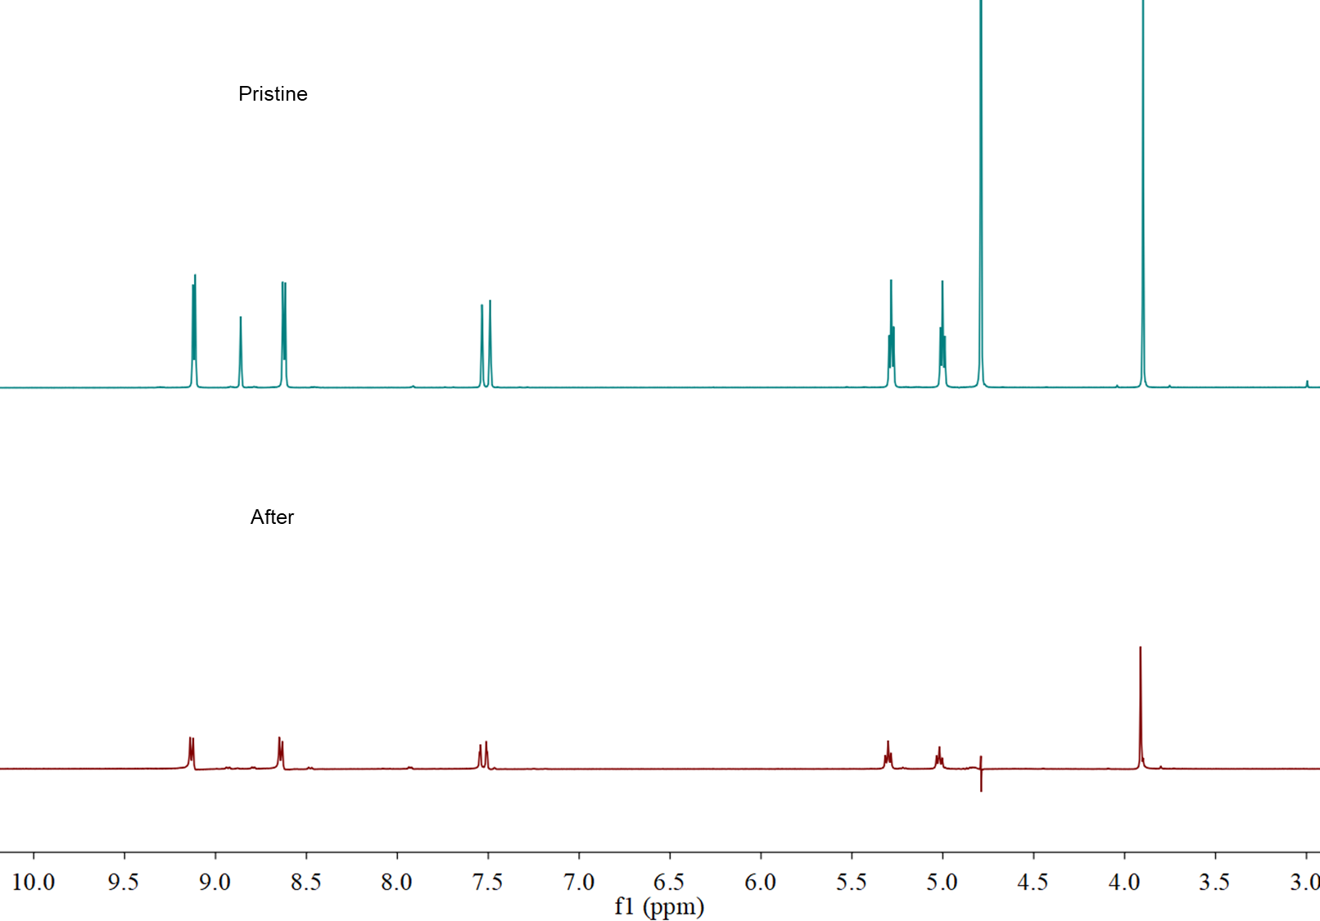
Supplementary Figure 33. ¹H NMR (400MHz, D₂O, 298 K) spectra comparison for symmetric C₂ViIm anolyte AORFB after 680 cycles (0.1 M flow cell). The spectroscopy of C₂ViIm after cycling was recorded in D₂O with water suppression

Notes: The test results of the symmetric battery show that C₂ViIm is the most stable among the three electrolytes (Fig. 3d). The spectral analyses reveal C₂ViIm with trace structural degradation for 680 cycles, suggesting that donor-acceptor interactions enhance C₂ViIm stability.

Supplementary Figure 34. (a) Cyclic voltammetry of C₂ViIm and M BTMAP-Fc in a 0.5 M NaCl aqueous solution (scan rate, 100 mV s⁻¹). (b) Ratability test of the flow battery with 0.1 M C₂ViIm (6 mL) anolyte and 0.1 M BTMAP-Fc (12 mL) catholyte (supporting electrolyte, 2 M NaCl). (c) Discharge capacity, charge capacity, coulombic efficiency, (d) voltage efficiency and energy efficiency under different current densities.

Notes: The BTMAP-Fc/C₂ViIm AORFB (Supplementary Figure 32a) reaches a cell voltage of 0.674 V, the cell was cycled at constant current densities from 20 to 80 mA cm⁻² with excellent retention of cell performance (Supplementary Figure 32b-d). The capacity utilization of 0.1 M C₂ViIm AORFB was around 89.6%, 75.4%, 69.8%, 61.9%, and 42.5% at 20, 40, 50, 60, and 80 mA cm⁻², respectively. The energy efficiency (EE) decreased from around 82.1% to 47.3% as the current density increased from 20 to 80 mA cm⁻² with the coulombic efficiency (CE) of nearly 99.9%.

Supplementary Figure 35. (a) Cyclic voltammetry of C₃ViIm and M BTMAP-Fc in a 0.5 M NaCl aqueous solution (scan rate, 100 mV s⁻¹). (b) Ratability test of the flow battery with 0.1 M C₃ViIm (8 mL) anolyte and 0.1 M BTMAP-Fc (14 mL) catholyte (supporting electrolyte, 2 M NaCl). (c) Discharge capacity, charge capacity, coulombic efficiency, (d) voltage efficiency and energy efficiency under different current densities.

Notes: The BTMAP-Fc/C₃ViIm AORFB (Supplementary Figure 33a) reaches a cell voltage of 0.746 V. The capacity utilization of 0.1 M C₃ViIm AORFB was around 87.3%, 73.7%, 56.0%, and 29.4% at 20, 40, 60, and 80 mA cm⁻², respectively. The energy efficiency (EE) decreased from around 81.2% to 37.3% as the current density increased from 80 to 20 mA cm⁻² with the coulombic efficiency (CE) of nearly 99.9%.

Supplementary Figure 36. (a) Cyclic voltammetry of C₄ViIm and M BTMAP-Fc in a 0.5 M NaCl aqueous solution (scan rate,100 mV s⁻¹). (b) Ratability test of the flow battery with 0.1 M C₄ViIm (7 mL) anolyte and 0.1 M BTMAP-Fc (14 mL) catholyte (supporting electrolyte, 2 M NaCl). (c) Discharge capacity, charge capacity, coulombic efficiency, (d) voltage efficiency and energy efficiency under different current densities.

Notes: The BTMAP-Fc/C₄ViIm AORFB (Supplementary Figure 34a) reaches a cell voltage of 0.804 V. The capacity utilization of 0.1 M C₄ViIm AORFB was around 92.5%, 86.8%, 82.1%, 77.3%, and 66.1% at 20, 40, 50, 60, and 80 mA cm⁻², respectively. The energy efficiency (EE) decreased from around 87.9% to 61.4% as the current density increased from 20 to 80 mA cm⁻² with the coulombic efficiency (CE) of nearly 99.9%.

Supplementary Figure 37. Ratability test of the flow battery with 0.1 M C_{n}ViIm (n=2,3,4) anolyte and 0.1 M BTMAP-Fc catholyte (supporting electrolyte, 2 M NaCl). Capacity utilization (a) and energy efficiency (b) under different current densities.

Supplementary Figure 38. Extended 1012 cycle testing performance of the BTMAP-Fc/C₃ViIm AORFB in the voltage range of 1.0-0.2 V at current density 50 mA cm⁻². The cell was constructed with 8 mL of a 0.1 M C₃ViIm anolyte and 14 mL of a 0.1 M BTMAP-Fc catholyte (supporting electrolyte, 2 M NaCl). (inset: charge/discharge profiles of the BTMAP-Fc/C₃ViIm AORFB at different cycles).

Notes: C₃ViIm reached a capacity retention of 82.3% after 1012 cycles, corresponding to a capacity fade rate of 0.018% per cycle. The energy and voltage efficiencies through the cycles remained around 54.2%, with an average coulombic efficiency of 99.9%.

Supplementary Figure 39. Extended 1300 cycle testing performance of the BTMAP-Fc/C₄ViIm AORFB in the voltage range of 1.1-0.2 V at current density 50 mA cm⁻². The cell was constructed with 7 mL of a 0.1 M C₄ViIm anolyte and 14 mL of a 0.1 M BTMAP-Fc catholyte (supporting electrolyte, 2 M NaCl). (inset: charge/discharge profiles of the BTMAP-Fc/C₄ViIm AORFB at different cycles).

Notes: The 0.1 M C₄ViIm AORFB was cycled at 50 mA cm⁻² between 0.2 and 1.1 V for 1300 cycles, corresponding to a capacity fade rate of 0.024% per cycle. The energy and voltage efficiencies through the cycles remained around 67.25%, with an average coulombic efficiency of 99.9%. Their (C₂ViIm, C₃ViIm and C₄ViIm) similar capacity fade rates agree with their similar strength of donor-acceptor interactions.

Supplementary Figure 40. Radar plot with five requirements for AORFBs (CE, cycling number, capacity retention, capacity decay per cycle, material utilization) to evaluate C_{n}ViIm (n=2,3,4) electrolytes.

Supplementary Figure 41. Characterization of electrolytes for 0.1 M BTMAP-Fc/C₂ViIm AORFB after cycling. (a) ¹H NMR spectra comparison for BTMAP-Fc, C₂ViIm, the catholyte and the anolyte after 10230 cycles. Cyclic voltammograms of the anolyte (b) and the catholyte (c) before and after 10230 cycles. The cell structure was 6 ml of a 0.1 M C₂ViIm anolyte and 10 ml of a 0.1 M BTMAP-Fc catholyte (supporting electrolyte, 2 M NaCl).

Notes: The ¹H NMR spectrum shows that after 10230 cycles of BTMAP-Fc/C₂ViIm flow cell, a new peak appears (3.1 ppm) at the anolyte, which is attributed to the membrane penetration of the BTMAP-Fc. In addition, there are no other new peak signals, indicating that the anolyte structure is stable. The capacity degradation of C₂ViIm with stronger donor-acceptor interactions flow cell was mainly attributed to the transmembrane crossover of BTMAP-Fc, while the capacity decay of C₃ViIm and C₄ViIm with weaker donor-acceptor interactions was primarily attributed to their own chemical degradation and transmembrane crossover of BTMAP-Fc, as confirmed by ¹H NMR, CV, and HRMS studies.
Supplementary Figure 42. Characterization of electrolytes 0.1 M BTMAP-Fc/C₃ViIm AORFB after cycling. (a) ¹H NMR spectra comparison for BTMAP-Fc, C₃ViIm, the catholyte and the anolyte after 1012 cycles. Cyclic voltammograms of the anolyte (b) and the catholyte (c) before and after 1012 cycles. The cell structure was 8 ml of a 0.1 M C₃ViIm anolyte and 12 ml of a 0.1 M BTMAP-Fc catholyte (supporting electrolyte, 2 M NaCl).

Notes: The ¹H NMR spectrum shows that after 1012 cycles of the BTMAP-Fc/C₃ViIm flow cell, no new signal peak appears at the anolyte electrode, and the electrochemical cyclic voltammetry curve does not show any new signal peak. However, HR-MS reveal that the C₃ViIm/BTMAP-Fc flow battery experience degradation of the anolyte and crossover of the catholyte (Supplementary Figure 44). This may not have reached the detection limit of ¹H NMR and CV.

Supplementary Figure 43. Characterization of electrolytes 0.1 M BTMAP-Fc/C₄ViIm AORFB after cycling. (a) ¹H NMR spectra comparison for BTMAP-Fc, C₄ViIm, the catholyte and the anolyte after 1300 cycles. Cyclic voltammograms of the anolyte (b) and the catholyte (c) before and after 1300 cycles. The cell structure was 7 ml of a 0.1 M C₄ViIm anolyte and 12 ml of a 0.1 M BTMAP-Fc catholyte (supporting electrolyte, 2 M NaCl).

Notes: The ¹H NMR spectrum shows that a series of new signal peaks (8.9, 8.7, 8.4, 7.9, and 3.1 ppm) appear at the negative electrode of the BTMAP-Fc/C₄ViIm flow cell after 1300 cycles, which belong to compound N-(4-(1-methyl-imidazolium)butyl)-4,4'-dipyrydyl chloride (purple arrow) and BTMAP-Fc (red arrow). These results are consistent with the product analysis of the symmetric cell (Supplementary Figure 30 and 31). CV shows a new more negative signal peak (green arrow) compared to C₄ViIm, which is probably the N-(4-(1-methyl-imidazolium)butyl)-4,4'-dipyrydyl chloride signal of the decomposition product. These degradation products were further confirmed by HRMS (Supplementary Figure 42).
Supplementary Figure 44. The HR-MS spectra of the samples after cycling for AORFBs in 0.1 M. (a) BTMAP-Fc/C₂ViIm flow cell. (b) BTMAP-Fc/C₃ViIm flow cell. (c) BTMAP-Fc/C₄ViIm flow cell.

Notes: Several m/z peaks corresponding to the ion fragments from C₃ViIm degradation was clearly observed (Supplementary Figure 44), attributed to N-(3-(1-methyl-imidazolium)propyl)-4,4'-dipyrydyl chloride ([M]²⁺ calcd for C₁₇H₂₀N₄²⁺ 140.0839, found 140.0838), indicating that weak donor-acceptor interactions make the N−C bond more polar, making it easier to break the N−C bond, thus causing battery capacity decay. The BTMAP-Fc catholyte crossover for C₃ViIm/BTMAP-Fc flow cell after cycling was observed ([M]²⁺ calcd for C₂₂H₃₈FeN₂²⁺ 193.1184, found m/z = 193.1188) (Supplementary Figure 44b). For C₄ViIm, NMR and CV results exhibit the presence of N-(4-(1-methyl-imidazolium)butyl)-4,4'-dipyrydyl chloride and trace amount of BTMAP-Fc (Fig. 5, and Supplementary Fig.44) in the anolyte, suggesting weaker donor-acceptor interactions significantly promoted the degradation of C₄ViIm. The C₄ViIm degradation is further experimentally confirmed by HRMS, which shows presence of N-(4-(1-methyl-imidazolium)butyl)-4,4'-dipyrydyl chloride ([M]²⁺ calcd for C₁₈H₂₂N₄²⁺ 147.0917, found 147.0916) and 1-(2-Chlorobutyl)-3-methylimidazolium chloride ([M+H] ⁺ calcd for C₁₈H₂₂N₄⁺ 174.0841, found 174.1151) (Supplementary Figure 44c). The appearance of N-(4-(1-methyl-imidazolium)butyl)-4,4'-dipyrydyl chloride and 1-(2-Chlorobutyl)-3-methylimidazolium chloride should originate from instability of C₄ViIm. We also observed crossover of BTMAP-Fc ([M]²⁺ calcd for C₂₂H₃₈FeN₂²⁺ 193.1184, found 193.1187) (Supplementary Figure 44c).

Supplementary Figure 45. Changes in the calculated Mulliken charges of important atoms in the during charge/discharge.

Notes: We conducted DFT calculations to analyze the possible mechanism of electrolytes degradation. As discussed in the main text (Fig. 5e), the strong polar bonds of electrolytes with the weak donor-acceptor interactions indicates preferable N−C bond breaking during charge/discharge thus generating charge. For electrolytes, we note that the carbon atoms of C₄ViIm exhibit the most negative Mulliken charges, and when C₄ViIm accept one electron (Supplementary Figure 45). This projects that the N−C bond of this carbon atom in C₄ViIm is highly polar. For charge state, we find that accepting one electron leads to the most negative Mulliken charges on carbon atoms of C₄ViIm in C₂ViIm, C₃ViIm and C₄ViIm. These findings are consistent with ESP results (Fig 2e). Therefore, the negative charged C and positive charged N atoms are projected to break (Supplementary Figure 15).

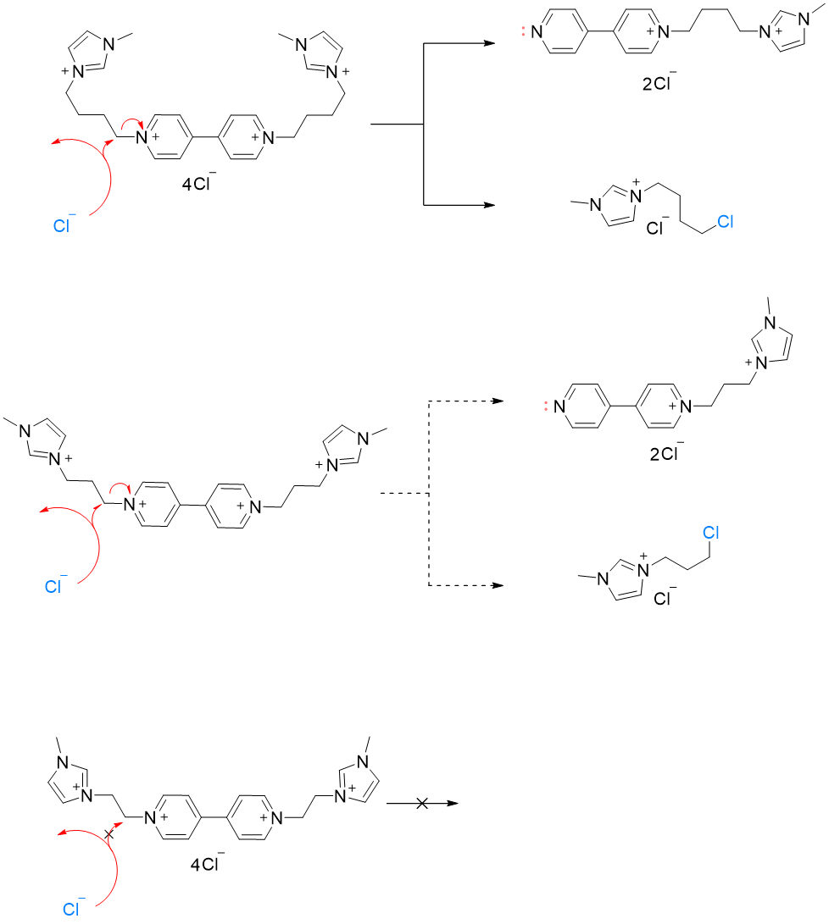
Supplementary Figure 46. Mechanisms of electrolyte degradation for C₂ViIm, C₃ViIm, and C₄ViIm.

Supplementary Figure 47. The molecular structure showing the charged I (1-(2-Chlorobutyl)-3-methylimidazolium chloride) and its mesomeric form.

Supplementary Figure 48. LUMO and HOMO energy levels of different electrolytes including C₂ViIm, C₃ViIm and C₄ViIm.

Notes: The energy levels of the lowest unoccupied molecular orbital (LUMO) and highest occupied molecular orbital (HOMO) of C₂ViIm, C₃ViIm and C₄ViIm were calculated using DFT. The HOMO diagram shows that C₂ViIm is lower than C₃ViIm and C₄ViIm due to effective electron delocalization and conjugation, indicating that its oxidation state is more chemically stable. The LUMO-HOMO gaps of C₃ViIm and C₄ViIm are smaller than that of C₂ViIm, which further indicates that C₂ViIm is more chemically stable.

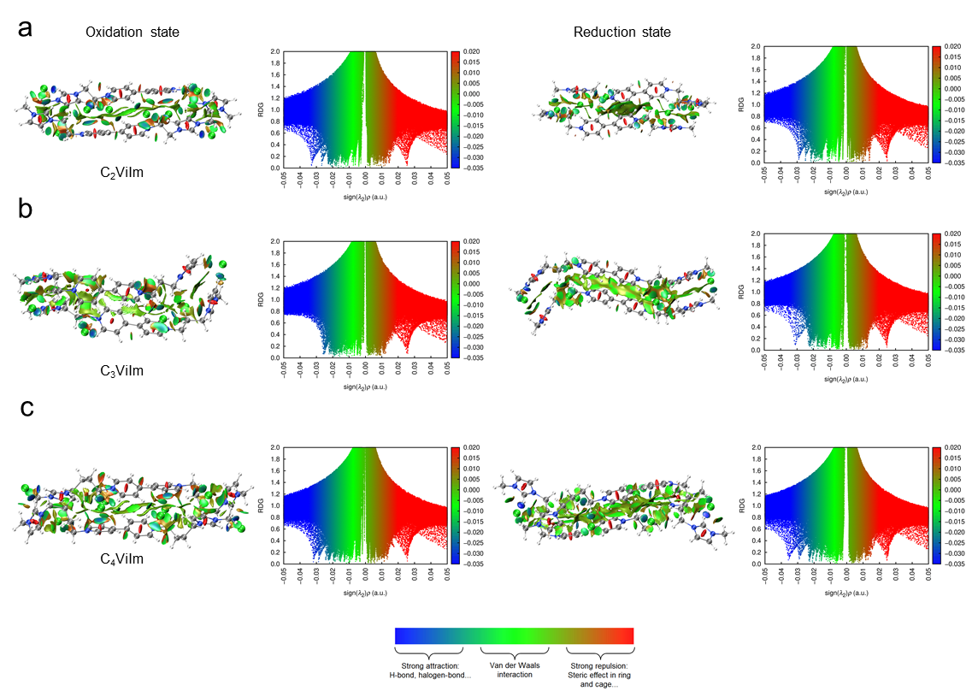
Supplementary Figure 49. NCI 3D isosurfaces and 2D-RDG scattered map of compound C₂ViIm (a), C₃ViIm (b), and C₄ViIm (c) in the density functional theory (DFT)¹⁸.

Notes: The electron density of sign (λ₂) relative to RDG indicates the nature and magnitude of intermolecular inter actions. In molecular systems, blue signifies repulsion, whereas red represents repulsive forces. Sign (λ₂) is an important factor in predicting the type of interaction. For example, sign 2 < 0 implies repulsive forces between bonded atoms, while sign (λ₂) > 0 suggests non-bonded atoms without repulsive force. The RDG scatter plot for the complexes is presented on the right side of Supplementary Figure 49. According to the expression at the top of the figure, red indicates strong repulsive forces (steric or cyclic effect); blue represents hydrogen bonding; and green reflects the presence of Van der Waals interactions. According to color classification, there is a Vander Waals interaction between the C_{n}ViIm molecule, which suggests that these molecules have weak interactions. These results are similar to previous reports that a relatively high surface potential due to the positively charged side groups, which hinders their aggregation¹⁹.

Supplementary Figure 50. Discharge capacity, charge capacity, CEs, VEs and EEs at different current densities.

Supplementary Figure 51. Representative charge and discharge profiles of 1st and 500th cycles (1.0 M C₂ViIm anolyte and 1.0 M BTMAP-Fc catholyte).

Supplementary Figure 52. Characterization of electrolytes for 1.0 M BTMAP-Fc/C₂ViIm AORFB after cycling. (a) ¹H NMR spectra comparison for BTMAP-Fc, C₂ViIm, the catholyte and the anolyte after 530 cycles. Cyclic voltammograms of the anolyte (b) and the catholyte (c) before and after 530 cycles. The cell structure was 8 ml of a 1.0 M C₂ViIm anolyte and 12 ml of a 1.0 M BTMAP-Fc catholyte (supporting electrolyte, 0.5 M NaCl).

References
1 Song, G., Wang, X., Li, Y. & Li, X. Iridium Abnormal N-Heterocyclic Carbene Hydrides via Highly Selective C−H Activation. Organometallics 27, 1187-1192 (2008).
2 Chen, Q. et al. Designer Ferrocene Catholyte for Aqueous Organic Flow Batteries. Chemsuschem 14, 1295-1301 (2021).
3 Beh, E. S. et al. A Neutral pH Aqueous Organic–Organometallic Redox Flow Battery with Extremely High Capacity Retention. Acs Energy Lett 2, 639-644 (2017).
4 M. J. Frisch, G. W. T., H. B. Schlegel, G. E. Scuseria, et al. Gaussian 09, Revision D.01. (Gaussian 2013).
5 Marenich, A. V., Cramer, C. J. & Truhlar, D. G. Universal solvation model based on solute electron density and on a continuum model of the solvent defined by the bulk dielectric constant and atomic surface tensions. J Phys Chem B 113, 6378-6396 (2009).
6 Florian Weigenda, R. A. Balanced basis sets of split valence, triple zeta valence and quadruple zeta valence quality for H to Rn: Design and assessment of accuracy. Phys Chem Chem Phys 7, 3297-3305 (2005).
7 Fukui, K. The path of chemical reactions - the IRC approach. Accounts Chem Res 14, 363-368 (2002).
8 D. A. McQuarrie, J. S. Physical Chemistry: A Molecular Approach, University Science Books. (1997).
9 Lu, T. & Chen, Q. Shermo: A general code for calculating molecular thermochemistry properties. Computational and Theoretical Chemistry 1200 (2021).
10 Wang, M. et al. Molecular Geometries and Vibrational Contributions to Reaction Thermochemistry Are Surprisingly Insensitive to the Choice of Basis Sets. J Chem Theory Comput 19, 5036-5046 (2023).
11 Zhao, Y. & Truhlar, D. G. The M06 suite of density functionals for main group thermochemistry, thermochemical kinetics, noncovalent interactions, excited states, and transition elements: two new functionals and systematic testing of four M06-class functionals and 12 other functionals. Theoretical Chemistry Accounts 120, 215-241 (2007).
12 Weigend, F., Häser, M., Patzelt, H. & Ahlrichs, R. RI-MP2: optimized auxiliary basis sets and demonstration of efficiency. Chemical Physics Letters 294, 143-152 (1998).
13 de Andrade, K. N., Peixoto, B. P., Carneiro, J. W. M. & Fiorot, R. G. Exploring borderline S(N)1-S(N)2 mechanisms: the role of explicit solvation protocols in the DFT investigation of isopropyl chloride. Rsc Adv 14, 4692-4701 (2024).
14 Grimme, S., Antony, J., Ehrlich, S. & Krieg, H. A consistent and accurate ab initio parametrization of density functional dispersion correction (DFT-D) for the 94 elements H-Pu. J Chem Phys 132, 154104 (2010).
15 Monkowius, U., Nogai, S. & Schmidbaur, H. A Conformational Analysis of the Spirocyclic Quaternary Ammonium Cation [(CH2)4N(CH2)4]+ in its Bromide and Picrate Salts. Zeitschrift für Naturforschung B 59, 259-263 (2004).
16 Ishigaki, Y., Shimajiri, T., Takeda, T., Katoono, R. & Suzuki, T. Longest C–C Single Bond among Neutral Hydrocarbons with a Bond Length beyond 1.8 Å. Chem-Us 4, 795-806 (2018).
17 Jin, S. et al. Near Neutral pH Redox Flow Battery with Low Permeability and Long‐Lifetime Phosphonated Viologen Active Species. Advanced Energy Materials 10, 202000100 (2020).
18 Johnson, E. R. et al. Revealing Noncovalent Interactions. J Am Chem Soc 132, 6498-6506 (2010).
19 Xiang, Z. et al. Manipulating Aggregate Electrochemistry for High‐Performance Organic Redox Flow Batteries. Angewandte Chemie International Edition 64 (2024).

