Supplementary material
Supplement S1.
EEG (pre-)processing, as well as conditions and montages employed, often differ considerably across studies which can hinder replication of findings and thereby implementation of biomarkers in clinical practice.
A positive linear correlation between iAPF and response to rTMS in MDD from prior work could not be replicated with a linked-mastoids (LM) montage ^{74,75} whereas a robust and replicated quadratic association could be found when using an average (AR) but not a LM reference ^{76,77}. This shows the need for a standardized and fixed (pre-) processing pipeline, uniformly applied across datasets. Another aspect is the choice of frequency range employed to determine the iAPF. Already in the 1930s it was reported that alpha oscillations in children are still immature and often slower than in adults with peaks even below 8Hz - while peaks above 12 Hz could also be observed ²². While most studies consider 8 and 12 Hz the outer bounds of the alpha range, in more heterogeneous populations values will likely scatter below or above these boundaries and the extreme ends of the frequency band might thus be clinically most relevant. This warrants a more flexible analysis with a wider frequency window of 7 to 13 Hz.

Supplement S2. Low-voltage alpha.
The average spectral power value in the alpha range (7-13Hz) was determined with the Fast Fourier Transform (FFT) in all 3 electrodes (Fz, Pz, Oz) for each individual and subsequently log-transformed. The z-score of -1.96 in Pz, i.e., the lowest 5% of the log-transformed spectral alpha power, marked the threshold for insufficient alpha power (supplementary figure S1). This value was validated by visually inspecting 1% of the recordings above and below this threshold for alpha oscillations. When the spectral power value in an electrode fell below this threshold the data of this electrode was discarded. This process was repeated for both LM and AR.

Supplementary Figure S1.
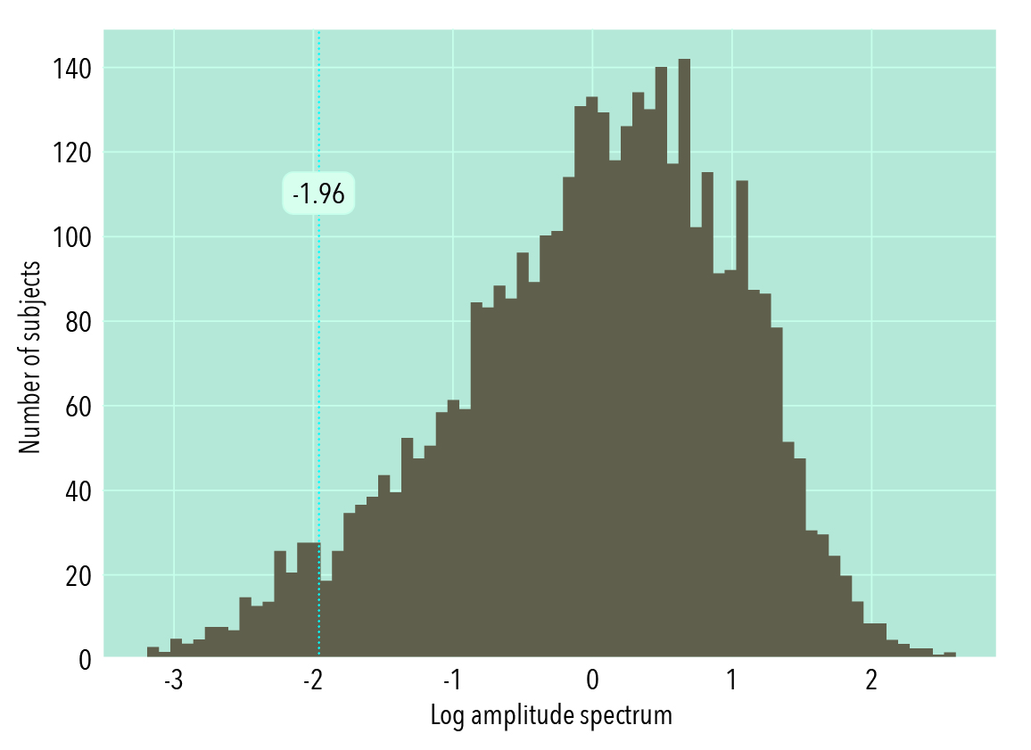
Normal distribution of alpha spectral power (7-13Hz) with threshold set at a z-score of -1.96 in electrode Pz.

Supplement S3. Biomarker Discovery Phase
First, subjects without alpha oscillations, so called low-voltage alpha, were discarded as specified in supplement S2 resulting in data loss of 4.8% (in Pz) to 7.3% (in Oz).
Subsequently, a total of 108 algorithm permutations were tested with 1) condition (eyes closed (EC), eyes open (EO) or EC-EO Difference (Diff)), 2) choice of segmentation length (2-7s), 3) montage (linked-mastoids (LM), average reference (AR)), and 4) topographical location (channel location Fz, Pz, Oz). The permutations were selected for further prospective testing of the biomarker based on 2 decision rules: 1) the highest correlation between age and iAPF in subjects <18 years and, 2) the highest retention of data. Particularly for later treatment stratification it is important to find a biomarker that is broad enough to be able to predict outcome for as many patients as possible. On the other hand, if a prediction of outcome can be made with high specificity but only for a limited amount of people, it might be worthwhile to use this approach for this smaller group. Following this reasoning, we chose the segment length that showed the highest correlation while retaining the highest number of subjects across electrodes (averaged across conditions and reference montages average and LM). Correlations and data retention averaged across all segment lengths was highest in the EC condition with ρ between 0.28 (Fz) and 0.34 (Oz) (except for Oz where the correlation was higher for EO but data retention was much lower). Therefore, EC was chosen as the condition for subsequent analyses. As depicted in Figure 1, electrodes Pz and Oz showed the highest correlation (Fz second highest) with age (Oz: ρ of 0.34) for a segment length of 5s (with condition EC and averaged across reference montages) while data retention was highest for 5s segment-length in all 3 electrode sites (97%). The strongest overall correlation between age and iAPF for both reference montages for 5s segment length and condition EC was found in electrode Oz. Since this correlation was slightly higher in LM than in AR (ρ= 0.34 vs ρ= 0.33), and data retention was the same (97% across all electrodes) for both LM and AR, LM was chosen as primary reference montage. All 3 electrode locations were examined in further prospective biomarker testing.
In a post hoc analysis, comparing reference montages between children (age 6-18 yrs.) and adults, the iAPF determined with a LM reference montage led to a slightly higher correlation with age for children (6-18yrs.) compared to the iAPF determined with an AR montage (ρ= 0.12 vs ρ=0.11), while this was reversed for adults (ρ=0.05 vs ρ= 0.06), i.e., the AR reflected the adult data better.
GraphPad Prism (GraphPad Software, La Jolla California USA, www.graphpad.com) was employed in the full TD-BRAIN+ data to find the mathematical model that most closely approximates the brain-maturation effect. In line with previous evidence ⁷³, a log Gaussian fit determined separately for males and females and for each electrode location most appropriately followed the data (males: r2 = 11.9% (Oz); females: r2= 12.6% (Oz)) and continuously outperformed the linear model (H0; p <1x${10}^{-15}$). Normalized iAPF values for each individual (divergence values), derived by subtraction of the model-predicted iAPF from the real iAPF, scattered around 0. Note that in Figure 1, divergence values seemingly following the previous age curvature pattern result from the temporal resolution limits of 0.2Hz caused by data segmentation.
A secondary analysis, comparing the curve fit of the clinical TD-BRAIN+ dataset with the curve fit specific to a normative dataset ⁷² in GraphPad prism, indicated that the parameters of the clinical dataset generalized significantly better (p=0.03) to the normative data relative to the other way around (p=.21), suggesting that the clinical data is better capable of capturing and explaining variance.

Supplementary Figure S2.
S.2.1.
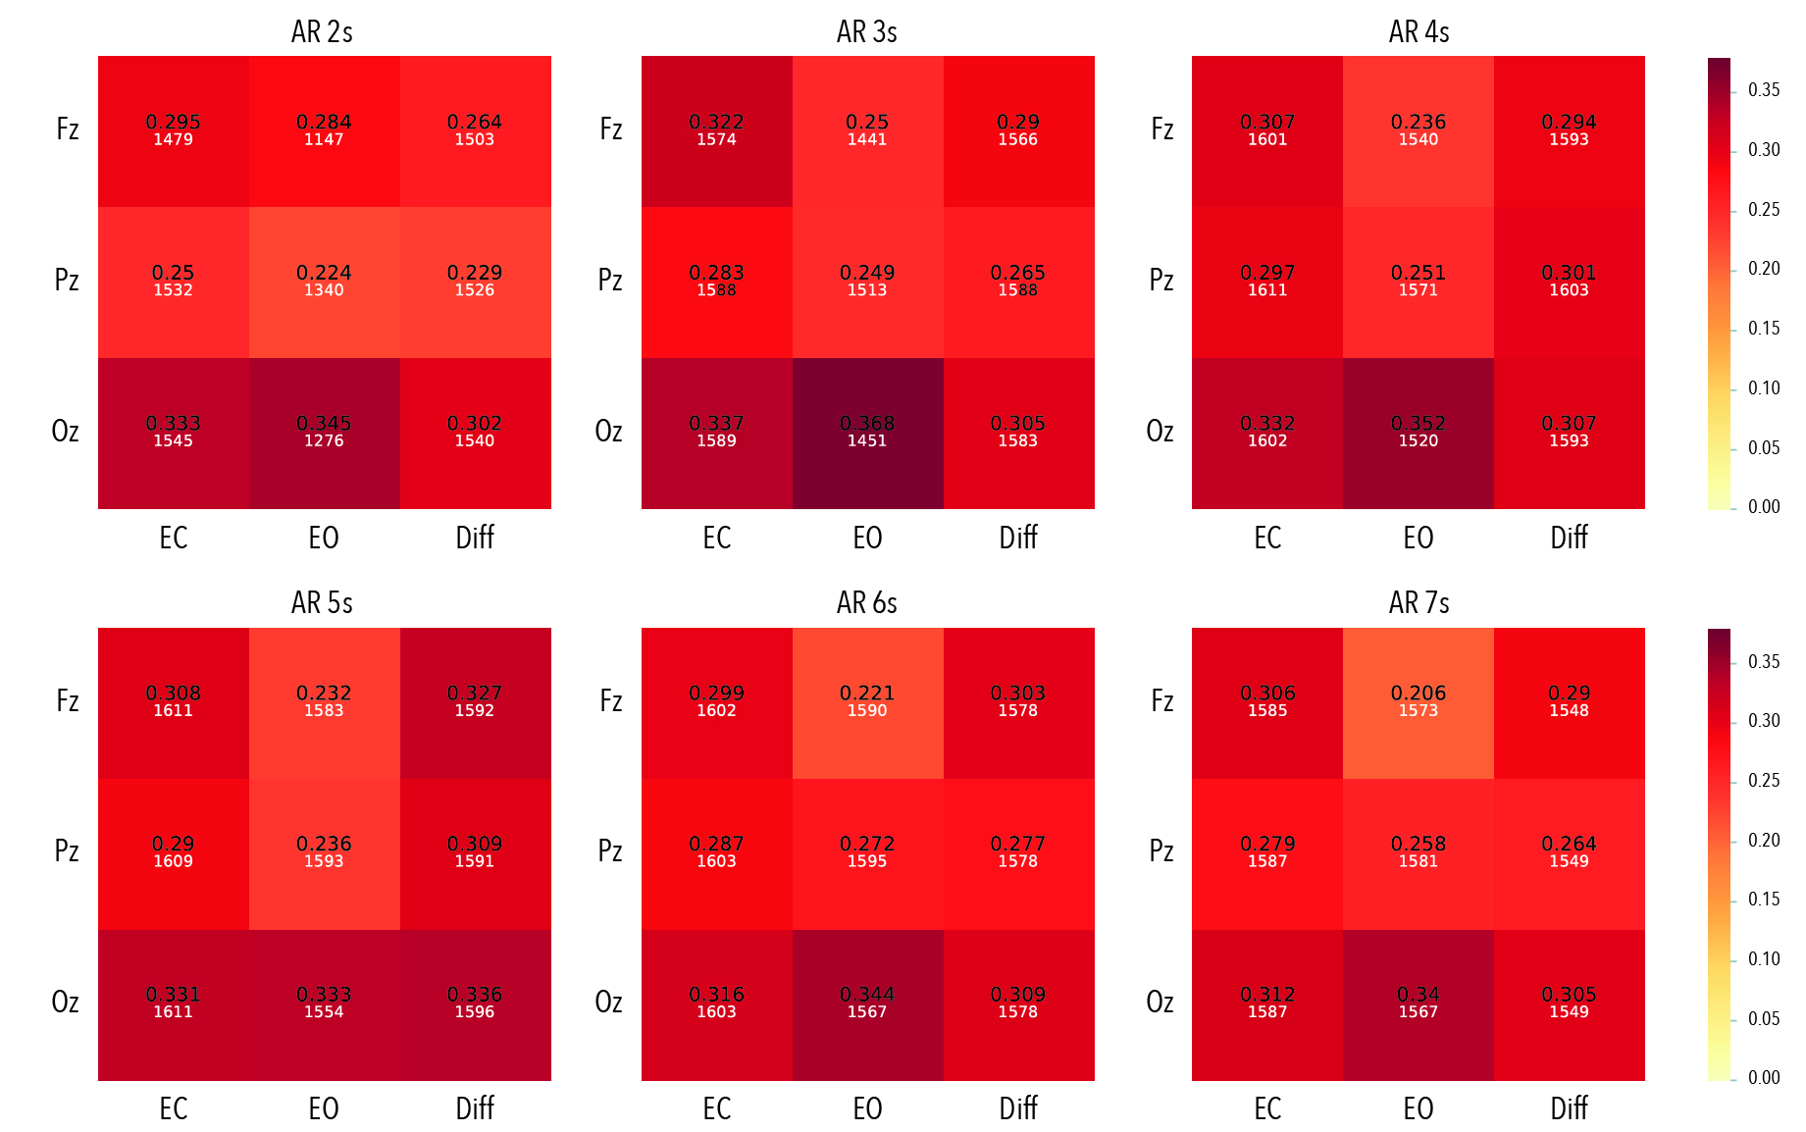
S.2.2.
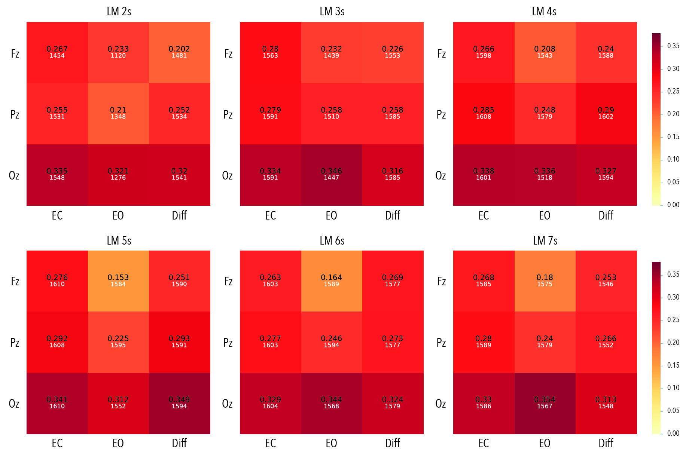
Heatmaps depicting Spearman correlations and number of subjects retained (Total N= 1662) between age (6-18y) and iAPF with Average reference montage (S.2.1) and Linked Mastoids montage (S2.2.), segment length of 2-7s and different conditions for electrodes Fz, Pz, Oz.
EC = Eyes Closed, EO= Eyes Open, Diff = Difference of Eyes Closed - Eyes open, AR = Average Reference, LM = Linked Mastoids reference

Supplementary Table S1. PPV for different decile cut-off points at Fz for males (6-18y).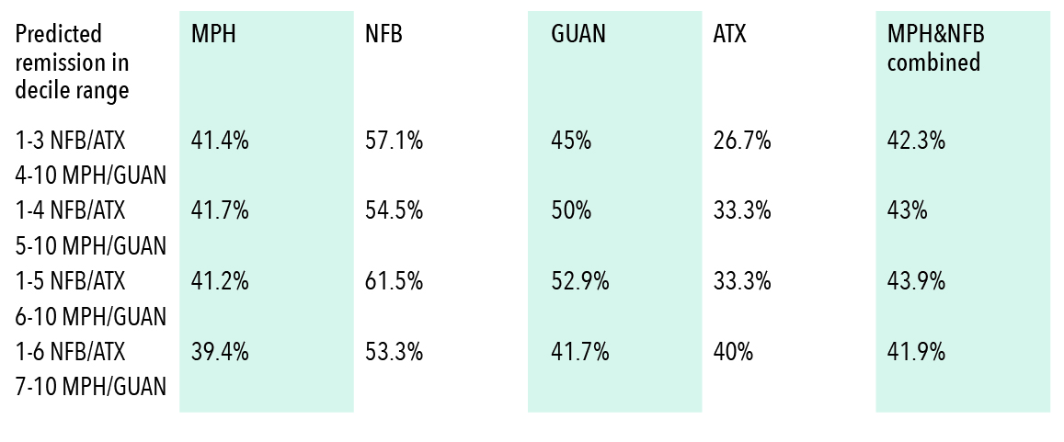
PPVs (predicted remission) per treatment group indicate remission if only subjects with the respective decile score had been assigned to the respective treatment. For instance, subjects with decile score of 1-3 who received NFB/ATX are included in the NFB/ATX PPV while subjects from the MPH/GUAN group with the remaining decile scores (e.g. 4-10) are included for MPH/GUAN PPV.

Supplementary Table S2. Biomarker accuracy males.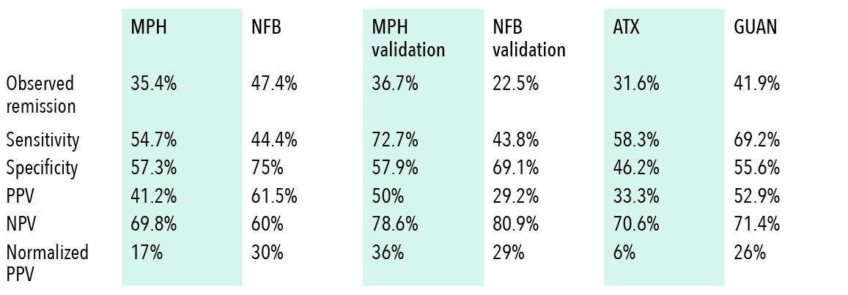
Stratification to MPH/GUAN for decile >=6, and to NFB/ATX for decile <=5 for males (6-18yrs.)
MPH = Methylphenidate, NFB= Neurofeedback, ATX = Atomoxetine, GUAN= Guanfacine, PPV = positive predictive value, NPV= negative predictive value.

Supplementary Table S3. Biomarker accuracy females.
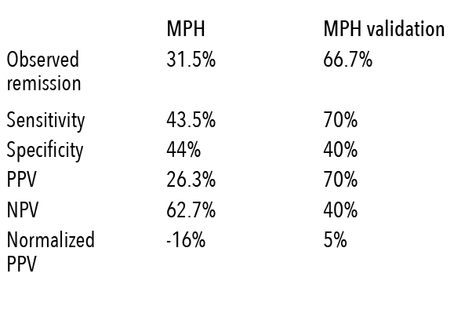
Supplement S4. Results Females
Analyses for girls are only reliable for MPH since samples for NFB and ATX were very small (N=9 and N=7, respectively). In the iSPOT-A dataset, analyses conducted only in females (N=73) showed a small trend towards a predicted worsening of remission rate after stratification based on the same rule as applied to males. In the blinded validation in the independent MPH/GUAN dataset, this trend disappeared and the predicted remission rate for girls neither improved nor worsened (see supplementary table S3). It is, thus, not possible to make any claim about the direction of effect for females based on this study and the biomarker presented here is only valid for boys.

Supplementary figure S3. Distribution of iAPF deciles for each dataset
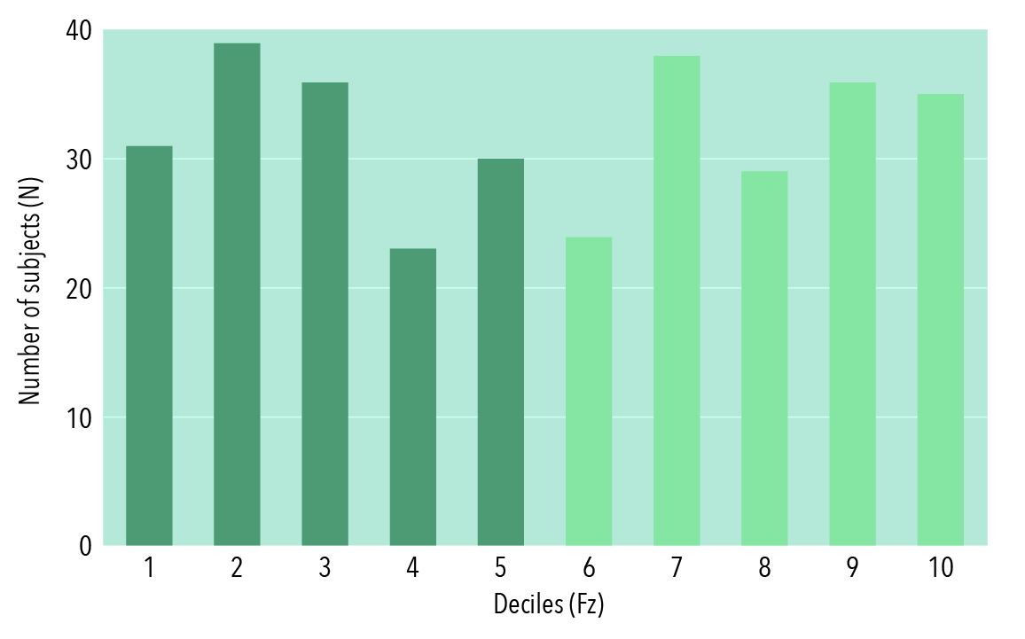
S3.1. Methylphenidate
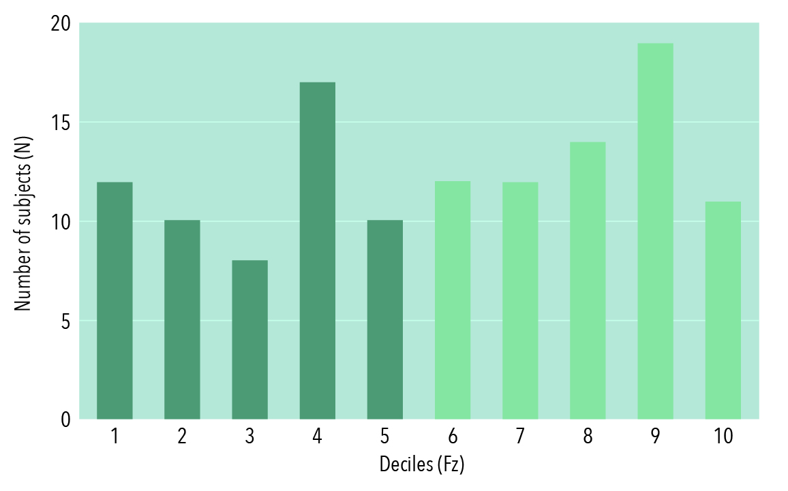
S3.2. Neurofeedback

Supplement S5. Post-hoc analysis of stratification based on electrode location Fz and Oz
As depicted in table S4, basing the stratification on the occipital electrode site Oz, tends to lead to an even higher gain in predicted stratified remission for NFB treatment (and also slightly for ATX treatment) while prediction for remission to MPH would worsen. It could therefore be valuable to take the prediction at Oz into account for the final stratification decision.
In an exploratory analysis, we examined how predicted remission rate would change if only those subjects were included that would have received the same recommendation for both Fz and Oz electrode. 67% of subjects from the pooled MPH and NFB transfer datasets received a matching recommendation. The PPV in this subgroup was 44.2% (normalized PPV = 24.3%) in the MPH dataset and 85.7% (normalized PPV = 80.8%) in the NFB sample, which reflects an improvement over the remission rates from the whole sample reported in figure 2.
This suggests that future research should examine the relevance of topographical location of the iAPF for prediction of treatment outcome.

Supplementary Table S4. PPV and normalized PPV for electrodes Fz and Oz.
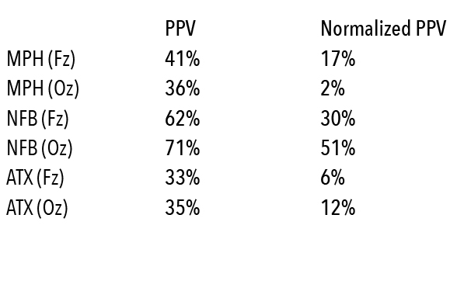
Comparison of PPVs (predicted remission) and normalized PPVs per treatment group for electrode sites Fz and Oz with decile scores 1-5 for NFB/ATX treatment and decile scores 6-10 for MPH treatment. Note that the prediction for NFB increases substantially when considering the Brainmarker-1 calculated at channel Oz.

