Carbapenem-resistant Acinetobacter baumannii ventilator-associated pneumonia in critically ill patients: potential inference with respiratory tract microbiota dysbiosis

Tingting Xiao^{1*}, Qian Guo^{2*}, Yanzi Zhou^{1*}, Ping Shen¹, Yuan Wang¹, Qiang Fang³, Mo Li², Shuntian Zhang¹, Lihua Guo¹, Xiao Yu¹, Yulin Liao², Chunhui Wang², Xiaohui Chi¹, Xiaoyang Kong¹, Kai Zhou⁴, Beiwen Zheng¹, Qixia Luo¹, Yunbo Chen¹, Huaiqiu Zhu^{2#}, Yonghong Xiao^{2#}

¹State Key Laboratory for Diagnosis and Treatment of Infectious Diseases, National Clinical Research Center for Infectious Diseases, National Medical Center for Infectious Diseases, Collaborative Innovation Center for Diagnosis and Treatment of Infectious Diseases, The First Affiliated Hospital, College of Medicine, Zhejiang University, Hangzhou, 310003, China;
² State Key Laboratory for Turbulence and Complex Systems, Department of Biomedical Engineering, College of Engineering, and Center for Quantitative Biology, Peking University, Beijing 100871, China.
³Department of Intensive care unit, The First Affiliated Hospital, College of Medicine, Zhejiang University, Hangzhou, 310003, China;
⁴ Shenzhen Institute of Respiratory Diseases, the First Affiliated Hospital (Shenzhen People's Hospital), Southern University of Science and Technology, and Second Clinical Medical College, Jinan University, Shenzhen, Shenzhen, 518000, China.

*TTX, QG and YZZ contributed equally to this work.
＃Correspondence to: hqzhu@pku.edu.cn; xiaoyonghong@zju.edu.cn.
Supplemental Figure
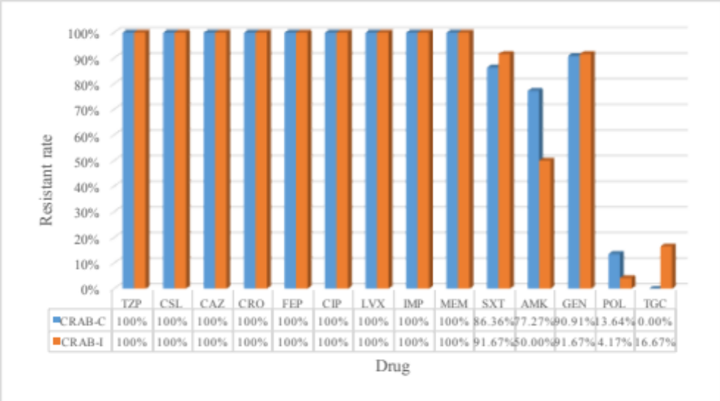
Supplemental Figure 1. Antimicrobial drug sensitivity test of Acinetobacter baumannii isolates collected in this study.
Note: TZP, Piperacillin/ tazobactam; CSL, Cefoperazone/sulbactam; CAZ, Ceftazidime; CRO, Ceftriaxone; FEP, Cefepime; CIP, Ciprofloxacin; LVX, Levofloxacin; IPM, Imipenem; MEM, Meropenem; TMX/SXT, Trimethoprim/sulfamethoxazole; AMK, Amikacin; GEN, Gentamicin; POL, Polymyxin; TGC, Tigecycline.

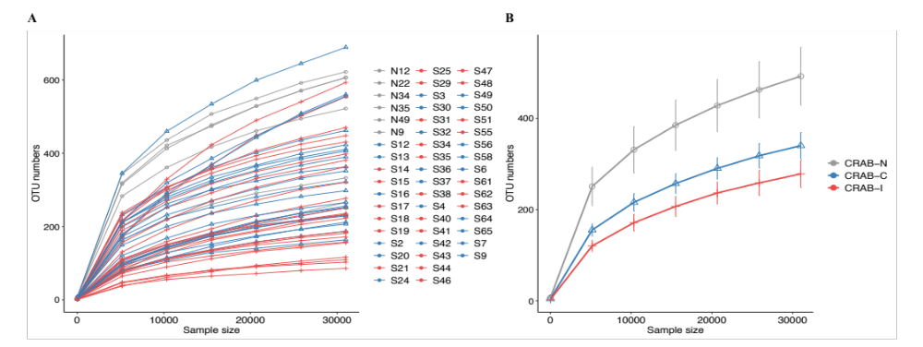
Supplemental Figure 2. Rarefaction analysis of bacterial 16S rRNA sequences.
(A) Rarefaction analysis of bacterial 16S rRNA gene sequences among samples was used to evaluate whether further sequencing would likely detect additional taxa, indicated by a plateau. The subject sample is indicated by the colour key at the top right corner. (B) Rarefaction analysis of bacterial 16S rRNA gene sequences among three group. The subject sample is indicated by the colour key at the top right corner. The y axis denotes the number of operational taxonomic units detected by Miseq sequencing at the corresponding sequencing depths shown along the x axis.
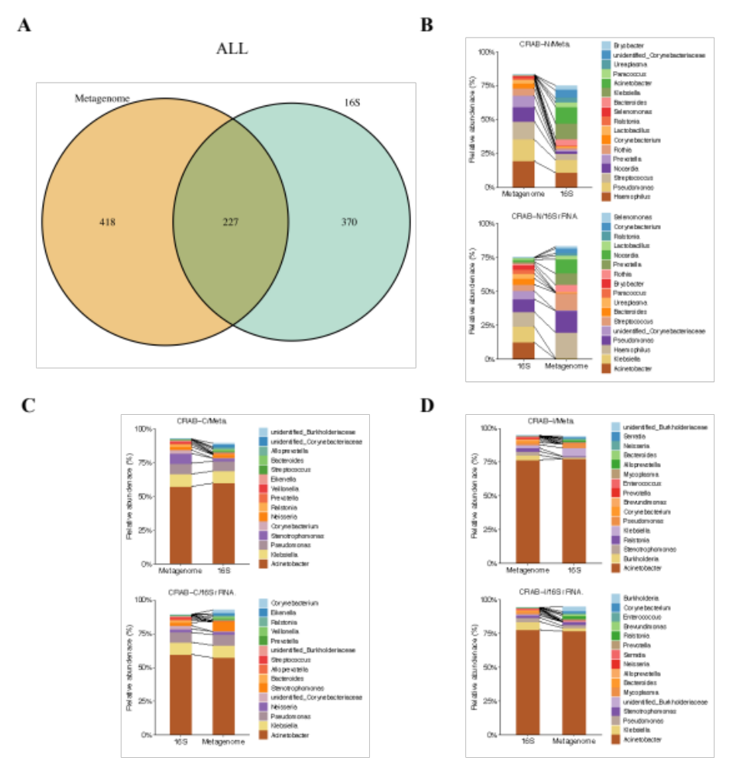
Supplemental Figure 3. Comparison of microbial composition between the metagenomics and 16S rRNA data.
(A) Overlap of identified genera between two data sets. The genera per group are visualized in as circle brownish yellowfor metagenomics data, and in green for 16S rRNA data. (B) The top 10 most abundant genera in the metagenomics and 16S rRNA analysis in CRAB-N group, respectively. (C) The top 10 most abundant genera in the metagenomics and 16S rRNA analysis in CRAB-C group, respectively. (D) The top 10 most abundant genera in the metagenomics and 16S rRNA analysis in CRAB-I group, respectively.
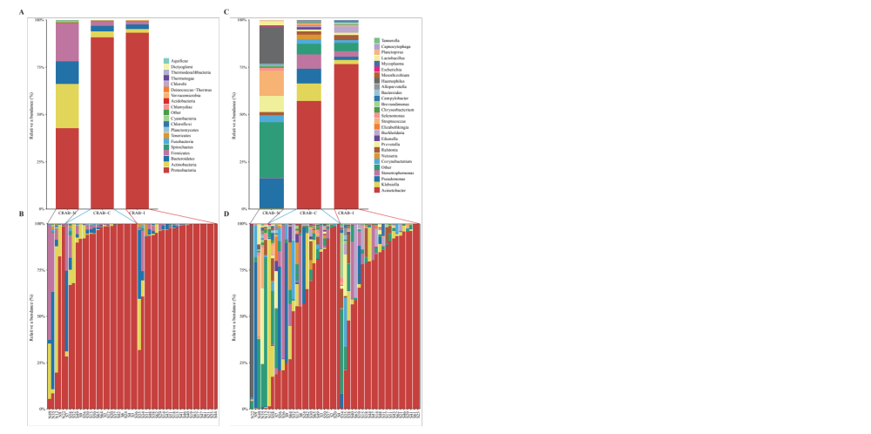
Supplemental Figure 4. Comparison of phyla and genus within the LRT microbiota of the three groups using Metagenomics analysis.
(A) Comparison of the average abundance of each bacterial phylum in each of the CRAB-N control groups and CRAB-C, CRAB-I patients, respectively. (B) Comparison of the average abundance of each bacterial phylum in each patient, respectively. (C) Comparison of the average abundance of each bacterial genus in each group, respectively. (D) Comparison of the average abundance of each bacterial genus in each patient, respectively. The subject group is indicated by the colour key at the top right corner.
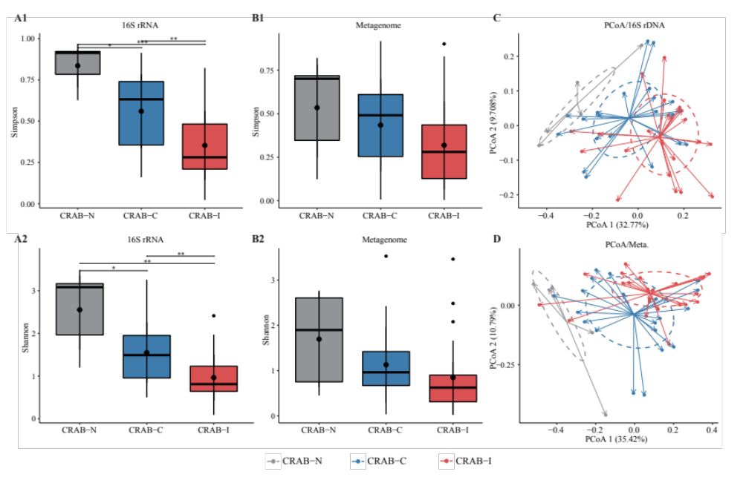
Supplemental Figure 5. Microbial alpha and beta diversity in the 16S amplicon and Metagenomics analysis of three groups.
(A) Box plots depict microbiome diversity differences according to the Shannon index, and Gini Simpson index between both CRAB negative groups and the CRAB positive group through 16S amplicon analysis. (B) Box plots depict Alpha diversity differences among three groups through metagenomics analysis. The upper and lower ranges of the box represent the 75% and 25% quartiles, respectively. (C) The x-axis shows PCo 1 and the y-axis PCo 2 form Bray-Curtis distances for β-diversity through 16S amplicon analysis. (D) The x-axis shows PCo 1 and the y-axis PCo 2 form Bray-Curtis distances through metagenomics analysis. The changes per patient are visualized in as dashed lines dark red for CRAB-I, in blue for CRAB-C and in gray for CRAB-N. Logistic regression analysis showed that the change of PCo1 was significantly lower in patients who developed pneumonia (p=0.002 and 0.001, respectively). Significant differences are indicated by *P<0.05, **P <0.01, ***P <0.001.
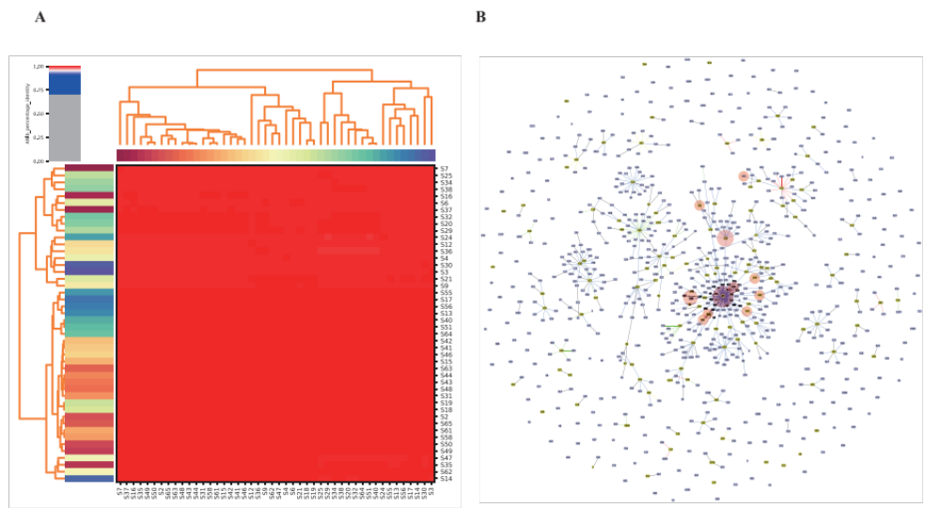
Supplemental Figure 6. PhyloGenetic characterizations of 46 Acinetobacter baumannii isolates.
(A) Average nucleotide identity (ANI) of 46 isolates. (B) Partial snapshot of Acinetobacter baumannii population analyzed using eBURST distance and PHYLOViZ 2.0 software. Groups are annotated as CCs. Abbreviations: CC: Clonal complex.

Supplemental Table
Supplemental Table 1. 16S rRNA gene sequences and Metagenomics Analysis sequences statistics of ETA and Whole genome sequencing analysis statistics of CRAB sequenced in this study.
Sample name | Group | 16S rRNA sequences |  |  | Metagenomics |  | Whole genome sequences
Sample name | Group | bioproject accession | accession | biosample accession | accession | biosample accession | bioproject accession | accession
S2 | CRAB-C | PRJNA681291 | SRR13162255 | SAMN16950843 | SRR13160954 | SAMN16948738 | PRJNA679997 | SAMN16869263
S3 | CRAB-C | PRJNA681291 | SRR13162254 | SAMN16950844 | SRR13160953 | SAMN16948739 | PRJNA679997 | SAMN16869264
S4 | CRAB-C | PRJNA681291 | SRR13162243 | SAMN16950845 | SRR13160942 | SAMN16948740 | PRJNA679997 | SAMN16869265
S6 | CRAB-C | PRJNA681291 | SRR13162232 | SAMN16950846 | SRR13160931 | SAMN16948741 | PRJNA679997 | SAMN16869266
S7 | CRAB-C | PRJNA681291 | SRR13162221 | SAMN16950847 | SRR13160920 | SAMN16948742 | PRJNA679997 | SAMN16869267
S9 | CRAB-C | PRJNA681291 | SRR13162210 | SAMN16950848 | SRR13160910 | SAMN16948743 | PRJNA679997 | SAMN16869268
S12 | CRAB-C | PRJNA681291 | SRR13162207 | SAMN16950849 | SRR13160909 | SAMN16948744 | PRJNA679997 | SAMN16869269
S13 | CRAB-C | PRJNA681291 | SRR13162206 | SAMN16950850 | SRR13160908 | SAMN16948745 | PRJNA679997 | SAMN16869270
S14 | CRAB-I | PRJNA681291 | SRR13162205 | SAMN16950851 | SRR13160907 | SAMN16948746 | PRJNA679997 | SAMN16869271
S15 | CRAB-I | PRJNA681291 | SRR13162204 | SAMN16950852 | SRR13160906 | SAMN16948747 | PRJNA679997 | SAMN16869272
S16 | CRAB-C | PRJNA681291 | SRR13162253 | SAMN16950853 | / | / | PRJNA679997 | SAMN16869273
S17 | CRAB-I | PRJNA681291 | SRR13162252 | SAMN16950854 | SRR13160952 | SAMN16948748 | PRJNA679997 | SAMN16869274
S18 | CRAB-I | PRJNA681291 | SRR13162251 | SAMN16950855 | SRR13160951 | SAMN16948749 | PRJNA679997 | SAMN16869275
S19 | CRAB-I | PRJNA681291 | SRR13162250 | SAMN16950856 | SRR13160950 | SAMN16948750 | PRJNA679997 | SAMN16869276
S20 | CRAB-C | PRJNA681291 | SRR13162249 | SAMN16950857 | SRR13160949 | SAMN16948751 | PRJNA679997 | SAMN16869277
S21 | CRAB-I | PRJNA681291 | SRR13162248 | SAMN16950858 | SRR13160948 | SAMN16948752 | PRJNA679997 | SAMN16869278
S24 | CRAB-C | PRJNA681291 | SRR13162247 | SAMN16950859 | SRR13160947 | SAMN16948753 | PRJNA679997 | SAMN16869279
S25 | CRAB-I | PRJNA681291 | SRR13162246 | SAMN16950860 | SRR13160946 | SAMN16948754 | PRJNA679997 | SAMN16869280
S29 | CRAB-I | PRJNA681291 | SRR13162245 | SAMN16950861 | SRR13160945 | SAMN16948755 | PRJNA679997 | SAMN16869281
S30 | CRAB-C | PRJNA681291 | SRR13162244 | SAMN16950862 | SRR13160944 | SAMN16948756 | PRJNA679997 | SAMN16869282
S31 | CRAB-I | PRJNA681291 | SRR13162242 | SAMN16950863 | SRR13160943 | SAMN16948757 | PRJNA679997 | SAMN16869283
S32 | CRAB-C | PRJNA681291 | SRR13162241 | SAMN16950864 | SRR13160941 | SAMN16948758 | PRJNA679997 | SAMN16869284
S34 | CRAB-I | PRJNA681291 | SRR13162240 | SAMN16950865 | SRR13160940 | SAMN16948759 | PRJNA679997 | SAMN16869285
S35 | CRAB-I | PRJNA681291 | SRR13162239 | SAMN16950866 | SRR13160939 | SAMN16948760 | PRJNA679997 | SAMN16869286
S36 | CRAB-C | PRJNA681291 | SRR13162238 | SAMN16950867 | SRR13160938 | SAMN16948761 | PRJNA679997 | SAMN16869287
S37 | CRAB-C | PRJNA681291 | SRR13162237 | SAMN16950868 | SRR13160937 | SAMN16948762 | PRJNA679997 | SAMN16869288
S38 | CRAB-I | PRJNA681291 | SRR13162236 | SAMN16950869 | SRR13160936 | SAMN16948763 | PRJNA679997 | SAMN16869289
S40 | CRAB-I | PRJNA681291 | SRR13162235 | SAMN16950870 | SRR13160935 | SAMN16948764 | PRJNA679997 | SAMN16869290
S41 | CRAB-I | PRJNA681291 | SRR13162234 | SAMN16950871 | SRR13160934 | SAMN16948765 | PRJNA679997 | SAMN16869291
S42 | CRAB-C | PRJNA681291 | SRR13162233 | SAMN16950872 | SRR13160933 | SAMN16948766 | PRJNA679997 | SAMN16869292
S43 | CRAB-I | PRJNA681291 | SRR13162231 | SAMN16950873 | SRR13160932 | SAMN16948767 | PRJNA679997 | SAMN16869293
S44 | CRAB-I | PRJNA681291 | SRR13162230 | SAMN16950874 | SRR13160930 | SAMN16948768 | PRJNA679997 | SAMN16869294
S46 | CRAB-I | PRJNA681291 | SRR13162229 | SAMN16950875 | SRR13160929 | SAMN16948769 | PRJNA679997 | SAMN16869295
S47 | CRAB-I | PRJNA681291 | SRR13162228 | SAMN16950876 | SRR13160928 | SAMN16948770 | PRJNA679997 | SAMN16869296
S48 | CRAB-I | PRJNA681291 | SRR13162227 | SAMN16950877 | SRR13160927 | SAMN16948771 | PRJNA679997 | SAMN16869297
S49 | CRAB-C | PRJNA681291 | SRR13162226 | SAMN16950878 | SRR13160926 | SAMN16948772 | PRJNA679997 | SAMN16869298
S50 | CRAB-C | PRJNA681291 | SRR13162225 | SAMN16950879 | SRR13160925 | SAMN16948773 | PRJNA679997 | SAMN16869299
S51 | CRAB-I | PRJNA681291 | SRR13162224 | SAMN16950880 | SRR13160924 | SAMN16948774 | PRJNA679997 | SAMN16869300
S55 | CRAB-I | PRJNA681291 | SRR13162223 | SAMN16950881 | / | / | PRJNA679997 | SAMN16869301
S56 | CRAB-C | PRJNA681291 | SRR13162222 | SAMN16950882 | SRR13160923 | SAMN16948775 | PRJNA679997 | SAMN16869302
S58 | CRAB-C | PRJNA681291 | SRR13162220 | SAMN16950883 | SRR13160922 | SAMN16948776 | PRJNA679997 | SAMN16869303
S61 | CRAB-I | PRJNA681291 | SRR13162219 | SAMN16950884 | SRR13160921 | SAMN16948777 | PRJNA679997 | SAMN16869304
S62 | CRAB-I | PRJNA681291 | SRR13162218 | SAMN16950885 | SRR13160919 | SAMN16948778 | PRJNA679997 | SAMN16869305
S63 | CRAB-I | PRJNA681291 | SRR13162217 | SAMN16950886 | SRR13160918 | SAMN16948779 | PRJNA679997 | SAMN16869306
S64 | CRAB-C | PRJNA681291 | SRR13162216 | SAMN16950887 | SRR13160917 | SAMN16948780 | PRJNA679997 | SAMN16869307
S65 | CRAB-C | PRJNA681291 | SRR13162215 | SAMN16950888 | SRR13160916 | SAMN16948781 | PRJNA679997 | SAMN16869308
N9 | CRAB-N | PRJNA681291 | SRR13162214 | SAMN16950889 | SRR13160915 | SAMN16948782 | / | /
N12 | CRAB-N | PRJNA681291 | SRR13162213 | SAMN16950890 | SRR13160914 | SAMN16948783 | / | /
N22 | CRAB-N | PRJNA681291 | SRR13162212 | SAMN16950891 | SRR13160913 | SAMN16948784 | / | /
N34 | CRAB-N | PRJNA681291 | SRR13162211 | SAMN16950892 | / | / | / | /
N35 | CRAB-N | PRJNA681291 | SRR13162209 | SAMN16950893 | SRR13160912 | SAMN16948785 | / | /
N49 | CRAB-N | PRJNA681291 | SRR13162208 | SAMN16950894 | SRR13160911 | SAMN16948786 | / | /

Supplemental Table 2. Demographics and clinical parameters of patients enrolled in the study.
 |  |  | CRAB-N (n=6) | CRAB-C (n=22) | CRAB-I (n=24) | P-value ^{e}
Demographic
 | male, n (%) |  | 4(66.7) | 14(63.6) | 16(66.7) | 0.829
 | Age, years, mean ± SD |  | 51.8±15.1 | 58.5±16.9 | 60.7±14.0 | 0.631
 | Total hospital stay, days, media (IQR) |  | 37.5(12.3-81.3) | 26(16.5-58) | 27(15.3-41) | 0.628
 | Prior hospital stay, days, media (IQR)ª |  | 1.5 (1–4) | 10(3-16) | 7(4-10.8) | 0.408
Mortality in 30 days |  |  | 0 | 1(4.5) | 8(33.3) | 0.023
Preexisting medical conditions
 | Pulmonary infection |  | 0 | 2(9.1) | 6(25.0) | /
 | Heart disease |  | 0 | 1(4.5) | 3(12.5) | /
 | Pancreatitis |  | 1(16.7) | 2(9.1) | 1(4.2) | /
 | Intestinal disease |  | 1(16.7) | 2(9.1) | 2(8.3) | /
 | Septic shock |  | 0 | 0 | 3(12.5) | /
 | Cerebrovascular disease |  | 3(50) | 5(22.7) | 6(25.0) | /
 | Brain trauma |  | 0 | 3(13.6) | 1(4.2) | /
 | Multiple injuries |  | 0 | 4(18.2) | 2(8.3) | /
 | Others |  | 1(16.7) | 3(13.6) | 0 | /
Smoking history ª |  |  | 2(33.3) | 8(36.4) | 9(37.5) | 0.936
Alcoholic drinking history ª |  |  | 2(33.3) | 6(27.3) | 4(16.7) | 0.608
Prior invasive procedure or devices, days (IQR) ^{b}
 | Mechanical ventilation |  | 1.5(1-4) | 10(3-15.3) | 7(4-9.8) | 0.372
Prior receipt of antibiotics within 14 days ^{b}
 | Cephalosporin |  | 3(50) | 7(31.8) | 6(25.0) | 0.608
 | Cefoperazone/Sulbactam |  | 1(16.7) | 8(36.4) | 8(33.3) | 0.829
 | Piperacillin/Tazobactam |  | 2(33.3) | 10(45.5) | 11(45.8) | 0.979
 | Carbapenem |  | 2(33.3) | 7(31.8) | 16(66.7) | 0.018
 | Fluoroquinolone |  | 1(16.7) | 3(13.6) | 5(20.8) | 0.702
 | Tigecycline |  | 0 | 2(9.1) | 7(29.2) | 0.139
 | Polymyxins |  | 0 | 1(4.5) | 5(20.8) | 0.19
 | Anti-Gram-positive bacteria drugs |  | 1(16.7) | 12 (15.4) | 10(41.7) | 0.382
 | Antifungal drugs |  | 1(16.7) | 5(22.7) | 4(16.7) | 0.718
Laboratory examination ^{c}
 | WBC (10^9/L) |  | 8.8(5.7-9.5) | 8.8(5.1-10.7) | 10.4(6.9-14.7) | 0.101
 | CRP (mg/L) |  | 20.9(15.5-69.86) | 33.3(19.0-62.2) | 101.4(38-158.2) | 0.017
Severity of illness ^{c}
 | APACHE II score (mean ± SD) |  | 13.0±5.2 | 13.3±10.6 | 16.5±8.5 | 0.265
Data are expressed as numbers (%) unless otherwise stated.
Abbreviations: CRAB, carbapenem-resistant Acinetobacter baumannii; VAP, ventilator-associated pneumonia; CRAB-N, patients with neither VAP nor CRAB colonization; CRAB-C, patients with CRAB colonization but without VAP; CRAB-I, patients with CRAB VAP; WBC, white blood cell; NEU, neutrophils; Hb, hemoglobin; Plt, blood platelet; ALT, alanine aminotransferase; AST, aspartate aminotransferase; CRP, C-reactive protein; APACHE II, Acute Physiology and Chronic Health Evaluation II.
ª Patient history.
^{b} During the 30 days preceding the onset of specimen collection.
^{c} On the day of specimen collection.
^{d} After the specimen collection date.
^{e} Data analysis of CRAB-C and CRAB-I patients.

Supplemental Table 3. Anosim analyzes differences in community structure between groups.
Group | R-value | P-value
CRAB-I vs. CRAB-N | 0.9582 | 0.001
CRAB-C vs. CRAB-N | 0.8018 | 0.001
CRAB-C vs. CRAB-I | 0.1292 | 0.002
Abbreviations: CRAB, Carbapenem -resistant Acinetobacter baumannii; LRT, lower respiratory tract; VAP, Ventilator associated pneumonia; CRAB-N, LRT microbiota of patients with neither VAP nor CRAB LRT colonization; CRAB-C, LRT microbiota of patients with CRAB colonization but without VAP; CRAB-I, LRT microbiota of patients who developed CRAB VAP.

