Strategy of extra Zr doping on the enhancement of thermoelectric performance for TiZr_{x}NiSn synthesized by a modified solid-state reaction
Jun-Liang Chenª, Hengquan Yang^{b}, Chengyan Liu^{c}, Jisheng Liangª, Lei Miao^{a,c,d,}*, Zhongwei Zhang^{c}, Pengfei Liu^{e}, Kenta Yoshida^{e}, Chen Chen^{f}, Qian Zhang ^{f}, Qi Zhouª, Yuntiao Liaoª, Ping Wangª, Zhixia Liª, Biaolin Pengª
ª School of Chemistry and Chemical Engineering & school of Physical Science and Technology, Guangxi University, Nanning 530004, China
^{b} School of Physics and Electronic & Electrical Engineering, and Jiangsu Key Laboratory of Modern Measurement Technology and Intelligent Systems, Huaiyin Normal University, Huai’an 223300, China
^{c} Engineering Research Center of Electronic Information Materials and Devices, Ministry of Education, Guilin University of Electronic Technology, Guilin 541004, China
^{d} Department of Materials Science and Engineering, SIT Research Laboratories, Innovative Global Program, Faculty of Engineering, Shibaura Institute of Technology, Tokyo, 135-8548, Japan
^{e} International Research Center for Nuclear Materials Science, Institute for Material Research, Tohoku University, Oarai, Ibaraki 311-1313, Japan
^{f} School of Materials Science and Engineering, Harbin Institute of Technology, Shenzhen, 518055, China
* Corresponding author.
E-mail addresses: miaolei@gutc.edu.cn (L. Miao).

Fig. S1. Temperature-dependent thermoelectric performance of the TiNiSn-based samples (TiNiSn, TiZr_{0.015}NiSn, Ti_{0.985}Zr_{0.015}NiSn): (a) XRD patterns; (b) electrical conductivity; (c) Seebeck coefficient; (d) power factor; (e) total thermal conductivity; (f) lattice thermal conductivity.

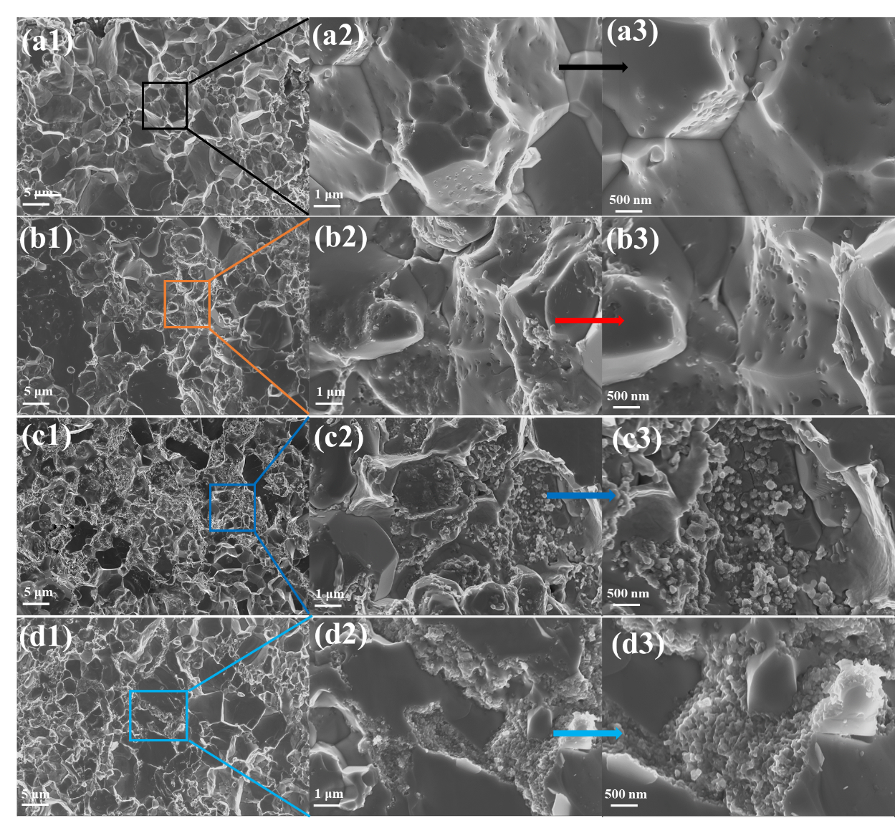
Fig. S2. SEM images of freshly fractured surface for TiZr_{x}NiSn samples: (a1−a3) x = 0; (b1−b3) x = 0.005; (c1−c3) x = 0.015; (d1−d3) x = 0.025.
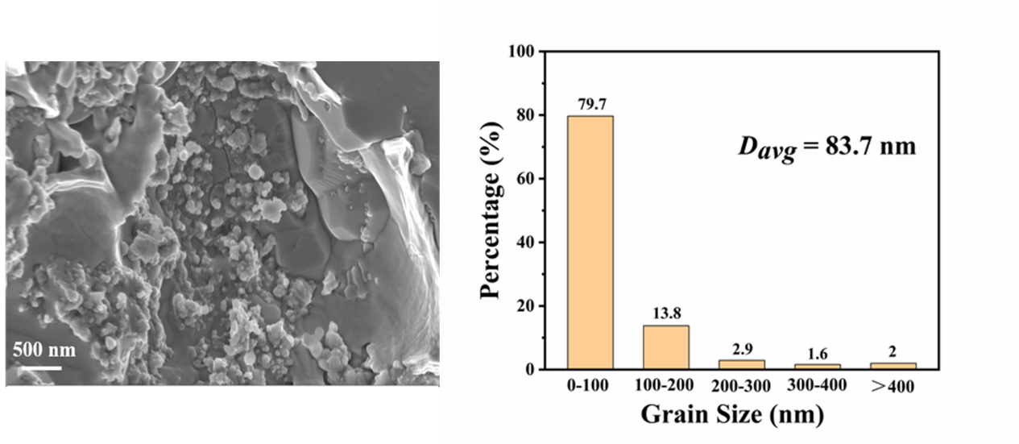
Fig. S3. SEM image of the sample TiZr_{0.015}NiSn and the statistics of the local grains size.
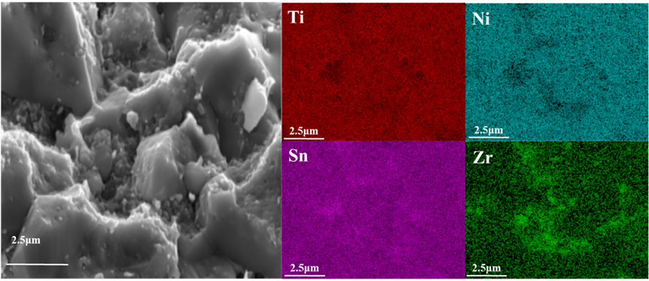
Fig. S4. SEM images of the sample TiZr_{0.015}NiSn and EDS mapping images.
Fig. S5. Temperature-dependent electrical properties of the TiNiSn and Rich-Sn samples: (a) electrical conductivity; (b) Seebeck coefficient.
Fig. S6. Temperature-dependent thermal properties of the samples TiZr_{x}NiSn (x = 0, 0.005, 0.015, 0.025): (a) thermal diffusivity; (b) specific heat; (c) the Lorentz number; (d) electronic thermal conductivity.
The Lorentz number L calculation
In this work, the scattering parameter r is assumed to be − 0.5 and the Lorentz number L is deducted from the measured Seebeck coefficient S based on the single parabolic band model using the following equations:
$S=±\frac{k_{B}}{e}\left(\frac{(r+5/2)F_{r+3/2}(ξ)}{(r+3/2)F_{r+1/2}(ξ)}-ξ\right)$ (S1)
$L=(\frac{k_{B}}{e})^{2}\left(\frac{(r+7/2)F_{r+5/2}(ξ)}{(r+3/2)F_{r+1/2}(ξ)}-{\left[\frac{(r+5/2)F_{r+3/2}(ξ)}{(r+3/2)F_{r+1/2}(ξ)}\right]}^{2}\right)$ (S2)
$F_{n}(ξ)=\int_{0}^{∞}{\frac{x^{n}}{1+e^{x-ξ}}}dx$ (S3)
$ξ=\frac{E_{F}}{k_{B}T}$ (S4)
where E_{F} is the Fermi energy, ξ is the reduced Fermi energy, k_{B} is the Boltzmann constant, e is the elemental charge, and F_{n} (ξ) is the Fermi integration.
Debye-Callaway Model Simulation
According to the research of Callaway et al., it is found that the scattering of point defects in the alloy is mainly affected by the quality difference (quality fluctuation) and size difference (strain field fluctuation) between the impurity atoms and the host lattice [1-3]. The Debye-Callaway model predicts the lattice thermal conductivity caused by point defects. The following equation calculates the lattice thermal conductivity crystal type of alloys with different compositions:[4]
${\text{u}}^{\text{2}}\text{=}\left(\frac{{\text{π}}^{\text{2}}{\text{θ}}_{\text{D}}\text{Ω}}{\text{h}{\text{ν}}^{\text{2}}}\right){\text{κ}}_{\text{L}}^{\text{pure}}Γ_{calc}$(S5)
$κ_{L}^{calc}=\frac{\tan^{-1}(u)}{u}κ_{L}^{pure}$(S6)
Where Ω, h, v, θ_{D}, $κ_{L}^{pure}$, $κ_{L}^{calc}$ and $Γ_{calc}$ are the average volume/atom, the Planck constant, the average sound velocity, the Debye temperature, the lattice thermal conductivity of the pure materials, the calculated lattice thermal conductivity of defected materials and the disorder scattering parameter, respectively.
According to the models of Slack [5] and Abeles [4], the disordered scattering parameter $Γ_{calc}$ is calculated by the formula $Γ_{calc}=Γ_{M}+Γ_{S}$, where the scattering parameters $Γ_{M}$ is mass fluctuations and $Γ_{S}$ is strain fluctuations, respectively. The mass and strain fluctuation scattering parameter is given by: [3]
$Γ_{M}=\frac{\sum_{i=1}^{n}{c_{i}{\left(\frac{\overline{M_{i}}}{\overset{̿}{M}}\right)}^{2}f_{i}^{1}f_{i}^{2}{\left(\frac{M_{i}^{1}-M_{i}^{2}}{\overline{M_{i}}}\right)}^{2}}}{\left(\sum_{i=1}^{n}{c_{i}}\right)}$(S7)
$Γ_{S}=\frac{\sum_{i=1}^{n}{c_{i}{\left(\frac{\overline{M_{i}}}{\overset{̿}{M}}\right)}^{2}f_{i}^{1}f_{i}^{2}{ε_{i}\left(\frac{r_{i}^{1}-r_{i}^{2}}{\overline{r_{i}}}\right)}^{2}}}{\left(\sum_{i=1}^{n}{c_{i}}\right)}$(S8)
Where n, c_{i}, M_{i}, $\overset{̿}{M}$, $M_{i}^{k}$, $r_{i}^{k}$, $f_{i}^{k}$ and $ε_{i}$ are the number of sublattice, the relative degeneracies of the respective sites, the average atomic mass of the i^{th} sublattice, the average atomic mass of the compound, the atomic mass of the k^{th} atom of the i^{th} sublattice, the atomic radius of the k^{th} atom of the i^{th} sublattice, the fractional concentrations of the k^{th} atom of the i^{th} sublattice and the lattice anharmonic parameter, respectively.
In this paper, θ_{D} is ~305 K [6], Ω is the volume per atom, h is the Planck constant, ν is the average sound velocity (~3806 m/s) for TiNiSn [6]. ε is an elasticproperties related adjusting parameter that can be estimated by:
$ε={\frac{2}{9}\left[(G+6.4γ)\frac{1+r}{1-r}\right]}^{2}$ (S9)
where G is a ratio between the relative change of bulk modulus and the bonding length and can be usually taken as a constant value of 4.32 for TiNiSn [6], γ is the Grüneisen parameter (2.06 for TiNiSn [7]), and r is the Poisson ratio (0.25 for TiNiSn [7]). These yield an ε value of ∼189 for TiNiSn.

References
[1] Dey TK, Chaudhuri KD. Lattice thermal conductivity of bismuth-antimony alloy single crystals at low temperatures. J Low Tem Phys 1976, 23: 419−26.
[2] Callaway J, Baeyer HV. Effect of Point Imperfections on Lattice Thermal Conductivity. Phys Rev 1960, 120: 1149−54.
[3] Yang J, Meisner GP, Chen L. Strain field fluctuation effects on lattice thermal conductivity of ZrNiSn-based thermoelectric compounds. Appl Phys Lett 2004, 85: 1140−2.
[4] Abeles B. Lattice thermal conductivity of disordered semiconductor alloys at high temperatures. Phys Rev 1963, 131: 1906−11.
[5] Slack GA. Thermal conductivity of potassium chloride crystals containing calcium. Phys Rev 1957, 105: 832−42.
[6] Hichour M, Rached D, Khenata R, Rabah M, Merabet M, Reshak AH, et al. Theoretical investigations of NiTiSn and CoVSn compounds. J Phys Chem Solids 2012, 73: 975−81.
[7] Toher C, Plata JJ, Levy O, De Jong M, Asta M, Nardelli M.B, et al. High-throughput computational screening of thermal conductivity, Debye temperature, and Grüneisen parameter using a quasiharmonic Debye model. Phys Rev B 2014, 90: 174107.

