Electronic supplementary material

Gelcast zirconia ceramics with high strength and simultaneously high translucency for dental applications
Jaroslav Kastyl^{1*}, Zdenek Chlup², Vaclav Pouchly¹, Lu Song³, Erik Scasnovic¹, Martin Trunec^{1, 4}
¹ CEITEC BUT, Brno University of Technology, Purkynova 123, 612 00 Brno, the Czech Republic
² CEITEC IPM, Institute of Physics of Materials, Czech Academy of Sciences, Zizkova 22, 616 00 Brno, the Czech Republic
³ State Key Laboratory of New Ceramics and Fine Processing, School of Materials Science and Engineering, Tsinghua University, Beijing 100084, China
⁴ Department of Materials Science and Engineering, Brno University of Technology,
Technicka 2, 616 69 Brno, the Czech Republic

* Corresponding author:
Central European Institute of Technology, Brno University of Technology
Purkynova 123, 612 00 Brno, the Czech Republic
Tel.: +420 541149710
e-mail: Jaroslav.Kastyl@Ceitec.Vutbr.cz

XRD analyses of gelcast and commercial dental ceramics

Table S1 Summary of phase composition.
Sample | Producerª | t-ZrO₂ | m-ZrO₂ | c-ZrO₂ | Rwp
Sample | Producerª | (wt%) | (wt%) | (wt%) | (%)
SZ 1350 | this study | 100.0 | 0 | 0 | 5.26
SZ 1450 | this study | 100.0 | 0 | 0 | 9.77
SZ 1550 | this study | 100.0 | 0 | 0 | 9.75
TZ-3YS-E | Ref. 41 | 100.0 | 0 | 0 | 7.41
Ceramill ZI | AG | 95.2 | 4.3 | 0.5 | 5.52
Ceramill Zolid HT+ | AG | 61.2 | 0 | 38.8 | 8.53
Nacera Pearl 1 | DMC | 99.4 | 0.5 | 0.1 | 8.94
ª The producer abbreviation stands for Amann Girrbach (AG) and Doceram Medical Ceramics (DMC)

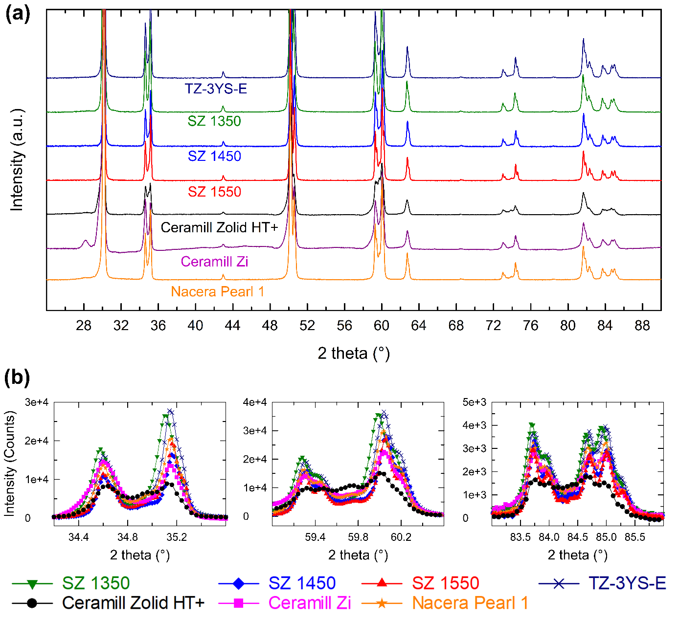
Fig. S1 XRD patterns of gelcast and commercial zirconia samples, a) whole 2theta range and b) details of doublet peaks for all samples except Ceramill Zolid HT+ where a broad singlet peak was recorded.

