Appendix

Appendix A: Variable Chart
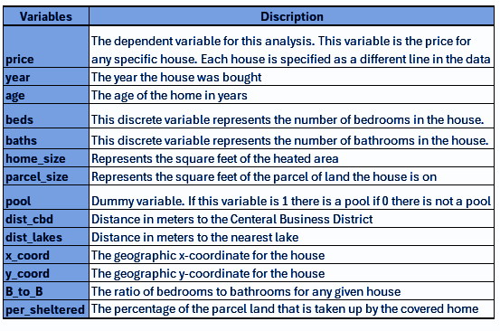

Appendix B: Data Summary Statistics
Statistic | price | year | age | beds | baths | home size | parcel size | pool | dist cbd | dist lakes | X coord | y_ coord
count | 10000 | 10000 | 10000 | 10000 | 10000 | 10000 | 10000 | 10000 | 10000 | 10000 | 10000 | 10000
Mean | 182.223 | 2002.34 | 13.1383 | 3.3662 | 2.2231 | 1920.1125 | 10619.2974 | 0.2153 | 14503.59 | 1481.2035 | 532770 | 1525657
std | 143.105 | 1.53245 | 14.5359 | 0.76991 | 0.71893 | 804.850684 | 15556.5281 | 0.41105 | 6216.664 | 1754.1342 | 40883.8 | 31255.1
Min | 7.021 | 2000 | 0 | 1 | 1 | 506 | 576 | 0 | 551.46 | 4.52 | 450433.8 | 1459446
25% | 113.979 | 2001 | 0 | 3 | 2 | 1359 | 6466 | 0 | 9725.96 | 331.5075 | 498964 | 1509210
50% | 151.028 | 2002 | 9 | 3 | 2 | 1751.5 | 8333 | 0 | 14857.96 | 707.835 | 529143 | 1527530
75% | 209.366 | 2004 | 21 | 4 | 2.5 | 2276.5 | 10973.5 | 0 | 19741.56 | 1872.055 | 566970 | 1544630
max | 3662.67 | 2005 | 101 | 8 | 9 | 9474 | 620806 | 1 | 43342.66 | 8203.53 | 670215 | 1617868

Appendix C: Pricing Distribution Histogram
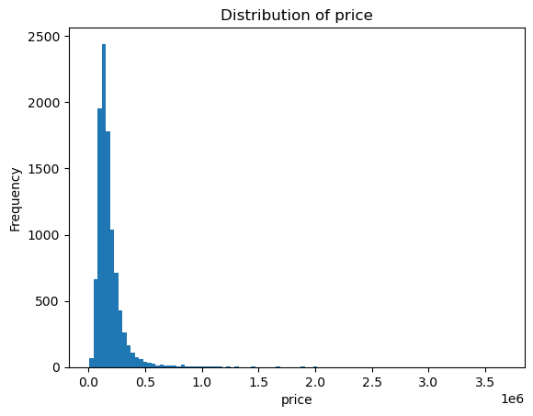

Appendix D: Histograms of some Continuous Variables
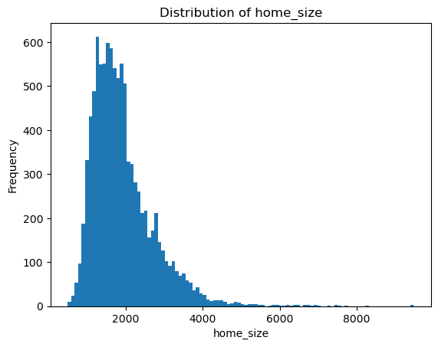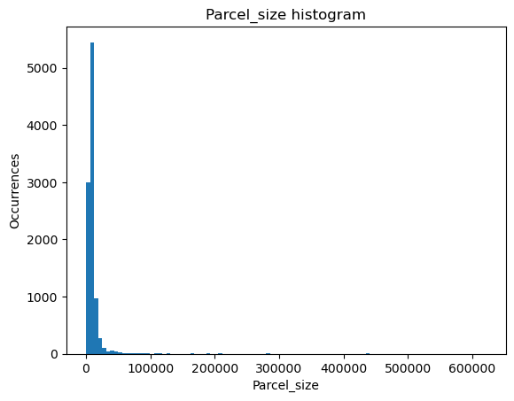
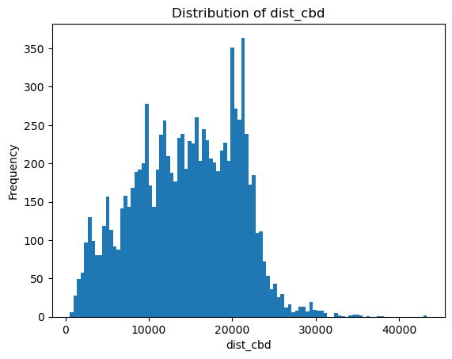

Appendix E: Histograms of Discrete Variables
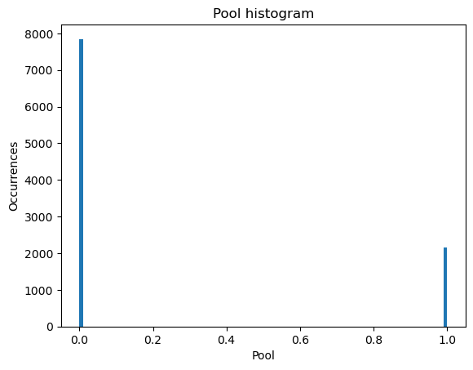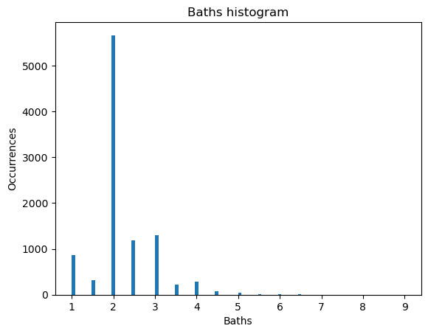
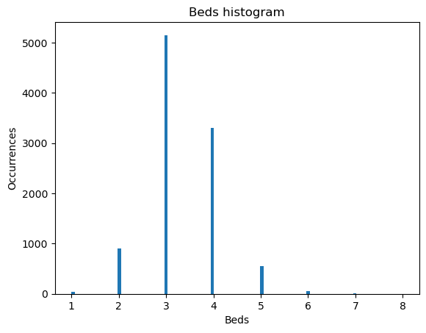

Appendix F: Scatter Plots of Different Variables to Price (in millions)
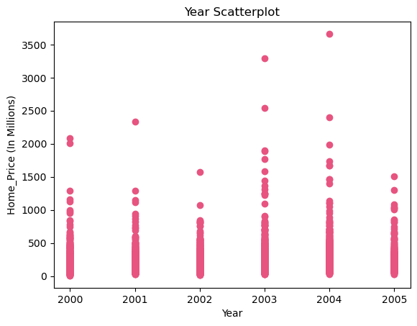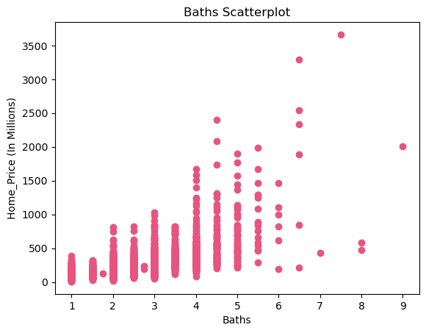
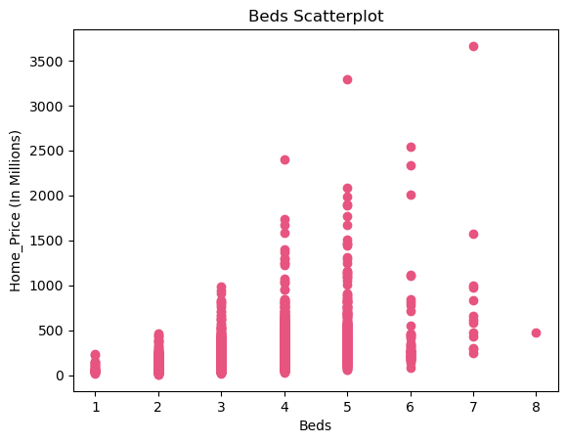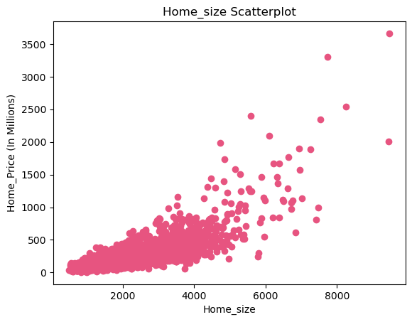
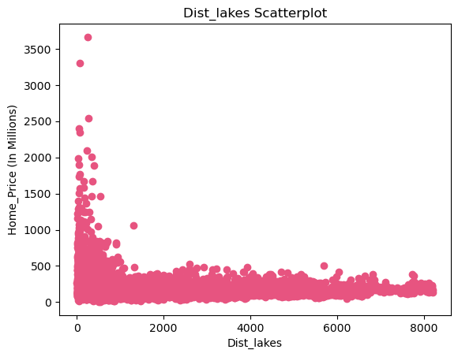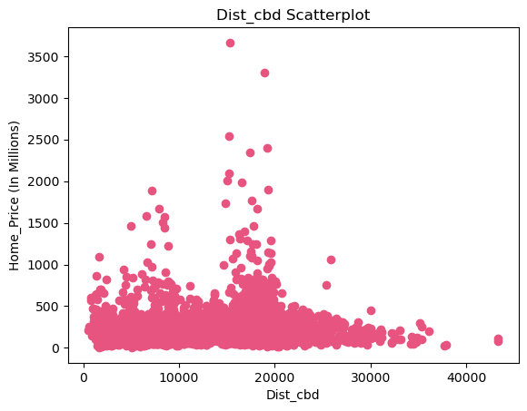

Appendix G: Variable Correlation Matrix
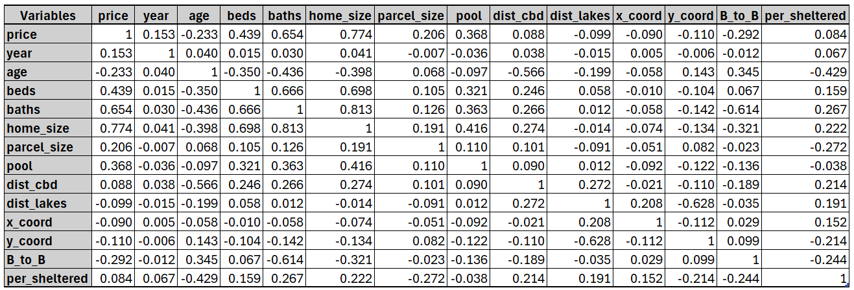

Appendix H: Libraries and Important Functions used in the Linear Regression Assignment
Pandas: Common Python library for creating and manipulating data structures. Mostly used for creating the dataframes in this code as well as altering those dataframes to better analyze them.
matplotlib.pyplot: A module in the Python matplotlib library that allows for data visualization. Used for creating the histograms and scatterplots in this code to understand the data.
Itertools: Python library used for quickly generating iterators for looping, useful for dataframes with a lot of data.
Combinations: Function from the itertools library that generates all combinations of variables given the length requested. Arguments needed area list of variables, and the length of the desired combination list.
Product: Function from the itertools library that returns the products of all the input, like nested loops in that regard. The arguments needed are two arrays.
statsmodels.api: Library for estimating and interpreting statistical models. Used for regression analysis.
sklearn.preprocessing: A Module in the sklearn library that has tools for preprocessing data. This includes scaling, normalization, etc.
PolynomialFeatures: This function is from sklearn.preprocessing generates polynomial interactions from the input data. The agreement needed is an integer that can the polynomial should be raised to. For example, if there were PolynomialFeatures(2), it would be x^2 +xy+y^2.
sklearn.model_selection: A Module in sklearn that allows for training and testing data. Including but not limited to cross-validation.
cross_validate: This function allows data to be trained using a cross-validation module with x number of folds. Arguments needed for this function type of regression, independent variables, dependent variables, number of folds, and scoring type.
sklearn.linear_model: Module in sklearn that implements different linear models.
LinearRegression: This model implements ordinary least squares linear regression.
NumPy: One of the most used numerical libraries in Python. Includes support for arrays, matrices, and a large number of numerical functions.
numpy.random: a module in NumPy that allows for generating random numbers and sampling.
Seed: A function of NumPy.random that allows the user to set a specific seed. This can help increase replicability for future modeling. The seed used in this code is 1234.

Appendix I: Correlation Matrix for All Interaction Variables with a Correlation of Greater than .7 to Price
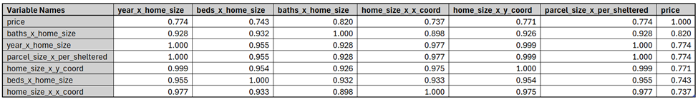

Appendix J: Regression Results for Module 2
