Supplementary Information
Temperature and Humidity as Drivers of Elevational Shifts in the Montane Forests-Paramo Boundary Over the Last 15,000 Years in the Northwest Andes

Andrés Silva Duque¹, Sebastian González-Caro^{1,2}, César Velásquez³, Álvaro Duque^{3*}

¹ Departamento de Ciencias Forestales, Universidad Nacional de Colombia Sede Medellín. Carrera 65 Nro. 59A – 110, Medellín, Colombia.
² Instituto de Biología, Universidad de Antioquia, Medellín, Colombia.
³ Facultad de Ciencias, Universidad Nacional de Colombia Sede Medellín, Carrera 65 Nro. 59A – 110, Medellín, Colombia.
*: Correspondent author: ajduque@unal.edu.co

Table S1. Data used to estimate de age – depth model. The table shows the laboratory code, the depth, the kind of material dated, the estimated age obtained by radiocarbon method and the calibrated age for each sample. Row marked with * refers the samples used to estimate the age model.
Lab No | Depth interval (cm) | Dated material | ¹⁴C yr BP | Calendar age range | Best date (cal yr BP)
Beta 321930 | 44 | Plant material | 106.8 +/-30 | Modern | Modern
GrA 58175 | 60 | Organic sediment | 430+/-35 | 430 | 430*
Beta 312931 | 90 | Plant material | 3440 +/- 30 BP | 3631-3780 | 3705*
Beta 329866 | 108 | Organic sediment | 5720 +/- 30 | 6630-6620 | 6625*
Beta 312932 | 136 | Plant material | 8510 +/ - 40 | 9540-9470 | 9505*
GrA 58178 | 143 | Organic sediment | 8310+/ - 45 | 9200-9450 | 9325*
GrA 58179 | 158 | Peat | 9010+/ - 45 | 10131-10248 | 10189*
Beta 329867 | 163 | Organic sediment | 10600 +/- 40 | 12600-12530 | 12565*
Beta 312933 | 187 | Plant material | 12400 +/- 60 | 14880-14130 | 14505*
GrA 58236 | 217 | Organic sediment | 34960+/-260 | 34960 | 34960
Beta 312934 | 226 | Plant material | 37820+/- 300 | 42790-42010 | 42400
GrA 58237 | 240 | Organic sediment | 34180+/-270 | 34180 | 34180
GrA 58305 | 241 | Organic sediment | 27120+/-150 | 31153-31573 | 31363
GrA 58238 | 260 | Organic sediment | 27530+/-140 | 31321-32044 | 31682
Beta 312935 | 270 | Organic sediment | 32800+/- 190 | 37860-36760 | 37310
GrA 58459 | 280 | Organic sediment | 34690+/-220 | 38937-40478 | 39707
Beta 312936 | 300 | Plant material | 30360 +/- 170 | 35060-34690 | 34875

Table S2. Taxa indicator species associated with different pollen compositional groups as referred in the Figure 1 of the main text.

Taxa | Stat | p Value | Group I | Group II | Group III | Group IV | Group V
Valeriana | 0,987 | 0,001 |  |  |  |  | X
Solanaceae | 0,907 | 0,001 |  |  |  |  | X
Acaena | 0,884 | 0,001 |  |  |  |  | X
Cariophyllaceae | 0,85 | 0,001 |  |  |  |  | X
Rubiaceae | 0,834 | 0,001 |  |  |  |  | X
Cecropia | 0,76 | 0,001 |  |  |  |  | X
Puya | 0,679 | 0,001 |  |  |  |  | X
Vallea stipularis | 0,668 | 0,001 |  |  |  |  | X
Aragoa | 0,54 | 0,001 |  | X
Iridaceae | 0,395 | 0,013 | X |  |  | X
Gordonia | 0,767 | 0,001 |  |  | X | X
Juglans | 0,603 | 0,001 |  |  | X | X
Melpomene | 0,521 | 0,001 |  |  |  | X | X
Euphorbiaceae | 0,906 | 0,001 |  |  |  | X | X
Drymis | 0,43 | 0,002 | X | X | X
Geranium | 0,903 | 0,001 | X |  | X | X
Bromelia | 0,487 | 0,007 | X |  |  | X | X
Myrtaceae | 0,694 | 0,001 | X |  |  | X | X
Rumex | 0,599 | 0,001 | X |  |  | X | X
Morella | 0,96 | 0,001 |  | X |  | X | X
Clusia | 0,832 | 0,001 |  | X |  | X | X
Paepalanthus | 0,645 | 0,004 | X | X | X | X
Viburnum | 0,597 | 0,002 | X | X | X | X
Araliaceae | 0,559 | 0,003 | X | X | X | X
Lycopodiaceae | 0,982 | 0,001 | X | X |  | X | X
Weinmannia | 0,765 | 0,001 | X | X |  | X | X
Clethra | 0,747 | 0,001 | X | X |  | X | X
Hypericum | 0,625 | 0,004 | X | X |  | X | X
Podocarpus | 0,99 | 0,001 | X |  | X | X | X
Rosaceae | 0,939 | 0,001 |  | X | X | X | X
Ericaceae | 0,828 | 0,001 |  | X | X | X | X

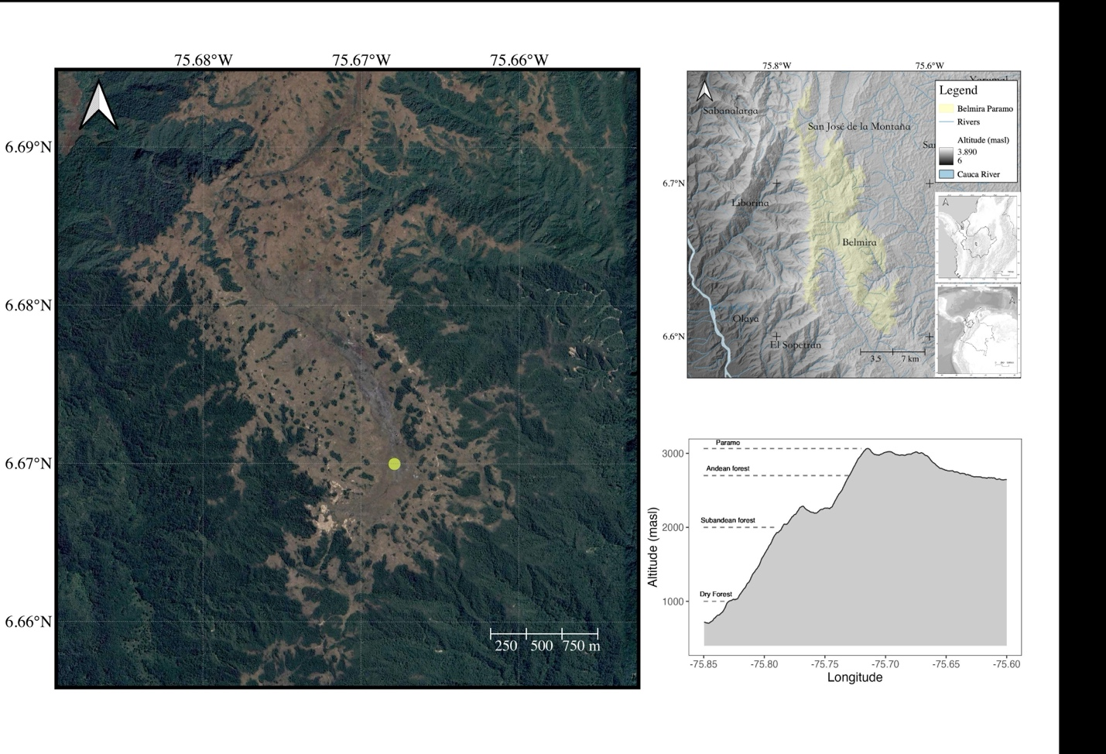
c)
b)
a)
Figure S1. Map of Belmira Paramo location. a) Sedimentary core localization. b). Map points out the elevational variation of study area (digital elevation model in grayscale) and some reference points such counties and main rivers. Yellow shades indicate the current Paramo extension. c) Elevational profile of Belmira. The X axis refers to longitude change, while y axis indicates elevational mean variation.

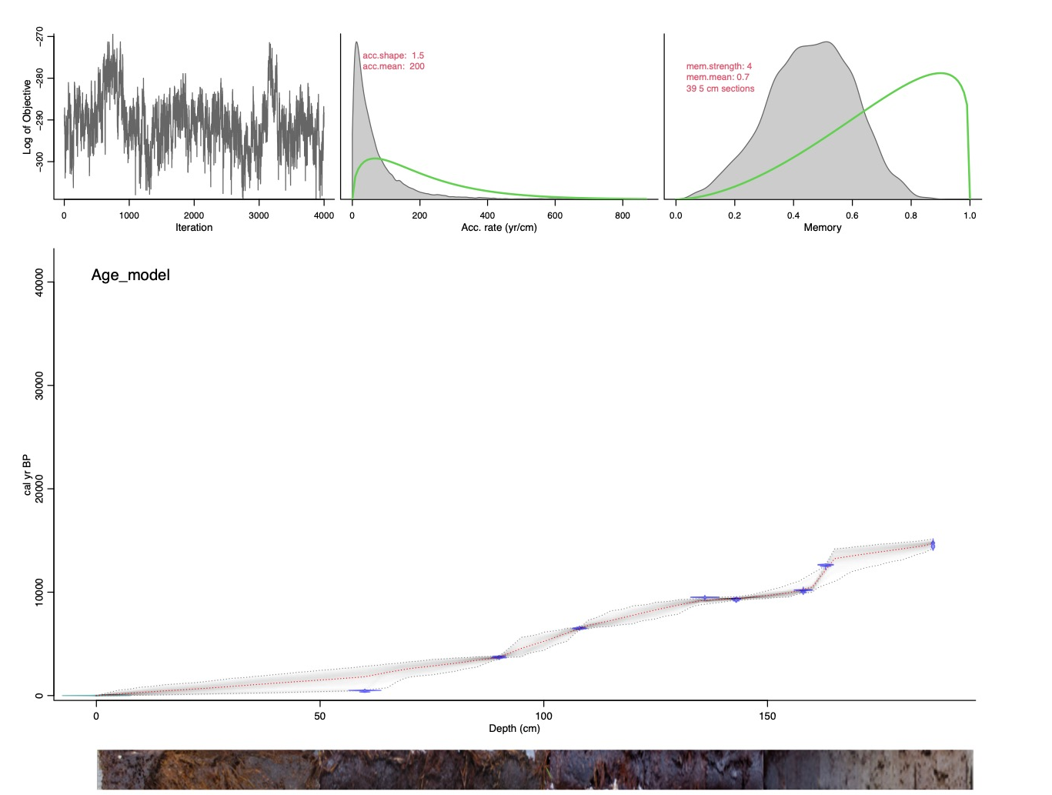
Figure S2. BACON model for age – radiocarbon sampling relationships. Left panel shows MonteCarlo parameter estimations. Middle and right panels depict the prior (green curve) and posterior (gray density plot) distribution for accumulation rate and memory associated parameters respectively. Main panel shows the calibrated radiocarbon samples (blue distributions) and the age-depth model; grey lines represent the 95% confidence interval for age predicted values while red lines indicate the estimated mean age for each depth.

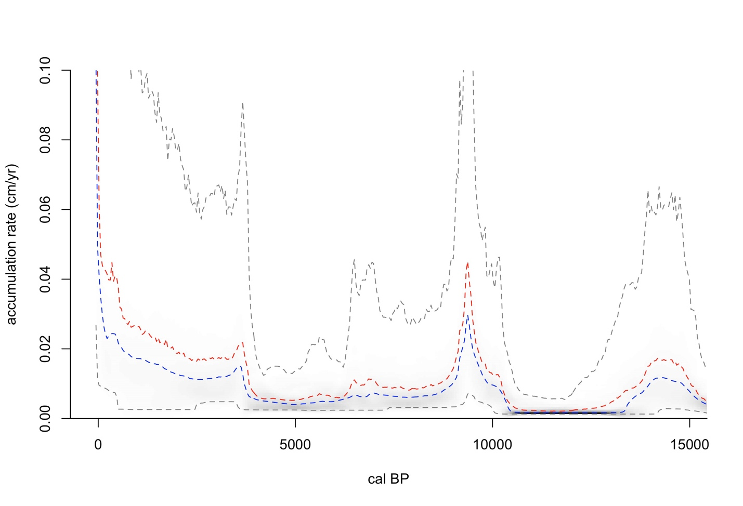
Figure S3. Accumulation rates for sedimentary core. Red and blue dashed lines depict mean and median accumulation rate for each age obtained from the BACON model. Gray lines indicate the 2.5% and 97.5% percentiles of accumulation rate parameter.

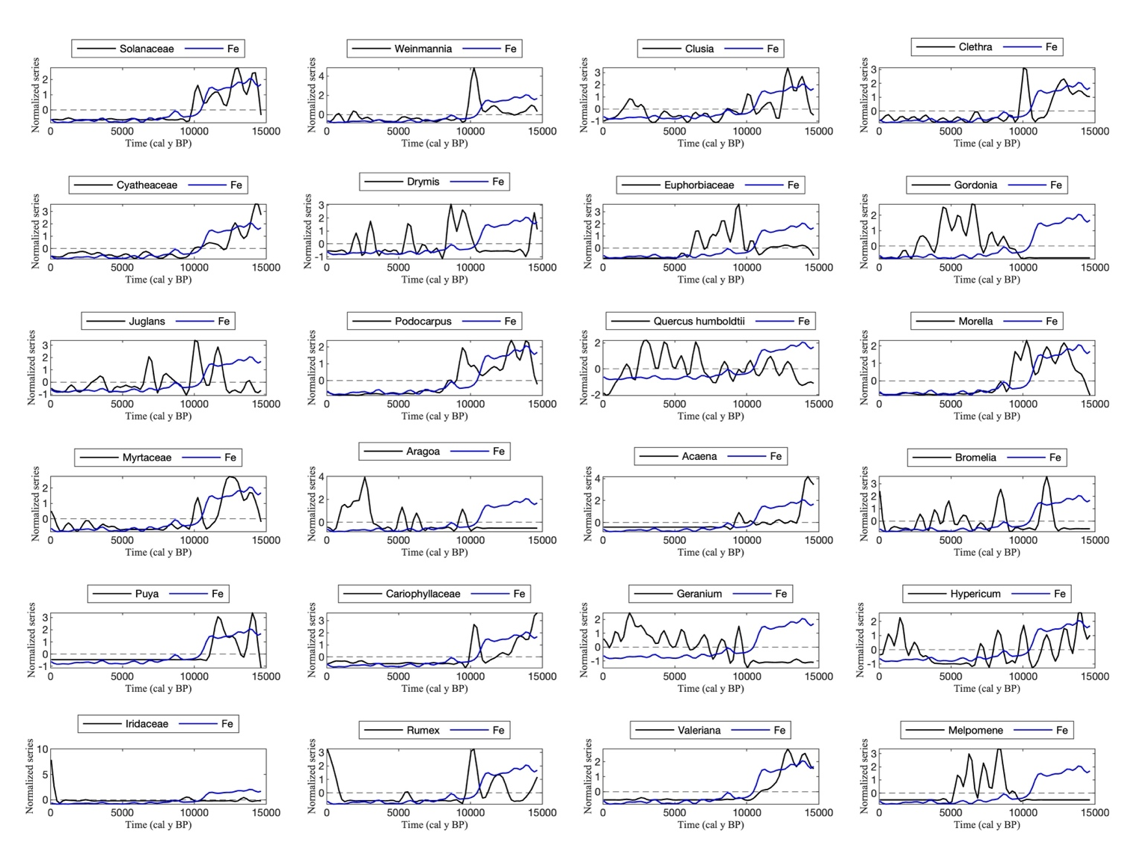
Figure S4. Normalized time series of Fe and some statistically significative indicator taxa. Each line represents a low filtered series using 500-year periodicities. In each panel, black line refers to one specific taxon while blue line indicate the Fe filtered series. Includes Q. humboldtii, which was not included as an indicator taxon.

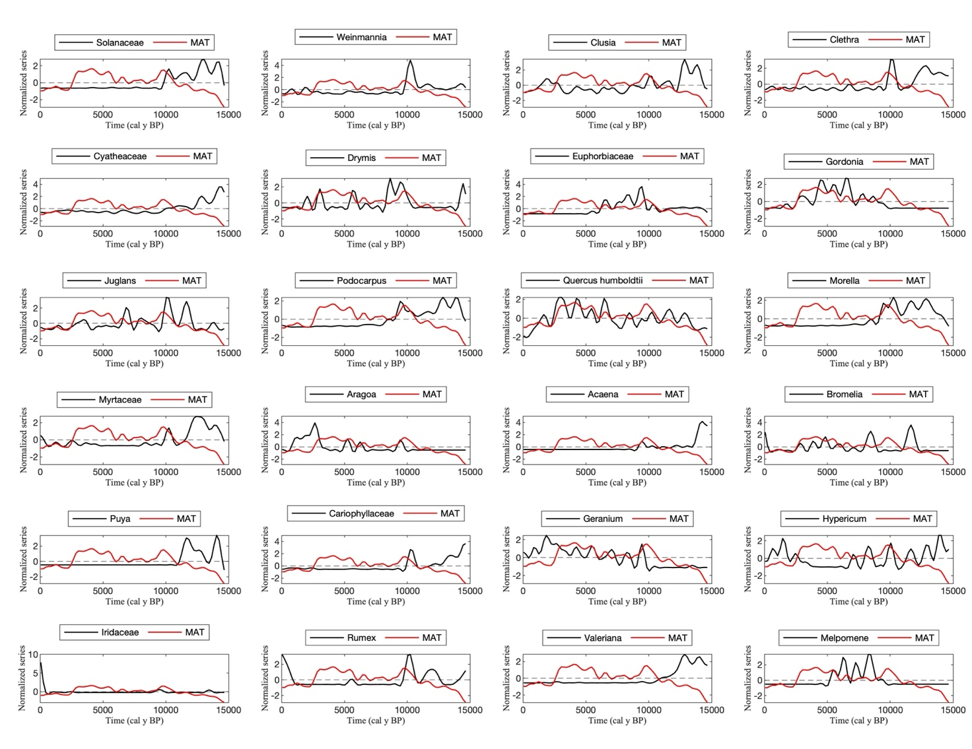
Figure S5. Normalized time series of MAT and some statistically significative indicator taxa. Each line represents a low filtered series using 500-year periodicities. In each panel, black line refers to one specific taxon while red line indicates the MAT filtered series. Includes Q. humboldtii, which was not included as an indicator taxon.

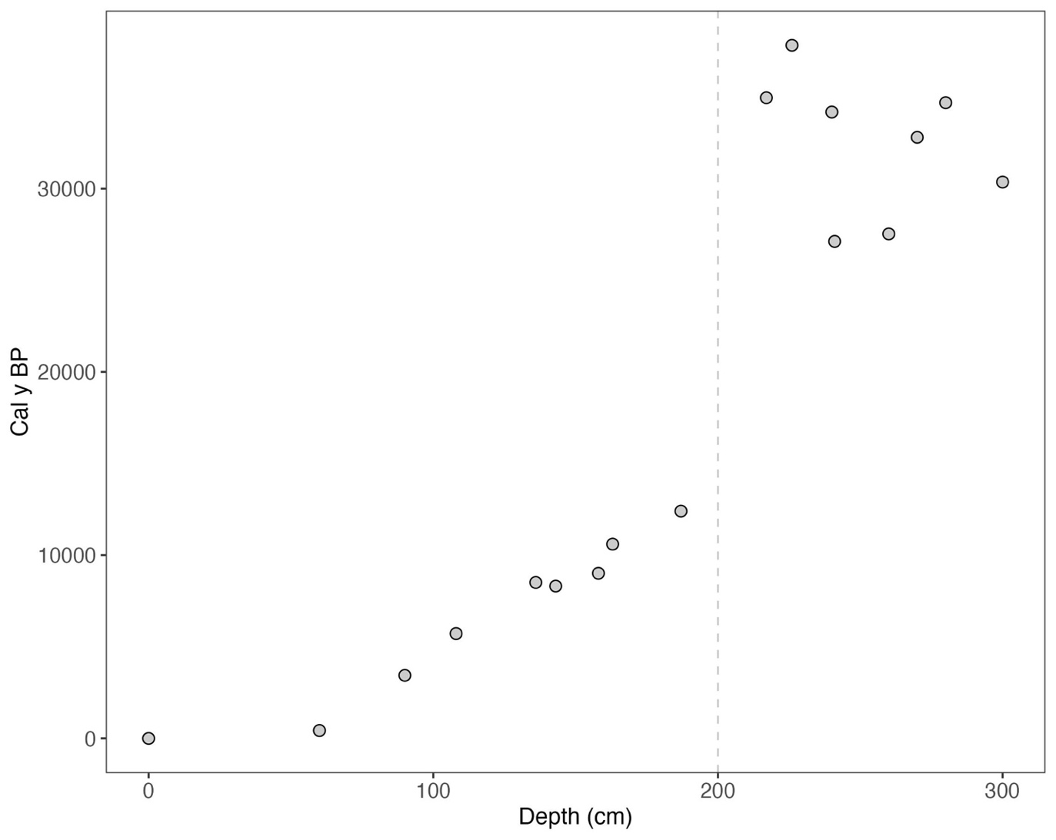
Figure S6. Relationship between estimated age obtained by radiocarbon method (y-axis) and the depth for each sample. Dotted vertical line (~ 200 cm) indicates the breakpoint in which the samples show reversal ages.

