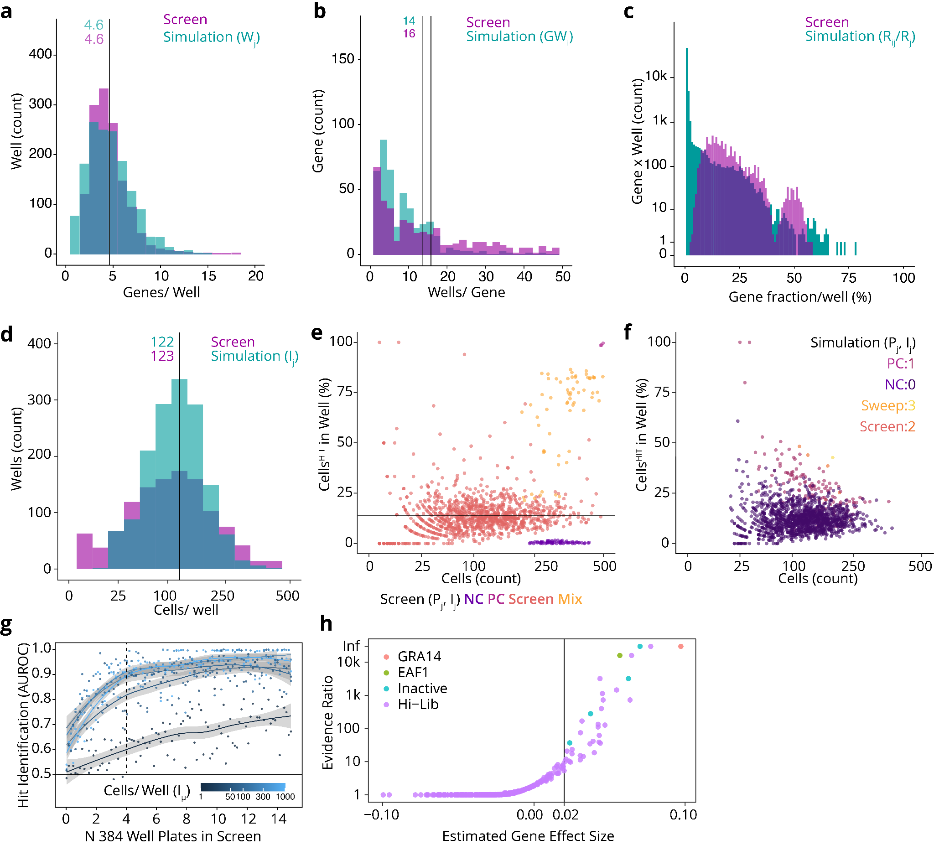
Extended Data Figure 1 | Fitted simulation parameters to TSG101 T. gondii screen. In panels a-f, comparing summary statistics from simulations with parameters fitted to the TSG101 screen. Seeder plate: a. Histogram of gene counts per well, b. Histogram of well counts per gene. Sequencing plates: c. Histogram of the percent of reads for a gene to the total reads in the well. Imaging plates: d. Histogram of cell counts per well. e. Positive cells per well in screen. Scatter plot of percent positive cells versus total cell count with PC, NC, and sweep control wells and screening wells. f. Positive cells per well in simulation, scatter plot of percent of positive cells in versus total cell count colored by the number of positive genes in the well. g. Additional simulation parameter sweep. Simulated hit identification area under the receiver operating curve (AUROC) across screens with increasing number of cells per well. The shaded area shows the 95% pointwise confidence interval for the mean prediction across 989 simulated screens. Dotted lines signify 4 plates as used in the TSG101 screen. h. Fitting the Bayesian MLR model to observed MaxViT classification and gRNA fraction data. The evidence ratio is the fraction of posterior density of each β_{i} > 0.02 (the assumed noise threshold), and the gene effect size is the posterior mean of each β_{i}. All tested genes are significant, and EAF1 is in the top 3 genes by effect size and evidence ratio.

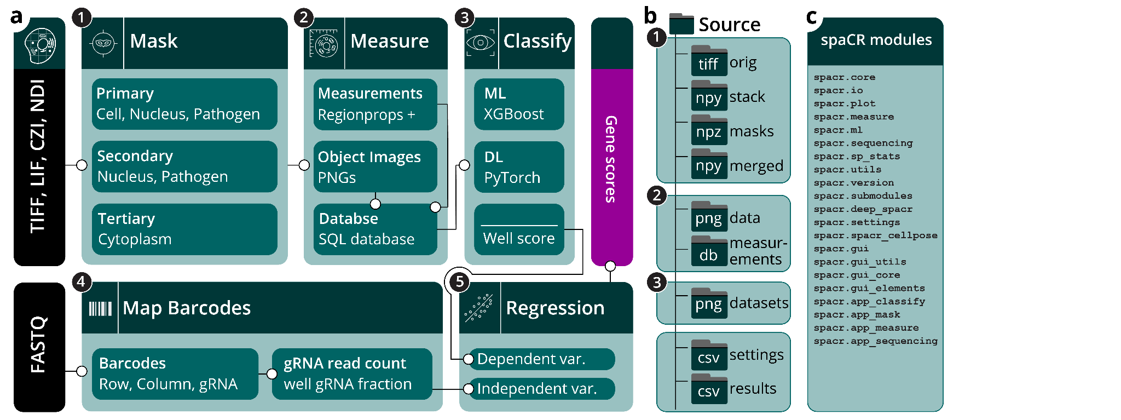
Extended Data Figure 2 | Overview and data organization of spaCR. a. Schematic workflow of the spaCR pipeline for pooled image-based CRISPR screens. Microscopy images (TIFF, LIF, CZI, NDI) and sequencing reads (FASTQ) are used as inputs (black). The main GUI sections (teal) are: (1) Mask: generates object masks for cells, nuclei, pathogens, and cytoplasm; (2) Measure: extracts object-level features and crops object images, storing quantitative single object feature data and cropped object paths in an SQL database; (3) Classify: applies machine learning (ML, e.g., XGBoost) or deep-learning (DL, e.g., PyTorch) models to classify objects, summarizing results as well-level classification scores; (4) Map Barcodes: extracts and maps row, column, and gRNA barcodes from sequencing data to corresponding wells; (5) Regression: estimates gRNA effect sizes via multiple linear regression using well-level summary statistics. b. spaCR output folder structure, including locations for raw and processed images, masks, object-level measurements, datasets, and results. c. List of all spaCR package modules.

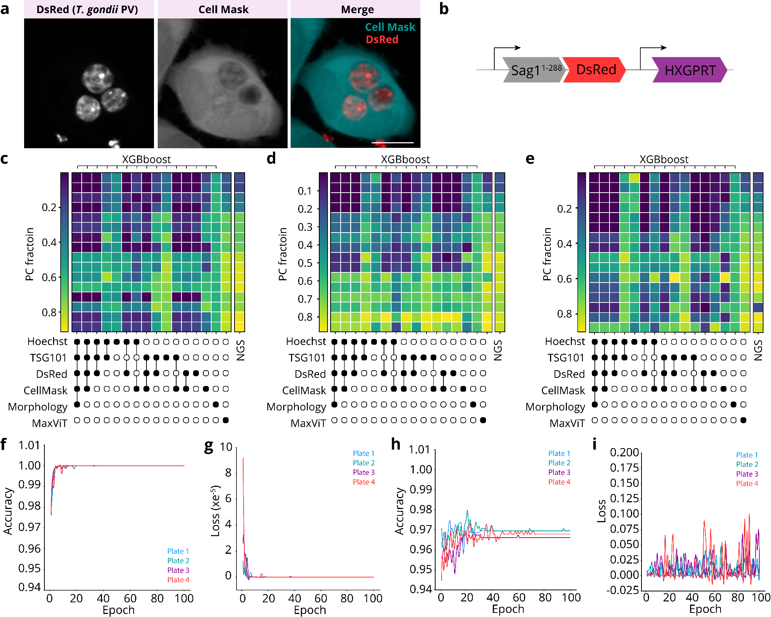
Extended Data Figure 3 | Generation of RHCas9DsRed parasites and XGBoost and MaxViT validation. a. RHCas9 parasites were transfected with pDsRedHXG and cultured in MPA/Xanthene (50 μg/ml) to generate RHCas9DsRed parasites. HeLa cells were then infected with RHCas9DsRed for 24h and stained with Cell Mask, as described in online methods. Left panel shows luminal DsRed expression, middle panel shows Cell Mask stained HeLa cell, right panel shows merged image. Scale bar represents 10 μm. b. Schematic representation of DsRed insertion. c-e. RHCas9DsRedΔsag1 (NC) and RHCas9DsRedΔgra14 (PC) parasites were mixed at different ratios and used to infect HeLa cells in one column per plate. The fractions of NC and PC were captured in each well by next gen sequencing (NGS). Cells from these wells were classified by the XGBoost models or MaxViT models, as indicated, for plate 2 (c), plate 3 (d), and plate 4 (e). f. One MaxViT model was trained for each screen plate. HeLa^{GFP-TSG101} cells infected with PC and NC parasites from columns 1 and 2, respectively, were used in training. 10% of the data was reserved for validation, 10% was reserved for testing. Graph shows the accuracy for each plate over 100 epochs. g. Graph shows the loss for each plate during training over 100 epochs. h. Graph shows the validation accuracy over 100 epochs. i. Graph shows the validation loss over 100 epochs.

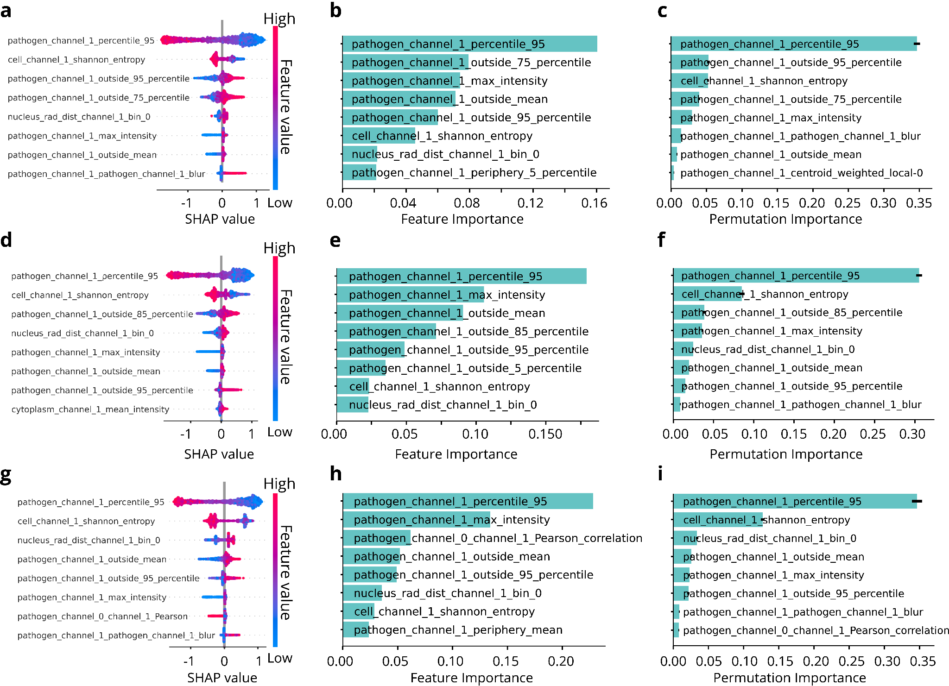
Extended Data Figure 4 | Key predictive drivers of XGBoost^{GFP-TSG101} classifiers. a-i Top 8 features calculated from XGBoost^{GFP-TSG101} models trained on data from PC and NC infected cells from plate two (a,b,c), three (d,e,f) and four (g,h,i). Graphs show SHAP feature importance (a,d,g), feature importance (b,e,h), and permutation importance (c,f,i).

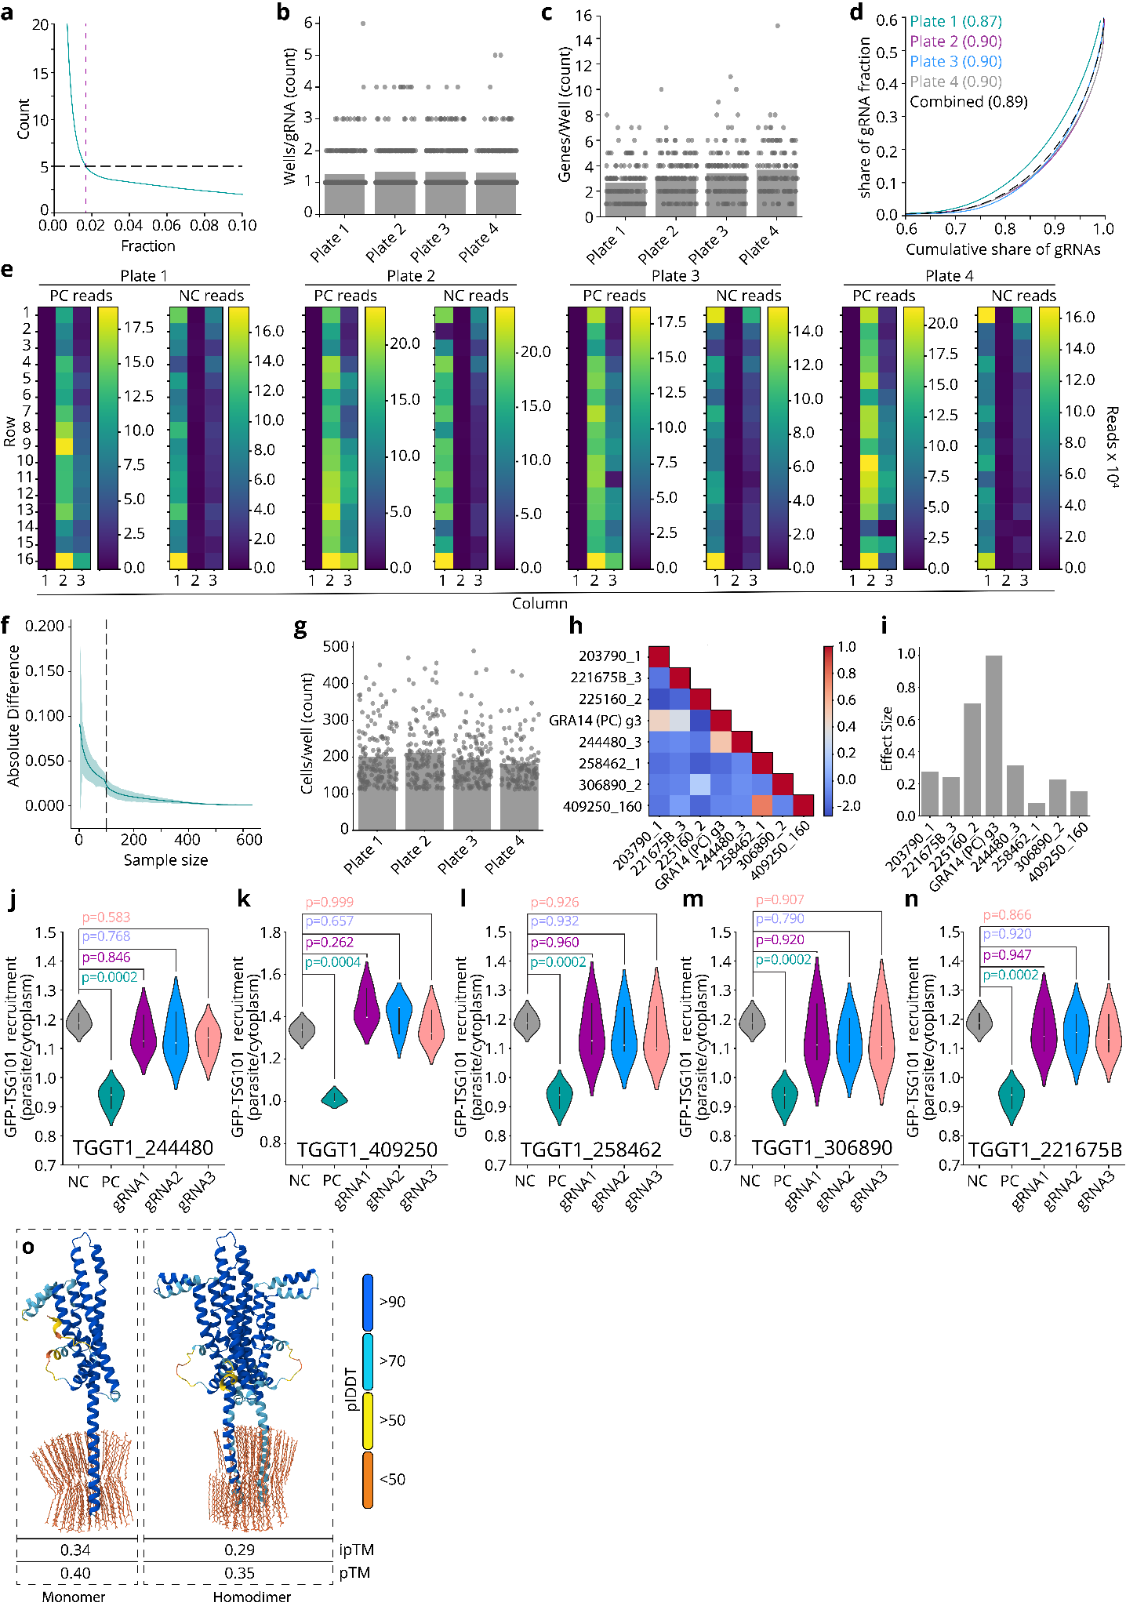
Extended Data Figure 5 | Quality control for dependent and independent variables and functional validation of screen hits. a. gRNA, row, and column barcode sequences were mapped from each read with spaCR.map_barcodes to generate read counts for each gRNA in each well (unique combinations of row, column). gRNA well fractions were then calculated. Graph shows the gRNA fraction threshold (~0.02, dashed purple line) defined by the fraction at which 5 gRNAs (dashed black line) were present on average per well. b. Graph shows the number of wells each gRNA was present in (wells/gRNA) for each plate. c. Graph shows the unique number of genes present in each well for each plate. d. Lorenz curve shows equality of gRNA abundance in screen wells from 4 plates. Gini coefficients are provided in brackets for each plate. e. Heat maps show the read count of the negative control (NC, TGGT1_233460_4) and the positive control (PC, TGGT1_239740_1) in control wells (columns 1, 2 and 3) for each plate. f. Graph shows the cell number threshold. g. Graph shows the cells per well for each plate after applying the cell number threshold. h. Correlation matrix shows the overlap in well location between the screen hits. i. Bar graph shows the estimated effect size miss attribution of screen hits given a fixed effect size of 1.0 for 239740_3 and 0.7 for 225160_2. spaCR.submodules.post_regression_analysis was used to generate h and i. j-n. RHCas9DsRed parasites were transfected with gRNAs targeting screen hit genes as indicated and passaged in pyrimethamine (3 µM) + chloramphenicol (20 µM) 3 times before infecting HeLa^{GFP-TSG101} cells for 24 h. Samples were then fixed and stained as described in online methods. Violin plot shows GFP-TSG101 recruitment (parasite mean GFP-TSG101/cytoplasm mean GFP-TSG101 intensity) in infected HeLa^{GFP-TSG101} cells. n=3 plates, One-Way ANOVA with Tukey's post hoc test. p values as indicated. NC and PC are from the same samples in j,l,m,n and Fig. 5e. o. Monomer and dimer homomere Alphafold3 protein EAF1 models folded with phospholipids. Models are coloured by pIDDT. ipTM and pTM scores are listed below each model, reflecting interface and fold confidence, respectively.

