Supp Figure 1. Longitudinal T2C study and pathway enrichment in male and female mice during the 3-week to 5-month study window. a. Experimental overview for T2C studies. Pathway enrichment for Hallmark (b) and KEGG (c) compendia.

Supp Figure 2. Impact of early-life toxicant exposures on the transcriptome. a. For each exposure, PCA and volcano plots are shown based on all detected genes, and heatmaps based on the differentially expressed genes (DEGs). b. Heatmap of NES for enriched GOBP pathways from Clusters 2 and 4 (identified in Figure 2c).

Supp Figure 3. Overlap between exposure and LAAsP gene signatures. a. Bar graph summarizing overlap of LAAsP genes with DEGs in the exposure signatures of female mice (irrespective of direction). b. Matrix of Pearson’s correlation coefficients (p<0.05) between summed z-scores for exposure signatures and LAAsP genes in female mice over the GTEx liver transcriptome dataset. c and d. UpSet plots showing overlap between LAAsP and exposure signature genes in male (c) and female (d) mice. e. Venn diagrams for LAAsP and exposure DEG overlaps associated with attenuated expression trajectories in male and in female mice.

Supp Figure 4. Epigenome programming of LAAsP-mods a. Signal heatmaps for active histone LAAsP-mods from 3 weeks to 5 months and from 5 to 10 months in male mouse liver. b. Global changes in DEPs of LAAsP-mods at gene promoters and enhancers. c. Merged enhancer anchor mapping strategy. d. Combinatorial changes of LAAsP-mods at LAAsP gene TSS or enhancers between 3 weeks and 5 months and between 5 months and 10 months. e. Concordant programming of LAAsP genes and LAAsP-mods for various liver cell types using cell-identity genes from the Aizarani liver compendium. Increased expression of cell identity genes in hepatocytes (left) and ORA pathway enrichments (right) for LAAsP genes increased with age using the Reactome compendium, and decreased expression of cell identity genes in nonparenchymal cells (left) and ORA pathway enrichments (right) for LAAsP genes decreased with age using the Reactome compendium.

Supp Figure 5. Epigenome reprogramming associated with early-life toxicant exposures. a. Signal heatmaps for all active marks and exposures. b. Circos plots indicating DEP direction and magnitude of changes for PM2.5-JHU, BPA.lo, DEHP, and Pb male mouse livers. c. UpSet plots for overlap of LAAsP and exposure signature genes for PM2.5-JHU, BPA.lo, DEHP, and Pb. d. UpSet plots for overlap of UpSet plots for overlap of LAAsP and exposure signature genes for TBT, TCDD, BPA.hi, and PM2.5-Chi. IGV examples of exposure-induced reprogramming in the promoter region for the Cyp2c38 (PM2.5) and Npas2 (TBT and TCDD) genes (e) and linked enhancer for Cldn7 (TBT)(f).

Supp Figure 6. Environmental exposures polarize the transcriptome and attenuate normal LAAsP gene expression trajectories. a. Heatmap of NES for LAAsP and exposure signature genes in young adult male liver using GSEA for Aizarani (31) cell-type identity genes. b. NES heatmap for young adult female livers using condensed Aizarani (8) cell-type identity genes. c. Network analysis of nonparenchymal cells vs LAAsP genes in females. d. GSEA enrichment plots with Venn diagrams for overlaps between LAAsP and exposure core genes from PM2.5-Chi, TBT, and TCDD in 5-month females using cell identity genes for Hepatocytes, Stellate, Kupffer, NK-NKT, and Endothelial cells. GSEA core genes were further analyzed using ORA for enriched gene sets from the GOBP compendium. e. MuSiC analysis for cell composition of T2C-exposed livers. f. Heatmaps for overlap of core genes in LAAsP and exposure comparisons showing attenuation of normal expression trajectories in cell identity genes for hepatocytes or nonparenchymal cells in response to BPA.hi, TBT, and TCDD (males) or PM2.5-Chi, TBT, and TCDD (females).

Supp Figure 7. Transcription factor enrichment in the TBT HR signature target genes. a. Core hepatocyte identity genes in the Endotype 1 (HR) signature. b. Venn diagram for core gene overlaps between cell identity genes of the four types of hepatocytes in the TBT HR Endotype 1 signature. c. Top most enriched transcription factor targets (-log10 FDR) for hepatocyte cell identity genes in the Endotype 1 (HR) signature induced by TBT (left) and percent of target genes in the HR Endotype 1 signature (right) for each transcription factor.

Supp Figure 1

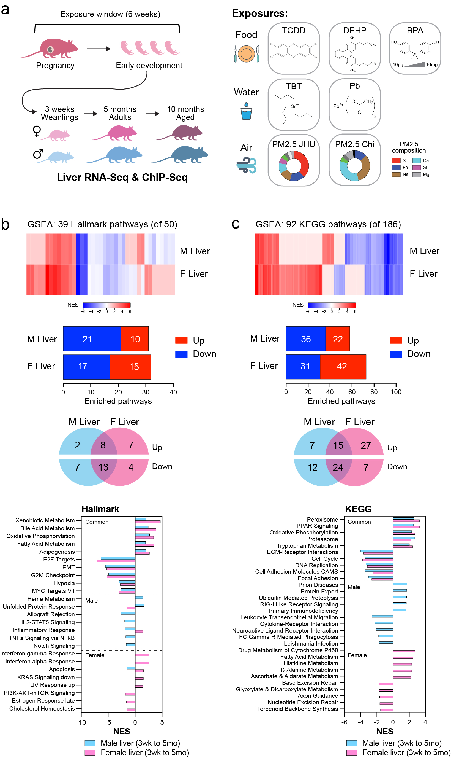

Supp Figure 2a

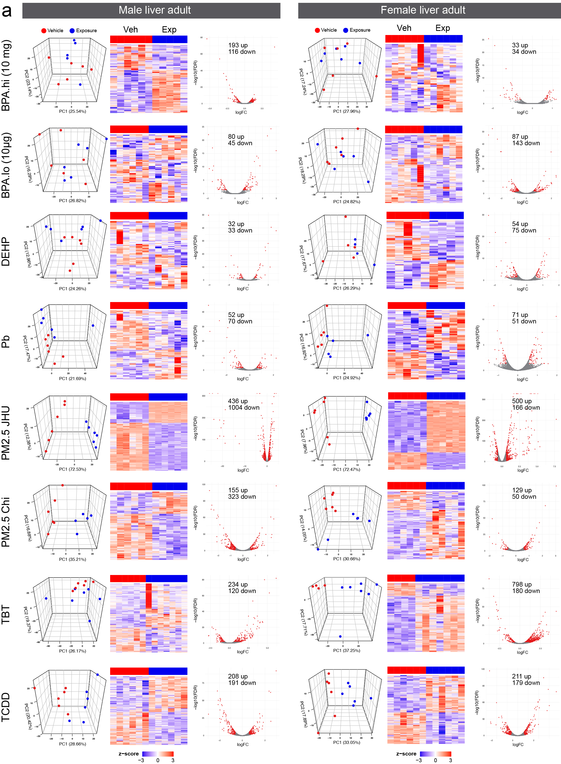
Supp Figure 2b

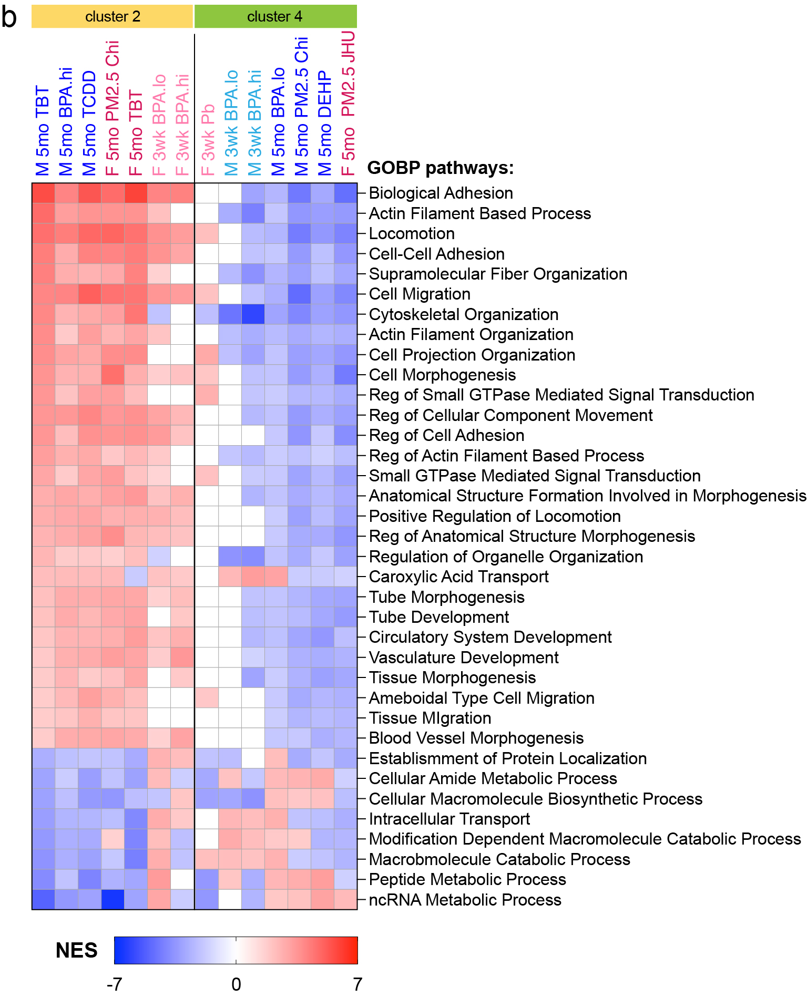

Supp Figure 3

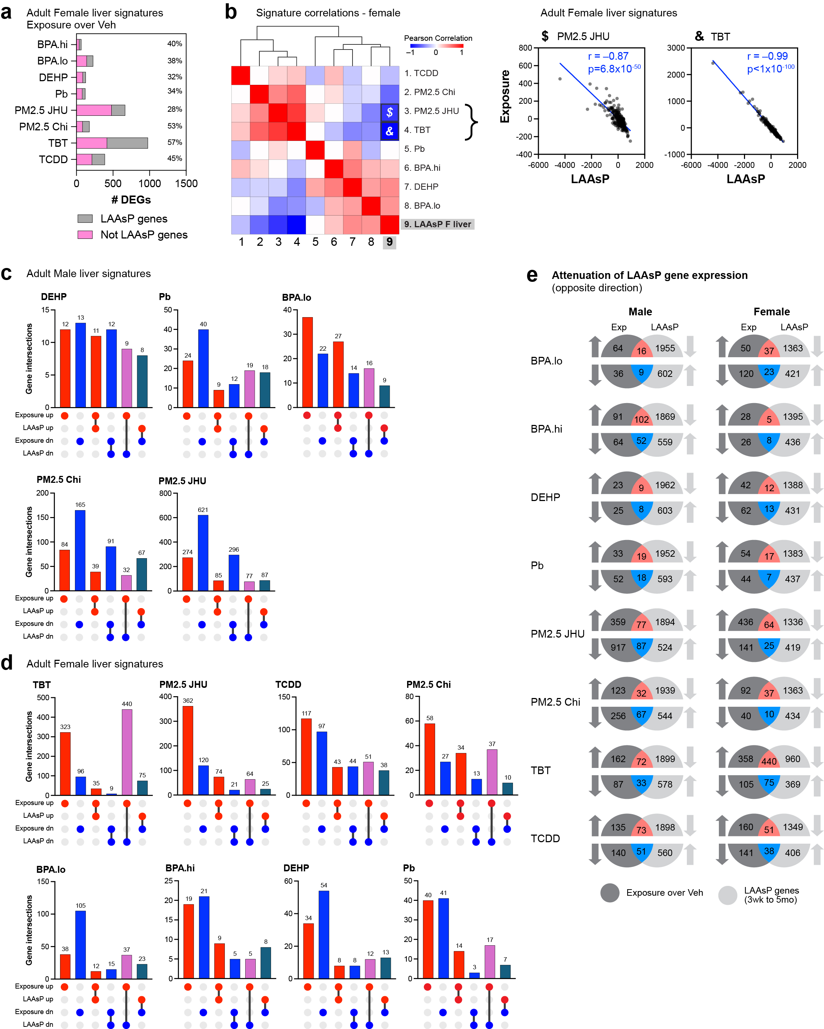

Supp Figure 4

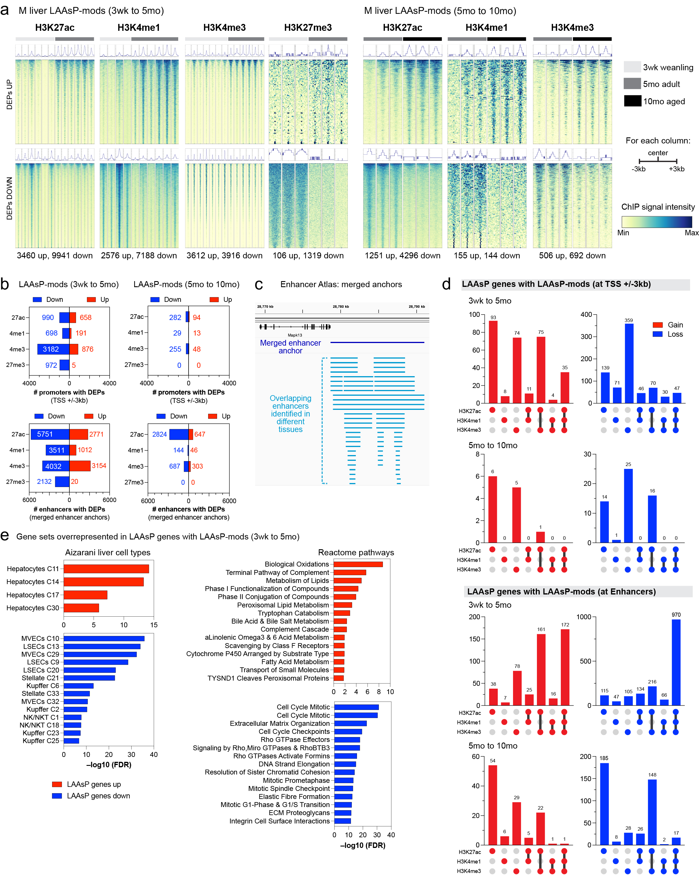

Supp Figure 5a

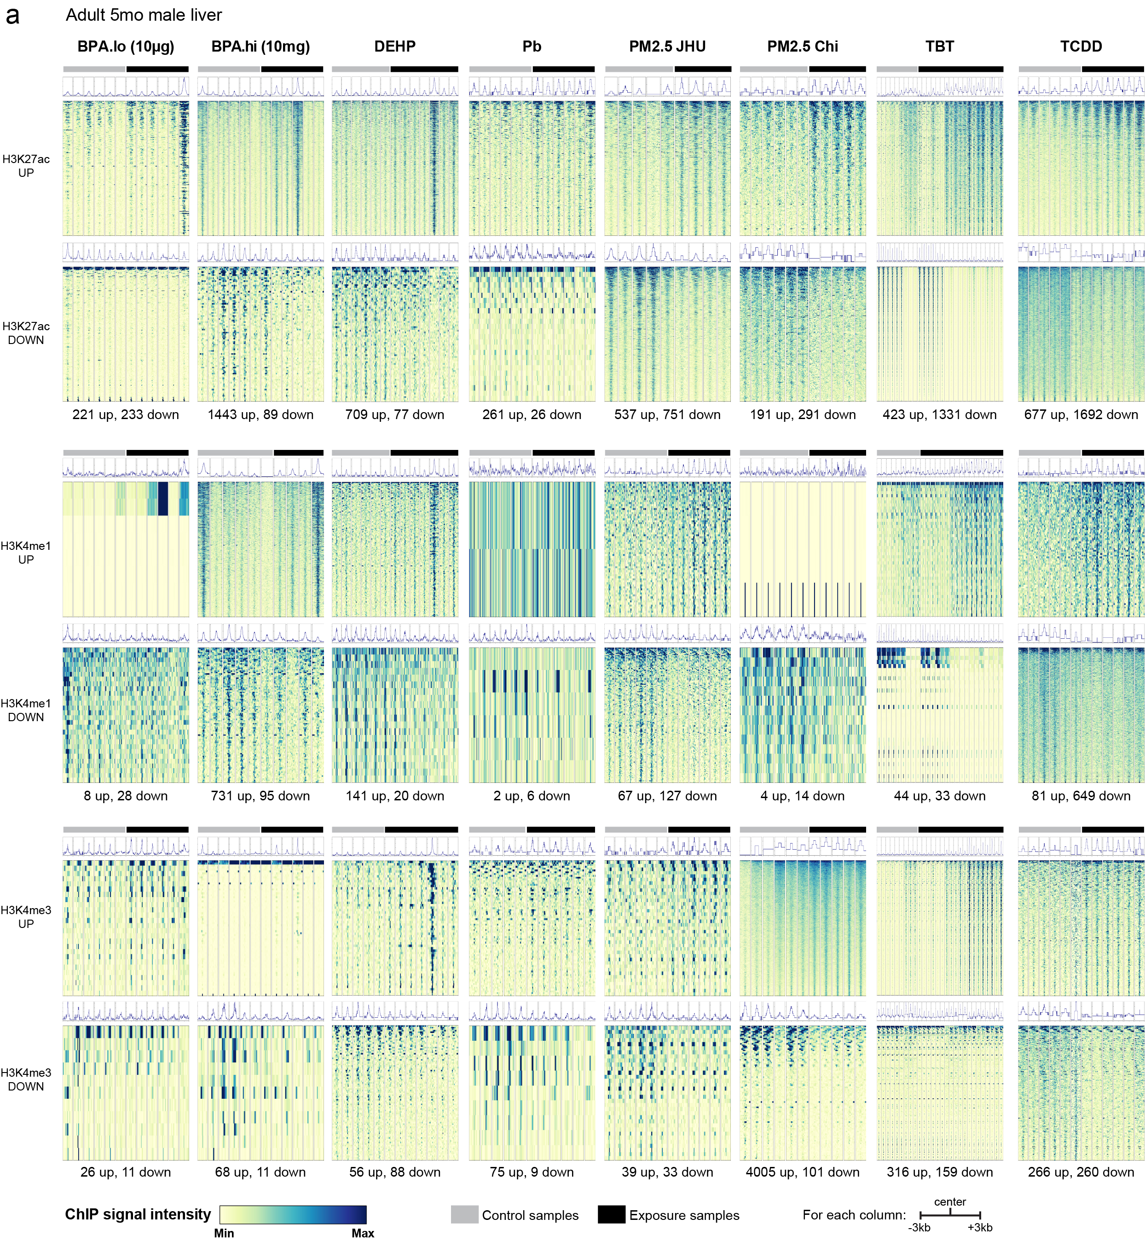

Supp Figure 5bc

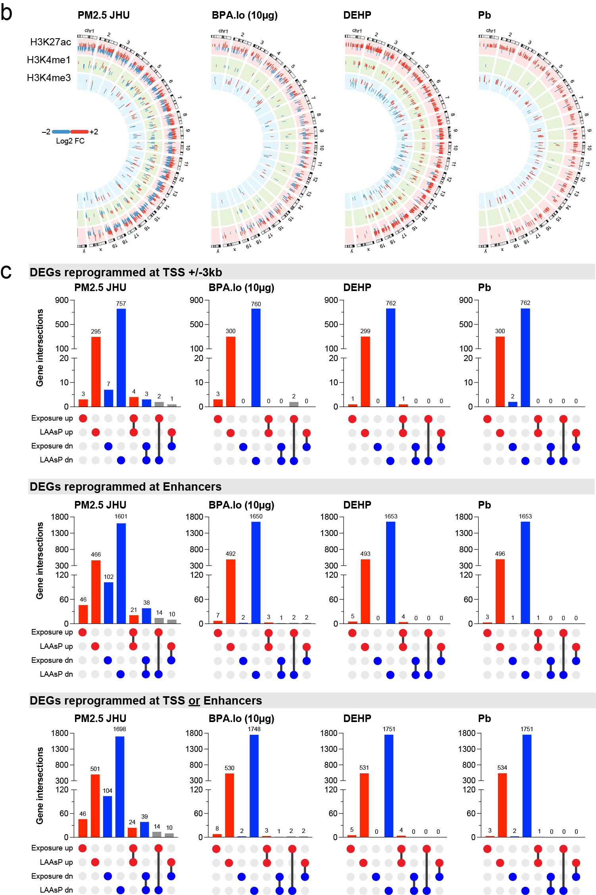

SuppFigure5d

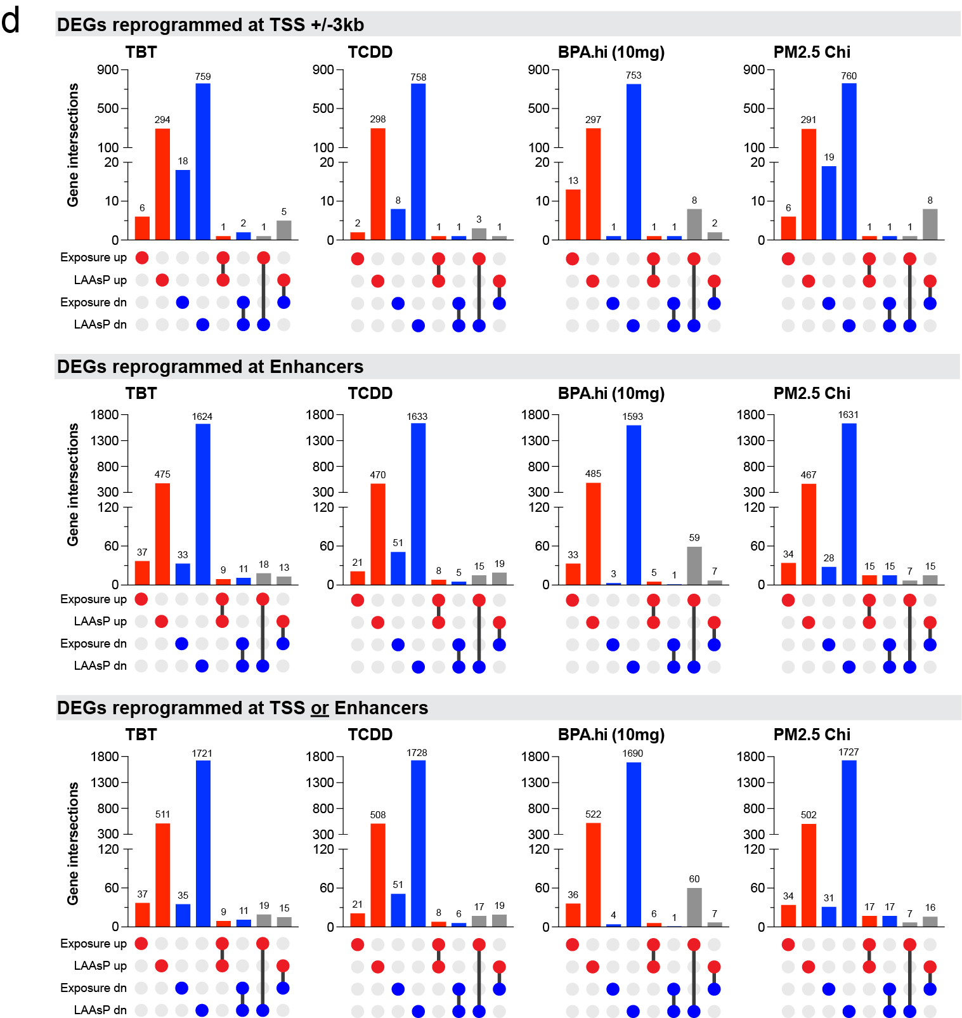

SuppFigure 5ef

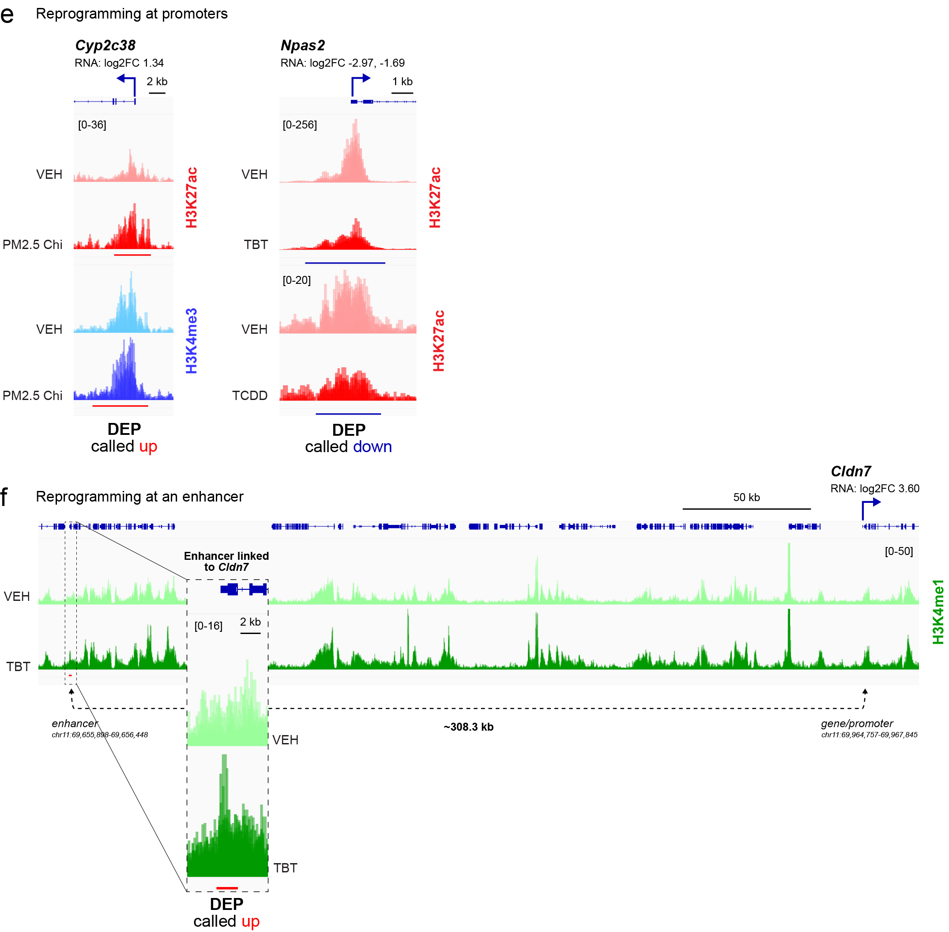

Supp Figure 6

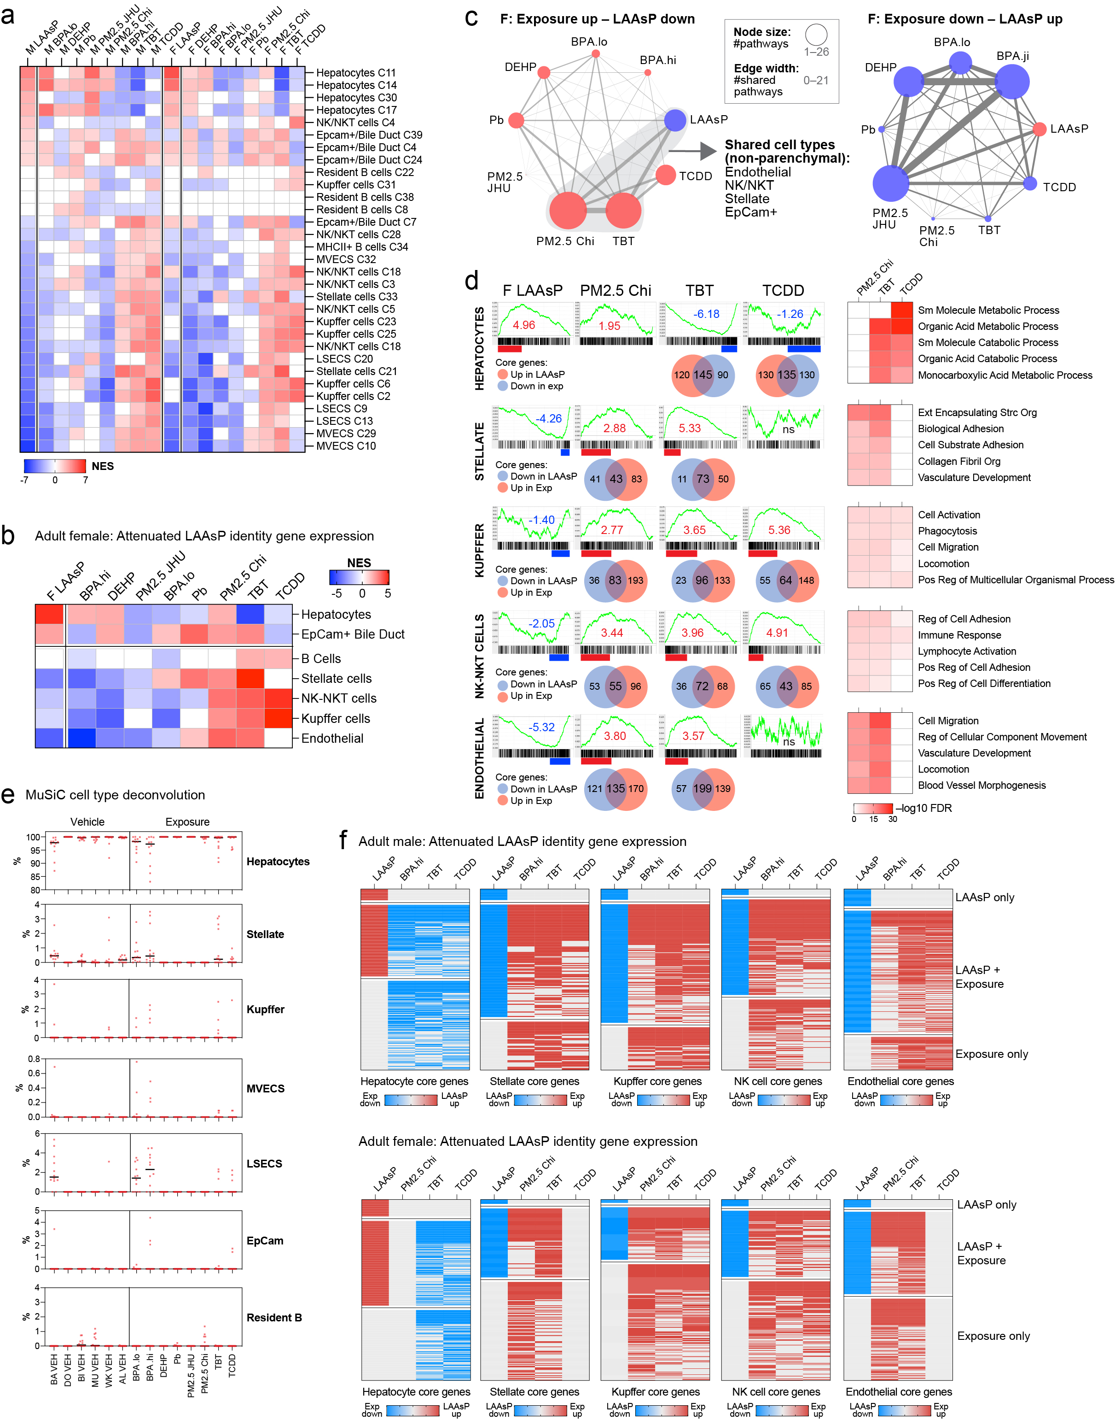

Supp Figure 7

