Table 1 Top male and female liver aging DEGs
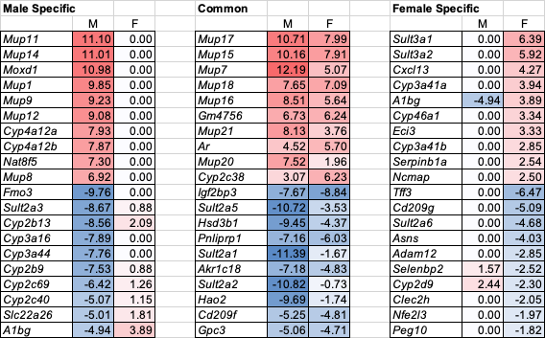

Table 2 Top LAAsP genes in exposure signatures
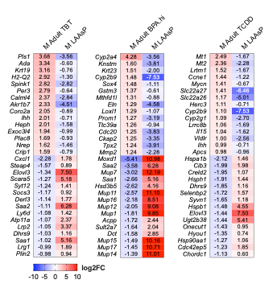

Table 3 Promoter and/or Enhancer Reprogramming at T2C Signature DEGs
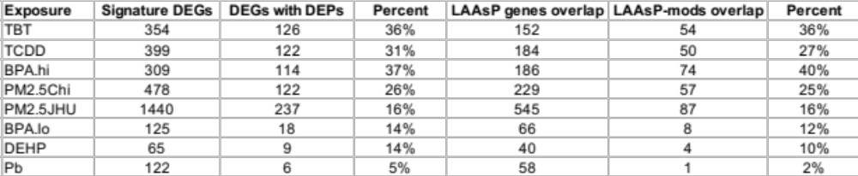

Table 4 Number of animals per omic
