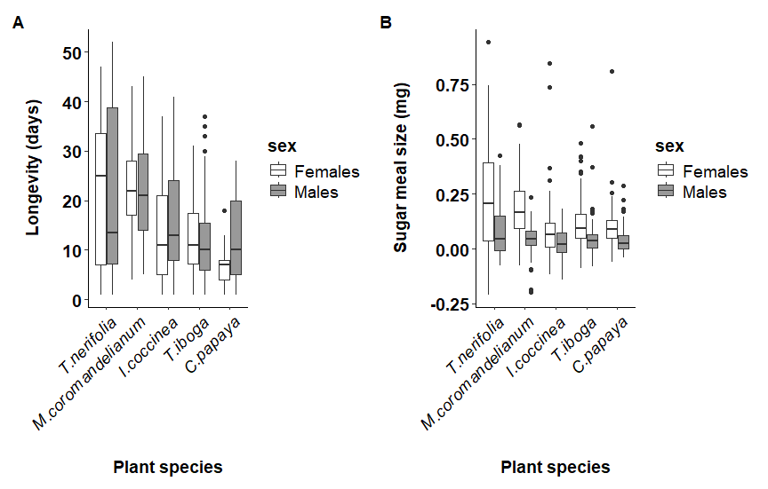
Figure 1: The effect of plant based diet on the longevity (A) and (B) the size of the sugar meal of mosquitoes. The rectangle represents the interquartile range, that is, longevities between the 25th and the 75th percentile. The thick horizontal line within the rectangle denotes the median value. The vertical lines span four times the interquartile range, and the dots show outliers that are beyond this range.

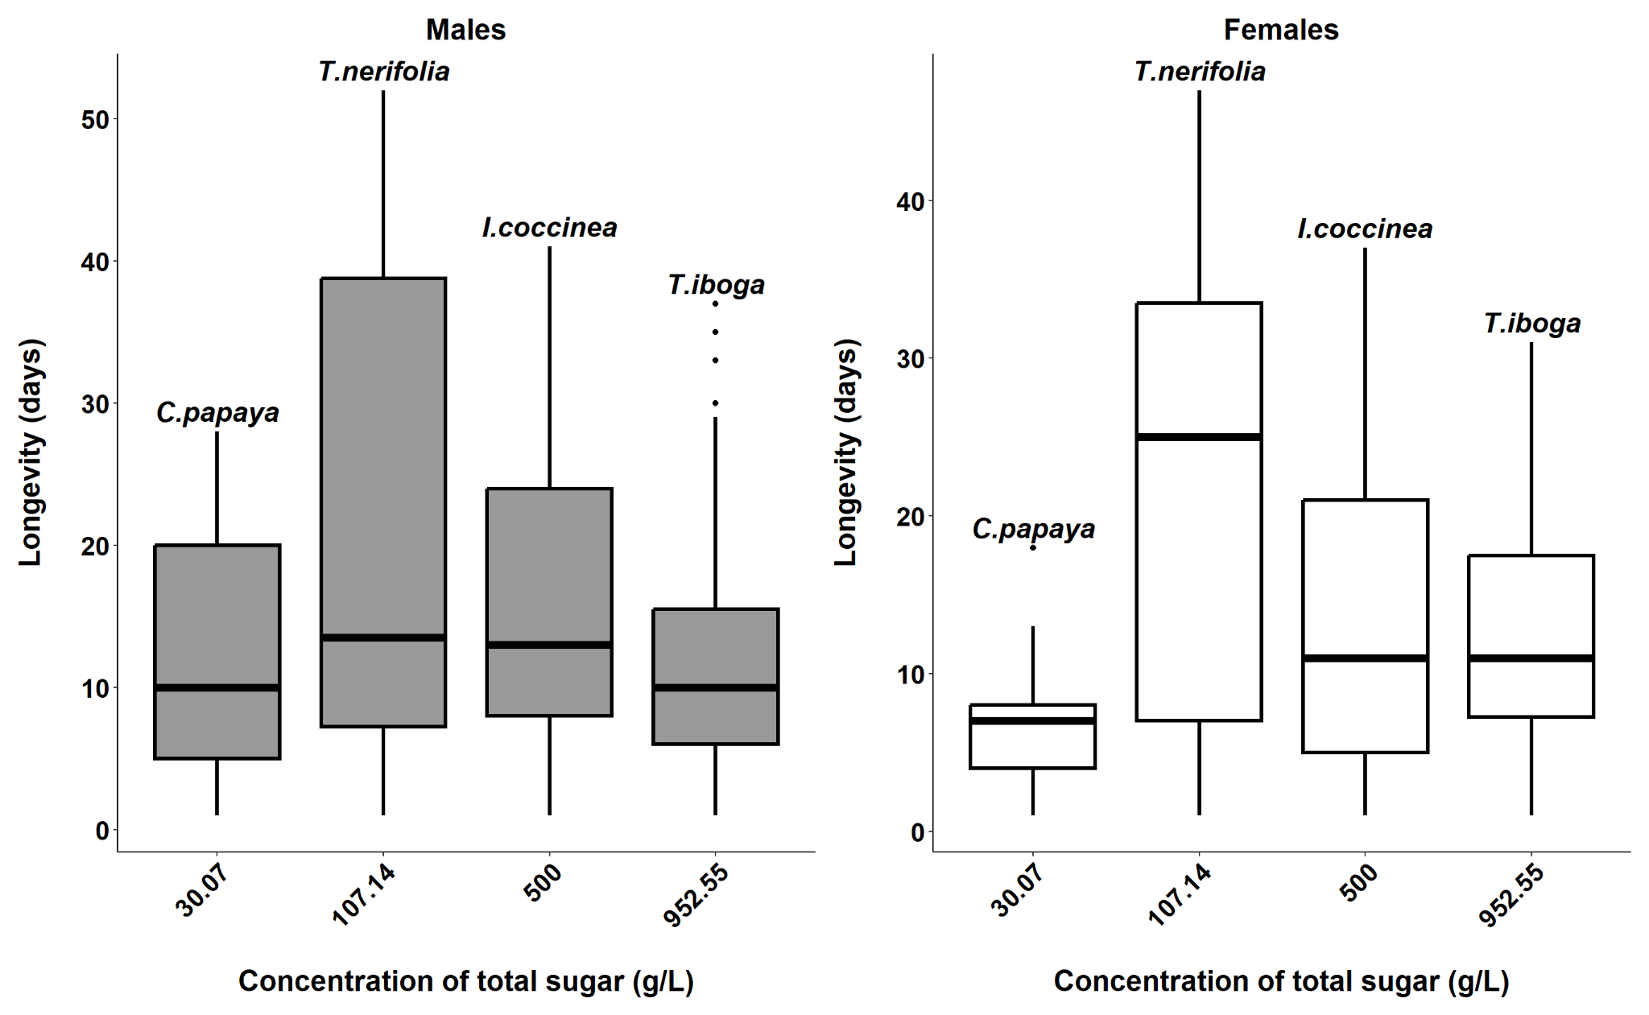

Figure 2: The effects of the concentration of total sugar in a plant sugar meal source on the longevity of mosquitoes. The rectangle represents the interquartile range, that is, longevities between the 25th and the 75th percentile. The thick horizontal line within the rectangle denotes the median value. The vertical lines span four times the interquartile range, and dots show outliers that are beyond this range.

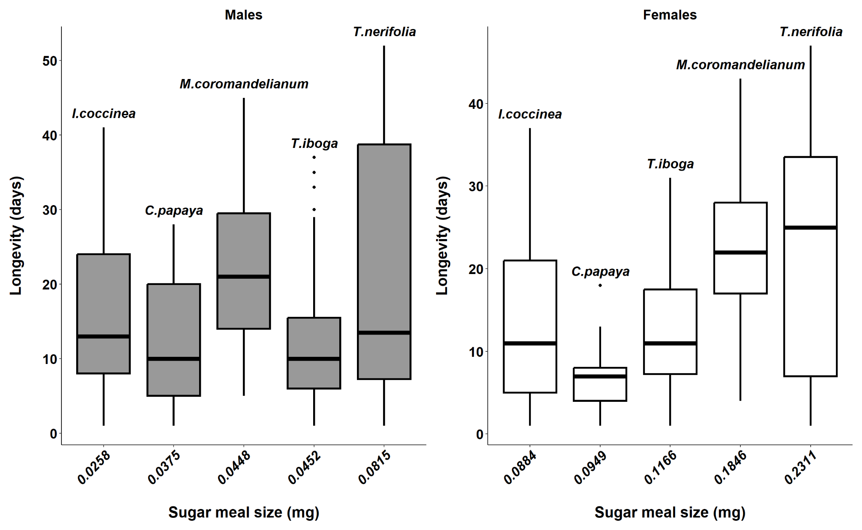

Figure 3: Relations between longevity and nectar meal size of mosquitoes feeding on different plant species. The rectangle represents the interquartile range, that is, longevities between the 25th and the 75th percentile. The thick horizontal line within the rectangle denotes the median value. The vertical lines span four times the interquartile range, and dots show outliers that are beyond this range.

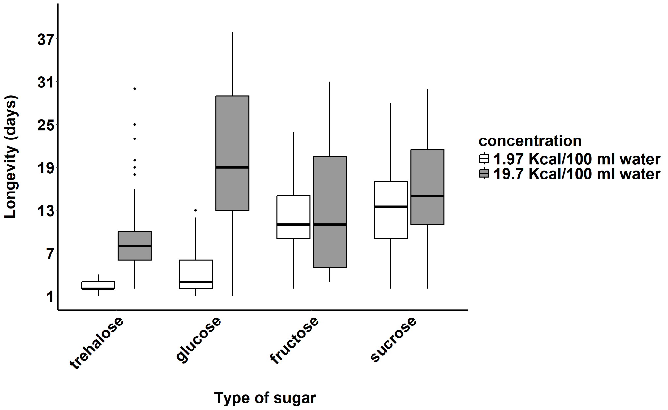

Figure 4: Effects of types and concentrations of sugar on the longevity of mosquitoes; The rectangle represents the interquartile range, that is, longevities between the 25th and the 75th percentile. The thick horizontal line within the rectangle denotes the median value. The vertical lines span four times the interquartile range, and the dots show outliers that are beyond this range.

