SUPPLEMENTARY INFORMATION

Millimeter-Wave Directed Energy-Mediated Neuronal Cell Injury: Insights into Protein Degradation and Cell Injury Mechanisms

Mojtaba Golpich, Hamad Yadikar, Sherifdeen Onigbinde, Joy Solomon, Vishal Sandilya, Moyinoluwa Adeniyi, Jiepei Zhu, Yehia Mechref, Firas Kobeissy, Kevin K. Wang

TABLE OF CONTENTS

Supplementary Table
Supplementary Table 1: Summary of differentially expressed proteins (DEPs) in the Center and Penumbra groups compared to the Control following mmWave DE exposure.

Supplementary Figures
Supplementary Figure 1: Original uncropped immunoblot and Coomassie-stained gel images
Supplementary Figure 2: Global distribution and multivariate separation of proteomic profiles across the Center, Penumbra, and Control groups.

SUPPLEMENTARY TABLES

Supplementary Table 1. Summary of differentially expressed proteins (DEPs) in the Center and Penumbra groups compared to the Control following mmWave DE exposure. Listed proteins meet the threshold of adjusted p < 0.05 and log₂ fold change ≥ 1 or ≤ –1 (≥2-fold increase or ≤0.5-fold decrease). Table includes UniProt accession, protein description, p-value, –log₂(p-value), fold change, log₂ fold change, and direction of regulation.

SUPPLEMENTARY FIGURES

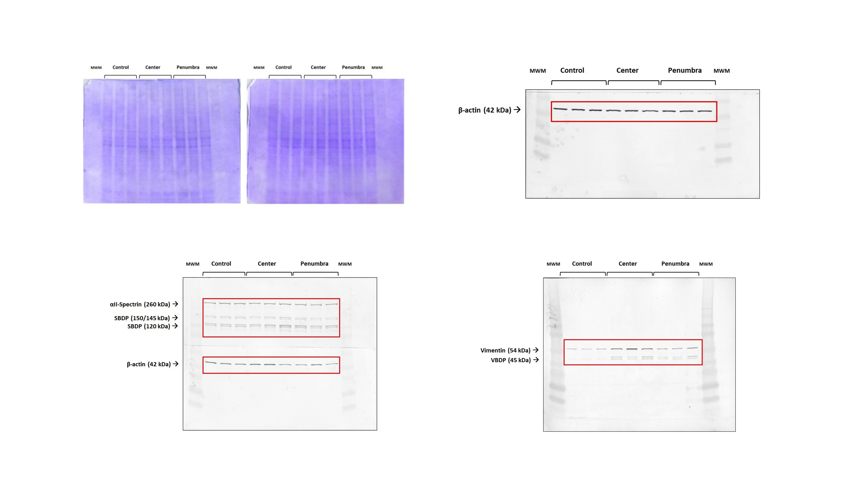
Supplementary Figure S1. Uncropped Western blot membranes and Coomassie-stained SDS-PAGE gels supporting data in Figure 4. Top left and top center panels: Coomassie-stained 4–20% Tris-Glycine SDS-PAGE gels confirming equal protein loading across Control, Center, and Penumbra groups. Top right panel: Western blot for β-actin (42 kDa), used as a loading control in all blots. Bottom left panel: Full Western blot showing αII-spectrin (260 kDa) and its proteolytic fragments at 150/145 and 120 kDa, with β-actin loading control below. Bottom right panel: Full Western blot for vimentin (54 kDa) and its cleavage product (VBDP, 45 kDa). MWM: Molecular Weight Marker. Red boxes indicate the regions shown in the central figure. Blots were developed using alkaline phosphatase-conjugated secondary antibodies and BCIP/NBT substrate.

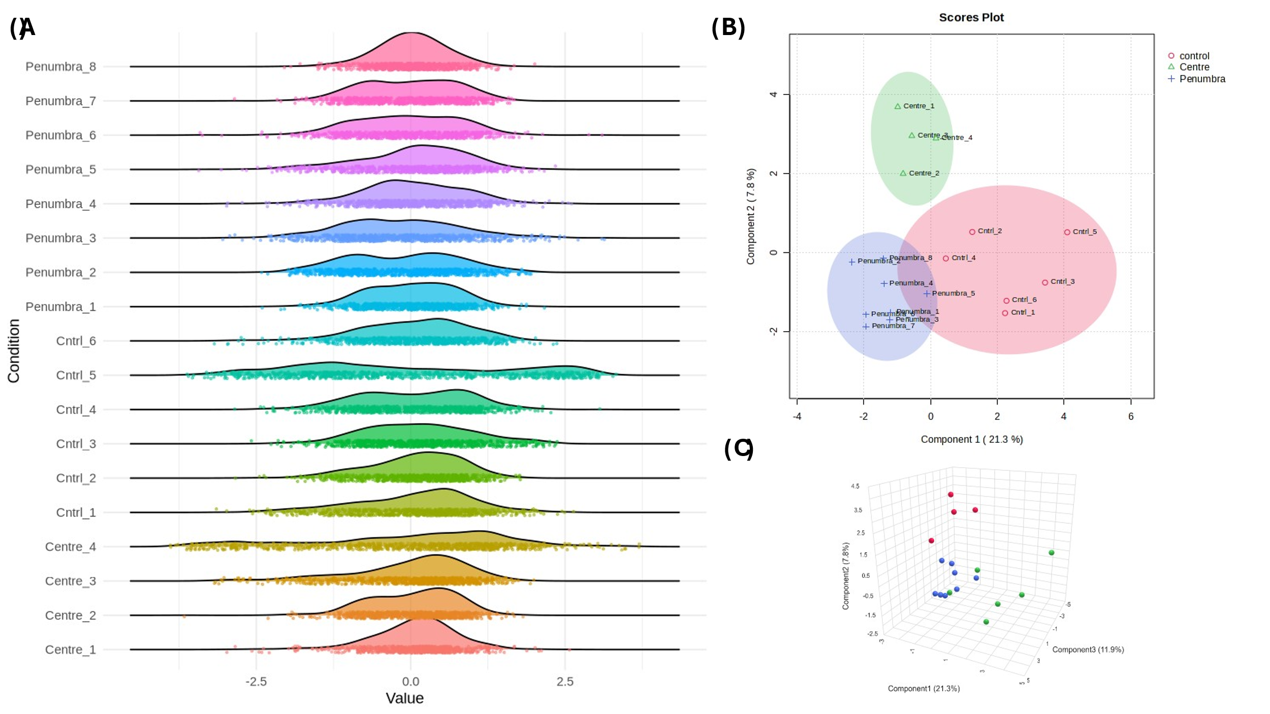
Supplementary Figure S2. Global distribution and multivariate separation of proteomic profiles across the Center, Penumbra, and Control groups. (A) Raincloud plots displaying the distribution of log₂-transformed LFQ intensity values for individual biological replicates across each condition. Each line combines kernel density estimation, jittered raw data points, and boxplot overlays to visualize the spread of intensity and replicate consistency. (B) Principal component analysis (PCA) scores plot showing clear group separation along PC1 (21.3%) and PC2 (7.8%). Colored ellipses represent 95% confidence intervals around each group centroid (Control: red, Center: green, Penumbra: blue). (C) Three-dimensional PCA plot mapping sample distributions across the first three components (PC1 = 21.3%, PC2 = 7.8%, PC3 = 11.9%) to capture spatial proteome-wide variance. All analyses were performed using log₂-transformed, normalized LFQ intensities. Missing values were imputed from a left-shifted normal distribution (width = 0.3, downshift = 1.8). PCA was computed via singular value decomposition on the covariance matrix.

